Lab assignment #9

Object Oriented Programming

# Submitted by

[Mujtaba Ahmed]

SP20-BSE-079

# Github link

<https://github.com/Mujtaba-cpu/OOP-SP21.git>

# TASK-1

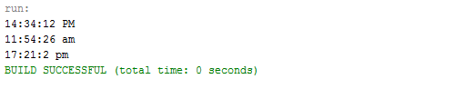

# TASk-2



# task-3

