EarthScape Developer Guide
System architecture, data workflows, models and maintenance
Contents
1. System overview 2
2. Repository layout 2
3. Data processing workflows 3
3.1 Batch pipeline 3
3.2 Live data and alerts 5
3.3 Sharing work across instances 5
4. Machine learning models 6
4.1 Trend prediction 6
4.2 Anomaly detection 6
4.3 Correlation analysis 6
5. Backend 7
5.1 API 7
5.2 Data model 8
5.3 Security 8
5.4 Settings 9
6. Frontend 9
7. Operations 9
7.1 Starting and stopping 9
7.2 Monitoring 10
7.3 Backup and restore 10
7.4 Load balancing and scaling 10
8. Testing 10
9. Known limitations and next steps 10

1. System overview
EarthScape stores public climate data in HDFS, processes it with Hadoop MapReduce, keeps the results in MongoDB, trains models on them, and serves everything through a FastAPI backend and a browser dashboard. Apache sits in front, handling HTTPS and balancing requests across two backend instances.
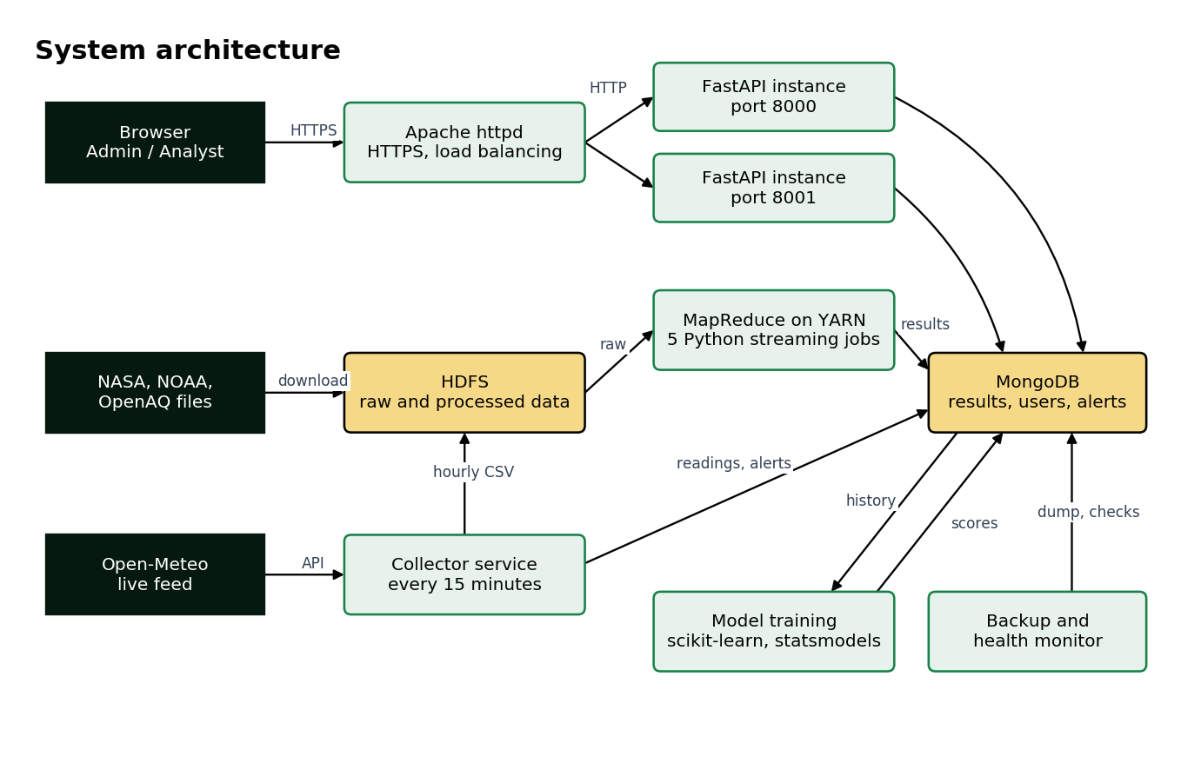
System architecture
Part | Technology | Where
Web server and load balancer | Apache httpd 2.4 | deploy/apache/httpd.conf
Backend API | Python 3.13, FastAPI, uvicorn | backend/app/
Database | MongoDB, database earthscape | Windows service
Distributed storage and processing | Hadoop 2.9.2 (HDFS, YARN), Hadoop Streaming | hadoop/, deploy/hadoop/
Machine learning | Python 3.7 (Anaconda), scikit-learn, statsmodels | ml/
Live data | Open-Meteo API, Python service | backend/collector.py, backend/app/live.py
Frontend | HTML, JavaScript, Tailwind CSS, Chart.js | frontend/
Operations | Python and PowerShell | ops/

2. Repository layout
Path | Contents
backend/app/ | API routes, login and roles, database setup, encryption, alerts, live data
backend/tests/ | Automated API tests
backend/seed.py | First-time setup: writes backend/.env and creates the first users
backend/serve.py, backend/collector.py | Runs one backend instance; runs the live data collector
data/ | Download scripts. Downloaded files go in data/raw/, which git ignores
hadoop/run_pipeline.py, hadoop/jobs/ | Batch pipeline and the five MapReduce jobs
ml/ | Training script, its tests, notebook, R correlation script
frontend/ | Website, sign-in page and dashboard. vendor/ holds local copies of libraries
deploy/apache/, deploy/hadoop/ | Apache configuration, and a copy of the Hadoop settings used
deploy/tailwind/ | Source for rebuilding frontend/css/dashboard.css
ops/ | Backup, health monitor, start and stop scripts, scheduled tasks, demo data loader
tableau/ | Export script and CSV files for Tableau
test_data/ | Sample input files, upload test cases, demo results
docs/ | These documents, their sources, screenshots and diagrams

3. Data processing workflows

3.1 Batch pipeline
hadoop/run_pipeline.py has three stages. Running it with no arguments runs them all, or name one of load, jobs or mongo.
- load unpacks the downloaded files and copies them into HDFS, foldered by source and year.
- jobs submits each Hadoop Streaming job to YARN.
- mongo reads each job's output from HDFS and loads it into MongoDB, recording run times in pipeline_runs.
Job | Input | Output | What it does
data_quality | GHCN-Daily | data_quality | Counts valid, missing, failed-QC and malformed readings
regional_monthly | GHCN-Daily and station list | regional_monthly | Monthly means by latitude zone
station_anomalies | GHCN-Daily | station_anomalies | Readings more than 3 standard deviations from that station and month's mean
satellite_zonal | NASA POWER | satellite_zonal | Zonal means of solar radiation and surface temperature
air_quality_monthly | OpenAQ | air_quality_monthly | Monthly mean and maximum for each sensor location

Bad data is handled in the mappers. Malformed rows, failed quality flags and missing values are skipped and counted, so a bad row never stops a job. The data_quality job reports how many were found.
HDFS layout:
/climate/raw/ghcn_daily/year_2020, year_2023 partitioned by year
/climate/raw/gistemp, co2, power, openaq one folder per source
/climate/raw/live hourly batches from the collector
/climate/raw/uploads files uploaded through the dashboard
/climate/reference GHCN station list
/climate/processed job output
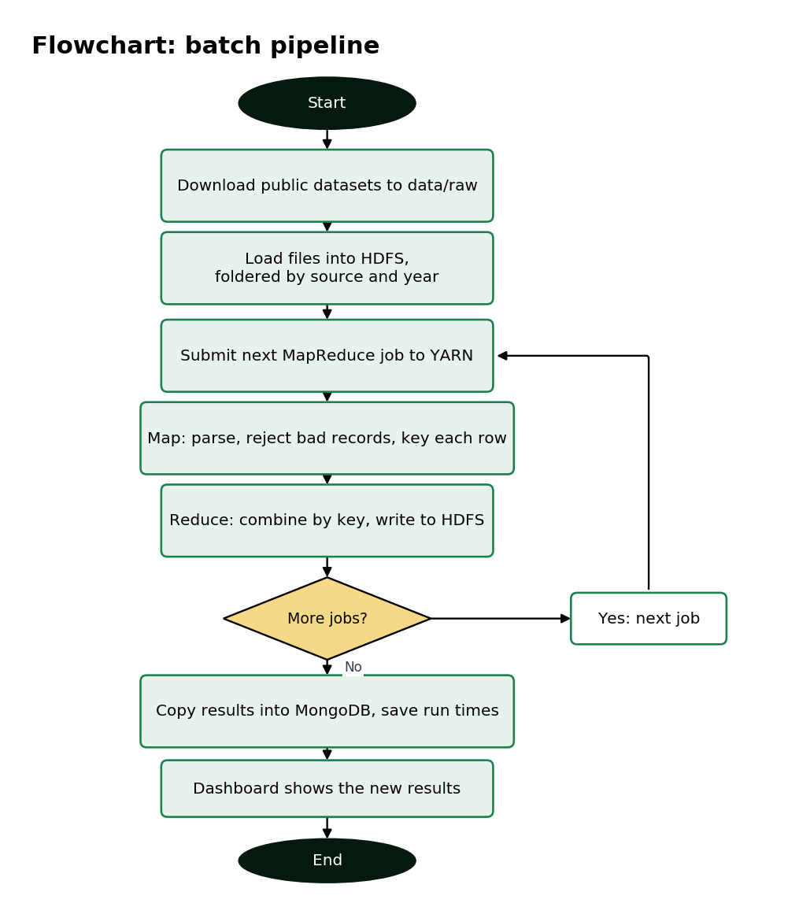
Flowchart of the batch pipeline

3.2 Live data and alerts
The collector calls live.poll() every 15 minutes (LIVE_POLL_MINUTES). Each poll fetches 12 cities from Open-Meteo and stores new readings. Then alert_checks.check_rules() compares the newest values with every rule. Each hour (LIVE_BATCH_MINUTES), unarchived readings are written to HDFS as a CSV batch, which joins the live feed to batch storage.
This is scheduled collection, not a streaming system such as Kafka. A new value is available within one 15-minute cycle.
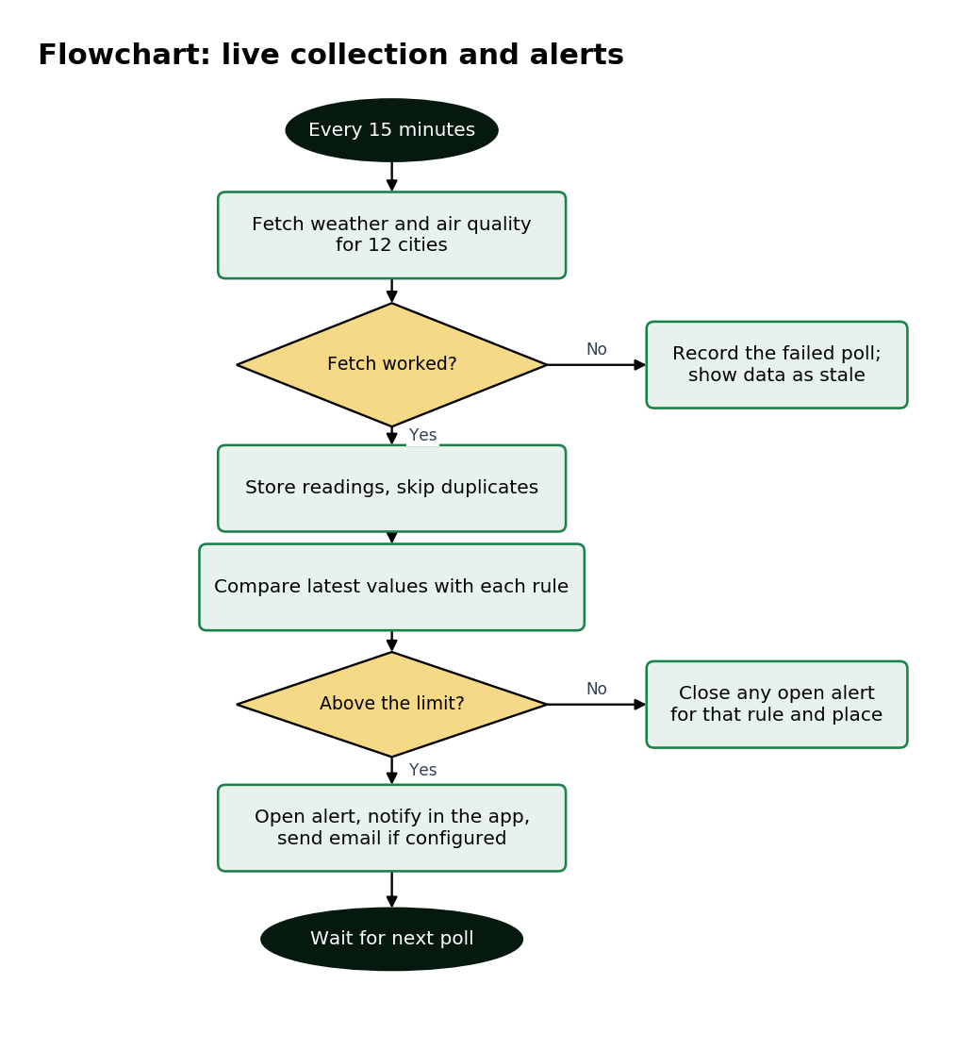
Flowchart of live collection and alerts

3.3 Sharing work across instances
Both backend instances, the collector and the monitor use the same MongoDB, so no state lives inside one process. Sign-in tokens are signed and work on either instance. Failed sign-in counts are in login_failures. The locks collection (backend/app/locks.py) makes sure only one job, retraining run or poll runs at a time. Each lock expires, so a crashed process can't hold it forever.

4. Machine learning models
ml/train_models.py runs in Anaconda's Python. A retrain from the dashboard runs it as a separate process, and each run saves scores to ml_runs and model files to ml/saved_models/. Because a run reads whatever is currently in MongoDB and the data files, retraining refines the models on the latest data.

4.1 Trend prediction
For each of nine series (global and eight latitude zones) of NASA GISTEMP data:
- Several methods compete: last value (the baseline), linear trends over recent windows, and Holt exponential smoothing.
- They are compared by backtesting from 1950 onward, using only what was known at each point, predicting 10 years ahead.
- The winner is scored once on the final, unseen 10 years (2016-2025). The baseline can't be chosen, so a forecast always shows a trend.
- The range is taken from the method's own past errors, and checked against those 10 years.

4.2 Anomaly detection
An Isolation Forest on daily OpenAQ readings, with each day's values expressed as z-scores against that sensor's previous 30 days. This stops naturally dirty locations from dominating. Nobody has labelled true anomalies, so it's tested by injecting artificial spikes into held-out data and measuring how many are found.

4.3 Correlation analysis
Pearson and Spearman correlations between variables. Two rising series always correlate strongly, so CO₂ and temperature are compared both as raw values and as year-to-year changes. ml/correlation_analysis.R repeats the analysis in R, and hasn't been run because R wasn't installed.
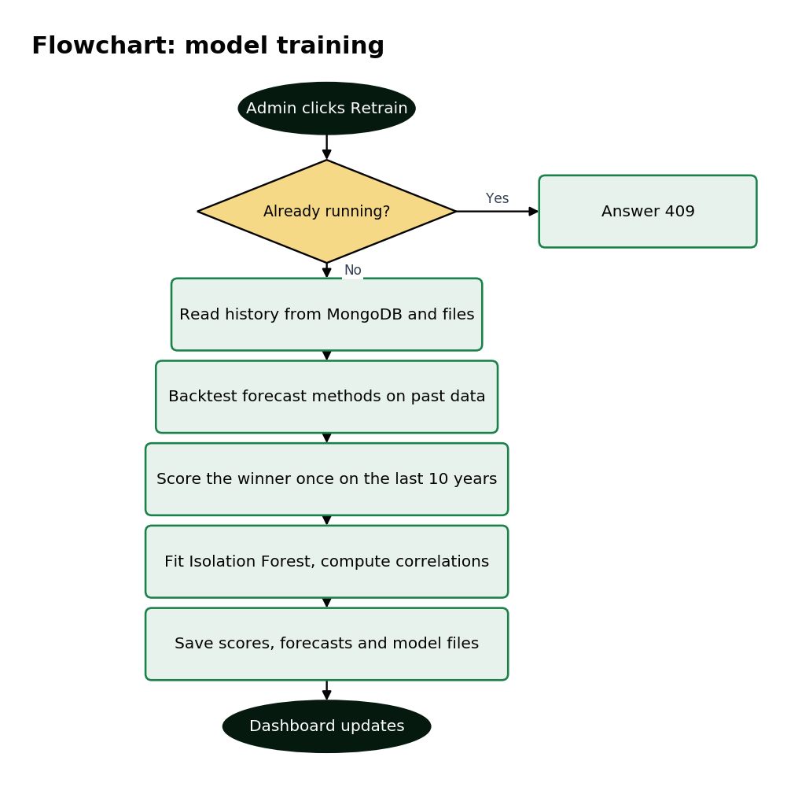
Flowchart of model training

5. Backend

5.1 API
Interactive reference: /docs on a running backend. All routes need a valid token unless marked as public, and those marked Admin need the Admin role.
Area | Routes
Sign-in | POST /api/auth/login (public), logout, GET and PATCH /api/auth/me, POST /api/auth/password
Users | GET /api/users, POST /api/users (Admin), PATCH /api/users/{id} (Admin)
Climate data | GET /api/overview, /api/climate/global, zonal, monthly, zones, /api/anomalies, /api/air-quality, /api/quality
Reports | GET /api/reports, /api/reports/{id}?format=csv, json or geojson
Cluster | GET /api/cluster, /api/jobs, /api/jobs/{id}, POST /api/jobs/{name}/run (Admin)
Datasets | GET /api/datasets, POST /api/datasets (Admin)
Live | GET /api/live/latest, /api/live/history, POST /api/live/poll (Admin)
Models | GET /api/ml/summary, forecast, anomalies, correlations, POST /api/ml/retrain (Admin)
Alerts | GET /api/alerts, PATCH /api/alerts/{id}, GET /api/alert-metrics, /api/alert-rules, POST and DELETE rules (Admin)
Support | GET and POST /api/tickets, PATCH /api/tickets/{id} (Admin), GET /api/notifications, POST /api/notifications/read
System | GET /api/health (public), /api/status, GET /api/maintenance (public), PUT /api/maintenance (Admin)

5.2 Data model
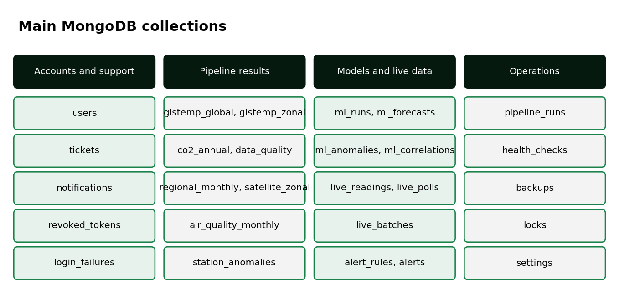
Main MongoDB collections
Indexes are created at startup by ensure_indexes() in backend/app/db.py, which also encrypts any older plain email or ticket fields. health_checks expire after 90 days, and login_failures and revoked_tokens expire when no longer needed.

5.3 Security
Concern | How it's handled | File
Passwords | bcrypt hashes | security.py
Sessions | Signed JWT, 8 hours, revoked on sign-out | security.py
Roles | require_admin checked on the server for each route | security.py
Sensitive fields | Emails and ticket text encrypted with Fernet (AES) | field_crypto.py
Finding a user by encrypted email | HMAC-SHA256 blind index | field_crypto.py
Password guessing | 5 failures per account, 30 per address, in 15 minutes | login_limit.py
Transport | TLS 1.2 or newer, HTTP redirected to HTTPS | httpd.conf
Browser headers | nosniff, DENY framing, same-origin referrer | main.py

Climate data, names and roles aren't encrypted. HSTS is left off because the certificate is self-signed for localhost.

5.4 Settings
Set in backend/.env or as environment variables. seed.py generates the keys and the first users' details.
Setting | Purpose
JWT_SECRET, ENCRYPTION_KEY | Signing and encryption keys. Keep a safe copy: backups can't be read without ENCRYPTION_KEY
SEED_ADMIN_EMAIL, SEED_ADMIN_PASSWORD, SEED_ANALYST_* | First users' details
MONGO_URI, MONGO_DB | Database connection
YARN_URL, NAMENODE_URL | Hadoop web addresses
ML_PYTHON | Python used for training
LIVE_POLL_MINUTES, LIVE_BATCH_MINUTES | Collector timing
SMTP_HOST, SMTP_PORT, SMTP_USER, SMTP_PASSWORD, SMTP_FROM, SMTP_TLS, ALERT_EMAIL_TO | Alert emails
BACKUP_DIR, BACKUP_KEEP, MONGO_TOOLS_DIR | Backups
MONITOR_TARGETS | What the health monitor checks

6. Frontend
frontend/dashboard.html holds every page as a section, and frontend/js/earthscape.js shows one at a time, fetches its data and draws its charts. To add a page, add a section id="view-name", add it to NAV and give it a render function.
The sign-in page and dashboard store their libraries locally, so they work without internet. The public website is the starting template, and loads some images and fonts from the internet. Its pages check frontend/css/harvestra.webflow.shared.css and frontend/js/ against fixed checksums, so .gitattributes stops Git changing their line endings. Tailwind is built ahead of time, so after adding a new class, rebuild:
npx tailwindcss@3.4.16 -c deploy/tailwind/tailwind.config.js -i deploy/tailwind/input.css -o frontend/css/dashboard.css --minify

7. Operations

7.1 Starting and stopping
After a restart:
- In a normal Command Prompt, run C:\hadoop\hadoop-2.9.2\sbin\start-dfs.cmd.
- In a Command Prompt run as administrator, run C:\hadoop\hadoop-2.9.2\sbin\start-yarn.cmd. Without administrator rights, jobs fail with CreateSymbolicLink error (1314).
- In PowerShell, run ops\start_all.ps1. It starts both backends, the collector, the monitor and Apache, and skips anything already running.
Stop them with ops\stop_all.ps1. Service output goes to logs/, and Apache's to logs/apache/.

7.2 Monitoring
ops/health_monitor.py --loop 60 checks each target every minute, writes to health_checks and logs/health.log, and sends a notification when something goes down or recovers. The System Status page turns those checks into availability figures, and shows job and training times. YARN and HDFS have their own pages at ports 8088 and 50070.

7.3 Backup and restore
ops/backup.py dumps MongoDB, restores the dump into a separate database to prove it works, copies the HDFS data that can't be downloaded again, and keeps the last seven backups. A failure raises a notification. ops/install_scheduled_tasks.ps1 schedules it for 2 am daily.
To restore a backup:
"C:\Program Files\MongoDB\Tools\100\bin\mongorestore" --gzip --drop --dir=backups\<folder>\mongo
ENCRYPTION_KEY isn't in the backup, because storing the key with the data would defeat the encryption. Keep it separately.

7.4 Load balancing and scaling
Apache's balancer://earthscape sends requests in turn to ports 8000 and 8001, checks /api/health every 5 seconds, and retries a failed request on the other instance. To add an instance, start backend\serve.py --port 8002 and add a BalancerMember line. The X-EarthScape-Instance response header shows which instance answered.
For more data, HDFS and YARN scale by adding DataNodes and NodeManagers. This is standard Hadoop behaviour, but this project has only run it on one node.

8. Testing
Run the backend tests with pytest in backend, using the backend's Python. Run ml\test_train_models.py with pytest using Anaconda's Python. Tests use a separate database, so they don't touch real data.

9. Known limitations and next steps
- Polling, not streaming. Kafka or Spark Streaming could replace the collector.
- Uploaded files are stored, but aren't processed until a matching job is written.
- No satellite imagery is processed. NASA POWER provides satellite-derived values as tables.
- Impala is listed in the brief but isn't installed. Queries go through MongoDB.
- Everything runs on one machine, so it can't survive a hardware failure.
- The app has no password reset for other users.
- Rebuilding the pipeline requires downloading about 330 MB, which unpacks to about 2.6 GB.

