EarthScape Climate Agency
Big data climate analysis platform: eProject report
Contents
1. Problem definition 3
1.1 Objectives 3
1.2 Users 3
2. Requirements and how they were met 3
2.1 Functional requirements 3
2.2 Non-functional requirements 4
2.3 Software listed in the brief 4
3. Design specifications 5
3.1 Architecture 5
3.2 Key design decisions 5
3.3 Data sources 6
3.4 Data model 6
3.5 User interface 6
4. Diagrams 8
4.1 Data flow diagrams 8
4.2 Flowcharts 9
5. Results 12
5.1 MapReduce 12
5.2 Trend prediction 13
5.3 Anomaly detection 13
5.4 Correlation 13
5.5 Reliability and load balancing 14
6. Test data and testing 14
6.1 Test data used 14
6.2 Automated tests 14
6.3 Test cases 15
7. Installation 15
7.1 Software needed 15
7.2 Website and database 16
7.3 HTTPS and load balancing 16
7.4 Hadoop and the full pipeline 16
8. Conclusion and future work 16
9. Source code 17

1. Problem definition
Climate change is a global challenge. Rising greenhouse gas emissions, deforestation and changes in land use are shifting climate patterns and making severe weather more frequent.
The EarthScape Climate Agency monitors these changes. It collects large amounts of data from satellites, weather stations and environmental sensors, but this data is too large and too varied to study by hand. The agency needs a system to store, process, analyse and present it, so that staff can make informed decisions.

1.1 Objectives
- Store large climate datasets reliably in Hadoop HDFS.
- Process them in parallel with MapReduce.
- Combine historical records with live data.
- Predict trends, and detect anomalies and correlations with machine learning.
- Present results in interactive dashboards.
- Alert people when readings cross configured limits.
- Protect the system with sign-in, roles and encryption.

1.2 Users
User | Needs
Administrator | Manage users, data, jobs, models, alert rules and support
Climate analyst | Explore data, read forecasts, respond to alerts, download reports, ask for help

2. Requirements and how they were met
Status key: Met means it was built and tested. Partly means it works within a stated limit. Not met means it wasn't built.

2.1 Functional requirements
Requirement | Status | How it was met
Authentication and roles | Met | Sign-in with signed tokens. Admin and Analyst roles are enforced on the server
Ingest diverse datasets | Partly | Station, sensor, gridded satellite-derived and tabular data. Satellite imagery isn't processed; imagery files can be uploaded and stored only
Historical and real-time sources | Partly | Historical files, plus live data polled every 15 minutes
Common climate formats | Partly | Uploads accept NetCDF, GeoTIFF, HDF5, Parquet, CSV and GRIB2 after a content check. Only CSV and JSON are processed
HDFS storage | Met | 2.5 GB of station data plus other sources, partitioned by source and year
MapReduce processing | Met | Five jobs on YARN. Run on one node, so parallel across tasks rather than across machines
Patterns, anomalies, correlations | Met | Zonal and monthly patterns, 48,715 flagged station readings, 12 correlation pairs
Missing or incomplete data | Met | Bad rows are skipped and counted, and shown on the data quality table
Real-time processing | Partly | Scheduled polling, not a streaming system. Hourly batches join live data to HDFS
ML models | Met | Forecasting, anomaly detection and correlation, retrained on demand
Interactive dashboards | Met | 14 pages, with region, variable, city and time span choices, and exports
Notifications and alerts | Met | Configurable rules, in-app notifications. Email is built, but only tested against a simulated mail server
Feedback and support | Met | Tickets with categories and status

2.2 Non-functional requirements
Requirement | Status | How it was met
Performance monitoring | Met | Status page, job and training times, health checks
Optimisation | Partly | Database indexes, and results computed ahead of time so pages load fast. No formal load test
Encryption | Met | HTTPS with TLS 1.2 or newer. Passwords hashed. Emails and tickets encrypted. Climate data isn't encrypted, as it's public
Data protection standards | Partly | Follows common practice. Not audited or certified
99% uptime | Partly | Availability is measured and maintenance notices exist. One computer can't prove this
Automated backups | Partly | Backup script with a restore check works. The daily schedule is installed separately from an administrator prompt
Horizontal scaling and load balancing | Partly | Two backends behind Apache, tested with failover. Real multi-machine scaling hasn't been tested
Environmental data standards | Partly | ISO 8601 dates and GeoJSON exports. No formal compliance claimed
Documentation | Met | User guide, developer guide, this report and a video script

2.3 Software listed in the brief
Software | Used? | Notes
Jupyter (Anaconda) | Yes | ml/climate_models.ipynb
RStudio | Script only | ml/correlation_analysis.R is written but hasn't been run
VS Code or PyCharm | Yes | Development
MongoDB Compass and Shell | Yes | Results database
Hadoop, HDFS, Apache | Yes | Hadoop 2.9.2, Apache 2.4.69
Tableau | Data ready | CSV exports and build steps are ready. The workbook is built in Tableau itself
Impala | No | Not installed. Queries are answered through MongoDB

3. Design specifications

3.1 Architecture
The system has three layers. Storage and processing are Hadoop. Results and application data are in MongoDB. The presentation layer is a FastAPI backend and a browser dashboard behind Apache.
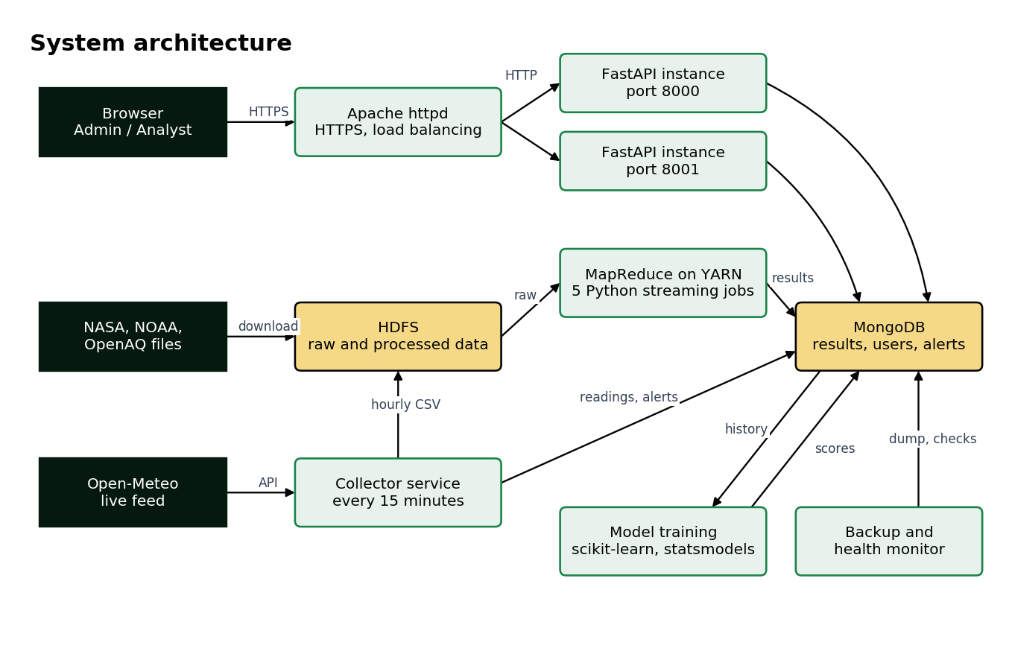
System architecture

3.2 Key design decisions
Decision | Reason
Hadoop Streaming with Python | The same language as the rest of the project, and each job can be tested without a cluster
Copy results to MongoDB | Dashboard pages need answers in milliseconds, while MapReduce takes minutes
Store state only in MongoDB | Any backend instance can answer any request, which makes load balancing possible
Compare forecasts against a baseline | A model is only useful if it beats simply repeating the last value
Check backups by restoring them | A backup that has never been restored isn't proven
Label estimates and limits on screen | People should know how far to trust what they see

3.3 Data sources
Source | Provides | Format | Size
NOAA GHCN-Daily, 2020 and 2023 | Weather station records | CSV (gzip) | 2.6 GB unpacked
NASA GISTEMP v4 | Temperature anomalies since 1880 | CSV | Small
NOAA Mauna Loa | Yearly CO₂ since 1959 | CSV | Small
NASA POWER | Satellite-derived solar radiation, surface temperature | JSON API, stored as CSV | Small
OpenAQ, 2023 | Air quality sensor readings | CSV (gzip) | 15 MB
Open-Meteo | Live weather and air quality estimates for 12 cities | JSON API | Grows over time

3.4 Data model
MongoDB holds the results. Collections are listed by purpose below, and the Developer Guide describes each in more depth.
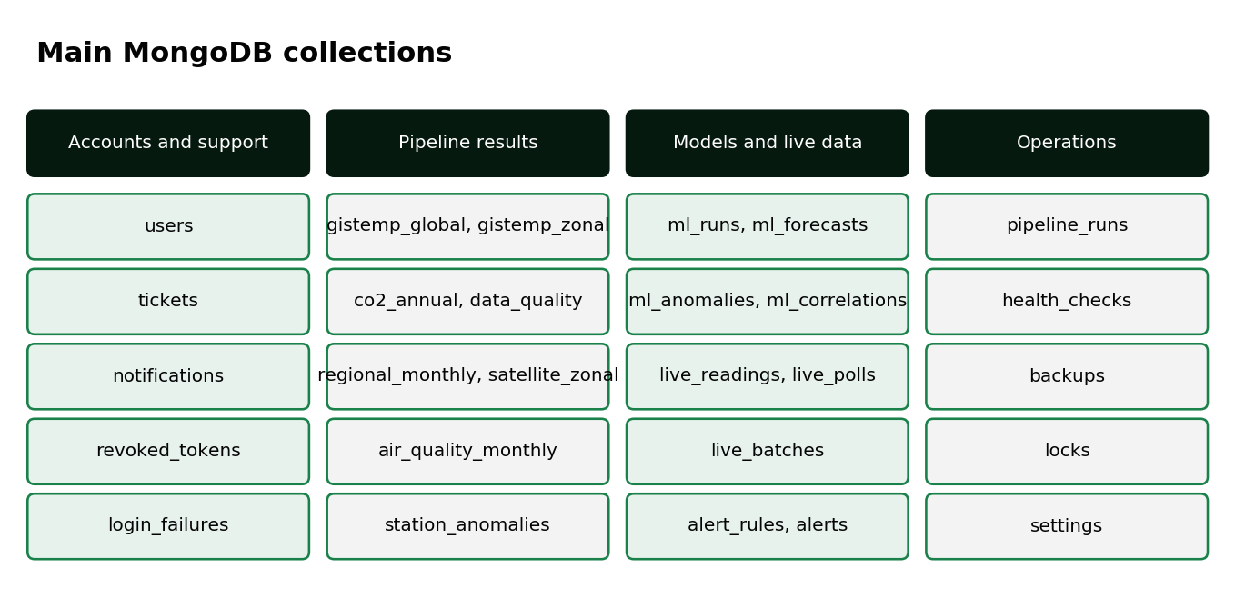
Main MongoDB collections

3.5 User interface
The public website is the template the project started from, and its Dashboard button leads to sign-in. The dashboard has a side menu with 14 pages. Green and gold are the agency's colours. Colour never carries meaning alone: every status has a text label. Screens adapt down to phone width.
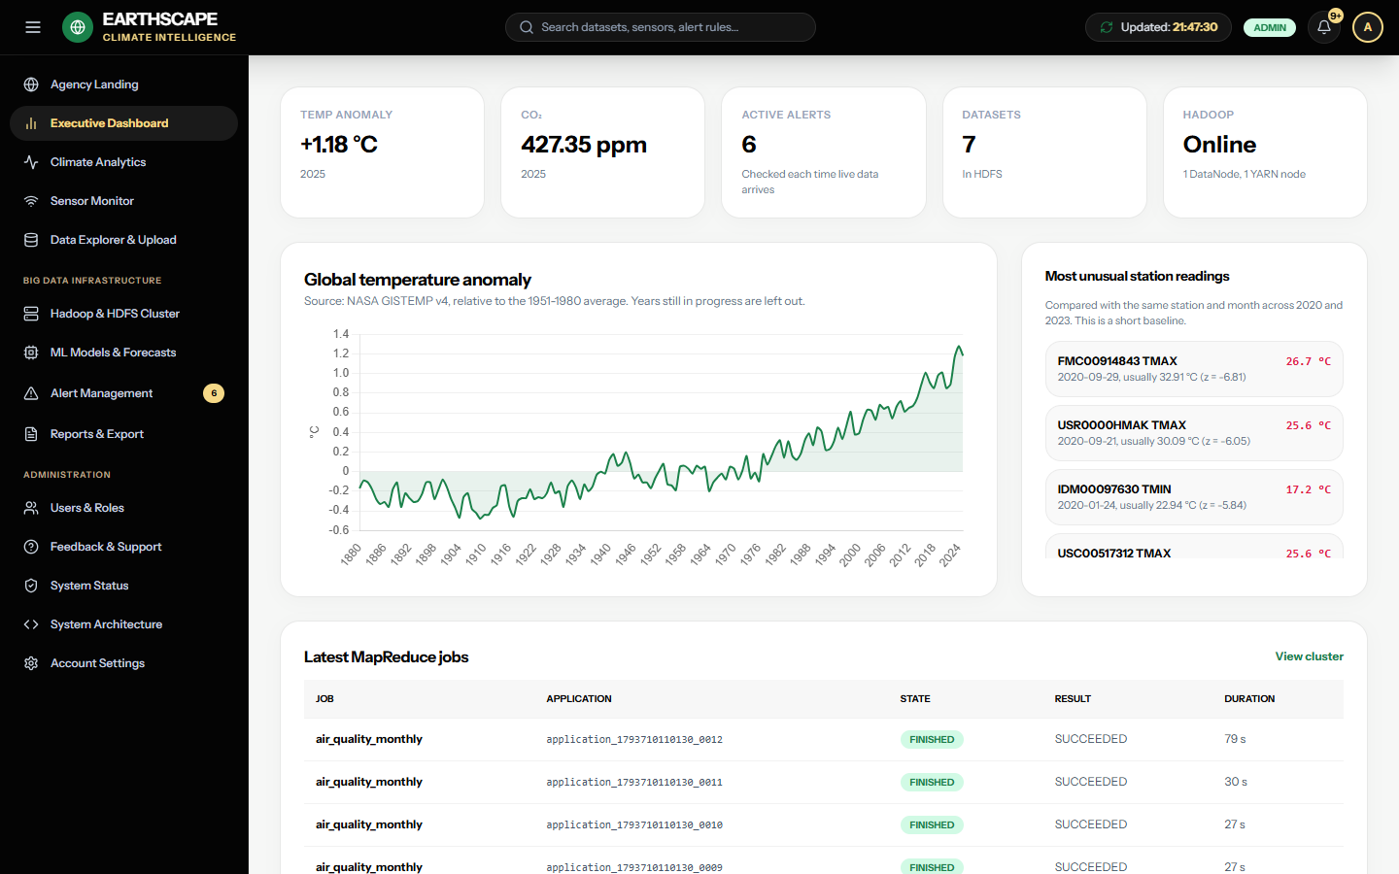
Executive Dashboard

4. Diagrams

4.1 Data flow diagrams
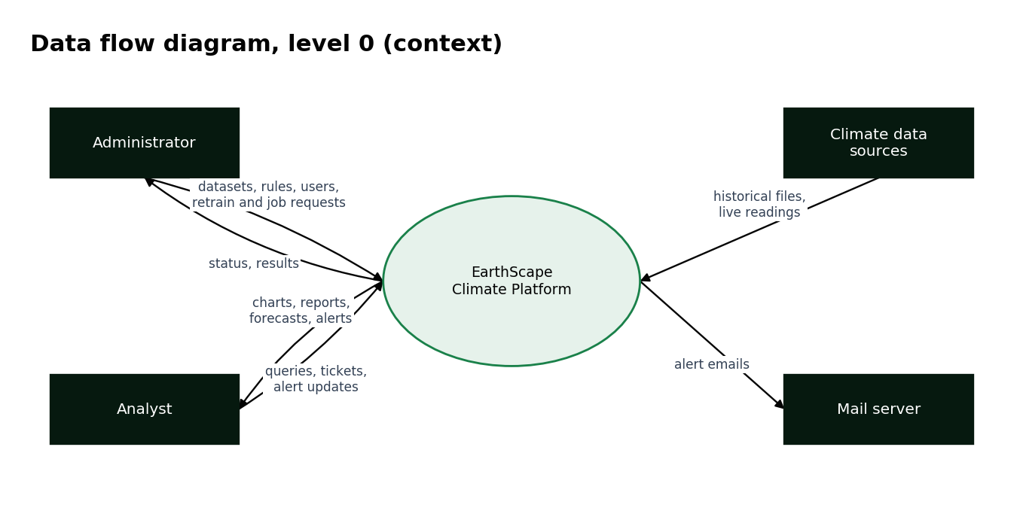
Level 0: the system and the people and services around it
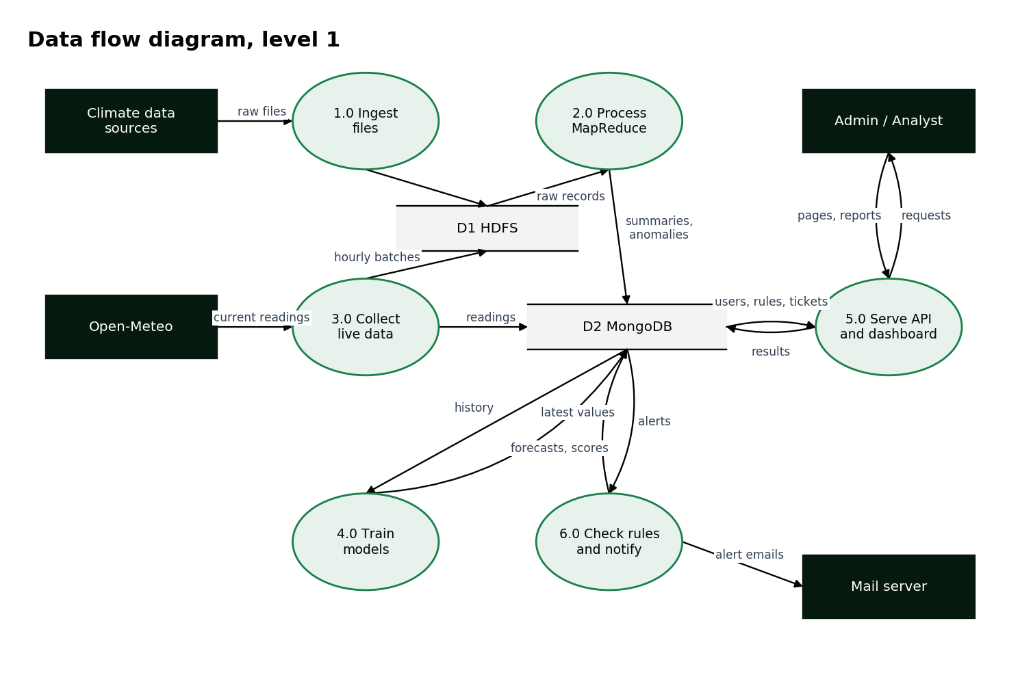
Level 1: the main processes and data stores

4.2 Flowcharts
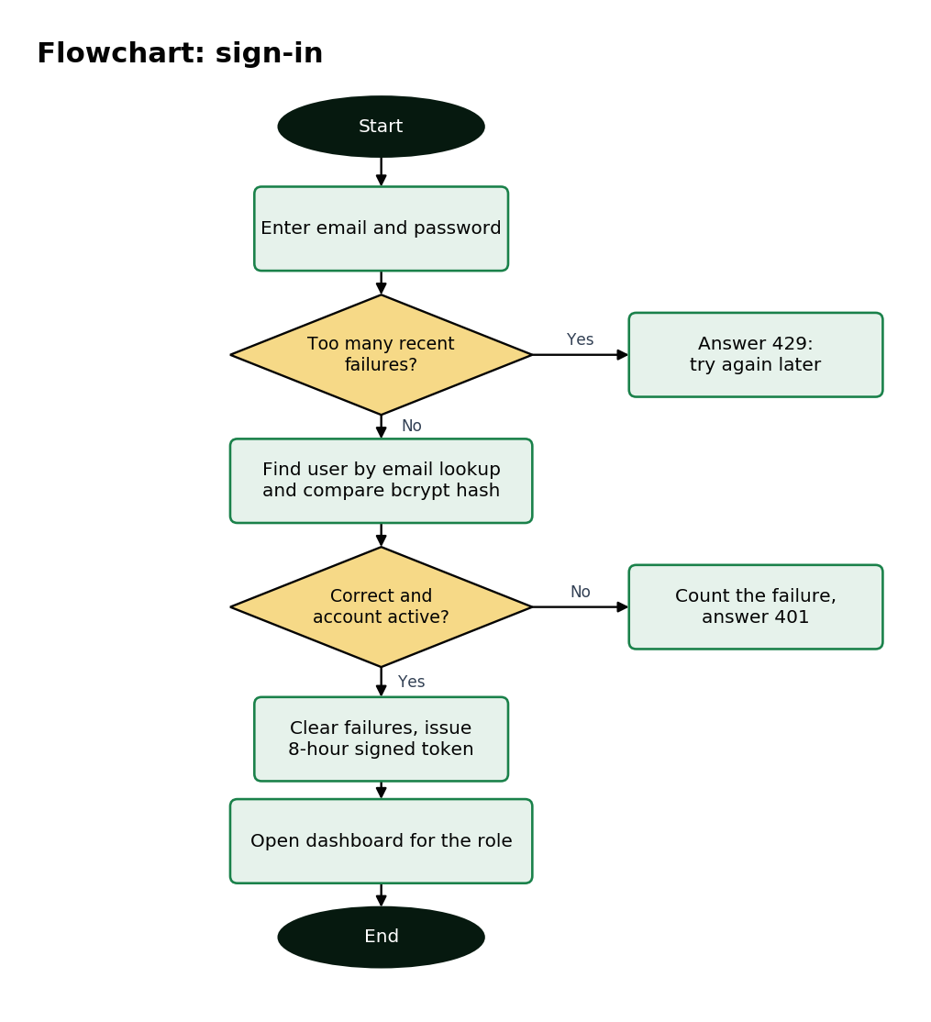
Signing in
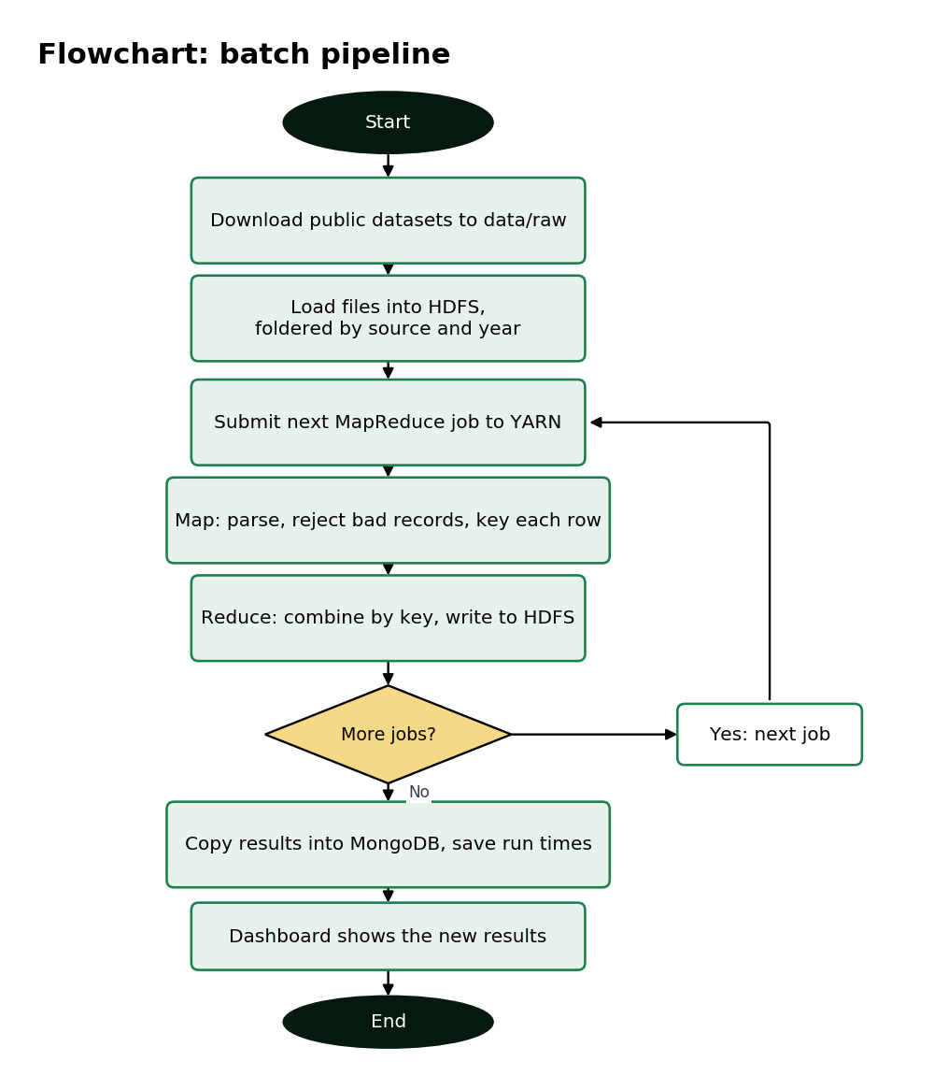
Batch pipeline
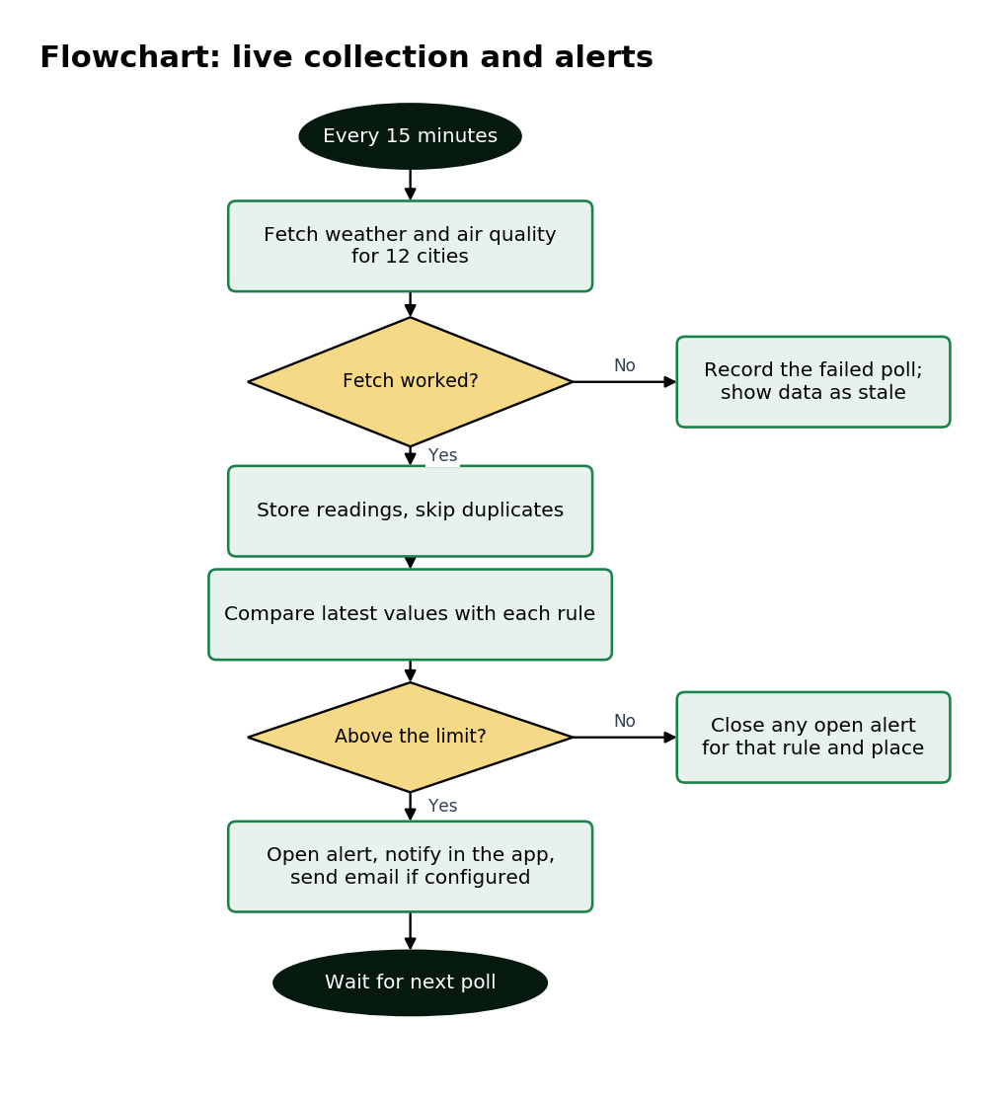
Live collection and alerts
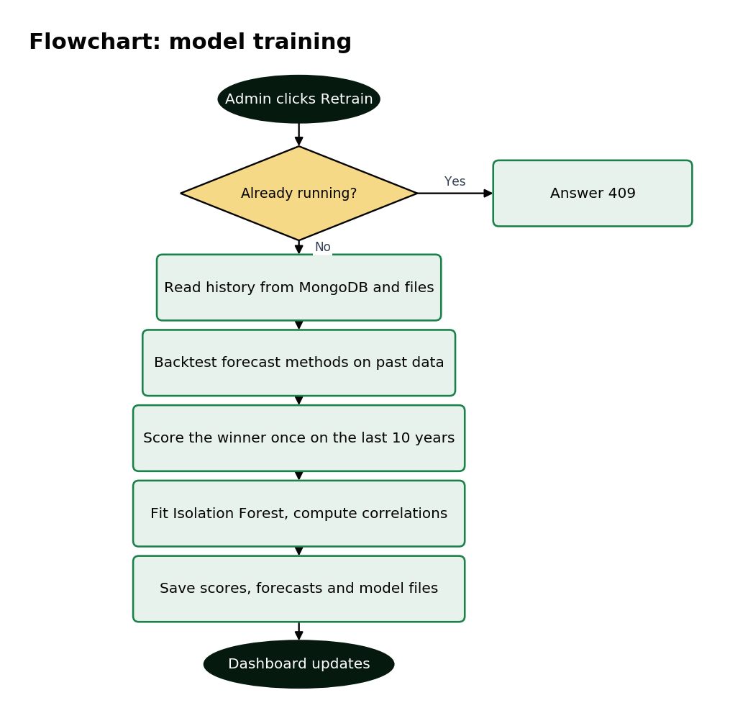
Model training

5. Results
All figures below come from running the system on the project computer.

5.1 MapReduce
Measure | Result
Station data in HDFS | 2.5 GB
Flagged unusual station readings | 48,715
Longest job in the latest run (station_anomalies) | About 97 seconds
Shortest job (satellite_zonal) | About 26 seconds

These flagged readings use a short baseline of only two years, which the dashboard states.

5.2 Trend prediction
Each method was chosen on data before 2016, then scored once on 2016-2025. RMSE is the typical error in °C, and lower is better. "Baseline" means repeating the last known value.
Series | Method chosen | RMSE | Baseline RMSE | Beats baseline | Range coverage
Global | Linear, 30 years | 0.189 | 0.188 | No | 80%
64N-90N | Holt | 0.654 | 0.726 | Yes | 90%
44N-64N | Linear, 30 years | 0.316 | 0.298 | No | 100%
24N-44N | Linear, 30 years | 0.297 | 0.337 | Yes | 100%
EQU-24N | Linear, 30 years | 0.213 | 0.188 | No | 90%
24S-EQU | Linear, 30 years | 0.238 | 0.232 | No | 80%
44S-24S | Linear, 50 years | 0.094 | 0.114 | Yes | 100%
64S-44S | Holt | 0.222 | 0.231 | Yes | 90%
90S-64S | Holt | 0.369 | 1.182 | Yes | 100%

The chosen method beat the baseline in five of nine series. In the other four, including the global series, it did slightly worse. Recent warming was unusually fast and sudden, and a 10-year test contains few data points, so this shows the limit of a purely statistical forecast. The models were also adjusted during development after seeing these test results, so the test years aren't perfectly independent.

5.3 Anomaly detection
Measure | Result
Days scored, across 24 sensors | 6,872
Days flagged | 69
Normal test days wrongly flagged | 0.59%
Artificial spikes found: 3 times normal size | 1%
Artificial spikes found: 6 times normal size | 35%
Artificial spikes found: 10 times normal size | 100%

The model reliably finds large spikes, and misses small ones. Artificial spikes only estimate real performance, because nobody has labelled which days were truly abnormal.

5.4 Correlation
Pair | Compared as | Pearson r
CO₂ and global temperature anomaly | Yearly values | 0.967
CO₂ and global temperature anomaly | Year-to-year changes | 0.316
Station daily high and satellite-model surface temperature, 44N-64N | Monthly values | 0.990
Solar radiation and surface temperature, EQU-24N | Monthly values | 0.032

The first two rows show why both are compared: two rising series will correlate strongly, whether or not they're linked. Correlation doesn't show cause.

5.5 Reliability and load balancing
Test | Result
Requests spread across two instances | 10 and 10 of 20
Requests after stopping one instance during traffic | 92 sent, 0 failed
Stopped instance after restarting | Back to receiving requests, 10 and 10 of 20
Sign-in token from one instance used on the other | Accepted
Failed sign-ins alternating between instances | Blocked on the 6th attempt
Second retrain request while one is running | Refused (409)
Backup | 10.5 seconds, 3.3 MB
Restore check | 50,713 rows restored and matched

These show the mechanisms work. They don't show 99% uptime over time, or that the design scales across machines, as everything ran on one computer.

6. Test data and testing

6.1 Test data used
Location | Contents
test_data/samples/ | The first 2,000 rows of each station and sensor file, plus the full GISTEMP and CO₂ files
test_data/upload_cases/ | A valid CSV, and a text file named .nc that must be refused
test_data/demo_results.archive.gz | Pipeline and model results, with no user accounts
data/raw/ in the zip | Small source files: GISTEMP, CO₂, NASA POWER, OpenAQ
Fixtures in backend/tests/ | Generated test users, readings and rules in a separate test database

The full GHCN-Daily files are too large for the zip, and data/download_data.sh downloads them.

6.2 Automated tests
Suite | Covers | Result
backend/tests/test_api.py | Sign-in, roles, data routes, reports | All pass
backend/tests/test_live.py | Collector, alert rules, email sending (simulated mail server) | All pass
backend/tests/test_ml.py | Model routes, retraining | All pass
backend/tests/test_resilience.py | Encryption, locks, sign-in limits, backups, monitoring, status | All pass
ml/test_train_models.py | Forecast methods, anomaly detection, correlation | All pass

In total, 109 backend tests and 14 model tests pass.

6.3 Test cases
No. | Test | Steps | Expected | Result
1 | Correct sign-in | Sign in as Analyst | Dashboard opens | Pass
2 | Wrong password | Enter a wrong password | "Incorrect email or password" | Pass
3 | Sign-in limit | 6 failed attempts on one account | Blocked on the 6th (429) | Pass
4 | Role limit | As Analyst, change maintenance notice through the API | Refused (403) | Pass
5 | Admin-only controls | Open System Status as Analyst | Maintenance form hidden | Pass
6 | Run a job | Start a MapReduce job as Admin | Job appears, and results update | Pass
7 | Upload valid file | Upload valid_readings.csv | Listed in HDFS datasets | Pass
8 | Upload false file | Upload invalid_not_really.nc | Refused | Pass
9 | Live poll | Press Check now | Readings update | Pass
10 | Alert opens and closes | Reading crosses a rule, then falls | Alert opens, then closes itself | Pass
11 | Retrain | Press Retrain models | New version appears in history | Pass
12 | Report download | Download CSV, JSON and GeoJSON | Files download correctly | Pass
13 | Support ticket | Submit a ticket | Stored encrypted, Admin can read it | Pass
14 | HTTPS | Open http://localhost | Redirects to HTTPS | Pass
15 | Failover | Stop one backend during traffic | No failed requests | Pass
16 | Backup | Run ops\backup.py | Backup restored and matched | Pass
17 | Offline use | Block all outside addresses and open the sign-in page and every dashboard page | Pages load with no errors | Pass
18 | Phone width | Open sign-in and status pages at 375 px | No sideways scrolling | Pass

7. Installation
See ReadMe.doc for the shortest route. The full steps are below.

7.1 Software needed
Software | Version used | Needed for
Windows | 11 (10 or newer) | Everything
Python | 3.13 | Backend
MongoDB and Database Tools | Service, Tools 100 | Database, backup
Anaconda | Python 3.7 | Models, notebook, diagrams
Java JDK | 1.8.0_202 | Hadoop
Hadoop | 2.9.2, with Windows native binaries | Pipeline, jobs page
Apache httpd (Apache Lounge) | 2.4.69, Win64 | HTTPS, load balancing
Visual C++ Redistributable | Recent x64 | Apache
Tableau Public, RStudio | Latest | Optional

7.2 Website and database
Run these in PowerShell, from the project folder. Use a folder path without spaces.
py -3.13 -m venv backend\.venv
backend\.venv\Scripts\python.exe -m pip install -r backend\requirements.txt
backend\.venv\Scripts\python.exe backend\seed.py
backend\.venv\Scripts\python.exe ops\load_demo_data.py
backend\.venv\Scripts\python.exe backend\serve.py --port 8000
Open http://localhost:8000. The sign-in details are in backend\.env.

7.3 HTTPS and load balancing
- Install the Visual C++ Redistributable.
- Unzip Apache so that C:\Apache24\bin\httpd.exe exists.
- Run ops\make_certificate.ps1, then ops\start_all.ps1.
- Open https://localhost, and accept the certificate warning.
- From an administrator PowerShell, run ops\install_scheduled_tasks.ps1 once for daily backups and automatic startup.

7.4 Hadoop and the full pipeline
These steps aren't needed to see results, as the demo data covers them.
- Install Java 8, and Hadoop at C:\hadoop\hadoop-2.9.2, with its Windows winutils.exe and hadoop.dll in bin.
- Copy the files from deploy\hadoop into Hadoop's etc\hadoop, and change the folder paths if needed.
- Run hdfs namenode -format once.
- Start HDFS in a normal Command Prompt with sbin\start-dfs.cmd.
- Start YARN in an administrator Command Prompt with sbin\start-yarn.cmd.
- Download the data with bash data/download_data.sh and python data/fetch_api_data.py.
- Set STREAMING_PYTHON to a Python path without spaces, then run hadoop\run_pipeline.py with Anaconda's Python.
- Run ml\train_models.py with Anaconda's Python, or press Retrain models.

8. Conclusion and future work
The platform stores and processes real climate data with Hadoop, adds live data, predicts trends, detects anomalies and presents everything in a secure, role-based dashboard with alerts and support.
Its main limits are that it runs on one computer, polls live data rather than streaming it, and doesn't process satellite imagery. Next steps would be a real multi-node cluster, Kafka for streaming, imagery processing with Spark, and an Impala query layer.

9. Source code
The source is in this zip and at https://github.com/Mujtaba19938/EarthScape. The Developer Guide explains its structure.

