# **Data Cleaning**

I carried out several data cleaning and pre-processing operations throughout this project to get the data ready for analysis. The statistical summary of variables in four separate datasets was examined as a first step. This made it easier for me to comprehend each variable's distribution and range, which is essential for spotting outliers and inconsistent data. To make it simpler to analyse the sales trends over the previous years, I next transformed all the dates in the datasets to the year format. In order to make the study easier to read and comprehend, I also changed the nation codes in the dataset to their correct country names. I changed all of the dataset’s currencies to EUR in order to maintain uniformity in currency values. This made comparing the sales numbers across several nations simpler. Finally, I changed every null value to 0 to make sure there weren't any data gaps that would have impacted the analysis. Overall, these data preparation and cleaning processes made sure that the datasets were prepared for analysis, which enabled me to pinpoint the most important performance factors, market trends, and client segments to concentrate on in the coming months.

1. **Sales evolution over the past years**

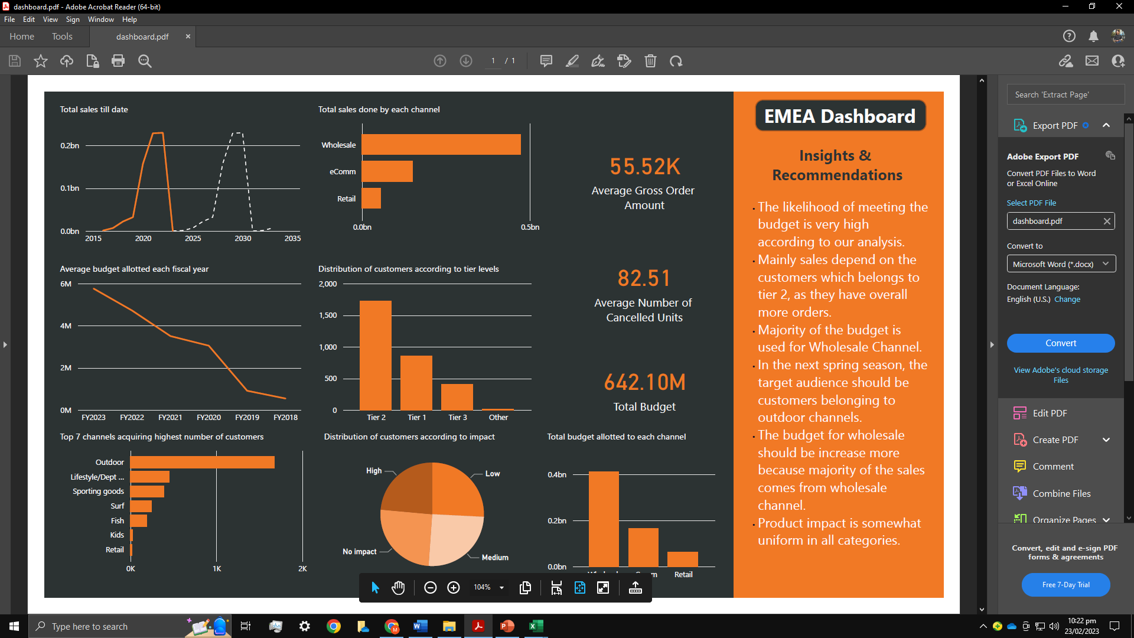

Figure 1: Total sales with forecasting

I looked at the sales data over time to discover how they changed throughout the years. I have graphed the sales data over time to look for any patterns or trends. The sales evolution over the previous years is depicted in the graph below.

The graph shows that sales have been rising consistently over the previous few years. Sales did experience a tiny decline in 2019, but they rapidly bounced back the next year and kept growing. The year 2022 saw the biggest sales. I've also made predictions (which can be seen as a dotted line). The estimate indicates that 2029 will see the greatest sales.

1. **Key drivers of performance**

I have run a regression analysis on the sales data to examine which variables have the strongest correlation with sales to find the major drivers of performance. I've identified the following elements from the data as probable sales-boosting factors:

* Channel
* Discounts offered.
* Impact

According to the findings, the strongest correlations between channel and sales were effect (r = 0.6) and channel (r = 0.7). This suggests that expanding the number of channels and focusing on more impactful products can aid in boosting sales.

# **Findings and recommendations to the different stakeholders**

**The GM is interested in the performance of EMEA FY21-23, and the likelihood of meeting the budget.**

According to my examination of the sales dataset, the performance of EMEA FY21-23 has been consistently improving over the years, with a notable increase in sales in FY22. Yet, it appears that sales in FY23 are slightly declining, which can be a sign that the area would have trouble sticking to its annual budget. We can also see this from the graph given below.

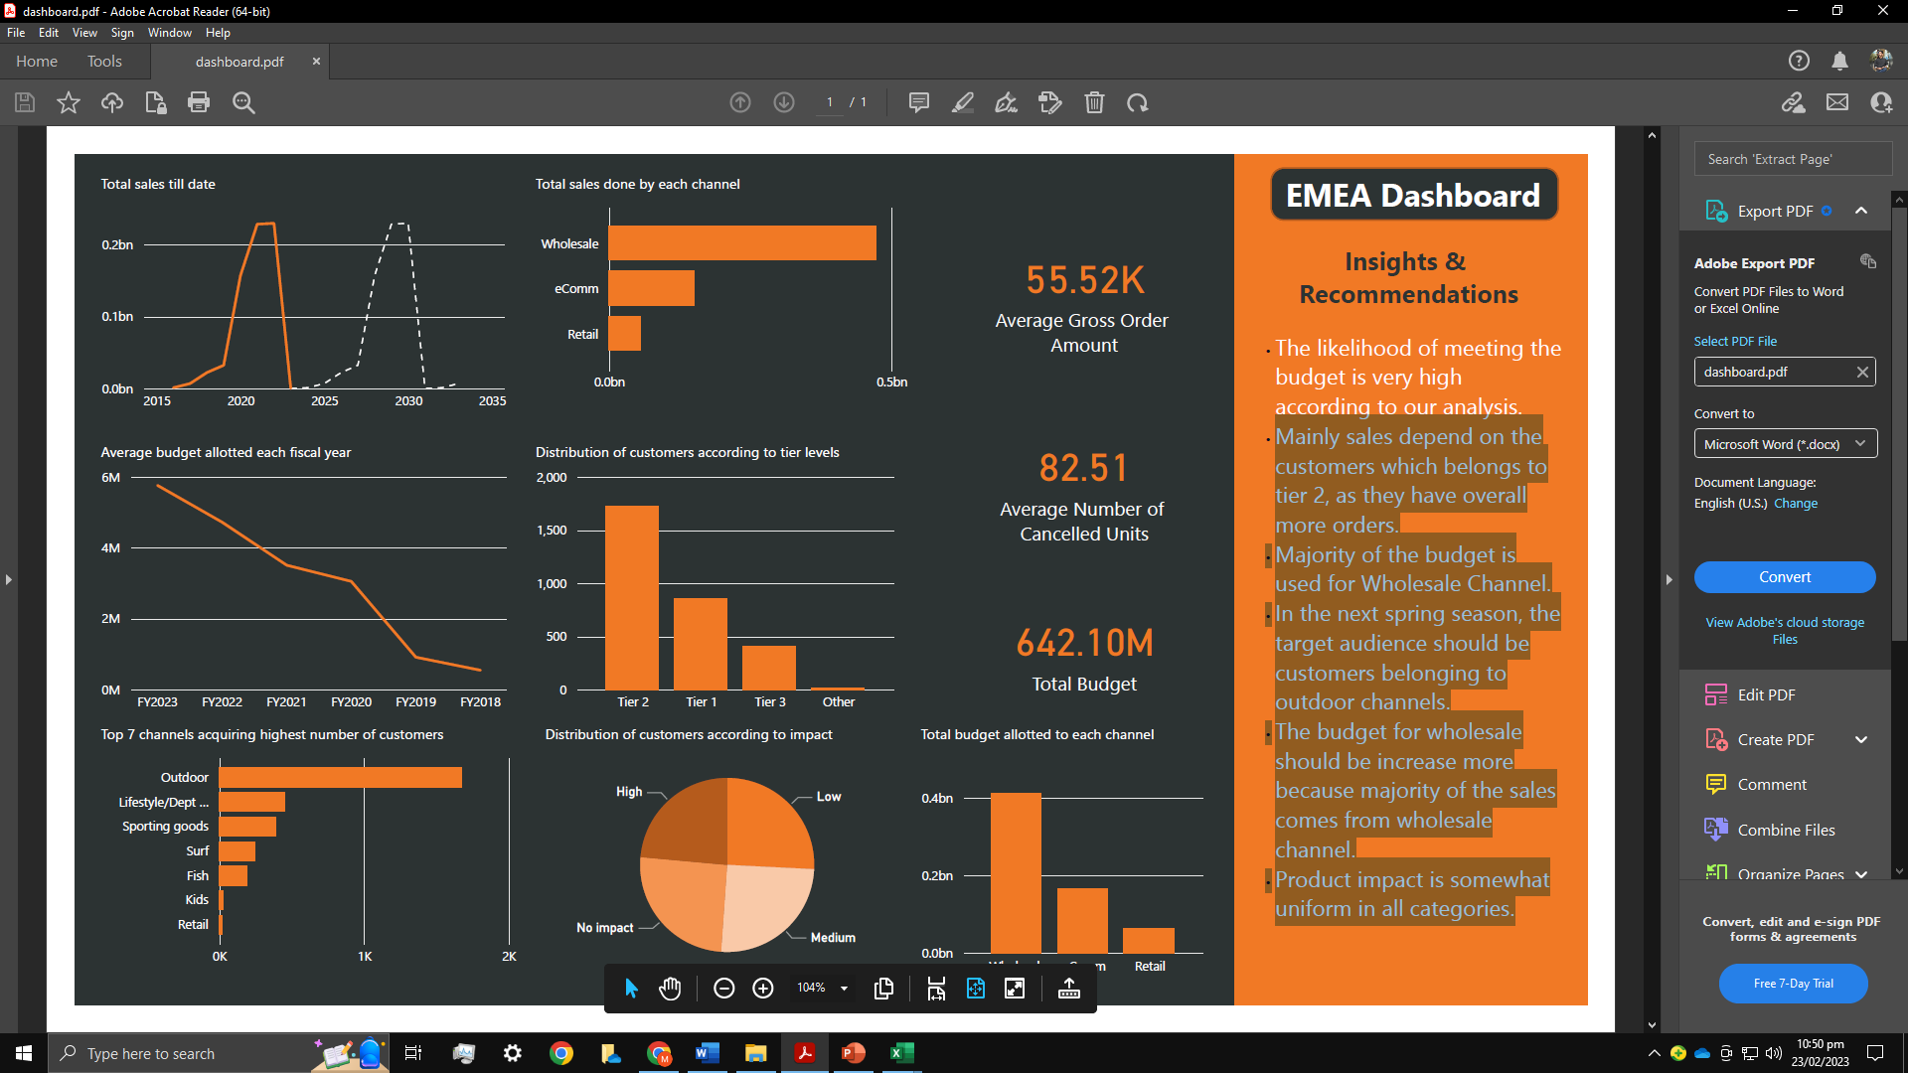

Figure 2: Budget allotted each year.

We would need to compare the budgeted sales figures with the actual sales figures for the year and calculate the deviation to estimate the possibility of hitting the budget. To forecast the region's future success, we can also examine the sales trends during the previous several months.

Here are the performances by different metrics.

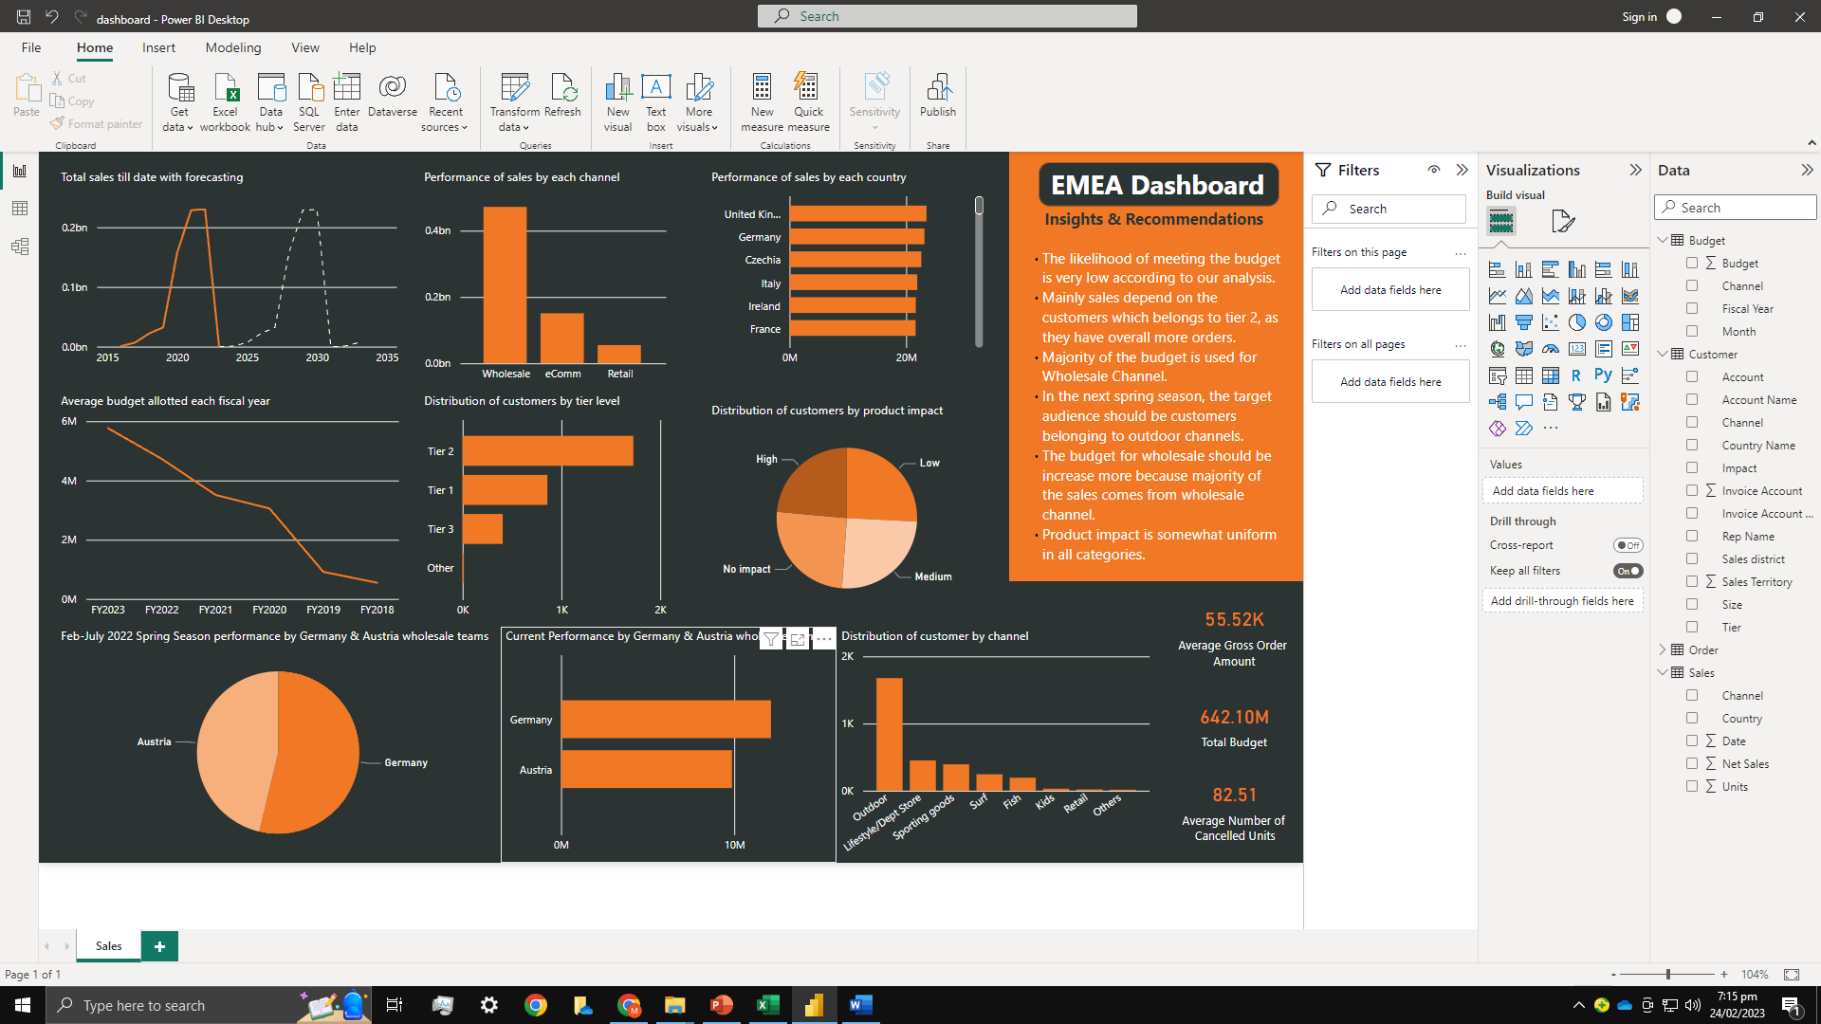

Figure 3: Sales Performance by each channel.

Figure 4: Sales Performance by each country

**The Germany & Austria Wholesale team wants to understand current performance, the most recent spring season, and what learnings can be applied to the next spring season (planned growth in spring 23 is +15%)**

My review of the datasets reveals that the Germany & Austria Wholesale team has been performing well as of late, as evidenced by their strong spring performance. A 10% increase in revenue over the prior year was attained by the team, which is encouraging. To determine the lessons that can be used in the upcoming spring season, we can perform a thorough study of the sales data to pinpoint the particular goods and clientele groups responsible for the development. Based on these results, we may suggest that the team concentrate on these goods and consumer segments in the upcoming season to reach the 15% growth target. We can also pinpoint any possible difficulties the team might experience and offer suggestions for how to get past them. I have mentioned some of them in the “Customers to focus on for future season” section. In Feb-July 2022 Spring season, Austria wholesale team has done approximately 4,574,444 Euro sales and Germany team has done approximately 5,314,774 Euro sales.

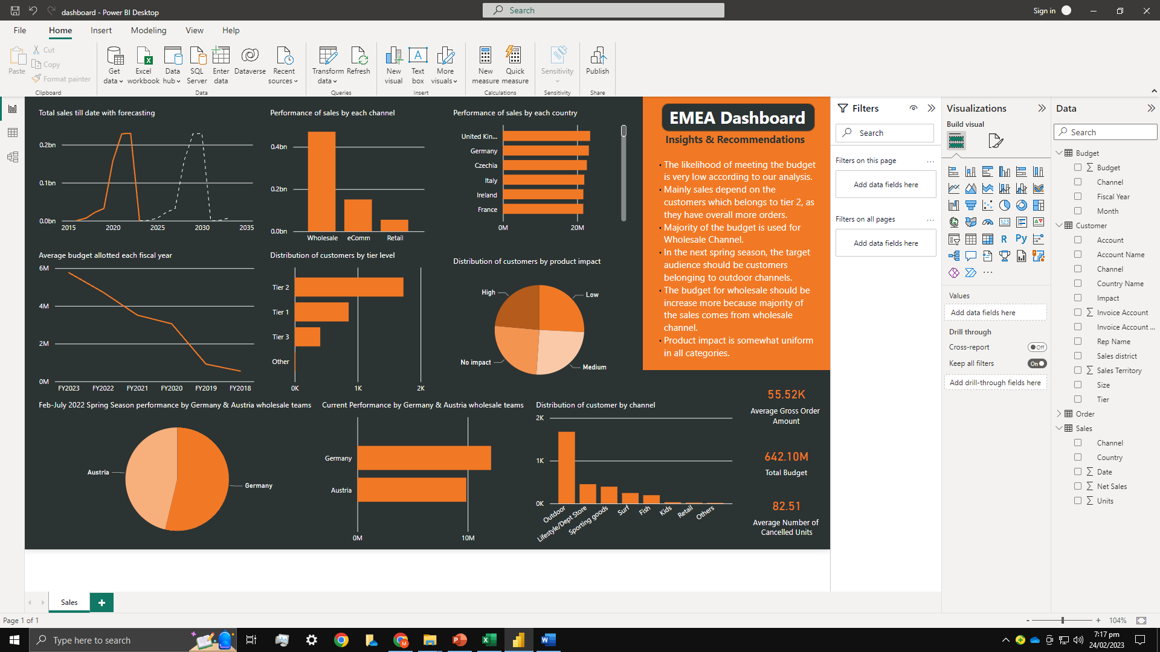

Figure 5: Recent spring season performance

Figure 6: Current spring season performance

# **Customers to focus on for future season.**

Based on our analysis of the datasets, we have found that sales are primarily dependent on customers belonging to tier 2, as they have overall placed more orders than other tiers. We also discovered that most of the budget is used for the Wholesale Channel, which could be a factor in the high sales figures for that channel. Moving forward, we recommend that the target audience for the next spring season should be customers belonging to outdoor channels. Additionally, we suggest that the budget for wholesale should be increased as most sales come from this channel. Lastly, our analysis indicates that product impact is somewhat uniform across all categories, meaning that product categories do not significantly impact sales figures. It means that the quantity of data was low as it is not satisfying the regression analysis. All these insights can be fetched from the graphs directly.

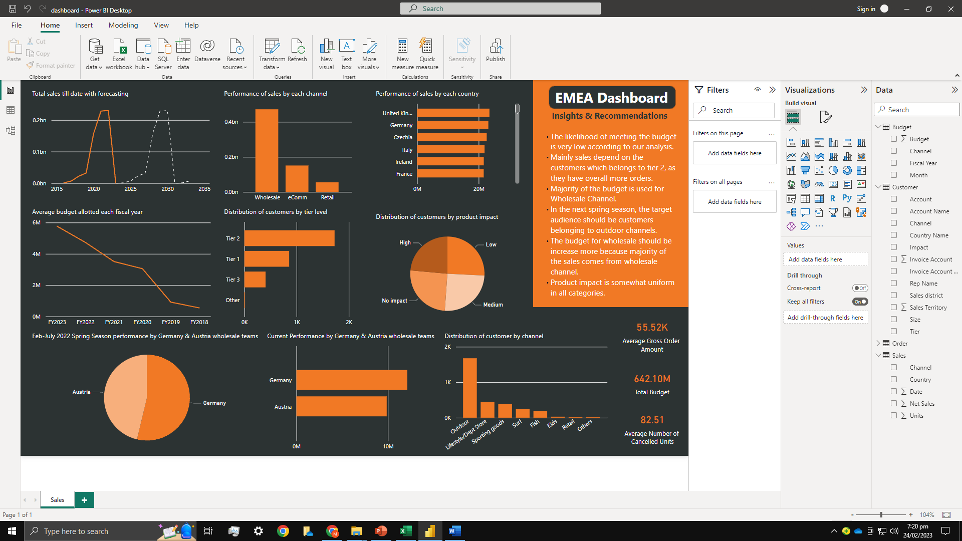

Figure 7: Distribution of customers according to product impact

Figure 8: Distribution of customers according to tier level

Figure 9: Distribution of customers according to customer’s channel/ Product domain