Table of Contents

**1.** **Introduction** 3

**2.** **Usability** 3

**3.** **Target Audience** 4

**4.** **Design Process** 4

**5.** **API Integration** 5

**6.** **Interactive Widgets** 6

**7.** **HCI Design Principles** 7

**8.** **Testing & Feedback** 7

**9.** **Conclusion** 7

# **Introduction**

Financial management can be complex and overwhelming, with various tasks such as currency conversion, daily price calculation, historical data analysis, and financial analytics requiring multiple tools and websites. However, with FinancePro, a web-app developed on Streamlit in Python, managing your finances has never been easier.

FinancePro is designed to provide users with a one-stop solution for all their financial needs. Whether you are a beginner in the world of finance or an experienced investor, FinancePro offers a friendly and intuitive interface that simplifies financial management tasks. In this report, we will introduce the features of FinancePro and showcase how it can streamline your financial management process.

From its currency converter that allows you to convert currencies quickly and accurately, to its daily price calculator that helps you stay updated with stock and cryptocurrency prices, FinancePro offers a wide range of tools to meet your financial requirements. Additionally, FinancePro provides access to historical data of stocks and cryptocurrencies, allowing you to analyze trends and make informed decisions. With its analytics feature, FinancePro empowers you with data-driven insights for better financial planning.

Our goal is to simplify financial management for individuals and professionals alike, by providing a comprehensive web-app with features such as currency conversion, daily price calculation, historical data analysis, and analytics through FinancePro. In this report, we will delve into the functionalities of FinancePro and demonstrate how it can transform your financial management experience.

# **Usability**

At FinancePro, I set several usability goals to ensure that my web app is intuitive, efficient, and enjoyable for my users. Here's how I addressed each goal:

* **Simplicity:** I aimed to create a clean and straightforward user interface that minimizes clutter and provides a seamless user experience. I used a minimalist design approach with a clean layout, simple navigation, and intuitive controls. I ensured that users can easily understand how to use the app without unnecessary complexity.
* **Efficiency:** I focused on optimizing the app's performance to ensure that users can accomplish their tasks quickly and efficiently. I utilized efficient algorithms and data structures to process data swiftly, and I optimized the app's loading times to minimize wait times for users. I also provided shortcuts, smart defaults, and clear instructions to streamline user interactions.
* **Flexibility:** I designed the app to be adaptable to different user needs and preferences. I provided multiple options for customizing settings, such as currency selection and date ranges for historical data. I also made sure that the app is responsive and accessible on different devices, including desktops, tablets, and mobile phones, to accommodate diverse user preferences.

# **Target Audience**

FinancePro is designed to cater to a wide range of individuals who are looking for a comprehensive financial management solution. The target audience for FinancePro includes:

* **Individual Investors:** Whether you are a beginner or an experienced investor, FinancePro provides valuable tools for managing your investments. From currency conversion for international investments to daily price calculation for stocks and cryptocurrencies, FinancePro is ideal for individual investors who want to stay updated with financial data and make informed decisions.
* **Traders:** FinancePro features, such as historical data analysis and analytics, make it a suitable tool for traders who require data-driven insights for making trading decisions. Traders can leverage FinancePro capabilities to analyze trends, monitor historical performance, and identify potential trading opportunities.
* **Financial Professionals:** FinancePro can be an asset for financial professionals such as financial advisors, analysts, and accountants. Its comprehensive features and user-friendly interface can assist professionals in managing client portfolios, analyzing financial data, and providing informed financial advice.
* **General Users:** Even if you are not an investor or financial professional, FinancePro can still be useful for managing your personal finances. Its currency converter feature can help with travel expenses or online purchases, and the daily price calculator can provide insights into stock or cryptocurrency prices for general knowledge. FinancePro is suitable for anyone looking for a convenient and efficient financial management tool.

# **Design Process**

I began the design process for FinancePro by carefully selecting the topic of financial data management. I then conducted extensive research to identify suitable APIs and libraries for retrieving financial data. After evaluating different options based on data accuracy, reliability, and compatibility with Streamlit, I chose the most appropriate ones.

Next, I sketched out the layouts for the web-app, leveraging Streamlit widgets to create interactive interfaces that would cater to the needs and preferences of my target audience. I paid close attention to the HCI design principles, ensuring that the web-app would be intuitive and user-friendly. I focused on simplicity, consistency, feedback, and error prevention to enhance the overall usability of the app.

Once the layouts were finalized, I implemented the design using Python and Streamlit, integrating the selected APIs and libraries to retrieve and process financial data. I conducted rigorous testing to identify and resolve any bugs or issues, ensuring the smooth functionality of the web-app.

Throughout the design process, I consistently considered the needs, preferences, and usability requirements of my target audience. I sought feedback from potential users and conducted user testing to gather insights and make iterative improvements to the design and functionality of FinancePro.

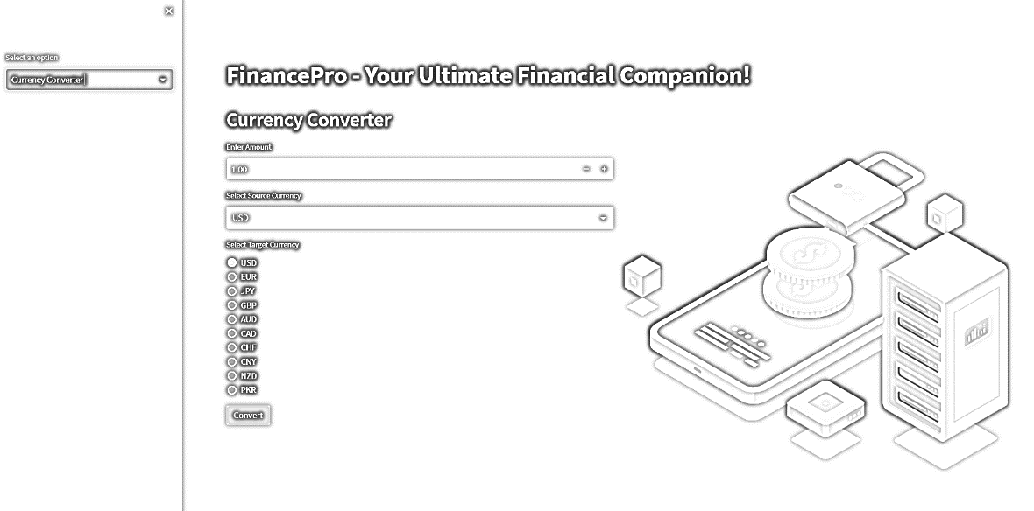

Figure 1: Homepage Sketch

# **API Integration**

As I integrated various APIs and libraries into FinancePro, I followed a systematic process to ensure seamless data retrieval and processing. Firstly, I registered for the required APIs, including the AlphaVantage API for stock and cryptocurrency data, the ExchangeRate API for currency conversion, and the Yahoo Finance (yfinance) library for historical stock data.

I then implemented the API integration in Python, using the respective libraries and endpoints provided by the APIs. This involved sending requests to the APIs, receiving, and parsing the data, and extracting the relevant information for each feature of FinancePro, such as currency conversion, daily price calculation, historical data retrieval, and analytics.

However, I encountered challenges during the integration process. One of the main challenges was inconsistent data formats from different APIs. For example, the data retrieved from the AlphaVantage API was sometimes in JSON format, while the ExchangeRate API provided data in XML format. This required me to implement format conversion logic to ensure consistent data processing across the web-app, which was time-consuming and required meticulous attention to detail.

Another challenge was dealing with rate limitations and API usage restrictions. Some APIs had rate limitations on the number of requests allowed per minute or per day, and others required authentication tokens or API keys for access. Managing these limitations and ensuring compliance with API usage policies required careful monitoring and implementation of appropriate handling mechanisms in the code.

# **Interactive Widgets**

As a part of the user interface design in FinancePro, I utilized several interactive widgets to enhance the user experience and provide dynamic functionality. These widgets were thoughtfully selected and incorporated into the web-app to enable users to interact with the data and make informed financial decisions.

* **Sidebar:** The sidebar widget was implemented to provide easy access to different sections or functionalities of the web-app, allowing users to switch between different features or views with a click.
* **Lottie Animation:** The Lottie animation widget was used to add visually appealing animations that provide feedback or visual cues to users, enhancing the overall user experience and engagement.
* **Radio Buttons:** Radio buttons were utilized as a user-friendly way to enable users to select from multiple options in a mutually exclusive manner, such as selecting different time frames for historical data or choosing between different financial metrics.
* **Drop-down:** Drop-down menus were incorporated to allow users to select from a list of options, such as choosing a specific stock or cryptocurrency to view its historical data or selecting a currency for conversion.
* **Success and Error Messages:** Success and error messages were implemented to provide informative feedback to users about the success or failure of a particular action, such as successful data retrieval or an error in processing.
* **Charts:** Various types of charts, including line charts, histograms, and candlestick charts, were utilized to visually represent financial data, making it easier for users to interpret and analyze the data.
* **Dataframe:** Dataframes were used to display tabular data in a structured and organized format, allowing users to view and analyze financial data in a tabular form.
* **Metrics for KPIs:** Metrics for key performance indicators (KPIs) were incorporated to provide users with relevant financial metrics, such as stock performance indicators or cryptocurrency metrics, to help them make informed decisions.
* **Calendar/Date Widget:** Calendar or date widgets were implemented to enable users to select specific dates or date ranges for historical data or to input date-related information for various functionalities.
* **Button:** Buttons were utilized as interactive elements that users can click to trigger specific actions, such as submitting data, executing calculations, or updating visualizations. Buttons provide a clear and intuitive way for users to interact with the web-app and perform actions.
* **Number Input:** Number input widgets were incorporated to allow users to input numerical values for various purposes, such as specifying the amount for currency conversion. Number inputs provide a convenient and efficient way for users to input numerical data accurately.
* **Map:** The Map widget is a dynamic and interactive visual representation of geographic data, in this case, the top 10 strongest currencies. It allows users to view the currency strength rankings on a map, with different countries or regions color-coded or marked according to their currency strength. Users can interact with the map, such as zooming in and out, panning, and clicking on map markers or regions to view currency strength details.

# **HCI Design Principles**

* **User-Centered Design:** I have prioritized the needs and preferences of the target audience throughout the design process. By conducting thorough research on the target audience's financial data needs and preferences, I have ensured that the web app caters to their specific requirements.
* **Consistency:** I have maintained consistency in the design elements, such as color schemes, typography, and layout, to create a cohesive and visually appealing interface. Consistency helps users quickly understand and navigate the web app, providing a seamless user experience.
* **Flexibility and Efficiency:** I have designed the web app with flexibility and efficiency in mind. The use of interactive widgets, such as buttons, drop-down menus, and radio buttons, allows users to easily input data and interact with the app. The streamlined workflow and intuitive interface help users efficiently accomplish their financial tasks.
* **Visual Clarity:** I have prioritized visual clarity in the web app's design by using appropriate fonts, contrasting colors, and clear visualizations. Visual clarity enhances the readability and comprehension of financial data, making it easier for users to interpret and analyze the information.
* **Accessibility:** I have considered accessibility guidelines and ensured that the web app is designed to be accessible to all users, including those with visual or motor impairments. This includes using alt text for images, providing keyboard navigation options, and ensuring color contrast for readability.

# **Testing & Feedback**

I have conducted usability testing for FinancePro, which involved gathering feedback from users who interacted with the web app. The results of the usability testing were positive, with users finding the app user-friendly and effective in accessing and analyzing financial data.

The incorporation of Lottie animation files based on the feedback received from usability testing has enhanced the feedback mechanisms in the web app. Users found the animations engaging and visually appealing, providing them with informative and interactive feedback on their actions.

# **Conclusion**

In conclusion, the development of FinancePro has resulted in a user-friendly web app that provides valuable financial data and tools, including currency conversion, daily price calculation, historical data viewing, analytics, and interactive widgets. The integration of APIs and libraries, along with the use of various widgets, has created an effective interface that adheres to key HCI design principles, resulting in a positive user experience. Usability testing and feedback from users have continuously refined and improved the web app, including the addition of Lottie animation files for enhanced feedback mechanisms.

Looking ahead, I plan to expand FinancePro by converting it into a stock and cryptocurrency marketplace. This will involve integrating additional APIs and functionalities to allow users to buy, sell, and trade stocks and cryptocurrencies directly within the web app. Continuous improvement of the user interface, incorporation of user feedback, and staying up to date with the latest trends and technologies in the finance industry will be my focus.