**PROGRAMMING FUNDAMENTAL ASSIGNMENT**

# LAB # 3 Assignment:

## *Question 1:*

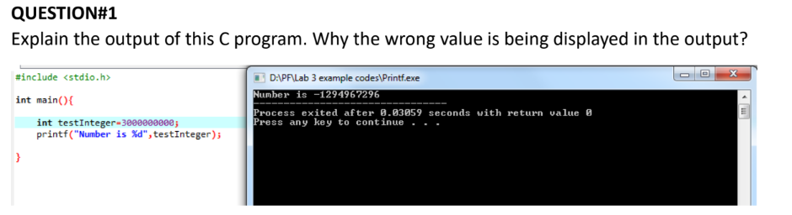

## *Solution:*

This is Printing incorrect value because int has its limit and the value stored is out of its range.

## *Question 2:*

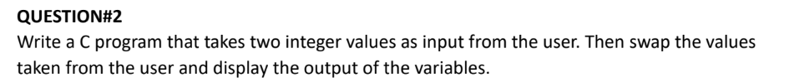

## *Solution (code):*

## *Solution (terminal):*

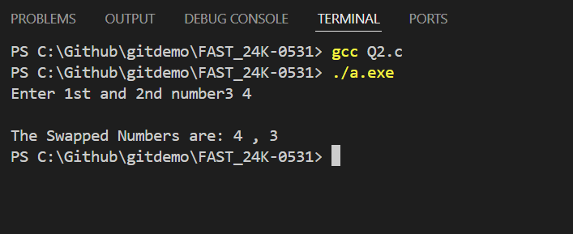

## *Question 3:*

## *1. 3 Solution (code):*

## *Solution (Terminal):*

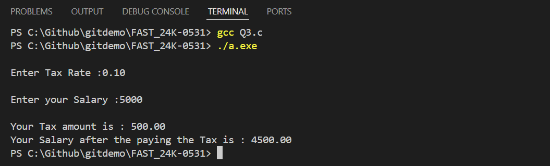

## *Question 4:*

## *Solution 4(code):*

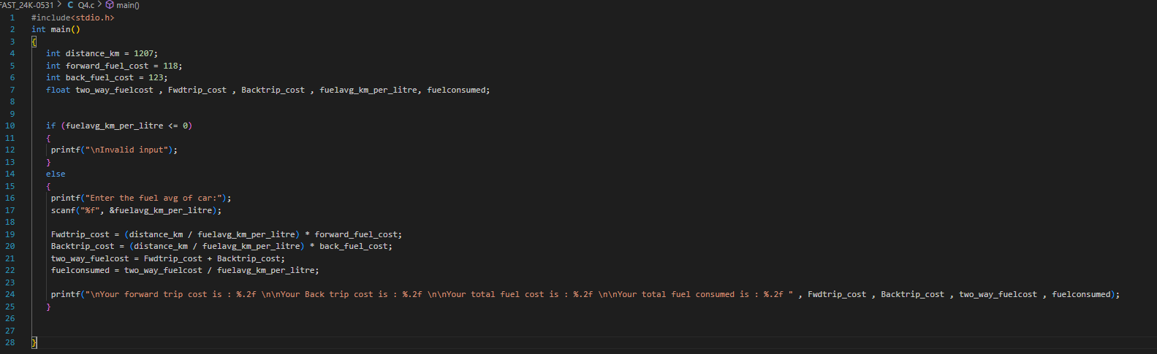

## *Solution 4 (terminal):*

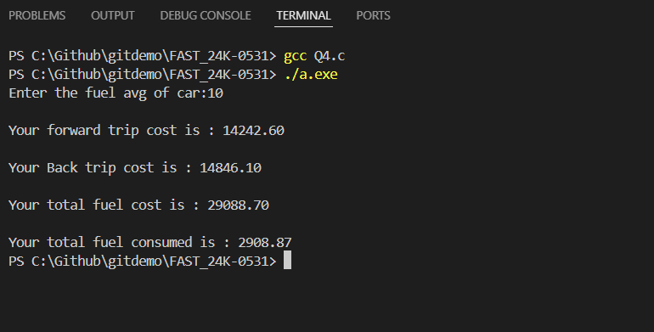

## *Question 5:*

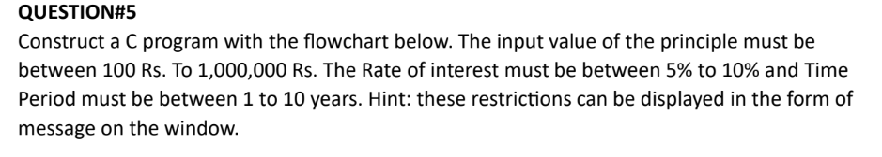

## *Solution 5(Code):*

## *Solution 5(Terminal):*

## *Question 6:*

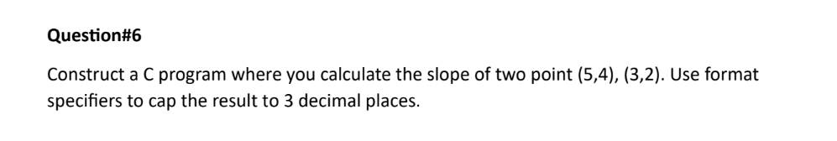

## *Solution 6(Code):*

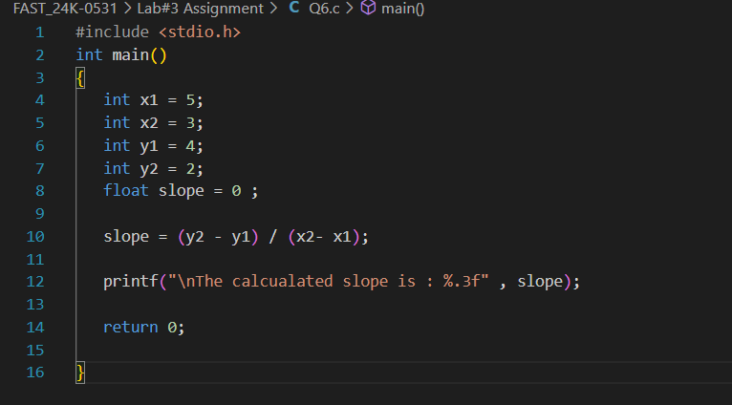

## *Solution 6(Terminal):*

