National University of Computer and Emerging Sciences
(FAST-NUCES)
Karachi Campus


Ping Pong : Irvine 32
Instructor: Miss Seema Hashwani
Group Members:
- Muhammad Adil Saeed – 24K-0705
- Mujtaba Qureshi – 24K-0535
- Muhammad Haseem Sammo – 24K-0666
Submission Date:
24/11/2025

1. Executive Summary

Overview: This project showcases a console-based Ping Pong Game written exclusively in x86 Assembly using the Irvine32 library. An emphasis is placed on low-level programming, cursor movement, ball movement, paddle movement, collision detection, points scoring, and other features that support game flow.

Key Findings: The project successfully implements various Assembly concepts including loops, conditions, keyboard input, randomization, and screen manipulation. The game is now a true two-player version (with difficulty options) and movement is not only functional but adds a realistic sport aspect to its playability.

2. Introduction

Background: Assembly Language permits a level of programming that is close to the hardware. Programmers are given the freedom to manipulate the cursor location, output characters, and read the keyboard in real time. The underlying theme of developing a Ping Pong or Pong-style game in Assembly is to encompasses the underlying version of low-level logic that exists in today's structured programming.

Project Objectives:
Including a working Ping Pong game and simulating ball acceleration, user control paddles, engage scoring, using concepts of Assembly Language, and native Irvine32 procedure.

3. Project Description

Scope: The game was developed including drawing boundaries, moving the paddle, and ball physics, a scoring mechanism, levels of difficulty, and real-time keyboard control. Sound, graphics, and advanced UI were omitted due mainly to restrictions of Assembly language.

Technical Overview: The developer made use of MASM, Irvine32.inc, Irvine32.lib, and Visual Studio as main development environments.

4. Methodology

Approach: The project was broken into parts: laying out the interface, programming paddle controls, ball movement, difficulty settings, and scoreboard. Weekly runs each had a filltime of play and debugging.

Roles and Responsibilities:
• Adil – Scoring System, Ball Collision Logic, Ball movement
• Mujtaba – Paddle Control, Input Handling, main screening.
• Haseem – Border drawing, difficulty level, debugging.

5. Project Implementation

Design and Structure:

The game area is surrounded in boundaries, with the ball and paddles arranged in specific position, and a scoreboard shown above.

Functionality Developed:

• A ball that moves freely within the outer walls and bounces at an angle.

• Two paddles that can be moved up and down by keyboard input and ball movement.

• A method of detecting collisions and bouncing off paddles.

• A scoring method that will increment and decrement during play.

• A setting that ramps up difficulty by changing paddle size.

Challenges Faced:

Making the ball run smoothly without flickering, getting user inputs in real time, ensuring the ball doesn't lag, and to sync up paddles with ball physics.

6. Results
Project Outcomes:
A fully functional Assembly Ping Pong game was built with complete moving, collision, rules. All objectives were completed successfully.
Screenshots and Illustrations
: 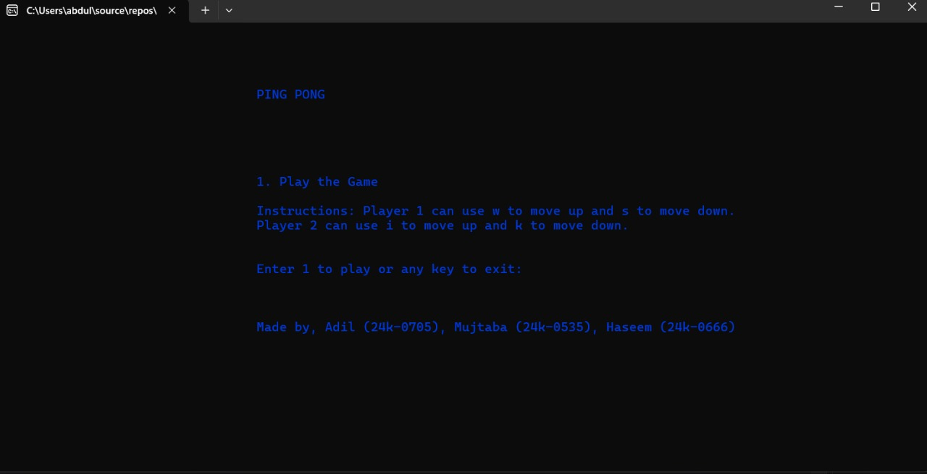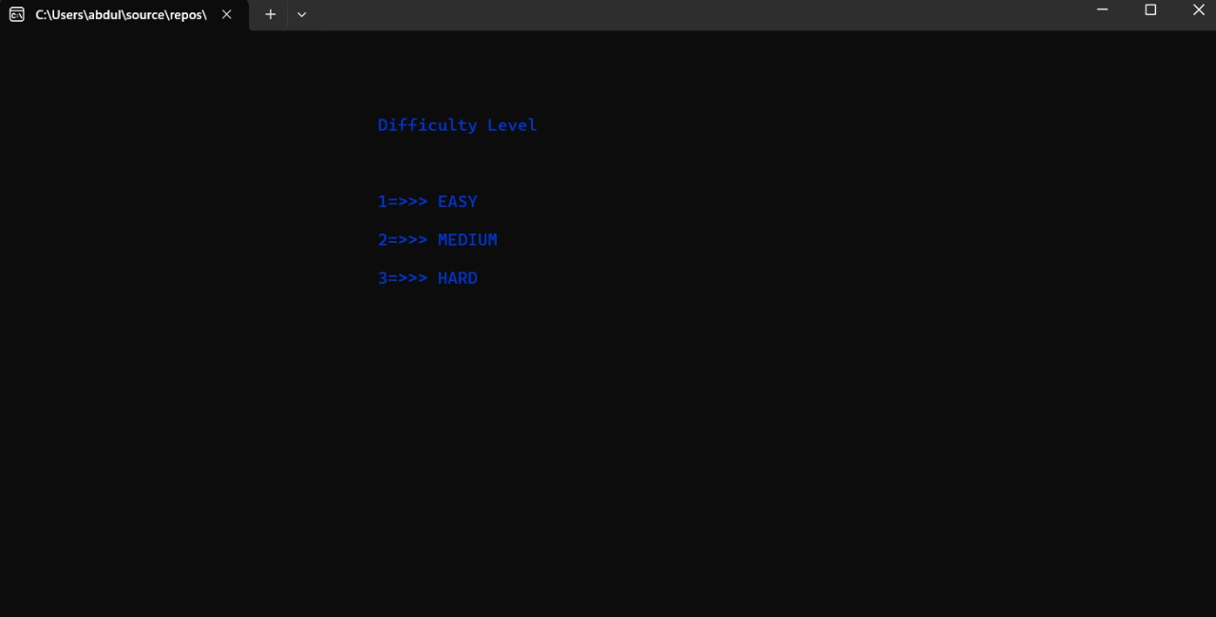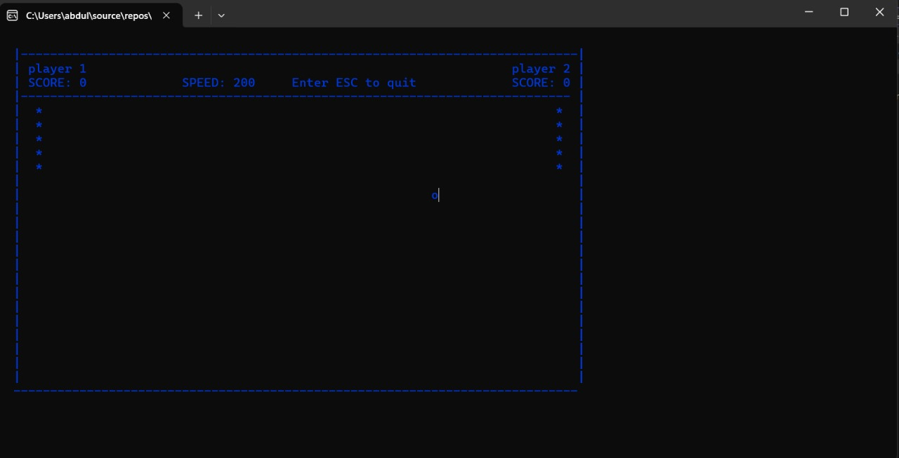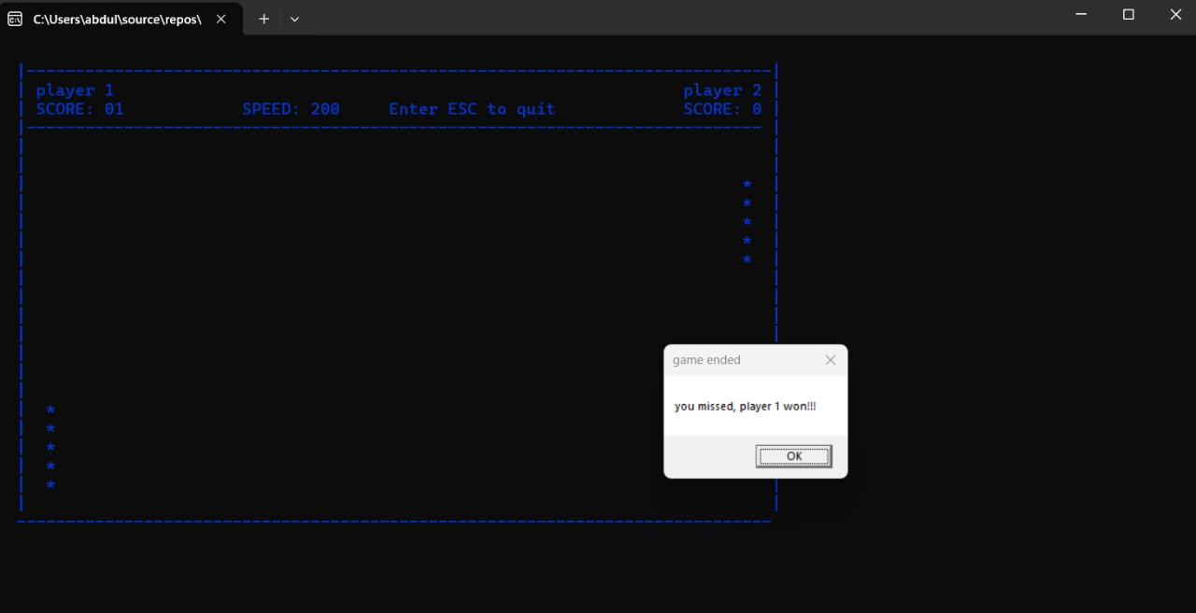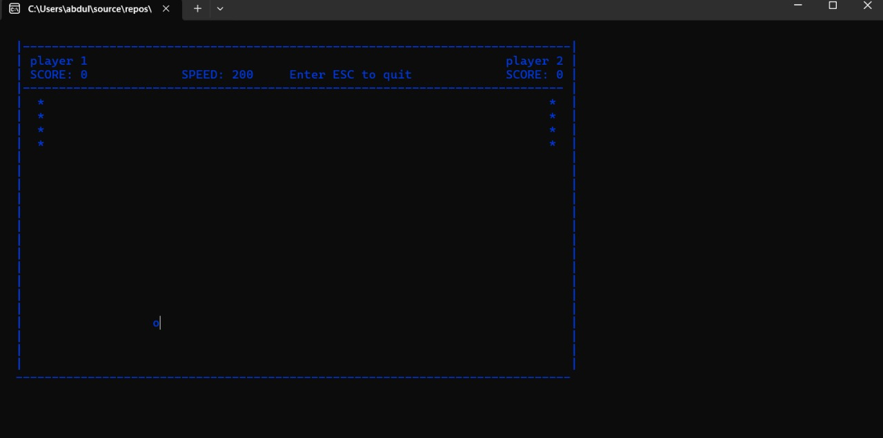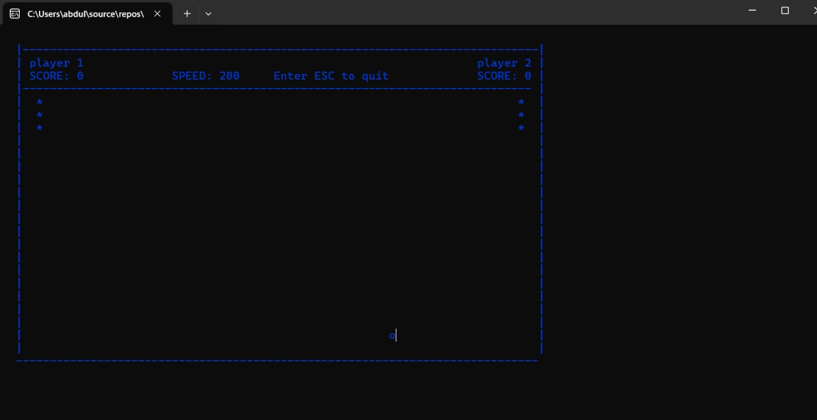
Testing and Validation: The game was tested for paddle responsiveness, collision accuracy,
boundary detection, scoring correctness, and difficulty level behavior.

7. Conclusion
Summary of Findings: The project enhanced the knowledge of low-level programming by applying Assembly language concepts to games and real-time movement.
Final Remarks: The project advanced my debugging skills and understanding of transmission in modern games to Hardware level code.

