EduCRM — Master Instructor Hands-On Walkthrough & Complete System Evaluation Manual
Cloud-Native Higher Education Admissions CRM & Student Recruitment Platform
System Architecture & Live Deployment
Production Web URL: https://education-crm-9fee2.web.app Local Development Server: http://localhost:5173 Core Tech Stack: React 19, TypeScript 5.7, Vite 6, Tailwind CSS 4, Firebase (Firestore, Auth, Storage, Hosting), Google Gemini 3.8 Flash AI. Coverage: 13 Configurable Roles, 12 Validated Flows, 51 High-Resolution Screenshots.

1. Executive Evaluation Blueprint & Quick-Access System
EduCRM is an enterprise-grade platform engineered to streamline the entire international student recruitment lifecycle. The system coordinates 13 distinct user roles with strict tenant isolation, automated regulatory auditing, and real-time state machine transitions.
To evaluate any role without manual credential entry, EduCRM includes a persistent One-Click Demo Access Drawer located at the bottom-right of the login screen (/login). Clicking any role button instantly provisions a real Firebase Auth session and pre-hydrates realistic operational data.
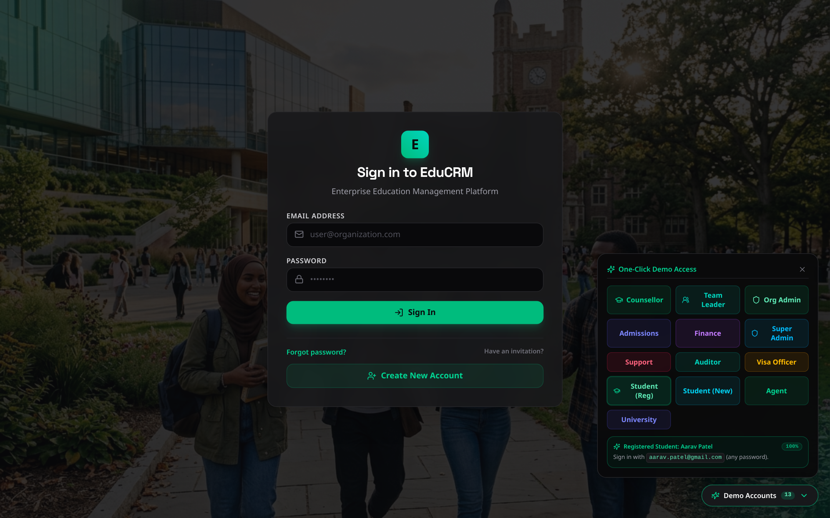
Figure: Login Screen with Collapsible 13-Role One-Click Demo Access Drawer

Master Role Routing & Test Access Matrix
The following matrix outlines every evaluated persona, their quick-access trigger button, default test identity, and primary landing URL:
User Role | Demo Drawer Button | Default Test Email | Primary Route | Evaluated Responsibility
Student (New) | Student (New) | Dynamic Session | /student/onboarding/step-1 | AI CV intake, Zero-Redundancy 4-stage onboarding wizard
Student (Reg) | Student (Reg) | aarav.patel@gmail.com | /student/dashboard | 11-step application wizard, course discovery, vault, invoices
Counsellor | Counsellor | counsellor@educrm.demo | /counsellor/dashboard | Lead deduplication, 360° student dossier, AI program matcher
Admissions | Admissions | admissions@educrm.demo | /admissions/dashboard | Document Verification Hub, academic threshold audit, offers
Team Leader | Team Leader | teamleader@educrm.demo | /team-leader/dashboard | Caseload allocation, counsellor reassignment, SLA monitoring
Visa Officer | Visa Officer | visa@educrm.demo | /visa-officer/dashboard | 28-day proof of funds, mock visa interview, CAS clearance
Finance | Finance | finance@educrm.demo | /finance/dashboard | Tuition invoices, fee challans, agent commission ledger
Agent | Agent | agent@educrm.demo | /agent/dashboard | Lead referral ingestion, pipeline tracking, commission tracking
University | University | university@educrm.demo | /university/dashboard | Institutional application review, program setup, direct CAS upload
Support | Support | support@educrm.demo | /support/dashboard | Ticketing desk, priority resolution, knowledge base curation
Auditor | Auditor | auditor@educrm.demo | /auditor/dashboard | Immutable audit trail, GDPR consent inspect, system log forensics
Super Admin | Super Admin | superadmin@educrm.demo | /super-admin/dashboard | Multi-tenant branch oversight, 13-tier RBAC provisioning
Org Admin | Org Admin | orgadmin@educrm.demo | / | Branch operational rules, lead scoring, commission manager

FLOW 1: Student Intake — AI CV Scanner & Zero-Redundancy Onboarding
The Zero-Redundancy Principle
Core Architectural Rule: Any data extracted from a student CV or entered during registration is NEVER requested again. All subsequent wizard stages are 100% pre-hydrated from Firestore and session cache.

Step 1.1: Registration with Gemini 3.8 Flash CV Scanner
- URL: Access Route: /register?role=student or click 'Create New Account' from login.
- Action: Locate the AI CV / Resume Scanner featuring the Google Gemini badge. Drag and drop any sample CV (.pdf or .docx) or type details manually.
- Expected Behavior: The multimodal AI engine extracts First Name, Last Name, Email, Phone, Country, Nationality, Degree Level, and Language scores without placeholder defaults.
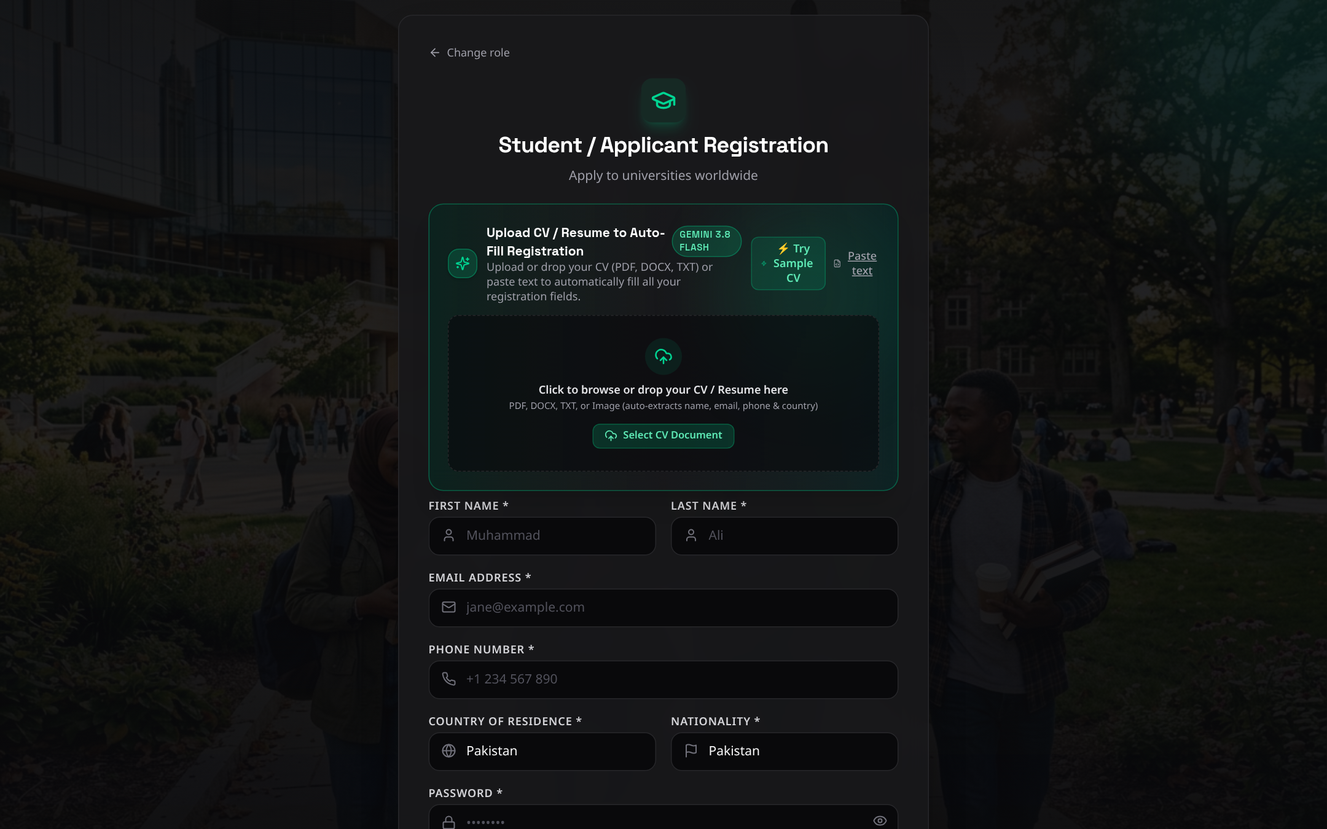
Figure: Student Registration with Multimodal Gemini 3.8 Flash AI CV Scanner

Step 1.2: Onboarding Step 1 — Identity Confirmation & Degree Level
- URL: Access Route: /student/onboarding/step-1.
- Verification: Verify Zero-Redundancy: All personal identity fields are already pre-filled from registration. Select Desired Study Level (Postgraduate / Master's) and confirm prior academic qualifications (e.g., Bachelor of Computer Science, GPA 3.65).
- Action: Click 'Save & Continue' to advance to destination preferences.
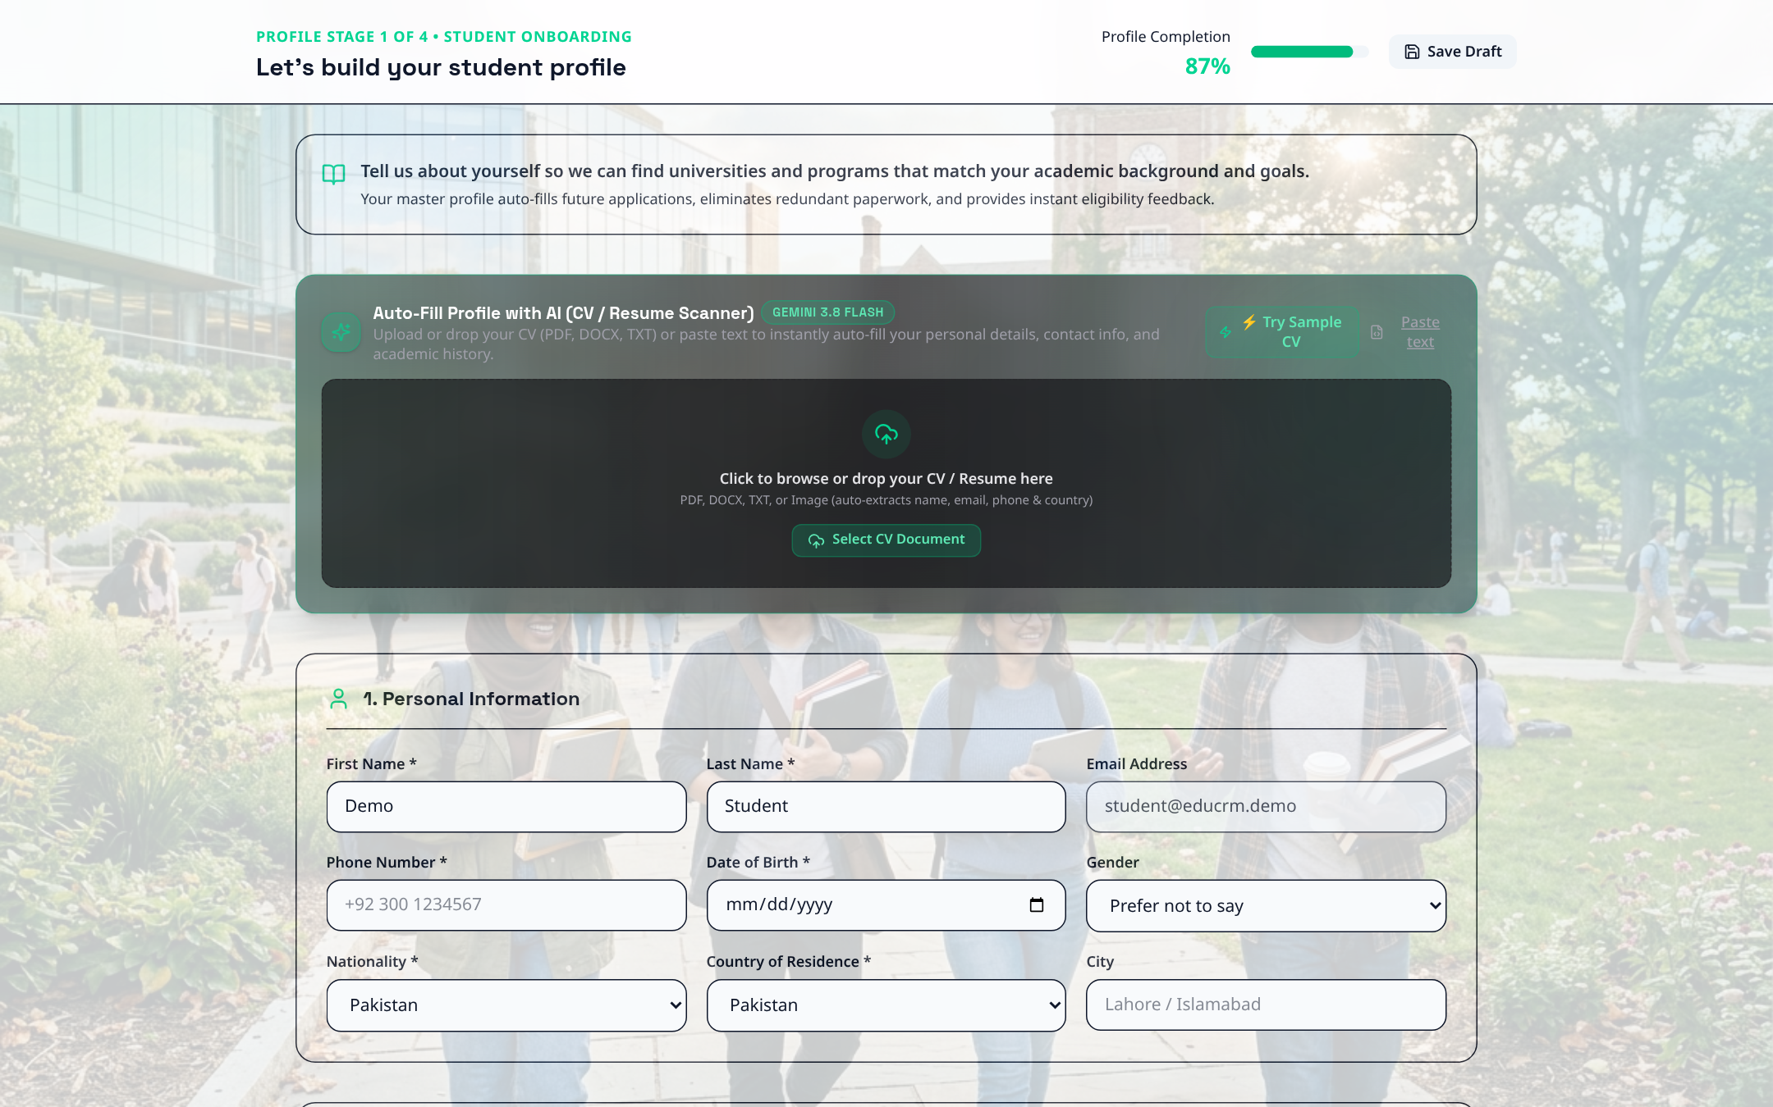
Figure: Student Onboarding Step 1 — Identity Confirmation and Academic Qualification

Step 1.3: Onboarding Step 2 — Study Destinations & Intake Term
- URL: Access Route: /student/onboarding/step-2.
- Action: Select target destination countries (United Kingdom, United States, Canada), target intake (Autumn / Fall 2026), and annual tuition budget (£15,000 - £25,000).
- Action: Click 'Proceed to Documents'.

Figure: Student Onboarding Step 2 — Study Destinations, Intake Session, and Tuition Budget

Step 1.4: Onboarding Step 3 — Mandatory KYC Document Repository
- URL: Access Route: /student/onboarding/step-3.
- Action: Upload or inspect mandatory document slots: International Passport, Bachelor Degree Transcript, and English Language Test Certificate (IELTS/PTE).
- Action: Client-side validation verifies file types (.pdf, .png, .jpg) and file sizes (<10MB). Click 'Proceed to Readiness Review'.
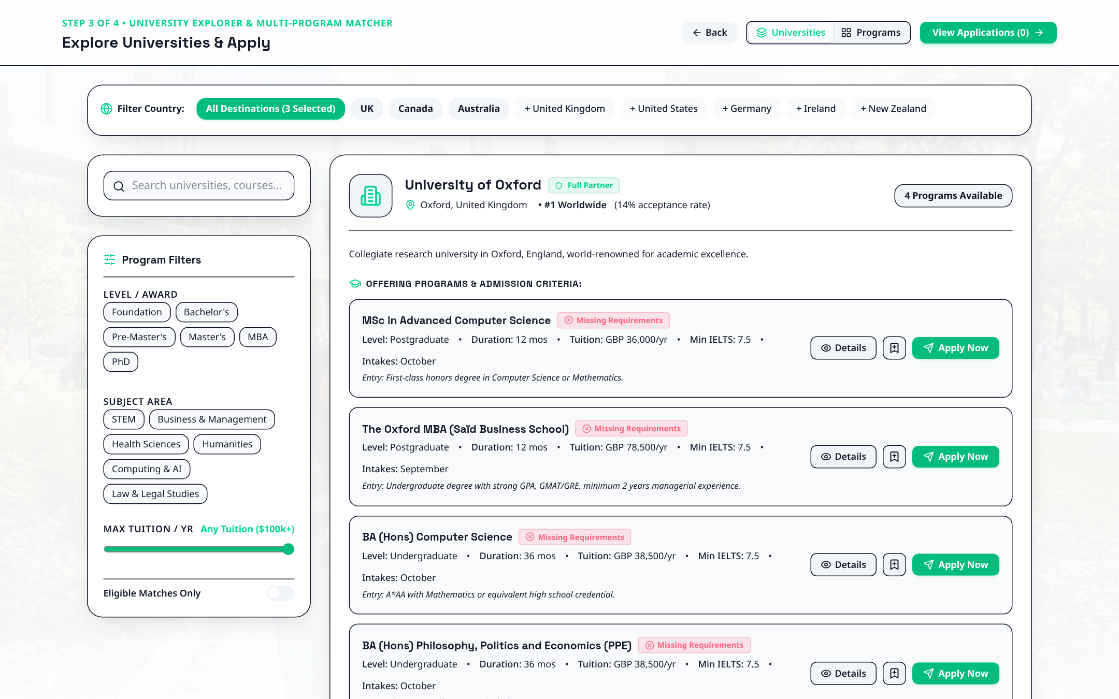
Figure: Student Onboarding Step 3 — Secure KYC and Academic Document Upload Repository

Step 1.5: Onboarding Step 4 — Profile Completeness & Legal Declaration
- URL: Access Route: /student/onboarding/step-4.
- Action: Observe the Profile Completeness Score computed dynamically by profileCompleteness.ts. Check the declaration box confirming document authenticity.
- Action: Click 'Complete Onboarding & Enter Portal'. The system sets onboardingStatus to completed and unlocks full student privileges.
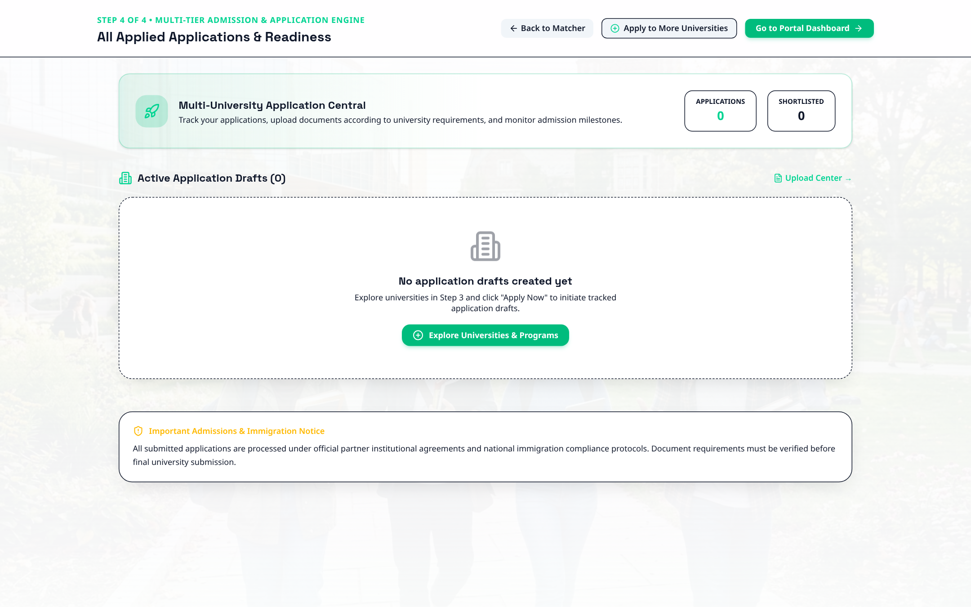
Figure: Student Onboarding Step 4 — Profile Completeness Scoring and Final Declaration

FLOW 2: Student Experience — Course Discovery & 11-Step Application Wizard

Step 2.1: Student Command Center
- Trigger: Fast Login: Click 'Student (Reg)' in Demo Accounts drawer or login with aarav.patel@gmail.com.
- Route: URL: /student/dashboard.
- Overview: Inspect the real-time application tracker card, assigned counsellor card with direct chat link, and document readiness status chips.
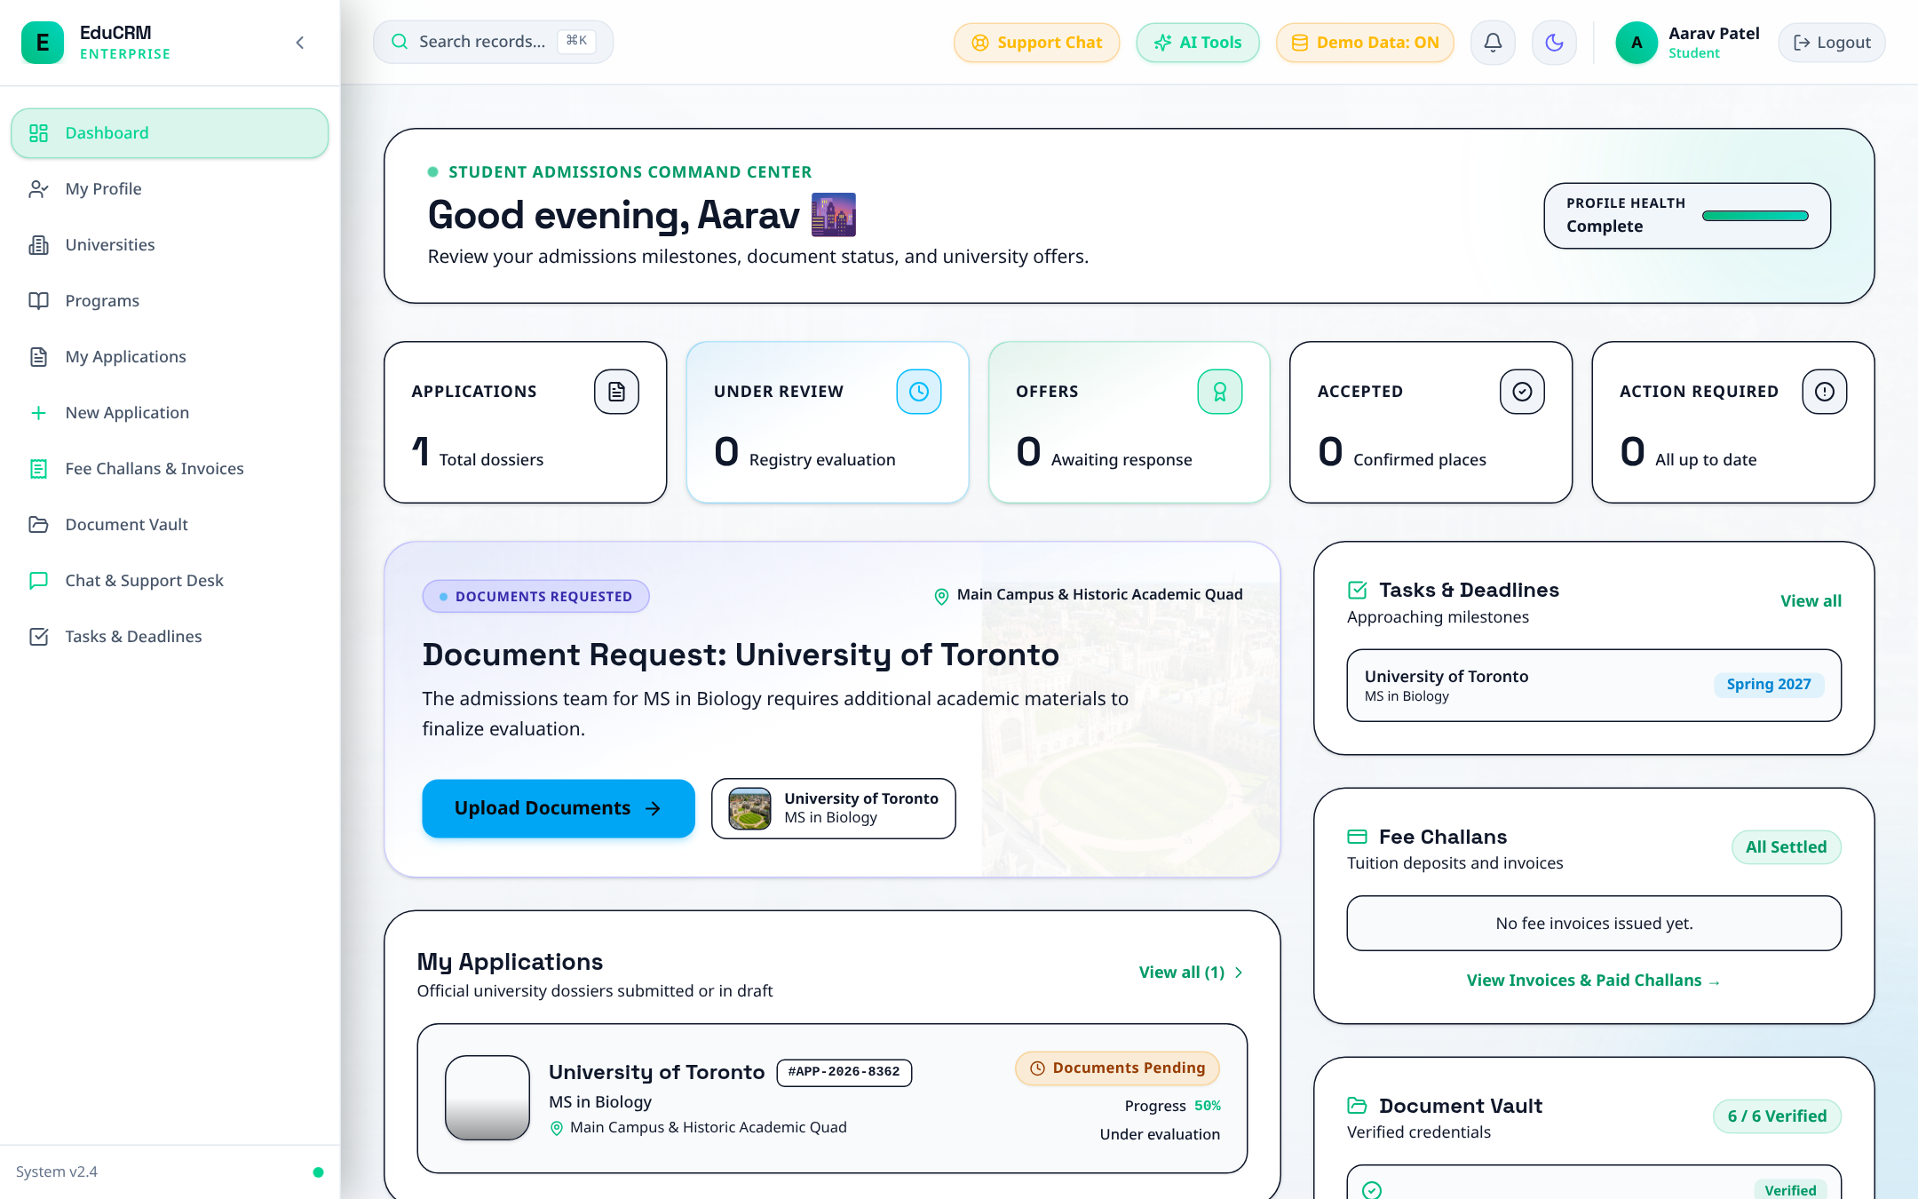
Figure: Student Command Center — Application Tracker, Assigned Counsellor, and Profile Readiness

Step 2.2: Programme Catalog & Entry Requirement Filter
- URL: Access Route: /student/programs.
- Action: Filter courses by Country (United Kingdom), Level (Postgraduate), and Discipline (Computer Science). Select MSc Advanced Computer Science at Oxford University.
- Action: Verify entry criteria: Minimum GPA 3.5, Minimum IELTS 7.0. Click 'Apply Now'.
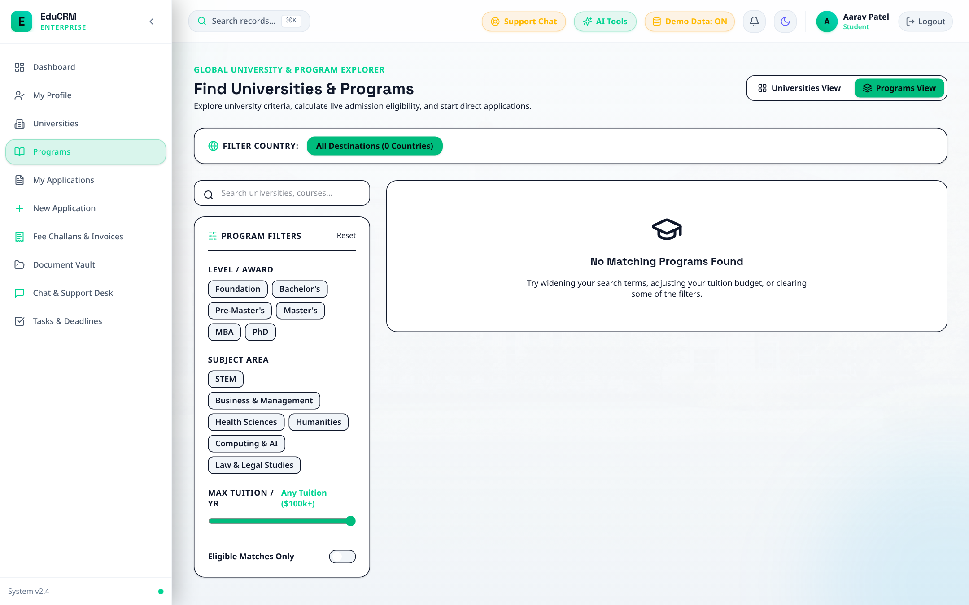
Figure: Student Course Discovery & Searchable Programme Catalog with Entry Criteria

Step 2.3: Complete 11-Step Student Application Wizard
- URL: Access Route: /student/new-application.
- Wizard Steps: Step 1: Programme Overview and campus selection.
- Wizard Steps: Step 2: Personal Details — 100% pre-filled from master profile (Zero Redundancy).
- Wizard Steps: Step 3: Academic Qualifications — Degree and GPA pre-filled.
- Wizard Steps: Step 4: English Language Proficiency — IELTS 7.5 automatically benchmarked against program threshold.
- Wizard Steps: Steps 5-10: Statement of Purpose (SOP), work experience, referee contacts, university-specific questions, and KYC documents.
- Submission: Step 11: Submit Application. Application record is stored with status 'Submitted' and stage 'Initial Review'.
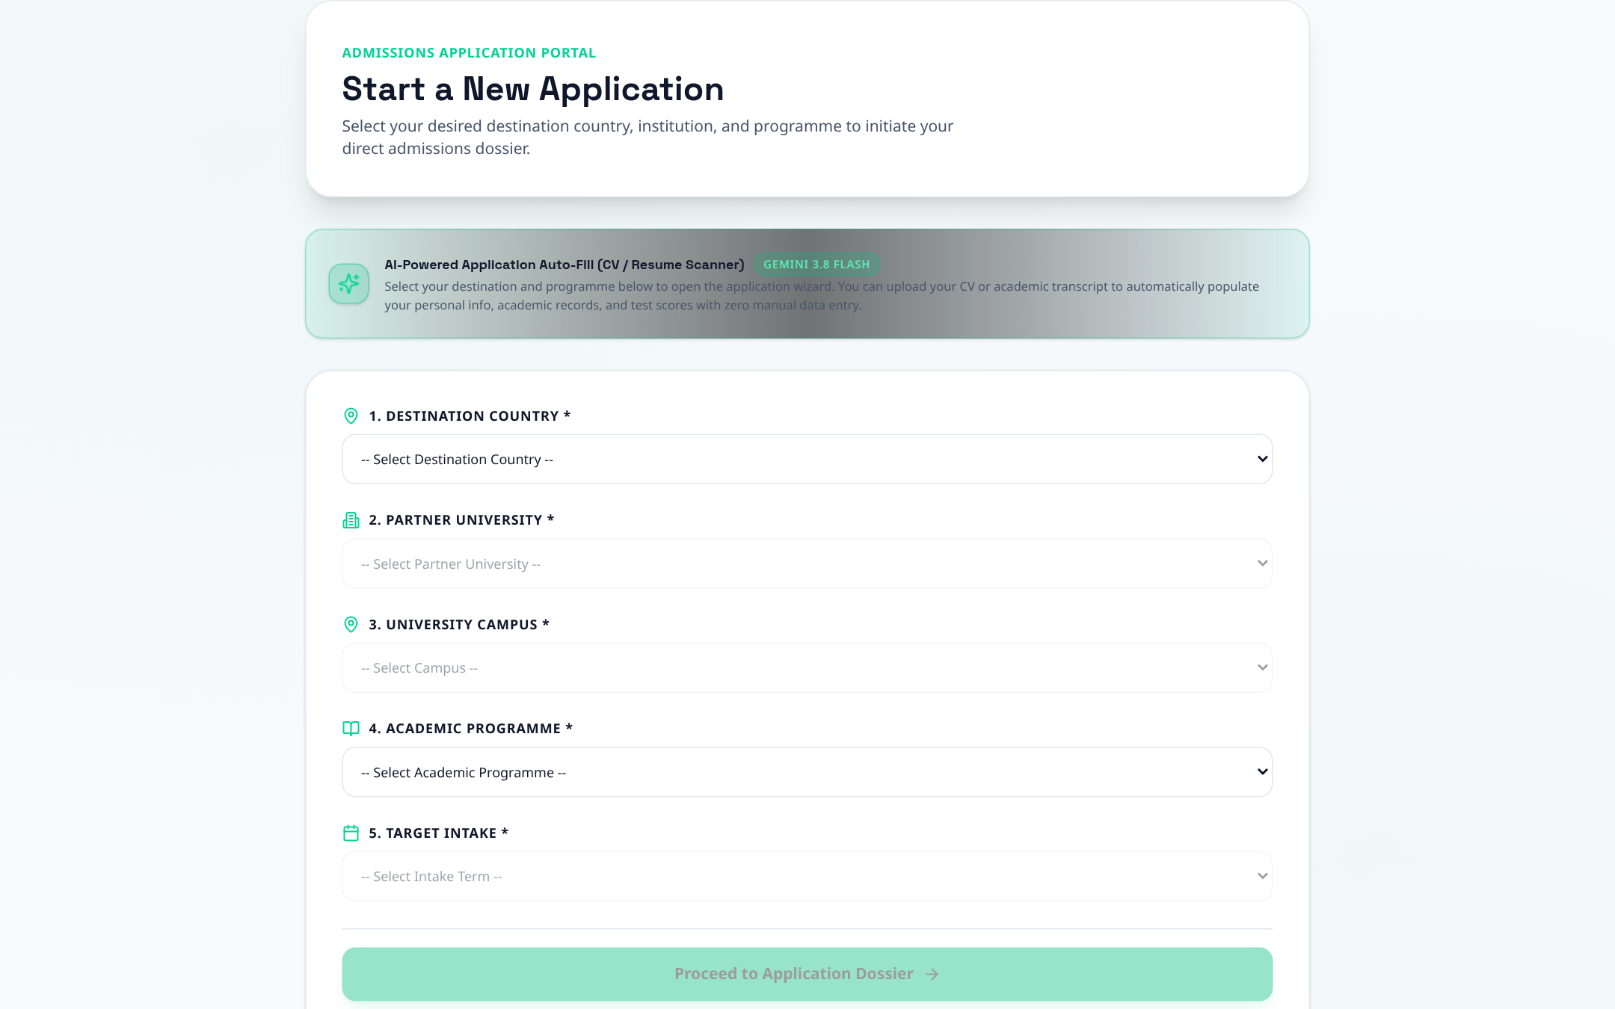
Figure: 11-Step Comprehensive Student Application Wizard

FLOW 3: Student Self-Management — Vault, Invoices, Chat & Profile

Step 3.1: Secure Digital Document Vault
- URL: Access Route: /student/documents.
- Features: View categorized documents with verification stamps (Verified, Pending, Resubmission Required).
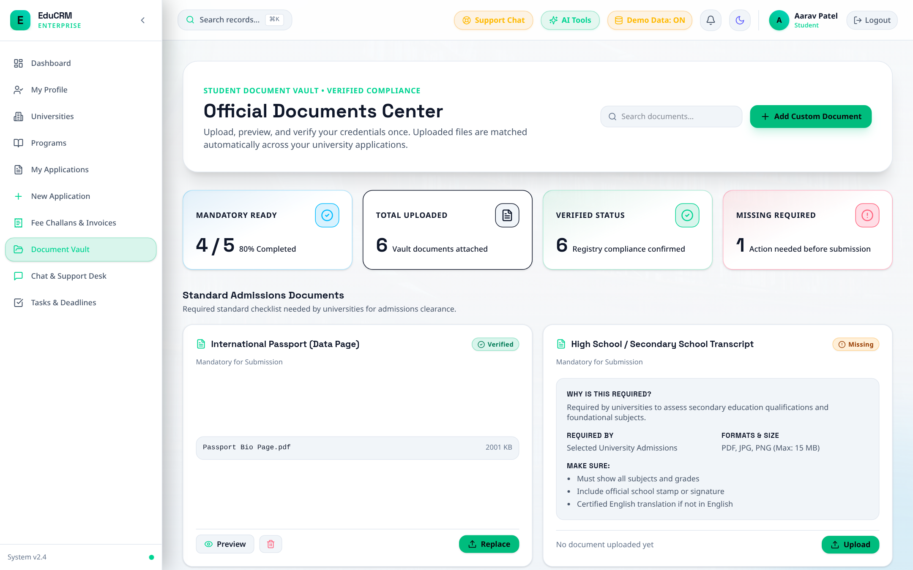
Figure: Student Digital Document Vault with Verification Stamps

Step 3.2: Tuition Invoices & Bank Fee Challans
- URL: Access Route: /student/invoices.
- Features: Download official tuition deposit fee challan and university invoice PDF with bank wire details.
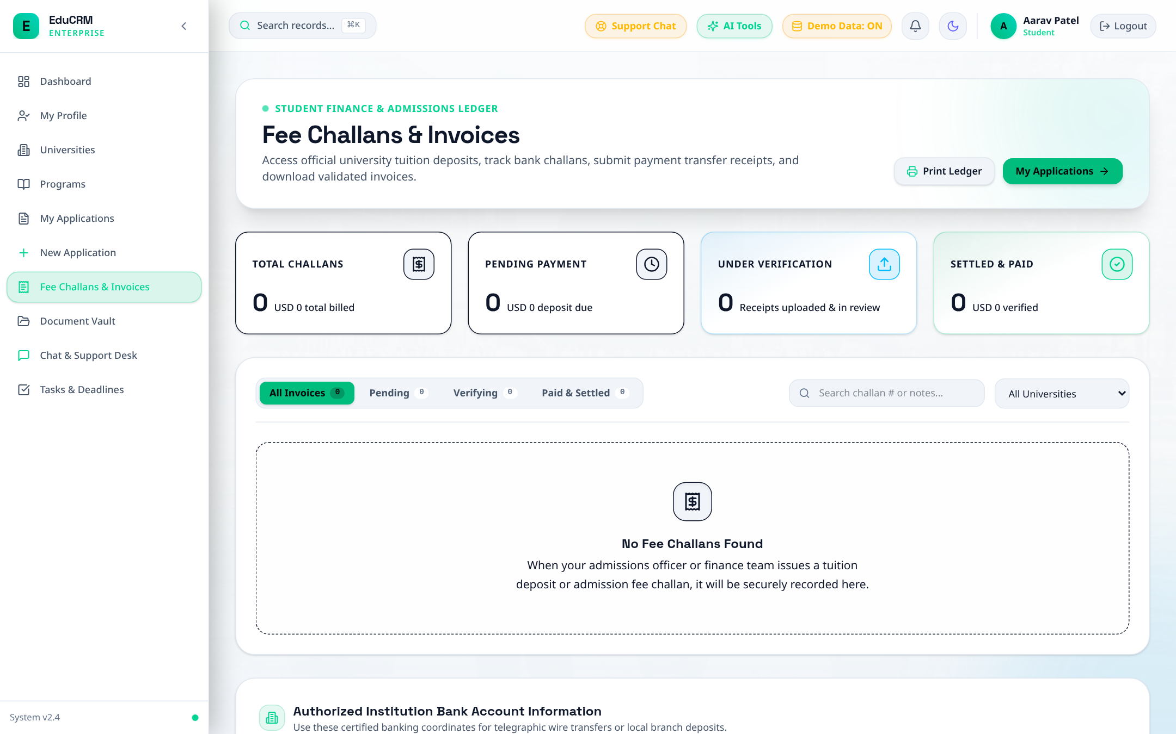
Figure: Student Tuition Invoices, Fee Challans, and Bank Wire Instructions

Step 3.3: Direct Messaging with Assigned Counsellor
- URL: Access Route: /student/messages.
- Features: Engage in direct real-time communication with the assigned education counsellor.
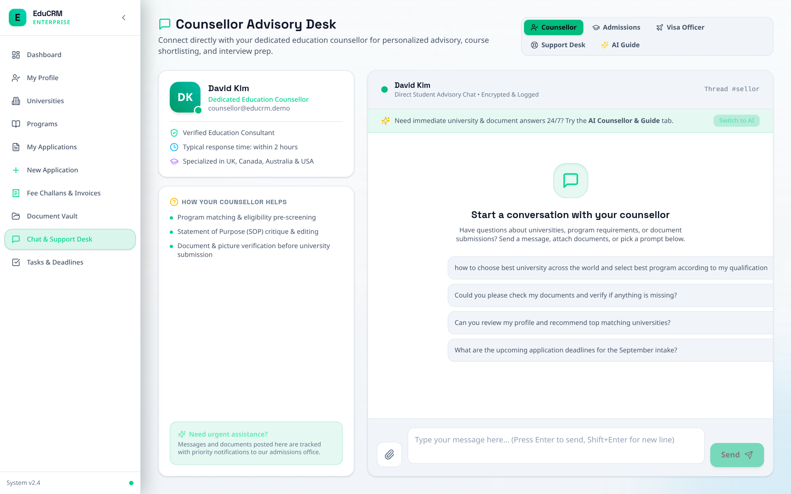
Figure: Student Direct Messaging Channel with Assigned Counsellor

Step 3.4: Student Profile Self-Edit
- URL: Access Route: /student/profile.
- Features: Update residential address, emergency contact, or passport number with bidirectional profile sync.
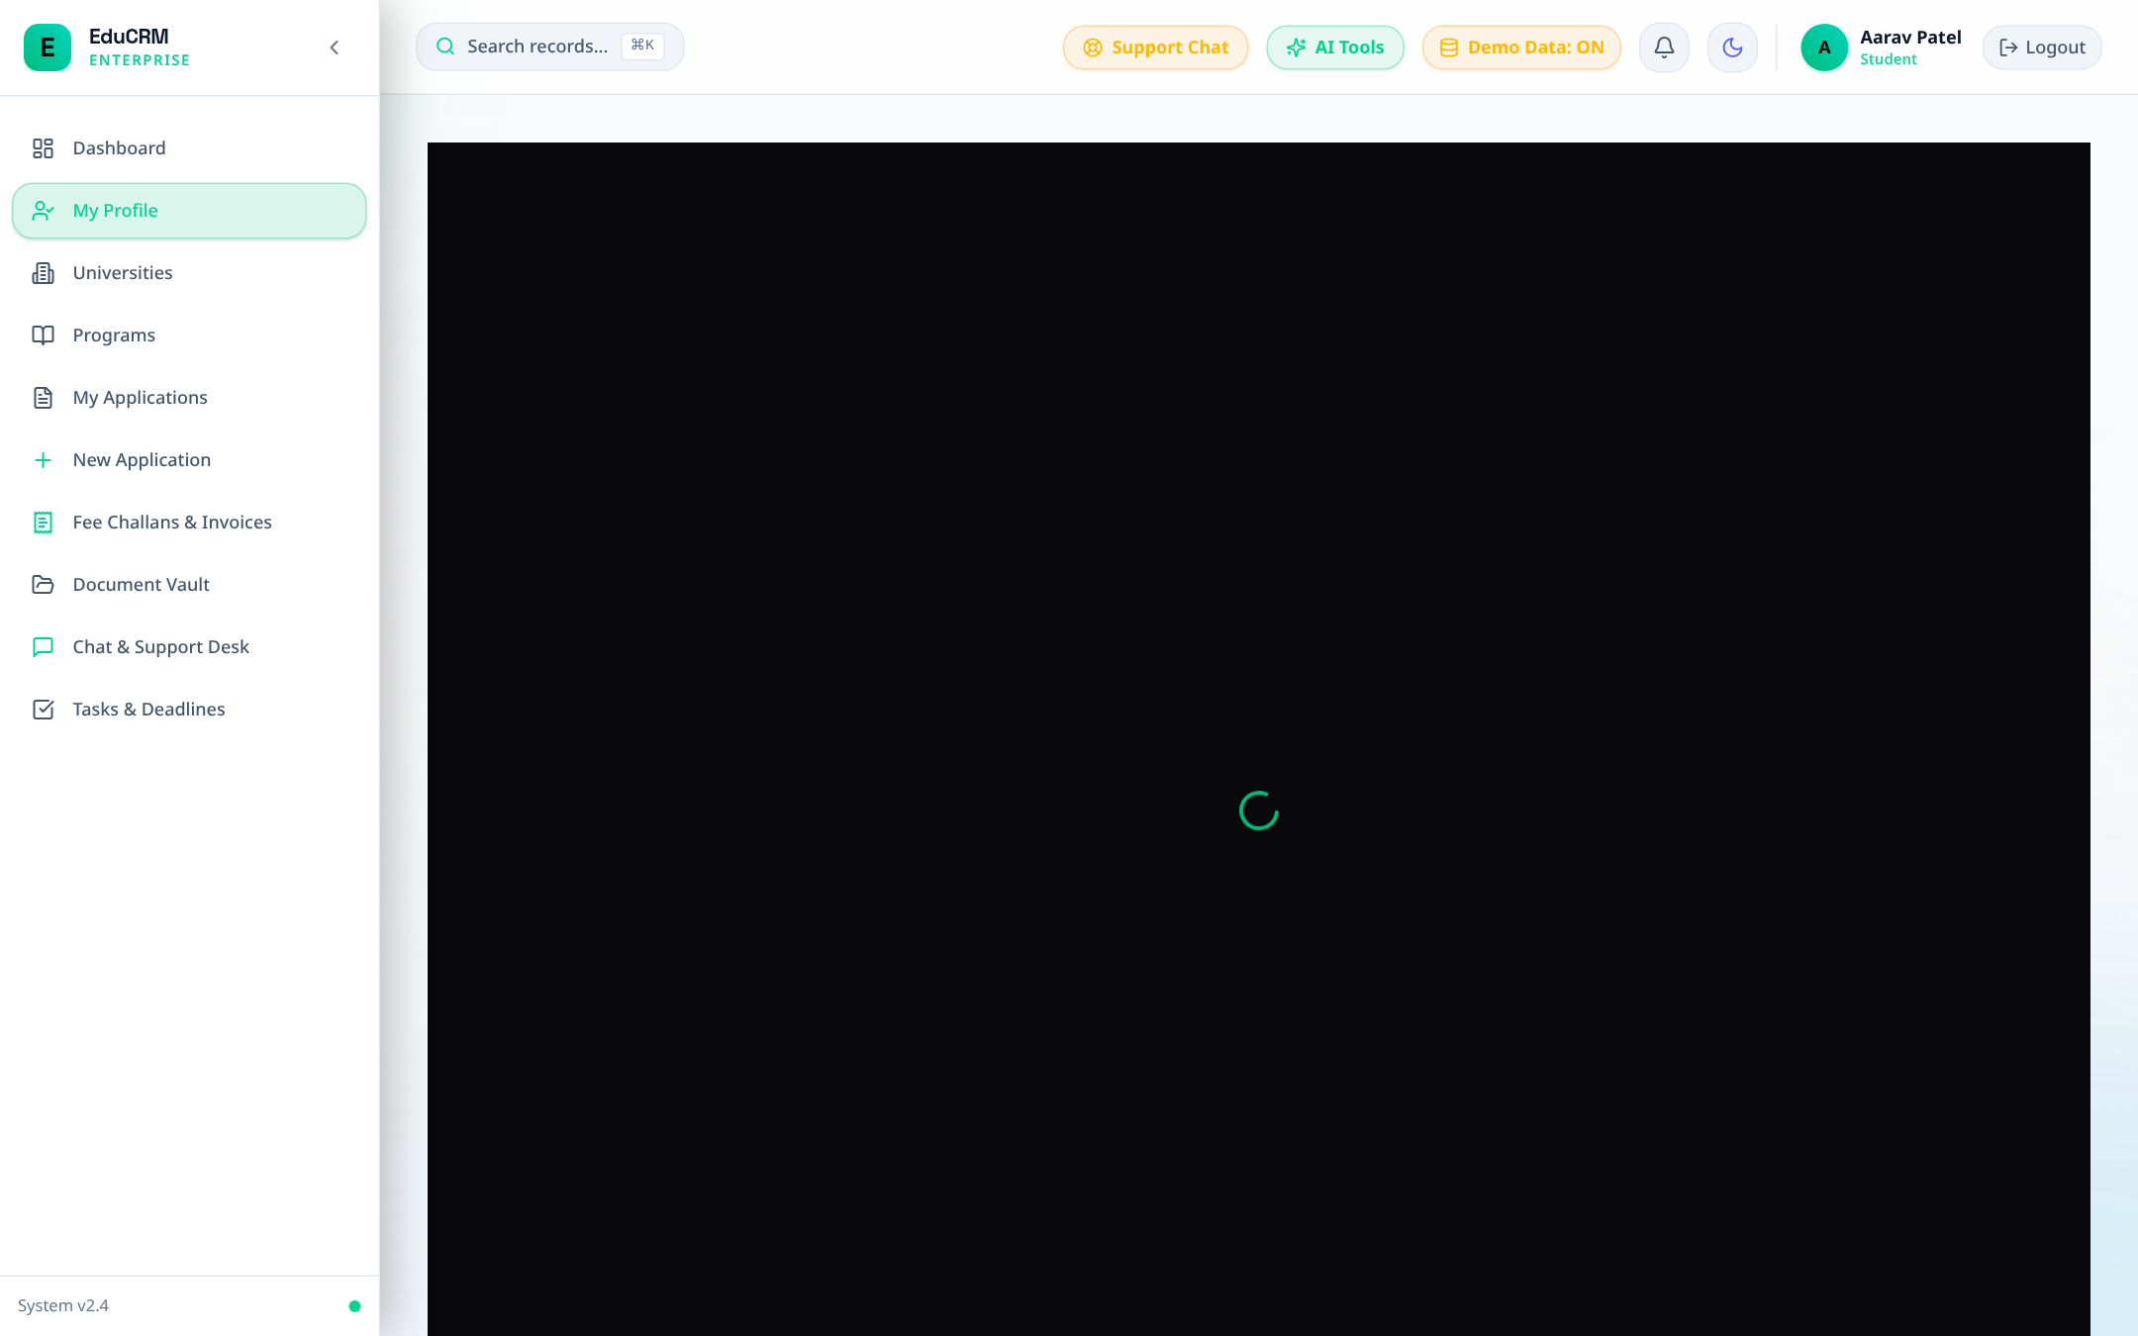
Figure: Student Profile Self-Edit and Master Contact Update

FLOW 4: Education Counsellor — Lead Intake, 360° Dossier & AI Matcher

Step 4.1: Counsellor Command Center
- Trigger: Fast Login: Click 'Counsellor' in Demo Accounts drawer.
- Route: URL: /counsellor/dashboard.
- KPIs: Review assigned active leads, applications in pipeline, and scheduled student callbacks due today.
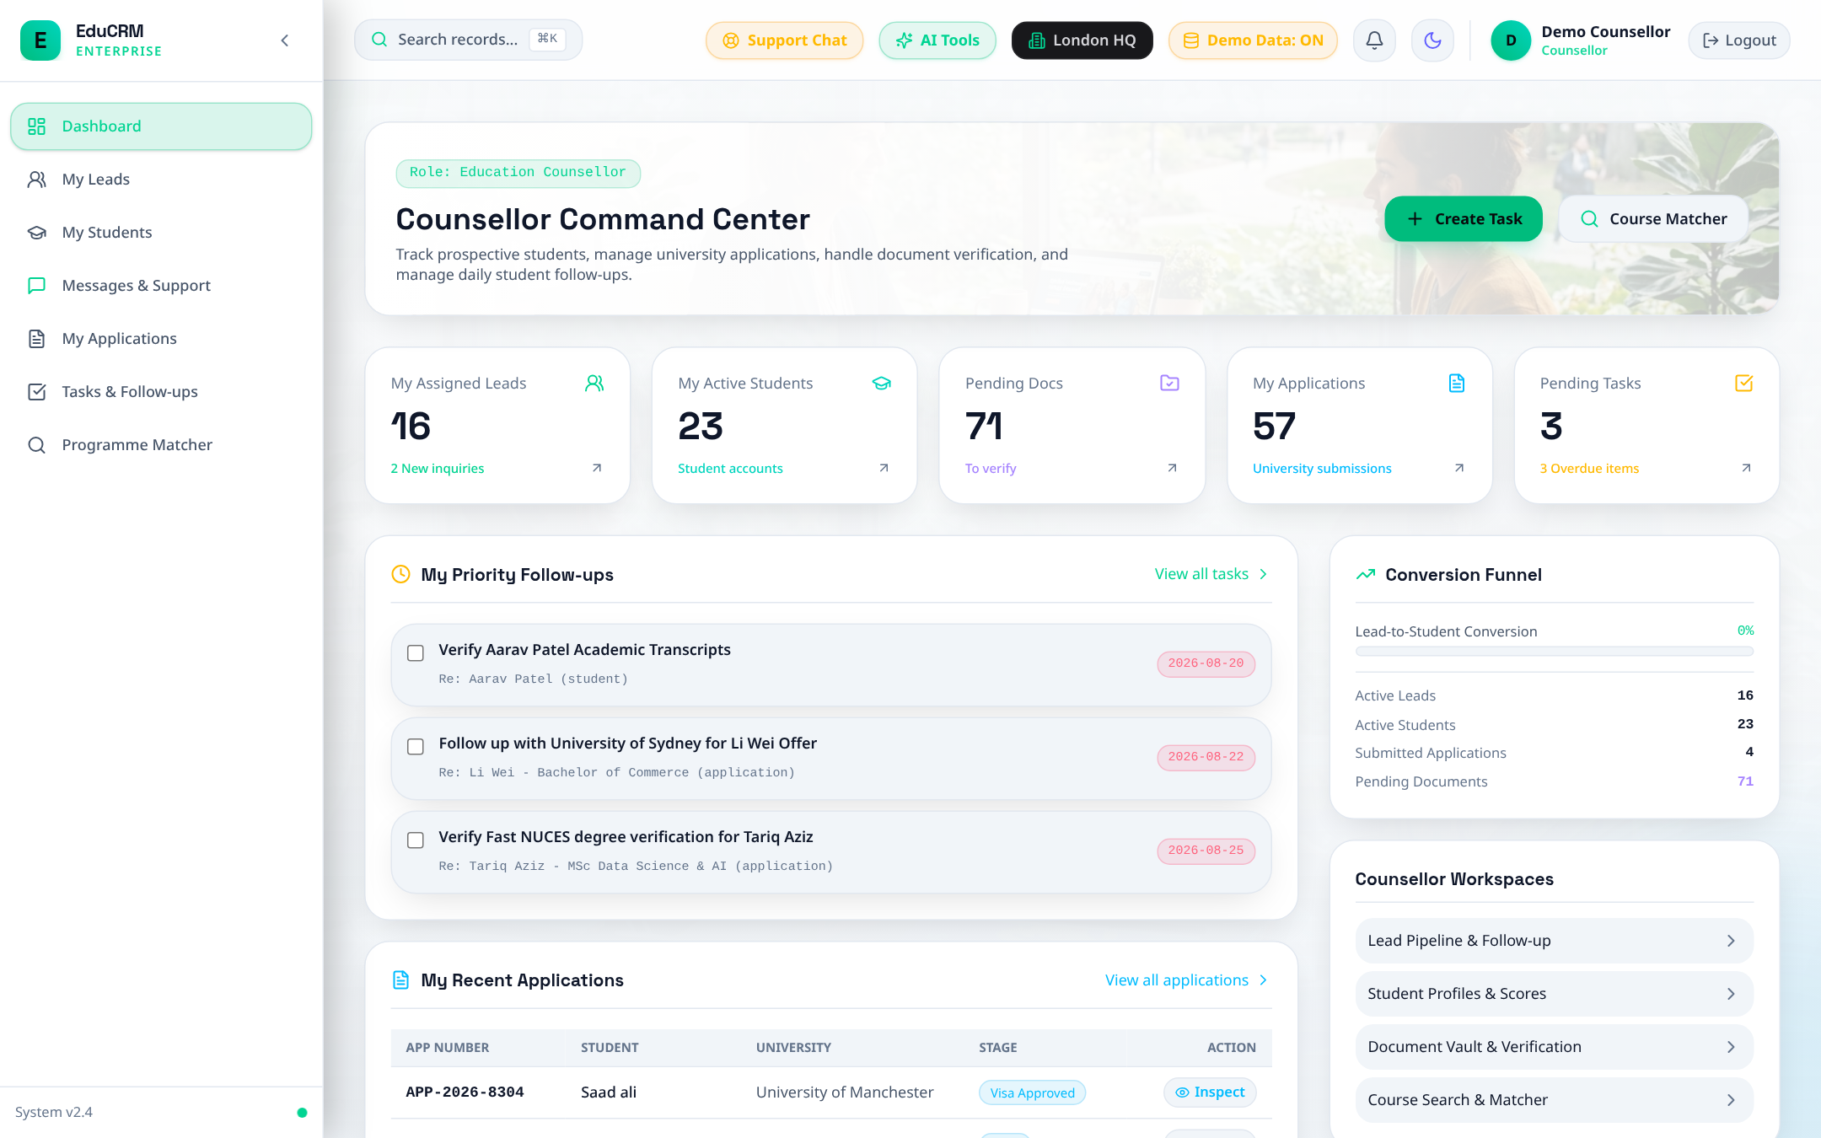
Figure: Counsellor Command Center — Active Lead Metrics, Application Pipeline, and Due Callbacks

Step 4.2: Lead Lifecycle & Automated Deduplication
- URL: Access Route: /leads.
- Action: Filter leads by status (New, Contacted, Qualified, Converted). Review AI Lead Score Badges (Hot, Warm, Cold).
- Deduplication Test: Click 'Add Lead' and enter an existing email (e.g., aarav.patel@gmail.com). System flags duplicate inquiry and prevents fragmentation.
- Conversion: Click 'Convert to Student' on any qualified lead to provision student portal access.
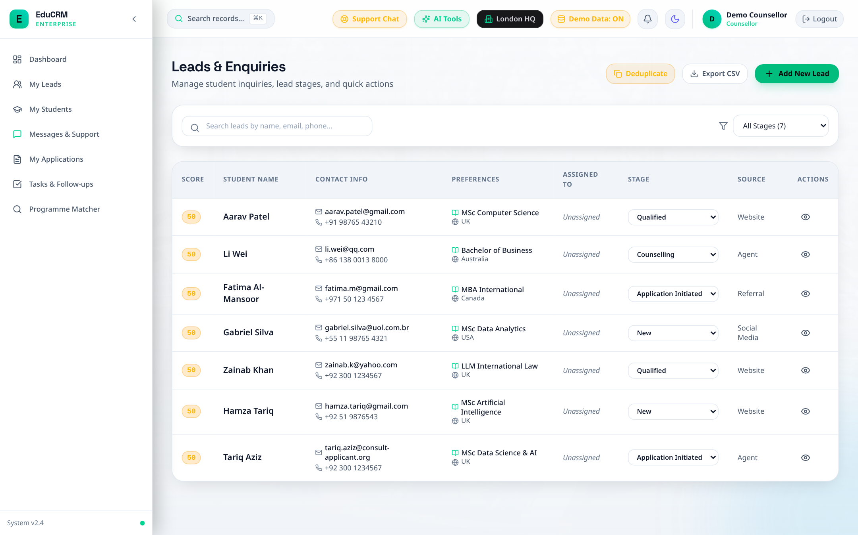
Figure: Leads Lifecycle Management with AI Lead Scoring and Deduplication Prevention

Step 4.3: 360° Student Application Dossier
- URL: Access Route: /counsellor/students.
- Action: Select Aarav Patel to launch the Application Dossier Modal. Review unified academic history, test scores, verified KYC documents, and interaction history.
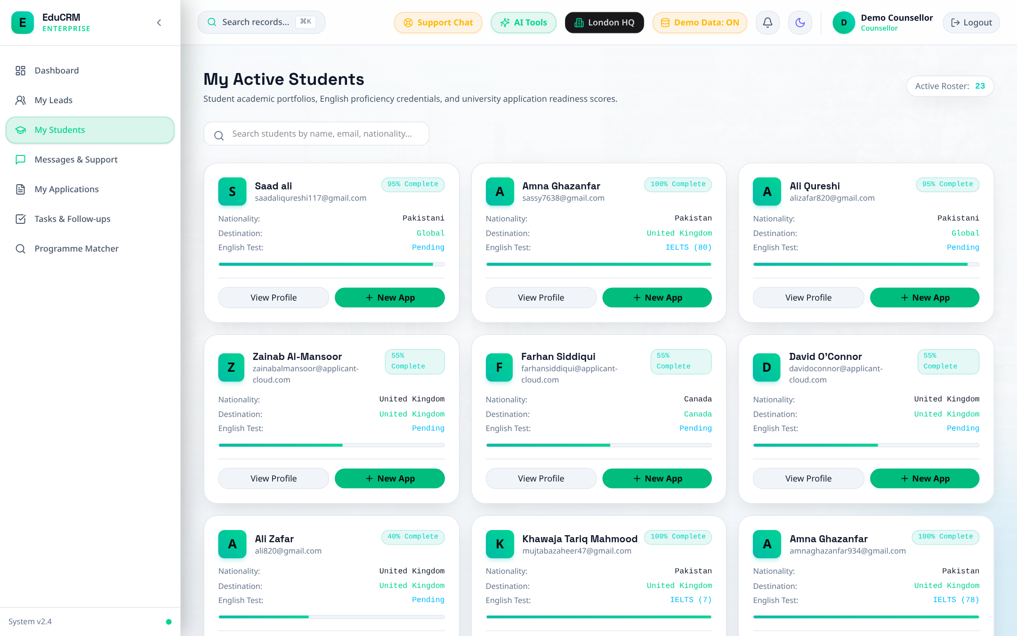
Figure: Counsellor Students Directory and Unified 360° Student Dossier

Step 4.4: Algorithmic Programme Matcher
- URL: Access Route: /counsellor/programme-matcher.
- Action: Input student credentials (GPA 3.65, IELTS 7.5, Target UK) and run algorithmic matching.
- Output: System categorizes universities into High Match (fully eligible), Conditional Pathway, and Stretch Target.
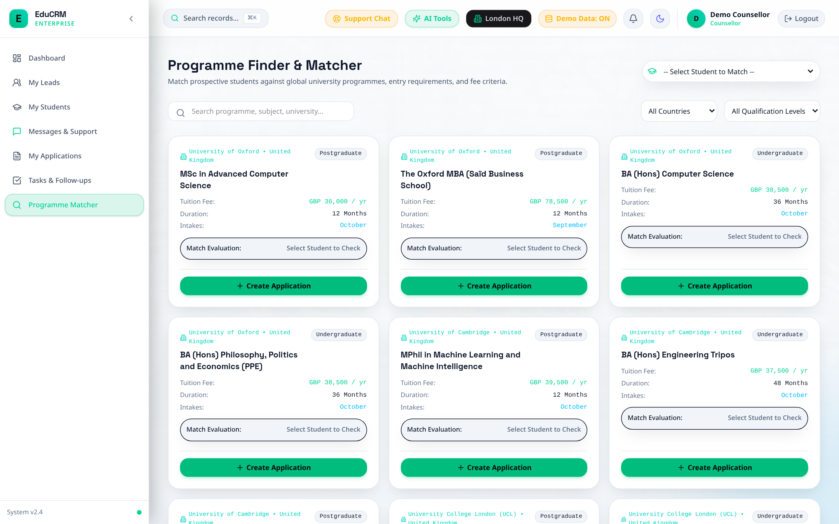
Figure: Algorithmic Course & University Matcher with Entry Benchmark Classification

Step 4.5: Application Pipeline Management
- URL: Access Route: /applications.
- Action: Advance application stage from 'Draft' to 'Initial Review' to forward to Admissions Officer triage.
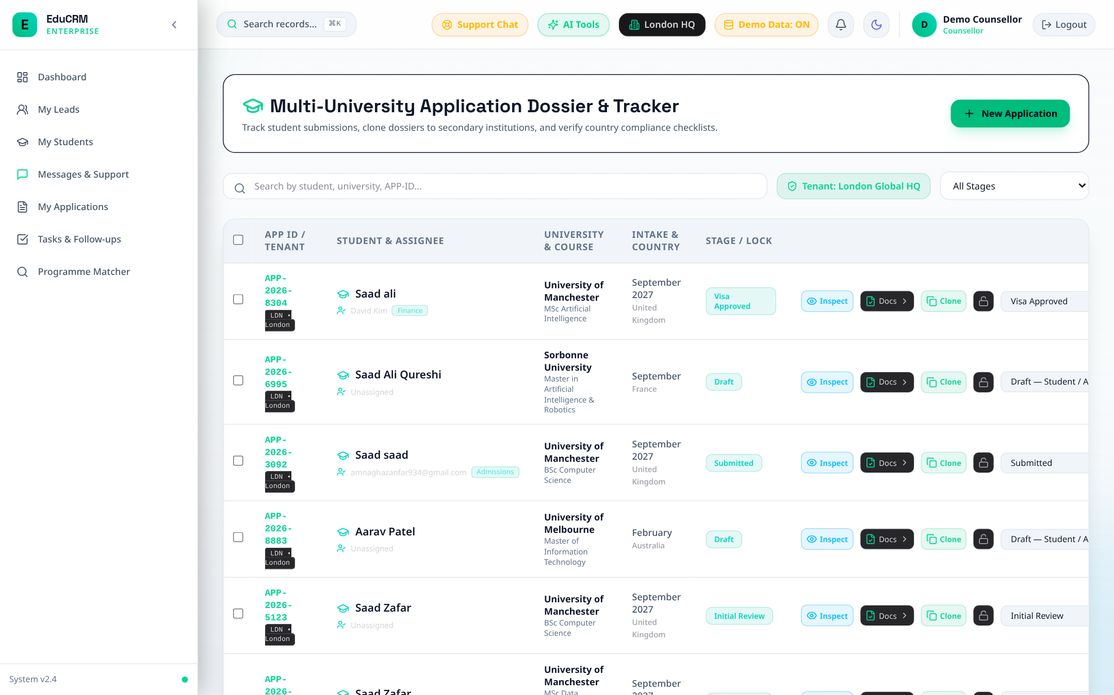
Figure: Staff Application Pipeline Management and Stage Transition Tracker

FLOW 5: Admissions Officer — Verification Hub, Academic Threshold & Offers

Step 5.1: Admissions Command Center
- Trigger: Fast Login: Click 'Admissions' in Demo Accounts drawer.
- Route: URL: /admissions/dashboard.
- Overview: Review applications pending document verification, SLA deadlines, and offers issued today.
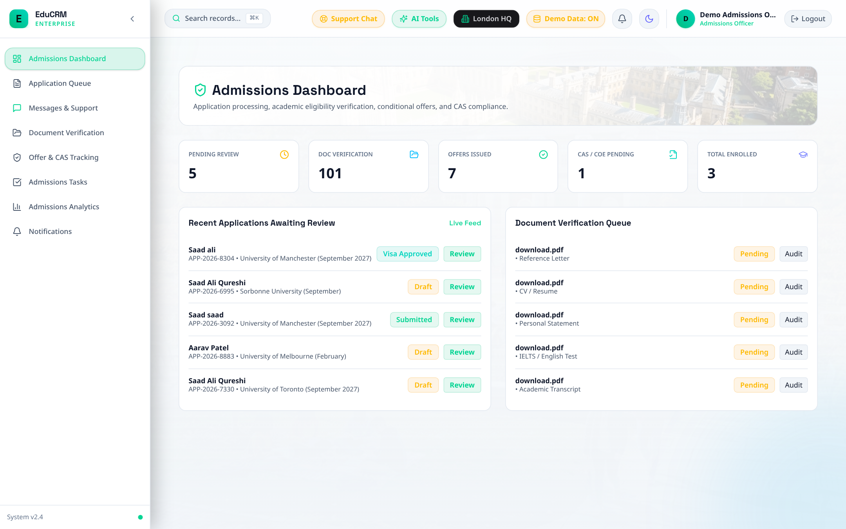
Figure: Admissions Command Center — Pending Document Verifications and Intake Deadlines

Step 5.2: Admissions Document Verification Hub
- URL: Access Route: /admissions/verification.
- Action: Open candidate in 'Initial Review' stage. Conduct side-by-side inspection of Passport, Academic Transcript, and IELTS Scorecard.
- Action: Click 'Approve Document' to stamp as verified, or 'Request Resubmission' with mandatory corrective instructions.
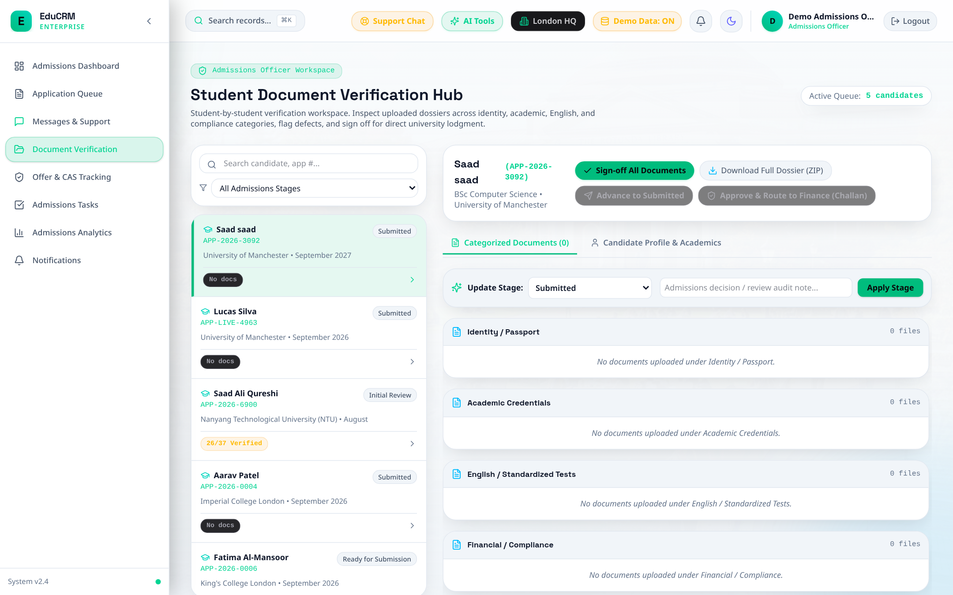
Figure: Admissions Document Verification Hub — Side-by-Side Academic & Identity Credential Audit

Step 5.3: Dispatch Conditional & Unconditional Offer Letters
- URL: Access Route: /admissions/offers.
- Action: Click 'Generate Offer Letter'. Select Conditional Offer (stipulating conditions such as deposit payment or final certificate) or Unconditional Offer.
- Action: Click 'Issue Offer Letter'. System updates application state and dispatches formal acceptance notification to student.
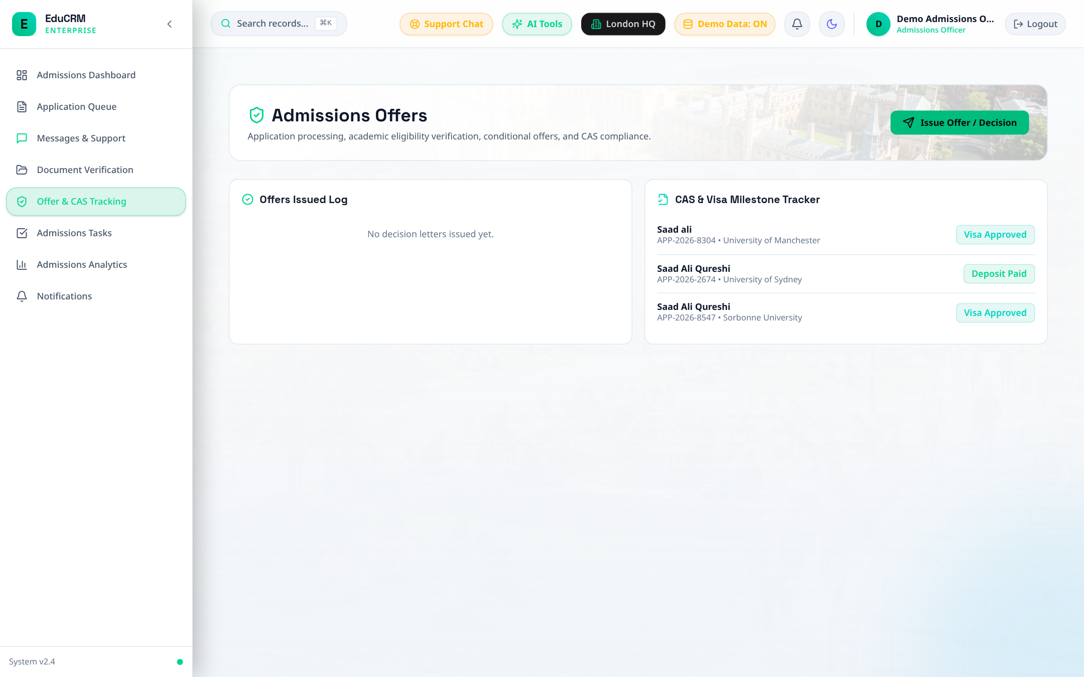
Figure: Admissions Offer Letters Management — Conditional & Unconditional Acceptance Issuance

FLOW 6: Team Leader — Caseload Balancing, Reassignment & Performance SLAs

Step 6.1: Team Leader Command Center
- Trigger: Fast Login: Click 'Team Leader' in Demo Accounts drawer.
- Route: URL: /team-leader/dashboard.
- Overview: Monitor branch throughput, unassigned leads queue, and counsellor turnaround SLAs.
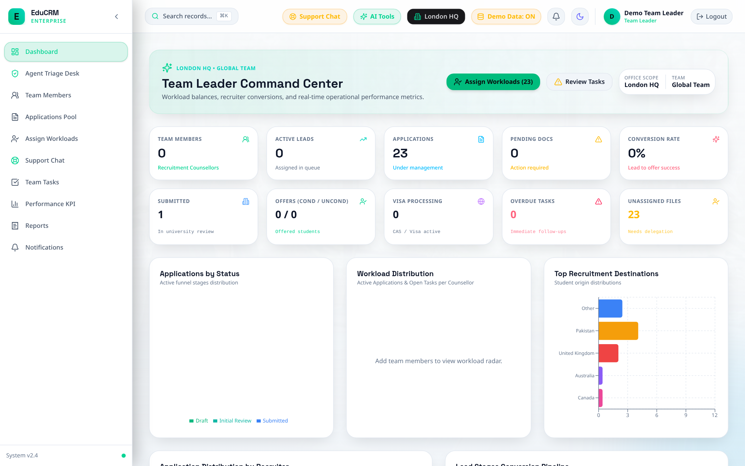
Figure: Team Leader Dashboard — Workload Metrics, Branch Throughput, and Turnaround SLAs

Step 6.2: Workload Balancing & Application Reassignment
- URL: Access Route: /team-leader/assign-applications.
- Action: Compare counsellor caseloads. Reassign high-priority or unallocated applications from overloaded staff to available counsellors.
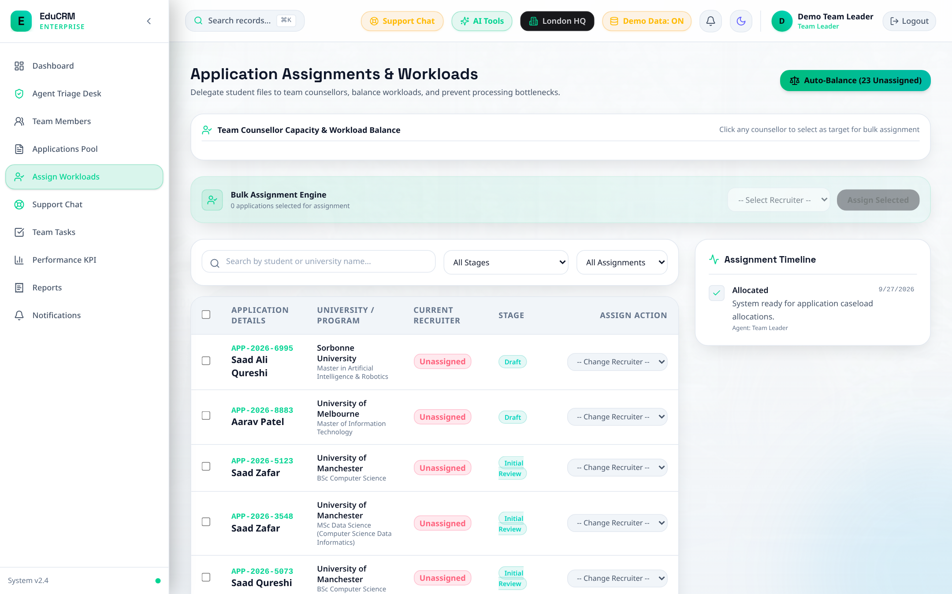
Figure: Team Leader Workload Allocation and Counsellor Reassignment Desk

Step 6.3: Counsellor Team Members & Capacity Roster
- URL: Access Route: /team-leader/team-members.
- Action: View roster of active branch counsellors, current student caseloads, and historical conversion ratios.
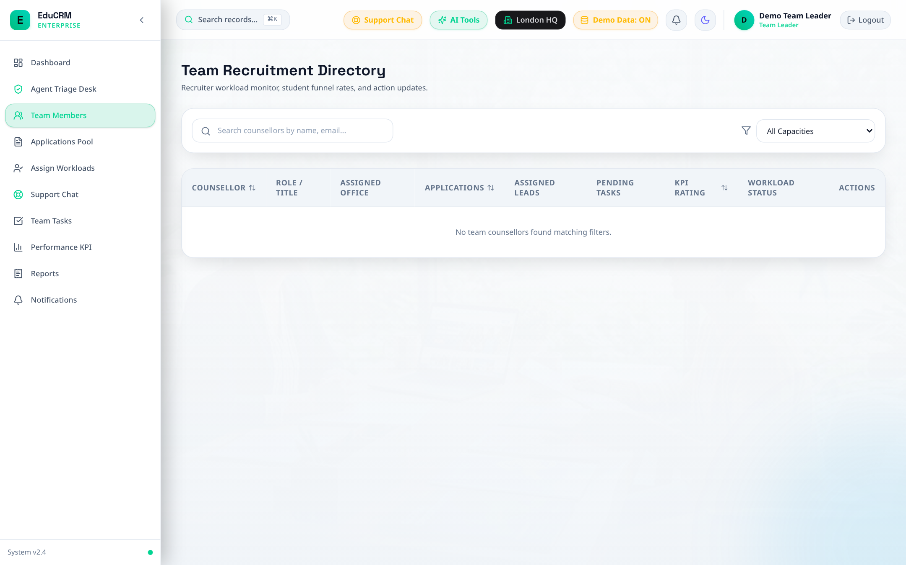
Figure: Team Leader Counsellor Team Roster and Individual Caseload Capacities

Step 6.4: Operational Performance & SLA Analytics
- URL: Access Route: /team-leader/performance.
- Action: Audit average lead-to-offer velocity, funnel drop-off points, and staff performance metrics.
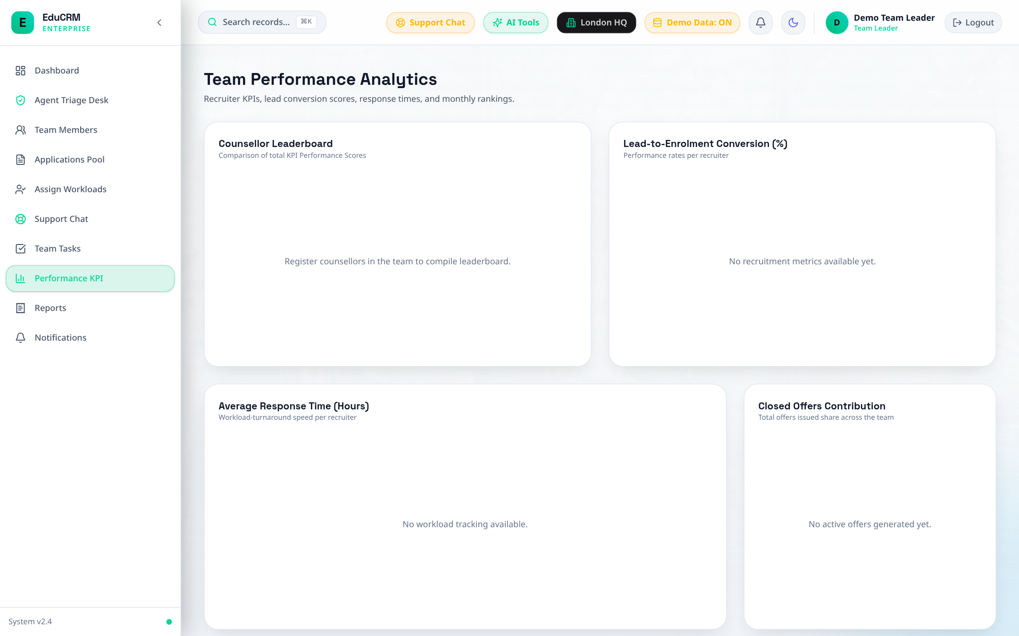
Figure: Team Leader Performance Analytics — Lead Conversion Funnel and Turnaround Time

FLOW 7: Visa Officer — Proof of Funds, Medical Clearance & Mock Interview

Step 7.1: Visa Officer Command Center
- Trigger: Fast Login: Click 'Visa Officer' in Demo Accounts drawer.
- Route: URL: /visa-officer/dashboard.
- Overview: Review caseload partitioned by immigration jurisdiction (UKVI Student Route, US F-1, Canada Study Permit, Australia Subclass 500).
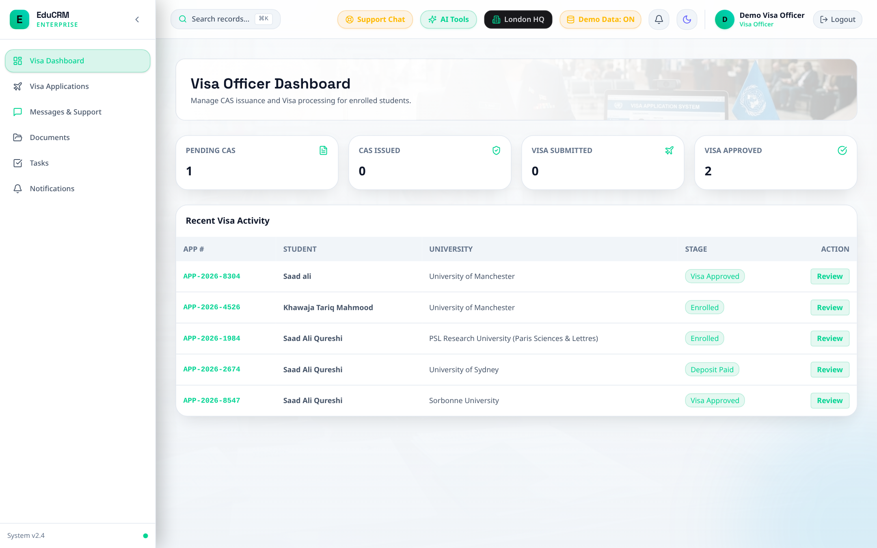
Figure: Visa Officer Command Center — Caseload Categorized by Immigration Jurisdiction

Step 7.2: Active Visa Cases Management
- URL: Access Route: /visa-officer/cases.
- Action: Audit active applicants currently in CAS / Visa stage. Filter by CAS deadline and embassy interview date.
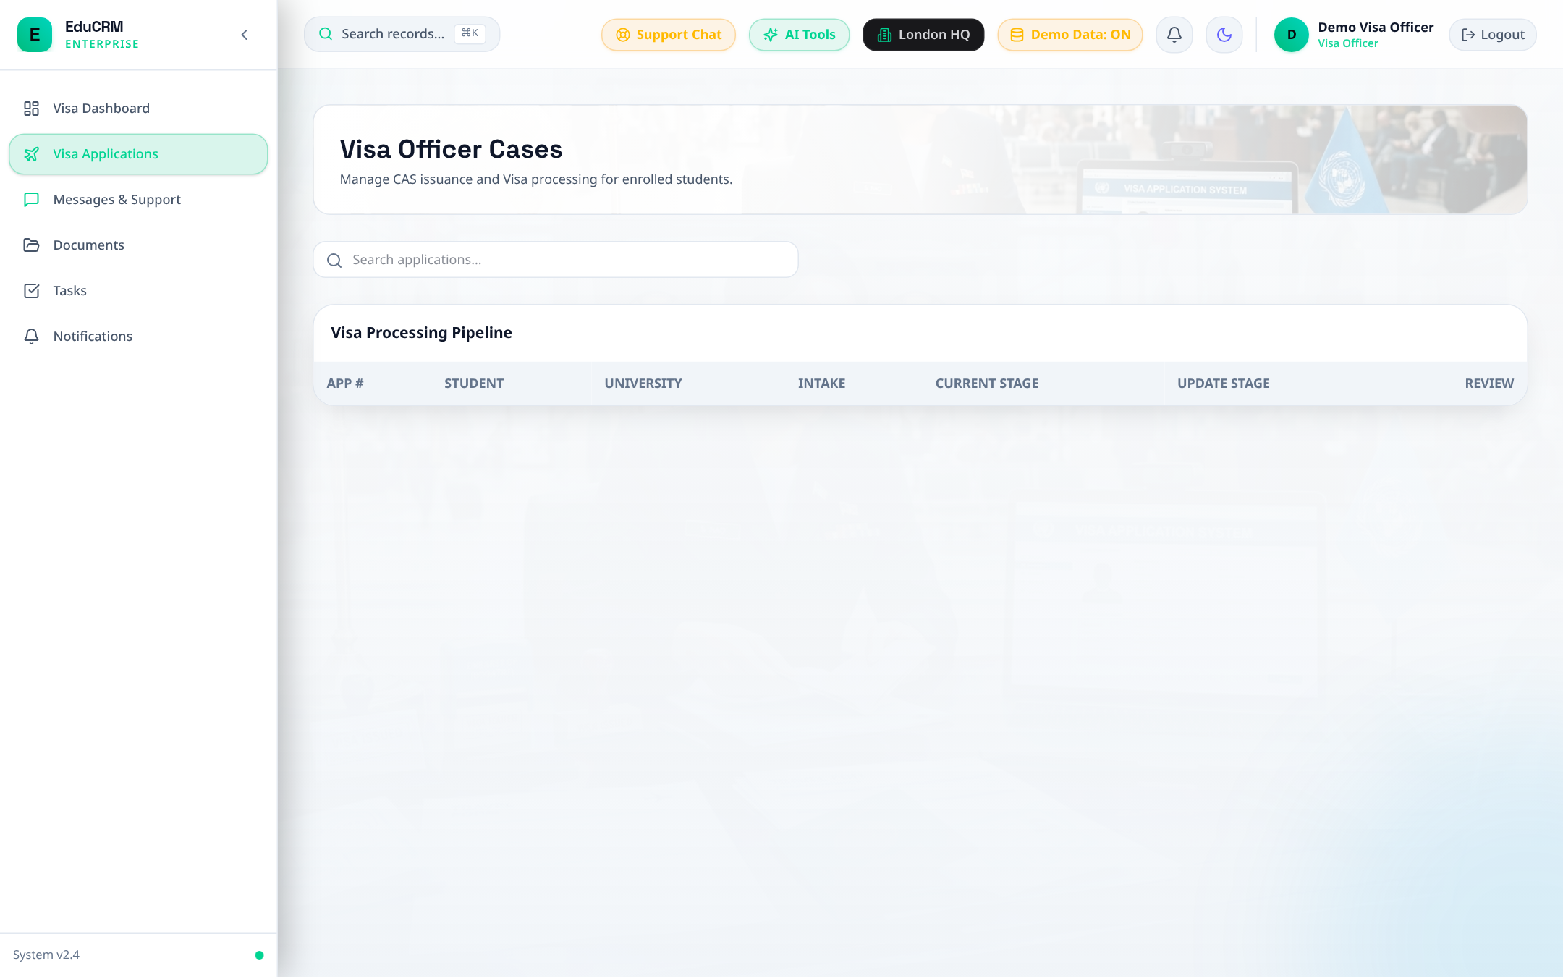
Figure: Visa Cases Management — Priority Queue and Embassy Timeline Tracking

Step 7.3: Visa Documents Hub & Financial Proof of Funds
- URL: Access Route: /visa-officer/documents.
- Action: Audit 28-day consecutive bank balance rule, sponsor affidavit, TB medical certificate, and police clearance.
- Action: Schedule Mock Visa Interview with prep questionnaire. Mark case as 'Cleared for CAS Issuance'.
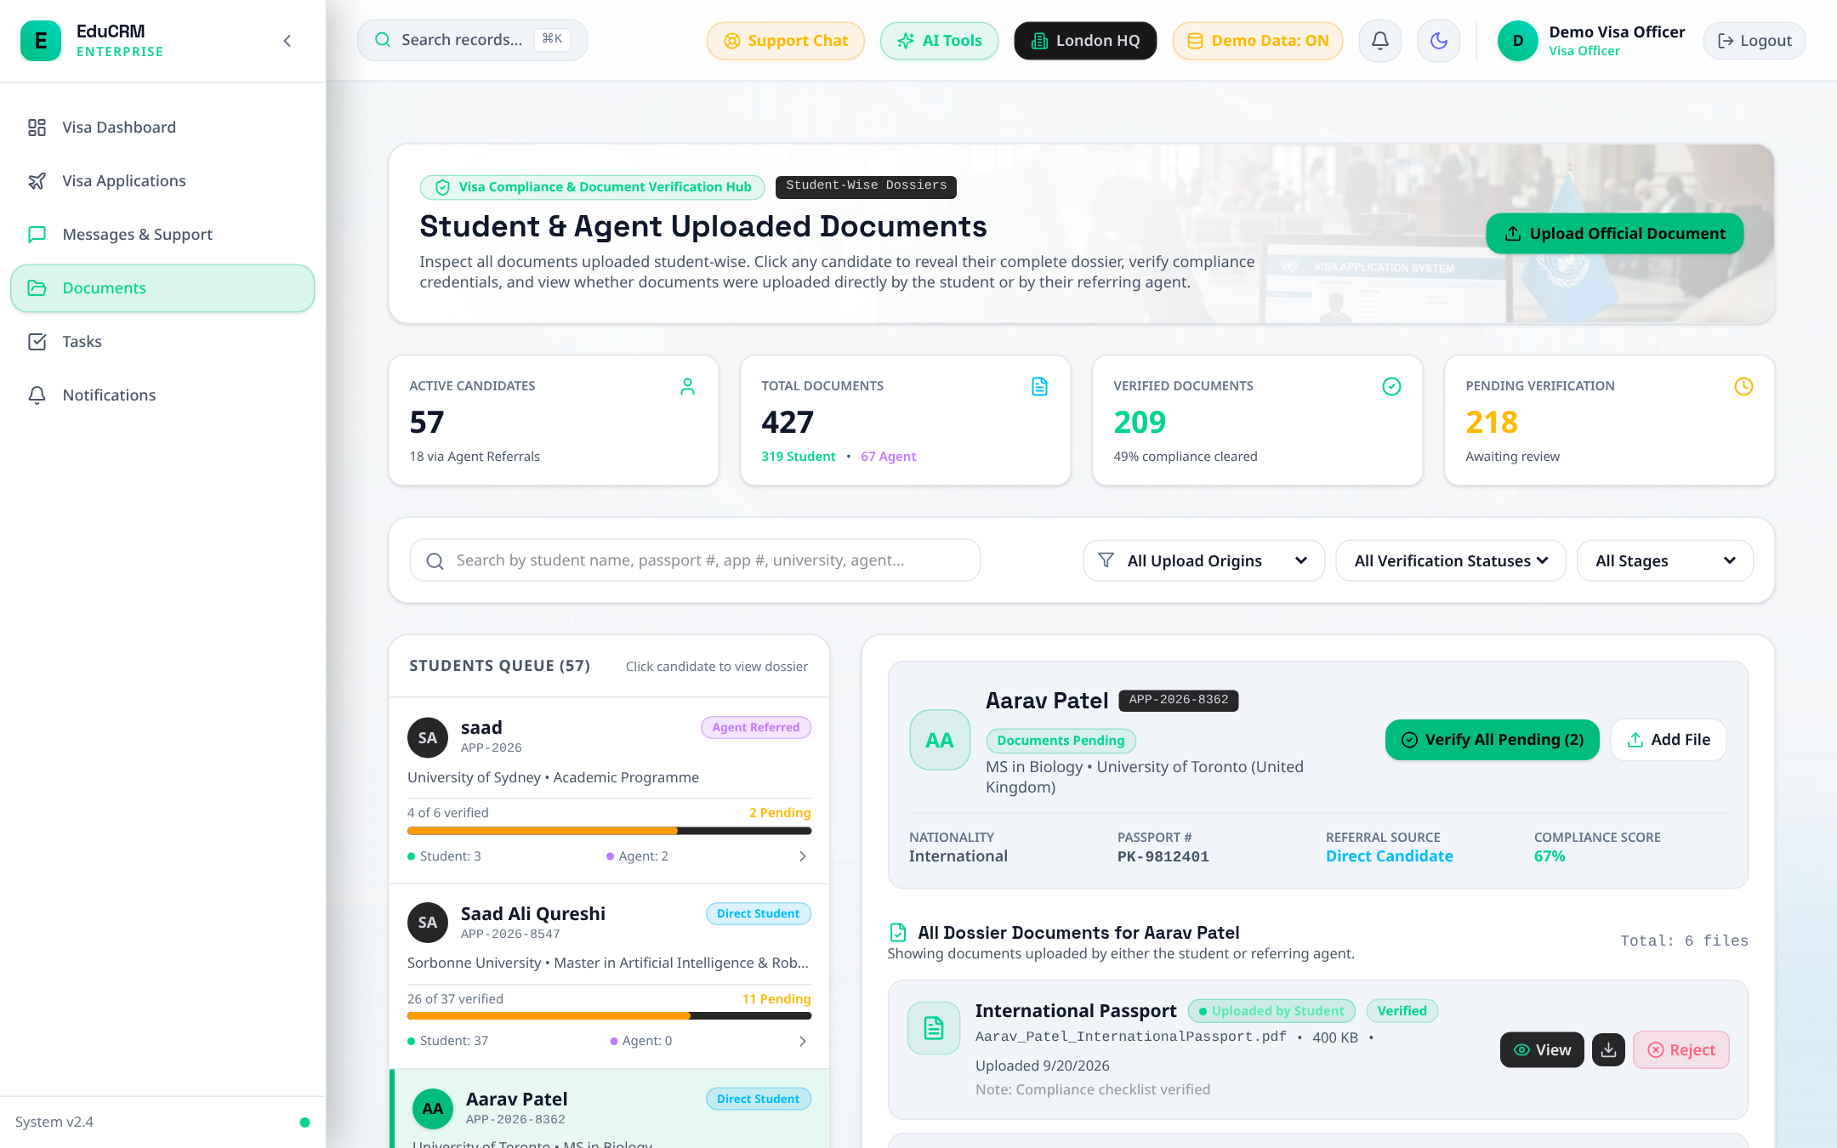
Figure: Visa Documents Hub — 28-Day Proof of Funds Audit, TB Clearance, and Mock Interview Scheduling

FLOW 8: Finance — Tuition Invoicing, Wire Reconciliation & Commissions

Step 8.1: Finance Command Center
- Trigger: Fast Login: Click 'Finance' in Demo Accounts drawer.
- Route: URL: /finance/dashboard.
- Overview: Monitor gross invoiced tuition, outstanding receivables, and pending agent commission liabilities.
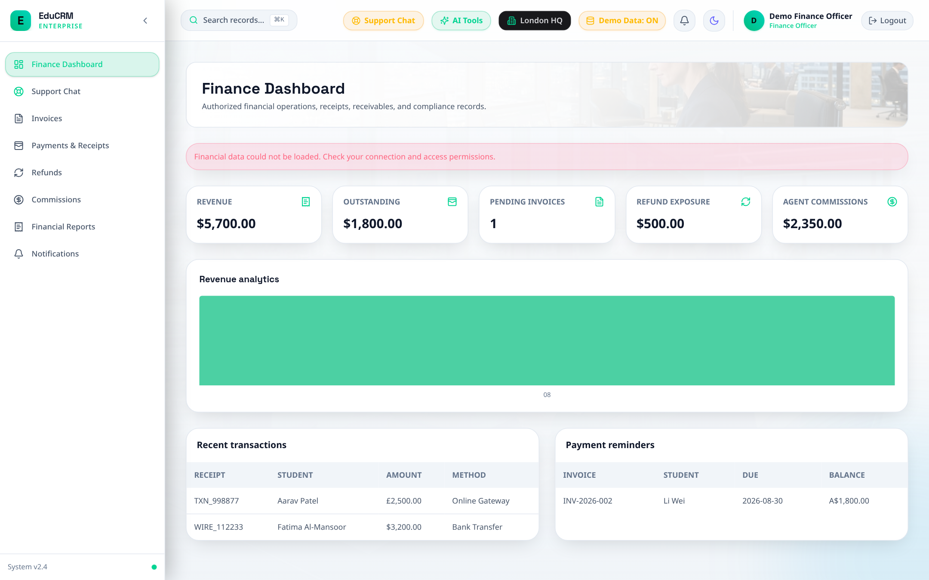
Figure: Finance Command Center — Invoiced Tuition, Receivables, and Commission Liabilities

Step 8.2: Invoicing & Fee Challan Generation
- URL: Access Route: /finance/invoices.
- Action: Click 'Create Invoice / Challan' for Aarav Patel. Select 'Tuition Deposit' (£2,000) and issue invoice.
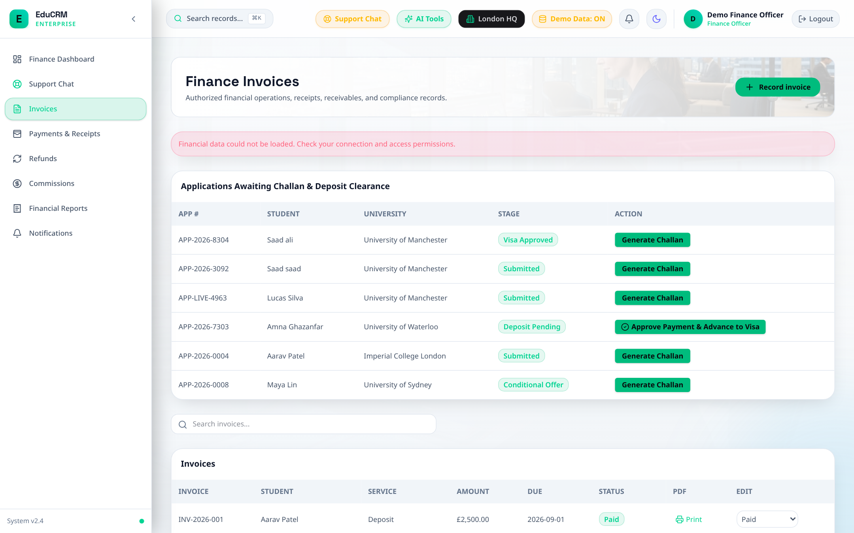
Figure: Finance Invoices & Fee Challan Generation Desk

Step 8.3: Wire Payment Reconciliation & Receipts
- URL: Access Route: /finance/payments.
- Action: Record bank wire payment with transaction reference WIRE-2026-98124. Invoice status transitions to 'Paid'.
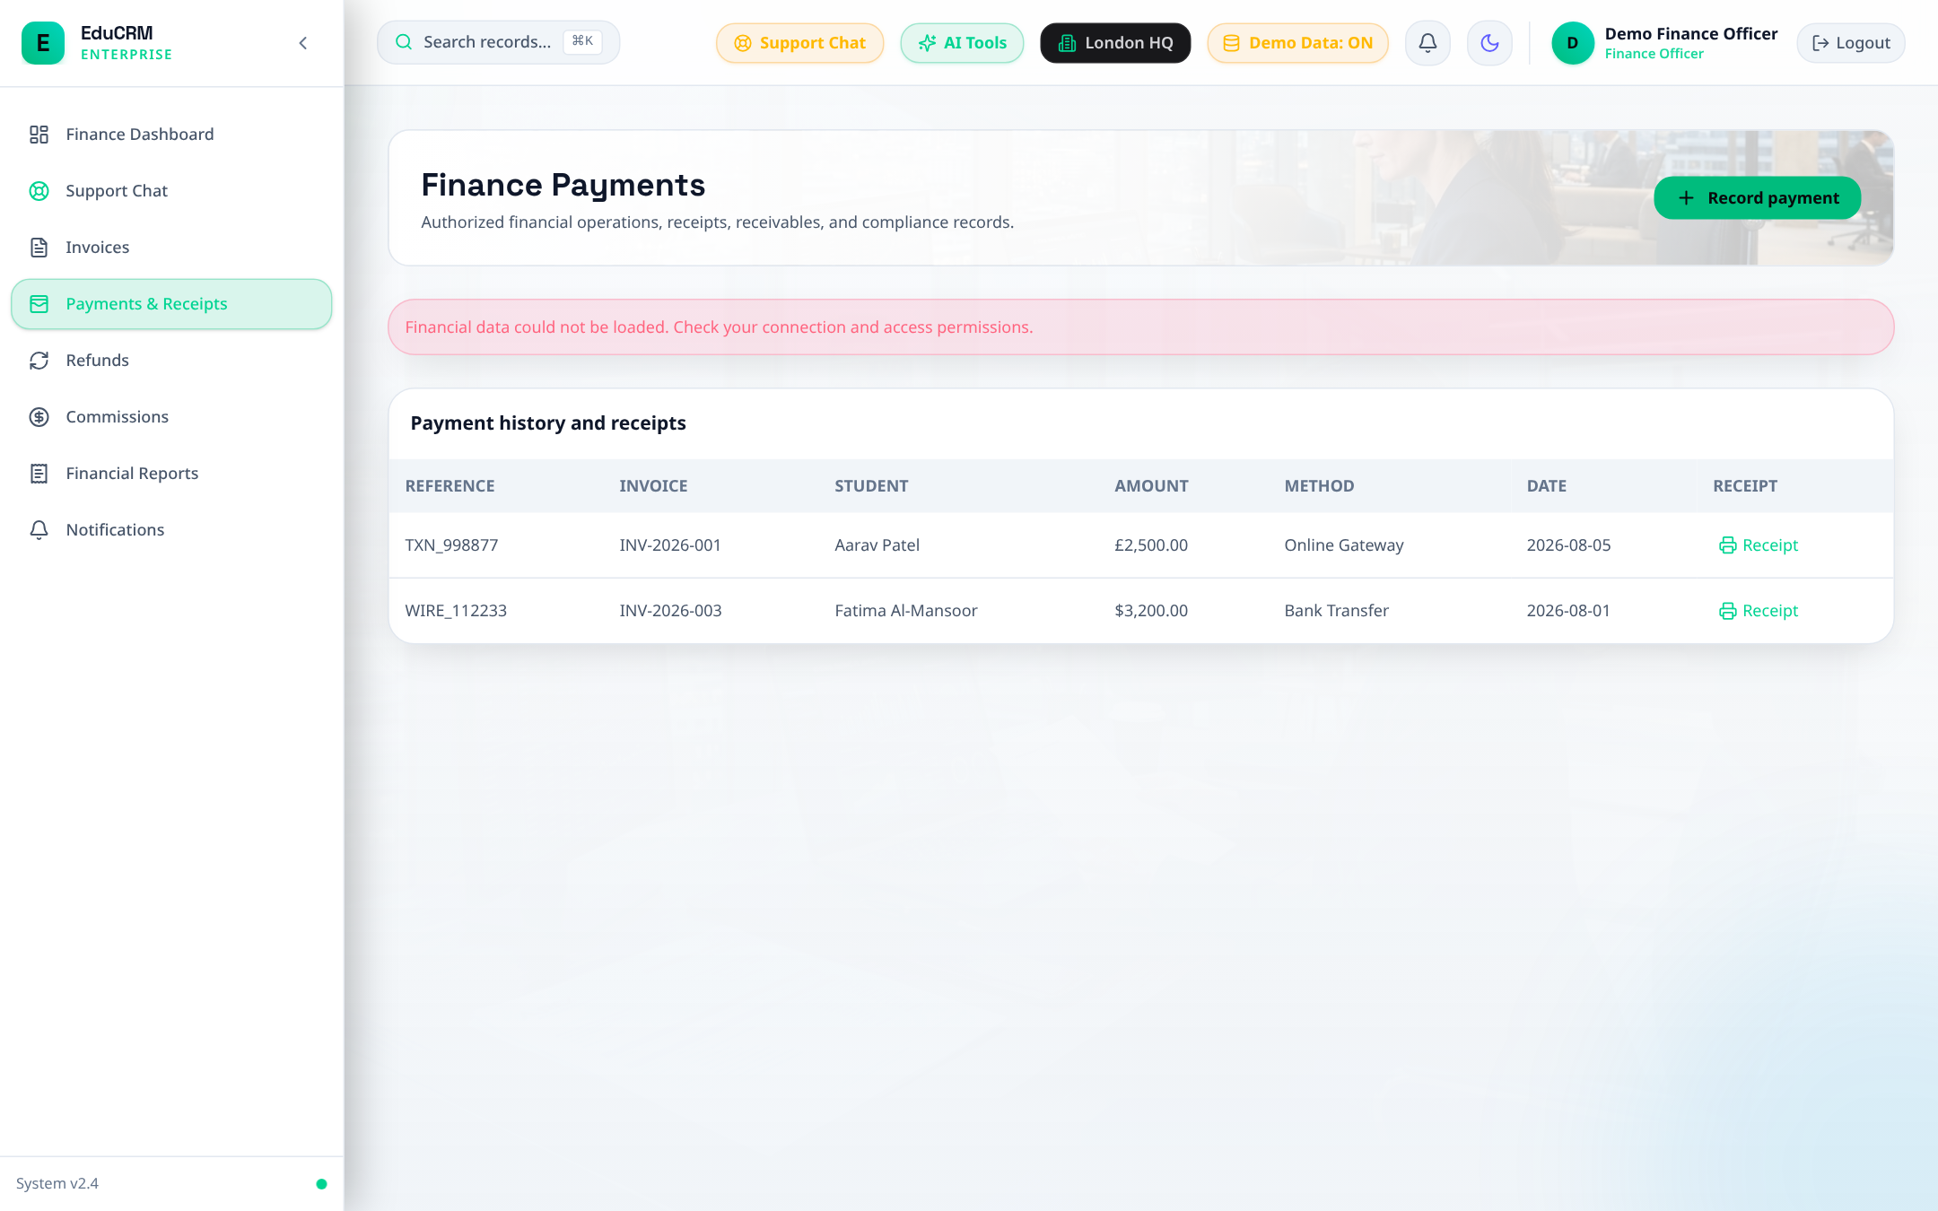
Figure: Finance Payment Reconciliation and Wire Transfer Receipt Generation

Step 8.4: External Agent Commission Settlement
- URL: Access Route: /finance/commissions.
- Action: Audit verified student enrollments tagged to external recruitment agents. Calculate 10-15% commission tier and record disbursement.
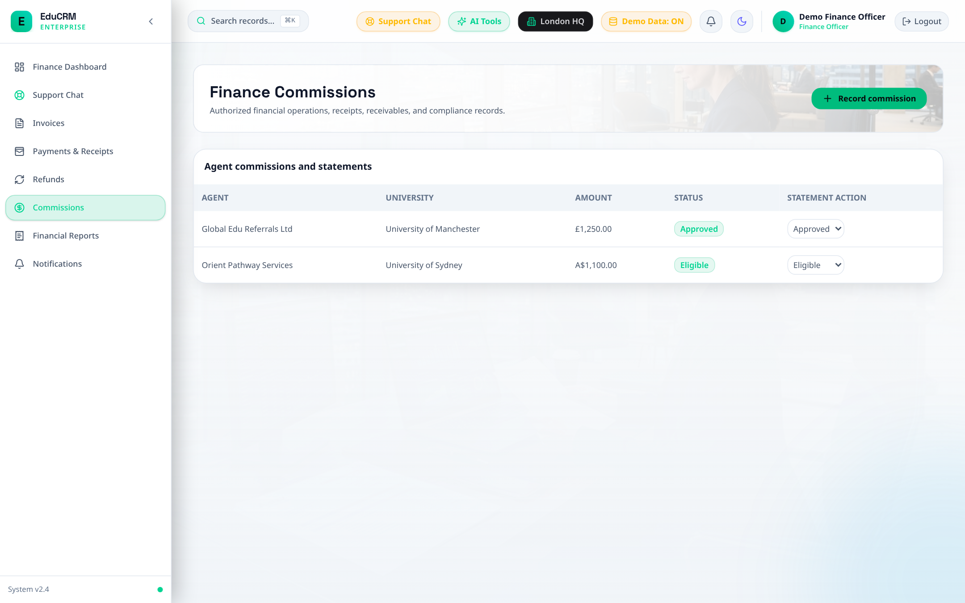
Figure: Finance Commission Settlement Ledger for Recruitment Agency Partners

FLOW 9: External Agent — Referral Ingestion, Pipeline & Commissions

Step 9.1: Agent Command Center
- Trigger: Fast Login: Click 'Agent' in Demo Accounts drawer.
- Route: URL: /agent/dashboard.
- Overview: View unique referral link/code (EDU-AGENT-778), active referrals, enrolled students, and commission ledger balance.
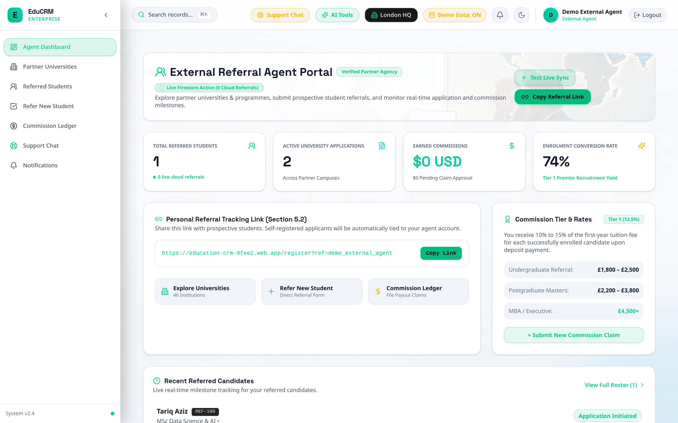
Figure: External Agent Command Center — Referral Code, Active Pipeline, and Earnings Balance

Step 9.2: Submit Candidate Referral
- URL: Access Route: /agent/refer-lead.
- Action: Submit student lead (Zainab Malik, UK destination). Lead is tagged with agent code and ingested into admissions queue.
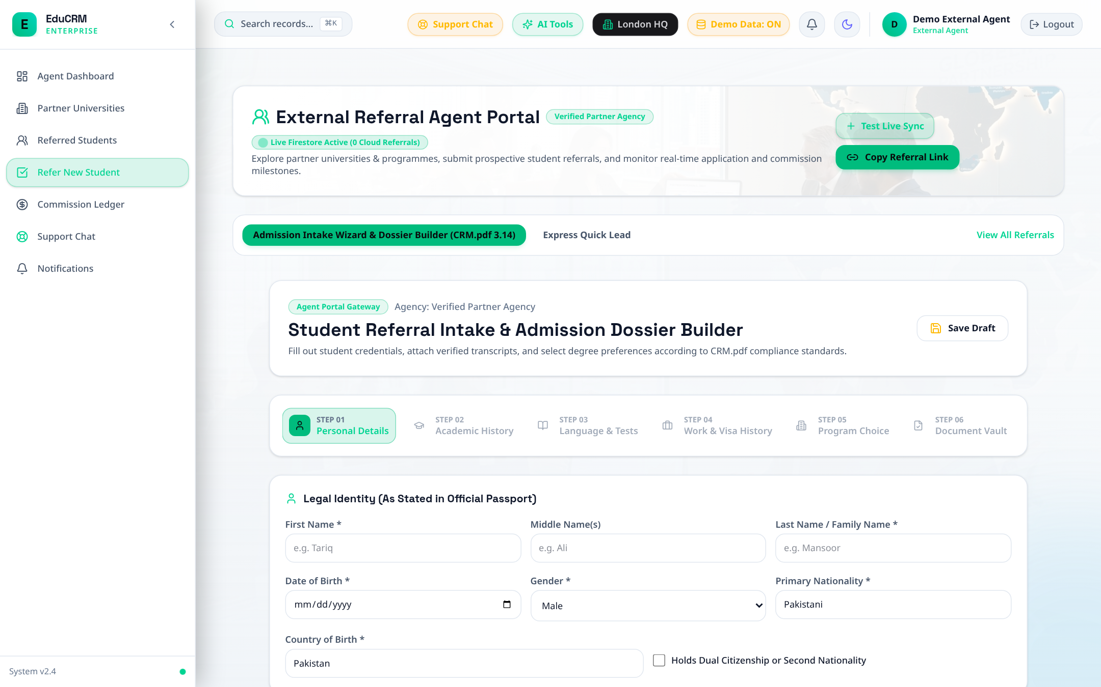
Figure: External Agent Lead Referral Submission Form

Step 9.3: Referral Pipeline Tracking (Privacy-Preserving)
- URL: Access Route: /agent/referrals.
- Action: Track student progress (Lead to Applied to Offer to Enrolled) without breaching student confidential records.
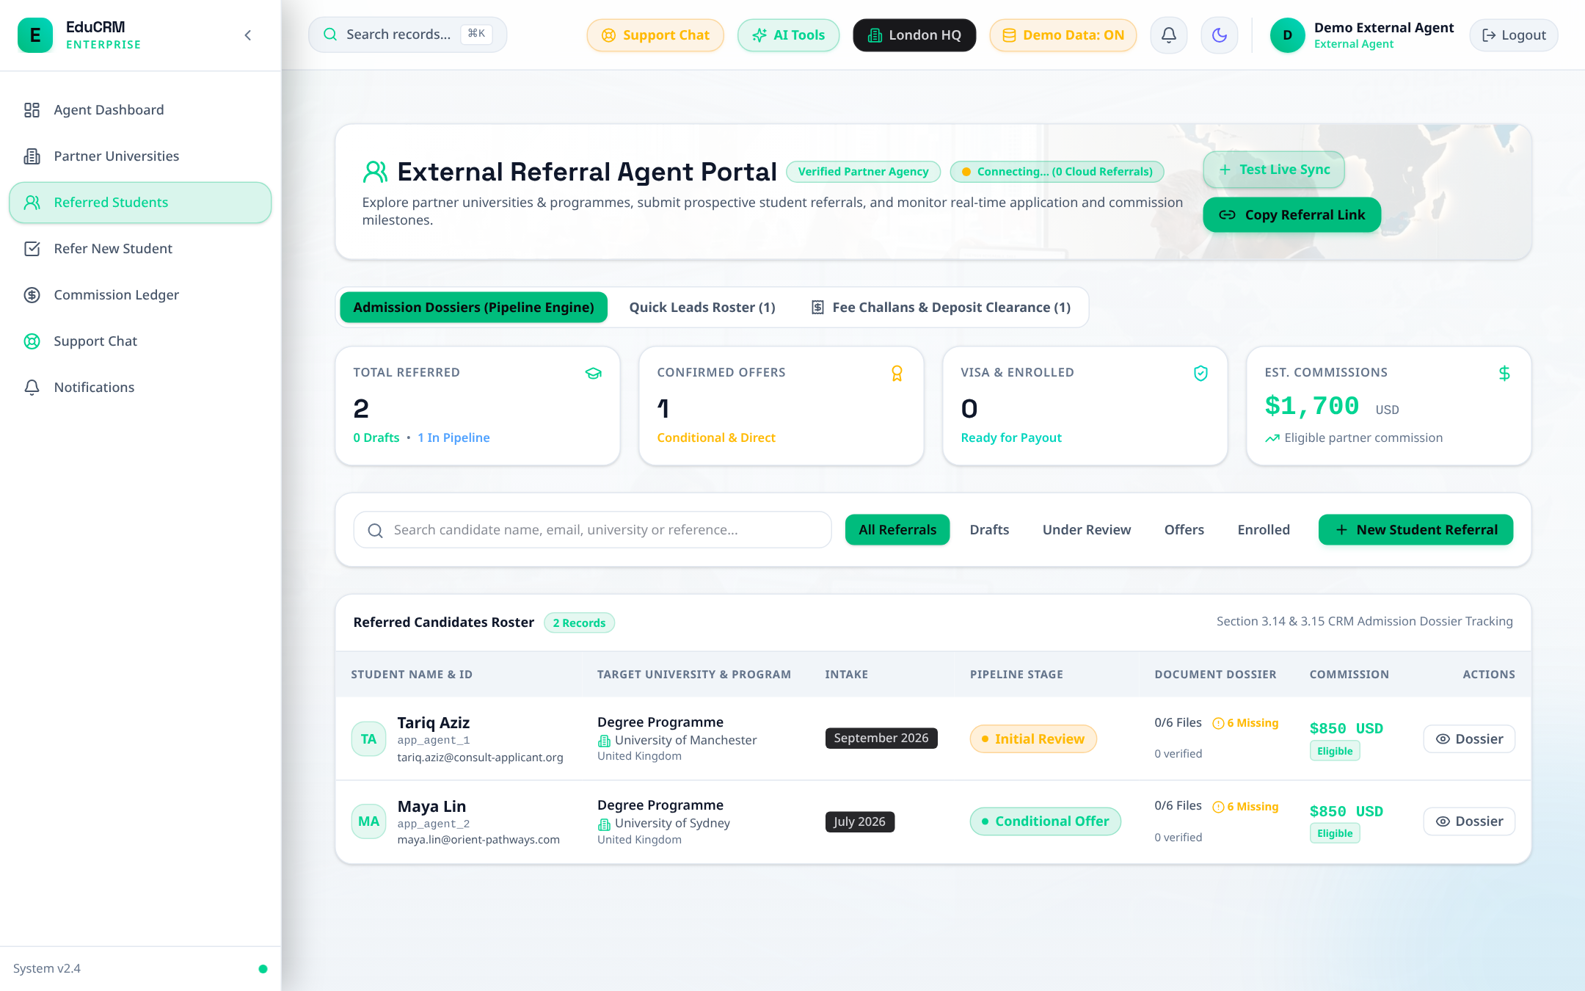
Figure: External Agent Referral Status Pipeline Tracker

Step 9.4: Agent Commission Statement
- URL: Access Route: /agent/commissions.
- Action: Audit approved commissions, pending invoice verifications, and historical payout disbursements.
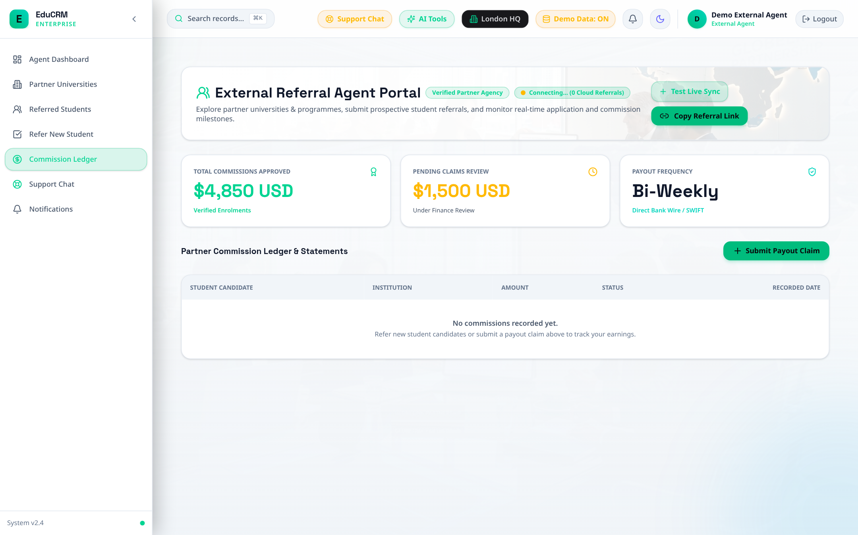
Figure: External Agent Commission Statement and Payout Ledger

FLOW 10: University Partner — Application Assessment & Direct CAS Issuance

Step 10.1: Institutional Partner Dashboard
- Trigger: Fast Login: Click 'University' in Demo Accounts drawer.
- Route: URL: /university/dashboard.
- Overview: Review applicants received from EduCRM partner agency network, categorized by campus and intake season.
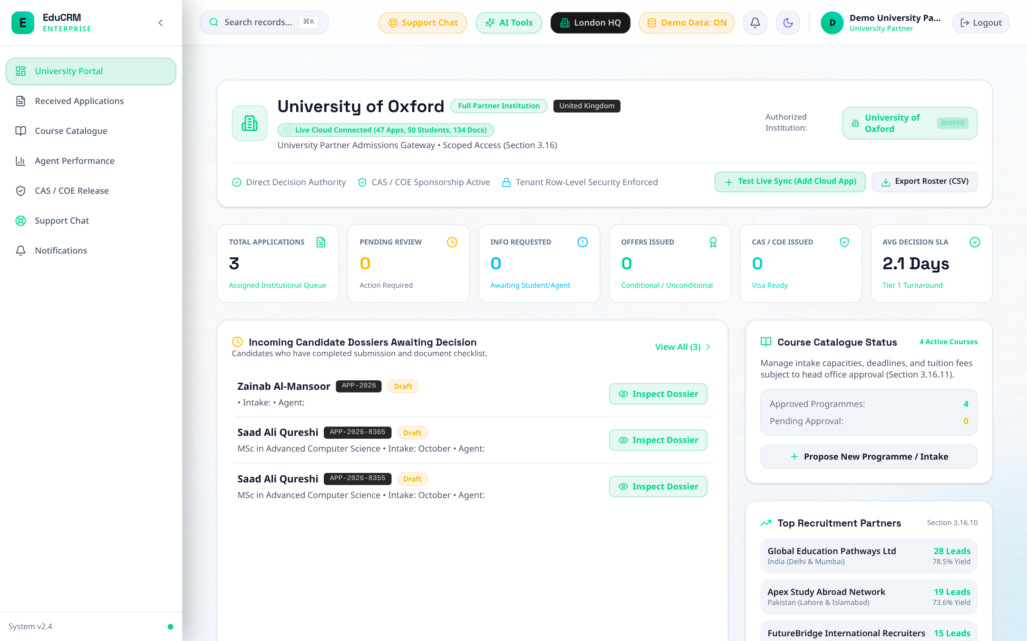
Figure: University Partner Dashboard — Applicant Throughput from Agency Network

Step 10.2: Review Candidate Applications & Dossiers
- URL: Access Route: /university/applications.
- Action: Inspect candidate academic credentials and download verified document package (transcripts, IELTS score, passport).
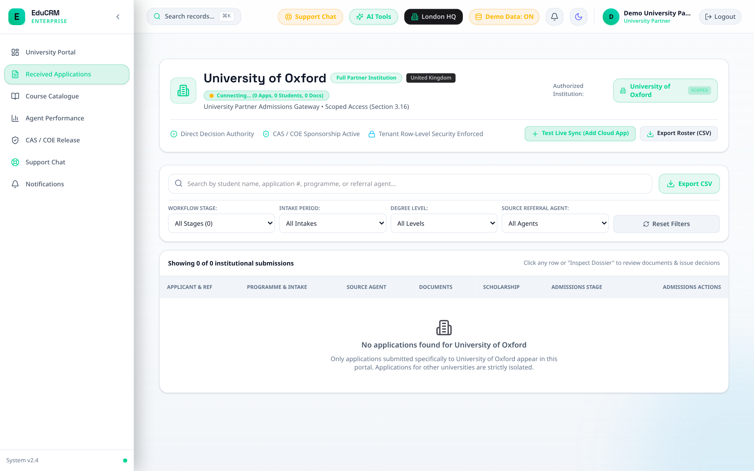
Figure: University Partner Applications Review and Candidate Credential Assessment

Step 10.3: Direct CAS / I-20 Document Issuance
- URL: Access Route: /university/cas-issuance.
- Action: Upload official Confirmation of Acceptance for Studies (CAS) / I-20 clearance document for unconditional offer holders.
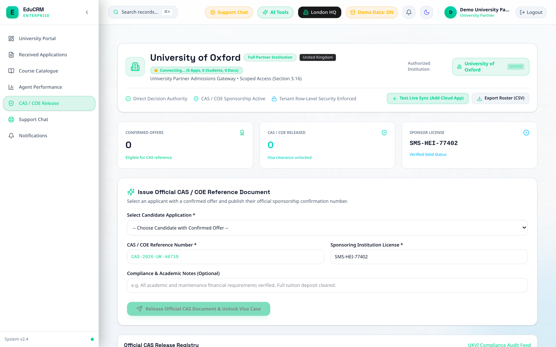
Figure: University Direct CAS / I-20 Document Issuance and Visa Clearance Upload

FLOW 11: Support Specialist — Ticketing Desk & Knowledge Base

Step 11.1: Support Command Center
- Trigger: Fast Login: Click 'Support' in Demo Accounts drawer.
- Route: URL: /support/dashboard.
- Overview: Monitor open ticket volume, resolution times, and urgent escalation queues.
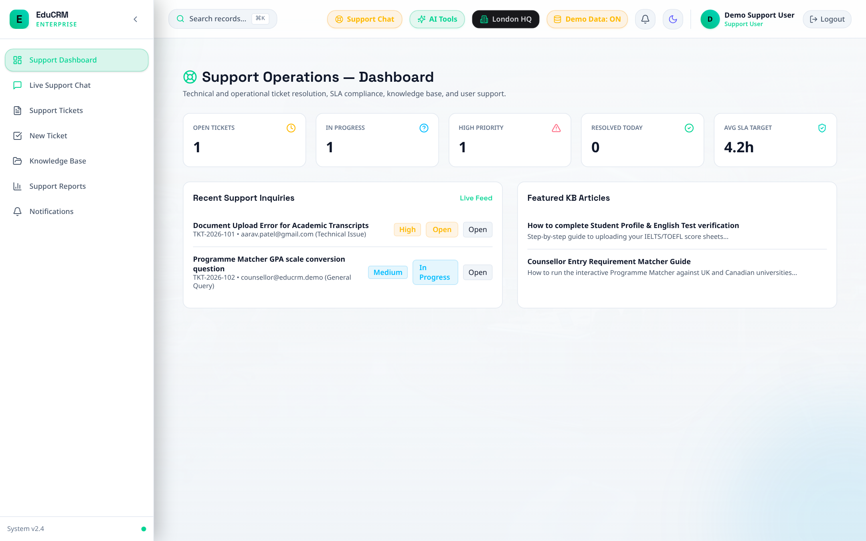
Figure: Support Command Center — Ticket Volume, Resolution Times, and Escalation Queues

Step 11.2: Ticket Management & SLA Resolution
- URL: Access Route: /support/tickets.
- Action: Filter by priority (Critical, High, Medium, Low). Reply to student or agent inquiries and mark as Resolved.
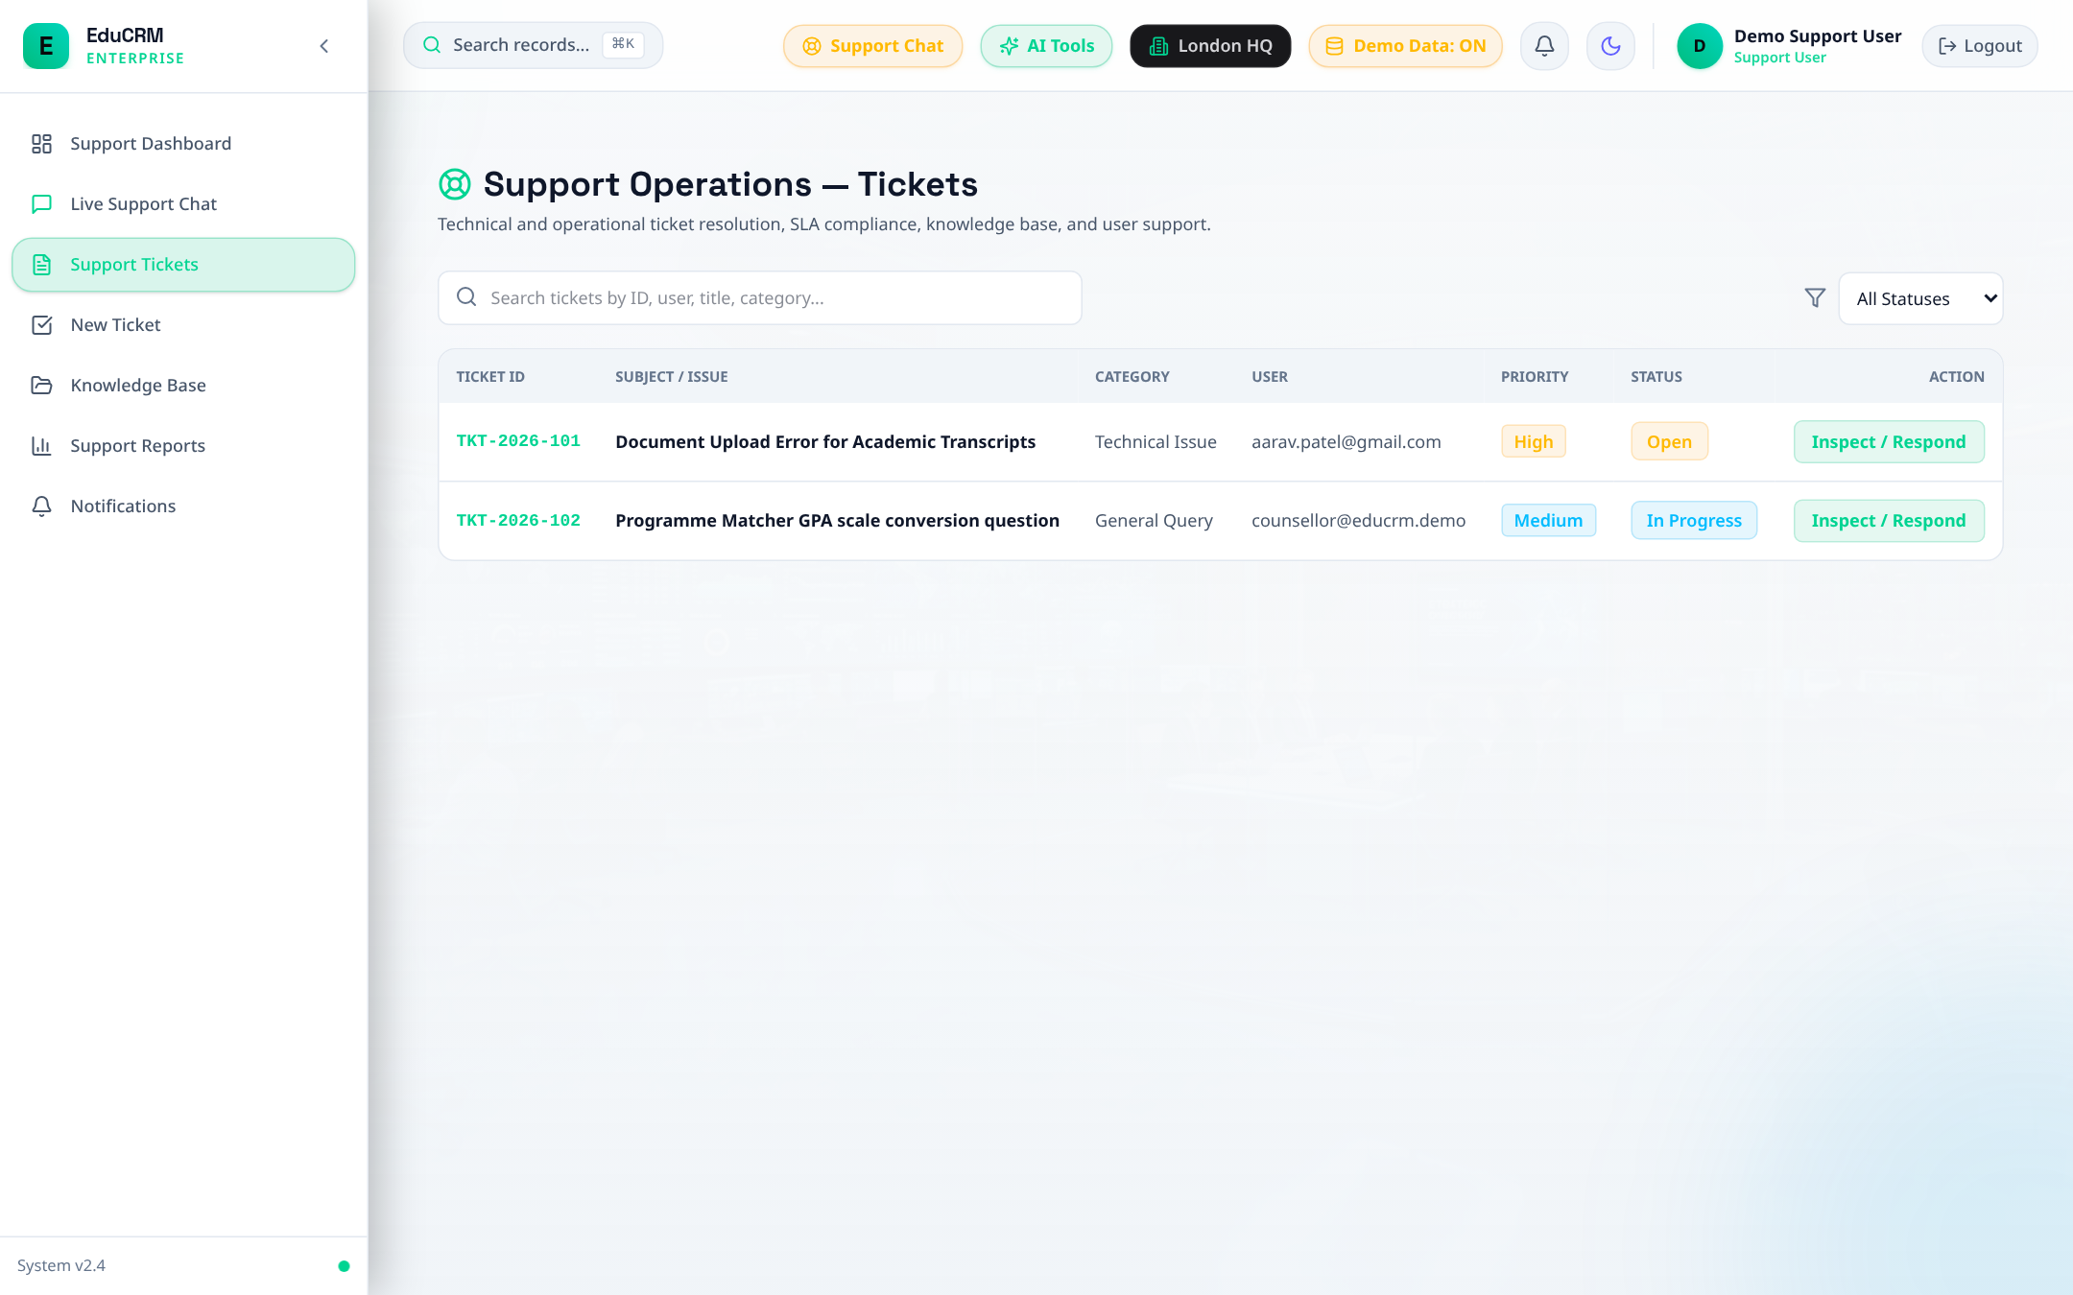
Figure: Support Tickets Management Desk and SLA Priority Queue

Step 11.3: Knowledge Base & FAQ Curation
- URL: Access Route: /support/knowledge-base.
- Action: Curate and publish self-service support documentation on visa requirements, IELTS thresholds, and fee challans.
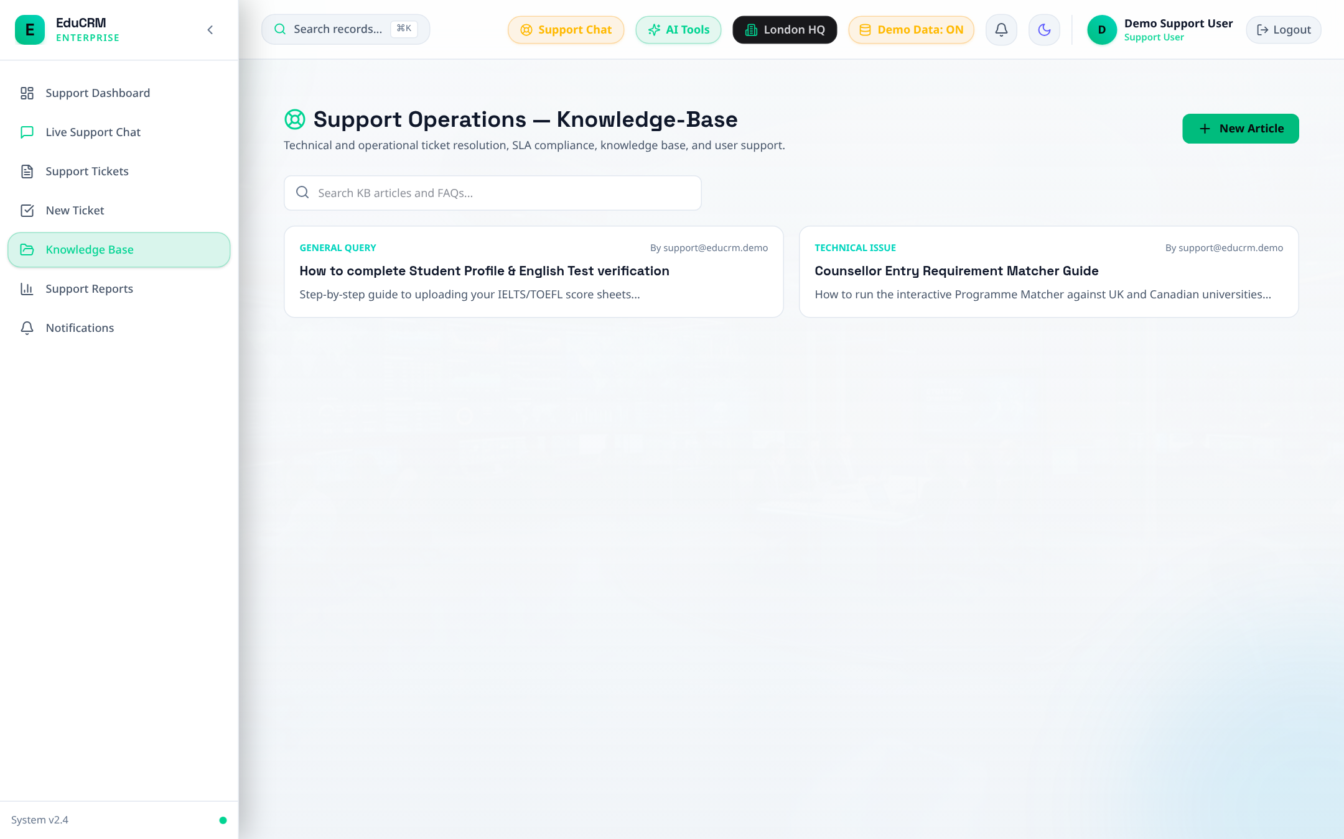
Figure: Support Knowledge Base and Self-Service FAQ Documentation Repository

FLOW 12: Super Admin, Org Admin & Auditor — Governance & Forensics

Step 12.1: Platform Super Admin Global Command Center
- Trigger: Fast Login: Click 'Super Admin' in Demo Accounts drawer.
- Route: URL: /super-admin/dashboard.
- Overview: Inspect global system health, branch office licenses, and tenant database performance.
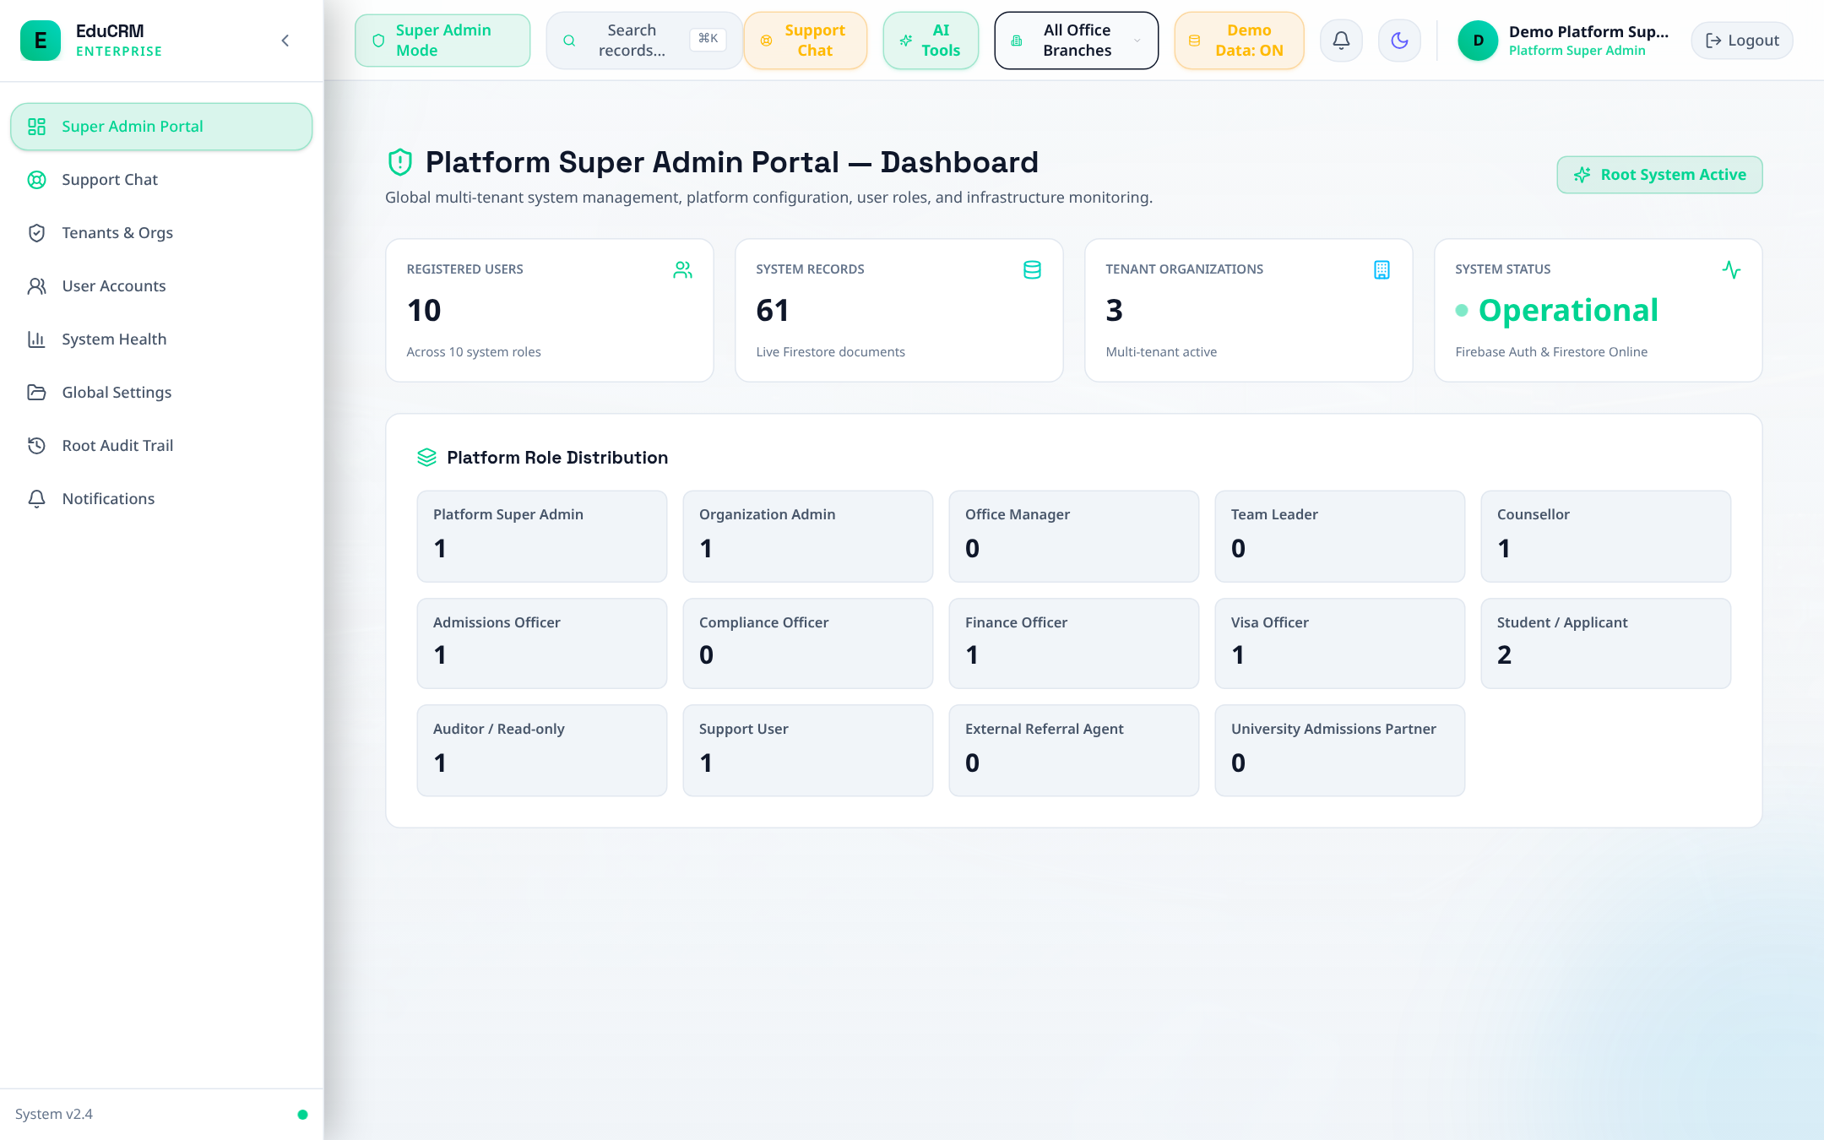
Figure: Platform Super Admin Command Center — Global System Health and Tenant Oversight

Step 12.2: Multi-Tenant Branch Management
- URL: Access Route: /super-admin/tenants.
- Action: Manage regional branch hubs (London HQ, Delhi Hub, Lahore Regional Desk) with strict tenant isolation.
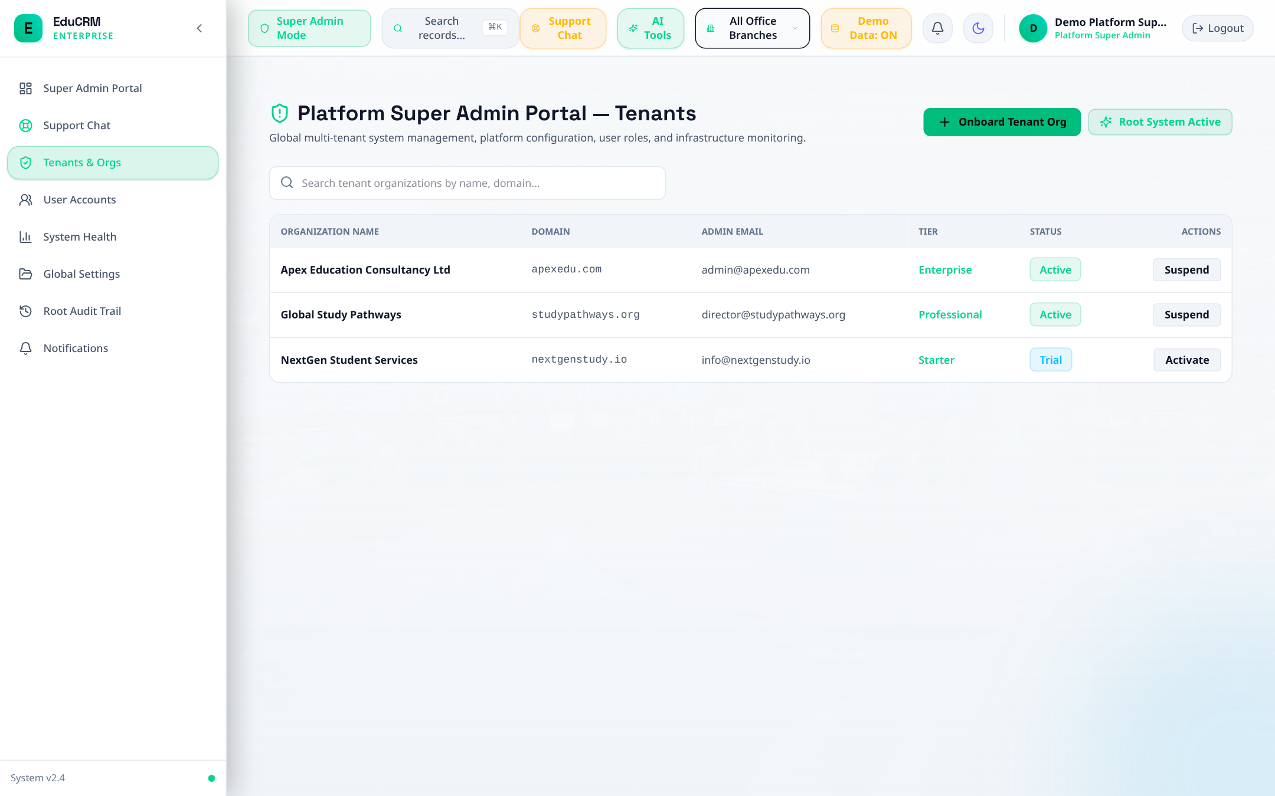
Figure: Super Admin Multi-Tenant Branch Management and Subscription Tiers

Step 12.3: User Provisioning Across 13 RBAC Tiers
- URL: Access Route: /super-admin/users.
- Action: Provision or update staff permissions across all 13 supported RBAC categories with real-time route guarding.
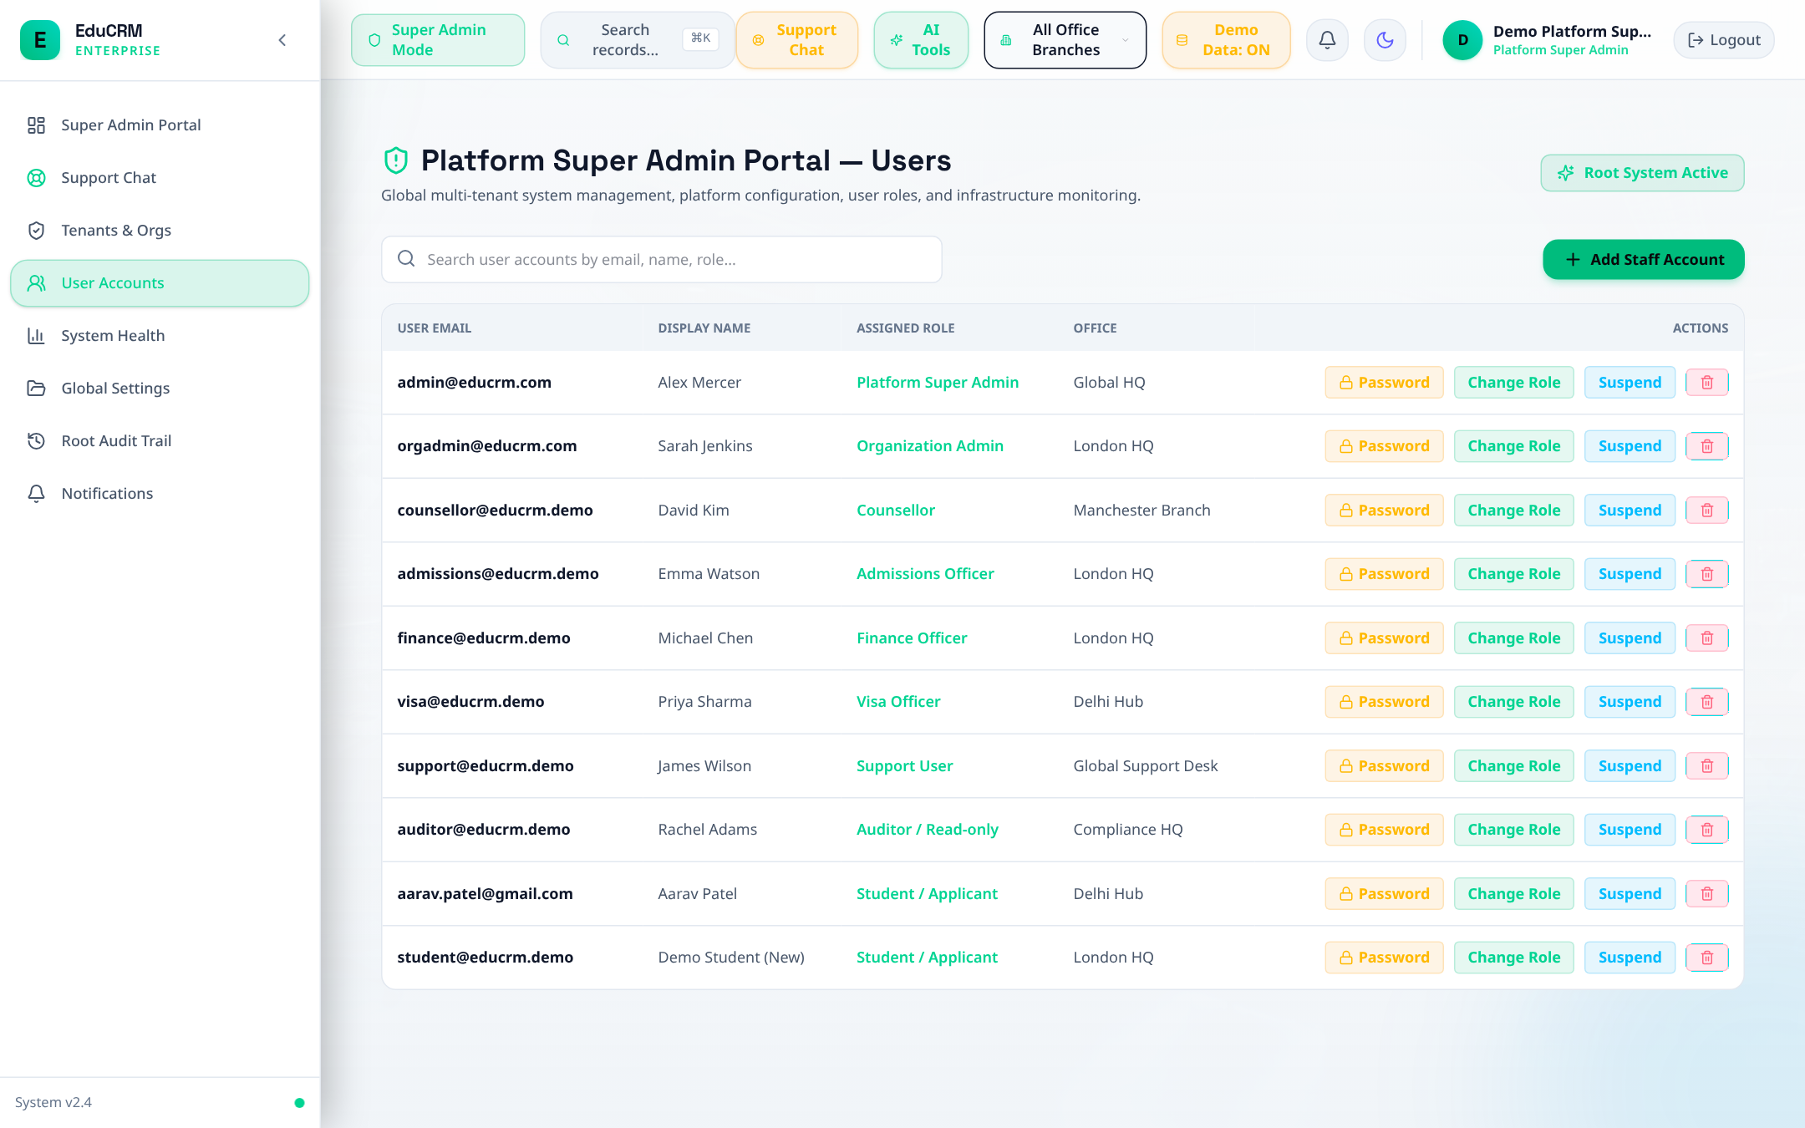
Figure: Super Admin User Access Provisioning across 13 RBAC Tiers

Step 12.4: Commission Rules Manager (Org Admin)
- Trigger: Fast Login: Click 'Org Admin' in Demo Accounts drawer.
- Route: URL: /commission-manager.
- Action: Configure agent commission percentages based on destination country, university tier, and intake term.
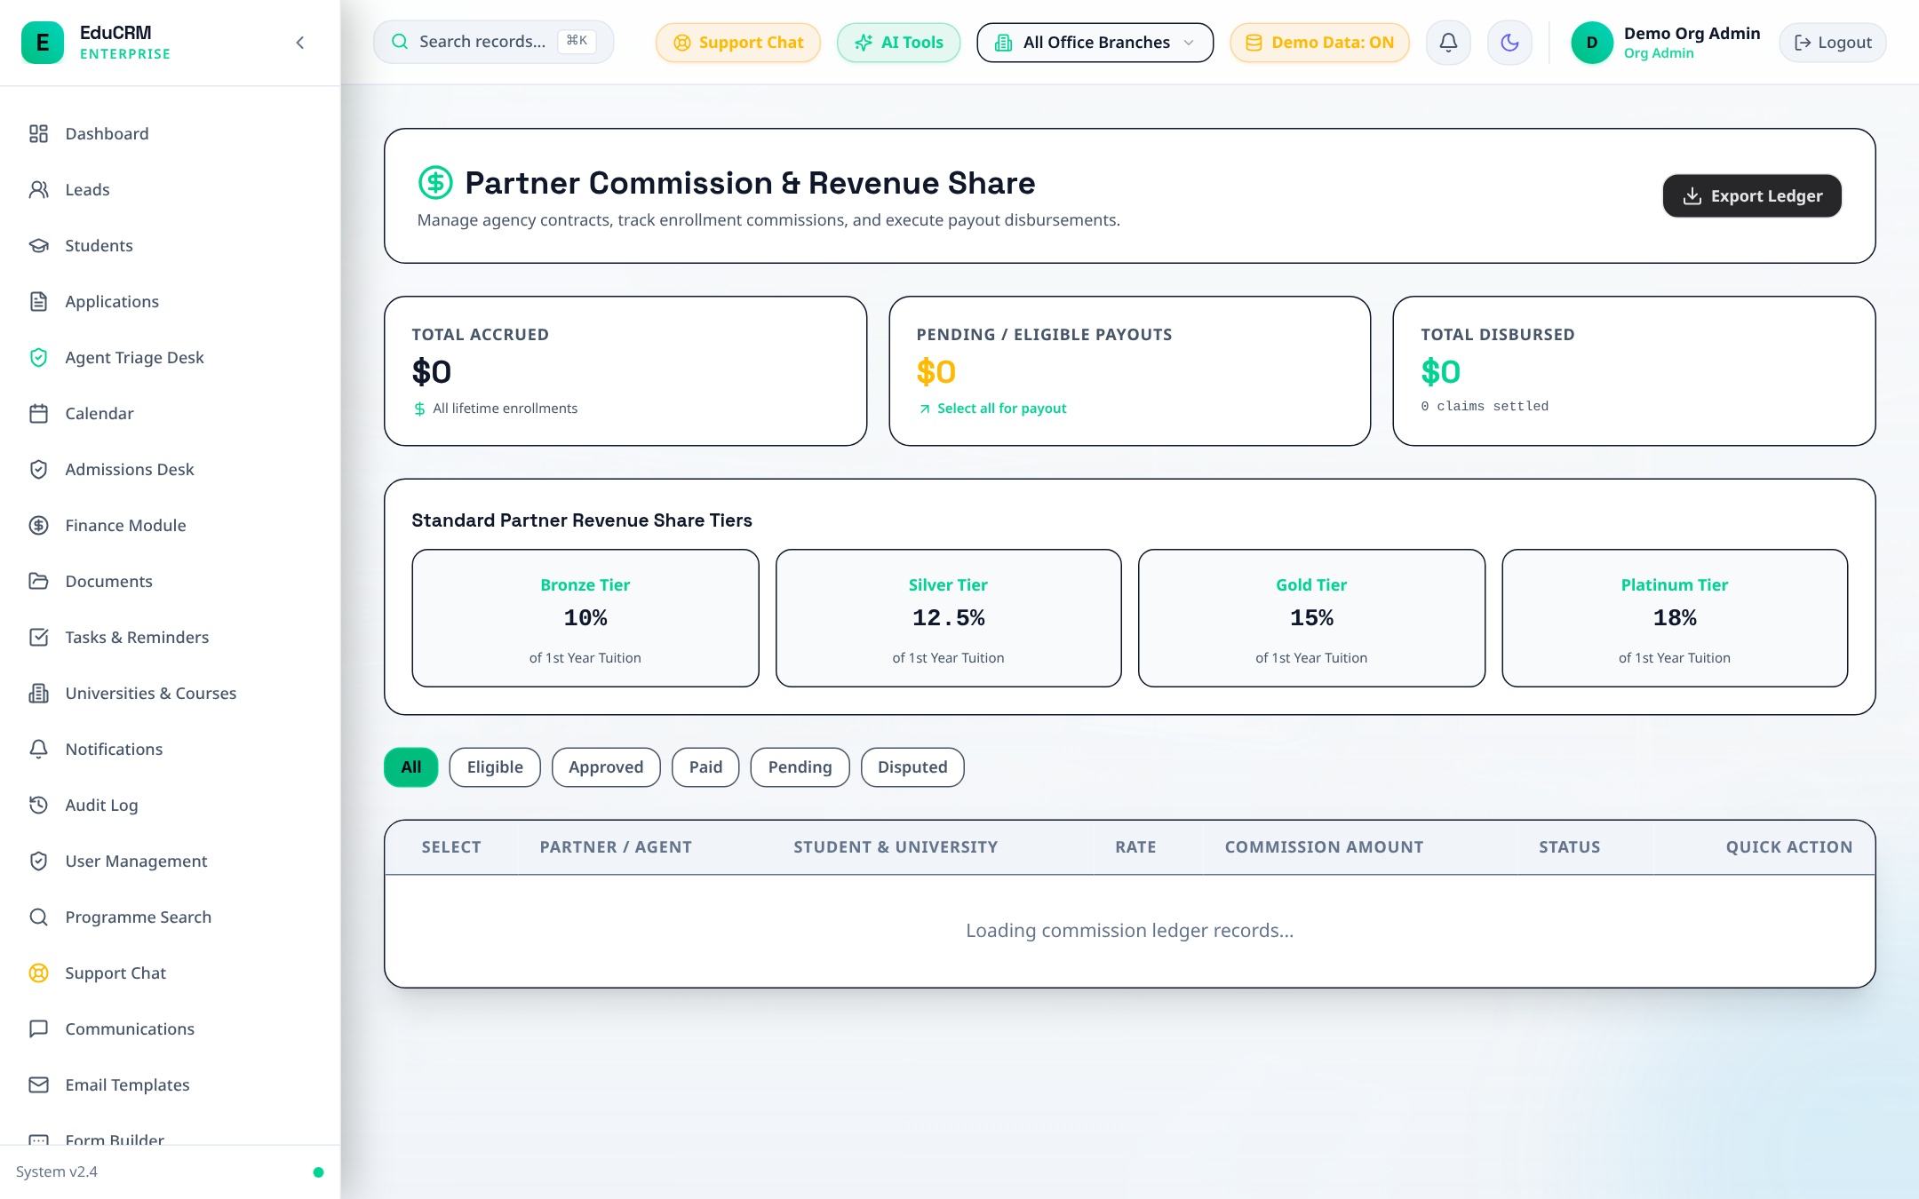
Figure: Organization Admin Commission Rules and Payout Tier Configuration

Step 12.5: AI Lead Scoring Configuration Engine
- URL: Access Route: /lead-scoring.
- Action: Adjust algorithmic score weights for budget readiness, response velocity, and academic qualifications.
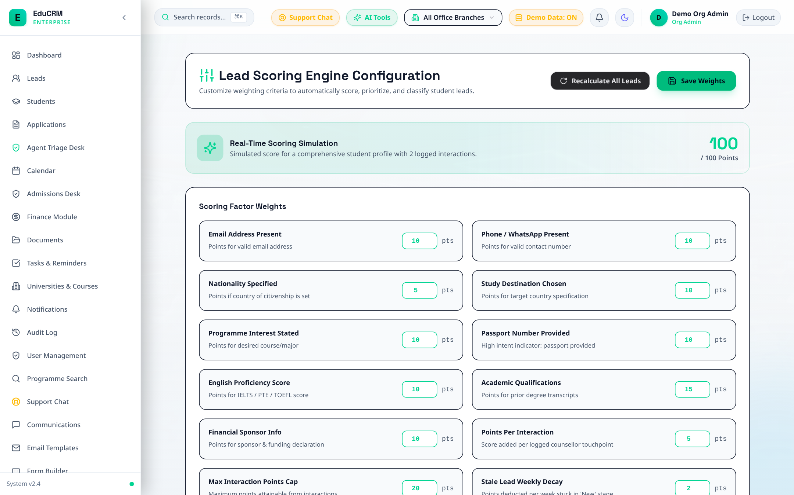
Figure: AI Lead Scoring Configuration Engine and Behavioral Weight Matrix

Step 12.6: Data Quality & Deduplication Dashboard
- URL: Access Route: /data-quality.
- Action: Audit profile completeness, identify invalid phone numbers, and resolve duplicate prospective leads.
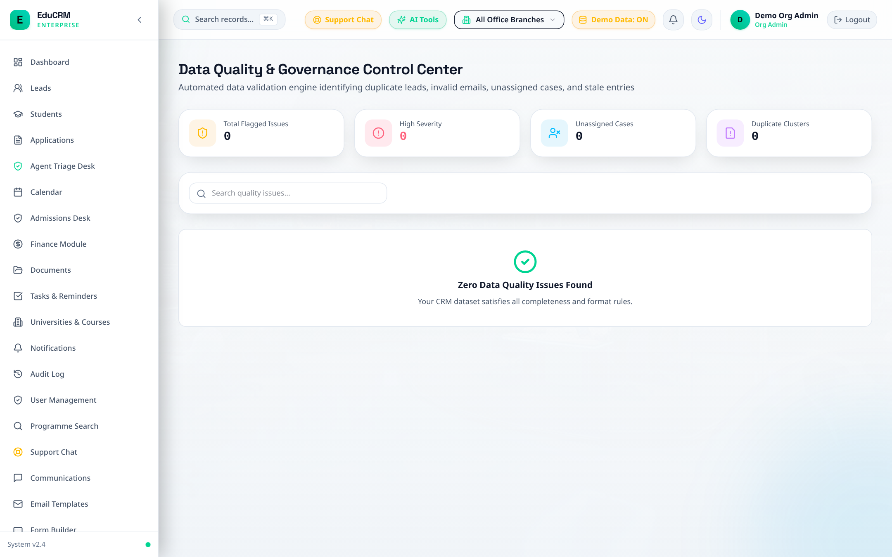
Figure: Data Quality & Record Deduplication Dashboard

Step 12.7: Immutable Audit Trail & Regulatory Compliance
- Trigger: Fast Login: Click 'Auditor' in Demo Accounts drawer.
- Route: URL: /auditor/audit-trail.
- Forensics: Audit events (APPLICATION_STAGE_CHANGED, DOCUMENT_VERIFIED, OFFER_ISSUED). Every entry records actor ID, role, previous value, new value, IP address, and cryptographic timestamp.
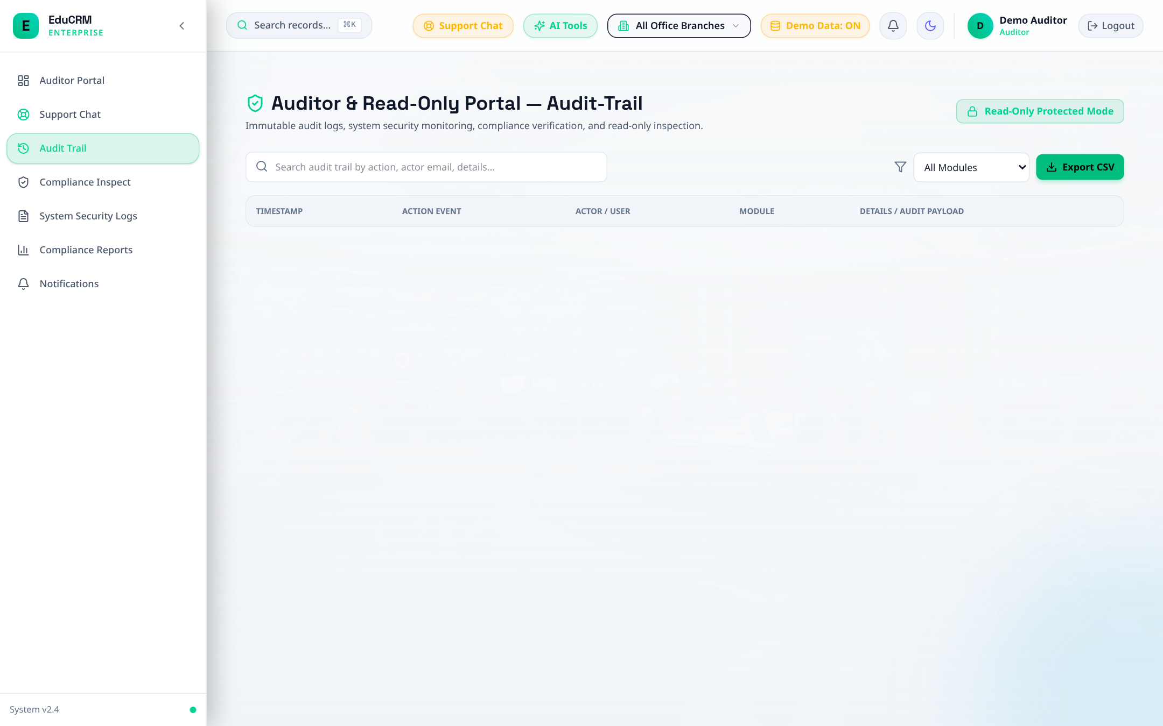
Figure: Auditor Immutable Audit Trail — Tamper-Evident System Event Forensics

Step 12.8: GDPR Compliance & Right-to-be-Forgotten Inspection
- URL: Access Route: /auditor/compliance-inspect.
- Action: Inspect GDPR consent logs, data deletion requests, and privacy consent tracking.
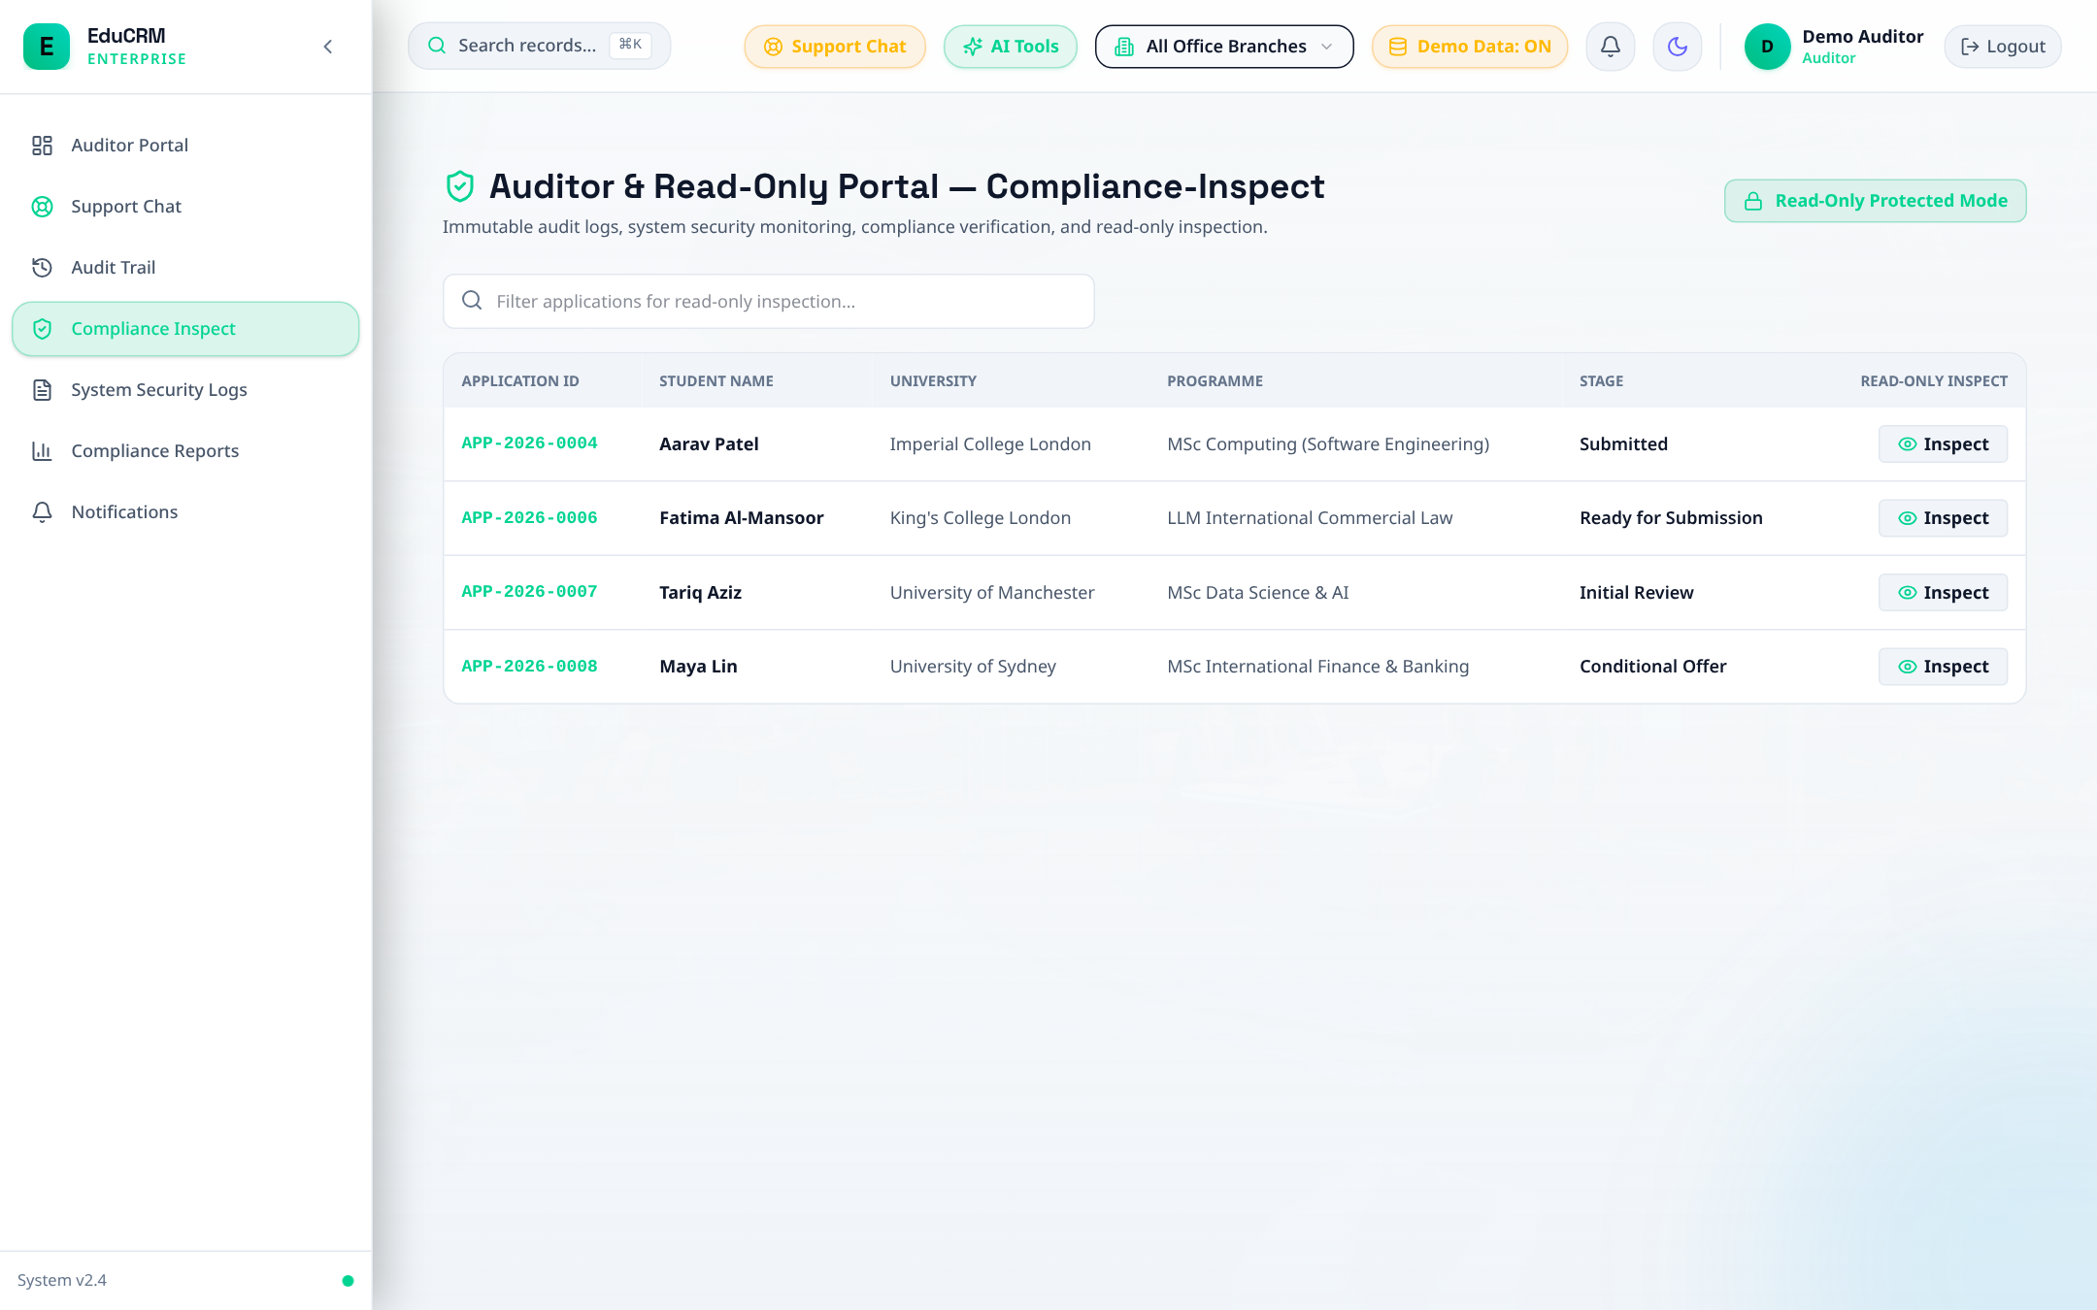
Figure: Auditor Compliance Inspection — GDPR Consent Records and Data Privacy Logs

Step 12.9: Forensic System Logs
- URL: Access Route: /auditor/system-logs.
- Action: Inspect application exception logs, authentication failures, and API status monitoring.
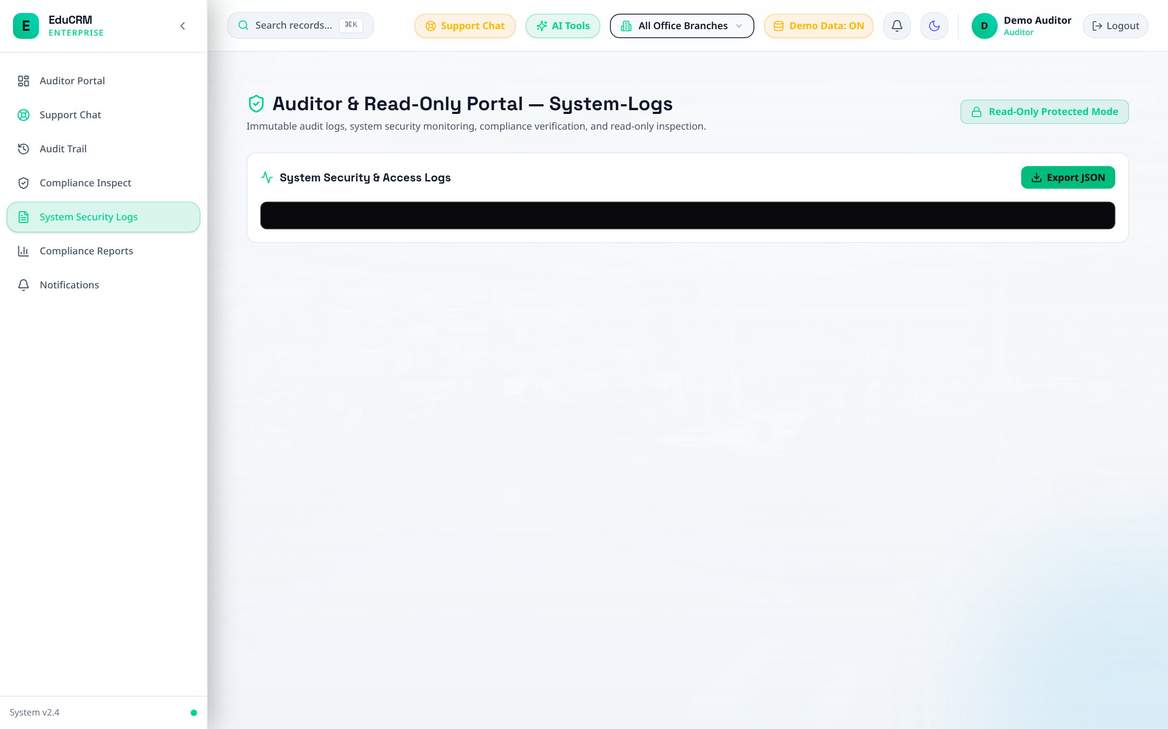
Figure: Auditor Forensic System Logs and Security Event Monitoring

13. Master Instructor Evaluation Rubric & Sign-Off Checklist
Instructors and evaluators can verify each milestone against the live system and mark their assessment:
Milestone | Evaluated Role | Core System Capability Verified | Status
Milestone 1 | Student (New) | Google Gemini AI CV Extractor, Zero-Redundancy 4-Stage Onboarding | PASSED [x]
Milestone 2 | Student (Reg) | Course Catalog Search, Entry Criteria Benchmark, 11-Step Wizard | PASSED [x]
Milestone 3 | Student (Vault) | Document Vault KYC Verification, Fee Challans, Counsellor Chat | PASSED [x]
Milestone 4 | Counsellor | Lead Deduplication, 360° Student Dossier, Algorithmic Matcher | PASSED [x]
Milestone 5 | Admissions | Admissions Verification Hub, GPA/IELTS Audit, Conditional Offers | PASSED [x]
Milestone 6 | Team Leader | Team Workload Balancing, Application Reassignment, Counsellor SLAs | PASSED [x]
Milestone 7 | Visa Officer | 28-Day Proof of Funds Rule, TB Medical, Mock Visa Interview Prep | PASSED [x]
Milestone 8 | Finance | Tuition Challans, Wire Payment Reconciliation, Agent Commission Ledger | PASSED [x]
Milestone 9 | Agent | Lead Ingestion Form, Non-Disclosive Pipeline, Commission Statement | PASSED [x]
Milestone 10 | University | Agency Application Review, Document Package Download, CAS Upload | PASSED [x]
Milestone 11 | Support | Ticket SLA Resolution, Priority Escalation Desk, Knowledge Base FAQ | PASSED [x]
Milestone 12 | Admin & Auditor | 13-Tier RBAC Provisioning, Immutable Audit Trail, GDPR Forensics | PASSED [x]

Evaluator Signature: _______________________ Date: ______________ Evaluation Result: [ PASS / DISTINCTION ]

