JARVIS
Implementation Design Document
Local-first • Private • Modular • Free-only model routing
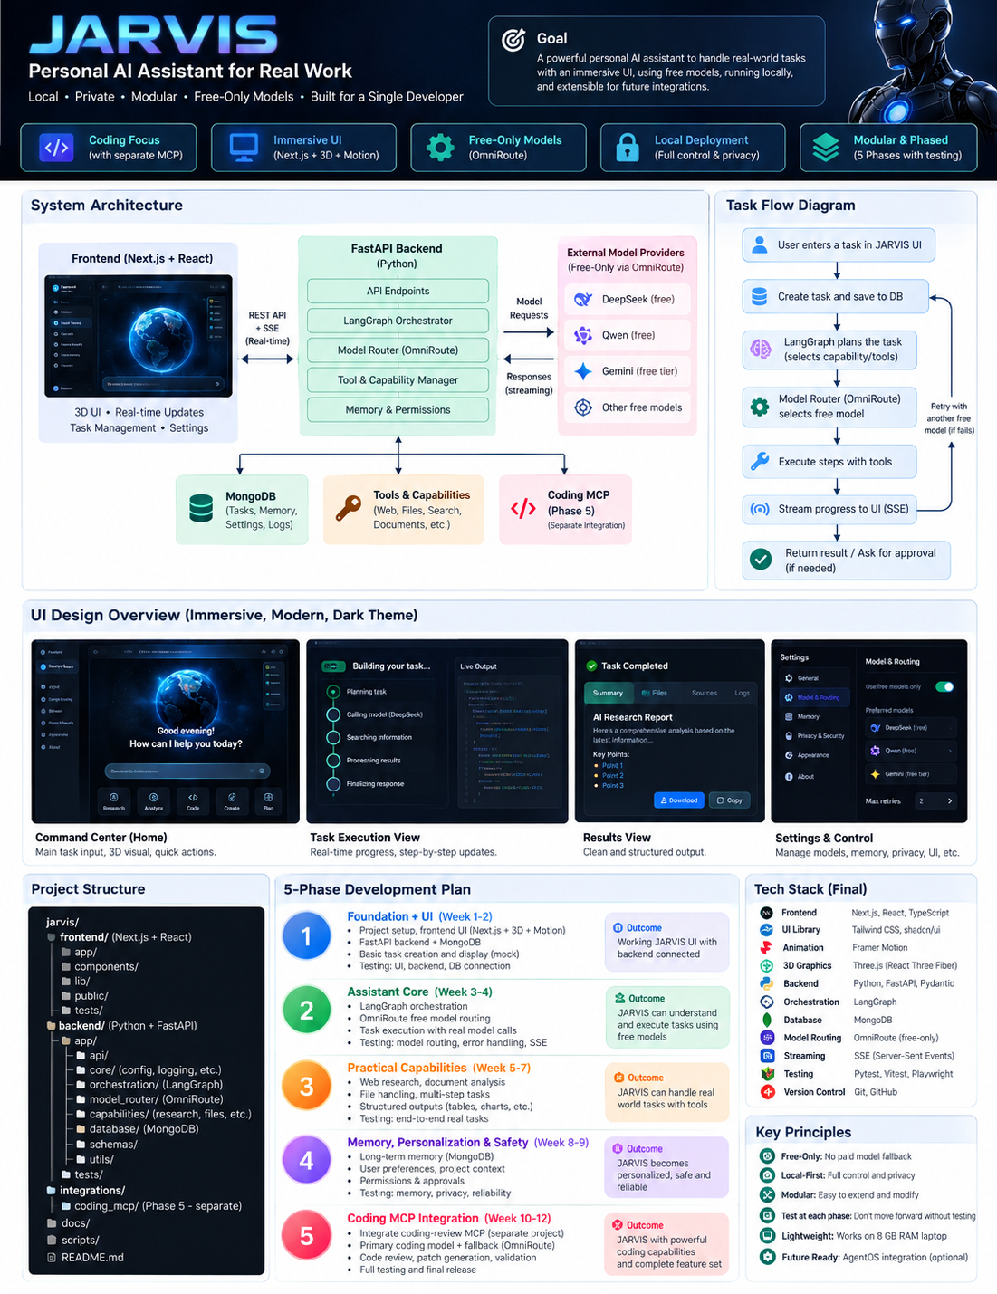
Proposed architecture • Five test-gated phases

1. Purpose and Scope
JARVIS is a general-purpose personal AI assistant that accepts natural-language requests, plans work, selects capabilities/tools, executes bounded steps and presents results in an immersive UI.

Goals
- Local-first UI, backend and database on the laptop; hosted models accessed through approved provider APIs.
- OmniRoute/provider adapter allows eligible free routes only; paid fallback is disabled.
- Modular capabilities; UI is built in Phase 1 and extended/tested in every phase.
- Persistent tasks and user-controlled memory, visible progress and approval for sensitive actions.
- Coding-review MCP is researched and tested separately, then integrated only in Phase 5.

Constraints / non-goals
- Target hardware: Intel i5, 8 GB RAM and about 90 GB free disk; no mandatory local LLM or fine-tuning.
- If all eligible free routes are unavailable, pause/report clearly rather than using a paid route.
- AgentOS integration is deferred until JARVIS is stable; A2A is out of scope initially.

2. Technology Stack
Layer | Technology | Responsibility
Frontend | Next.js App Router, React, TypeScript | Command center, tasks, settings, results
UI / motion | Tailwind CSS, shadcn/ui, Motion | Reusable components and animation
3D / charts | React Three Fiber + Drei; Recharts | Optional lightweight 3D and visualizations
Backend | Python, FastAPI, Pydantic | API, validation, task lifecycle, permissions
Orchestration | LangGraph | Planning, bounded execution and recovery
Database | MongoDB | Tasks, events, memory, settings and audit
Model routing | OmniRoute via adapter | Eligible free routes and controlled fallback
Streaming | REST + Server-Sent Events (SSE) | Requests and live progress
Testing | Pytest, Vitest, RTL, Playwright | Unit, integration and end-to-end tests

3. High-Level Architecture
Frontend communicates with FastAPI via REST/SSE. FastAPI persists tasks, invokes LangGraph and enforces permissions. The model adapter permits only eligible free routes. MongoDB stores durable state; capabilities are modular. Coding MCP is added in Phase 5.
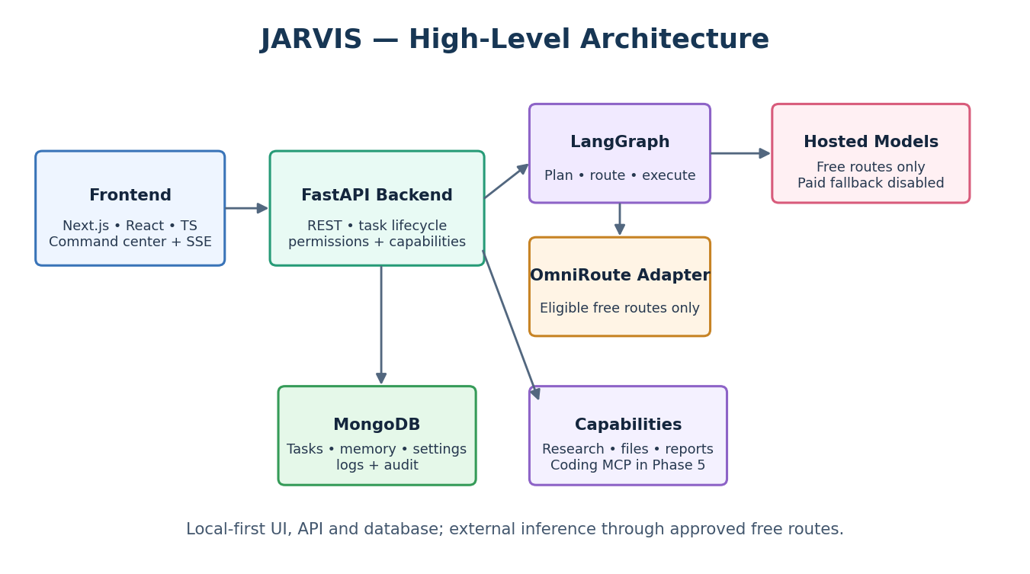

4. Task Flow
Each task is bounded and observable. Provider errors trigger limited retries and an alternative eligible free route when configured. If none remain, JARVIS pauses or fails clearly.
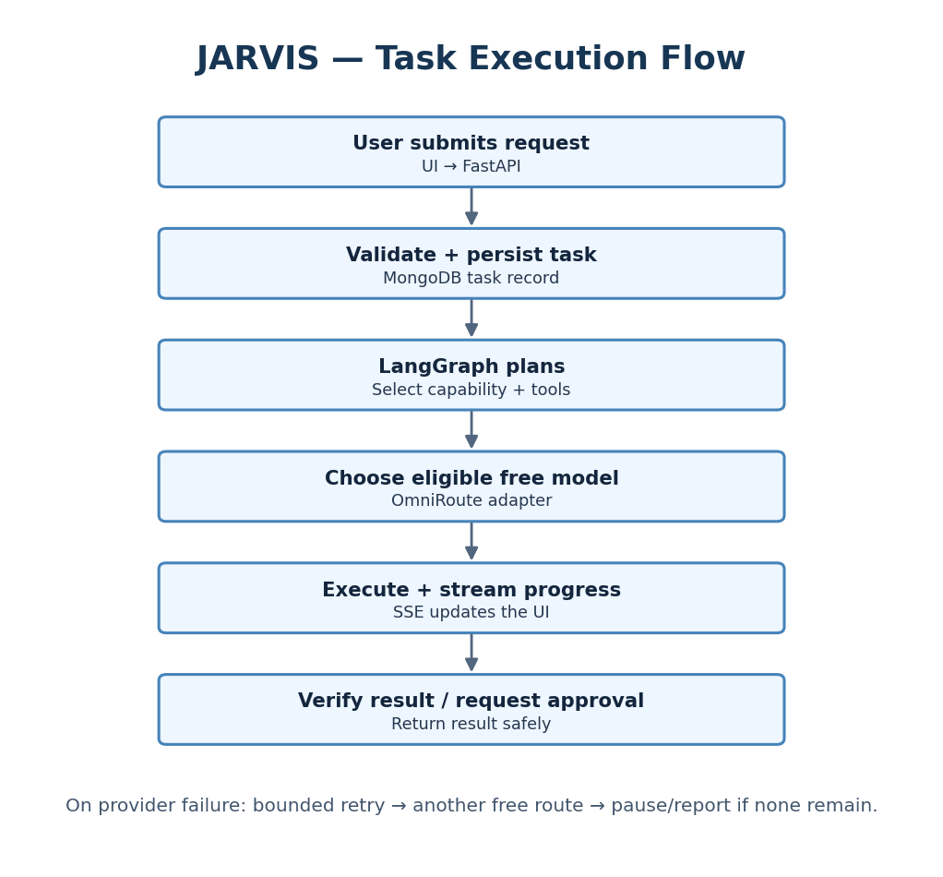

5. UI Concept
Visual direction: immersive dark command center, restrained sci-fi details, clear task status and responsive layout. 3D effects are optional and must remain lightweight.
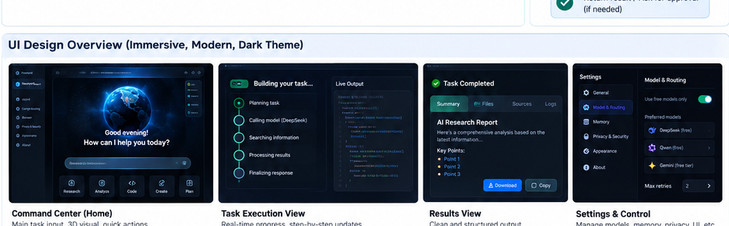
Screen | Purpose
Command Center | Task input, quick actions, system status and recent tasks
Task Execution | Plan, current step, progress, tool activity, retries/errors
Results | Answer, citations, files, charts and copy/download
Settings & Privacy | Free-only routes, memory, privacy and retry settings
Approval Dialog | Exact action/diff, validation results, Approve / Reject

6. Project Structure
jarvis/
├── frontend/ # Next.js UI
│ ├── app/ components/ lib/ tests/
├── backend/
│ └── app/
│ ├── api/ core/ orchestration/
│ ├── model_router/ capabilities/
│ ├── memory/ permissions/
│ ├── database/ schemas/
│ └── tests/
├── integrations/coding_mcp/ # Phase 5 integration
├── docs/ scripts/
├── .env.example .gitignore README.md

7. Five-Phase Execution Plan

Phase 1 — Foundation + UI
Build repository, design system, command center, task list/detail/settings shell, FastAPI health/readiness, MongoDB connection and frontend/backend wiring. Use clearly labeled mock responses for unfinished features.
Gate: UI submits/displays demo task; backend and DB connect; error/offline states work; basic tests pass.

Phase 2 — Assistant Core
Implement LangGraph lifecycle, persistent tasks, OmniRoute adapter, free-only allowlist, bounded retries, provider error handling and SSE progress.
Gate: real eligible free model completes an end-to-end task; state survives restart; paid fallback is blocked; streaming/failure tests pass.

Phase 3 — Practical Capabilities
Add web research, file/document analysis, multi-step execution, structured outputs and capability registry; update existing UI for every output type.
Gate: research, document and multi-step scenarios pass; citations, path permissions, output validation and UI rendering are tested.

Phase 4 — Memory, Personalization + Safety
Add user-controlled memory, project context, action-specific approvals, privacy controls, audit records, recovery and reliability improvements.
Gate: memory review/edit/delete works; changed actions need new approval; privacy, safety, recovery and regression tests pass.

Phase 5 — Coding MCP + Release
Independently test coding MCP, integrate via capability registry, add findings/diff/validation/approval UI, test free-model fallback and run full regression.
Gate: MCP tests pass; unsafe patches cannot be applied; fallback/no-free-route cases work; clean-install and full regression pass.

8. Testing and Delivery Rules
- Every phase ends with explicit acceptance tests; do not proceed with unresolved critical failures.
- Test backend, API contract, UI state and end-to-end behavior for each feature.
- Use mocked failure scenarios, then verify real eligible free routes.
- Enforce free-only routing in code/configuration, not prompts or UI labels alone.
- Require approval for consequential actions and coding patch application.
- Avoid logging secrets; measure RAM and responsiveness on the actual 8 GB laptop.

9. Deferred Work and Risks
Item / risk | Decision
Coding MCP | Separate research/build/test; integrate only in Phase 5.
Colab inference | Optional; verify current terms and reliability; keep backend replaceable.
Free model quotas | Can change or run out; pause if no eligible free route remains.
Local model | Optional experiment only; not required for initial operation.
AgentOS / A2A | AgentOS adapter after stability; A2A and extra infrastructure deferred.

Definition of Done
Initial release is ready when all five phase gates pass, UI and backend remain integrated, free-only routing is enforced, capabilities are modular and tested, approvals/privacy controls work, the coding MCP passes its independent tests, and setup is reproducible on the target laptop.

