

Bachelor Thesis

**DSL-Driven Generation of User Documentations for Web Applications**

Mukendi Mputu September 2021

Supervisors:

Prof. Dr. Bernhard Steffen M.Sc. Alexander Bainczyk

Technical University of Dortmund Department of Computer Science

Chair 5 for Programming Systems (LS-5) [http://ls5-www.cs.tu-dortmund.de](http://ls5-www.cs.tu-dortmund.de/)

**Contents**

1. Introduction 1

1.1 Objectives . . . . . . . . . . . . . . . . . . . . . . . . . . . . . . . . . . . . . 2

1.2 Related Work . . . . . . . . . . . . . . . . . . . . . . . . . . . . . . . . . . . 2

1.3 Outline . . . . . . . . . . . . . . . . . . . . . . . . . . . . . . . . . . . . . . . 3

1. Preliminary 5

2.1 End User Documentation . . . . . . . . . . . . . . . . . . . . . . . . . . . . 6

* + 1. Documentation Characteristics . . . . . . . . . . . . . . . . . . . . . 7
    2. Documentation Software Tools . . . . . . . . . . . . . . . . . . . . . 7
  1. Core Principles of Model-Driven Development . . . . . . . . . . . . . . . . 9
  2. Domain Specific Language 10
  3. Cinco SCCE Meta Tooling Framework 11
     1. Meta Graph Language 12
     2. Meta Style Language 14
     3. Cinco Product Definition 14
     4. Xtend Generators 15

1. WebDoc - Web Application Documentor 17
   1. Graphical DSL 18
   2. Graph Editor 18
   3. WebDoc’s Model Elements 19
      1. FeatureGraphModel 19
      2. DocGraphModel 21
   4. Graph Model Checks 23
   5. Generation Process 24
2. Evaluation 27
   1. Method selection 27
   2. Setup 28
   3. Results 29

i

|  |  |
| --- | --- |
| ii | *CONTENTS* |
| **5 Future Work** | **31** |
| **6 Conclusion** | **33** |
| **List of Figures** | **35** |
| **List of Listings** | **37** |
| **Glossary** | **39** |
| **Abbreviations** | **41** |
| **Bibliography** | **45** |
| **Declaration** | **45** |

**Chapter 1**

**Introduction**

One of the most challenging tasks in software development is developing a long-term strategy for creating, managing and updating the documentation for the end users as the software product develops, adapts or increases in complexity [4]. The challenge lies in the fact that the development team tasked to document the software has to do it manually by first selecting the information most valuable to the end users, structuring it and then when required updating it. In other words, the developer has to reproduce the steps or whole scenarios a potential end user would go trough and document where useful information are to be provided in order to reduce the time needed to understand the main functionality of the software.

Completing this process once does not necessarily free the developer from the task, for it is a cycle that has to be repeated every time an update is introduced or a relevant part of the program has been changed. For a small static Web page this might not sound dramatic, but considering complex applications developed by multiple teams, this task can raise the cost in time and resources as the information about the whole project has to be collected for the design of the documentation [1]. So the problem is to find a way to automatically go through all those steps and generate parts of the documentation model extended with semantic description and later on assemble those to generate a complete documentation.

Software projects are bound by budget and deadline requirements. This leads to the fact that automation processes become essential where the reduction of the development time can be increased [14]. It is therefore of significant advantage for the developing team *and* the end user that the generation of user documentation is modeled in such a way that it always reflects the most current development status of the software product [28]. This thesis introduces the use of a graphical domain-specific language (DSL) – a programmatic

1

2 *CHAPTER 1. INTRODUCTION*

languages adapted to a specific domain problem [22] – as an alternative way of modeling end user documentation.

# Objectives

This thesis proposes a solution for automatically generating end user documentation for Web application by means of a graphical DSL, a similar approach to [6]. We developed an application for modeling di*ff*erent user action sequences in a Web application using the Cinco SCCE Meta Tooling Framework [8] and subsequently generate an end user documentation in Markdown syntax. The Cinco framework is a generator-driven de- velopment environment for domain-specific graphical modeling tools. It is based on the Eclipse Modeling Framework and Graphiti Graphical Tooling Infrastructure, but aims to hide much of their complexity and intricate Application Programming Interface (API)1. For evaluation purposes, we document a task management Web application of our own. Nonetheless, the applied method can be extrapolated to any other Web application, since the elementary building blocks of those applications are the same.

The project has a Maven nature, which allows us to manage the package dependencies and take advantage of its build life cycles for building and distributing the application2.

The Markdown-based documentation is supplemented with screenshots taken with the Web browser automation engine, which drives the Web application to replicate user actions. In addition to that we serve the generated Markdown files containing references to the screenshots as static site.

# Related Work

Documenting a software application – be it as desktop application or a Web application

– has always been a daunting task for the developer. Nonetheless, it is a task many developers are neither enthusiastic nor motivated to do [18]. This raised the attention of many researchers on the topic, so that previous similar solution had been proposed in the past:

[13] also proposed in 2015 the Écrit Toolkit, a solution in which the Eclipse Rich Client Platform [16] application model is used to provide a semantic description of the model

1More information can be found at [https:*//*cinco.scce.info*/*](https://cinco.scce.info/)

2The code for the application can be found here [https:*//*github.com*/*MukendiMputu*/*UserDocGenerator](https://github.com/MukendiMputu/UserDocGenerator)

*1.3. OUTLINE* 3

element. Those semantic description were later on aggregated to a user documentation complying with ISO*/*IEC 26514 [13]. The generation steps consisted of an application model with semantic description being analyzed and converted into an EcritDocument model, that was used as input for a Document Outputter, which produced LATEXor HTML code. Coding knowledge were necessary to be able to verify the produced documentation. The project is no longer under active development.

GuideAutomator [21] was for example proposed in 2016 as part of a Bachelor’s thesis. The approach was to provide Markdown files with short JavaScript chunks that determine how to capture each screencast [27]. This implied that preexisting Markdown file were required as input for the generator, which then executed the JavaScript code snippet using Selenium. This approach limited itself in a way that knowledge of the JavaScript programming language where required and also that the Markdown file had to manually be generated prior to the execution the generator, which did not support reusability of the such Markdown file. According to the last Github commit, which goes back to September 2018, to project is not being actively developed any longer.

# Outline

Chapter presents the Cinco SCCE Meta Tooling Framework, in particular the two meta- languages (Meta Graph Language (MGL) and Meta Style Language (MSL)) that constitute the meta-specification (Section 2.4.1 and 2.4.2) of our graphical domain-specific language. The chapter then rounds o*ff* with an outline of the Generator classes written in Xtend, a Java dialect that o*ff*ers much flexibility and expressiveness in its syntax (Section 2.4.4).

The specifics of the generated modeling platform are described in chapter 3. Whereby Sec- tion 3.1 explains the basic concepts of a graphical domain-specific language, then Sections 3.3.1, 3.3.2 and 3.5 relate about di*ff*erent modeling elements for configuring and designing the end user documentation. In chapter 4 a in-depth explanation of the methodology is given. Beginning with the evaluation of the selected work method in Section 4.1 followed by the system setups and the result of the approach taken in this thesis(Section 4.2 and 4.3). Further improvements of the program are presented in chapter 5. Lastly, chapter 6 winds up with a discussion on the thesis.

4 *CHAPTER 1. INTRODUCTION*

**Chapter 2**

**Preliminary**

**Cinco DSL Specification WebDoc End-user Documentation**

Xtend Generator Model Checks

Web Elements

Cinco Product Definition WebDrivers

Screenshots

Best Practices

**Cinco**

**graphical DSL**

**Selenium-Java**

**Markdown**

Meta Style Language

Appearance Provider

Project Structure Generation

Maven

Meta Graph Language

VuePress

This chapter introduces the various notions necessary for achieving our goal. We first look at the structure of our end user documentation as recommended by known standards and what technologies are actually available to help us complete this task. Then we will allude the fundamentals of model-driven development with the Cinco Meta Tooling Suite, while introducing the meta languages we based our graphical models on and explain briefly what need to be generated from those models.

5

6 *CHAPTER 2. PRELIMINARY*

# End User Documentation

The value of a good software product, in fact, of any product destined to be brought to the consumer is determined on how e*ff*ective the end user is able to learn to use the product. Hence, putting a great e*ff*ort to generate and manage a useful, well-structured documentation is as much important as the development of the product itself [2].

End user documentation aim to provide the application end users with the information necessary to properly interact with the software. It is part of the development life cycle and the bridge between the product developer and the user [3]. By improving the structure and usefulness of the information delivered to end user, the developer not only reduces significantly the return of calls for support, but enhances also reputation of the product as well as of the producing company [1].

**Cinco DSL Specification**

**Cinco Product WebDoc**

**End-user Documentation**

Xtend Generator Model Checks

Web Elements

Cinco Product Definition WebDrivers

Screenshots

Best Practices

**Cinco**

**graphical DSL**

**Selenium-Java**

**Markdown**

Meta Style Language

Appearance Provider

Project Structure Generation

Maven

Meta Graph Language

VuePress

In this section we will go trough the main characteristics of end user documenta- tion, focusing on the standards establish by the ISO*/*IEC and the IEEE [1, 2]. Next we will talk about the specifics of documenting Web application by giving an example of a documented Web application. We will also present the currently used technologies for creating and managing such documentation. Our main goal is to produce an entire end user documentation page from a graphical model. Before going further, we ought to precise that the type of documentation to be created will depend on how the documen- tation designer lays out the model, that means the model could be designed to represent a technical documentation – requiring deep knowledge of the application documented – or it could also be structured to produce a documentation for simple end users with no technical knowledge at all of the underlying Web application [4].

* 1. *END USER DOCUMENTATION* 7

## Documentation Characteristics

Since our focus is primarily on Web applications, we will be documenting the User Inter- face (UI), which is composed of Web elements (like buttons, navigation links, checkboxes, etc.) the user can interact with. This settles implicitly the type of documentation we aim to create: a step-by-step guide for navigating UI to reach the expected result. Nonethe- less, the ISO*/*IEC*/*IEEE Standard 26511:2012 mandates i.e. that completeness and accuracy should be of the utmost importance when designing the end user documentation.

Bearing that in mind, a good documentation should respond to three important ques- tions: *why* the application has been programmed, meaning the problem the application intends to solve, *what* is the end user supposed to do to quickly and e*ffi*ciently get to the solution and *how* is it achieved [2]. This is a task we leave to the information manager. The last question, however, is better answered by providing visual help in form of screen captures or any illustration that fastens the understanding of the documentation.

As we mentioned before, we intend to document Web applications from the viewpoint of the application end user. This means that documentation developer should keep in mind the readership of end product [2], so identifying the key tasks and activities ot the common users should be integral part of the planning process. That being said, our solution puts the developer at charge for how detailed the documentation becomes.

## Documentation Software Tools

Choosing the format in which the documentation is brought to the end user is as much important as the rest of the milestones of the planning process. A inadequate choice in this matter can reduce the potential of the documentation to reach a maximum number of users, rendering it ine*ff*ective. A good decision is to opt for technologies that have already gained acceptance among most users. This ensures greater reach and preexisting knowledge amongst that same audience:

### Markdown

Markdown is a lightweight markup language created by John Gruber1 in 2004. Since, it has established itself as one of the world’s most popular markup language [9]. Gruber states on his webpage that Markdown is comprised of formatting syntaxes that can be applied to plain-text file and optionally a converter to other markup languages files like HyperText

1John Gruber’s o*ffi*cial project website [https:*//*daringfireball.net*/*projects*/*Markdown*/*](https://daringfireball.net/projects/Markdown/)

8 *CHAPTER 2. PRELIMINARY*

Markup Language (HTML).In this acronym, HyperText means the link that connects Web pages to each other, either within the same website or between di*ff*erent websites [11]. On Mozilla Developer Network website2, HTML is described as the fundamental building block of any Web page, that uses markup syntax to annotate text, images, and other content for display in a Web browser.

For its popularity, it is a great choice for our project, since description of the UI is first made as plain-text and then transform to a rich-text format using markup syntax as depicted below. Moreover, Markdown files can be opened and edited with any kind of text editor available. There is tremendous amount of documentation about Markdown syntax available online for the interested reader to get started.

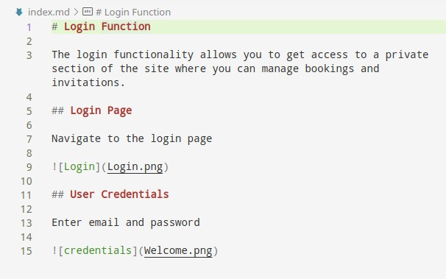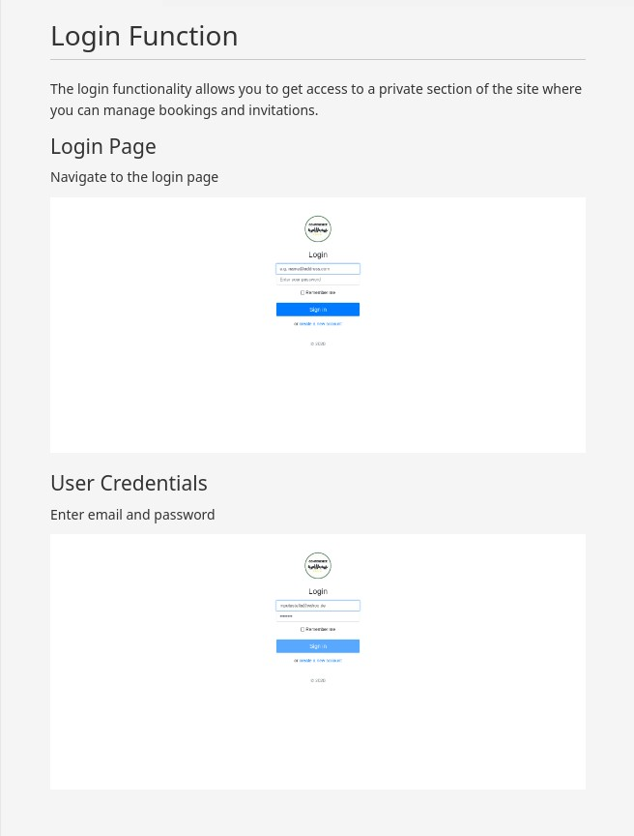

**Figure 2.1:** Plain-text transformation with Markdown

Although there exists a plethora of applications that transform Markdown files into HTML files to be rendered in a Web browser application, we choose to work with one framework that also established itself throughout the developer community and that especially works very well with Markdown files: VuePress.

### VuePress

VuePress is a minimalistic static website generator powered by VueJS [29], which is a open source JavaScript framework created by Evan You3. As an open source software, it is maintained by a huge community of contributors, what makes it robust and up-to-date.

2MDN: [https:*//*developer.mozilla.org*/*en-US*/*docs*/*Web*/*HTML](https://developer.mozilla.org/en-US/docs/Web/HTML)

3Eva You’s website [https:*//*evanyou.me*/*](https://evanyou.me/)

* 1. *CORE PRINCIPLES OF MODEL-DRIVEN DEVELOPMENT* 9

We will use VuePress to statically launch the end user documentation as a website, relieving the developer of the task of configuring the server. The principal task remaining is therefore to create a solid documentation model.

# Core Principles of Model-Driven Development

**Cinco DSL Specification**

**Cinco Product WebDoc**

**End-user Documentation**

Xtend Generator

Cinco Product Definition

**Cinco**

Meta Style Language

Appearance Provider

Meta Graph Language

Model Checks

Web Elements

WebDrivers

Screenshots

Best Practices

**graphical DSL**

**Selenium-Java**

**Markdown**

Project Structure Generation

Maven

VuePress

This section lays down the fundamentals of the model-driven development (MDD) – also referred to as model-driven software development (MDSD) [17] – using the Cinco SCCE Meta Tooling Framework, as well as the steps necessary to get up and running with the framework. The term MDD refers to a development paradigm where the function- alities of the software are first specified as models, from which then executable code can be automatically generated. To create and use models to represent the software system, a DSL that is close to the problem domain, is needed. Application domain experts pos- sess the knowledge of the application structure, which they represent in form of models. Domain experts and application programmers have to agree on how the specification language determines syntax and semantic of the model elements.

The core principles of MDD reside in the fact that software development is accelerated by providing a simple, but e*ffi*cient abstraction of the software structure as a model. Those model abstraction, representation of real-world objects, are transposed through a series of model-to-model or model-to-code transformations [24]. Our work is to utilize the DSL provide by the Cinco framework to design our graphical DSL, which in turn will permit the generation of a functioning Selenium-Java application (Selenium is a suite of application tools for automating Web browsers) to take screenshots of the di*ff*erent Web application states.

Opposed to the common development method, applying a graphical model to layout the di*ff*erent user sequences allows even non-programmer (here the domain expert with

10 *CHAPTER 2. PRELIMINARY*

much more expertise on how to design a great software documentation) to accomplish the task of documenting the features o*ff*ered by the Web application. Nonetheless, the programmer has the tasks – in collaboration with the domain expert – to specify the meaning of each model element for the code generation process.

When applied correctly, the result of the model-driven development process is a tailored application to domain. This reflects one of the main advantages of MDD: the accuracy of targeting directly the specific problem [7]. Besides, it is still possible to change the DSL so that it adapts to the new challenges emerging during the development process. This can be iterated until the specification reaches preciseness wanted to solve the problem.

# Domain Specific Language

A domain-specific language (DSL), as mentioned before, is a language adapted to specific development domain. In [20] a succinct analogy to DSLs is given by saying that it is comparable to a tool specially crafted only for one specific task as opposed to general programming languages, which can be seen as tools for multiple di*ff*erent tasks. If we stick to this analogy, just as one would start with a blueprint to construction a mechanical tool, designing as DSL required similar steps. One have to conceptually lay out the behavior and eventually – in case it is a graphical language we seek to design – the look of each element that can be used in our DSL.

Blueprinting our DSL is equivalent to defining a metalanguage or meta-DSL to our language. *Meta* literally means *situated behind or beyond*4. So the metalanguage is the descriptive language coming before our language, describing the meaning (semantic) and the relationship between the objects of our target language. In other words, the meta- DSL is the abstract syntax and the resulting DSL concrete syntax. It is possible to ascend the modeling hierarchy of meta-definition until we reach a self-referencing language, like it is the case Unified Modeling Language (UML).

In our case, we want a graphical language for creating models that represent the di*ff*erent parts of a Web application and how the end user can possibly interact with them. The metalanguage to our graphical DSL is provided by the Cinco SCCE Meta Tooling Suite. It comprises the Meta Graph Language (MGL), the Meta Style Language (MSL) and the Cinco Product Definition (CPD). All have been constructed using Xtext [5], a language Workbench for writing textual DSLs [19]. The next section explains those concepts in detail.

4According to the definition given at [https:*//*www.merriam-webster.com*/*](https://www.merriam-webster.com/)

*2.4.* CINCO SCCE *META TOOLING FRAMEWORK* 11

# Cinco SCCE Meta Tooling Framework

The Cinco Framework is a generator-driven development environment for domain- specific graphical modeling tools [8]. It is actually developed by the chair of programming systems at the Technical University of Dortmund and one of the many projects of the SCCE Group 1, which aims at allowing the application-domain experts, rather than program- ming experts, to take charge of the development tasks [23]. One of the great features of this framework is that it allows us to generate an entire editor application with just one click from a simple textual specification language – the MGL mentioned in the previous section.

The MGL together with the MSL form the metamodel from which Cinco generates a ready-to-run modeling tools called Cinco product. The MSL is where the Cinco developer defines the look every node and edge element, as well as the font and color of the text to be displayed in the graphical model [19]. The created metamodel is based on Ecore, the metamodeling language of the Eclipse Modeling Framework (EMF) and the Graphiti framework is used to generate the corresponding graphical model editor. Additionally, you find the right button to trigger code generation in the created editor. Chapter 3 is devoted to our Cinco product (the editor application), in particular section 3.5 gives an in-depth explanation of the generation process.

**Level 1: Meta-meta specification**



**Level 3: Feature.mgl & Doc.mgl**

EMF's Ecore.ecore

Cinco's MGL.ecore

Doc.mgl

& Feature.mgl

Login.doc

**Level 2: Meta specification**

**Level 4: Graph model**

**Figure 2.2:** Hierarchy of our graphical DSL specification

The full generation process of a graphical modeling tool (of a Cinco Product Appli- cation) comprises four essential (meta) levels [20]. The first level, associated with the role Eclipse Developer, is where the Ecore.ecore and GraphitiDiagram.ecore metamodel are developed. The second level is where Cinco Developers of the Chair 5 for Programming Systems used the metamodel from the first level to develope the MGL.ecore, which in turn becomes metamodel of the third specification level, where the Cinco Product Developer operates and also where this thesis comes in, see fig. 2.2. This means the Eclipse Develop- ers are now at the meta-metalevel, the Cinco Developers at metalevel of the specification elaborated in this work. For the remainder of the chapters we will be focusing on the third and fourth specification level. Latter is the level where the Cinco Product Users use the generated graphical editor to create the domain specific models.

1[https:*//*www.scce.info*/*](https://www.scce.info/)

12 *CHAPTER 2. PRELIMINARY*

## Meta Graph Language

The MGL sketches the behavior, the constraints and gathers the all the graphical compo- nents that will constitute the model elements that come in use in every graph diagram created in the modeling tool. As a Cinco Product developer, this is where we start devel- oping our editor application: the main elements that can be define in a MGL are **nodes**, **containers** and **edges** as illustrates listing 2.2.

The main graph model, the FeatureGraphModel, is the one containing all the features of the Web application we want documented. For instance, our Web application provides the login feature as starting point, then after successfully logging in and getting access to the dashboard, task lists can be created or deleted, tasks can be added to or removed from them, etc. The graph diagram can be assigned name and description. We specified .feat (short for feature) as model extension. And since the login feature i.e. requires a series of user actions to be performed, the FeatureGraphModel contains another graph model type, where those sequences of actions will be modeled: the DocGraphModel. It contains the meta specification of all the commonly used Web elements (i.e. input field, buttons, dropdown, etc) we want to use in our graph models, as well as sectioning elements to structure the diagram and edges to connect them to each other. The listing below shows a excerpt from the concrete FeatureGraphModel implementation.

1

2

3

4

5

6

7

8

9

10

11

12

13

14

15

16

17

18

19

20

21

22

23

graphModel FeatureGraphModel { iconPath "icons/16/ feature_16 .png" diagram Extension "feat"

containableElements( FeatureContainer , DocNode [1 ,*]) attr EString as modelName := "New Feature"

attr EString as description := "New Description"

}

container FeatureContainer {

style featureContainer("${title}") containableElements(Start[1 ,1], Stop[1 ,1], DocNode [1 ,*]) attr EString as title := "New Feature"

@multiLine

attr EString as documentation := "This feature is about ..."

}

node DocNode{

style docNode("${mgl. modelName}")

prime docMgl:: DocGraphModel as mgl

attr EBoolean as createScreenshots := true

incomingEdges (Edge[1 ,1])

outgoingEdges (Edge[1 ,1])

}

**Listing 2.1:** Excerpt from the feature.mgl, meta-specification of the FeatureGraphModel

As you can see we define a container element to hold the DocGraphModel instances (see lines 9 and 17). To integrate a whole DocGraphModel inside a FeatureGraphModel

*2.4.* CINCO SCCE *META TOOLING FRAMEWORK* 13

we used the so called *PrimeReference*, which is a Cinco feature that allows to reference another model by only one attribute of a node or container [8]. It is applied by adding the keyword prime, as we did in line 9. By doing so, we can simply drag and drop a DocGraphModel diagram into a FeatureGraphModel diagram to incorporate it.

As for the DocGraphModel, we specified four categories of model elements to use while designing the diagram: the most important ones, the Web elements, represent the UI element the user can interact with. The we have the Selenium action nodes, which perform some actions to drive the Web browser through the Selenium WebDriver. This are i.e. the Navigation node to change from one Web page to another and the Screenshot node to capture the application current state as an image. Finally, we have the semantic element Comment, to give a descriptive text to the screenshots and the basic elements (start and end as well as the section node) which help structure the user sequence graph.

1

2

3

4

5

6

7

8

9

10

11

12

13

14

15

16

17

18

19

20

21

22

23

graphModel DocGraphModel {

iconPath "icons/16/ sequence_16 .png" diagram Extension "doc" containableElements(*)

attr EString as modelName := " UserSequence"

@multiLine

attr EString as documenation := "Lorem ipsum dolor et si met"

}

node Screenshot {

style screenshotNode

incomingEdges ( Transition [1 ,1], Anchor[1 ,*])

outgoingEdges ( Transition [1 ,*]) attr EString as pictureName attr Comment as description

}

node Input extends WebElement {

style inputNode("Input: ${ content}") attr EString as content incomingEdges ( Transition [0 ,*]) outgoingEdges ( Transition [0 ,*])

}

**Listing 2.2:** Excerpt from the Doc.mgl, meta-specification of the DocGraphModel

For demonstration purposes, we kept our example listings short. An exhaustive list of all the usable elements and annotations can be found on the Cinco’s documentation page1.

1Wiki page: [https:*//*gitlab.com*/*scce*/*cinco*/*-*/*wikis*/*Cinco-Product-Specification](https://gitlab.com/scce/cinco/-/wikis/Cinco-Product-Specification)

14 *CHAPTER 2. PRELIMINARY*

## Meta Style Language

The appearance of all the elements defined in the MGL are laid down using the textual Meta Style Language (MSL). As explained in [12], three essential elements constitute the design of a MSL model, namely: **appearance**, **nodeStyle** and the **edgeStyle**.

Each nodeStyle specification makes use of an appearance element, which in fact determines the attributes like background color, the thickness of the drawn lines and so on (see listing 2.3). The nodeStyle is hierarchically composed of a shape that can be given a size, position and a text element with a value attribute that takes a (format) string (line 12) that will be display in the graphical model. We can say that it is left to the Cinco product developer’s imagination to style the elements as seen fit.

1 nodeStyle featureContainer(1) {

2 rectangle {

3 appearance extends default {

4 background (246 ,245 ,244)

5 }

6 size (300 ,75)

7 text {

8 appearance {

9 font("Sans", BOLD , 10)

10 }

11 position (LEFT 5, TOP 5)

12 value "% s"

13 }

14 }

15 }

**Listing 2.3:** Excerpt from feature.style to be applied to feature.mgl

It is also worth mentioning that the concept of inheritance from the Object Oriented Programming (OOP) can be applied between metamodel element of the same type, hence avoiding repetitive definition of the same attributes within multiple di*ff*erent elements and allowing some elements to extends the properties of the parent elements. For example, we see in line 3 the featureContainer appearance extends the default one and at the same time redefines the background color.

## Cinco Product Definition

In the Cinco Product Definition (CPD) is where it all comes together. Herein, the Cinco Product Developer has to provide key information like the Cinco product name, at least one or more MGL files to be included into the generation process. Optionally, one can setup a splash screen with branding images, add a descriptive text about the application

*2.4.* CINCO SCCE *META TOOLING FRAMEWORK* 15

and specify plugins and*/*or features [12]. The listing below gives an insight into the CPD specification language.

1

2

3

4

5

6

7

8

9

10

11

12

13

14

15

16

17

18

CincoProduct UserDocumentationTool {

mgl "model/ Feature.mgl"

mgl "model/Doc.mgl"

splashScreen " branding/splash.bmp" {

progressBar (37 ,268 ,190 ,10)

progressMessage (37 ,280 ,190 ,18)

}

image16 " branding/ Icon16_dark.png" image32 " branding/Icon32 .png" image48 " branding/Icon48 .png" image64 " branding/Icon64 .png" image128 " branding/ Icon128 .png" linuxIcon " branding/ Icon512 .xpm"

19

20

21

22

23

24

25

about {

text "WebDoc is a DSL -driven generator of end user documentation for Web application. It is a bachelor thesis project developed with the Cinco SCCE Meta Tooling Suite ( http:// cinco.scce.info )."

}

plugins {

info.scce.cinco. product. userdocumentation.edit, info.scce.cinco. product. userdocumentation.editor

}

}

**Listing 2.4:** UserDocumentationTool.cpd

## Xtend Generators

For our documentation application we need to create two di*ff*erent application folder structures from our model diagrams: the first one is the Selenium-Java application, that basically replays the modeled user action sequences and takes screenshots as laid out by the designer. It follows the specific Maven project structure, for which we applied the rule of convention over configuration as recommended on the Maven Apache 1 website and added Selenium as a dependency. The other project structure we generate by following convention is for the VuePress project, which in fact is the end result we aim to obtain. In this project, we generate the Markdown files containing all the semantic text the documentation developer specified as description and*/*or comment in the model elements. This is achieved by following each sequence beginning from the start node all the way through to the end note, constructing a cohesive documentation text.

1[https:*//*www.apache.org*/*](https://www.apache.org/)

16 *CHAPTER 2. PRELIMINARY*

This generation approach utilizes Java’s and Xtend’s text templating feature which is based on the generation pattern used in the Java Application Building Center (jABC) [25, 26]. In fact, many generator classes in our example project implement and extends inter- faces from the generator runtime and template package of the jABC Cinco metaplugin.

Additionally, other template classes are implemented to create configuration files, application class and project files. In chapter 1 section 1.1 we provided a link to the Github repository, where the complete application code can be found. In the next chapters, we show the output of the generator and feature classes, while introducing our application as an on going example.

**Chapter 3**

**WebDoc - Web Application Documentor**

**Cinco DSL Specification**

**Cinco Product WebDoc**

**End-user Documentation**

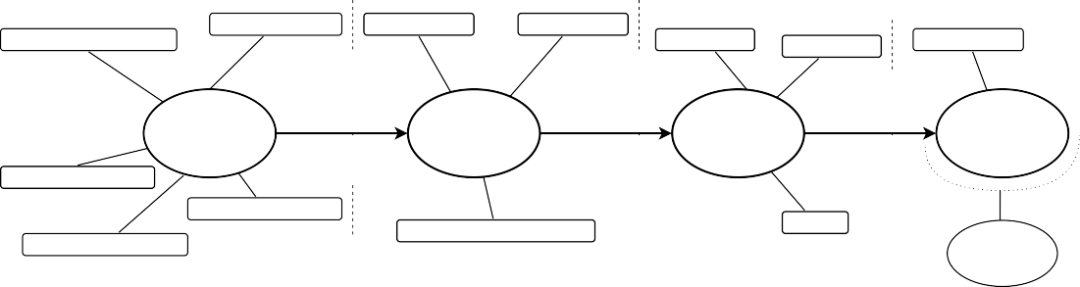

Xtend Generator

Cinco Product Definition

Best Practices

**Cinco**

**Markdown**

Meta Style Language

Appearance Provider

Meta Graph Language

VuePress

Model Checks

Web Elements

WebDrivers

Screenshots

**graphical DSL**

**Selenium-Java**

Project Structure Generation

Maven

Having described the Cinco DSL specification of the graphical modeling tool, we come now to the description of the model editor instantiated from it. First, we give a succinct explanation of our graphical DSL, then illustrate the fundamental building blocks of our documentation model and by presenting at the same time our Cinco product: WebDoc. Later on, we demonstrate the use of these graphical elements to model a specific user workflow on the website we want to document. At the end, we show how using the editor built-in generator, we generate the target application that generate the Markdown files to be shown in the Web browser.

17

18 *CHAPTER 3. WEBDOC - WEB APPLICATION DOCUMENTOR*

# Graphical DSL

Our graphical DSL mainly comprises node elements, which have been applied di*ff*erent appearances to, in order to resemble to some extent the corresponding Web elements they represent, as well as connector elements to connect the nodes to sequence graphs. The purpose behind this approximated replication is not to recreate all possible Web elements, but to give the developer a sense of control over the interactable UI elements. With those elements at hand, the designer can simply model a user action by arranging node elements following the navigation path of the Web application. This graphical language is in such way domain specific, that it is tailored for modeling Web applications inside a Web browser; modeling a documentation for a desktop application for example would not be possible.

# Graph Editor

The WebDoc editor is mainly composed of the canvas in the middle of the working environment (1), where the developer can drag and drop model elements from the palette located on the right-hand side (2). Herein, elements are grouped in categories. On the left-hand side we have the project explorer showing the current project structure (3). The main model files have the extensions .doc and .feat, where the latter is the entry point of the documentation application.

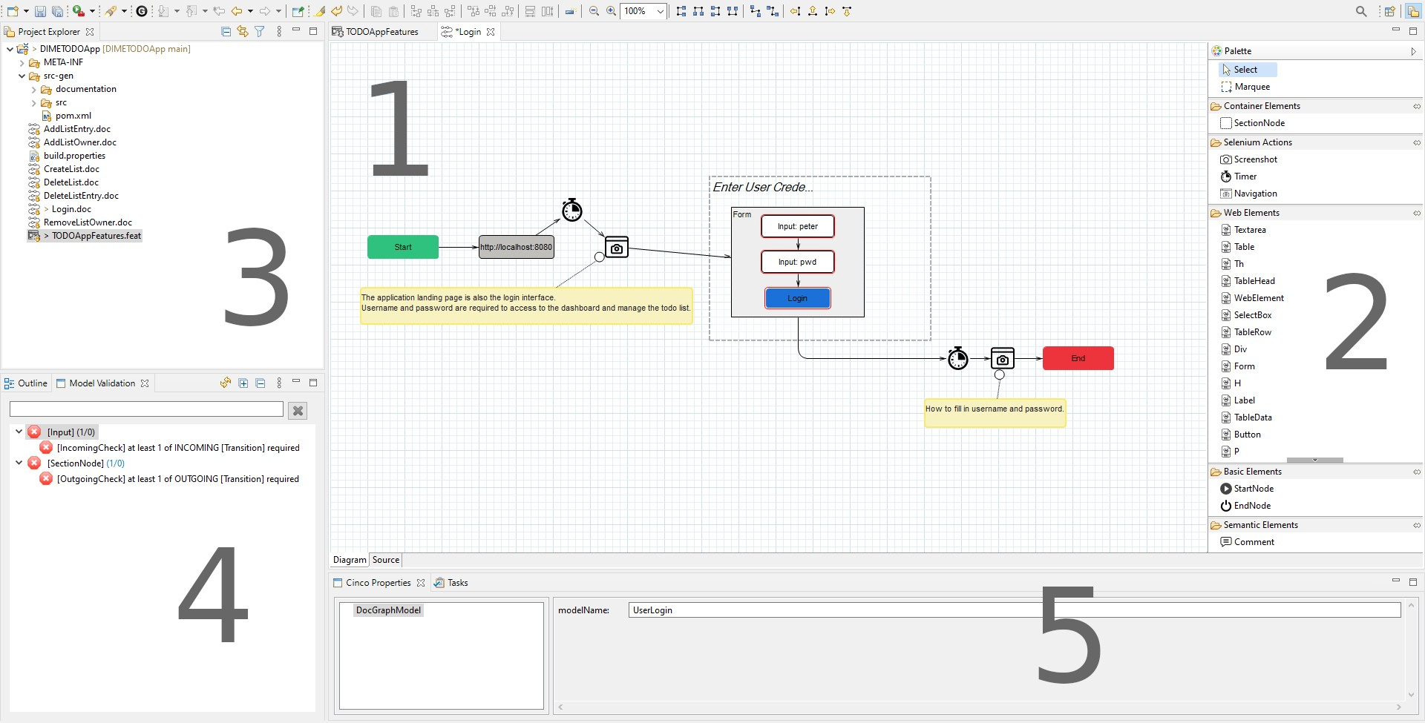

**Figure 3.1:** Cinco Product Application - Graph model editor

*3.3. WEBDOC’S MODEL ELEMENTS* 19

All diagrams that are open in the editor are checked in the background for compliance with the requirements described on the metalevel and shown in the Model Checking view right beneath the project explorer (4). There’s also the Cinco property view (5) that displays the attributes and values of any selected element in the editor. This is where the developer can modify those values if the attribute field allows it.

# WebDoc’s Model Elements

On a Web page rendered in the Web browser, there is a small amount of HTML elements the user can interact with. Most of them resides within the HTML forms, tools that are used for collecting data from the user, or allowing them to control a user interface [11]. Input fields (of all types: text, password, textarea, checkbox, etc) and buttons are the prominent ones. Those are the Web elements that primarily constitute the palette of our model elements. In the previous chapter, we defined two di*ff*erent MGLs: one for modeling the Web application features and the other one for modeling the user actions that make up those features.

## FeatureGraphModel

The FeatureGraphModel is the application starting point specified by the feature.mgl. Here, the developer groups all the features that needs to be documented in feature containers. Figure 3.2 depicts a portion of the features modeled for our task management application: the ability to login, to create a new list, add a task to that list or remove it and lastly delete the whole list. Moreover, our application o*ff*ers the possibility to also add a new list owner, which already exist in the system as regular user. On the top left-hand corner you can see an property container holding the WebDriver property, whose value is set to FIREFOX. It is one of the additional model elements that help the developer define configuration that otherwise could not be modeled, but still essential for the execution of the application. This property value will be assigned to the Selenium WebDriver variable in the Java class. Remember that the executable file for the chosen WebDriver muss already exist somewhere in file system and the path to it has to been specified here in the property view.

20 *CHAPTER 3. WEBDOC - WEB APPLICATION DOCUMENTOR*

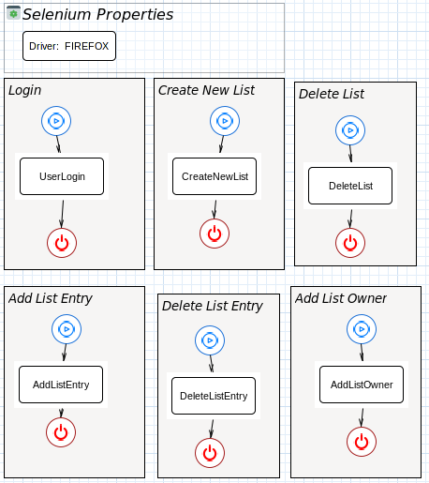

**Figure 3.2:** Cinco product - Feature Graph Model with Feature Containers

Even though the features are presented in logical workflow order, they still are in- dependent from one another and will be generated independently as well. However, as mentioned in the previous chapter, this separation does not exclude reusability, since it is possible to integrate a whole DocGraphModel inside another one. Considering, for instance, the CreateNewList feature, it requires the user to be logged in to be able to create a new tasks list. So the documentation developer does not have to repeat the login sequence inside the this one and can simply drag and drop the UserLogin.doc file inside the diagram of the new model graph, connect it within the sequence as if it were a regular graph node (see figure 3.3). Double-clicking on the imported subgraph leads directly to the original graph model. This double-click action has been implemented by applying the @doubleClickAction annotation the corresponding node specification and by providing a custom action class that holds the implementation logic.

* 1. *WEBDOC’S MODEL ELEMENTS* 21

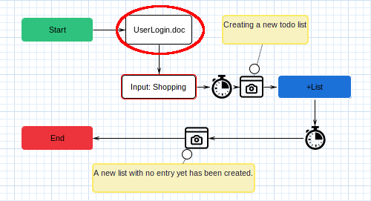

**Figure 3.3:** Cinco product - Reusing Login graph model in the CreateNewList graph model

The feature graph model contains also semantic elements, which are integrated in the existing featureContainer for simplicity’s sake. Clicking on such a featureContainer opens up simultaneously the Cinco property view with a multiline input field description. This is where the documentation designer can enter some descriptive text to give meaning to the diagram elements and at the same time provide text content for the Markdown documentation files. Those information will be collected during the code generation process.

## DocGraphModel

The model in Figure 3.4 illustrates the sequence a user would eventually undergo to log into our example Web application, with the Web elements that will be interacted with. Connected together into a logical sequence, they form the user login sequence for our Web application.

The sequence begins with the start node, which is the starting point of every user sequence, then comes the navigation node, used to navigate from one Web page to another. Next, the timer node waits explicitly for an amount of second determined by the designer in the property view and for a certain condition to become true before continuing. Those ExpectedConditions are i.e. presenceOfElementLocated, elementToBeClickable, just to name a few. If we take for example the condition presenceOfElementLocated, the timer holds the WebDriver execution for 3 seconds, checking every 500 milliseconds if the targeted

22 *CHAPTER 3. WEBDOC - WEB APPLICATION DOCUMENTOR*

Web element appears on the page. Right after the timer comes the Screenshot node, that captures the current application state, displaying the application landing page, also the login pane. In the property view, one can give a specific file name to each image that has to be saved. The comment node allows the documentation creator to add descriptive text about the picture, that will be later added to the Markdown file as image caption. Next comes a section describing the action of typing in and validating the user credentials. As you can hopefully see, all input node, as well as the button node have a red border that simulates the element state of being highlighted. This visual help show the model designer which elements will be marked on the next screenshot, after which the login sequence ends.

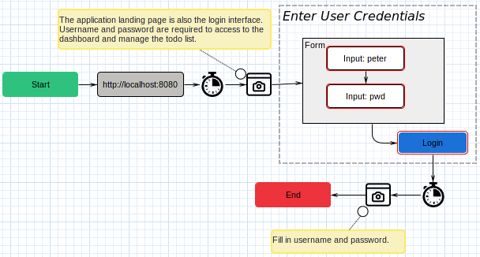

**Figure 3.4:** Example of a user workflow: here the login sequence

The purpose of the Web element nodes is to allow the concrete HTML elements in the browser to be addressed. This implies that appropriate actions can be applied to such a representation of an HTML element. Considering for instance the input field in the picture below, the action of typing in a text is made possible by providing a property variable content, whose value is then display inside the node element (here i.e. ”peter” and ”pwd”). The same holds true for button elements, which can be applied the click action or for selectboxes, which can be dropped down to reveal the options they contain, etc. In addition to that, all Web element can be highlighted either by setting the highlighted property to true or by letting the Highlight node under the *Selenium Actions* category take care of it.

* 1. *GRAPH MODEL CHECKS* 23

# Graph Model Checks

Modeling valid graph diagrams is crucial for the correctness of the generated application code. Especially the Selenium-Java application code has to replicate correctly the user sequence in order capture the correct application state as the user would do. This is particularly daunting if the navigation graph of the underlying Web application is huge.

This means that we have to ensure that there is a distinct path for every single using action and that there is no cycle within such path. This strongly reminds of some graph theory problems: checking is a path from start to end node exists and whether or not a given graph is cycle free. The Cinco framework o*ff*ers a meta plugin ready-to-go for this task, the MCaM Meta Plugin [12].

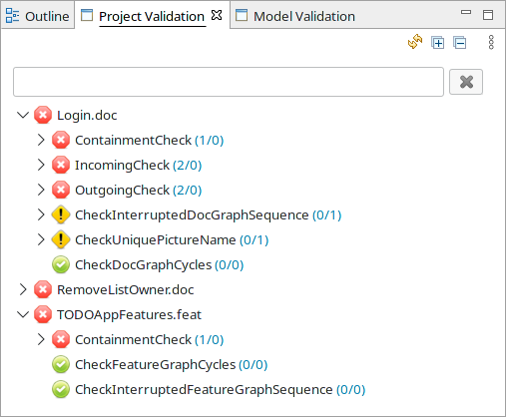

**Figure 3.5:** Project Validation view showing passed and failed checks

The plugin has to be activated by specifying the @mcam("...") or the @mcam_checkmodule("...") annotation with the corresponding parameter in parentheses. The first one has to be de- clared right above the graphModel declaration with the parameter ”check”; this activates the check on the constraints on the graph nodes, for example the multiplicity of the incoming and outgoing edges between them or containment constraints on container nodes, meaning that they can only contain those node elements explicitly specified with

24 *CHAPTER 3. WEBDOC - WEB APPLICATION DOCUMENTOR*

the containableElements attribute. The second annotation allows us to specify our own module checks. For instance, we need to ensure that two di*ff*erent screenshot nodes do not bear the same file name or that each sequence starts with the appropriate start node and ends with the end node. We also have to ensure that by integrating graph in another one we do not create cycle within the execution path. The *Project Validation* view shows all the checks done on the entire project and marks those that failed or passed the checks accordingly. Figure 3.5 shows for example the checks done on our example project.

# Generation Process

As mentioned before, one of the most impressive features of Cinco is the generate but- ton. Clicking on this button generates a executable Selenium-Java application, which, once started, runs the user sequence model as a Selenium script in the Web browser. Figure 3.6 shows where the generate button is located. As mentioned in the preliminary chapter, the generator classes behind this process are written in Xtend, as statically-typed programming language based on Java and actually translates to Java source code [15].

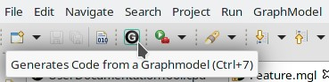

**Figure 3.6:** Cinco product - generator button

To be able to start a generation process from a graph model we have to declare it ”generatable”. We do so bei adding the @generatable("path.to.generator.Class") annotation in the graph model meta-specification. This annotation accept as parameter a Xtend or Java class that implements the IGenerator, whose generate method starts the whole process and the path to a location where the generation end product will be saved (in our case it is in the src-gen folder). Recalling the goal we set for application code, we create two folder structures inside the src-gen folder: the first one is the Java project structure with the Selenium script and the second one is the VuePress project holding all the Markdown files with the documentation text. Going deeper into technical details is beyond the scope of this paper, hence we provide an illustration of the whole generation process in figure 3.7. As you can see, we begin by designing a graph model in the Cinco product application, the WebDoc editor; clicking on the generate button starts a simultaneous creating of both the aforementioned project files. At this point, a fully functional documentation has already been created. We have chosen to generate the documentation file with references to

* 1. *GENERATION PROCESS* 25

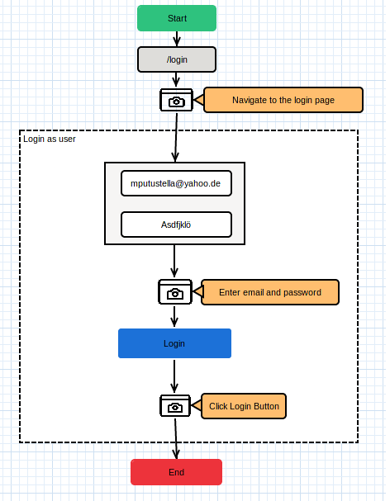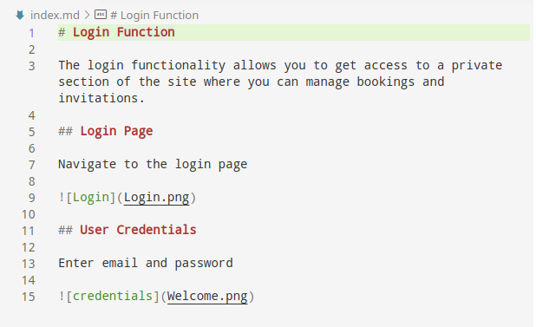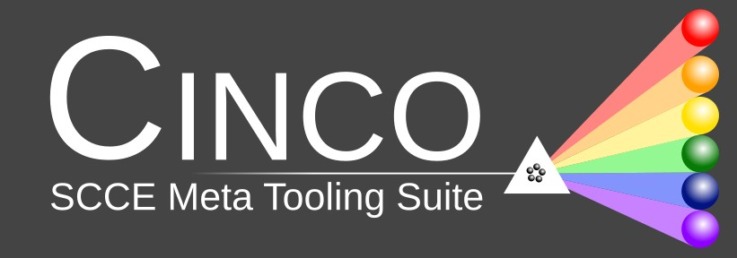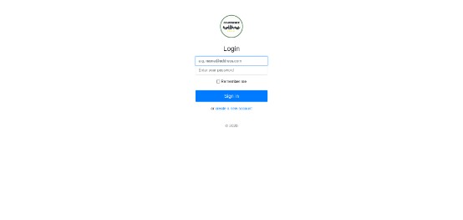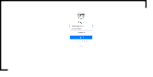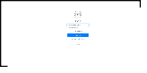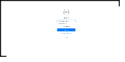

**Figure 3.7:** Generation process of End user Documentation

placeholder pictures, that will be overridden once the Selenium script has been executed. To launch the documentation website two simple commands are needed. Then again, we will not go deeper in details to stay in the scope of our thesis, but there is a great online guide on how to get started with VuePress [29]. As for the Selenium-Java project, it can be imported in an integreted development environment (IDE) such as Eclipse and launch there. After successful execution, all the placeholder picture will have been overridden and we have a complete documentation.

26 *CHAPTER 3. WEBDOC - WEB APPLICATION DOCUMENTOR*

**Chapter 4**

**Evaluation**

The purpose of this chapter is to explain our approach and its results. First, we justify the decision for the chosen approach to the topic, as well as the challenges posed and the solutions found for them. A brief description of the design pattern used and the resulting benefits is also given. Subsequently, a minimal system is used to demonstrate the development of end user documentation. In addition, we present the resulting application, how it can be created and launched. Finally, the overall results and any alternative approaches will be discussed.

# Method selection

Selenium is at the core of our methodology, as it is per se the default automated testing and manipulation framework for Web application. Not only the documentation of the API is thorough and exhaustive – due to the fact that it is open-source – it also allows the manipulation of the majority of the browser engines through WebDrivers [10]. In addition to that, it integrates very well in a Java project as a Maven dependency, making it well- fitted for purposes. It has to be noted that we do not intend to use Selenium for testing our application, rather than for automatically replicating the steps the documentation developer would have to take in order to create screen captures. In that sense, the Selenium WebDriver simulates the end user steps, captures the intermediate states of the Web application and saves them as pictures in a dedicated folder.

Another state-of-the-art framework we chose is VuePress; it is well suited for creating static websites and is therefore perfect for designing technical documentation pages. Moreover, the e*ff*ort required to configure a VuePress project is so low that the website can be up and running quickly. Alternatively, you can e*ff*ortlessly bind the generated

27

28 *CHAPTER 4. EVALUATION*

website to an existing domain, for example a company wiki page or similar. VuePress also has a great online documentation page, with a step-by-step guide on how to quickly setup a project and launch the server.

The link between the Selenium WebDriver and the VuePress project is the generated Java-Maven project. Here, we decided to relieve the documentation developer of the task of adjusting the project properties, adding the dependencies, naming the di*ff*erent packages and so on. This are the tasks an experienced java programmer would have to complete; and as we intend to empower non-programmer to be comfortable using our application, it is best we take care of the implementation of said application ourselves. We have also decided to generate dummy picture to make it possible to create the doc- umentation with having the execute the Selenium script. This brings the advantage that di*ff*erent kind of picture can be added in place of the dummy ones in case the script is never intended to be executed.

Consequently, our editor application o*ff*ered the capability to create a graphical model, which upon clicking the *generate button*, triggers the creation of both the Java application and the VuePress project structure, and subsequently, the Selenium WebDriver takes the indicated screenshots and saves them within the VuePress project folders.

# Setup

The WebDoc editor application is a Cinco editor, which is based on Eclipse. Setting up the development environment is straight forward – at least if a certain acquaintance with the Eclipse environment already exists. Beforehand, a version of Java must be present on the system in order to run the application. Also, to automate a Web browser of choice, the corresponding Selenium WebDriver executable has to be downloaded and its location path has to be added to the system’s PATH variable. Concerning the Selenium libraries, we already take care of it by generating the pom.xml file, containing the required dependencies, along with the whole application structure.

After downloading and extracting the application package, it has to be started just like a common Eclipse IDE would normally be. A splash screen presenting the application and indicating the progress of the launch process appears and within a few second a WebDoc IDE is started.

*4.3. RESULTS* 29

# Results

We implemented a Web Application Documentor (WebDoc) that creates an end user doc- umentation based on graph models using a graphical DSL. The use of graphical elements that resemble the actual HTML elements brings the advantages that the application is easy to use and building model graphs occurs almost intuitively. Also, we the implementation of module checks, we assist the designer in the process of constructing valid model graph that will generate correct, executable application code.

The solution proposed in this thesis yields a well structured and fully function doc- umentation website. To achieved the same result by apply customary methods would require much more time and lines of code (LOC), since the documentation developer would have to navigate the entire Web application take screenshot of the page to be documented and later on create the documentation structure by hand. Our approach uses the Selenium WebDriver, which navigates the Web application in a short amount of time while taking screen captures at the indicated places. Writing such a Selenium script would not only required deep knowledge of the Web automation framework but also good programming skills in Java. In our solution the WebDoc takes care of it for the developer.

The documentation developer would also benefit of the fact that the WebDoc con- veniently creates the VuePress project with all the configuration files ready-to-go. This helps save a great amount of time, since a tutorial on how to create such a project is not necessarily needed.

30 *CHAPTER 4. EVALUATION*

**Chapter 5**

**Future Work**

We have identified a couple of development opportunities for future improvements:

### Cross-referencing model graphs

Reusability dictate that we be able to integrate complete model graphs in others to avoid modeling sequences multiple times. In this thesis, we achieved it by using the PrimeReference feature o*ff*ered by the Cinco framework. Since Cinco itself is still under active development, cross-referencing DocGraphModels inside other could be subject to major improvements in the future, enabling us for example to list all available graph models in the palette, where they would be visible to the WebDoc user and more intuitive to integrate to the currently edited model.

### Implement more checks

We have implemented so far module checks that help build syntactically correct model graphs, by enforcing the constraints defined on the meta-specification level of our graphical DSL. In the future, we could implement more checks to assist the developer in validation some other aspects of the model. For example, we could validate that the string values for the Web element selectors have actually the correct syntax of CSS selectors or XPath selectors by validating them against a well-constructed regular expression.

### Vary the way of selecting Web elements (by XPath or CSS)

The example mentioned in the previous point raises the concern of allowing the developer to address Web elements by XPath and*/*or CSS. We have implemented so far only the user of CSS selector to address them. Many development framework for Web application use dynamic CSS id attributes, which makes it challenging to use as selector for the WebDriver to find. This issue could as well be addressed in future version of our application.

31

32 *CHAPTER 5. FUTURE WORK*

### Extend the list of usable Web elements

One last point issue that require our attention is the list of available Web elements to use while modeling. For those who are experienced in Web development, it is not surprising that new HTML elements be implement in the future. We fast-developing technologies and the growing amount of devices that can launch browser applica- tion, we might have to adapt and o*ff*er more model elements to reflect new ones. In the same way, we might be forced to remove some elements, since it is also possible that some HTML elements be marked as deprecated and not be rendered by any Web browser anymore.

**Chapter 6**

**Conclusion**

We have proposed a solution for a DSL-driven generation of end user documentation for Web applications along the ongoing example of our tasks management Web applica- tion using the Cinco Meta Tooling Suite, which has provided us with the possibility to implement a specification for our own graphical DSL.

Making use of the Cinco Meta Graph Language (MGL) and Meta Style Language (MSL), we determined the look of each model element of our graphical DSL by keeping a close fidelity to the actual HTML elements they represent. This allowed us to create an editor application, that enables the documentation designer to use those model elements to create graph diagram illustrating the needed user workflow. By applying model check- ing methods to validate resulting diagrams, we ensure that executable application code be generated within corresponding folder structure following established conventions.

We have been able to identify the characteristics of an end user documentation by following known standards and wisely apply the appropriate format, namely Markdown, to structure our it and also choose VuePress as the right framework technologies to transform it to a static website rendered in the Web browser.

33

34 *CHAPTER 6. CONCLUSION*

**List of Figures**

* 1. Plain-text transformation with Markdown . . . . . . . . . . . . . . . . . . . 8
  2. Hierarchy of our graphical DSL specification 11
  3. Cinco Product Application - Graph model editor 18
  4. Cinco product - Feature Graph Model with Feature Containers 20
  5. Cinco product - Reusing Login graph model in the CreateNewList graph model 21
  6. Example of a user workflow: here the login sequence 22
  7. Project Validation view showing passed and failed checks 23
  8. Cinco product - generator button 24
  9. Generation process of End user Documentation 25

35

36 *LIST OF FIGURES*

**Listings**

* 1. Excerpt from the feature.mgl, meta-specification of the FeatureGraphModel 12
  2. Excerpt from the Doc.mgl, meta-specification of the DocGraphModel . . . 13
  3. Excerpt from feature.style to be applied to feature.mgl 14
  4. UserDocumentationTool.cpd 15

37

38 *LISTINGS*

**Glossary**

### DOM

The Document Object Model (DOM) is a cross-platform and language-independent interface that treats an XML or HTML document as a tree structure wherein each node is an object representing a part of the document. The DOM represents a doc- ument with a logical tree. [https:*//*en.wikipedia.org*/*wiki*/*Document_Object_Model](https://en.wikipedia.org/wiki/Document_Object_Model).

### Ecore

The core Eclipse Modeling Framework (EMF) includes a metamodel (Ecore) for de- scribing models and runtime support for the models including change notification, persistence support with default XMI serialization, and a very e*ffi*cient reflective API for manipulating EMF objects generically..

### Selenium

Selenium is a suite of tools for automating Web browsers. See [https:*//*www.selenium.](https://www.selenium.dev/about/) [dev*/*about*/*](https://www.selenium.dev/about/).

### VuePress

VuePress is a Static Site Generator that generates pre-rendered static HTML for each page, and runs as an SPA once a page is loaded..

39

40 *Glossary*

**Abbreviations**

**API** Application Programming Interface.

**CPD** Cinco Product Definition. **DOM** Document Object Model. **DSL** domain-specific language. **EMF** Eclipse Modeling Framework.

**HTML** HyperText Markup Language.

**IDE** integreted development environment.

**IEC** International Electrotechnical Commission.

**IEEE** Institute of Electrical and Electronics Engineers.

**ISO** International Standards Organization.

**jABC** Java Application Building Center.

**LOC** lines of code.

**MDD** model-driven development.

**MDSD** model-driven software development.

**MGL** Meta Graph Language.

**MSL** Meta Style Language.

**OOP** Object Oriented Programming.

**UI** User Interface.

**UML** Unified Modeling Language.

**WebDoc** Web Application Documentor.

41

42 *Abbreviations*

**Bibliography**

1. *IEEE Standard for Adoption of ISO*/*IEC 26514:2008 Systems and Software Engineering– Requirements for Designers and Developers of User Documentation*, January 2011.
2. *ISO*/*IEC*/*IEEE International Standard - Systems and software engineering - Requirements for managers of information for users of systems, software, and services*. ISO*/*IEC*/*IEEE 26511:2018(E), pages 1–90, 2018.
3. *ISO*/*IEC*/*IEEE International Standard - Systems and software engineering–Software life cycle processes–Part 2: Relation and mapping between ISO*/*IEC*/*IEEE 12207:2017 and ISO*/*IEC 12207:2008*. ISO*/*IEC*/*IEEE 12207-2:2020(E), pages 1–278, 2020.
4. Amalfitano, Domenico, Anna Rita Fasolino and Porfirio Tramontana: *Using dynamic analysis for generating end user documentation for Web 2.0 applications*. In *2011 13th IEEE International Symposium on Web Systems Evolution (WSE)*, pages 11–20. IEEE, September 2011.
5. Bettini, Lorenzo: *Implementing domain-specific languages with Xtext and Xtend*. Packt Publishing Ltd, 2016.
6. Bosselmann, Steve, Markus Frohme, Dawid Kopetzki, Michael Lybecait, Stefan Naujokat, Johannes Neubauer, Dominic Wirkner, Philip Zweihoff and Bernhard Steffen: *DIME: A Programming-Less Modeling Environment for Web Applications*. In Margaria, Tiziana and Bernhard Steffen (editors): *Leveraging Applications of Formal Methods, Verification and Validation: Discussion, Dissemination, Applications*, pages 809– 832, Cham, 2016. Springer International Publishing.
7. Brambilla, Marco, Jordi Cabot and Manuel Wimmer: *Model-driven software engi- neering in practice*. Synthesis lectures on software engineering, 3(1):1–207, 2017.
8. Cinco, Dev. Team: *About Cinco SCCE Meta Tooling Framework*. [https:*//*cinco.scce.info*/*](https://cinco.scce.info/about/)[about*/*](https://cinco.scce.info/about/)„ July 14, 2021.
9. Cone, Matt: *Markdown Guide* | *Getting Started*. https:*//*[www.markdownguide.org*/*getting-started*/*,](http://www.markdownguide.org/getting-started/) October 2021.

43

44 *BIBLIOGRAPHY*

1. Conservancy, Software Freedom: *Getting Started* | *Selenium*. [https:*//*www.selenium.](https://www.selenium.dev/documentation/getting_started/) [dev*/*documentation*/*getting_started*/*](https://www.selenium.dev/documentation/getting_started/), October 2021.
2. contributors, MDN: *HTML: HyperText Markup Language*. https:*//*developer.mozilla.org*/*en-US*/*docs*/*Web*/*HTML.
3. Daniel Busch, Annika Fuhge: *Cinco Product Specification*. [https:*//*gitlab.com*/*scce*/*](https://gitlab.com/scce/cinco/-/wikis/Cinco-Product-Specification)[cinco*/*-*/*wikis*/*Cinco-Product-Specification](https://gitlab.com/scce/cinco/-/wikis/Cinco-Product-Specification). Accessed: October 02, 2021.
4. Descher, Marco, Thomas Feilhauer and Lucia Amann: *Automated user documenta- tion generation based on the Eclipse application model*. 04 2015.
5. Despa, Mihai Liviu: *Comparative study on software development methodologies*. Database Systems Journal, 5(3):37–56, 2014.
6. Eclipse.org: *Java with Spice*. [https:*//*www.eclipse.org*/*xtend*/*documentation*/*](https://www.eclipse.org/xtend/documentation/). Ac- cessed: September 24, 2021.
7. Foundation, Eclipse: *Rich Client Platform*. https:*//*wiki.eclipse.org*/*Rich_Client_Platform.
8. Fowler, Matin: *ModelDrivenSoftwareDevelopment*. [https:*//*martinfowler.com*/*bliki*/*](https://martinfowler.com/bliki/ModelDrivenSoftwareDevelopment.html)[ModelDrivenSoftwareDevelopment.html](https://martinfowler.com/bliki/ModelDrivenSoftwareDevelopment.html), 2008.
9. Kipyegen, Noela Jemutai and William PK Korir: *Importance of software documenta- tion*. International Journal of Computer Science Issues (IJCSI), 10(5):223, 2013.
10. Naujokat, Stefan: *Heavy meta: model-driven domain-specific generation of generative domain-specific modeling tools*. PhD thesis, Technical University of Dortmund, 2017.
11. Naujokat, Stefan, Michael Lybecait, Dawid Kopetzki and Steffen Bernhard: *CINCO, a simplicity-drivern approach to full generation of domain-specific graphical mod- eling tools.* International Journal on Software Tools for Technology Transfer, 20(3), 2018.
12. Oliveira, Allan dos Santos: *GuideAutomator: Automated user manual generation with Markdown*. 2016.
13. Pe´rez Andre´s, Francisco, Juan de Lara and Esther Guerra: *Domain Specific Lan- guages with Graphical and Textual Views*. In Schu¨ rr, Andy, Manfred Nagl and Albert Zu¨ ndorf (editors): *Applications of Graph Transformations with Industrial Relevance*, pages 82–97, Berlin, Heidelberg, October 2008. Springer Berlin Heidelberg.
14. SCCE, Group: *Sustainable Computing for Continuous Engineering*. [https:*//*www.scce.](https://www.scce.info/) [info*/*](https://www.scce.info/). Accessed: September 29, 2021.

*DECLARATION* 45

1. Stahl, Thomas, Markus Voelter and Krzysztof Czarnecki: *Model-Driven Software Development: Technology, Engineering, Management*. John Wiley & Sons, Inc., Hoboken, NJ, USA, July 2006.
2. Steffen, Bernhard, Tiziana Margaria, Ralf Nagel, Sven Jo¨ rges and Christian Kubczak: *Model-Driven Development with the jABC*. In Bin, Eyal, Avi Ziv and Shmuel Ur (editors): *Hardware and Software, Verification and Testing*, pages 92–108, Berlin, Heidelberg, 2007. Springer Berlin Heidelberg.
3. TU Dortmund, Chair of Programming Systems: *Java Application Building Center*. [http:*//*ls5-www.cs.tu-dortmund.de*/*projects*/*jabc*/*index.php](http://ls5-www.cs.tu-dortmund.de/projects/jabc/index.php). Accessed: October 04, 2021.
4. ufba aside: *GuidAutomator Github Repository*. https:*//*github.com*/*aside-ufba*/*guide- automator.
5. Waits, Todd and Joseph Yankel: *Continuous system and user documentation integration*. In *2014 IEEE International Professional Communication Conference (IPCC)*, pages 1–5, 2014.
6. You, Evan: *VuePress* | *Vue-powered Static Site Generator*. https:*//*vuepress.vuejs.org*/*, October 2021.

46

*DECLARATION* 47

I hereby certify that I have written this paper independently and have not used any sources or aids other than those indicated, and that I have clearly marked any citations.

Dortmund, November 1, 2021

Mukendi Mputu

48