**EBS-Elastic Block Store**

It’s durable. Block level storage volumes can attached in running EC2 instance and we can use it like physical harddrive.it support encryption feature also. And we can work single AZ only at the time.

Create EC2 instance

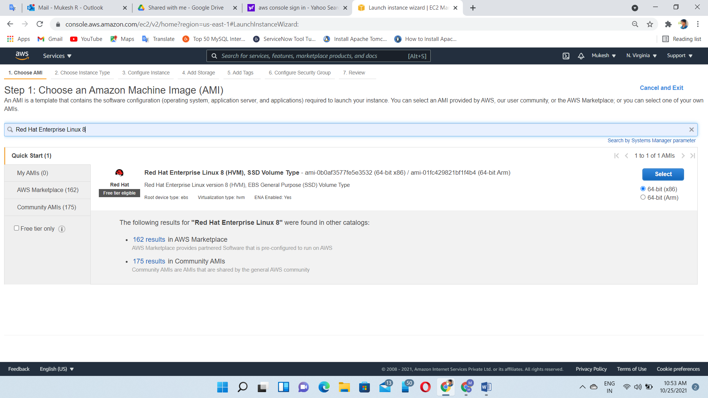

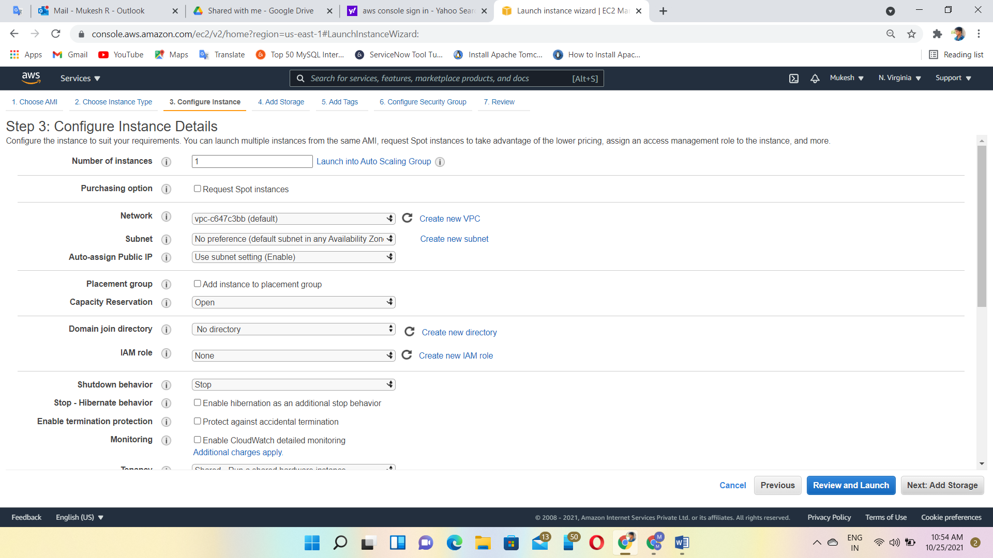

Allow All traffic

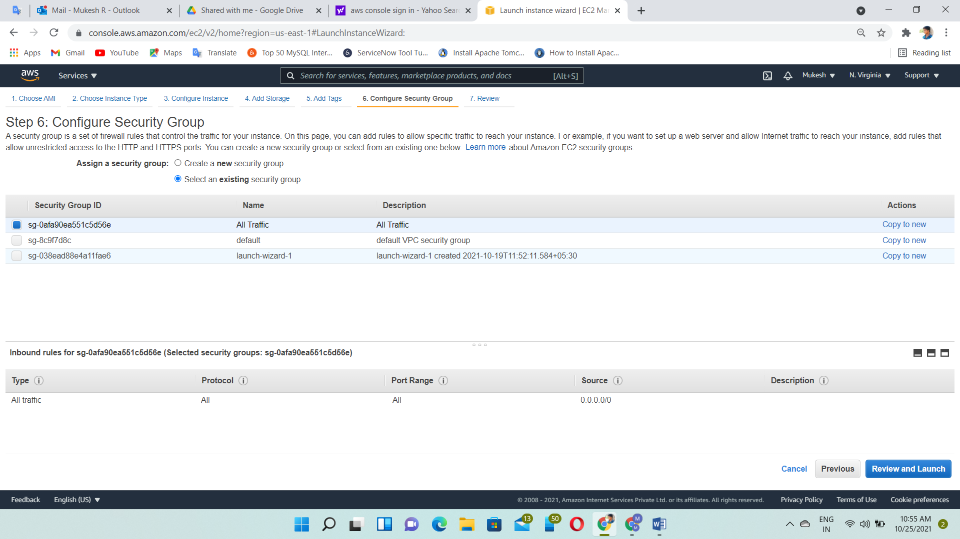

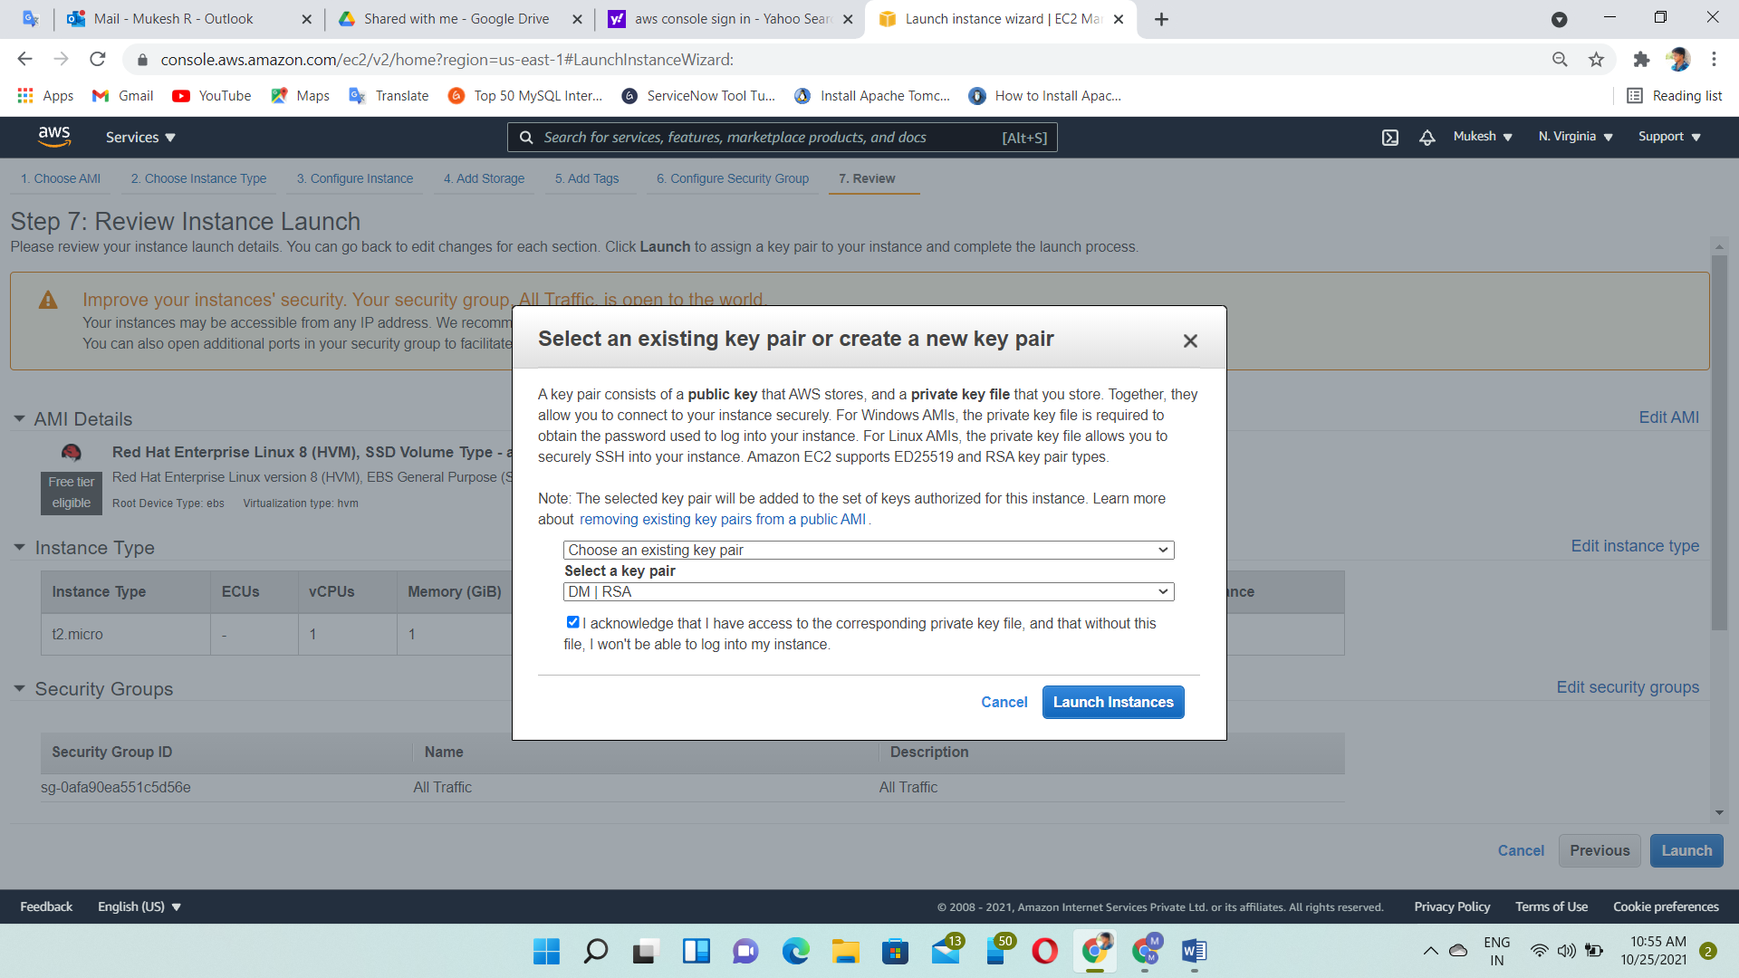

Login to the Ec2 instance through putty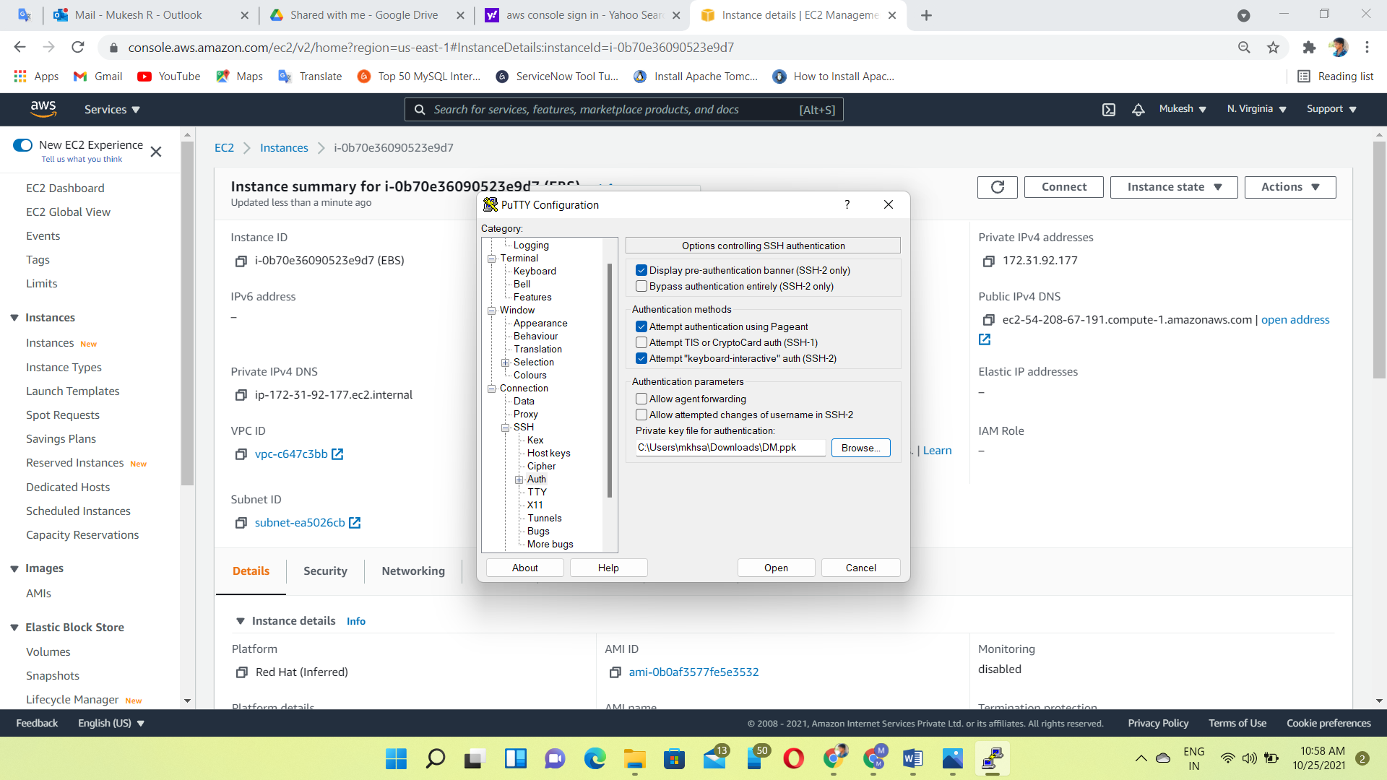

Command: check default blocks

View the Block🡪 lsblk

Parted /dev/xvda

print free

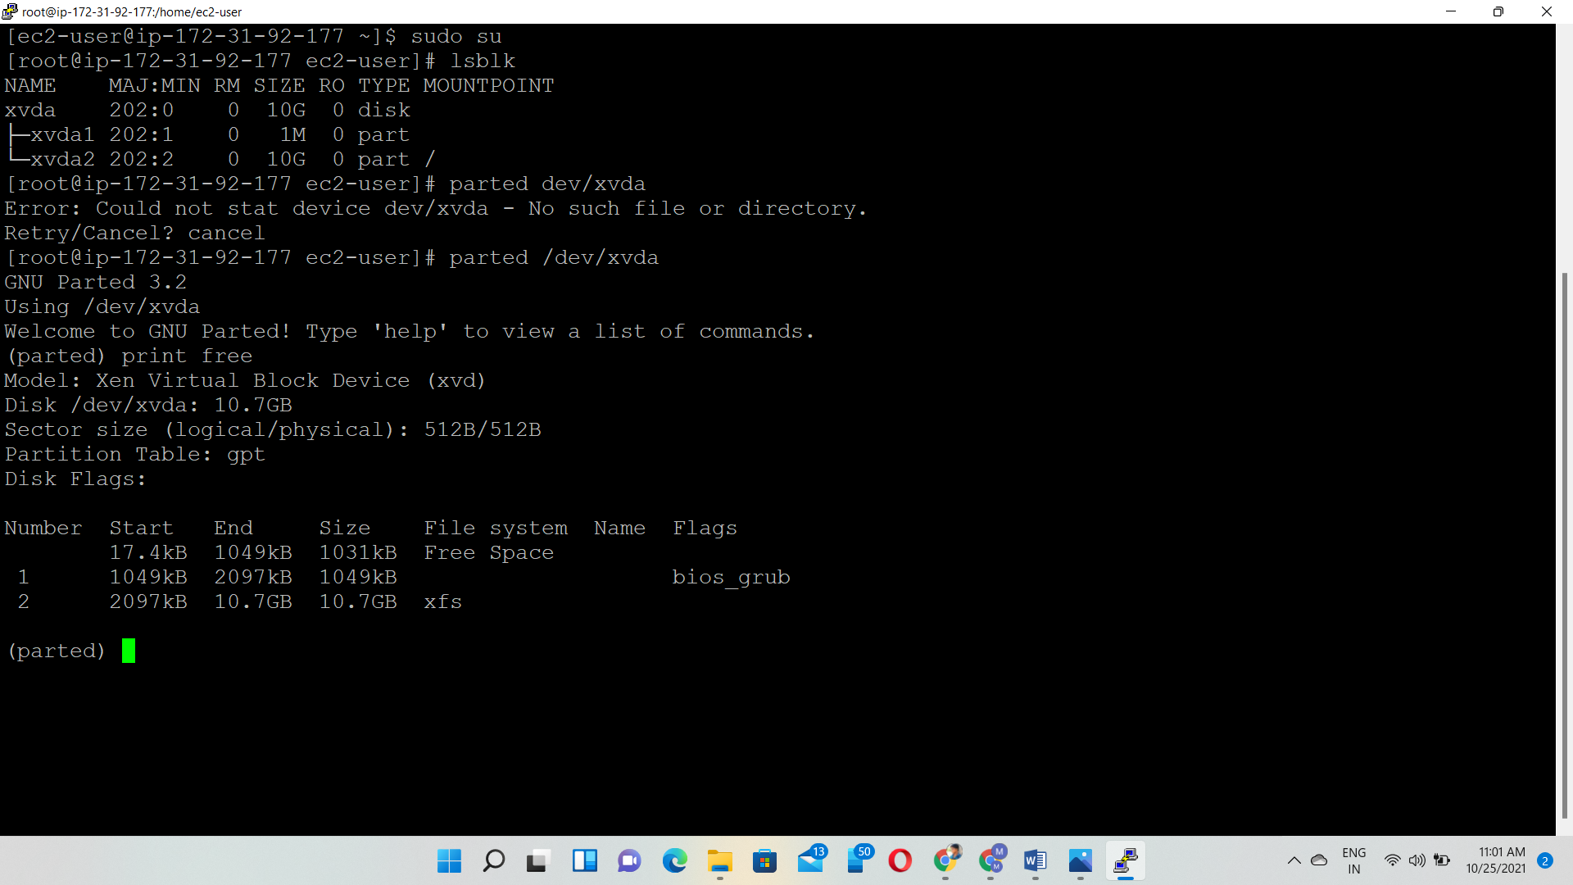

Create EBS Volume

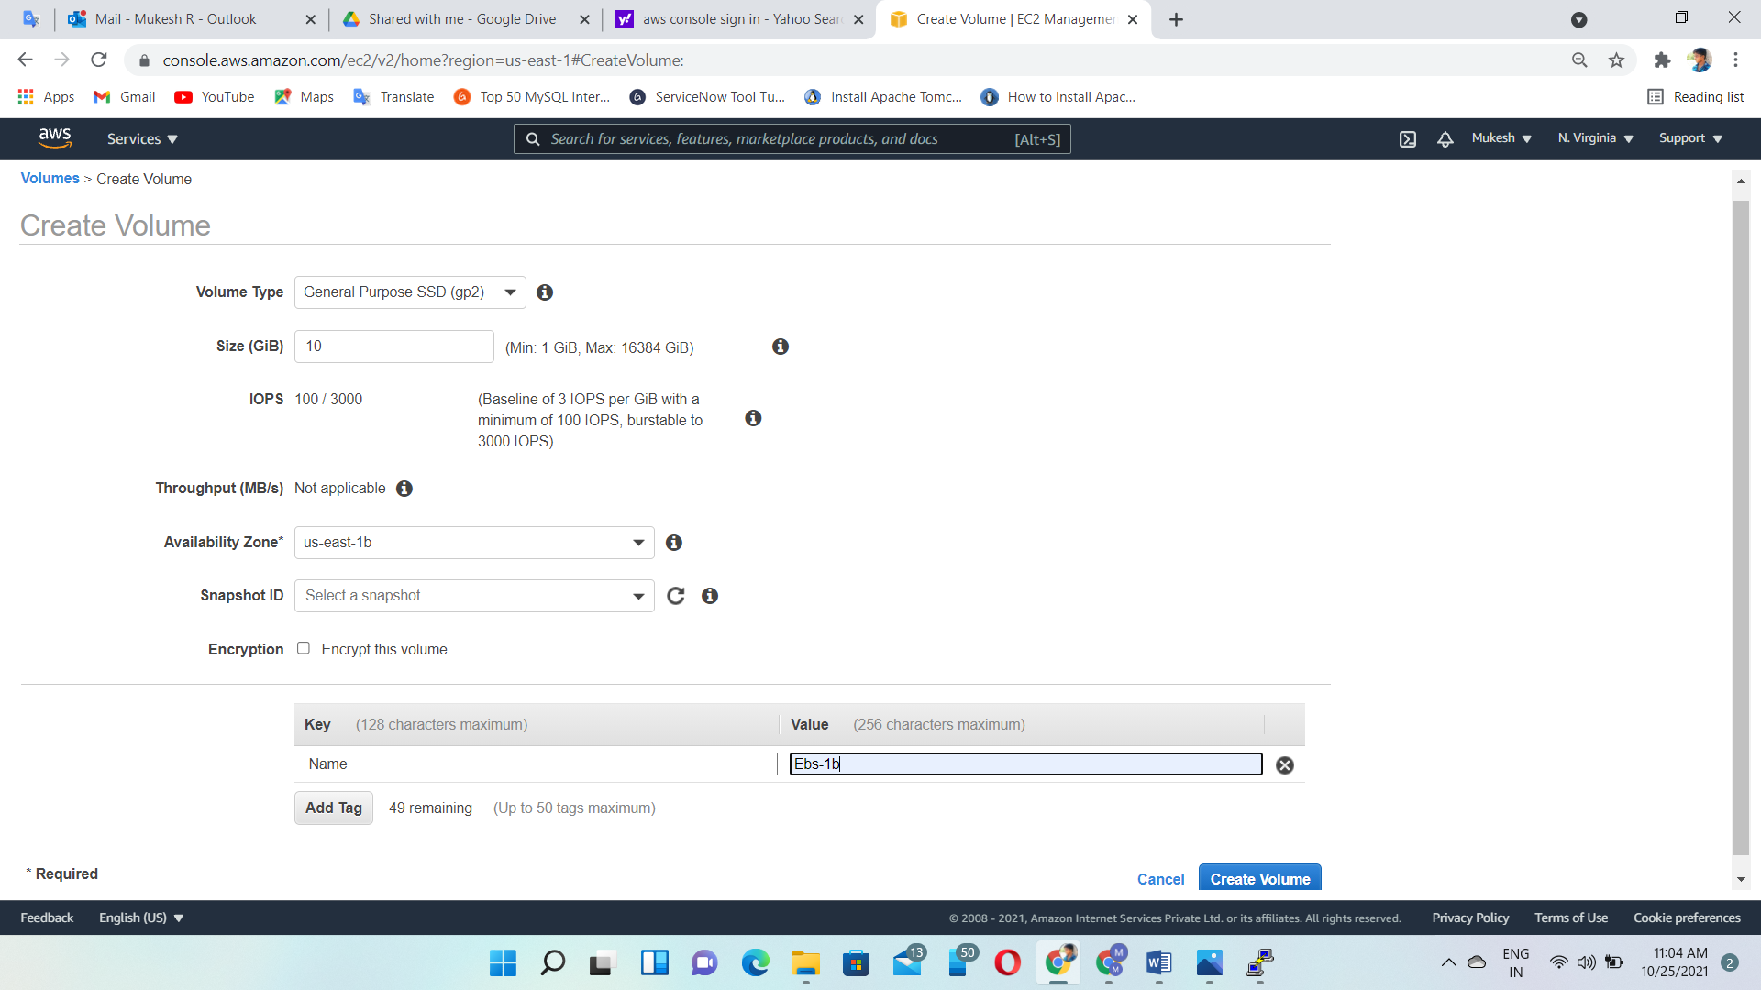

Attach volume to the EC2 instance

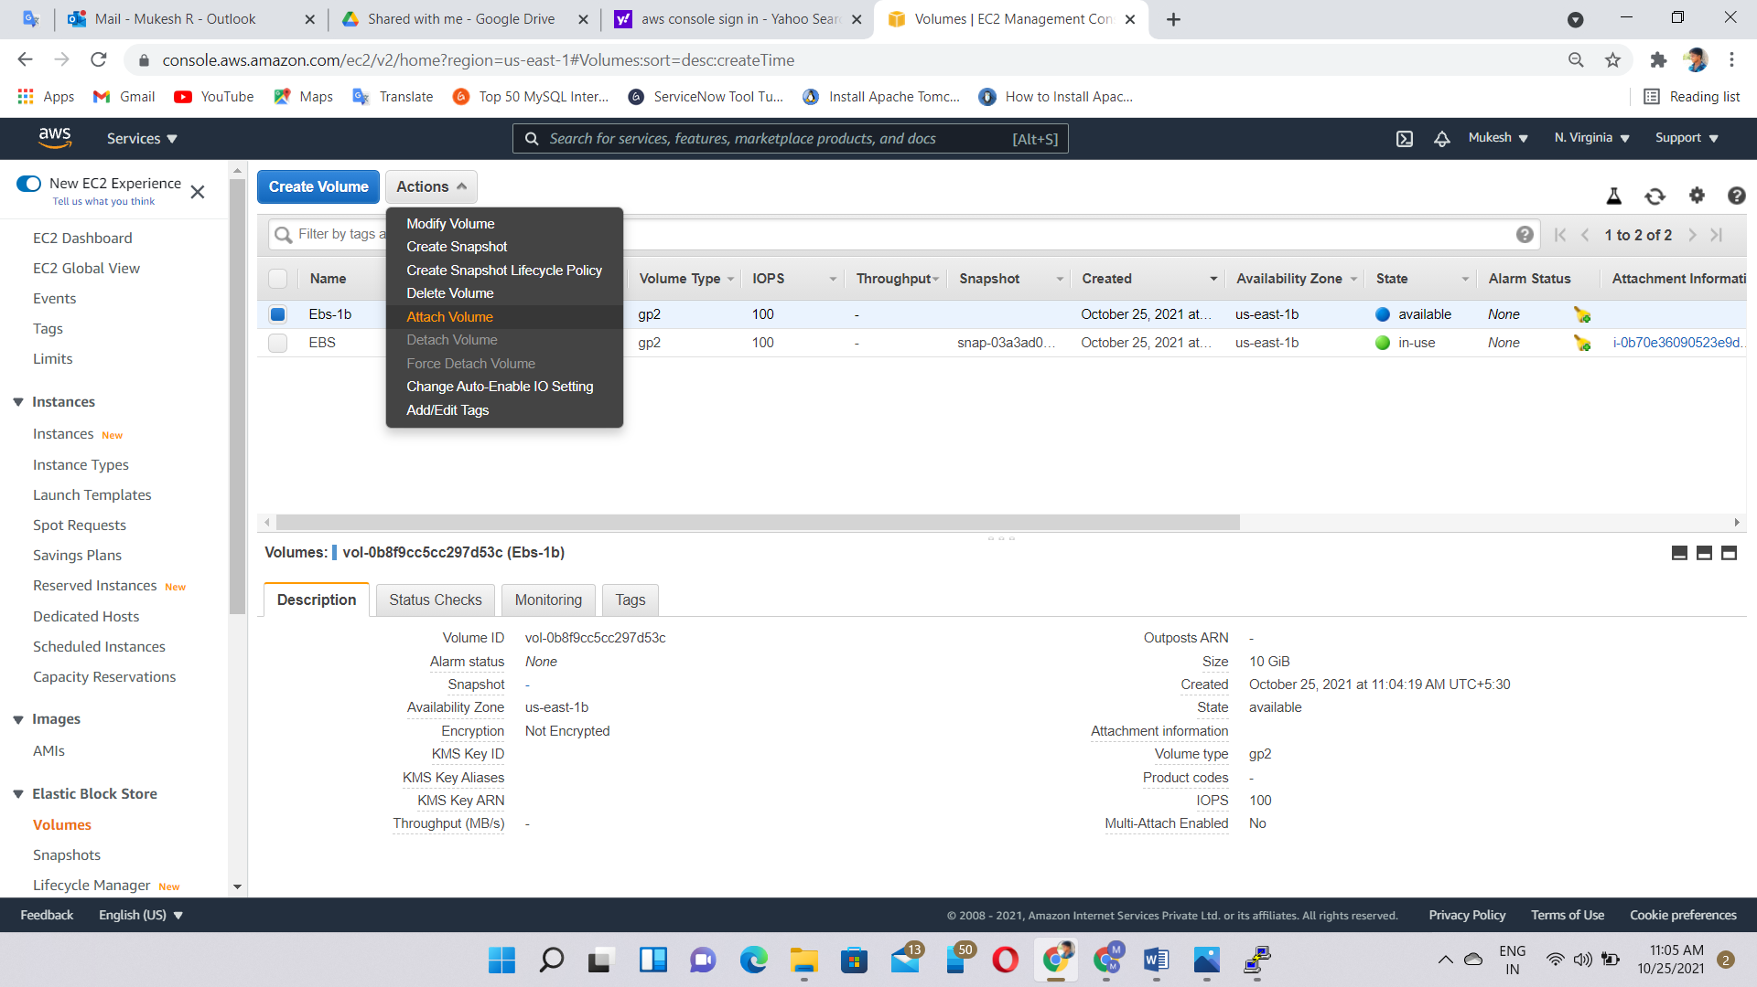

Attached

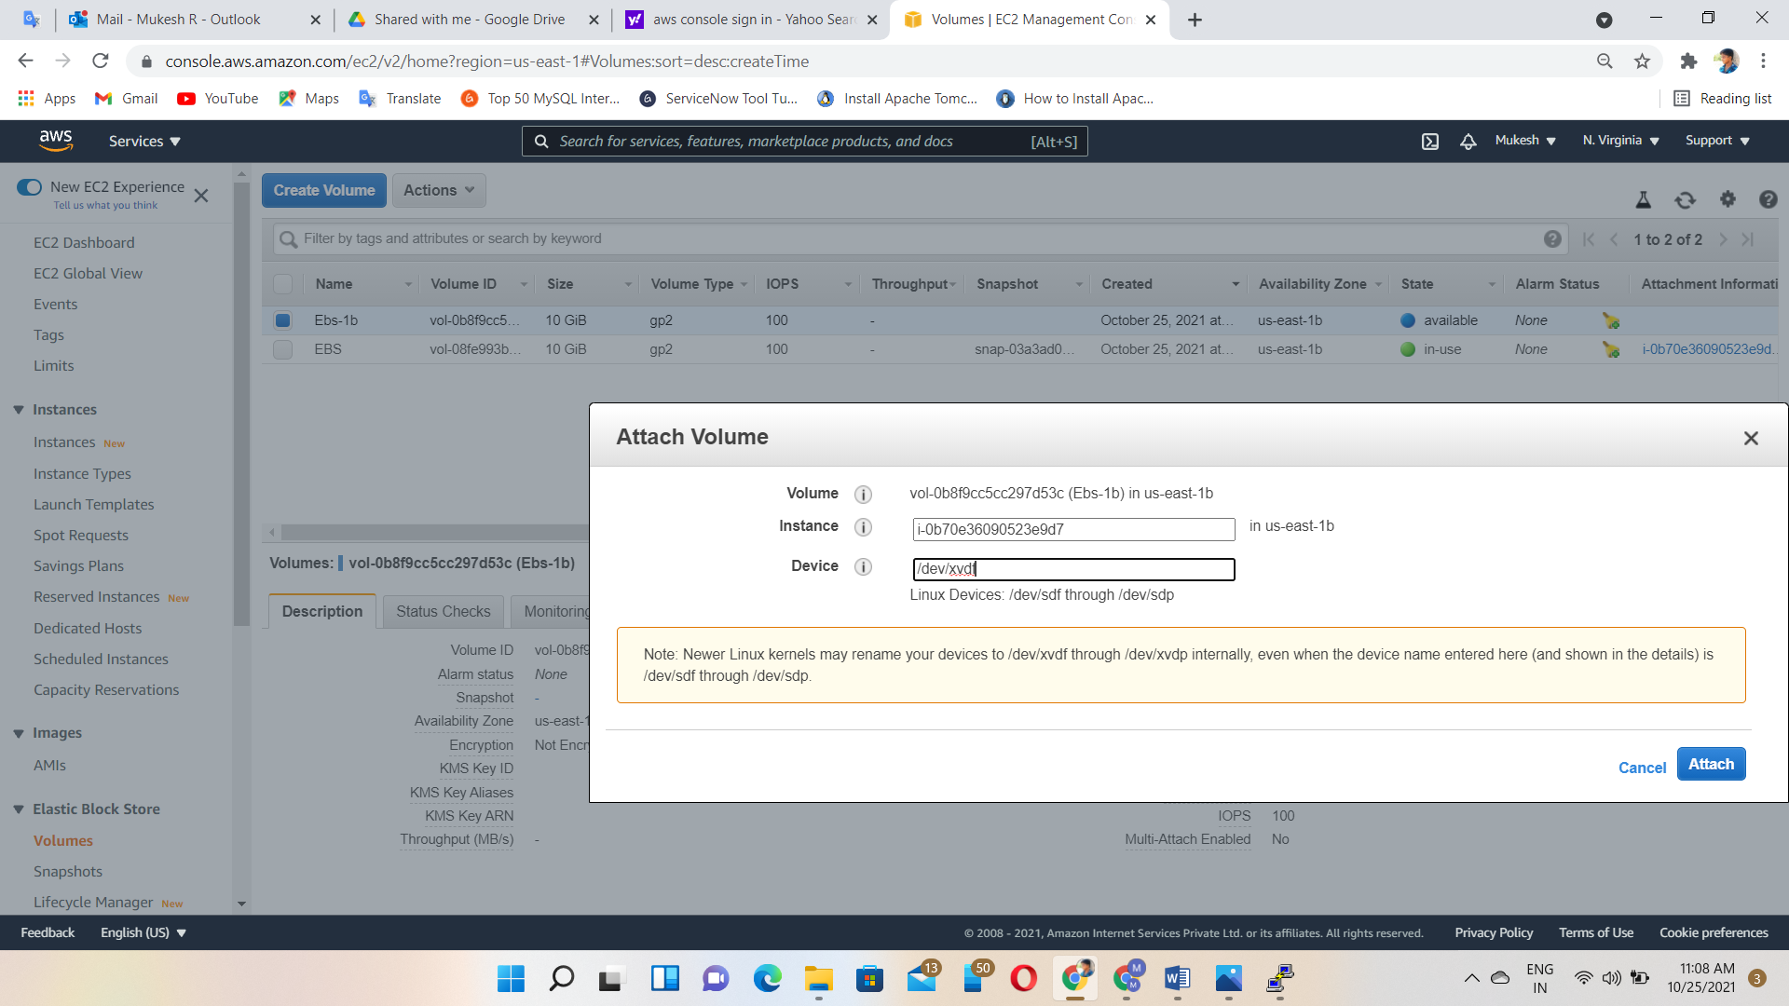

Again, check & view the Blocks

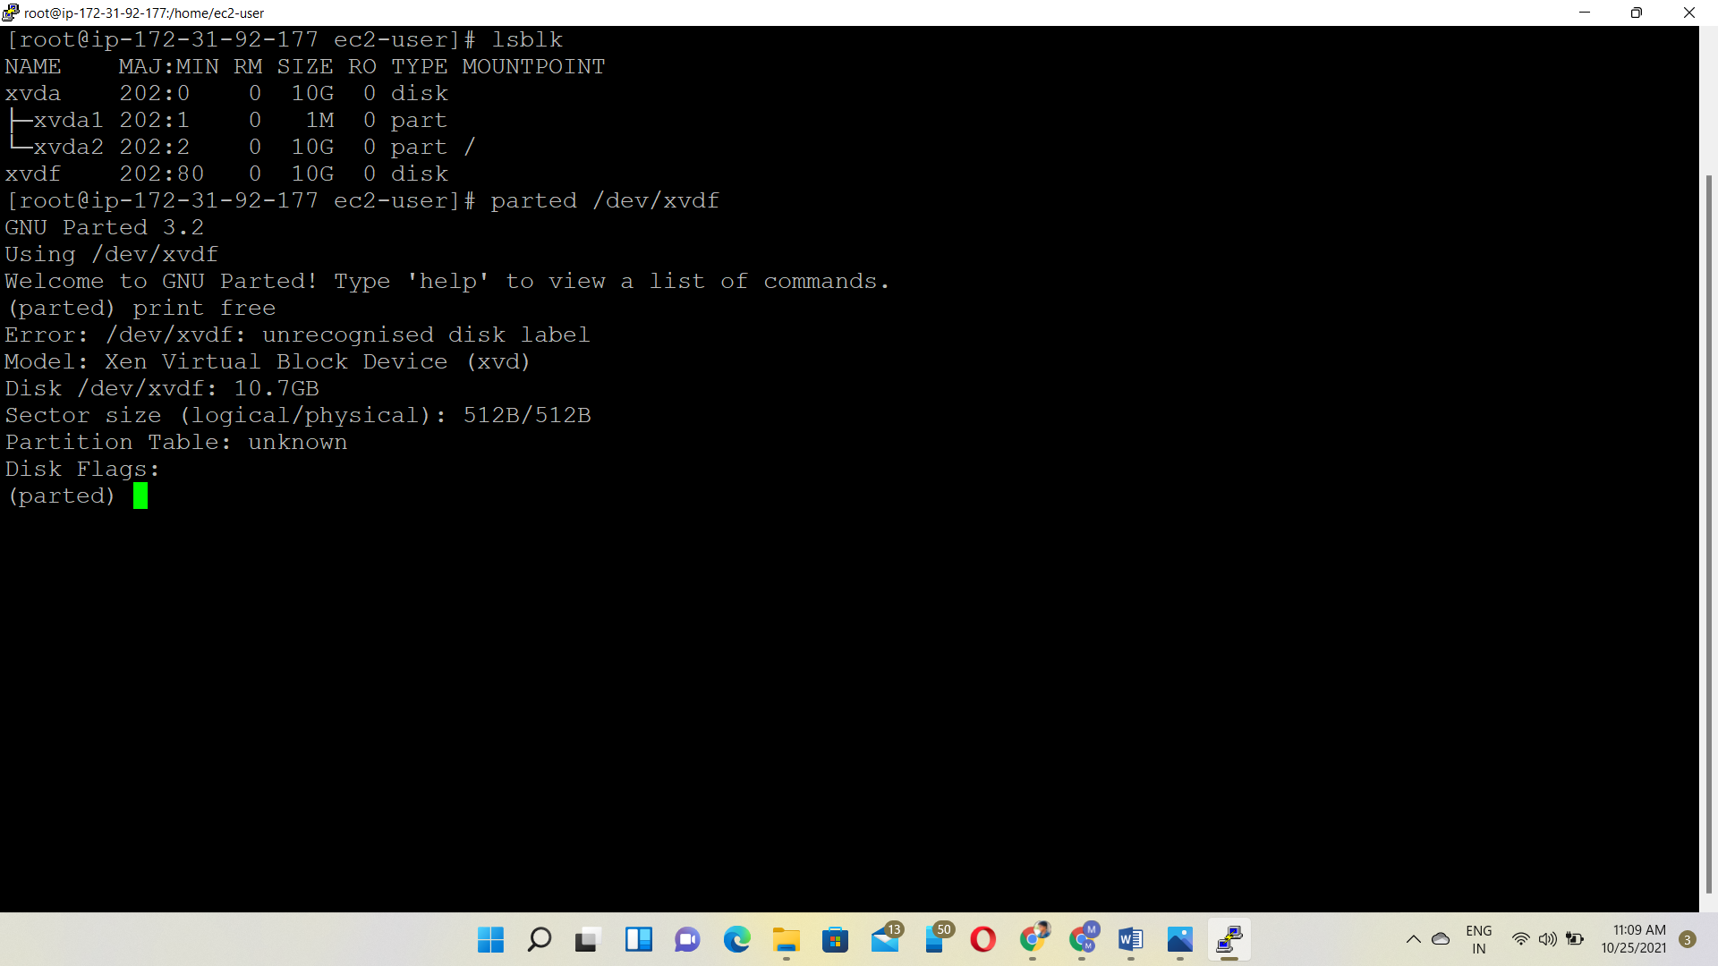

Next we have to partitioned the storage volume as per our necessity for that we use fdisk /dev/xvdf command

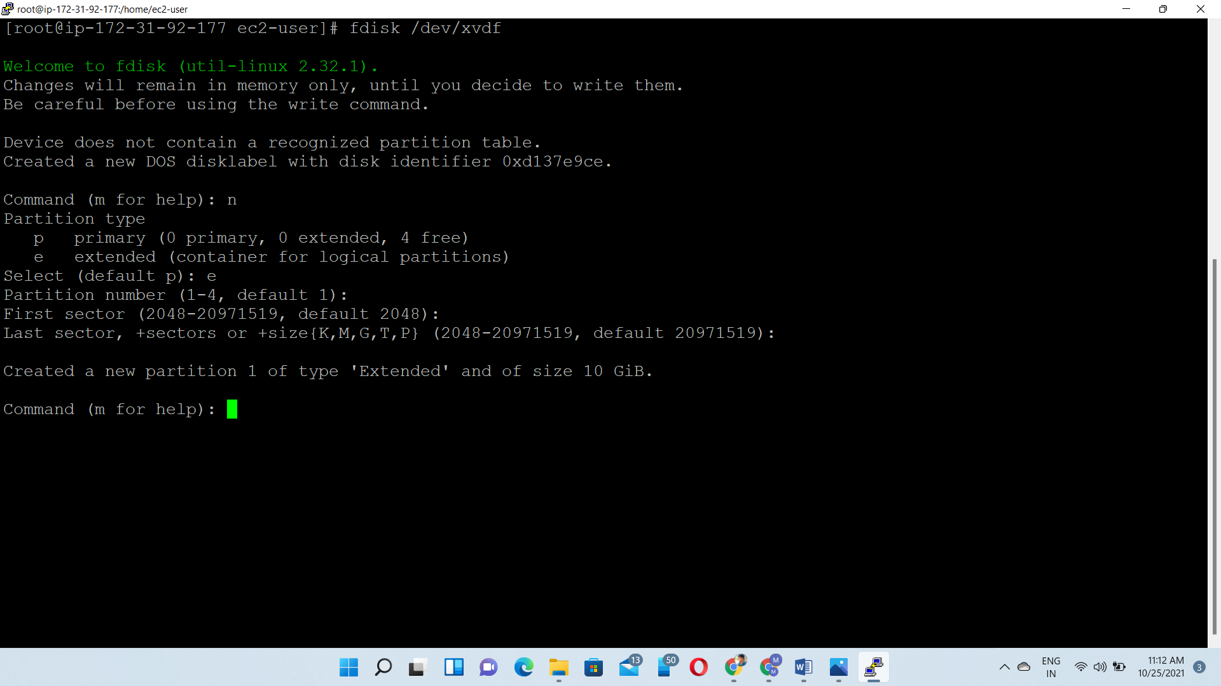

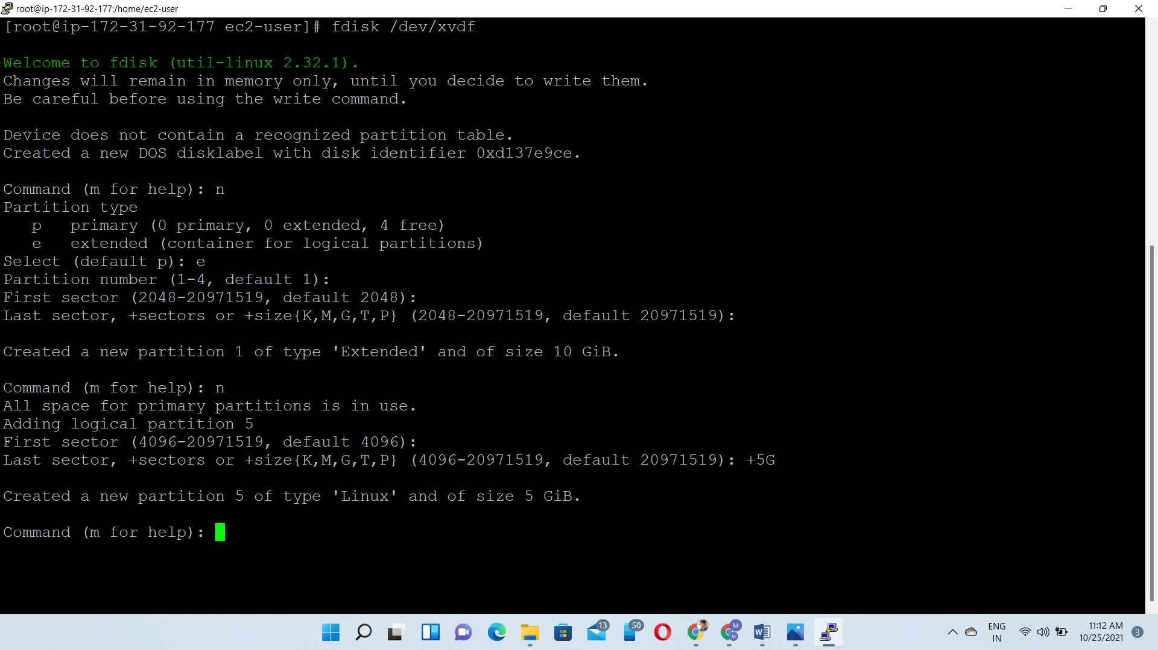

Output:

