**S3-Glacier**

It is secure, durable and low cast storage for data archiving and we can reliably store any amount of data and costs also cheaper than on-premises solutions.

Create a windows Ec2 instance

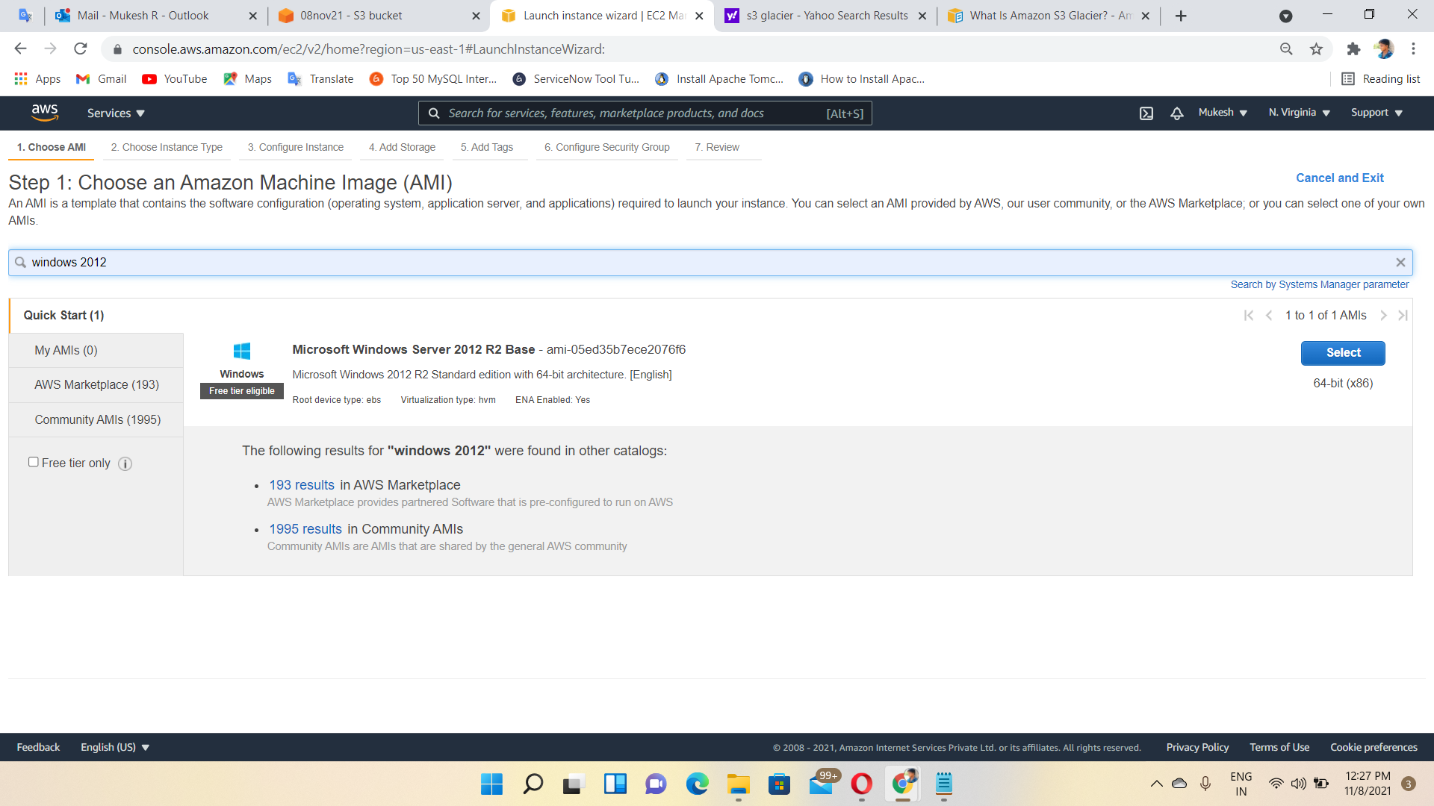

Instance Created

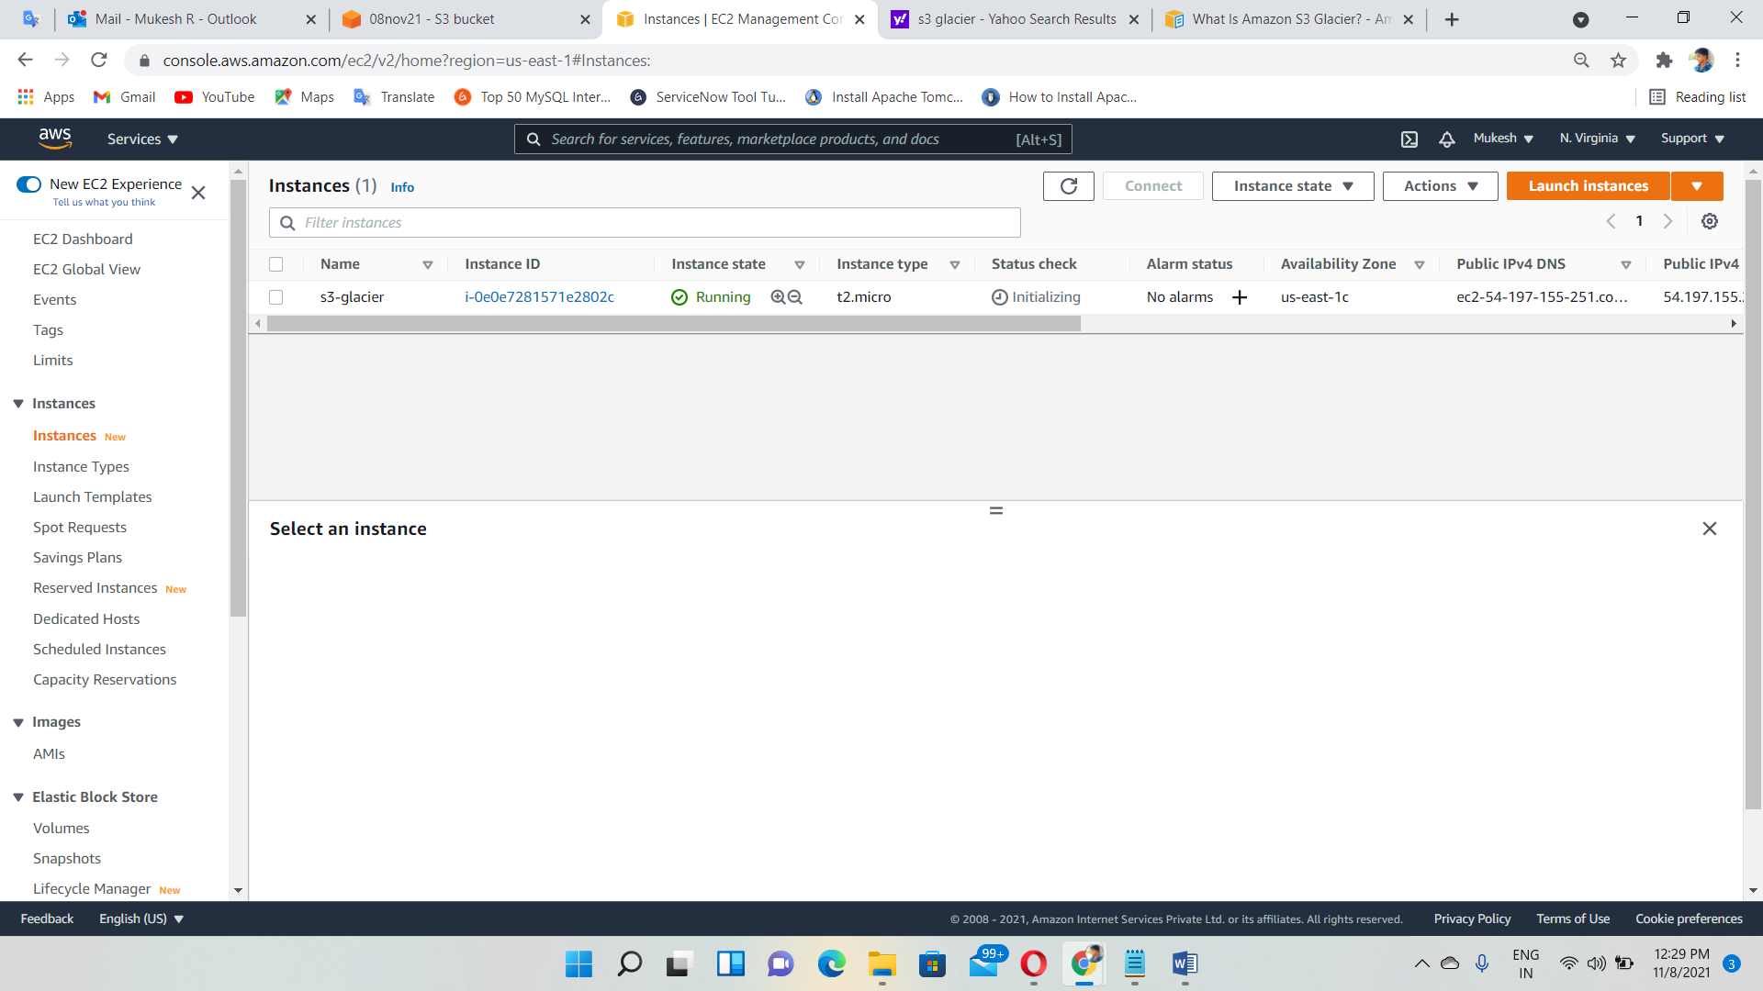

Create Role with “Glacier Full access” permission

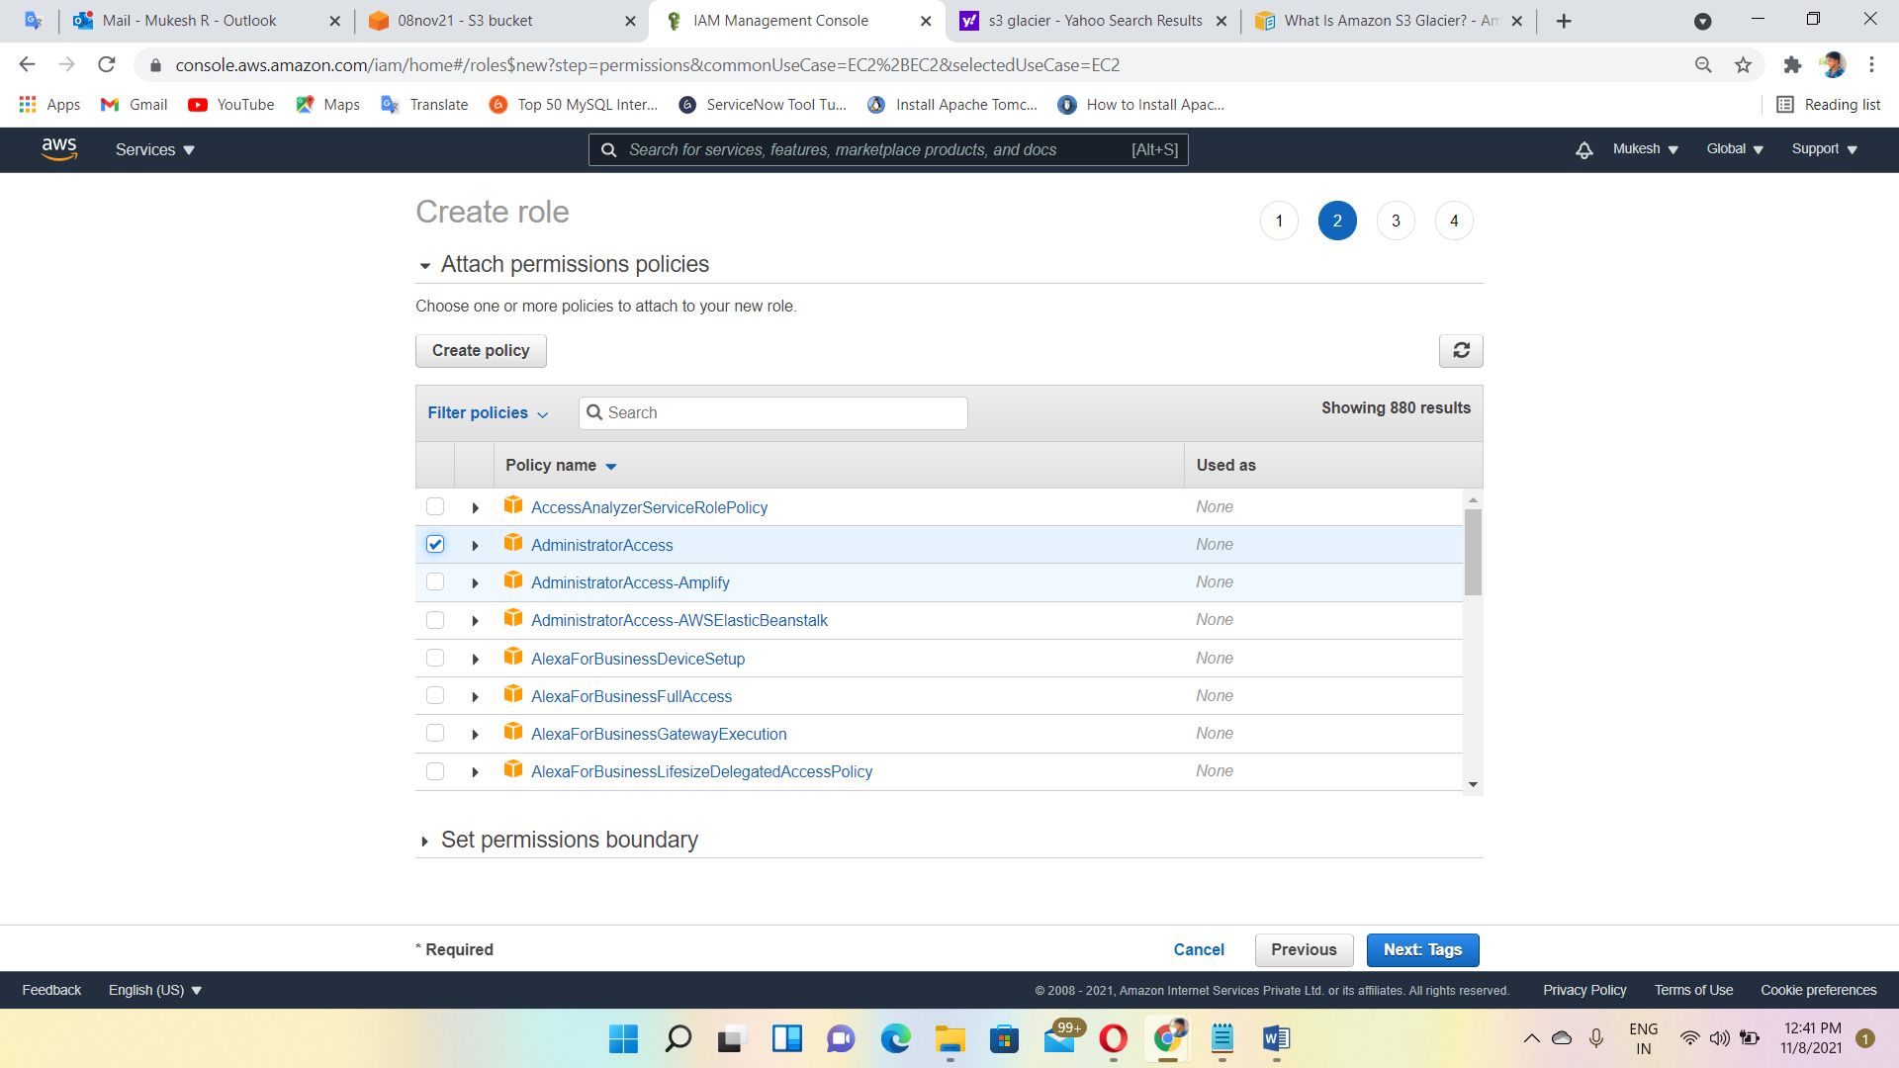

Role Created

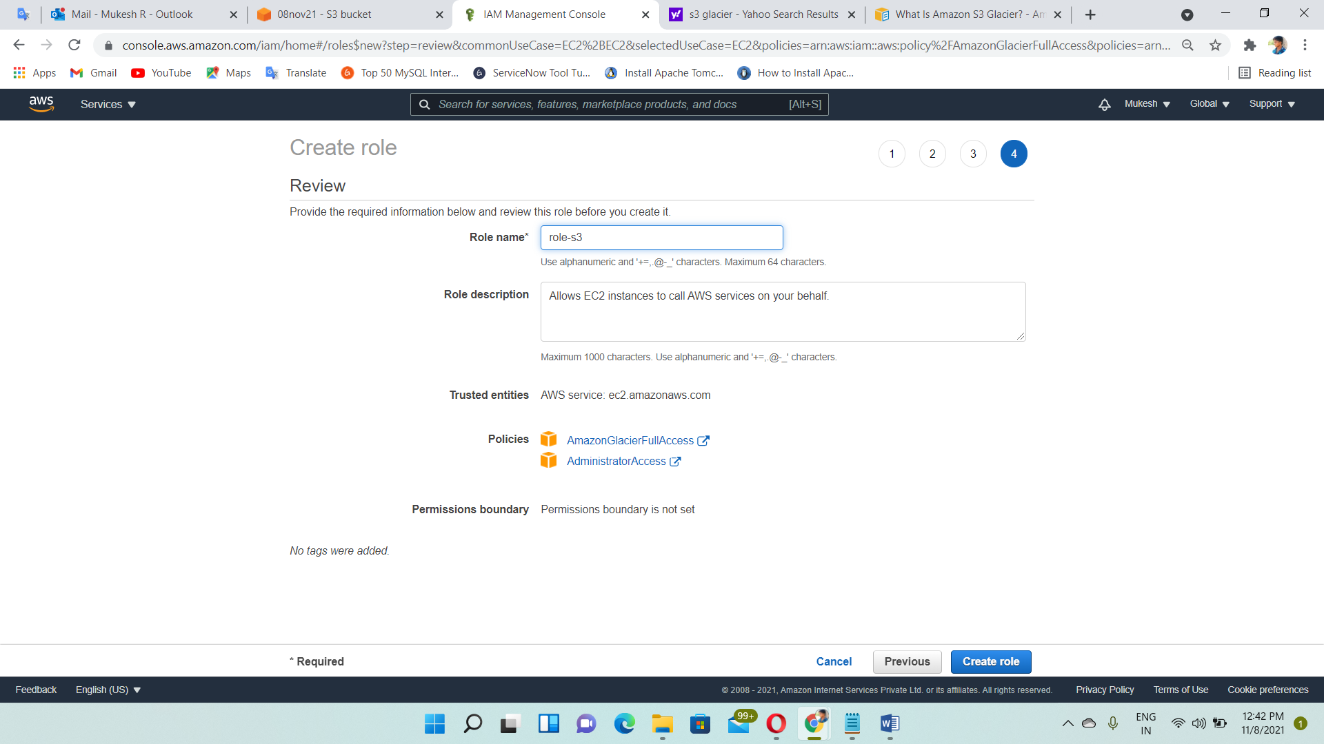

Attach Role to the Instance

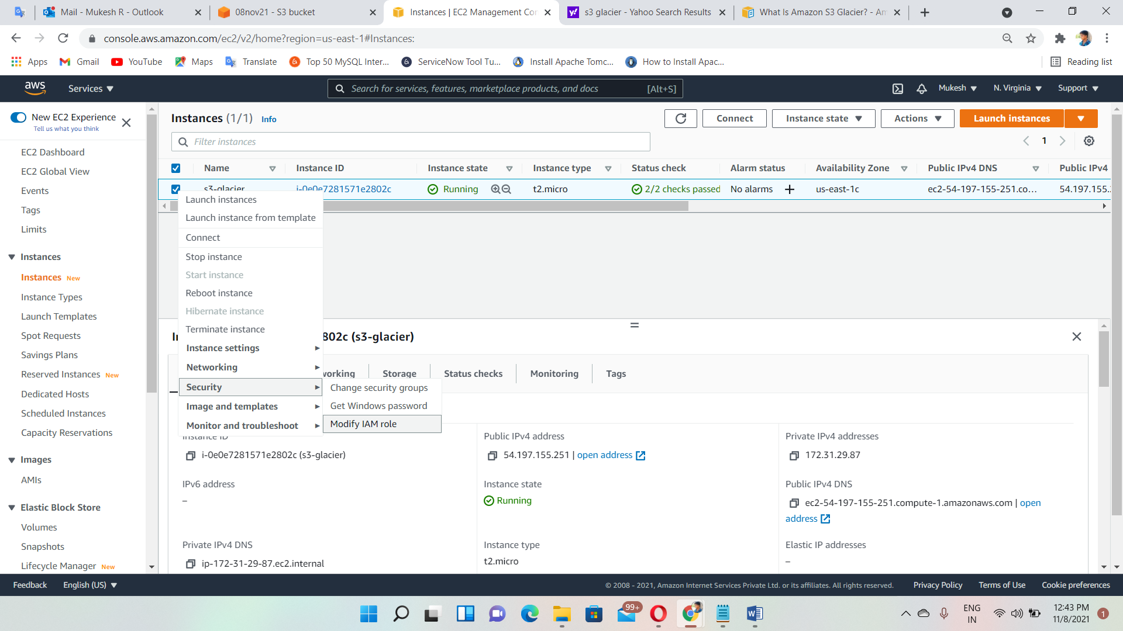

Role attached

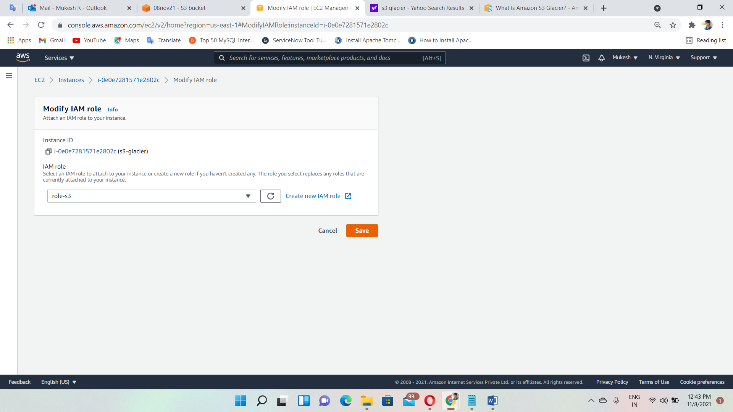

Login to the instance via RDP

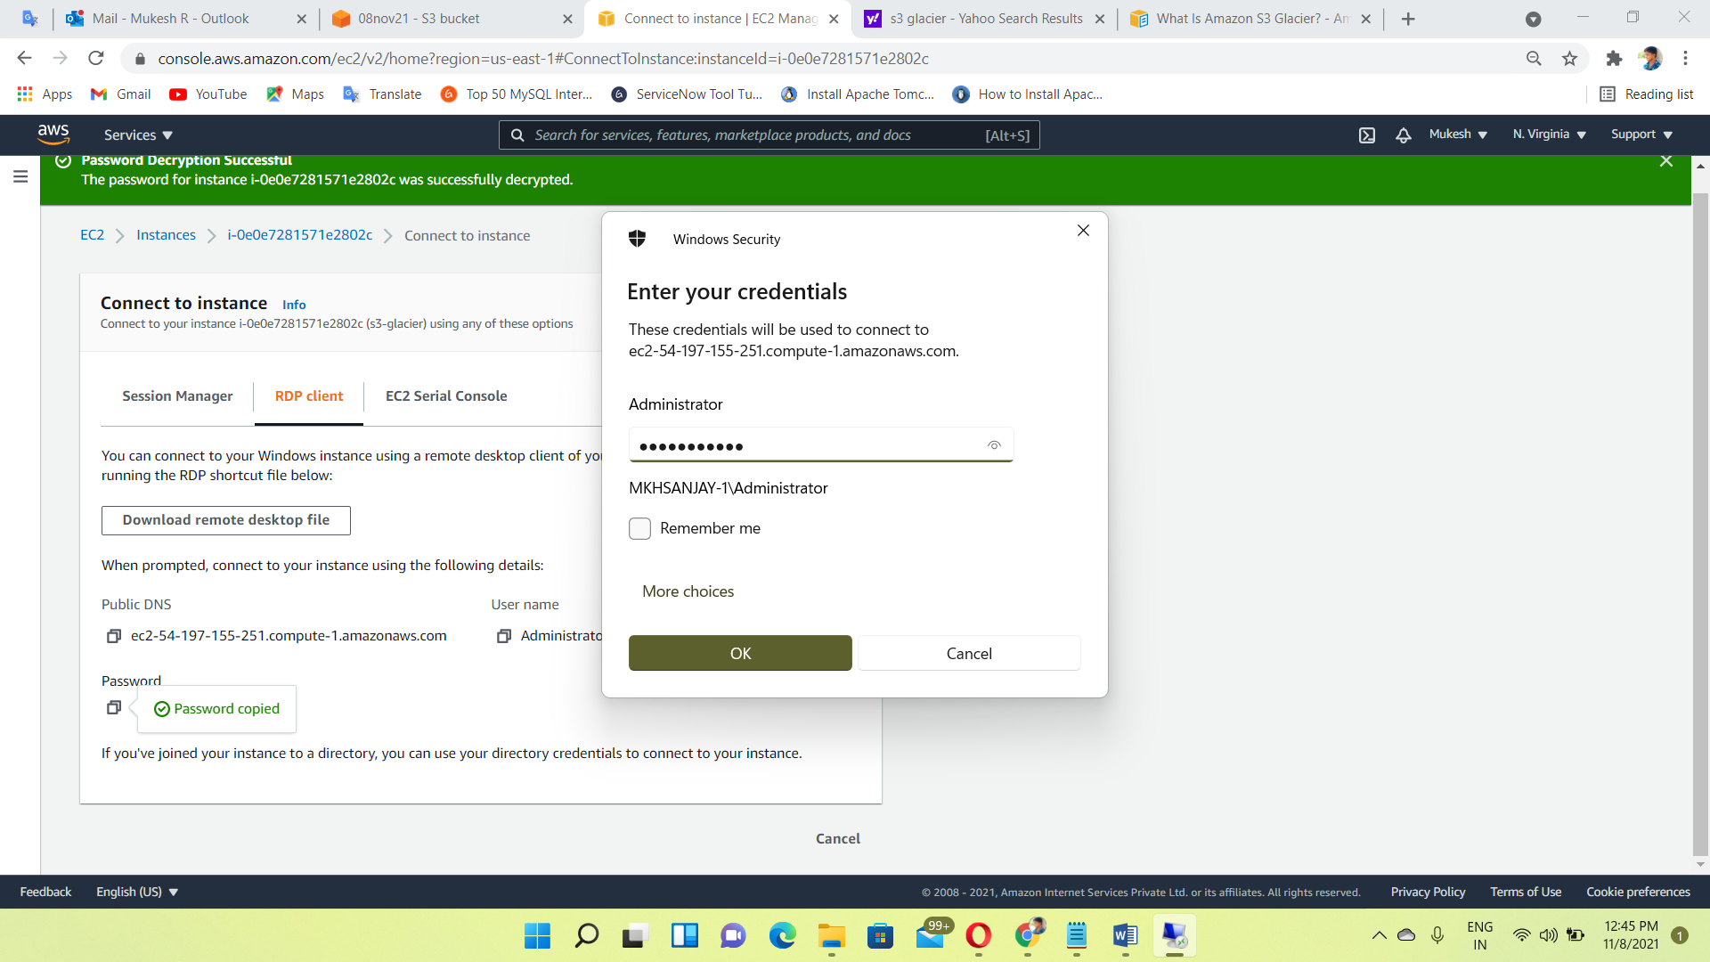

Entered to the windows instance

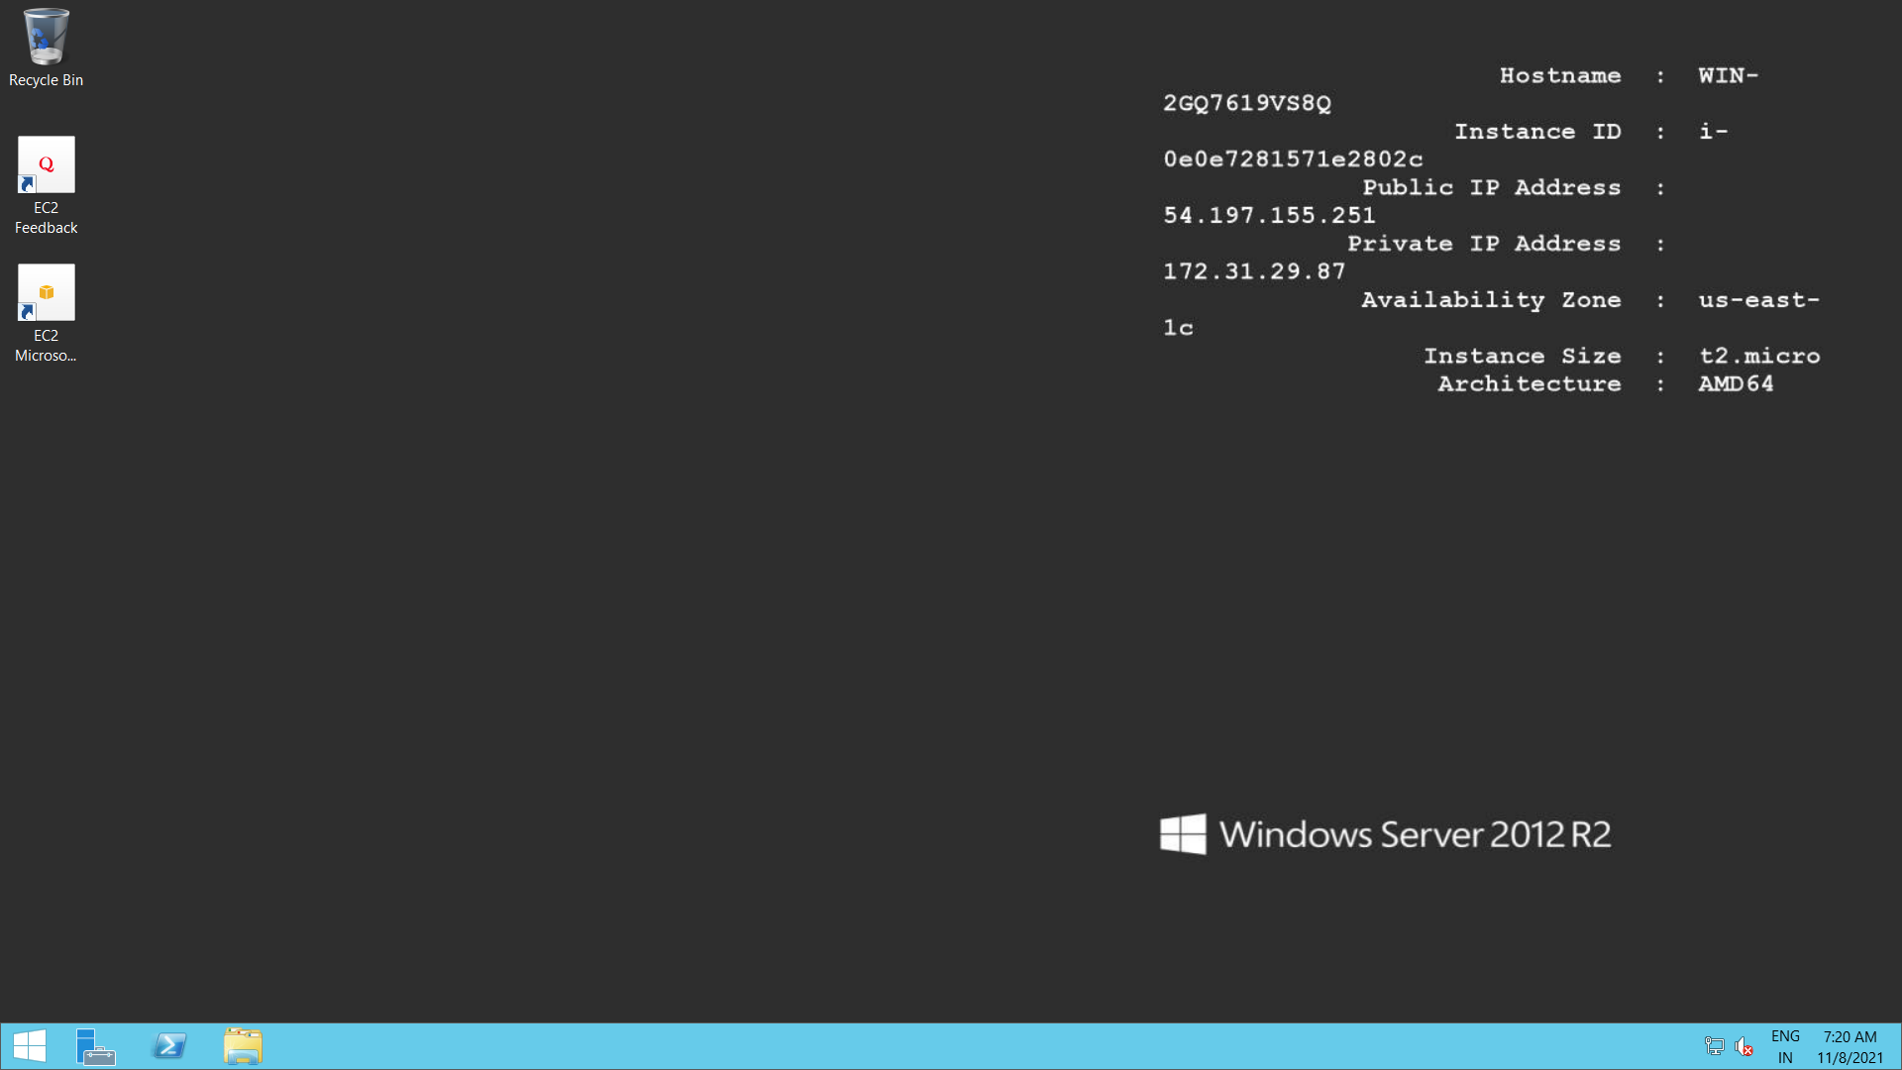

Open command prompt and install AWS CLI🡪 msiexec.exe /i <https://awscli.amazonaws.com/AWSCLIV2.msi> or aws --version

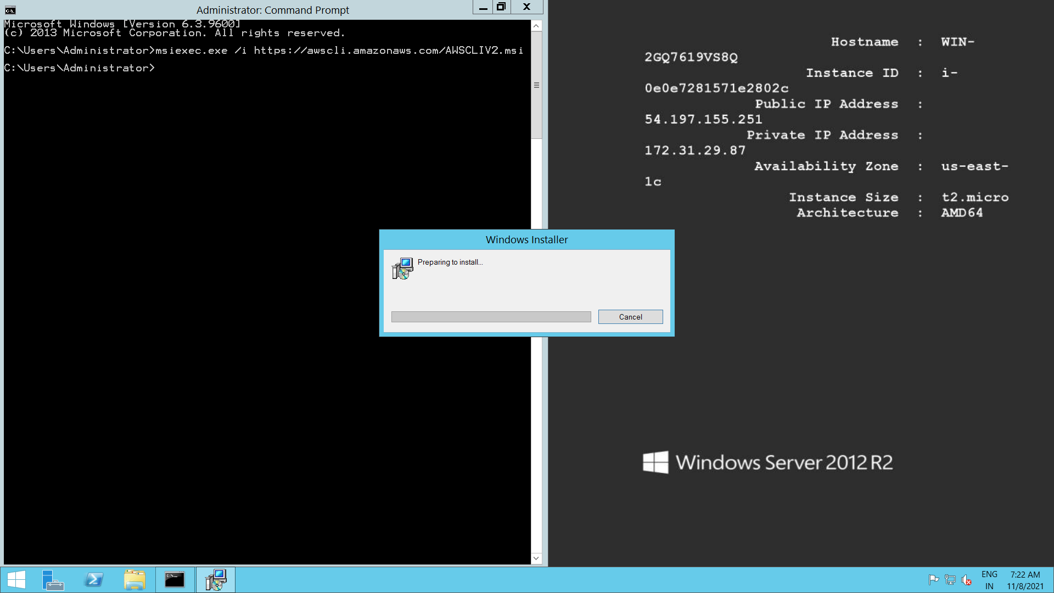

Processing of AWS CLI installation

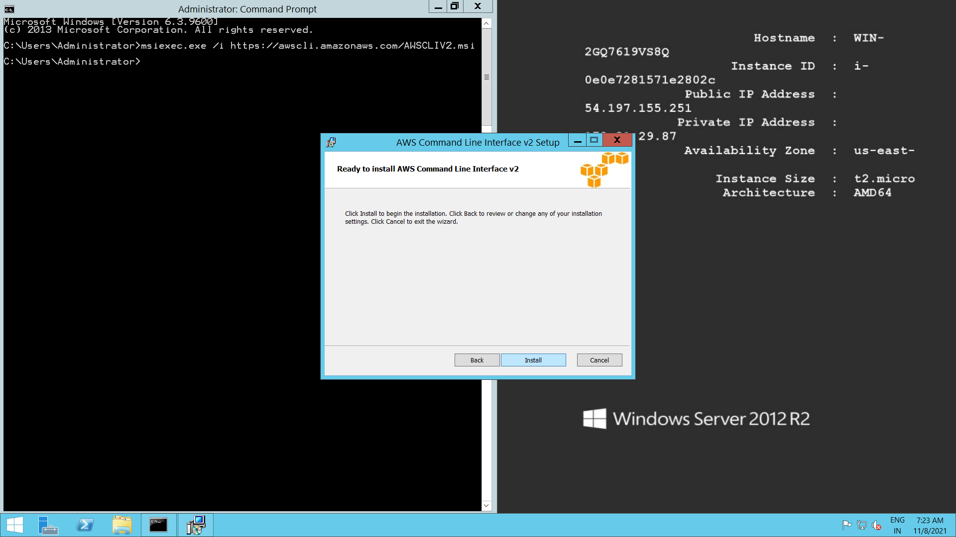

Create Glacier vault using AWS CLI🡪 aws glacier create-vault --vault-name my-vault --account-id -

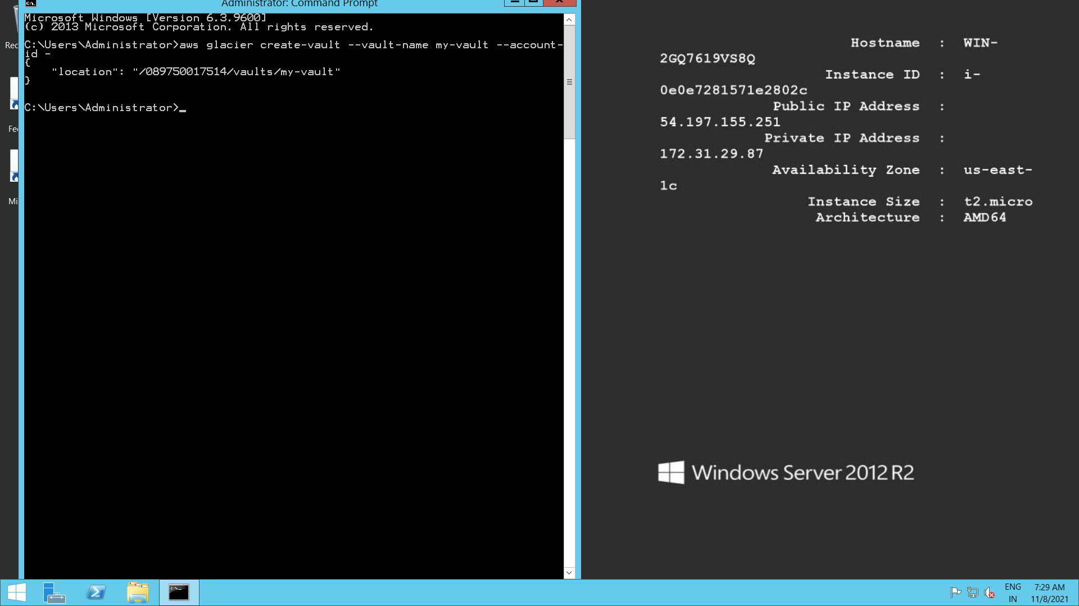

Vault created

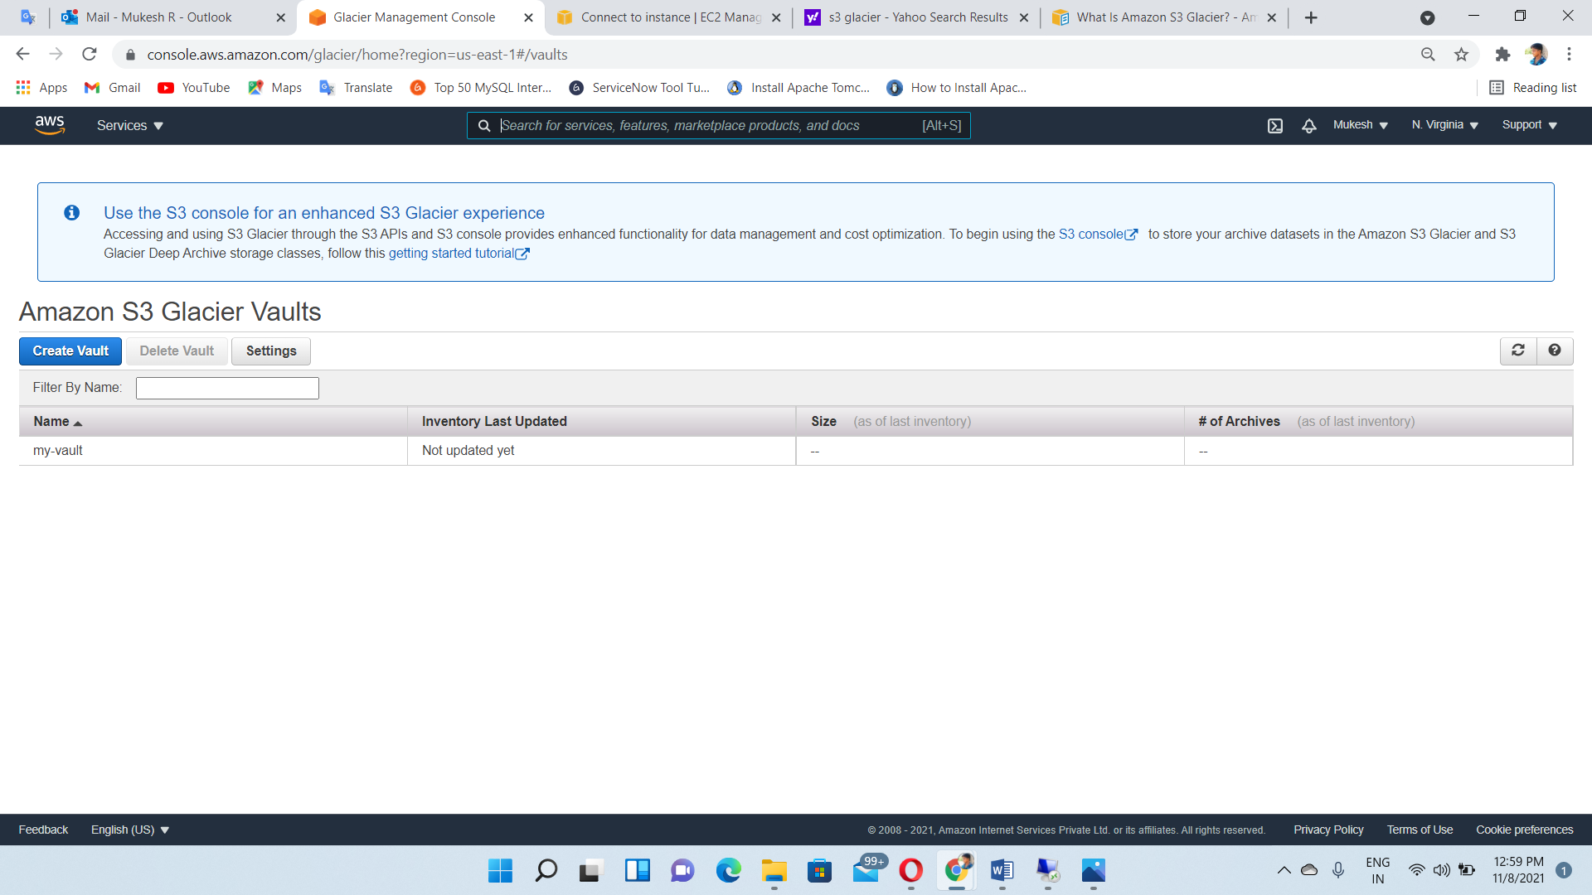

Create new text file

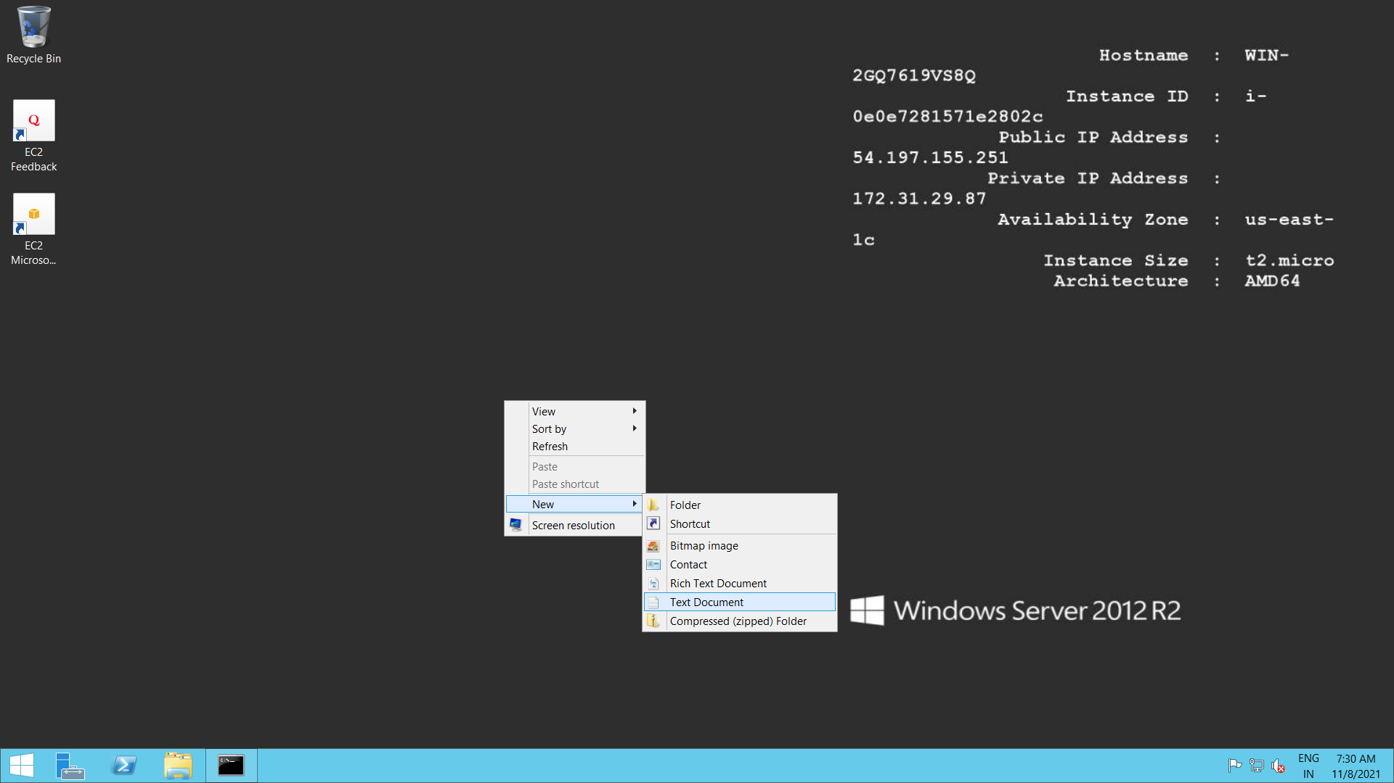

Write some data inside the text file

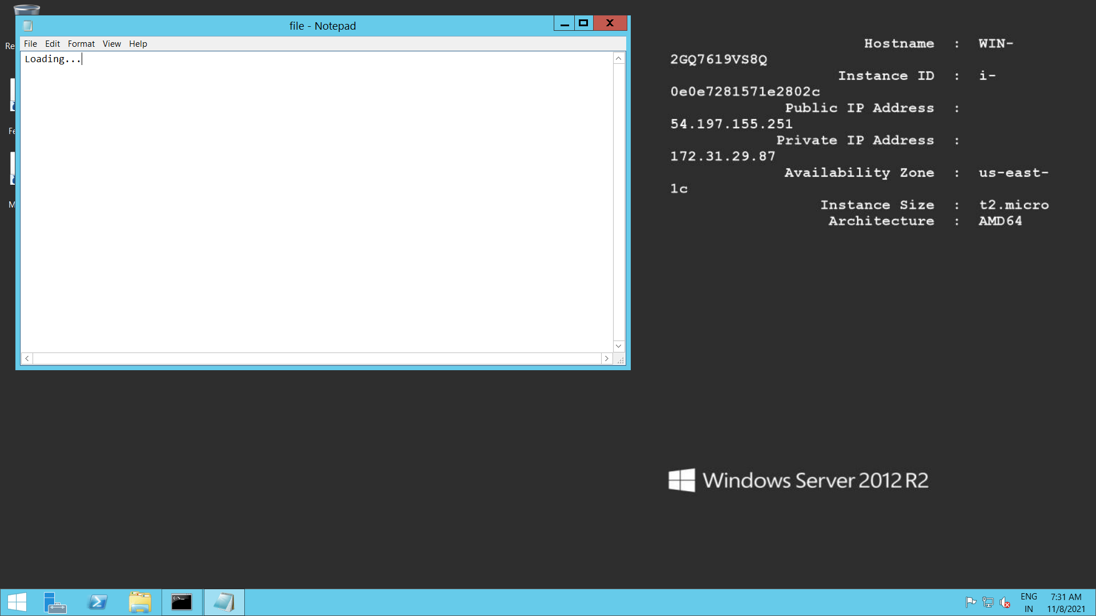

Uploading file to the vault🡪aws glacier upload-archive --account-id - --vault-name my-vault --body file.txt

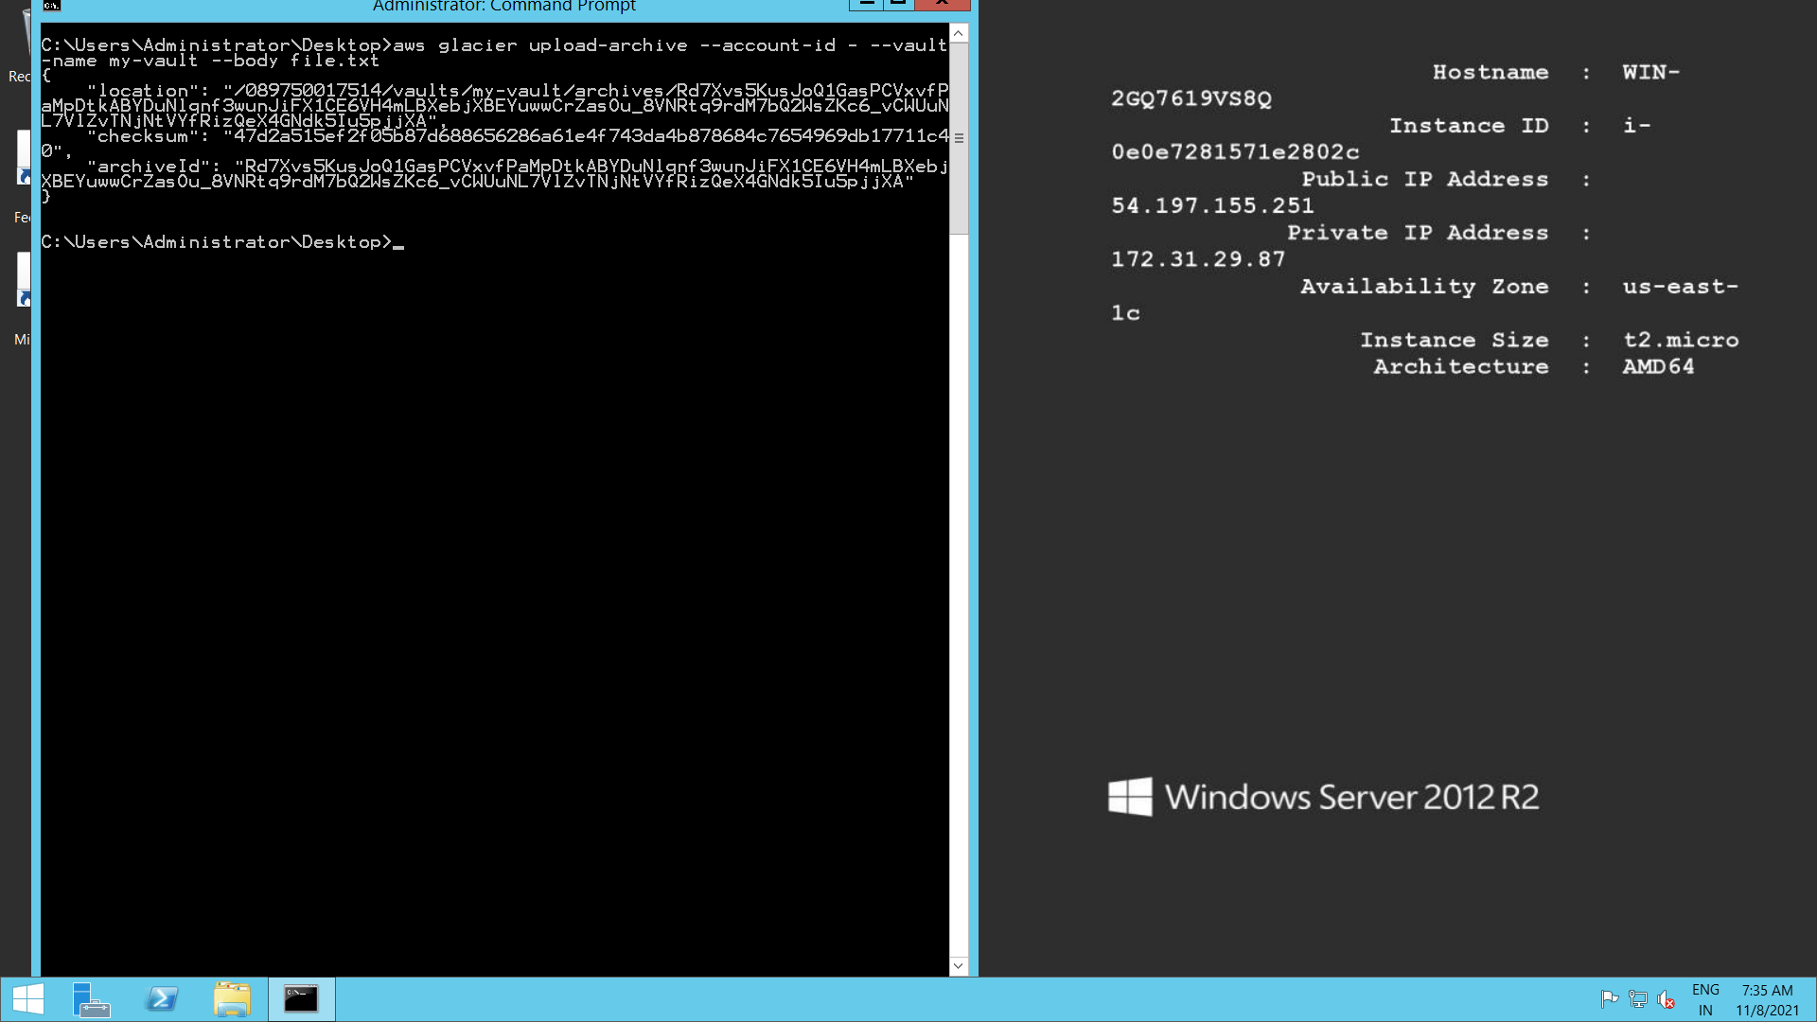

Glacier AWS CLI Command🡪<https://docs.aws.amazon.com/cli/latest/reference/glacier/index.html>