**Centralized Research Project Database**

Name – Mukesh Jha

Roll No. - 205223018

Problem Statement:

• Currently, there is no efficient system in place at NIT Trichy to collate, organize, and provide easy access to the extensive body of research work undertaken by students and faculty across various disciplines.

• The lack of a comprehensive database hinders knowledge sharing, collaboration, and the potential for leveraging past research to enhance the quality and scope of future projects.

• Addressing these challenges is critical to fostering a culture of research excellence, innovation, and continuous learning within the university community.

List of Stakeholders:

1. Students looking for project ideas.
2. Research scholars/students uploading their research work.
3. Research Faculty for Supervision and Research.

Active Research Projects:

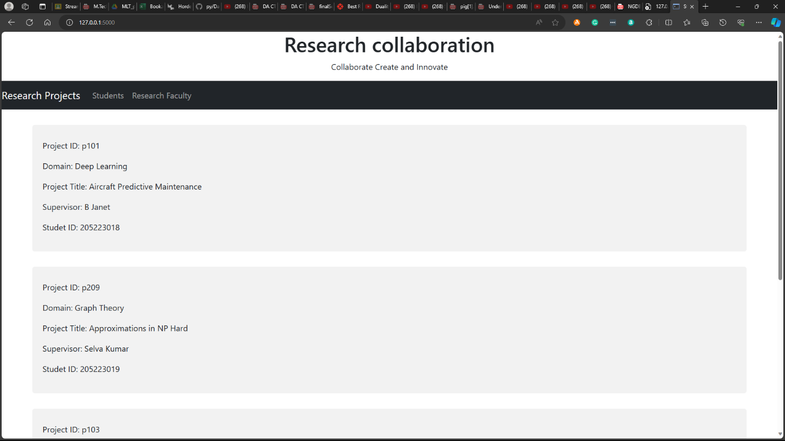

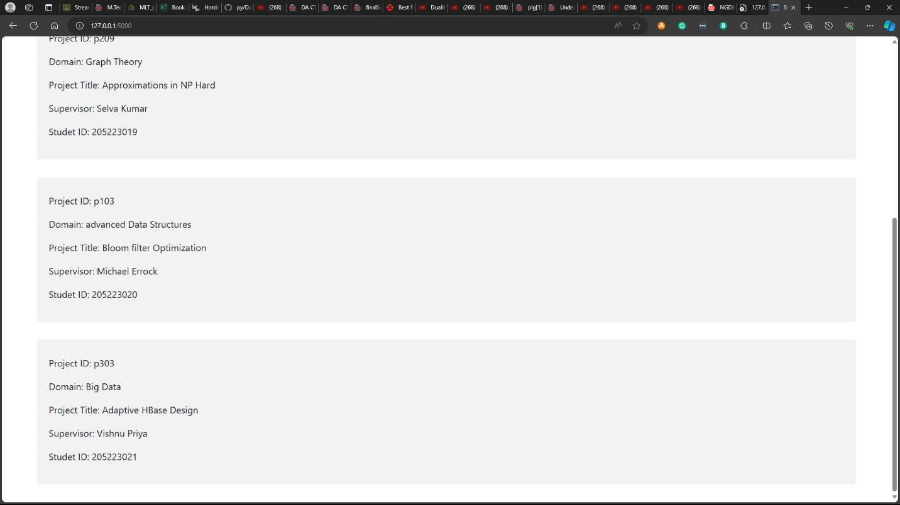

Research Scholar View: (Mostly Masters and PHD scholars)

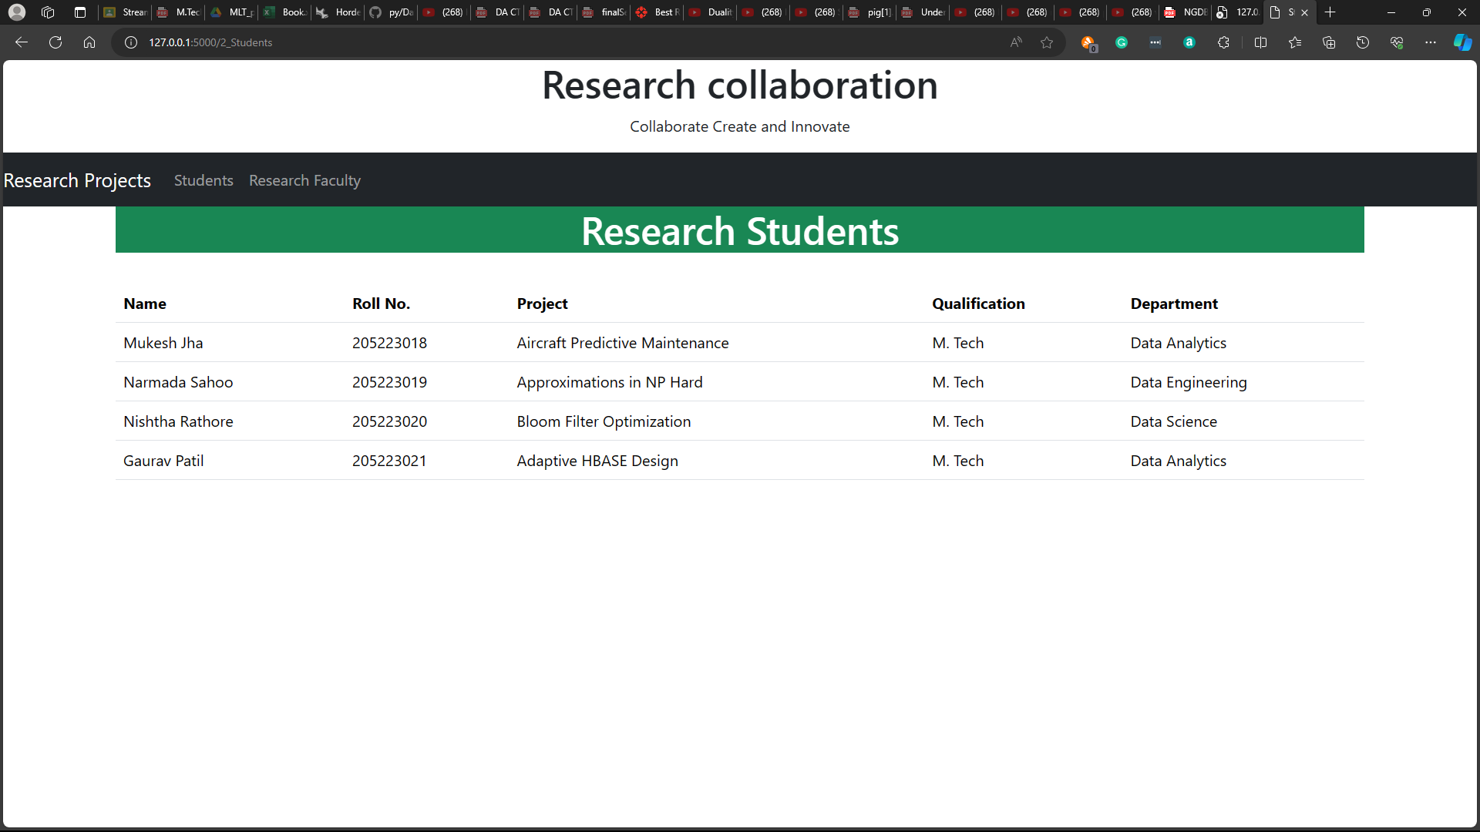

Research Faculty View:

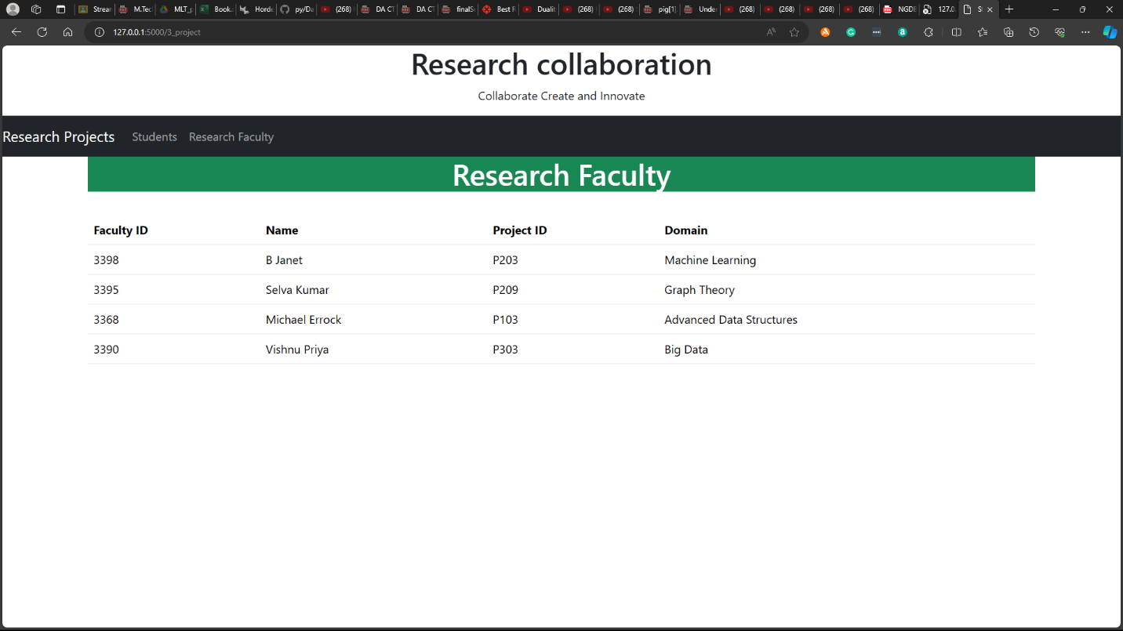

Database used: MongoDB

All the collections:

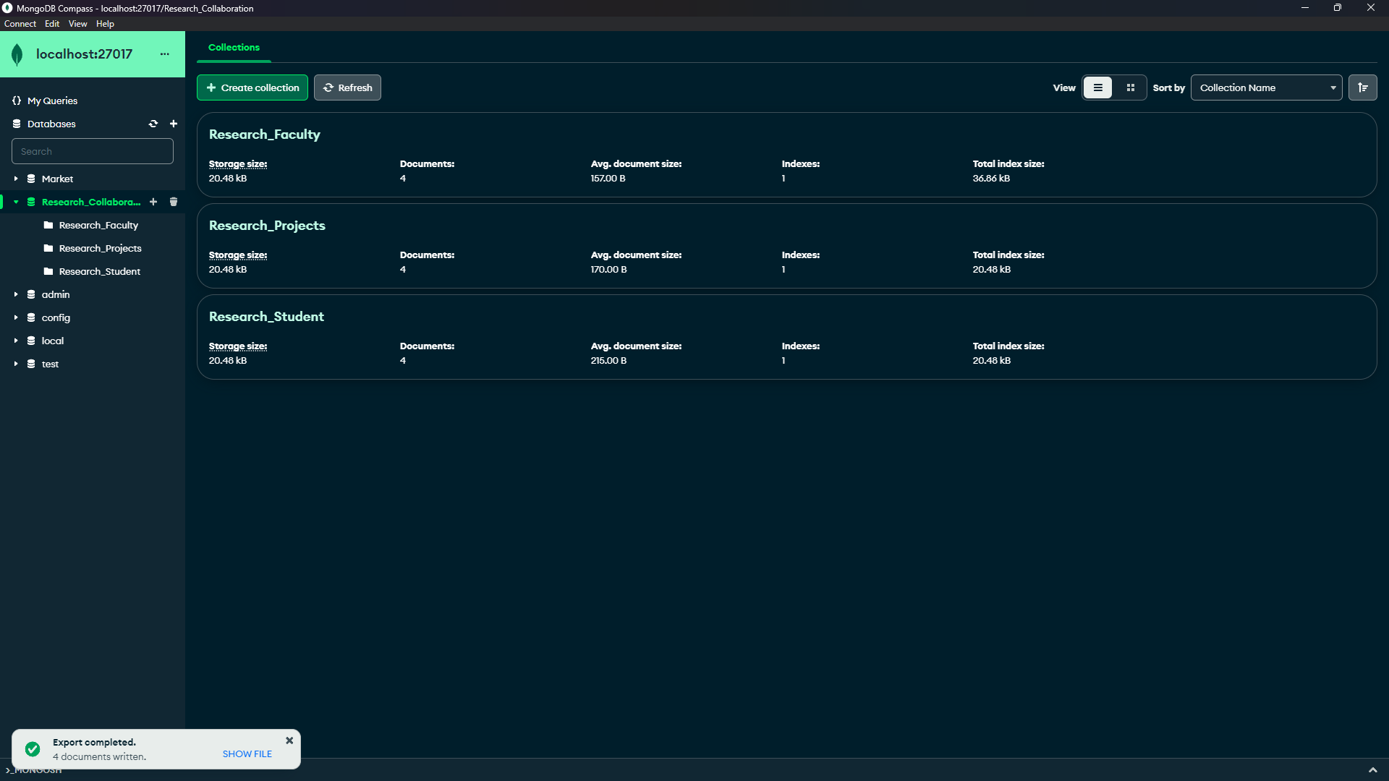

Research Projects:

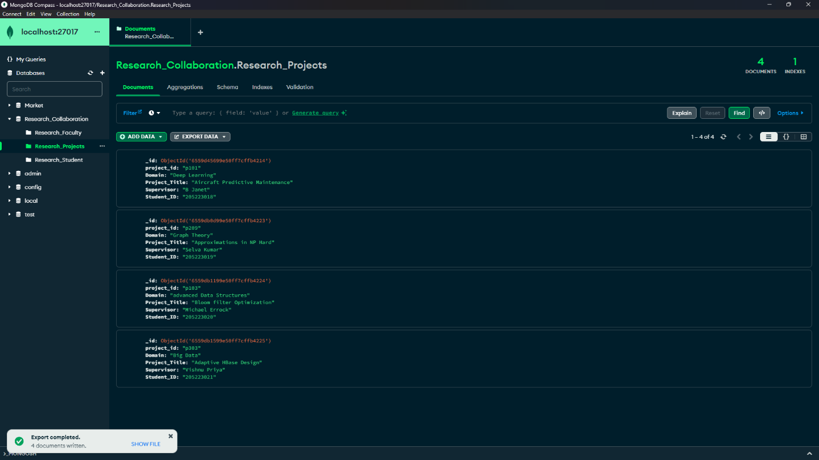

Research Students:

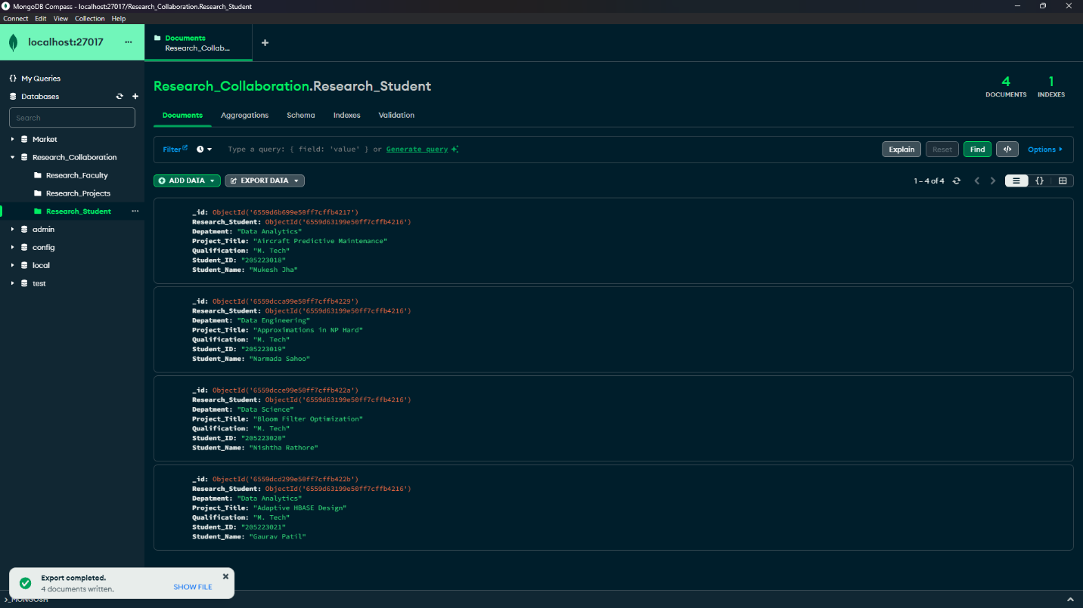

Research Faculty:

