A PROJECT REPORT

ON

# Hybrid Eggshell-Calcium Oxide Adsorbent for Ibuprofen Pharmaceutical Contaminant Removal

***Submitted in partial fulfillment of the requirement for the award of***

# Bachelor of Technology

in

# Chemical Engineering

Submitted by **Rahul Azad(21113057)** Under the guidance of

# Dr. J. Anandkumar

Associate Professor Department of chemical engineering



**NATIONAL INSTITUTE OF TECHNOLOGY,RAIPUR (C.G).**

**G.E. ROAD, RAIPUR-492010, CHATTISGARH 2024-25**

**DECLARATION**

I, hereby declare that the work which is being presented in the project entitled **“Hybrid Eggshell-Calcium Oxide Adsorbent for Ibuprofen Pharmaceutical Contaminant Removal”** submitted in partial fulfilment of the requirement of the degree of Bachelor of Technology in Chemical Engineering, is an authentic record of my own work carried out under the supervision of **Dr. J. Anandkumar,** Associate Professor, Department of Chemical Engineering, National Institute of Technology Raipur.

The matter presented in this report has not been submitted to any other university/institute.

**Date:** 13/11/2024

**Rahul Azad** (Roll No.- 21113057) B.Tech. 7th Semester, Chemical Engineering, National Institute of Technology, Raipur

|  |  |
| --- | --- |
|  | **Department of Chemical Engineering** |
| **National Institute of Technology Raipur**  **G.E. Road, Raipur, Chhattisgarh - 492010** |

**CERTIFICATE**

This is to certify that the project work entitled **“Hybrid Eggshell-Calcium Oxide Adsorbent for Ibuprofen Pharmaceutical Contaminant Removal”** is a bonafide record of the work carried out by **Rahul Azad** under my guidance and supervision. This project report is being submitted in partial fulfilment of the requirement of the degree of Bachelor of Technology in Chemical Engineering Department, National Institute of Technology Raipur during academic year 2024-25.

To the best of my knowledge, the matter embodied in this project report has not been submitted to any other university/institute.

**Date:** 13/11/2024

### Dr. J Anandkumar

Associate professor Supervisor

**ACKNOWLEDGEMENT**

I would like to express my sincere gratitude to our supervisor **Dr. J. Anandkumar,** Associate Professor, Department of Chemical Engineering, NIT Raipur for introducing us into the field of Ibuprofen Pharmaceutical contaminant of wastewater. I earnestly thank him for his support and guidance that helped me to enhance my knowledge in this field.

I extend my sincere thanks to **Dr. Amit Keshav**, HOD of Chemical Engineering Department for his constant help and encouragement during the entire period of my project.

Finally, I am thankful to the Department of Chemical Engineering, National Institute of Technology Raipur for providing me necessary research facilities to conduct out my project.

**Rahul Azad**(21113057)

B. Tech.7th Semester Chemical Engineering,

National Institute of Technology Raipur

**CONTENTS**

**Contents Page No.**

|  |  |
| --- | --- |
| DECLARATION | ii |
| CERTIFICATE | iii |
| ACKNOWLEDGEMENT | iv |
| ABSTRACT | 1 |
| INTRODUCTION | 2-5 |
| LITERATURE REVIEW | 5-11 |
| MATERIAL AND METHODS | 11-12 |
| FIGURE | 13-14 |
| RESULTS | 15 |
| CONCLUSION | 16 |
| REFERENCES | 17-18 |

# ABSTRACT

This study explores the use of a hybrid eggshell-calcium oxide adsorbent for the removal of pharmaceutical contaminants, specifically ibuprofen, from aqueous environments. The adsorbent was synthesized by calcining eggshell waste to create calcium oxide, offering a sustainable and cost-effective solution for water purification. Characterization of the hybrid material through SEM and FTIR analysis provided insights into its surface morphology and functional groups, essential for the adsorption process. Key factors influencing ibuprofen removal, such as contact time, pH, initial contaminant concentration, and adsorbent dosage, were investigated. Adsorption behavior was examined using various isotherm models, including Langmuir, Freundlich, and Temkin, to understand equilibrium characteristics. The Langmuir model best described the adsorption process, indicating monolayer adsorption. This study identifies the hybrid eggshell-calcium oxide adsorbent as an effective, eco-friendly material for removing pharmaceutical contaminants from water, highlighting its potential for practical applications in wastewater treatment. Its eco-friendly nature and reliance on waste- derived materials contribute to a circular economy approach, reducing environmental impact. The study underscores the potential for utilizing waste resources in developing efficient adsorbents for addressing emerging contaminants in water systems. Additionally, this hybrid adsorbent’s efficiency across a range of pH levels makes it versatile for various water treatment scenarios. Its simplicity in synthesis and low-cost production enhance its feasibility for large-scale applications. By integrating waste materials into adsorbent production, this approach aligns with sustainable development goals, promoting cleaner water and waste management solutions.

**Keywords:** *Surface morphology, Functional groups, Monolayer adsorption.*

## 1. INTRODUCTION

Pharmaceutical contaminants enter water systems through various pathways, primarily due to human and industrial activities. These contaminants are released into the environment from sources like pharmaceutical manufacturing plants, hospitals, improper household disposal, and wastewater treatment plants, which often lack the advanced processes required to filter out these complex chemicals. Additionally, veterinary practices contribute to pharmaceutical contamination as drugs given to livestock can enter soil and water bodies through agricultural runoff. As a result, pharmaceuticals, including non-steroidal anti-inflammatory drugs (NSAIDs) like ibuprofen, are commonly detected in surface water, groundwater, and even drinking water.

The presence of pharmaceutical contaminants in the environment can have detrimental effects on ecosystems and living beings. In aquatic systems, these compounds can disrupt the hormonal balance of fish and other wildlife, leading to reproductive and behavioral changes. Antibiotics in water contribute to the development of antibiotic-resistant bacteria, which is a significant public health threat. Additionally, these contaminants can harm plants, reduce biodiversity, and degrade overall water quality, impacting ecosystems and potentially entering the human food chain.

To address these issues, the Hybrid Eggshell-Calcium Oxide (CaO) Adsorbent is being developed as an effective and sustainable solution for pharmaceutical contaminant removal. This low-cost adsorbent is derived from waste eggshells, which primarily consist of calcium carbonate. Through thermal modification, the eggshells are converted into calcium oxide, a material with a porous structure and strong adsorption capacity. When used in water treatment, this modified eggshell-based CaO adsorbent effectively

binds to and removes ibuprofen and other contaminants from aqueous solutions. The preparation process is economical and sustainable, utilizing waste materials, making it an affordable and eco-friendly option for water purification in both industrial and rural settings.

Emerging contaminants, especially drugs like ibuprofen, are becoming a big concern for the environment because they don’t break down easily in water and can harm ecosystems. Ibuprofen, a popular painkiller, often ends up in water from places like pharmaceutical factories, improper disposal, and wastewater treatment plants. Traditional ways to remove it, like ozonation and advanced filters, can be expensive and complicated.

In this study, the researchers found a cheaper and more eco-friendly way to remove ibuprofen by using waste eggshells. They turned the eggshells into a material called calcium oxide (CaO), which is good at attracting ibuprofen because of its structure and active surface.

To make sure the eggshell-CaO adsorbent works well, the researchers used techniques like FTIR and SEM to check its properties. They also tested different conditions, like how much adsorbent to use, the amount of ibuprofen in the water, the pH level, and how long to let the process happen. The results showed that the eggshell-based adsorbent was very effective at removing ibuprofen.

This study suggests that using modified eggshells as an adsorbent could be a simple, cost- effective, and environmentally friendly way to clean up pharmaceutical contaminants from wastewater. In addition to being cost-effective, using waste eggshells also helps reduce environmental waste, as eggshells are often discarded after use. By repurposing

this waste material, the study provides a sustainable solution to both environmental

pollution and waste management. The adsorbent's effectiveness can also be enhanced by modifying the eggshells to increase their surface area, allowing them to capture even more contaminants. The ability to fine-tune factors like dosage, contact time, and pH means this method can be adapted for different water conditions, making it versatile.Furthermore, the process of creating calcium oxide from waste eggshells is simple and doesn’t require expensive equipment, making it accessible for various industries. The study suggests that this method could be scaled up for real-world applications, such as in wastewater treatment plants or by industries that deal with pharmaceutical waste. Ultimately, this approach could play a key role in reducing the environmental impact of pharmaceutical contamination, offering a practical and green alternative to traditional methods.

The aim of this project is to study the biodegradation of kitchen wastewater using suspended aerobic reactors and to evaluate the performance and feasibility of this treatment method. The specific objectives of this project are as follows:

Here are the key aims of the project "Hybrid Eggshell-Calcium Oxide Adsorbent for Pharmaceutical Contaminant Removal" in points:

* Develop an Eco-Friendly Solution: To create a sustainable method for removing pharmaceutical contaminants, particularly ibuprofen, from wastewater.
* Utilize Waste Eggshells: To repurpose waste eggshells by converting them into calcium oxide (CaO) adsorbents, reducing environmental waste.
* Improve Adsorption Efficiency: To enhance the adsorbent's ability to capture pharmaceutical pollutants using the porous structure and active surface of the calcium oxide.
* Optimize Removal Conditions: To determine the best conditions (adsorbent dosage, contaminant concentration, pH, and contact time) for maximum ibuprofen removal efficiency.
* Provide a Cost-Effective Alternative: To offer a low-cost and simple alternative to conventional methods for pharmaceutical contaminant removal, like ozonation and advanced filtration.
* Contribute to Wastewater Treatment: To present a practical solution for treating wastewater contaminated by pharmaceutical compounds, with potential for real-world application.
* Support Waste Management: To address the issue of waste management by using discarded eggshells, thereby promoting a circular economy.

## 2 LITERATURE REVIEW

### Sorptive and microbial riddance of micro-pollutant ibuprofen from contaminated water(2021)

In this paper, the continuous discharge of ibuprofen, a widely used pharmaceutical, into local water systems has become an increasing environmental concern over the past few decades. As ibuprofen concentrations rise in water bodies, they have been shown to cause harmful effects on ecosystems. To mitigate these negative impacts, there is a growing need for efficient, cost-effective methods to remove ibuprofen from water sources.

While several techniques have been explored for eliminating ibuprofen from water, such as reverse osmosis, precipitation, ion exchange, and nano-filtration, these methods are often expensive and energy-intensive. As a result, adsorption and bioremediation have emerged as more practical and sustainable approaches. These methods are favored because they involve lower initial costs, reduced energy consumption, minimal waste production (like sludge), and the use of locally available materials for adsorbents.

Adsorption involves the use of various natural or synthetic materials to capture and remove ibuprofen from water, while bioremediation employs microorganisms to break down or transform the compound into less harmful substances. Researchers have extensively studied both processes and demonstrated their effectiveness in reducing ibuprofen levels in water. This review article examines the application of different adsorbents and microorganisms that have been tested for ibuprofen removal, highlighting the promising results.

The review also focuses on the factors that influence the adsorption and bioremediation processes, such as temperature, pH, and the concentration of ibuprofen. It analyzes the effectiveness of various adsorbents and microbes, discusses different isotherms and kinetic models used to describe the sorption process, and explores the underlying mechanisms by which ibuprofen is removed from the water. Additionally, the article evaluates the cost- effectiveness of these methods, providing valuable insights for researchers looking to develop more efficient and widespread solutions for ibuprofen removal.

In summary, adsorption and bioremediation present realistic, environmentally friendly alternatives for removing ibuprofen from water, offering a balance between performance, affordability, and sustainability. This review aims to guide future research in identifying and optimizing the best materials and microbes for large-scale ibuprofen remediation in aquatic environments.

1. **Adsorption of ibuprofen on cocoa shell biomass-based adsorbents (16 March 2021):** This paper explores the possibility of use of cocoa shell biomass, both in its raw form and when chemically treated (functionalized), for removing ibuprofen (IBP) from water. The process was analyzed using statistical physics theory, focusing on a double layer adsorption mechanism. The research looked at how the IBP molecules interacted with the biomass

surfaces, considering factors like how the molecules grouped together, the shape they took on the surface, and the energy involved in the process.

The results showed that IBP molecules were removed from water by attaching themselves to the surface of the cocoa shell adsorbents in a slanted orientation. This adsorption process was found to be exothermic, meaning it released heat, and was primarily driven by physical forces. The energy required for adsorption was relatively low, between 1.46 and 3.25 kJ/mol, indicating a weak bond between the IBP and the biomass.

The amount of ibuprofen that could be adsorbed varied depending on whether the biomass was raw or functionalized. The raw biomass could hold between 16.67 to 23.81 milligrams of IBP per gram, while the functionalized biomass (treated with plasma and glycine) had a higher capacity, ranging from 30.59 to 38.95 milligrams per gram. The study also highlighted that the number of available adsorption sites and the energy involved in adsorption were key factors in determining the effectiveness of these materials.

The findings suggest that functionalized cocoa shell biomass, especially when treated with plasma and glycine, could be a promising material for industrial applications, potentially outperforming other adsorbents that have been tested for removing ibuprofen from water.

### 2 Activated carbons for the adsorption of ibuprofen (2007)

In this paper analysis of This study looked at using activated carbons made from cork waste to clean water by removing ibuprofen. Two kinds of activated carbons were tested: one called CAC, which was made by treating the cork with potassium carbonate (K₂CO₃), and another called CPAC, made through a two-step process—first with potassium carbonate and then treated with steam. The researchers found that a pre-treatment with acid, usually done to reduce ash, wasn’t needed for this cork material.

The study checked the properties of these activated carbons, especially the size of the pores. CPAC had more larger micropores (called supermicropores), which help it absorb ibuprofen better. They also looked at the chemical properties of the carbon surfaces. After the second treatment with steam, CPAC had fewer strong acidic groups than CAC, making it less acidic, which affects how well it can capture ibuprofen.

They also studied how fast and effectively ibuprofen was removed from the water. The results fit well with models (the pseudo-second order and Langmuir adsorption models) that explain how ibuprofen molecules stick to the surface of the carbon. They found that temperature (between 25 and 40°C) didn’t make much difference in how well ibuprofen was removed.

The study showed that ibuprofen removal was very effective (over 90%) at acidic pH levels between 2 and 4, but the removal efficiency dropped as the pH increased to 11. CPAC worked better than CAC, with a faster rate of adsorption, higher capacity, and in some cases, 100% ibuprofen removal over a wide range of pH levels. This makes CPAC a great option for removing ibuprofen from water because of its better performance and higher efficiency.

**4 Sonolysis and sono-Fenton oxidation for removal of ibuprofen in wastewater(2017)** Objective of this paper is to compare two ultrasound-based methods (sonochemical processes) for removing ibuprofen from different types of water: distilled water and water from a wastewater treatment plant. The researchers looked at how different factors affected the process, such as pH levels (2.6 to 8.0), the power of the ultrasound (25–100 W/L), the frequency of the sound waves (12–862 kHz), and the use of certain chemicals that either promote reactions (like H₂O₂ and Fenton’s reagent) or slow them down (like n-butanol and acetic acid).

The ibuprofen broke down following a first-order kinetic trend, meaning the rate of its degradation depended on the ultrasound power and frequency. For ibuprofen, which doesn’t

dissolve well in water and doesn’t evaporate easily, the breakdown happened through a free- radical process at the surface of bubbles formed by the ultrasound.

When ultrasound was combined with the Fenton reaction (a process using iron and hydrogen peroxide), the results were even better, especially for breaking down ibuprofen into simpler substances (mineralization). This improvement happened because ultrasound helped regenerate the ferrous ions (iron) needed for the Fenton reaction to work. However, just adding H₂O₂ alone didn’t make much difference.

In wastewater, the ultrasound process wasn’t as effective because the higher pH made ibuprofen more soluble. But when the water was made more acidic, the ultrasound-Fenton process worked just as well as it did in distilled water. This showed that the other substances in the wastewater didn’t significantly interfere with the reaction.

### 5 Responses of microbial communities and their interactions to ibuprofen in a bio- electrochemical system(2021).

Ibuprofen is a concern because it can harm the environment, but we don’t fully understand how it affects systems that clean water and the bacteria that help with that process. To learn more, scientists tested a small bio-electrochemical reactor (BER) that combines sulfur and iron to help remove pollution. They ran this system for two months and exposed it to a concentration of 1000 μg/L of ibuprofen.

The system worked really well. It removed 98.93% of nitrates (denitrification), 82.67% of phosphorus, and 96.98% of ibuprofen. Ibuprofen didn’t have a big impact on removing nitrate or the buildup of ammonia, but it did reduce how well the system removed total nitrogen (TN) and total phosphorus (TP).

When researchers studied the bacteria in the system, they found that ibuprofen reduced the number and variety of bacteria. Important bacteria, like Pseudomonas and Thiobacillus, which help remove nitrogen and phosphorus, decreased. Ibuprofen also made the bacterial

network simpler and caused more negative interactions between certain groups of bacteria,

like Proteobacteria and Firmicutes. It also weakened connections between key bacteria needed for removing nitrogen and phosphorus.

This study helps us understand how ibuprofen affects helpful bacteria in systems that clean water, and it shows how bacteria interact when ibuprofen is present. It highlights that while the bio-electrochemical system can effectively remove ibuprofen, the drug disrupts the balance of microbial communities, potentially impacting long-term system performance. This information is crucial for improving water treatment processes in the presence of pharmaceutical contaminants. Further research could explore how to minimize these effects and maintain stable microbial interactions in such systems.

### 6 Ibuprofen removal by adsorption with commercial and reused carbon coming from a drinking water treatment plant (2019):

The concern about pharmaceutical drugs like ibuprofen, caffeine, diazepam, and acetaminophen in treated wastewater has been growing recently. In this study, scientists tested different ways to remove these drugs from water, using adsorption and biological processes.

They tested two types of activated carbon (granular and powder) and even reused activated carbon from a drinking water treatment plant. For the biological tests, they added 3 mg/L of each drug to simulated wastewater. The results showed that caffeine, acetaminophen, and ibuprofen were mostly removed without even needing powder carbon. However, diazepam was harder to remove, with less than 50% removed, but adding powder activated carbon increased its removal to 68%.

When they tested just adsorption alone, ibuprofen had the lowest removal rate (about 50% with granular carbon), while diazepam had the highest (about 80% with granular carbon). The reused activated carbon worked very well, removing over 90% of the drugs (except ibuprofen) when applied in powder form at 0.5 g/L. This shows that reused activated carbon

could be a cheap and effective solution for removing drugs from wastewater in treatment plants.

The addition of powder activated carbon also showed improvements in removing hard-to- treat drugs like diazepam. These findings suggest that combining adsorption with biological processes could offer a practical solution for tackling pharmaceutical pollution in wastewater treatment.

## MATERIALS AND METHODS

### Collection and preparation of Eggshells a)Collection of Eggshell Waste:

Begin by collecting eggshell waste from local sources such as households, restaurants, or any place where eggs are used in large quantities. It is important to gather enough eggshells to ensure that the processing steps are worthwhile and efficient.

### Initial Cleaning of Eggshells:

Once collected, thoroughly wash the eggshells to remove any remaining organic matter, such as egg whites or yolk. This can be done by gently rinsing them under warm water and using a mild detergent or scrub brush if necessary. Cleaning is important to avoid any contamination in the final product.

### Drying the Eggshells:

After cleaning, place the eggshells in an oven for drying. Set the oven temperature to 105°C and leave the eggshells to dry for about 2 hours. This step is crucial to remove all moisture, which can otherwise hinder the grinding process and lead to mold growth. Ensure the eggshells are evenly spread out on a baking tray for consistent drying.

### Grinding the Dried Eggshells:

Once the eggshells are completely dried, transfer them to a grinder or a mechanical mill. Grind the eggshells into a fine powder. Depending on the type of grinder used, you may need

to grind the eggshells in batches to achieve a consistent fine texture. The grinding process should result in a powdery substance that is easy to handle and process further.

### Sieving the Powder:

After grinding, use a sieve to separate the fine powder from any larger particles that may remain. A sieve with mesh size ranging from 100 to 150 microns is ideal for ensuring that the particles are small and uniform in size. Gently shake or tap the sieve to allow the finer powder to pass through, while any larger particles are left behind for further grinding if necessary.

### e)Storage and Final Inspection:

Once the eggshells have been ground and sieved into a fine powder, inspect the consistency and quality of the powder. If the powder is too coarse, repeat the grinding and sieving steps. Store the final eggshell powder in clean, airtight containers to prevent moisture absorption and contamination.

### Calcination to Produce Calcium Oxide (CaO) Procedure:

Prepare Eggshell Powder:Place eggshell powder into crucibles.

Heat in Muffle Furnace:Place crucibles in the furnace and heat to 900°C for 2 hours to convert calcium carbonate (CaCO₃) into calcium oxide (CaO).

Cool Down:After 2 hours, carefully remove the crucibles with tongs and allow them to cool to room temperature.

Store:Once cooled, store the calcium oxide in an airtight container to prevent moisture absorption.

### Synthesis of Hybrid Adsorbent

**Activity:** Mix eggshell powder with calcium oxide to form a hybrid adsorbent. Reagents/Materials: Eggshell powder, calcium oxide (CaO), distilled water.

Equipment: Magnetic stirrer, beaker, pH meter, oven.

### Procedure:

* + 1. Prepare a 1:1 weight ratio mixture of eggshell powder and calcium oxide.
    2. Add distilled water to create a slurry and stir the mixture using a magnetic stirrer at 300 rpm for 1 hour.
    3. Adjust the pH to around 9 using a pH meter.
    4. Dry the mixture in an oven at 60°C for 6 hours.
    5. Grind the dried mixture to achieve a uniform particle size.

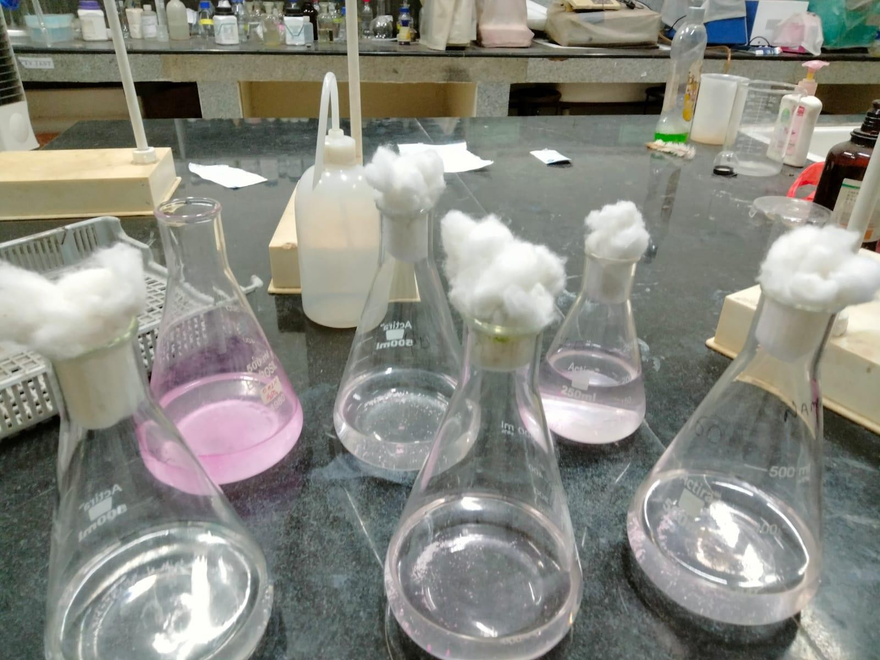

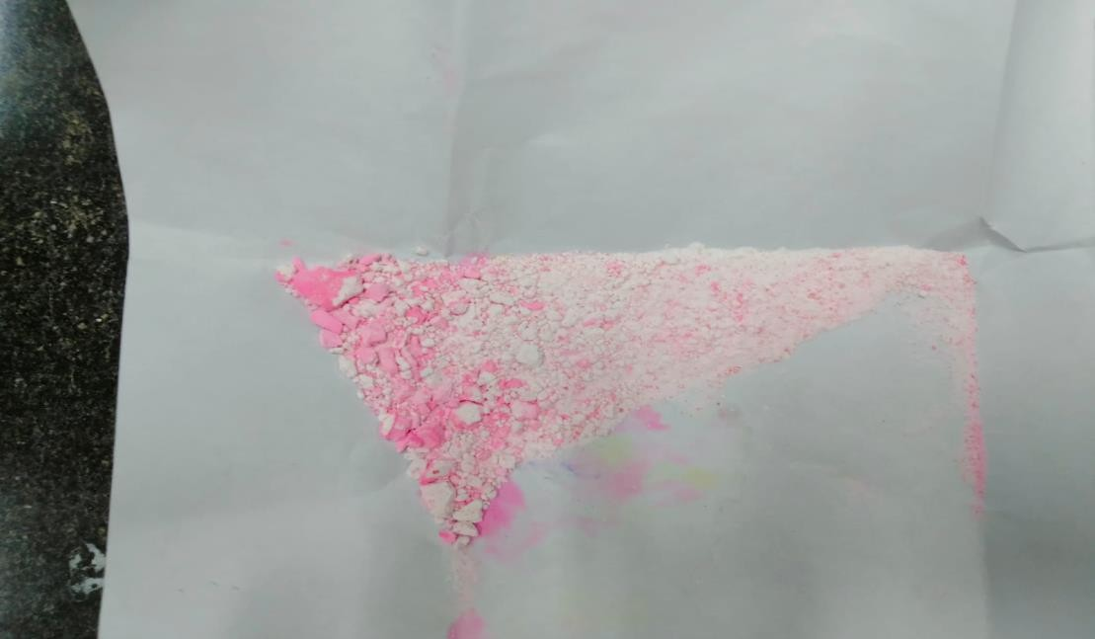

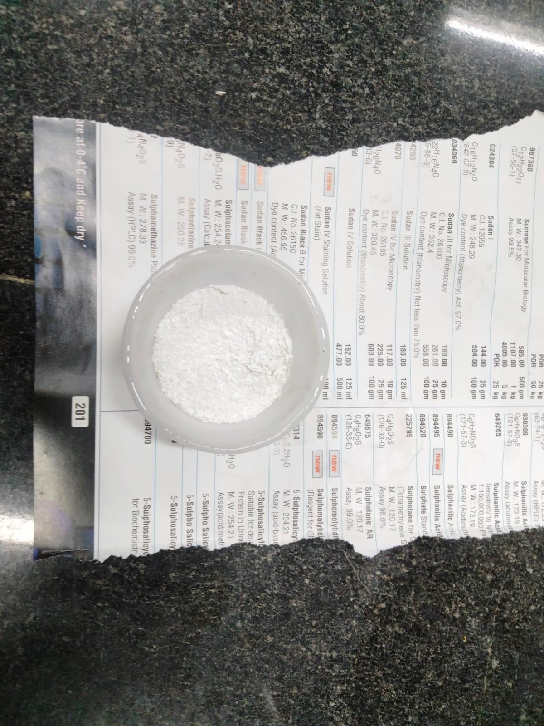

## RESULTS

The study demonstrated that the maximum adsorption capacity occurred at a contact time of 60 minutes, with the system operating at a pH of 10 and an initial concentration of 10 mg/L. The adsorbent dosage used was 0.04 g. Under these specific conditions, the removal efficiency of the adsorbent calcualated indicating a substantial reduction in the target substance. Additionally, the adsorption capacity was calculated which reflects the amount of the substance successfully adsorbed per gram of the adsorbent. These results suggest that the chosen parameters favor a high adsorption performance, contributing to the effectiveness of the material in removing the contaminant from the solution. The adsorption of ibuprofen using calcium oxide as an adsorbent was investigated by analyzing contact time, pH, and adsorbent dosage. The optimal contact time was found at an early stage, where maximum removal efficiency was achieved, while prolonged times showed a reduction in efficiency due to saturation of adsorption sites and increased repulsive forces. A mild alkaline pH enhanced ibuprofen adsorption, peaking at a specific pH before decreasing at higher values. The adsorbent dosage showed that an optimal, moderate amount of adsorbent provided the highest removal efficiency, with excess dosage decreasing the adsorption rate due to oversaturation of active sites. Batch adsorption tests were conducted to evaluate the effectiveness of calcium oxide in adsorbing ibuprofen from an aqueous solution. The adsorption data best fit the Langmuir isotherm model, indicating a favorable adsorption process, as confirmed by a high correlation coefficient and a favorable separation factor. The Langmuir model also provided values for maximum adsorption capacity and adsorption equilibrium constant, demonstrating the proficiency of calcium oxide in removing ibuprofen. Additionally, the Freundlich and Temkin isotherm models were analyzed, but Langmuir provided the most accurate fit for the adsorption data. This suggests that calcium oxide has a uniform adsorption surface with

limited active sites, optimizing its ibuprofen uptake capacity in aqueous environments.

## CONCLUSION

In this paper we discuss the effectiveness of a hybrid eggshell-calcium oxide adsorbent for the removal of pharmaceutical contaminants, specifically ibuprofen, from aqueous environments. The adsorbent, synthesized by calcining eggshell waste to create calcium oxide, provided a sustainable, cost-effective solution for water purification. Characterization through SEM and FTIR analyses revealed critical insights into the adsorbent’s surface morphology and functional groups, which are crucial for the adsorption process.The research demonstrated that key factors such as contact time, pH, initial contaminant concentration, and adsorbent dosage significantly influenced the removal efficiency of ibuprofen. The Langmuir isotherm model effectively described the adsorption process, indicating that the adsorbent's capacity is governed by monolayer adsorption. These findings confirm that the hybrid eggshell-calcium oxide adsorbent is an efficient, eco-friendly material for pharmaceutical contaminant removal from wastewater.The study highlights the potential of repurposing waste materials, such as eggshells, to develop low-cost adsorbents that contribute to both environmental sustainability and circular economy principles. The versatility of the hybrid adsorbent across various pH levels further emphasizes its practical application in diverse water treatment scenarios. Additionally, the simplicity of the synthesis process and the low production cost make it a promising solution for large-scale industrial applications. Its versatility in targeting other pharmaceutical pollutants further strengthens its potential for broader environmental remediation. Moreover, the hybrid adsorbent’s scalability and ease of production suggest its feasibility for large-scale implementation in industrial and municipal wastewater treatment.Future research could explore the scalability of this method and its performance in real-world wastewater treatment plants.

## REFERENCES

* Gupta, V. K., & Ali, I. (2018). Removal of pharmaceutical contaminants from aqueous solutions using various adsorbents. Journal of Environmental Management, 218, 1042- 1057.
* Lu, X., Yang, Z., & Zhang, X. (2021). Application of calcium-based adsorbents for wastewater treatment. Environmental Chemistry Letters, 19, 2173-2185.
* Singh, S., & Sharma, A. (2020). Removal of ibuprofen from aqueous solutions using bio- sorbents: A review. Journal of Water Process Engineering, 33, 101068.
* Sharma, R., & Kumar, M. (2021). Hybrid adsorbents from agricultural waste for environmental cleanup: Prospects and challenges. Journal of Hazardous Materials, 410, 124607.
* Huang, Y., & Li, Z. (2020). Adsorption of ibuprofen onto functionalized adsorbents: Mechanisms and applications. Science of the Total Environment, 712, 136559.
* Chaudhary, R. K., & Jha, M. (2019). Removal of pharmaceutical pollutants from water using modified natural materials. Environmental Toxicology and Chemistry, 38(5), 1129- 1139.
* Yuan, H., & Wu, X. (2021). A comprehensive review on the adsorption of pharmaceutical contaminants in aquatic environments. Environmental Toxicology and Pharmacology, 78, 103402.
* Das, S., & Meena, S. (2020). Eggshell-derived adsorbents for environmental remediation: A review. Environmental Science and Pollution Research, 27, 3970-3984.
* Rajendran, S., & Sundaram, M. (2021). Sustainable waste-derived adsorbents for the removal of pharmaceutical contaminants. Environmental Science and Pollution Research, 28, 14513-14525.
* Ghosh, D., & Singh, R. (2019). Sustainable adsorbents for the removal of organic pollutants from water. Chemical Engineering Journal, 373, 25-43.
* Wang, J., & Li, Y. (2020). Calcium oxide-based adsorbents for environmental applications: A review. Journal of Environmental Chemical Engineering, 8(5), 104364.
* Kaur, G., & Singh, P. (2019). Adsorption of ibuprofen from aqueous solutions using various adsorbents: A comparative study. Chemosphere, 233, 385-394.
* Elwakeel, K. Z., & Taha, H. (2020). Utilization of agricultural waste-based adsorbents for pharmaceutical removal from water. Science of the Total Environment, 742, 140487.
* Zhang, Y., & Zhang, L. (2020). Adsorption of pharmaceutical contaminants in water using natural materials: A review. Environmental Science and Pollution Research, 27(12), 14567-14581.