HLD: ECommerce Product Management System
1. Purpose
Build a secure, scalable platform to manage product lifecycle in ecommerce: create, enrich, review, approve, publish, and report.
2. Scope
- Backend microservices in ASP.NET Core (.NET 8).
- API Gateway using Ocelot.
- SQL Server with database-per-service.
- JWT-based authentication and role-based authorization.
- RabbitMQ for asynchronous domain events.
- Planned frontend (Angular in PRD) consuming gateway APIs.
3. High-Level Architecture
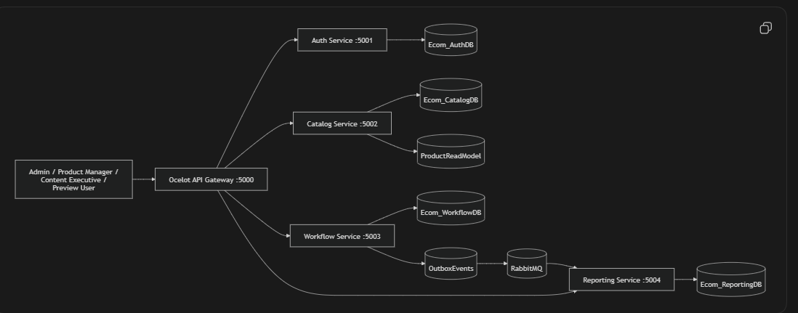

4. Service Boundaries
- Auth Service
  - Signup/login, email verification, forgot/reset password.
  - JWT + refresh token lifecycle.
  - User/role administration.
  - Auth audit logs.
- Catalog Service
  - Product CRUD, category/brand, media handling.
  - Product variants.
  - Storefront read model (ProductReadModel) for fast reads.
  - Catalog audit logs.
- Workflow Service
  - Pricing and inventory updates.
  - Submit/approve/reject/publish/archive flows.
  - Publish-readiness checks.
  - Outbox pattern for reliable event emission.
- Reporting Service
  - Dashboard KPI aggregation.
  - Audit history queries.
  - CSV report export.
  - RabbitMQ consumers for workflow events.
- API Gateway
  - Single entry point /gateway/*.
  - Request routing to downstream services.
  - JWT validation for protected routes.
  - Basic rate-limiting config on auth route.
5. Key Domain Workflow
- User authenticates via /gateway/auth/*.
- Product Manager creates product in Catalog (Draft).
- Content Executive enriches content/media.
- Workflow updates pricing and inventory.
- Product is submitted for review.
- Admin approves/rejects.
- Admin publishes if checklist is satisfied.
- Reporting consumes events and updates analytics/audit.
6. Data Architecture
- Database-per-service ensures bounded-context ownership.
- Cross-service references are logical IDs via API/events.
- Core entities:
  - Auth: Users, Roles, RefreshTokens, EmailVerificationTokens.
  - Catalog: Products, Categories, Brands, MediaAssets, ProductVariants, ProductStatuses, ProductReadModels.
  - Workflow: Prices, Inventories, Approvals, OutboxEvents.
  - Reporting: AuditLogs.
7. Integration Pattern
- Synchronous: REST via gateway for transactional operations.
- Asynchronous: RabbitMQ for eventual consistency and reporting updates.
- Reliability: Workflow writes domain events into OutboxEvents, then background processor publishes and marks processed.
8. Security Design
- JWT bearer authentication on protected APIs.
- Role-based authorization (Admin, ProductManager, ContentExecutive, Customer).
- Password hashing with BCrypt.
- Refresh token rotation and revocation.
- Rate limiting in auth and gateway layers.
- Correlation IDs and request logging middleware for traceability.
9. Deployment View
- Containerized using Docker Compose.
- Ports:
  - Gateway 5000
  - Auth 5001
  - Catalog 5002
  - Workflow 5003
  - Reporting 5004
  - SQL Server 1433
  - RabbitMQ 5672 (Mgmt 15672)
- Internal network: ecom-network.
10. Non-Functional Design
- Scalability: Independent service scaling; stateless APIs.
- Reliability: Outbox, health checks, structured logs.
- Performance: Pagination/search in catalog; read model for storefront.
- Maintainability: Clean Architecture separation in each service.
- Observability: Health endpoints, correlation IDs, service logs.
11. Risks and Mitigations
- Event contract or exchange naming drift across services.
  - Mitigation: shared event contract versioning and integration tests.
- Incomplete end-to-end frontend integration in current repo.
  - Mitigation: finalize Angular client against gateway contracts.
- Coverage target from PRD (90%) may not yet be met uniformly.
- Mitigation: CI coverage gates per service and prioritized test expansion.
12. HLD Conclusion
This design is a strong enterprise-style microservices foundation for ecommerce product lifecycle management, with clear domain separation, secure access, and event-driven extensibility.

