LLD (Low-Level Design) - ECommerce Product Management System
Code Baseline
Solution
Gateway Program
Gateway Ocelot Config
1. Module Decomposition
- gateway/Ecom.Gateway: API gateway, JWT validation, request forwarding.
- services/auth/Ecom.Auth: identity, token lifecycle, user management, auth audit.
- services/catalog/Ecom.Catalog: product domain, media, categories/brands, storefront read model.
- services/workflow/Ecom.Workflow: pricing, inventory, approvals, publishing, outbox.
- services/reporting/Ecom.Reporting: dashboard, audit query/export, event consumers.
- Shared projects: contracts and infrastructure messaging utilities.
2. Gateway LLD
Files
Program.cs
ocelot.json
GatewayLoggingMiddleware.cs
- Adds JWT bearer auth and validates issuer/audience/signing key.
- Adds Ocelot middleware for downstream routing.
- Adds request/response logging with correlation header.
Routing rules
- /gateway/auth/{*} -> auth -> /api/v1/auth/{*}
- /gateway/catalog/{*} -> catalog -> /api/{*}
- /gateway/workflow/{*} -> workflow -> /api/{*}
- /gateway/admin/{*} -> reporting -> /api/{*}
3. Auth Service LLD
Files
Program.cs
AuthController.cs
UsersController.cs
AuthService.cs
TokenService.cs
3.1 API Endpoints
- POST /api/v1/auth/signup
- GET /api/v1/auth/verify-email
- POST /api/v1/auth/resend-verification
- POST /api/v1/auth/login
- POST /api/v1/auth/refresh
- POST /api/v1/auth/logout
- POST /api/v1/auth/logout-all
- POST /api/v1/auth/forgot-password
- POST /api/v1/auth/reset-password
- GET /api/v1/auth/me
- POST /api/v1/auth/change-password
- Admin user management under /api/v1/auth/users/*
3.2 Core Class Flow
- AuthController -> IAuthService (AuthService)
- AuthService uses IUserRepository, ITokenService, IRefreshTokenRepository, IEmailService, IEventPublisher
- TokenService generates JWT access token and random refresh token, supports rotation + reuse detection
3.3 DB Entities (AuthDb)
- Roles, Users, RefreshTokens, EmailVerificationTokens, AuditLogs
- Constraints: unique email, unique role name, unique token fields, FK Users.RoleId
3.4 Middleware Pipeline
- Exception handling
- Correlation ID
- Security headers
- Request logging
- CORS, rate limiter, authentication, user logging, audit logging, authorization
4. Catalog Service LLD
Files
Program.cs
ProductsController.cs
ProductService.cs
ProductRepository.cs
4.1 API Endpoints
- /api/v1/products GET/POST
- /api/v1/products/{id} GET/PUT/DELETE
- /api/v1/products/{productId}/media GET/POST
- /api/v1/categories GET
- /api/v1/brands GET
- /api/v1/storefront/products GET
- /api/v1/storefront/products/{id} GET
4.2 Core Design
- ProductsController -> IProductService (ProductService) -> IProductRepository
- SKU duplication check before create.
- Soft delete (IsDeleted) for products.
- Audit write on create/update/delete via IAuditService.
- Storefront reads from ProductReadModel table (CQRS-style read side).
4.3 DB Entities (CatalogDb)
- Products, Categories, Brands, ProductStatuses, ProductVariants, MediaAssets, ProductReadModels
- Relation highlights:
  - Category 1..N Products
  - Product 1..N Variants
  - Product 1..N MediaAssets
  - Category self hierarchy through ParentCategoryId
- Constraints:
  - Unique Products.SKU
  - RowVersion concurrency tokens
  - Search index (Name, SKU)
5. Workflow Service LLD
Files
Program.cs
PricingController.cs
ApprovalController.cs
PublishController.cs
OutboxProcessor.cs
5.1 API Endpoints
- PUT /api/workflow/products/{id}/pricing
- PUT /api/workflow/products/{id}/inventory
- POST /api/workflow/products/{id}/submit
- PUT /api/workflow/products/{id}/approve
- PUT /api/workflow/products/{id}/reject
- GET /api/workflow/products/{id}/checklist
- POST /api/workflow/products/{id}/publish
- POST /api/workflow/products/{id}/archive
5.2 Role Controls
- Pricing/Inventory: Admin, ProductManager
- Submit: Admin, ProductManager
- Approve/Reject/Publish/Archive: Admin
5.3 Core Logic
- PricingService: validates SalePrice <= MRP, stores outbox event pricing.updated
- InventoryService: validates Quantity >= 0, stores inventory.updated
- ApprovalService: submit/approve/reject events, reject requires comments
- PublishService: checks readiness and writes product.published
- OutboxProcessor: every 5 sec reads unprocessed outbox events, publishes to RabbitMQ, marks processed
5.4 DB Entities (WorkflowDb)
- Prices, Inventories, InventoryLogs, Approvals, OutboxEvents
- Constraints:
  - Prices check SalePrice <= MRP
  - Inventories check Quantity >= 0
  - Unique event key in outbox
6. Reporting Service LLD
Files
Program.cs
DashboardController.cs
ReportsController.cs
RabbitMqConsumerBase.cs
6.1 API Endpoints
- GET /api/reports/dashboard (Admin)
- POST /api/reports/export (Admin)
- GET /api/audit/products/{productId} (Admin)
- GET /api/audit (Admin)
6.2 Internal Design
- Controllers call IDashboardService, IAuditService, IReportExportService
- AuditRepository provides aggregate counts and filtered query with limit
- CSV export is generated in-memory from filtered logs
- Background consumers derive from RabbitMqConsumerBase and write audit logs per event type
6.3 DB Entity (ReportingDb)
- AuditLogs with index on (EntityName, EntityId)
7. Sequence Designs
7.1 Login + Token Issue
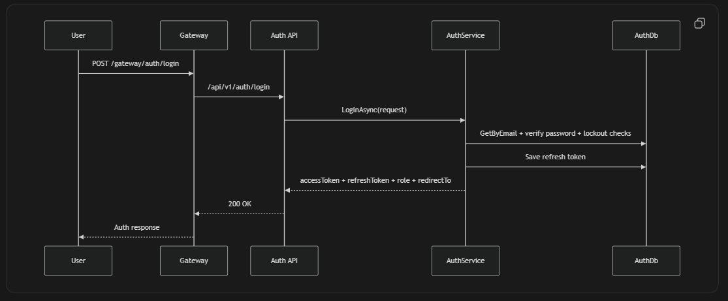

7.2 Product Publish Flow
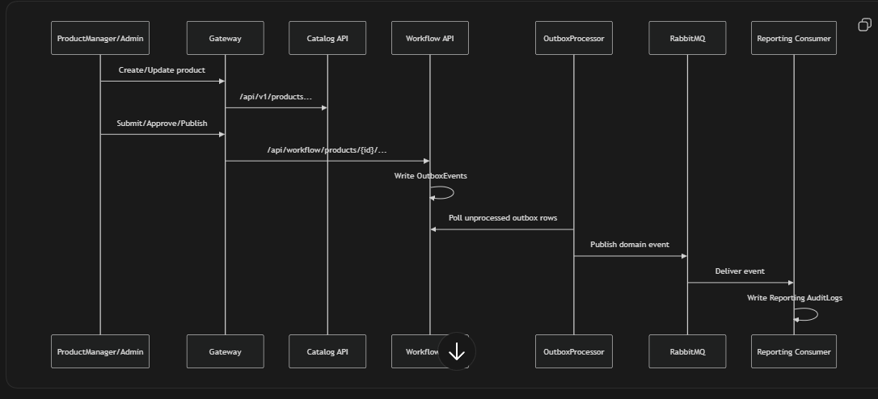

8. Security LLD
- JWT bearer auth across services.
- Role-based [Authorize(Roles=...)] at controller/action level.
- Auth rate limiting policies for login/forgot/refresh/admin.
- Password hashing with BCrypt.
- Correlation IDs and structured logs across request path.
9. Integration Notes
- Gateway + Auth/Catalog/Workflow/Reporting routing is implemented.
- Data ownership is isolated per service DB.
- Event-driven reporting is implemented via consumers.
- Event exchange/routing naming must stay consistent across publishers/consumers for full E2E reliability.

