COIMBATORE INSTITUTE OF TECHNOLOGY
COIMBATORE

Department of Artificial Intelligence & Data Science

BlockVote: Decentralized Blockchain Voting System Using Ethereum Smart Contracts

Project Report

Name: Muthu Meenakshi S
Reg.no: 2303717624322037

Abstract
Transparent and verifiable voting is important for reducing unauthorized participation and duplicate ballots. BlockVote is a decentralized voting application that combines Solidity smart contracts with a React-based web interface. Administrators create elections, register candidates, whitelist eligible voter addresses, and configure voting deadlines. Registered voters connect through MetaMask and submit ballots that are validated and recorded by the smart contract. The system uses a local Hardhat network, Ethers.js v6, and a React + Vite frontend. Its features include live vote tallies, election lifecycle controls, wallet-based access, and JSON/CSV audit exports. The documentation reports 23 automated smart-contract unit tests. BlockVote is an academic demonstration: voter addresses and candidate choices are publicly observable on-chain, so the system does not provide secret-ballot privacy.
The application supports multiple elections, candidate management, single and batch voter registration, deadline extension, early closure, and read-only browsing for visitors. The smart contract stores election, candidate, and voter state, while MetaMask signs state-changing transactions. The current setup targets a local Hardhat blockchain (Chain ID 31337); deployment to a public network and privacy-preserving voting are future work.
Keywords: Blockchain, Ethereum, Solidity, Smart Contract, Decentralized Voting, Hardhat, React, MetaMask, Ethers.js

1. Introduction

1.1 Background
Voting systems need to enforce eligibility, prevent duplicate ballots, and provide a trustworthy way to inspect results. Conventional digital voting applications may rely on centralized databases and administrators, making independent verification difficult. Blockchain provides a shared, tamper-evident record of transactions and smart contracts can enforce voting rules consistently.
BlockVote applies these principles to an academic voting demonstration. Election data and ballots are recorded through a smart contract on an Ethereum-compatible network. While this improves traceability and public auditability, the public nature of standard EVM transactions means that voter choices are not anonymous.

1.2 Problem Statement
To design and implement a decentralized voting system in which:
- administrators can create elections and configure voting periods;
- eligible wallet addresses can be registered and permitted to cast one ballot per election;
- smart-contract rules validate votes and maintain election tallies;
- observers can inspect results and export election data without administrative privileges.

1.3 Objectives
- Develop a Solidity smart contract for election creation, candidate management, voter registration, voting, and result queries.
- Enforce voter eligibility and prevent repeat voting from the same wallet address in an election.
- Provide an administrator interface to manage elections, candidates, voter whitelists, and deadlines.
- Provide a voter interface with MetaMask integration and a public dashboard for viewing elections and tallies.
- Validate contract behaviour using automated Hardhat unit tests and support audit data exports.

1.4 Scope
The current implementation targets a local Hardhat development network (Chain ID 31337) and demonstrates election creation, voter registration, voting, result inspection, and election closure. It is intended for academic demonstration and does not provide cryptographic ballot privacy or establish production readiness.

2. Technology Stack
Layer | Technologies
Smart contracts | Solidity ^0.8.24, Hardhat, OpenZeppelin, Chai / Mocha
Front-end framework | React 18, Vite
Blockchain client | Ethers.js v6 (BrowserProvider + JsonRpcProvider)
Styling and UI | React components, dashboard, admin console, audit/export views
Wallet | MetaMask for transaction signing
Blockchain network | Local Hardhat node, JSON-RPC, Chain ID 31337
Prerequisites for running the project: Node.js v18 or higher, npm, and the MetaMask browser extension.

3. System Overview
BlockVote consists of a client presentation layer, a wallet integration layer, and a blockchain layer.
- Client browser: a React 18 + Vite interface with dashboard, ballot details, administrator console, and audit/export views.
- Blockchain layer: a JSON-RPC endpoint at 127.0.0.1:8545, the BlockVote.sol smart contract, and EVM storage for elections, candidates, and voter records.
- Actors: administrators create elections and manage eligibility; registered voters cast ballots; auditors and observers inspect election state and export results.
The central design idea is to enforce voting rules in the smart contract while using the frontend for interaction and presentation. Read operations can use a JSON-RPC provider, while state-changing operations require a connected wallet to sign transactions.

4. Core Components

4.1 Election and Voting Lifecycle
- Each election has a start timestamp and end timestamp. Before the start time its state is NotStarted; during the permitted voting window it is Active; after the deadline or an administrator's early closure it is Ended.
- The smart contract checks the election state, voter registration, previous voting status, and candidate identifier before accepting a ballot.
- When a valid vote is accepted, the candidate's vote count and the election's total vote count are updated, and the voter is marked as having voted. Reverted transactions do not partially update contract state.

4.2 Smart Contract: BlockVote.sol
The contract uses Solidity ^0.8.24 and is configured with Hardhat. The documentation specifies OpenZeppelin Ownable for ownership and ReentrancyGuard for protection of critical voting operations.
Data structures
struct Candidate { uint256 id; string name; string party; string avatarUrl; uint256 voteCount; }
State variables and records
Record / variable | Type | Purpose
Election | struct | Stores title, description, timestamps, counts, creator, and lifecycle flags
Candidate | struct | Stores candidate ID, name, party/manifesto, avatar URL, and vote count
Voter | struct | Stores registration, voting status, chosen candidate ID, and vote timestamp
Election records store the title, description, start and end timestamps, candidate count, total votes, existence flag, early-termination flag, and creator address. Voter records store registration status, whether the voter has voted, the selected candidate ID, and the vote timestamp.
Function | Access | Cost profile | Description
createElection | Admin only | State write | Creates an election and validates its title and voting window
addCandidate | Admin only | State write | Adds a candidate to an existing election
registerVoter | Admin only | State write | Whitelists one eligible wallet address
registerVotersBatch | Admin only | State write | Registers multiple voter addresses in one transaction
vote | Registered voter | State write | Validates eligibility and records one ballot; protected by nonReentrant
closeElectionEarly / extendElectionDeadline | Admin only | State write | Ends an election early or extends its deadline
Core functions
- ElectionCreated, CandidateAdded, VoterRegistered, and VotersBatchRegistered
- VoteCast
- ElectionClosed
- ElectionDeadlineExtended
Access control and validation
Function / condition | Message | Meaning
createElection | Invalid election details | Title or voting timestamps fail validation
addCandidate | Invalid candidate | Candidate name is empty or election is closed
registerVoter | Already registered / zero address | Address is invalid or already whitelisted
vote | Duplicate vote / voter ineligible | Wallet has already voted or is not registered
Election queries return the election details and computed state. The documented voting rules reject unregistered voters, repeat voting from the same address, invalid candidate IDs, and ballots outside the permitted voting window.

5. Frontend Architecture

5.1 Wallet and Provider Design
- Wallet-connected provider (BrowserProvider): connects to MetaMask and signs state-changing transactions such as creating elections, registering voters, managing candidates, and casting votes.
- Read-only provider (JsonRpcProvider): connects to http://127.0.0.1:8545 so visitors can browse elections and read tallies without connecting a wallet, when the local node is reachable.

5.2 Web3 Context
The Web3Context.jsx provider centralizes wallet connection, account and network changes, contract access, and administrator status.
Property / method | Description
account | Connected wallet address
contract | Signer-connected contract for write transactions
readContract | Read-only contract for queries
isAdmin | Indicates whether the connected wallet has administrator privileges
isCorrectNetwork | True when MetaMask is connected to Hardhat Chain ID 31337
rpcConnected | Indicates whether the local JSON-RPC node is responsive
connectWallet() | Connects MetaMask to the frontend
switchToHardhatNetwork() | Requests the local Hardhat network in MetaMask
refreshElectionData() | Refreshes election state and tallies

5.3 Role-Based Access in the UI
- Public / observer: browse elections and view tallies and audit information.
- Registered voter: inspect eligibility and submit one ballot in an active election.
- Administrator: create elections, add candidates, register voters, and manage election deadlines.

5.4 Repository Structure
blockchain-based-voting-system/\n├── docs/ # User manual and technical specifications\n├── smart-contracts/\n│ ├── contracts/BlockVote.sol # Main voting smart contract\n│ ├── scripts/deploy.js # Deployment and demo seeding\n│ ├── test/BlockVote.test.js # Automated contract tests\n│ └── hardhat.config.js # Hardhat configuration\n└── frontend/\n └── src/ # React components, context, utilities, ABI and address
The deployment script exports the deployed contract address and ABI to the frontend so that the interface can interact with the current local deployment.

6. Workflows

6.1 Election Creation and Configuration
- The administrator connects MetaMask using the deployer or another authorized administrator account and opens the Admin Console.
- The administrator enters the election title, description, start time, and end time.
- The frontend submits the createElection transaction through MetaMask.
- After transaction confirmation, the contract records the election and assigns an election ID.
- The administrator selects the election and adds candidates with names, party or manifesto text, and optional avatar URLs.
- Eligible voter addresses are registered individually or in a batch before they cast ballots.

6.2 Voting
- The voter connects MetaMask, browses elections, and opens an active election.
- The frontend queries election details and voter status. The voter selects a candidate and confirms the transaction in MetaMask.
- The contract validates the voting window, registration, previous voting status, and candidate ID before recording the ballot.
Election state | Condition | Meaning
NotStarted | block.timestamp < startTime | Voting has not opened
Active | startTime <= block.timestamp <= endTime and not forceEnded | Eligible registered voters may vote
Ended | block.timestamp > endTime or forceEnded == true | Voting is closed

6.3 Result Inspection and Audit
- Observers open the Audit & Proofs view to inspect the contract address, network information, election records, and candidate tallies.
- The dashboard displays election totals and candidate vote shares based on contract state.
- Election data can be exported in JSON or CSV format for review and analysis.
- The on-chain record provides a traceable transaction history, but the voter address and selected candidate are not confidential in this design.

6.4 Election Lifecycle Management
The administrator can extend an election deadline or close an election early. These controls are enforced by the contract and prevent further voting once the election is ended.

7. Security Analysis
Threat | Mitigation in BlockVote
Unauthorized voting | Only registered voter addresses are permitted to vote
Duplicate voting | hasVoted state prevents a second ballot from the same address per election
Reentrancy | The vote function uses ReentrancyGuard as documented
Late voting | Election timestamps restrict voting to the permitted window
Integer overflow | Solidity 0.8+ includes checked arithmetic by default
Public ballot exposure | Documented limitation: addresses and candidate choices are visible on-chain
The trust model relies on the administrator to register eligible voter addresses correctly. The system enforces wallet-level participation rules, but a whitelist alone does not prove a voter's real-world identity and does not prevent one person from controlling multiple registered wallets.

8. Testing
The architecture and README report 23 automated unit tests for the BlockVote smart contract using Hardhat. The tests cover deployment, election creation, candidate management, voter registration, voting restrictions, lifecycle controls, and query functions.
Area | Test / invariant described
Deployment | Owner/admin initialization and initial state
Deployment | Academic disclaimer / configuration checks
Election management | Admin can create elections; unauthorized callers are rejected
Election management | Empty titles and invalid time windows are rejected
Candidate management | Admin can add candidates and events are emitted
Candidate management | Invalid candidate names and election IDs are rejected
Voter registration | Single voter registration and duplicate rejection
Voter registration | Batch registration of multiple addresses
Voting | Valid vote updates candidate and election totals
Voting | Duplicate votes are rejected
Voting | Unregistered wallets are rejected
Voting | Invalid candidate IDs and out-of-window votes are rejected
Lifecycle | Deadline extension and early closure work as expected
Queries | getAllElections returns election summaries
The documentation reports successful tests for duplicate-vote rejection, unauthorized voting, invalid candidate IDs, voting-window enforcement, deadline extension, and early election closure. These are documented results and have not been independently rerun as part of this document conversion.

9. Setup and Deployment
Smart contracts
- Open a terminal in the smart-contracts directory and run npm install.
- Run npx hardhat test to execute the automated contract test suite.
- Start the local blockchain with npx hardhat node. It listens on http://127.0.0.1:8545 and provides pre-funded development accounts.
- In a second terminal, run npx hardhat run scripts/deploy.js --network localhost to deploy the contract and export its address and ABI to the frontend.
Front end
- Open a terminal in the frontend directory and run npm install.
- Run npm run dev and open the local URL printed by Vite (the documentation commonly specifies http://localhost:5174, with 5173 also possible depending on configuration).
MetaMask configuration: add the Hardhat Localhost network with RPC URL http://127.0.0.1:8545, Chain ID 31337, and currency symbol ETH. The published Hardhat development private keys are for local testing only and must never be used on a real network.
Troubleshooting
- Wrong Network: switch MetaMask to Hardhat Localhost (Chain ID 31337).
- Voter Ineligible: connect the wallet that the administrator registered for the selected election.
- Duplicate Vote Prevented: a wallet can cast only one ballot per election; use another registered test account for additional test cases.

10. Limitations
- Local network only: the documented RPC endpoint points to 127.0.0.1:8545, so other users cannot access the same local chain unless their environment is configured to reach it.
- No ballot privacy: voter addresses and candidate choices are publicly observable on the EVM ledger. This design is not suitable for elections requiring secret ballots.
- Wallet-level eligibility: the whitelist prevents unregistered addresses from voting but does not by itself establish real-world identity or prevent coordinated registration of multiple wallets.
- Administrative control: authorized administrators can extend deadlines or close elections early, so election governance and oversight must be clearly defined.
- Production readiness: the documents report unit tests but do not provide an independent security audit, formal verification, or measured scalability results.

11. Screenshots
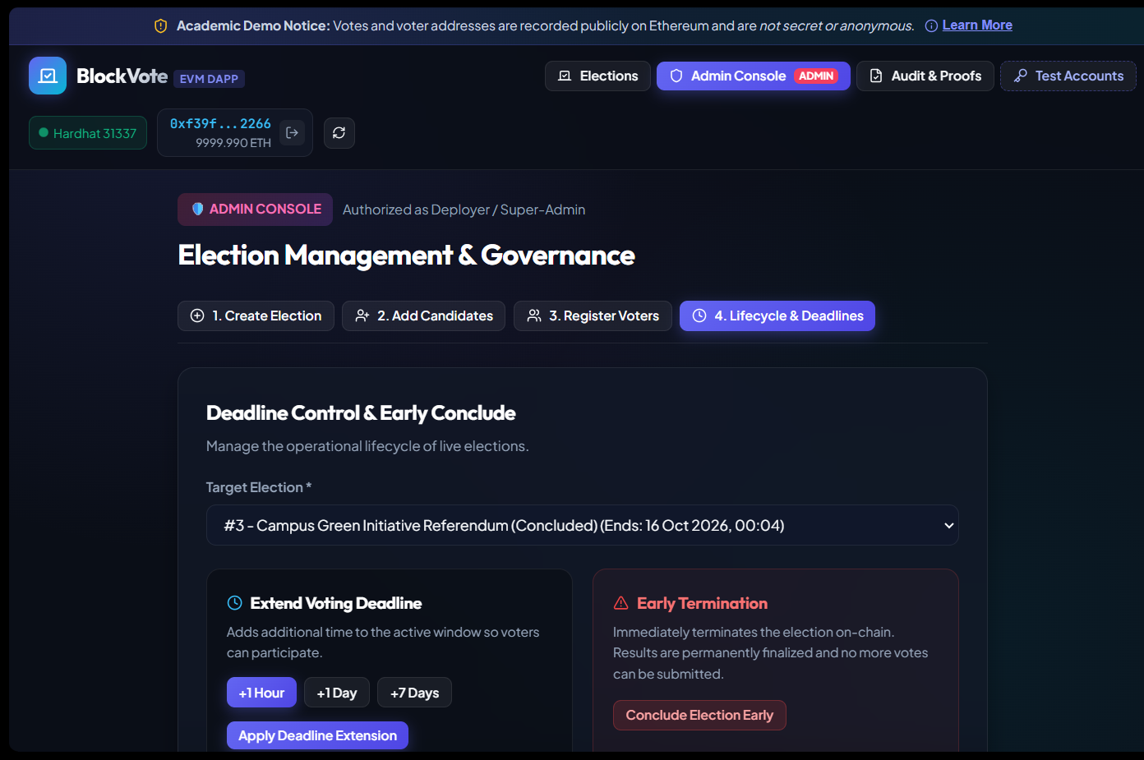

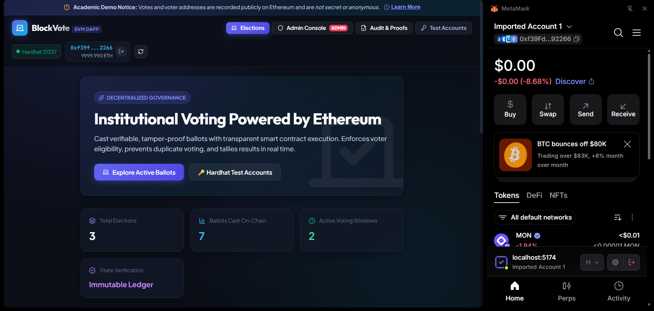

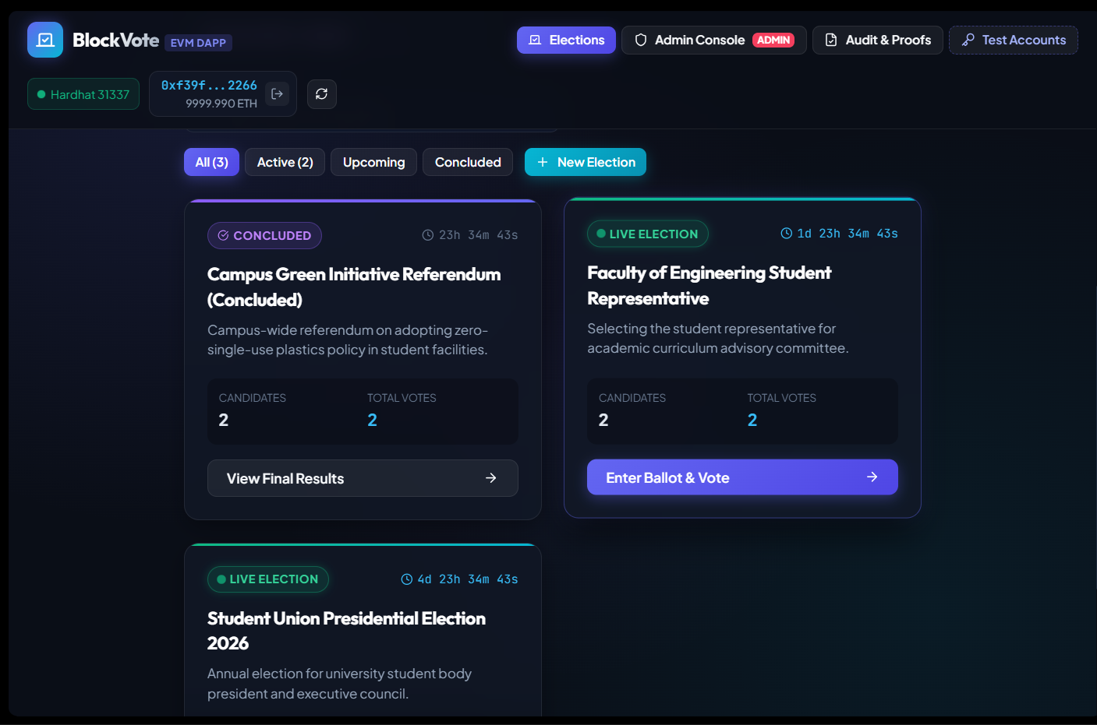

12. Future Scope
- Privacy-preserving ballots: investigate zero-knowledge proofs, ring signatures, or other cryptographic designs that can separate voter eligibility from ballot choice.
- Identity and eligibility assurance: integrate a robust voter-registration process while minimizing unnecessary personal information on-chain.
- Scalability: evaluate deployment on an appropriate public network or Layer 2 solution and measure transaction costs and throughput.
- Governance: consider multi-signature administration, transparent election policies, and independent oversight for sensitive elections.
- Testing and audit: add formal verification, external smart-contract security review, load testing, and broader integration tests.

13. Conclusion
BlockVote demonstrates how an Ethereum-compatible smart contract can manage election creation, candidate registration, voter whitelisting, ballot validation, and result inspection in a local academic environment. Its React frontend and MetaMask integration provide role-based workflows, while the contract records voting state and enforces one ballot per registered wallet per election. The documented test suite covers key functional rules, and audit exports support review of election data. However, the public visibility of voter choices, reliance on administrator-managed whitelists, and local-network setup limit its suitability for real-world elections. Privacy-preserving cryptography, stronger identity assurance, independent audits, and deployment evaluation are important areas for future work.

References
- Ethereum Foundation, Ethereum Developer Documentation.
- Solidity Documentation, version 0.8.x.
- Hardhat Documentation.
- Ethers.js v6 Documentation.
- MetaMask documentation and EIP-1193 provider API.
- OpenZeppelin Contracts documentation: Ownable and ReentrancyGuard.
- React and Vite documentation.
- Mocha and Chai documentation.

