*CSS /CSS3*

Q=1 What are the benefits of using CSS?

Ans:-ThereareanumberofbenifitofCSS**,** including**:**

1) Faster Page Speed. More code means slower page speed. ...

2) Better User Experience. CSS not only makes web pages easy on the eye, it also allows for user-friendly formatting. ...

3) Quicker Development Time. ...

4) Easy Formatting Changes. ...

5) Compatibility Across Devices.

Q=2 What are the disadvantages of CSS?

Ans:-Confusion due to many CSS levels. Beginners are more vulnerable to this issue.

Cross-Browser Issues. Different browsers work differently

Q=3 What is the difference between CSS2 and CSS3?

Ans:- The main difference between CSS and CSS3 is that CSS3 has modules.CSS is the basic version and it does not support responsive design.

Q=4 Name a few CSS style components

Ans:- The components of css style are: 1)Selecter:HTML element name, id name, class name. 2)Property:It's like an attribute such as background color,font-size etc.

Q=5 What do you understand by CSS opacity?

Ans:-  Opacity is the degree to which content behind an element is hidden, and is the opposite of transparency.

Q=6 How can the background color of an element be changed?

Ans:- To add background color in HTML, use the CSS background-color property.

Q=7 How can image repetition of the backup be controlled?

Ans:- This task can be achieved by using the background-repeat property that will help us to control the repetition of the image.

Q=8 What is the use of the background-position property?

Ans:- The background-position property sets the starting position of a background image.

Q=9 Which property controls the image scroll in the background?

Ans:- To set the scrolling of an image in the background, use the background-attachment property. Example. You can try to run the following code.

Q=10 Why should background and color be used as separate properties?

Ans:-  It enhances the legibility of style sheets.

Q=11 What are the external style sheets?

Ans:- An external style sheet is a separate CSS file that can be accessed by creating a link within the head section of the webpage.

Q=12 What is the meaning of the CSS selector?

Ans:- . It is a pattern of elements and other terms that tell the browser which HTML elements should be selected to have the CSS property values inside the rule applied to them.

Q=13 What are the media types allowed by CSS?

Ans:- continuous or paged.

visual, audio, speech, or tactile.

grid , or bitmap.

Interactive,or static (for those that do not).

all includes all media types

Q=14 What is the rule set?

Ans:- **A** collection of rules or signatures that network traffic or system activity is compared against to determine an action to take—such as forwarding or rejecting a packet, creating an alert, or allowing a system event.

Q=15 Create Layouts

Ans:-

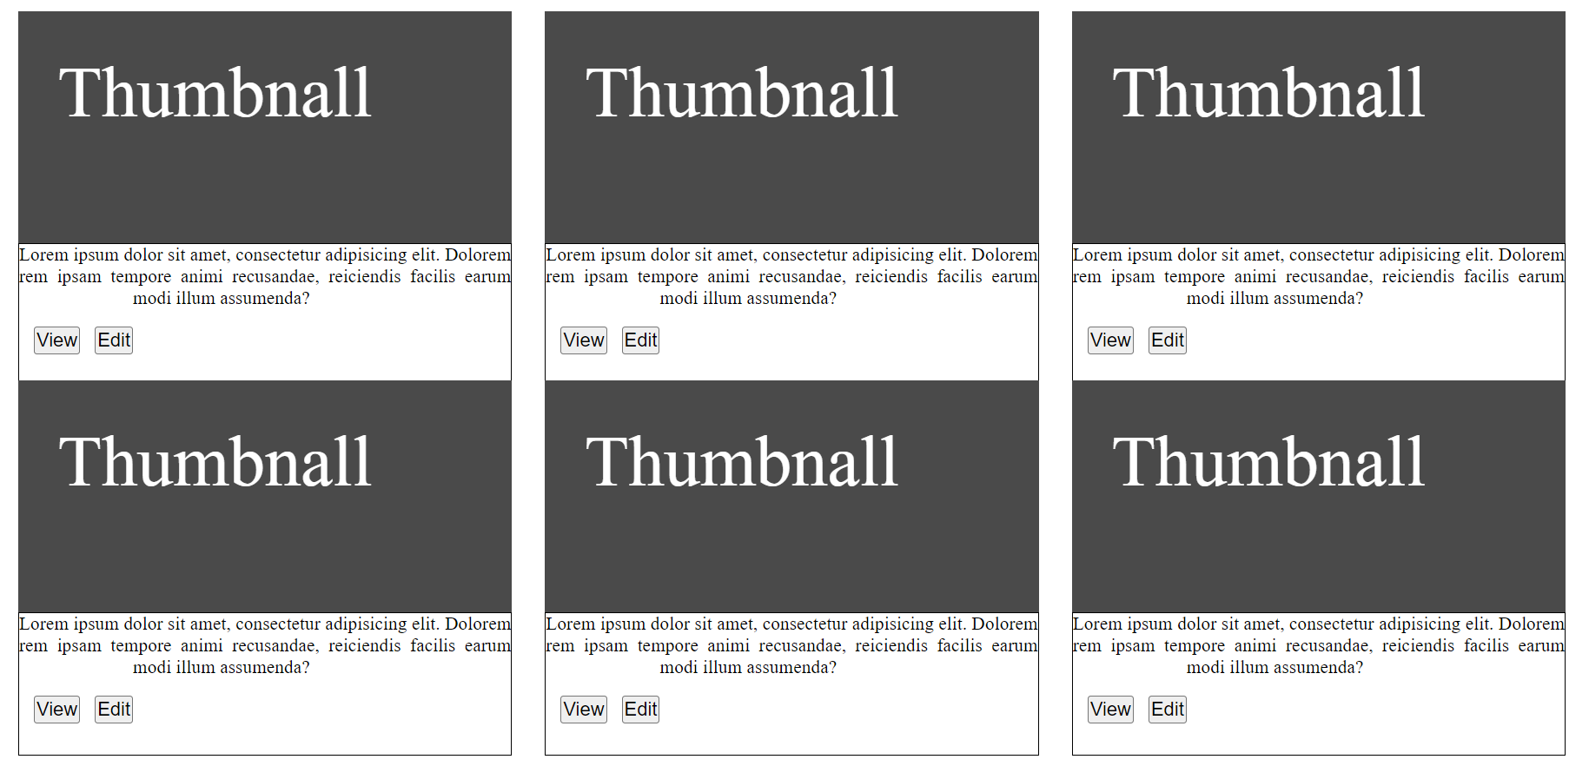

==================The End==================================