**MODULE : 2 (HTML)**

1. Define the terms: Website, Webpage, Web browser, Web server, HTML, CSS ?

* **Website** : Websites is a providing information from anywhere in world.
* **Webpage** : Web page is a document available on World Wide Web. Web Pages are stored on web server and can be viewed using a web browser.
* **Web Browser** : Web browsers are applications for displaying web pages.
* **Web Server** : On the server side of the HTTP link, application servers and other dynamic content servers such as Web content management systems provide content through a large variety of techniques and technologies typified by the scripting approach.
* **HTML** : HTML, which stands for Hyper Text Markup Language, is the predominant markup language for web pages.
* **CSS :**Cascading Style Sheets is a style sheet language used for describing the presentation of a document written in a markup language such as HTML or XML. CSS is a cornerstone technology of the World Wide Web, alongside HTML and JavaScript.:

1. Create a webpage to show “This is my first HTML page”

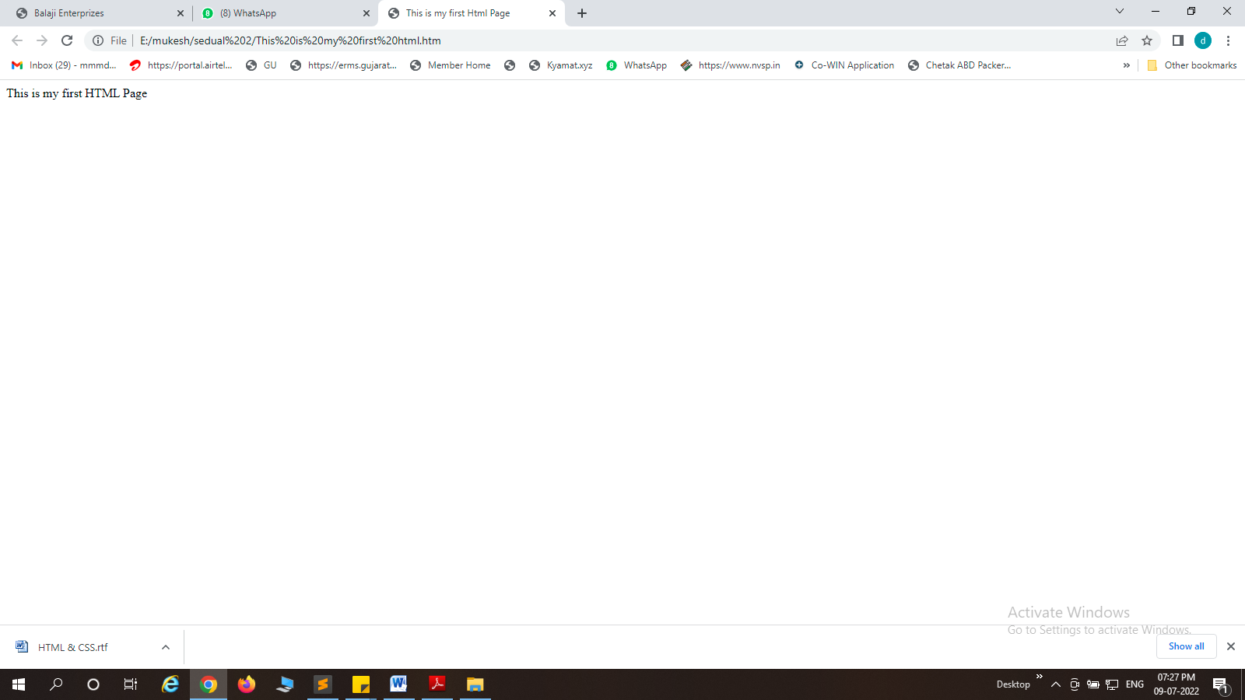

1. Display Top 10 IT companies list in html webpage

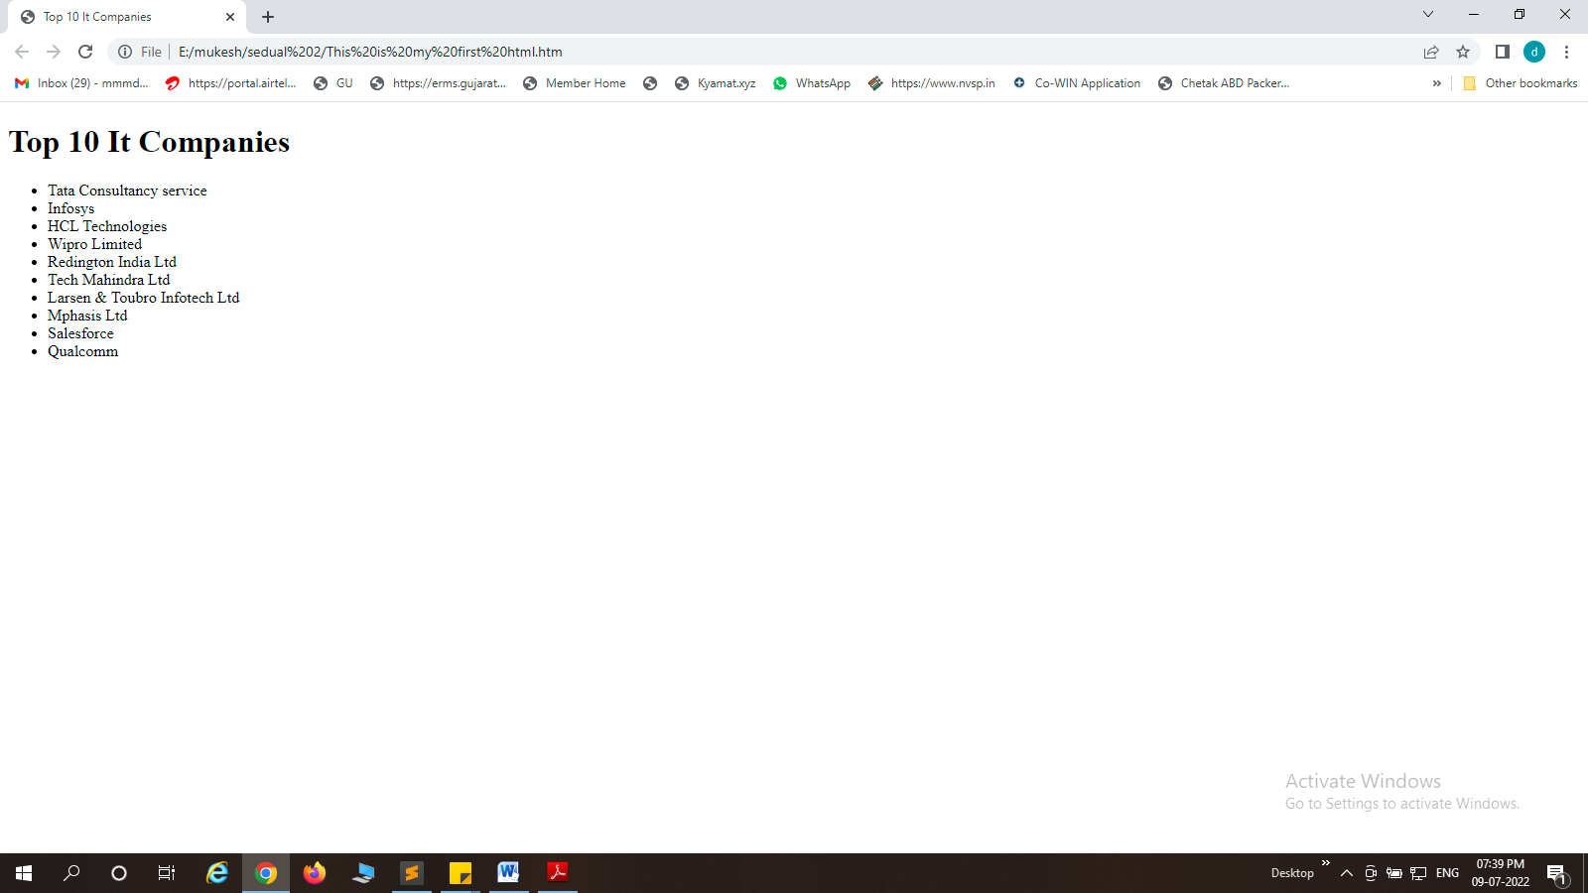

1. Create a dropdown list
2. Create a Table Of collage Management system using row span &

Col span

1. Create below table using HTML table tags
2. Create a Registration form using HTML,CSS
3. In How many ways can a CSS be integrated as a web page?

Ans:Inline,internal and external is a CSS be intergrated as a web page.

1. Create Simple three pages using External CSS,Internal CSS and Inline CSS.
2. Create below page using HTML CSS