Selenium Web Table Automation – 8 Test Cases

TC01: Print all column headings
from selenium import webdriver
from selenium.webdriver.common.by import By
driver = webdriver.Chrome()
try:
driver.get("https://the-internet.herokuapp.com/tables")
driver.maximize_window()
headers = driver.find_elements(By.CSS_SELECTOR, "#table1 thead th")
print("Column Headings:")
for header in headers:
print(header.text)
finally:
driver.quit()
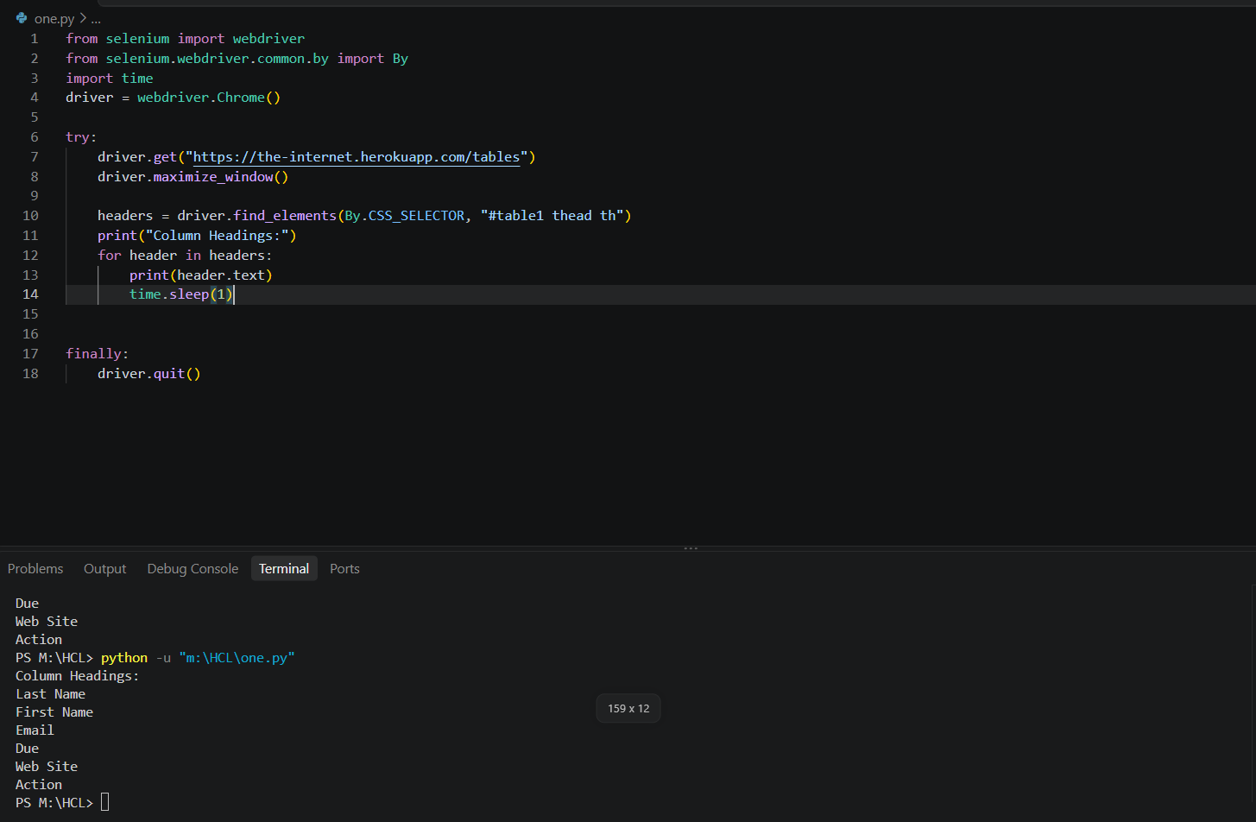

TC02: Print the first data row
from selenium import webdriver
from selenium.webdriver.common.by import By
driver = webdriver.Chrome()
try:
driver.get("https://the-internet.herokuapp.com/tables")
first_row = driver.find_element(By.CSS_SELECTOR, "#table1 tbody tr:first-child")
cells = first_row.find_elements(By.TAG_NAME, "td")
print("First Data Row Data:")
row_data = [cell.text for cell in cells]
print(row_data)
finally:
driver.quit()
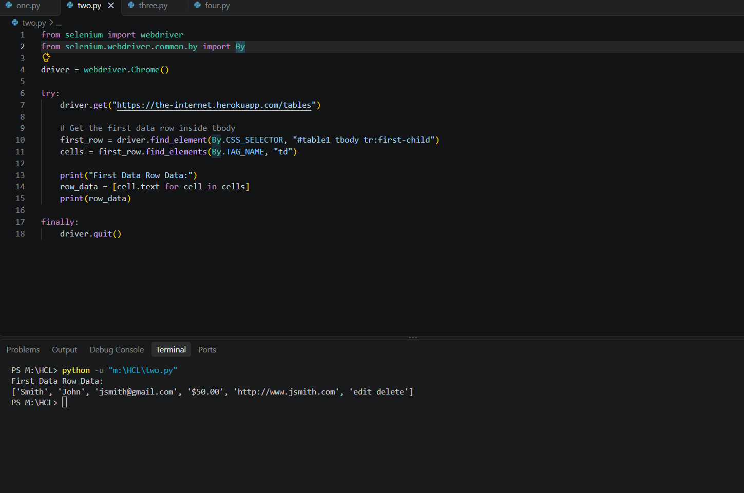

TC03: Print the last data row
from selenium import webdriver
from selenium.webdriver.common.by import By
driver = webdriver.Chrome()
try:
driver.get("https://the-internet.herokuapp.com/tables")
rows = driver.find_elements(By.CSS_SELECTOR, "#table1 tbody tr")
if rows:
last_row = rows[-1]
cells = last_row.find_elements(By.TAG_NAME, "td")
print("Last Data Row Data:")
row_data = [cell.text for cell in cells]
print(row_data)
finally:
driver.quit()
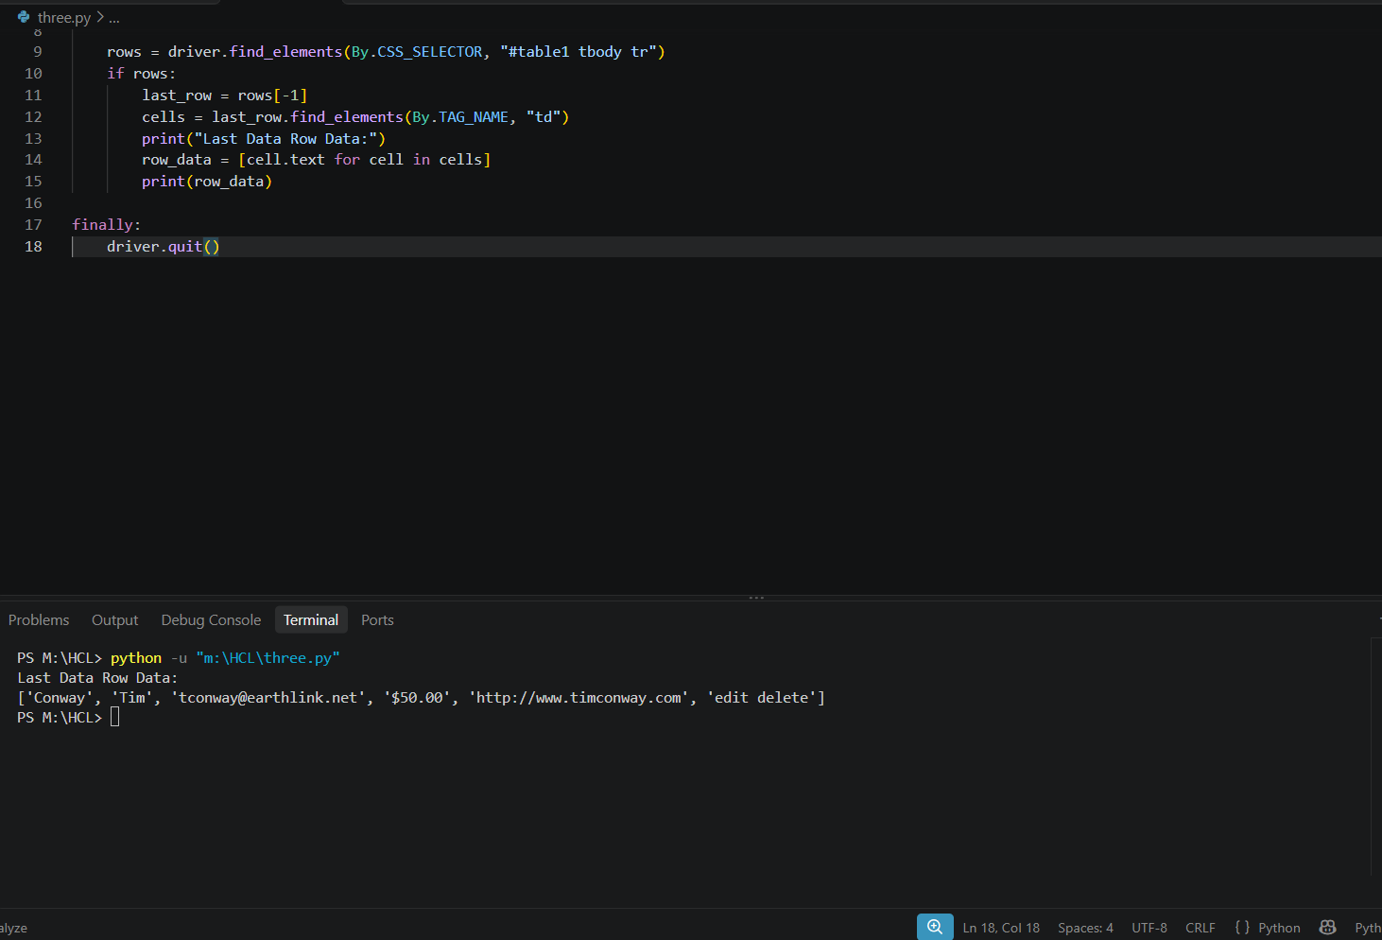

TC04: Search for an employee by last name
from selenium import webdriver
from selenium.webdriver.common.by import By
driver = webdriver.Chrome()
try:
driver.get("https://the-internet.herokuapp.com/tables")
rows = driver.find_elements(By.CSS_SELECTOR, "#table1 tbody tr")
search_last_name = "Smith"
found = False
for row in rows:
cells = row.find_elements(By.TAG_NAME, "td")
last_name = cells[0].text
if last_name == search_last_name:
print(f"Employee found with last name '{search_last_name}':")
print("Employee details:", row.text)
found = True
break
if not found:
print("Employee not found")
finally:
driver.quit()
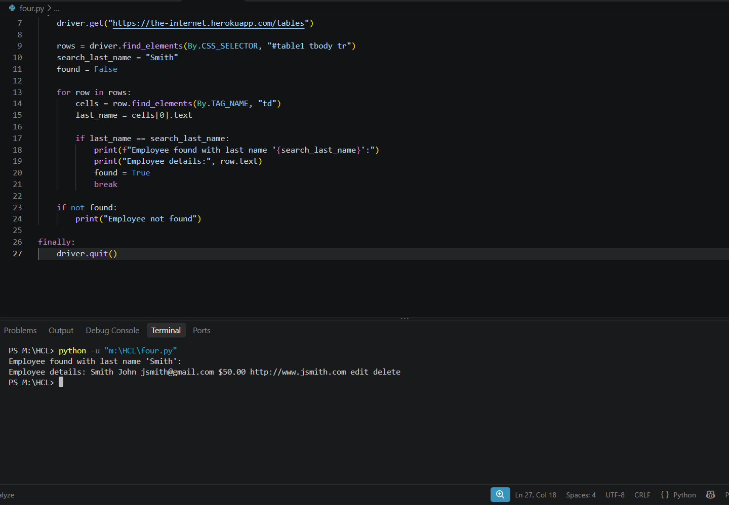

TC05: Extract all email addresses
from selenium import webdriver
from selenium.webdriver.common.by import By
driver = webdriver.Chrome()
try:
driver.get("https://the-internet.herokuapp.com/tables")
rows = driver.find_elements(By.CSS_SELECTOR, "#table1 tbody tr")
print("Extracted Email Addresses:")
for row in rows:
cells = row.find_elements(By.TAG_NAME, "td")
email = cells[2].text
print(email)
finally:
driver.quit()
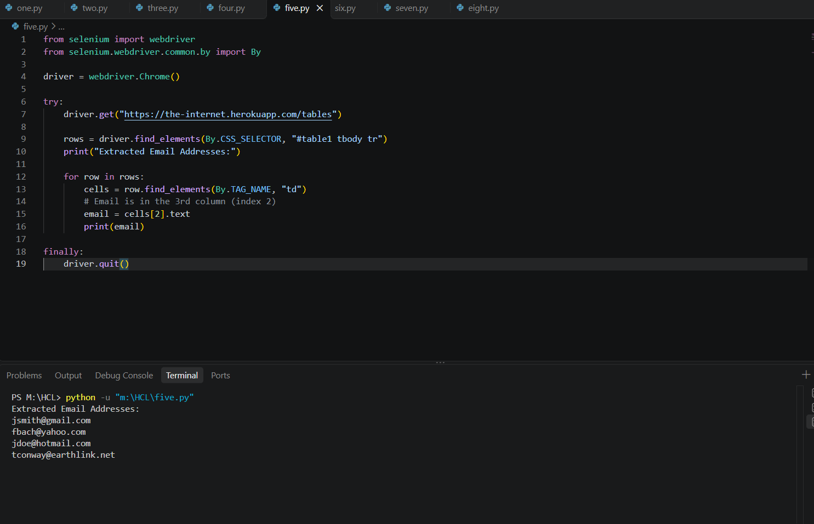

TC06: Find the employee with the highest Due amount
from selenium import webdriver
from selenium.webdriver.common.by import By
driver = webdriver.Chrome()
try:
driver.get("https://the-internet.herokuapp.com/tables")
rows = driver.find_elements(By.CSS_SELECTOR, "#table1 tbody tr")
max_due = -1.0
max_due_employee = None
for row in rows:
cells = row.find_elements(By.TAG_NAME, "td")
due_text = cells[3].text.replace("$", "")
due_amount = float(due_text)
if due_amount > max_due:
max_due = due_amount
max_due_employee = row.text
print(f"Highest Due Amount: ${max_due}")
print("Employee Details:", max_due_employee)
finally:
driver.quit()
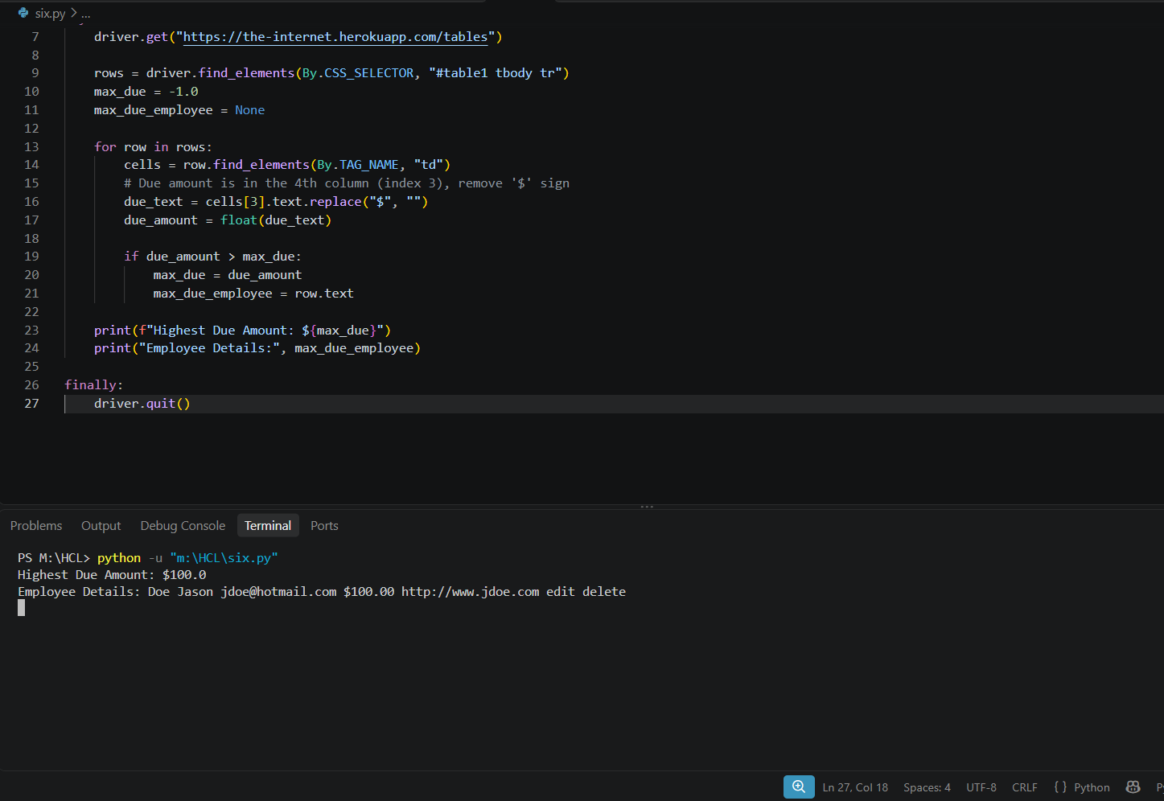

TC07: Verify that a particular website link exists
from selenium import webdriver
from selenium.webdriver.common.by import By
driver = webdriver.Chrome()
try:
driver.get("https://the-internet.herokuapp.com/tables")
target_url = "http://www.jsmith.com"
links = driver.find_elements(By.CSS_SELECTOR, "#table1 tbody tr td a")
found = False
for link in links:
href = link.get_attribute("href")
if href == target_url:
print(f"Pass: Website link found -> {href}")
found = True
break
if not found:
print(f"Fail: Website link '{target_url}' not found.")
finally:
driver.quit()
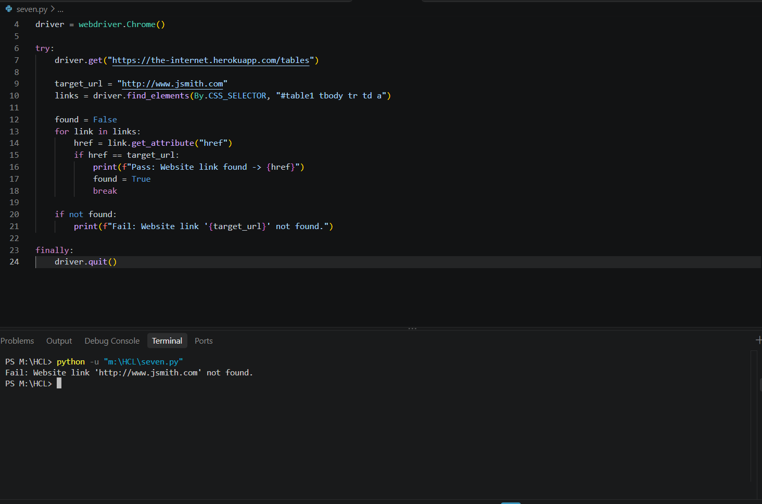

TC08: Count data rows without counting the header
from selenium import webdriver
from selenium.webdriver.common.by import By
driver = webdriver.Chrome()
try:
driver.get("https://the-internet.herokuapp.com/tables")
rows = driver.find_elements(By.CSS_SELECTOR, "#table1 tbody tr")
print("Number of data rows (excluding header):", len(rows))
finally:
driver.quit()

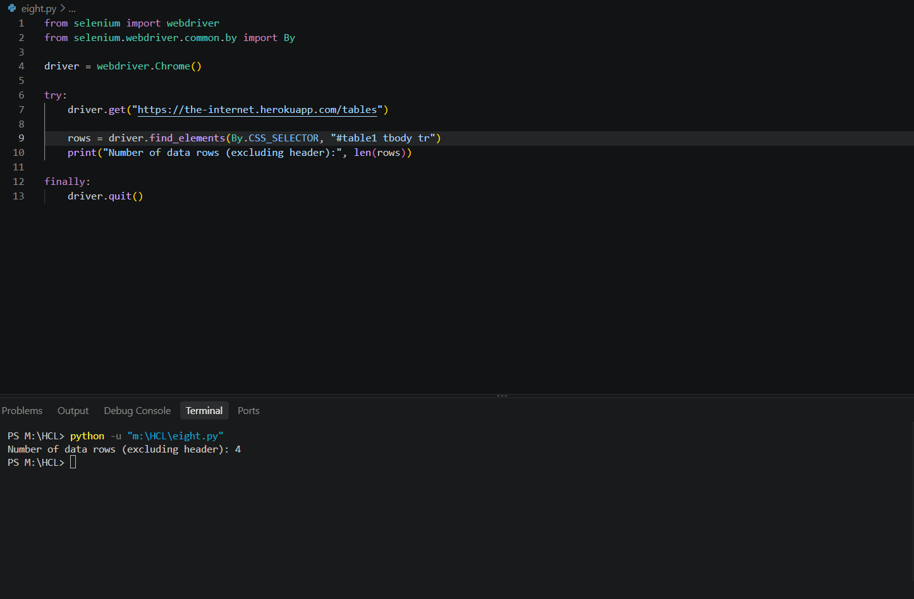
Github:
https://github.com/Mukesh2142006/Selenium-Web-Table-Automation-Programs/tree/main

