**PORTFOLIO PROJECT**

Submitted by

**V.MUKESH**

**Reg.No :1P22MC029**

In partial fulfillment of the requirement for the award of the Degree of

**Master of Computer Applications**

**Bharathiar University Coimbatore**.

Under the Internal Supervision of

**K. SWATHY**

**Associate Professor**

**School of Computer Studies-MCA**



**Master of Computer Applications**

**Rathnavel Subramaniam College of Arts and Science**

**(Autonomous),**

**Sulur, Coimbatore – 641 402**

**December 2022**

**RATHNAVEL SUBRAMANIAM COLLEGE OF ARTS AND SCIENCE**

**(AUTONOMOUS)**

**AFFILIATED TO BHARATHIAR UNIVERSITY**

**NAAC Re-accredited & ISO 9000:2008 Certified SULUR, COIMBATORE-641402.**



**December 2022**

**Register Number – 1P22MC029**

Certified bona fide original record of work done by **V. MUKESH**

**Internal Supervisor HOD**

Submitted for the project Evaluation and Viva voice held on**………………….**

**Internal Examiner External Examiner**

INDEX

Chapter-1: 5

Video Introduction

1.1 YouTube video

Chapter-2: 6

Website Bio Score

* 1. About me
  2. Resume Page

### Chapter-3: 19

Pages & Navigations

* 1. Landing Page
  2. Project Page
  3. Navigation Bar
  4. Skill Page

### Chapter-4: 55

Style Score

* 1. Font link
  2. Style link

### Chapter-5: 56

Website include the following Information

* 1. Project link to the Github
  2. Project Description

### Chapter-6: 61

Bootstrap

6.1 Uses of Bootstrap

### Chapter-7: 62

Project README

* 1. Title description
  2. How to run the project
  3. Future improvement in the project

### Chapter-8: 67

File structure

8.1 Github file structure

**Portfolio Project**

Chapter 1:

## You Tube Video

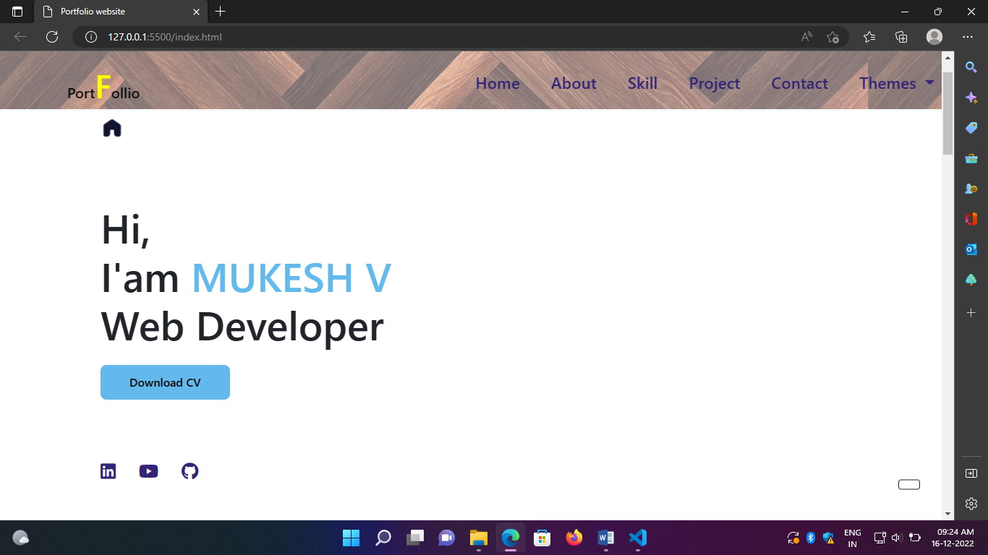

# 

# Chapter 2

**Website Bio Score:**

This is my Portfolio Project. This project is including about me and my projects and my skill. I added my contact details in this project. I created one page for my GIT Repository of my class assignments. I insert my photo in this project. I created a link to my Linked in profile and Github profile in this project. I use very simple UI and UX. This project is easily understood by all age group people. Create it with full Responsiveness for all devices.

## 2.1 ABOUT

## 

## HTML Coding:

<!--===== ABOUT =====-->

            <section class="about section " id="about">

                <h2 class="section-title">

                    <script src="https://cdn.lordicon.com/fudrjiwc.js"></script>

                    <script src="https://cdn.lordicon.com/fudrjiwc.js"></script>

                    <lord-icon

                         src="https://cdn.lordicon.com/hpivxauj.json"

                         trigger="hover"

                          style="width:32px;height:32px">

                    </lord-icon>

                    About</h2>

                <div class="about__container bd-grid">

                    <div class="about__img">

                        <img src="./image/Portfolio image.jpg" alt="Portfolio" >

                    </div>

                     <div>

                        <h2 class="about__subtitle">I'am MUKESH V</h2>

                        <p class="about__text">First and foremost, I am pursuing MCA at RVS college of art & science . i'm Web page desingner,

                            that thrivies helping others, going above and beyond every task. I am enthusiastiac about growig a new skill.

                            I had well known about HTML , CSS , JS and JAVA. I'am particularly proud to devolope my infotech knowledge.

                            my passion for selling inovative ideas and sollution, the trust in me and the joy i take in findings

                            and developing talent. When i was a computer science undergraduate student, I did not understand the importance

                            the infotech. I am a hard-working and driven individual who is not afraid to face a challenge.

                            I am passionate about my work and I know how to get the job done.

                            In my free time, I enjoy going out with friends and trying new cuisines. I also enjoy watching movies, listening to music, reading, working out, and going on road trips.

                            I am looking forward to knowing more about this opportunity and I will be happy to answer more questions.

                            I would describe myself as an open and honest person who does not believe in misleading other people and tries to be fair in everything I do..</p>

                    </div>

                </div>

            </section>

**Css:**

/* ===== ABOUT =====*/

.about__container {

  row-gap: 2rem;

  text-align: center;

}

.about__subtitle {

  margin-left: -2.5em;

  margin-bottom: var(--mb-2);

}

.about__img {

  display: inline-block;

  height: 207px;

  width: 207px;

  margin: 0 2px;

  margin-top: -14em;

  margin-left: 9%;

}

.about__img img {

  width: 250px;

  border-radius: .5rem;

}

.about__text{

  width: 110%;

  margin-left: -5em;

}

**2.2 RESUME**



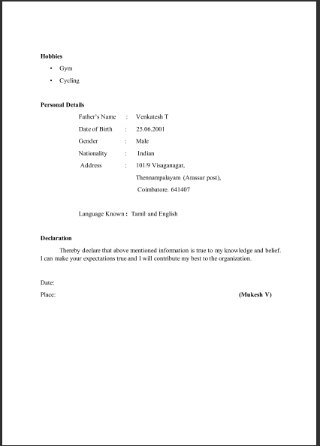

**CHAPTER 3**

**3.1 LANDING PAGE**

This is the Landing page or Home page of my project.



## HTML Coding:

        <main class="l-main">

            <!--===== HOME =====-->

            <section class="home bd-grid" id="home">

                <div class="home__data">

                    <script src="https://cdn.lordicon.com/fudrjiwc.js"></script>

                    <lord-icon

                        src="https://cdn.lordicon.com/slduhdil.json"

                        trigger="hover"

                        style="width:32px;height:32px">

                    </lord-icon>

                    <h1 class="home__title">Hi,<br>I'am <span class="home__title-color">MUKESH V</span><br> Web Developer</h1>

                    <a href="./Mukesh Resume.pdf" class="button">Resume</a>

                </div>

                 <div class="home__social">

                    <a href="https://www.linkedin.com/in/mukesh-v-6413a822a/" class="home__social-icon"><i class='fab fa-linkedin'></i></a>

                    <a href="https://studio.youtube.com/channel/UCL_0bcWmzzUMuFWsGCB19tA/videos/upload?filter=%5B%5D&sort=%7B%22columnType%22%3A%22date%22%2C%22sortOrder%22%3A%22DESCENDING%22%7D" class="home__social-icon"><i class='fab fa-youtube' ></i></a>

                    <a href="https://github.com/Mukesh27560704" class="home__social-icon"><i class='fab fa-github' ></i></a>

                  </div>

                </div>

                </section>

**Css Coding:**

/*===== HOME =====*/

.home {

  position: relative;

  row-gap: 5rem;

  padding: 4rem 0 5rem;

}

.home__data {

  align-self: center;

}

.home__title {

  font-size: var(--big-font-size);

  /* margin-bottom: var(--mb-5); */

  margin-top: 8%;

}

.home__title-color {

  color: var(--first-color);

}

.home__social {

  display: flex;

  flex-direction: column;

}

.home__social-icon {

  width: max-content;

  margin-bottom: var(--mb-2);

  font-size: 1.5rem;

  color: var(--second-color);

}

.home__social-icon:hover {

  color: var(--first-color);

}

.home__img {

  position: absolute;

  right: 0;

  bottom: 0;

  width: 260px;

}

.home__blob {

  fill: var(--first-color);

}

.home__blob-img {

  width: 450px;

  height: 400px;

}

/*BUTTONS*/

.button {

  text-decoration: none;

  display: inline-block;

  background-color: var(--first-color);

  color: black;

  padding: .75rem 2.5rem;

  font-weight: var(--font-semi);

  border-radius: .5rem;

  transition: .3s;

  margin-top: 15px;

}

 .button:hover {

  box-shadow: 0px 10px 36px rgba(15, 15, 15, 0.15);

}

**3.2 PROJECT PAGE**

This is my project page and it contains all my project.

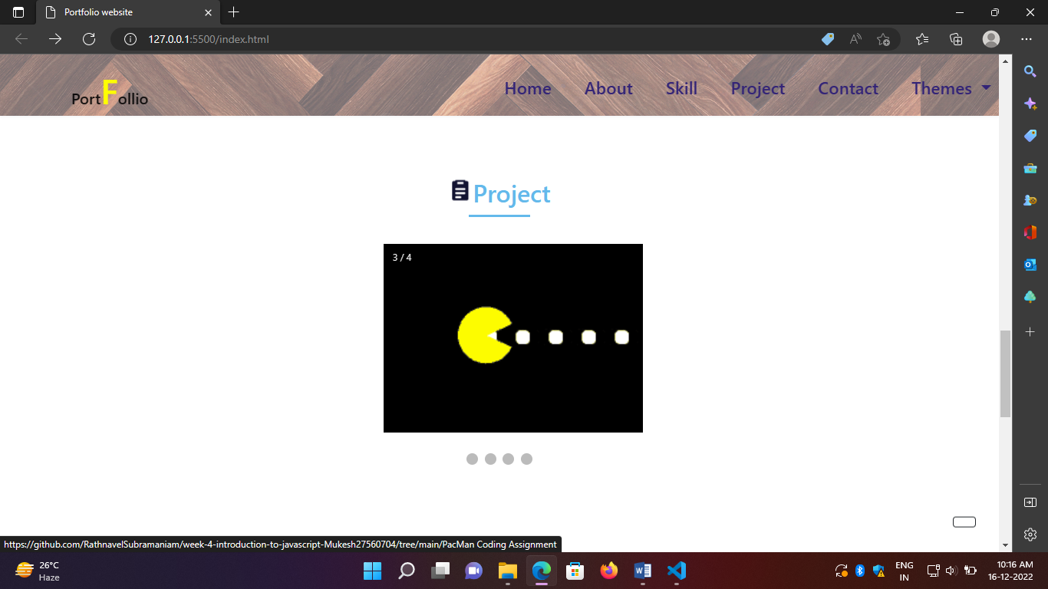

**HTML Coding:**

 <!--===== Project =====-->

            <section class="work section" id="work">

                <h2 class="section-title"><script src="https://cdn.lordicon.com/fudrjiwc.js"></script>

                    <lord-icon

                        src="https://cdn.lordicon.com/zncllhmn.json"

                        trigger="hover"

                        style="width:32px;height:32px">

                    </lord-icon>Project</h2>

                    <div class="slideshow-container">

                        <div class="mySlides fade">

                          <div class="numbertext">1 / 4</div>

                          <a href="https://github.com/RathnavelSubramaniam/week-2-javascript-Mukesh27560704/tree/main/Simulating%20Ball%20Movement%20Coding%20Assignment-4"><img src="./image/Ball Movement.gif" alt="ball" style="width:75%" style="height: 30%;"></a>

                        </div>

                        <div class="mySlides fade">

                          <div class="numbertext">2 / 4</div>

                          <a href="https://github.com/RathnavelSubramaniam/week-3-javascript-Mukesh27560704/tree/main/Graphics%20Animation%20Of%20The%20Random%20Walk%20Assignment"><img src="./image/Graphics Animation.gif" alt="random_balls" style="width:75%" style="height: 30%;"></a>

                        </div>

                        <div class="mySlides fade">

                          <div class="numbertext">3 / 4</div>

                          <a href="https://github.com/RathnavelSubramaniam/week-4-introduction-to-javascript-Mukesh27560704/tree/main/PacMan%20Coding%20Assignment"><img src="./image/PacMan.gif" alt="PacMan" style="width:75%" style="height: -15vh;"></a>

                        </div>

                        <div class="mySlides fade">

                            <div class="numbertext">4/4</div>

                            <a href="https://github.com/RathnavelSubramaniam/week-5-functions---array-manipulation-and-scope-Mukesh27560704/tree/main/boston-city-data"><img src="./image/boston-city.gif" alt="boston-city" style="width:75%" style="height: 30%;"></a>

                        </div>

                        <a class="prev" onclick="plusSlides(-1)"></a>

                        <a class="next" onclick="plusSlides(1)"></a>

                        </div>

                        <br>

                        <div style="text-align:center">

                          <span class="dot" onclick="currentSlide(1)"></span>

                          <span class="dot" onclick="currentSlide(2)"></span>

                          <span class="dot" onclick="currentSlide(3)"></span>

                          <span class="dot" onclick="currentSlide(4)"></span>

                        </div>

                        <script>

                            let slideIndex = 1;

                            showSlides(slideIndex);

                            function plusSlides(n) {

                              showSlides(slideIndex += n);

                            }

                            function currentSlide(n) {

                              showSlides(slideIndex = n);

                            }

                            function showSlides(n) {

                              let i;

                              let slides = document.getElementsByClassName("mySlides");

                              let dots = document.getElementsByClassName("dot");

                              if (n > slides.length) {slideIndex = 1}

                              if (n < 1) {slideIndex = slides.length}

                              for (i = 0; i < slides.length; i++) {

                                slides[i].style.display = "none";

                              }

                              for (i = 0; i < dots.length; i++) {

                                dots[i].className = dots[i].className.replace(" active", "");

                              }

                              slides[slideIndex-1].style.display = "block";

                              dots[slideIndex-1].className += " active";

                            }

                            </script>

            </section>

**3.3 NAVIGATION BAR**

I use four navigation menus in this project. There are Home (This is the main page), Project (This page contains my project details), About (This page has content about me) and Contact (This one for my contact details).

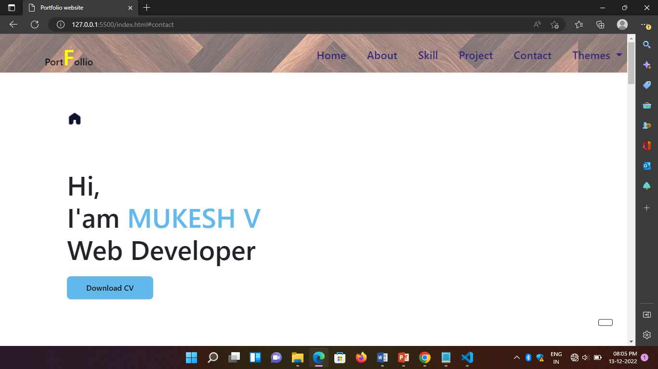

**HTML Coding:**

  <!--====== nav_menu=========== -->

         <link href="https://cdn.jsdelivr.net/npm/bootstrap@5.0.2/dist/css/bootstrap.min.css" rel="stylesheet">

        <script src="https://cdn.jsdelivr.net/npm/bootstrap@5.0.2/dist/js/bootstrap.bundle.min.js"></script>

<style>

    header{

        background-image: url(/image/header\ image.jpg);

    }

</style>

    </head>

    <body>

        <!--===== HEADER =====-->

        <header class="l-header">

            <div class="navdiv">

            <nav class="navbar navbar-expand-lg navbar-light" class="nav1">

                <div class="container">

                  <a href="#" class="navbar-brand nav__logo">Port<span style="font-size: 45px; color: yellow;">F</span>ollio</a>

                  <button class="navbar-toggler" type="button" data-bs-toggle="collapse" data-bs-target="#navbarSupportedContent" aria-controls="navbarSupportedContent" aria-expanded="false" aria-label="Toggle navigation">

                    <span class="navbar-toggler-icon"></span>

                  </button>

                  <div class="collapse navbar-collapse" id="navbarSupportedContent">

                    <ul class="navbar-nav me-auto mb-2 mb-lg-0 nav__list" class="" id="nav__list">

                        <li class="nav__item nav_li"><a href="#home" class="nav__link">Home</a></li>

                        <li class="nav__item nav_li"><a href="#about" class="nav__link">About</a></li>

                        <li class="nav__item nav_li"><a href="#skills" class="nav__link">Skill</a></li>

                        <li class="nav__item nav_li"><a href="#work" class="nav__link">Project</a></li>

                        <li class="nav__item nav_li"><a href="#contact" class="nav__link">Contact</a></li>

                        <li class="nav__item dropdown">

                            <a class="nav__link dropdown-toggle" href="#" id="navbarDropdown" role="button" data-bs-toggle="dropdown" aria-expanded="false">

                              Themes

                            </a>

                            <ul class="dropdown-menu" aria-labelledby="navbarDropdown">

                              <li class="nav__item"><span class="dropdown-item"> <i class="fas fa-palette" id="first"></i></span></li>

                              <li class="nav__item"><span class="dropdown-item"> <i class="fas fa-palette" id="second"></i></span></li>

                              <li class="nav__item"><span class="dropdown-item"> <i class="fas fa-palette" id="third"></i></span></li>

                            </ul>

                          </li>

                         </ul>

                  </div>

                </div>

              </nav>

            </div>

        </header>

**Css Coding:**

/*===== NAV =====*/

.nav {

  height: var(--header-height);

  display: flex;

  justify-content: space-between;

  align-items: center;

  font-weight: var(--font-semi);

}

.nav__item{

  margin-bottom: var(--mb-4);

  margin: -5px;

}

.nav__item span i{

  font-size: 2rem;

}

.nav__link {

  position: relative;

  color: var(--first-color);

  text-decoration: none;

  font-size: 1.4em;

  font-weight: 500;

}

.nav__list{

  margin-left: 40%;

}

.nav__logo{

  font-size: 2em;

  font-weight: 500;

}

.navdiv{

  width: 100%;

  height: 80px;

  background-color:rgba(255, 255, 255, 0.432);

}

.nav__link:hover {

  position: relative;

}

.nav__link:hover::after {

  position: absolute;

  content: '';

  width: 100%;

  height: 0.18rem;

  left: 0;

  top: 2rem;

  background-color: var(--first-color);

}

* 1. **SKILL PAGE:**

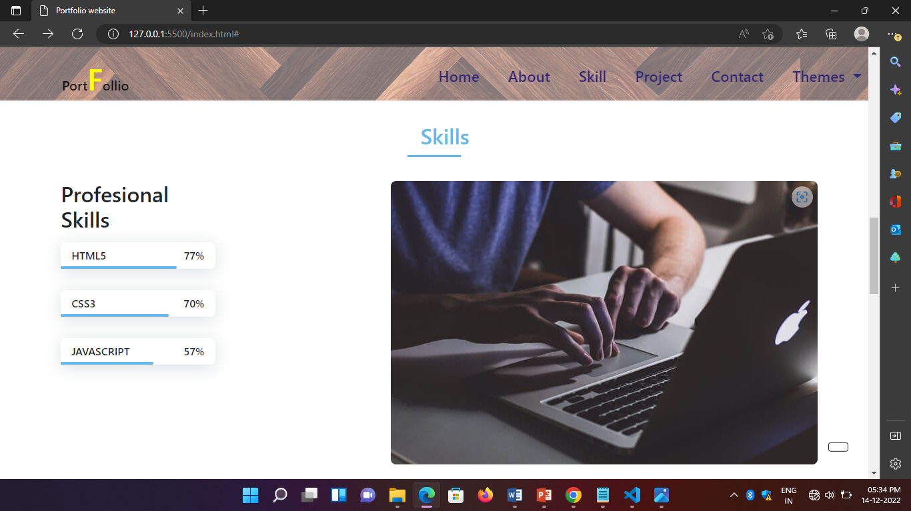

**HTML CODING:**

 <!--===== SKILLS =====-->

            <section class="skills section" id="skills">

                <h2 class="section-title">

                    <script src="https://cdn.lordicon.com/fudrjiwc.js"></script>

                    <lord-icon

                        src="https://cdn.lordicon.com/enzmygww.json"

                        trigger="hover"

                        style="width:32px;height:32px">

                    </lord-icon>Skills</h2>

                <div class="skills__container bd-grid">

                    <div>

                        <h2 class="skills__subtitle">Profesional Skills</h2>

                       <div class="skills__data">

                            <div class="skills__names">

                                <i class='fab fa-html5 skills__icon'></i>

                                <span class="skills__name">HTML5</span>

                            </div>

                            <div class="skills__bar skills__html">

                            </div>

                            <div>

                                <span class="skills__percentage">77%</span>

                            </div>

                        </div>

                        <div class="skills__data">

                            <div class="skills__names">

                                <i class='fab fa-css3 skills__icon'></i>

                                <span class="skills__name">CSS3</span>

                            </div>

                            <div class="skills__bar skills__css">

                            </div>

                            <div>

                                <span class="skills__percentage">70%</span>

                            </div>

                        </div>

                        <div class="skills__data">

                            <div class="skills__names">

                                <i class="fab fa-js-square skills__icon"></i>

                                <span class="skills__name">JAVASCRIPT</span>

                            </div>

                            <div class="skills__bar skills__js">

                            </div>

                            <div>

                                <span class="skills__percentage">57%</span>

                            </div>

                        </div>

                     </div>

                    </div>

                    <div>

                        <img src="./image/work3.jpg" alt="skill_img" class="skills__img">

                    </div>

                </div>

            </section>

**CSS CODING:**

/* ===== SKILLS =====*/

.skills__container {

  row-gap: 2rem;

  text-align: center;

}

.skills__subtitle {

  margin-bottom: var(--mb-2);

}

.skills__data {

  display: flex;

  justify-content: space-between;

  align-items: center;

  position: relative;

  font-weight: var(--font-semi);

  padding: .5rem 1rem;

  margin-bottom: var(--mb-4);

  border-radius: .5rem;

  box-shadow: 0px 4px 25px rgba(14, 36, 49, 0.15);

}

.skills__container{

  float: left;

  width: 45%;

  padding-left: 7%;

  padding-right: -17em;

}

.skills__icon {

  font-size: 2rem;

  /* margin-right: var(--mb-2); */

  color: var(--first-color);

}

.skills__names {

  display: flex;

  align-items: center;

}

.skills__bar {

  position: absolute;

  left: 0;

  bottom: 0;

  background-color: var(--first-color);

  height: .25rem;

  border-radius: .5rem;

  z-index: var(--z-back);

  width: 400px;

}

.skills__html {

  width: 75%;

}

.skills__css {

  width: 70%;

}

.skills__js {

  width: 60%;

}

.skills__ux {

  width: 85%;

}

.skills__img {

  border-radius: .5rem;

}

**CHAPTER 4**

* 1. **FONT LINK**

Mostly I use the font color white, black and blue.

**Background image:**

I use a background image for the home page.

/*===== GOOGLE FONTS =====*/

@import url("https://fonts.googleapis.com/css2?family=Poppins:wght@400;600;700&display=swap");

* 1. **STYLE LINK**

This project uses color linear-gradient in full background color in this project .I used dark blue light blue.

I created a link style like a buttons with hover effects. Some links I gave style using some icons.

<link href="https://cdn.jsdelivr.net/npm/bootstrap@5.0.2/dist/css/bootstrap.min.css" rel="stylesheet">

        <script src="https://cdn.jsdelivr.net/npm/bootstrap@5.0.2/dist/js/bootstrap.bundle.min.js"></script>

**CHAPTER 5**

**Website include the following Information**

* 1. project links to *Github:* **Project Description** *:*

### * Project-1

**Title: *SIMULATION BALL MOVEMENT***

**Link:** https://github.com/RathnavelSubramaniam/week-2-javascript-Mukesh25060704

* + - **Project Description:**

This project has a simple green color ball, Which will move from top to bottom and bottom to top, like bouncing from between the x and y axis. It will repeat this process whenever we load the page. The ball is created by HTML, CSS. And making the ball to do some event by JAVASCRIPT.

### * Project-2

**Title: *GRAPHIC ANIMATION OF THE RANDOM WALK EXERCISE***

**Link:** https://github.com/RathnavelSubramaniam/week-3-javascript-Mukesh25060704

* + - **Project Description:**

This was a graphic animation of the random ball using plain JavaScript. Drawing in HTML Canvas, also plain CSS is used. The balls will bounce randomly within the box.

### * Project-3

**Title: *PAC-MAN MOVEMENT***

**Link:** https://github.com/RathnavelSubramaniam/week-4-introduction-to-javascript-Mukesh25060704

* **Project Description:**

In Simulation scheduler a Pac-man in made to move is fixed direction and with a fixed velocity. It will move from the one place of the browser to the end of the screen.

### * Project-4

**Title: *WALK BOSTON DATA CODING EXERCISE***

**Link:** https://github.com/RathnavelSubramaniam/week-5-functions---array-manipulation-and-scope-Mukesh25060704

* + - **Project Description:**

The walk Boston shows the top five earning employees and the details of the employees by JAVASCRIPT. So through this we can identify and filter the top values from the n number of data’s.

### * Project-5

**Title: *FIND THE MOST COMMON WORD***

**Link:** [**https://github.com/Jamuna014/week-6**](https://github.com/Jamuna014/week-6)

* + - **Project Description:**

In this exercise, we can count the words that how many time it take place in the paragraph. And also it will display the top 3 repeated words.

### * Project-6

**Title: *PACMEN FACTORY***

**Link:** [**https://github.com/Jamuna014/week_7**](https://github.com/Jamuna014/week_7)

* + - **Project Description:**

This Project creates Pac-Man on demand. These Pac- Man are made to move across the Page. The Pac-Man created moves in different velocities. Whenever the user the click on the add Pac-man button the new Pac-man will be created and after click on the move button it will move across the page.

*** Project-7**

**Title: *EYE BALL MOVEMENT***

**Link:** [**https://github.com/Jamuna014/Week-8**](https://github.com/Jamuna014/Week-8)

* + - **Project Description:**

In this project there will be a two eye, which will move synchronize to follow the directions of the mouse pointer. Mouse events are a popular way to bind the DOM elements to events. So, the eye-ball is selected and make it to move by the use of DOM method. It will move wherever the mouse move in the directions.

### * Project-8

**Title: *WORKING WITH THE DOM TO ADD ANIMATION TO THE MAPS***

**Link:** [**https://github.com/Jamuna014/Week-9**](https://github.com/Jamuna014/Week-9)

* + - **Project Description:**

In map animation we have a marker placed in MIT and travel to Harvard. The marker shows the stops between MIT and Harvard while it moves.

### * Project-9

**Title: *TOWER’S OF HANOI***

**Link:** [**https://github.com/Jamuna014/Week-10**](https://github.com/Jamuna014/Week-10)

**Project Description:**

Tower of Hanoi is a mathematical puzzle where we have three rods and n disks. The objective of the puzzle is to move the entire stack to another rod, obeying the following simple rules: Only one disk can be moved at a time.

**CHAPTER 6**

**BOOTSTRAP**

**6.1 USES OF BOOTSTRAP**

 </script>  <link href="https://cdn.jsdelivr.net/npm/bootstrap@5.0.2/dist/css/bootstrap.min.css" rel="stylesheet">

        <script src="https://cdn.jsdelivr.net/npm/bootstrap@5.0.2/dist/js/bootstrap.bundle.min.js"></script>

### Description:

I have used bootstrap in this website. Which was a ready- made CSS file, so we can use it to reduce our time and also it carries a (N) number of designs. So, I had linked them to the code in HTML.

**CHAPTER 7**

**Project README**

**7.1 Title description**



|  |
| --- |
|  |
| **344.954C373.74 401.245 326.068 462.801 255.442 466.189C179.416 469.835 111.552** |
| **422.137 65.1576 361.805C17.4835 299.81 -17.1617 219.583 9.19024 145.964Z"/>** |
| **</mask>** |
| **<g mask="url(#mask0)">** |
| **<path d="M9.19024 145.964C34.0253 76.5814 114.865** |



|  |
| --- |
|  |
| **344.954C373.74 401.245 326.068 462.801 255.442 466.189C179.416 469.835 111.552** |
| **422.137 65.1576 361.805C17.4835 299.81 -17.1617 219.583 9.19024 145.964Z"/>** |

|  |
| --- |
| **<image class="home__blob-img" x="50" y="80"** |
| **href="./image/profile.png"/>** |
| **</g>** |
| **</svg>** |
| **</div>** |
| **</section>** |

**Contact Information**

### Coding:

 <!--====== nav_menu=========== -->

         <link href="https://cdn.jsdelivr.net/npm/bootstrap@5.0.2/dist/css/bootstrap.min.css" rel="stylesheet">

        <script src="https://cdn.jsdelivr.net/npm/bootstrap@5.0.2/dist/js/bootstrap.bundle.min.js"></script>

<style>

    header{

        background-image: url(/image/header\ image.jpg);

    }

</style>

    </head>

    <body>

        <!--===== HEADER =====-->

        <header class="l-header">

            <div class="navdiv">

            <nav class="navbar navbar-expand-lg navbar-light" class="nav1">

                <div class="container">

                  <a href="#" class="navbar-brand nav__logo">Port<span style="font-size: 45px; color: red;">F</span>ollio</a>

                  <button class="navbar-toggler" type="button" data-bs-toggle="collapse" data-bs-target="#navbarSupportedContent" aria-controls="navbarSupportedContent" aria-expanded="false" aria-label="Toggle navigation">

                    <span class="navbar-toggler-icon"></span>

                  </button>

                  <div class="collapse navbar-collapse" id="navbarSupportedContent">

                    <ul class="navbar-nav me-auto mb-2 mb-lg-0 nav__list" class="" id="nav__list">

  <li class="nav__item nav_li"><a href="#home" class="nav__link">Home</a></li>

  <li class="nav__item nav_li"><a href="#about" class="nav__link">About</a></li>

  <li class="nav__item nav_li"><a href="#skills" class="nav__link">Skill</a></li>

  <li class="nav__item nav_li"><a href="#work" class="nav__link">Project</a></li>

<li class="nav__item nav_li"><a href="#contact" class="nav__link">Contact</a></li>

  <li class="nav__item dropdown"><a class="nav__link dropdown-toggle" href="#" id="navbarDropdown" role="button" data-bs-toggle="dropdown" aria-expanded="false"></a>

                              Themes

<ul class="dropdown-menu" arialabelledby="navbarDropdown">

<li class="nav__item"><span class="dropdown-item">

<i class="fas fa-palette" id="first"></i></span></li>

 <li class="nav__item"><span class="dropdown-item">

<i class="fas fa-palette" id="second"></i></span></li>

<li class="nav__item"><span class="dropdown-item">

<i class="fas fa-palette" id="third"></i></span></li>

                            </ul>

                          </li>

                         </ul>

                  </div>

                </div>

              </nav>

            </div>

        </header>

**Coding:**

<!--===== Project =====-->

<section class="work section" id="work">

                <h2 class="section-title"><script src="https://cdn.lordicon.com/fudrjiwc.js"></script>

                    <lord-icon

                        src="https://cdn.lordicon.com/zncllhmn.json"

                        trigger="hover"

                        style="width:32px;height:32px">

                    </lord-icon>Project</h2>

<div id="carouselExampleControls" class="carousel slide" data-bs-ride="carousel">

                        <div class="carousel-inner">

                          <div class="carousel-item active">

<a href="https://github.com/RathnavelSubramaniam/week-2-javascript-Mukesh25060704"><img src="./image/ball_move.gif" class="d-block w-100" alt="..." width="500px" height="500px"></a>

                          </div>

                          <div class="carousel-item">

<a href="https://github.com/RathnavelSubramaniam/week-3-javascript-Mukesh25060704"><img src="./image/random_balls.gif" class="d-block w-100" alt="..." width="500px" height="500px"></a>

                          </div>

                          <div class="carousel-item">

 <a href="https://github.com/RathnavelSubramaniam/week-4-introduction-to-javascript-Mukesh25060704"><img src="./image/pacman.gif" class="d-block w-100" alt="..." width="500px" height="500px"></a>

                          </div>

                        </div>

<button class="carousel-control-prev" type="button" data-bs-target="#carouselExampleControls" data-bs-slide="prev">

<span class="carousel-control-prev-icon" aria-hidden="true"></span>

<span class="visually-hidden">Previous</span>

                        </button>

 <button class="carousel-control-next" type="button" data-bs-target="#carouselExampleControls" data-bs-slide="next">

  <span class="carousel-control-next-icon" aria-hidden="true"></span>

            <span class="visually-hidden">Next</span>

                        </button>

                      </div>

                </div>

            </section>

**Coding:**

|  |
| --- |
| **<div class="collapse navbar-collapse" id="navbarSupportedContent">** |
| **<ul class="navbar-nav me-auto mb-2 mb-lg-0 nav__list"** |
| **class="" id="nav__list">** |
| **<li class="nav__item nav_li"><a href="#home"** |
| **class="nav__link">Home</a></li>** |
| **<li class="nav__item nav_li"><a href="#about"** |
| **class="nav__link">About</a></li>** |
| **<li class="nav__item nav_li"><a href="#skills"** |
| **class="nav__link">Skill</a></li>** |
| **<li class="nav__item nav_li"><a href="#work"** |
| **class="nav__link">Project</a></li>** |
| **<li class="nav__item nav_li"><a href="#contact"** |
| **class="nav__link">Contact</a></li>** |
| **<li class="nav__item dropdown">** |
| **<a class="nav__link dropdown-toggle" href="#"** |
| **id="navbarDropdown" role="button" data-bs-toggle="dropdown"** |
| **aria-expanded="false">** |
| **Themes** |
| **</a>** |
| **<ul class="dropdown-menu"** |
| **aria-labelledby="navbarDropdown">** |
| **<li class="nav__item"><span** |
| **class="dropdown-item"> <i class="fas fa-palette" id="first"></i></span></li>** |
| **<li class="nav__item"><span** |
| **class="dropdown-item"> <i class="fas fa-palette" id="second"></i></span></li>** |
| **<li class="nav__item"><span** |
| **class="dropdown-item"> <i class="fas fa-palette" id="third"></i></span></li>** |
| **</ul>** |
| **</li>** |
| **</ul>** |
|  |
| **</div>** |

**Coding:**

.section-title::after {

  position: absolute;

  content: '';

  width: 64px;

  height: 0.18rem;

  left: 0;

  right: 0;

  margin: auto;

  top: 2rem;

  background-color: var(--first-color);

}

##### }

##### ;

**}**

**Style Link:**

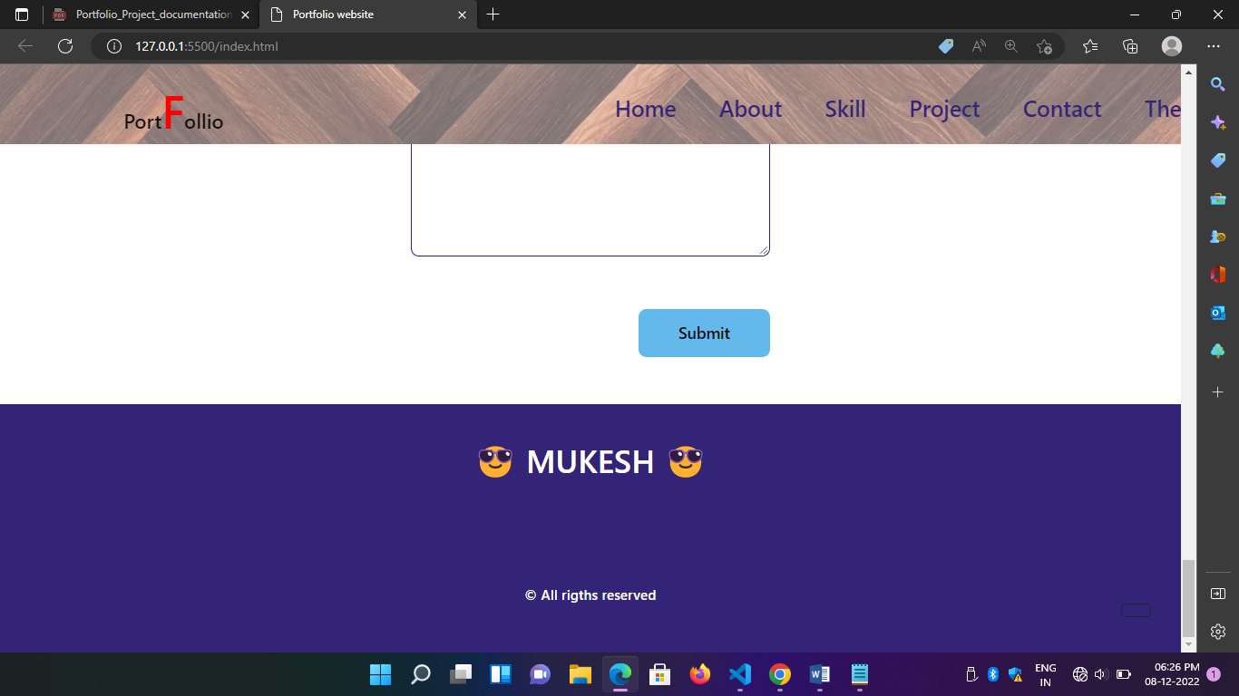

**Coding:**

.home__social-icon {

  width: max-content;

  margin-bottom: var(--mb-2);

  font-size: 1.5rem;

  color: var(--second-color);

}

.home__social-icon:hover {

  color: var(--first-color);

}

##### }

**Use of animation:**

Animation is very useful to bring Responsive Light to this

project . It’s helped a divide a section in this project.

coding:

 position: absolute;

  left: 0;

  bottom: 0;

background-color: var(--first-color);

  height: .25rem;

  border-radius: .5rem;

  z-index: var(--z-back);

}



## Chapter 5:

**Projects links to GitHub**

**Assignment links:**

I insert my class assignment in this project and I created a separate section for this assignment links. I will describe some points about the assignment.

## Chapter 6:

**Bootstrap**

**Uses of Bootstrap:**

I use Bootstrap to create a Navigation Bar and create a

layout for the webpage. I use Bootstrap icons to the links.

#### Coding:

<!--====== nav_menu=========== -->

         <link href="https://cdn.jsdelivr.net/npm/bootstrap@5.0.2/dist/css/bootstrap.min.css" rel="stylesheet">

        <script src="https://cdn.jsdelivr.net/npm/bootstrap@5.0.2/dist/js/bootstrap.bundle.min.js"></script>

<style>

    header{

        background-image: url(/image/header\ image.jpg);

    }

</style>

    </head>

    <body>

## Chapter 7:

**Project Readme**

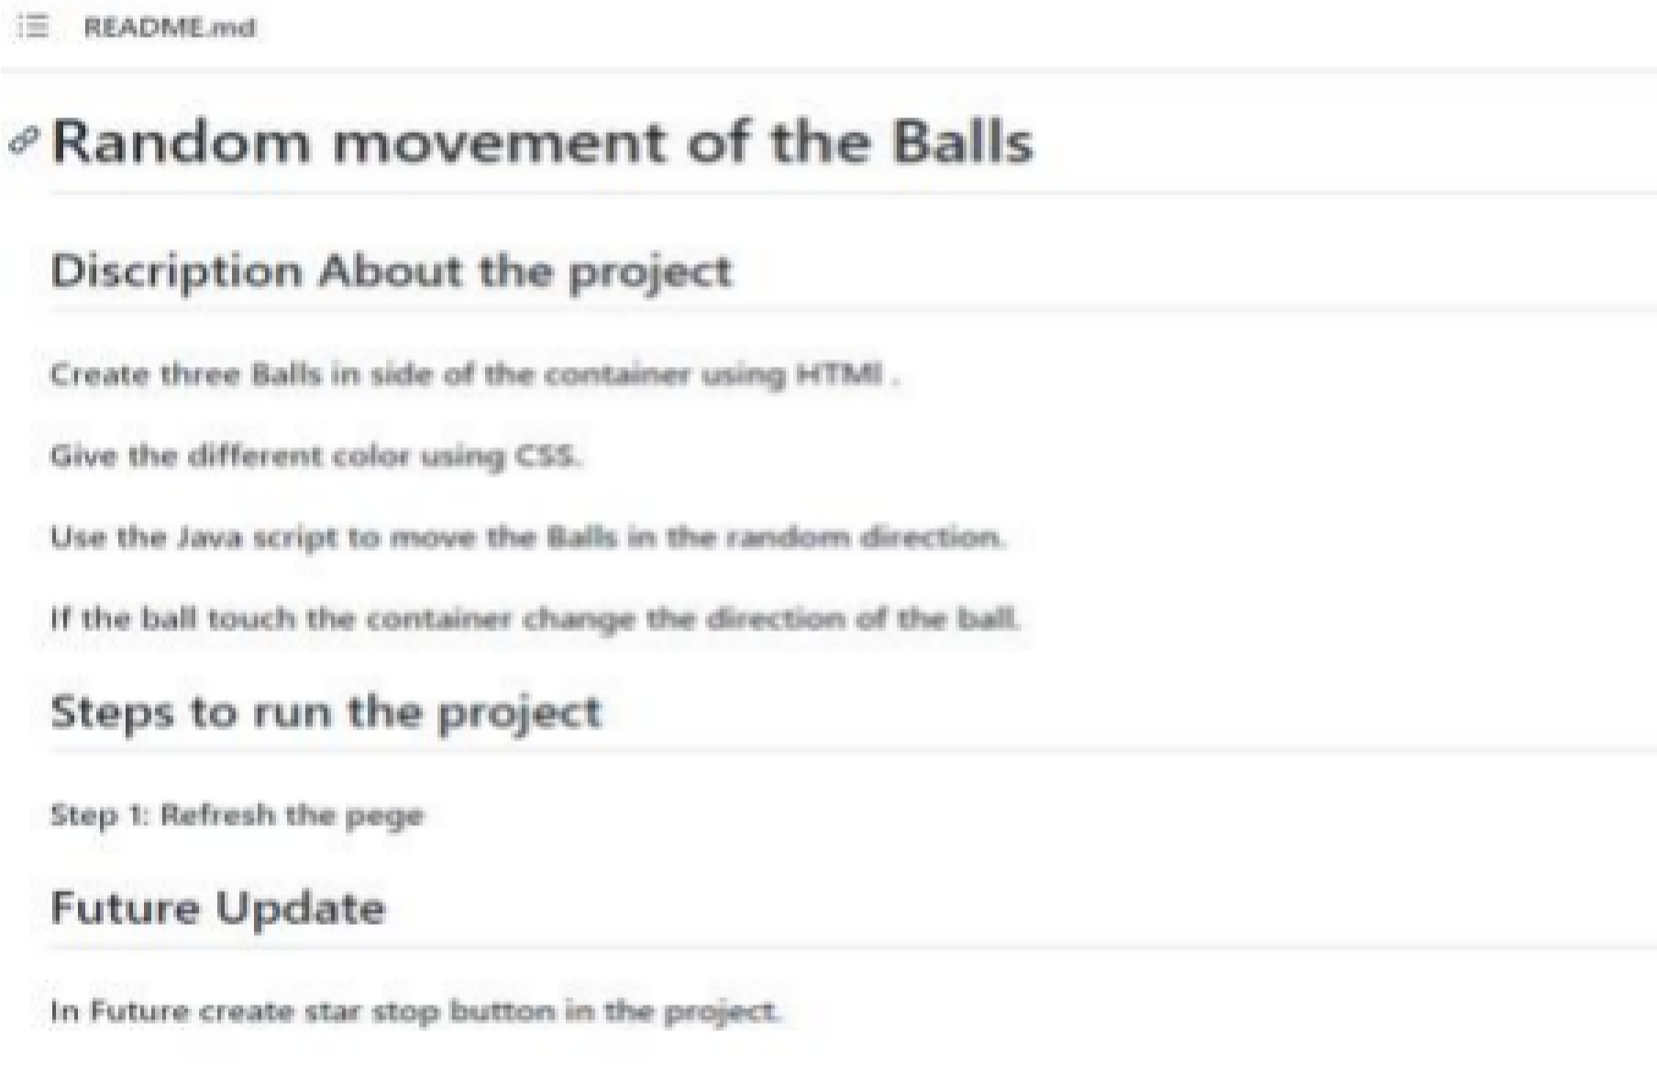

25

## Chapter 8:

**File Structure**

