COMPUTER

Modern **computers** are electronic and digital. The actual machinery — wires, transistors, and circuits is called hardware, the instructions and data are called software. All general-purpose **computers** require the following hardware components: Memory: enables a **computer** to store, at least temporarily, data and programs.

**Parts Of Computer**

* Monitor.
* CPU (Central Processing Unit)
* Keyboard.
* Mouse.
* Speakers.
* Printer

**CENTRAL PROCESSING UNIT**

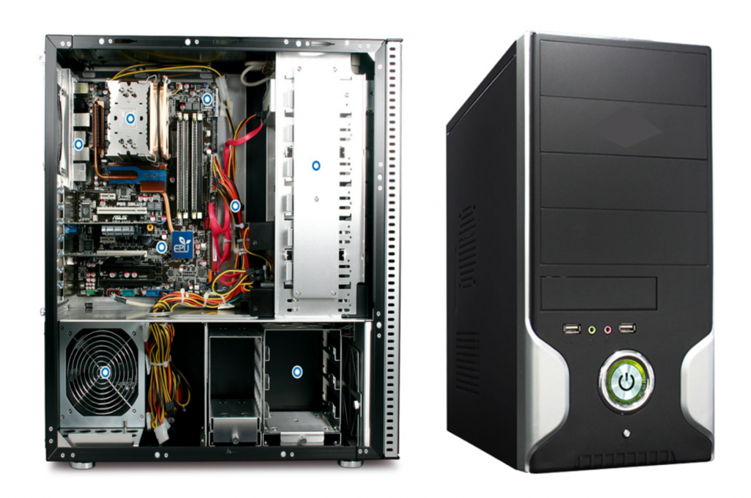

**1) Input/Output Ports**

* Input and output ports are placed at the very side
* The I/O ports is built to connect the monitor, speakers, a microphone, an Ethernet networking cable and multiple USB devices.
* At the same time, sometimes you can see the connection with the legacy devices.

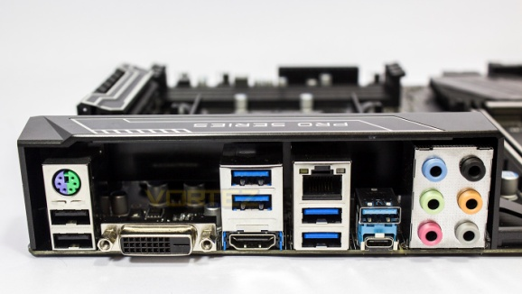

**2) BIOS:**

* BIOS is the short form of *“Basic Input Output System.”*
* It is positioned as the Integrated Chip.
* BIOS contains all the information and settings of the motherboard, and you can update or modify the setting from the BIOS mode.

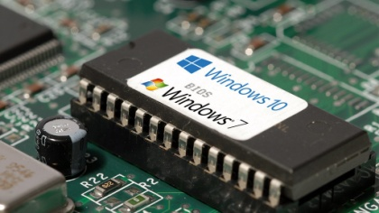

**3. CPU Socket**

* CPU socket helps to install the processor into the Motherboard.
* The socket carries hundreds of metal connectors for the metal pins or balls. It helps to supply the power to the processor.

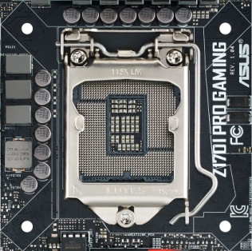

**4. RAM (Memory) Slots**

* RAM is most needed parts of the motherboard and it refers to *Random Access Memory*.
* It is the temporary memory of the computer, but it helps to run the applications and opening the files.
* Particularly, if the processors have a large amount of RAM, it can operate the computer more smoothly and surely it helps to increase the performance of the computer.

**5. Expansion Card Slots**

* A Motherboard’s expansion card slots allow you to add new components to the motherboard or to update any parts of the motherboard.
* An expansion card slots help to add external devices to display.

**6. Storage Device Connectors**

* A computer needs some types of storage devices to store the data, here has the cable which is compatible with the motherboard to transfer the data.
* The connector itself has 40 pins while the cables can variate between 40 and 80 wired ribbon cables where the latter has redundancy.
* The original IDE standard was capable of 16 MB/s transfer speeds while newer ones slowly increased it to 33, 66, 100, and then finally 133 MB/s.

.

**7. Power Connectors**

A Motherboard needs the power to keep running and it gets the power from SMPS. There are connectors to keep the process going on.

**8. IDE connector**

IDE is the short form of “Integrated Drive Electronics” and it is used to connect the disk drives including floppy disk drives and HDD (Hard Disk Drives). Here you will find 40-pin male connector that connects HDD. At the same time, the 34-pin male connector that connects the FDD.

**9. SATA connector**

SATA is the abbreviation of “Serial Advanced Technology Attachment.” Important to realize, it is the latest connectors with 7-pin interface. It is used to connect the SATA hard disks or optical drives. It is faster and better than the IDE Connector.

**10. Co-Processor**

One of vital parts or components of the motherboard is Co-Processors. It is used to perform mathematical calculations and computer graphics with the main processors.