**Ideation Phase**

**Brainstorm & Idea Prioritization Template**

|  |  |
| --- | --- |
| Date | 22 September 2023 |
| Team ID | 0B2261B720394B2A8A546D257F963062 |
| Project Name | GlobeTrekInsights:NavigatingGlobal Country Data With IBM Cognos |
| Maximum Marks | 4 Marks |

**Brainstorm & Idea Prioritization Template:**

Brainstorming provides a free and open environment that encourages everyone within a team to participate in the creative thinking process that leads to problem solving. Prioritizing volume over value, out-of-the-box ideas are welcome and built upon, and all participants are encouraged to collaborate, helping each other develop a rich amount of creative solutions.

Use this template in your own brainstorming sessions so your team can unleash their imagination and start shaping concepts even if you're not sitting in the same room.

**Step-1: Team Gathering, Collaboration and Select the Problem Statement**

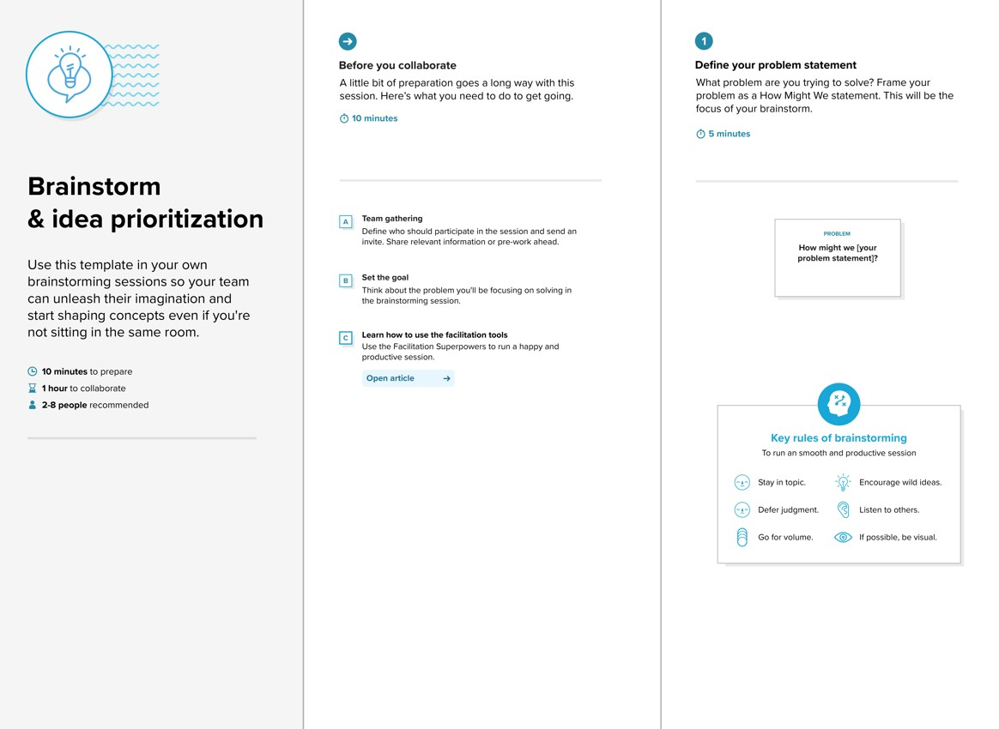

**Step-2: Brainstorm, Idea Listing and Grouping**

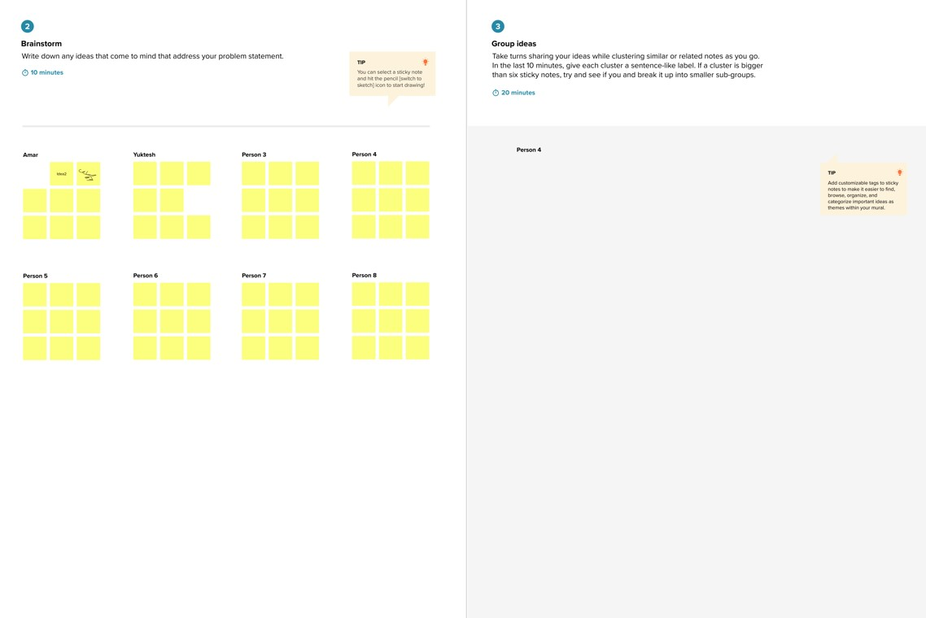

Pavankumar.S.M-

Detailed Information,data privacy

Mukesh.C-User friendly,Interactive design

Parthibanmuthuvel-

Easy to maintain

Vishnuprakash-Userfriendly,Custom data

Data Visualization

Documentation

Maintenance

Deployment

Testing

Dashboard design

Data Gathering

IBM Cognos setup

**Step-3: Idea Prioritization**

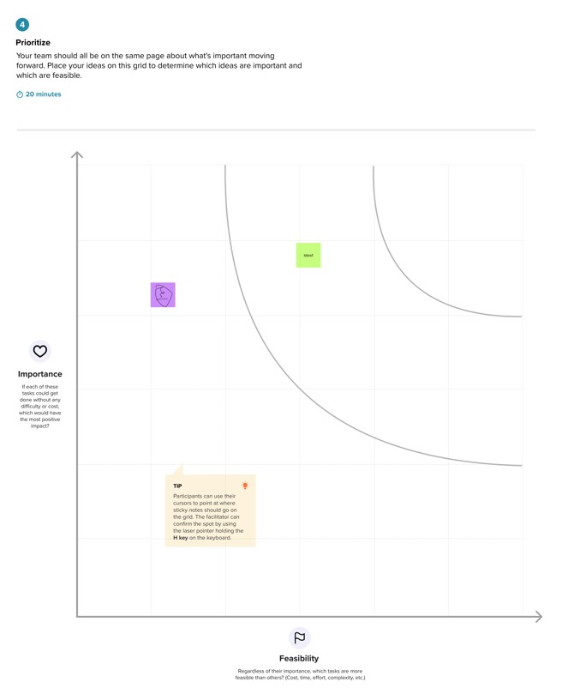

Data Analytics

Project development

Technology

Transparency

User friendly

Entertainment