**Project Design Phase-II**

**Data Flow Diagram & User Stories**

|  |  |
| --- | --- |
| Date | 22 October 2023 |
| Team ID | 0B2261B720394B2A8A546D257F963062 |
| Project Name | GlobeTrekInsights:NavigatingGlobal Country Data With IBM Cognos |
| Maximum Marks | 4 Marks |

**Data Flow Diagrams:**

A Data Flow Diagram (DFD) is a traditional visual representation of the information flows within a system. A neat and clear DFD can depict the right amount of the system requirement graphically. It shows how data enters and leaves the system, what changes the information, and where data is stored.

Example: DFD Level 0 (Industry Standard)

**Example:** [**(Simplified)**](https://developer.ibm.com/patterns/visualize-unstructured-text/)

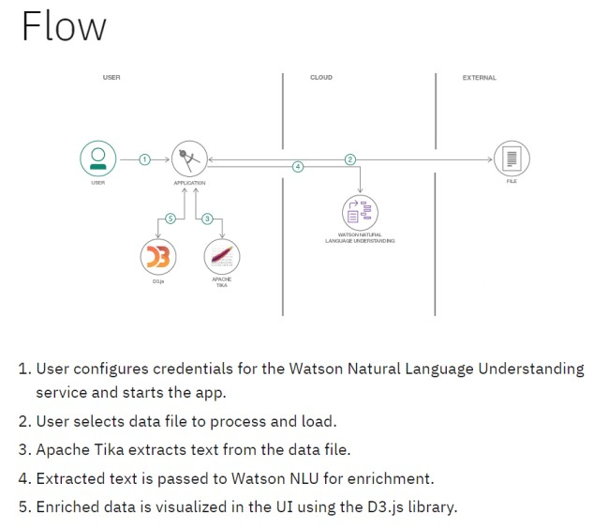

Data Storage:

>Database

Processes:

>IBM Cognos Data

>Data Input

>Data Output

External Entities:

>Users

**User Stories**

Use the below template to list all the user stories for the product.

|  |  |  |  |  |  |  |
| --- | --- | --- | --- | --- | --- | --- |
| **User Type** | **Functional**  **Requirement (Epic)** | **User Story**  **Number** | **User Story / Task** | **Acceptance criteria** | **Priority** | **Release** |
| Customer  (Mobile user) | Registration | USN-1 | As a user, I can register for the application by entering my email, password, and confirming my password. | I can access my account / dashboard | High | Sprint-1 |
|  |  | USN-2 | As a user, I will receive confirmation email once I have registered for the application | I can receive confirmation email & click confirm | High | Sprint-1 |
|  |  | USN-3 | As a user, I can register for the application through Facebook | I can register & access the dashboard with Facebook Login | Low | Sprint-2 |
|  |  | USN-4 | As a user, I can register for the application through Gmail |  | Medium | Sprint-1 |
|  | Login | USN-5 | As a user, I can log into the application by entering email & password |  | High | Sprint-1 |
|  | Dashboard |  |  |  |  |  |
| Customer (Web user) |  |  |  |  |  |  |
| Customer Care Executive |  |  |  |  |  |  |
| Administrator |  |  |  |  |  |  |
|  |  |  |  |  |  |  |
|  |  |  |  |  |  |  |
|  |  |  |  |  |  |  |