**Ideation Phase**

**Empathize & Discover**

|  |  |
| --- | --- |
| Date | 22 October 2023 |
| Team ID | GlobeTrekInsights:NavigatingGlobal Country Data With IBM Cognos |
| Project Name | 0B2261B720394B2A8A546D257F963062 |
| Maximum Marks | 4 Marks |

**Empathy Map Canvas:**

An empathy map is a simple, easy-to-digest visual that captures knowledge about a user’s behaviours and attitudes.

It is a useful tool to helps teams better understand their users.

Creating an effective solution requires understanding the true problem and the person who is experiencing it. The exercise of creating the map helps participants consider things from the user’s perspective along with his or her goals and challenges.

**Globe Trek Insights: Navigating Global Country Data With IBM Cognos**

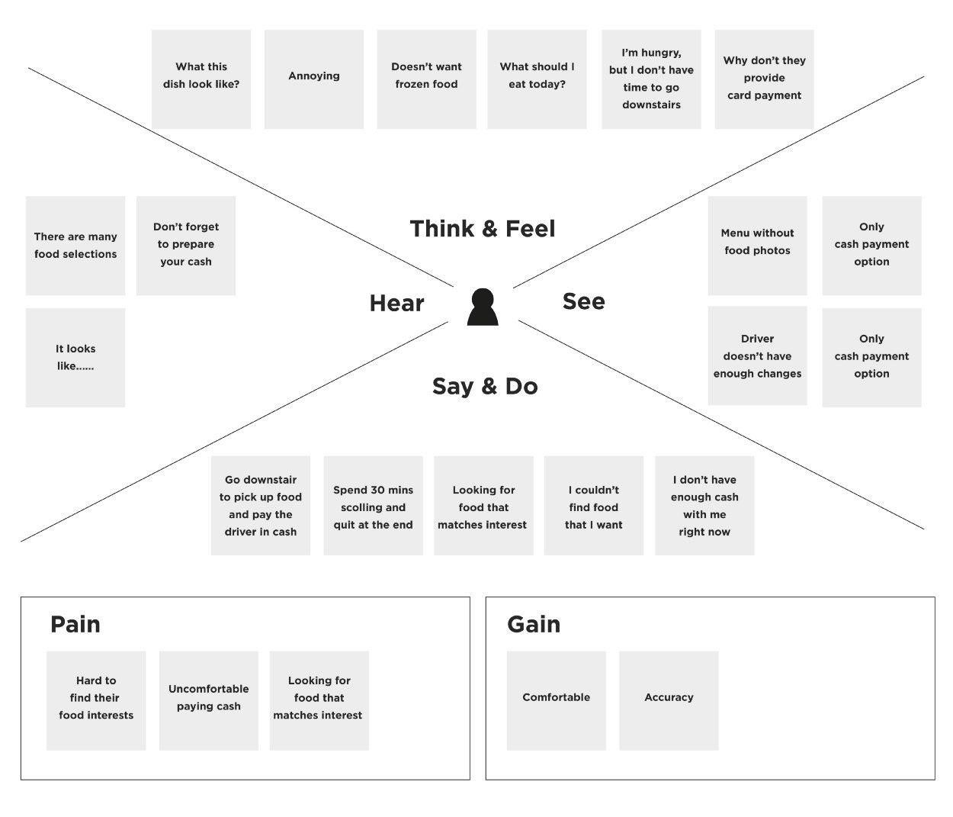

Access to valuable global country insights

Efficient and user friendly data analysis

Uncertainty in decision making

Complex and slow data analysis

Anxious about making informed decisions

Feedback and Requests

User Conversations

Gain valuable insights for decisions making

Optimism about IBM Cognus

IBM Cognos should provide efficient data

Efficient data analysis

Quick Access

I want userfriendly dataanalysis tool

I need insights on global country data