DEPARTMENT OF ELECTRONICS AND COMMUNICATION

Team id :NM2023TMID0096

RAKCHITHA VS

GOKULAKRISHNAN K

VASANTH P

DHAYANITHI S

SIVA R

**The banking industry world-wide is being transformed. The global forces for change include tec**

A comprehensive financial plan involves: A thorough review of your current financial situation. A discussion and understanding of your long term, financial goals. The development of a plan including all financial products needed to take you from where you are today to where you need to be in the future.

**had dominated their banking systems in the past. In this project we are trying to analysis the bank related data and able to extract some insights from the data using Business Intelligence tools. To Extract the Insights from the data and put the data in the form of visualizations, Dashboards and Story we employed Tableau tool.**

BRAINSTROM TEMPLATE

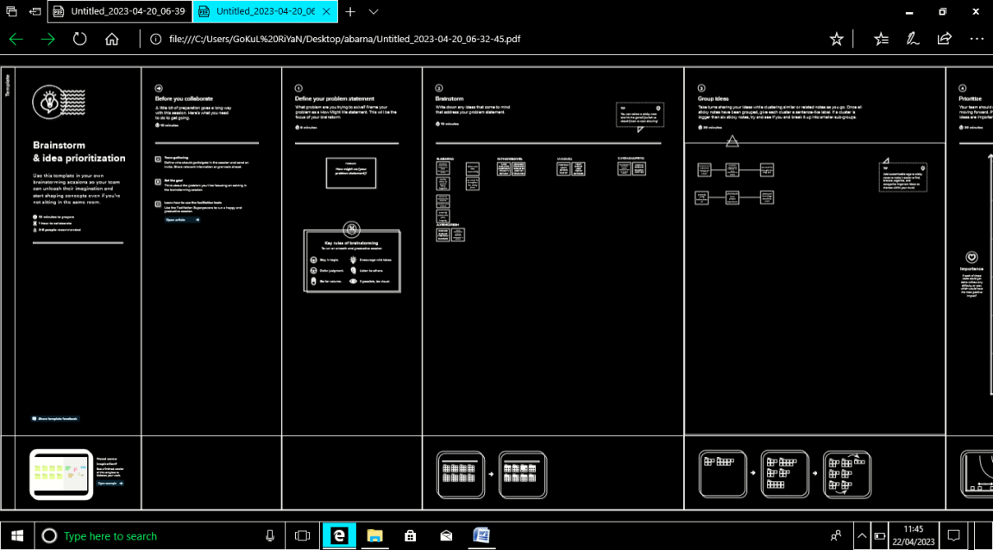

EMPATHY MAP CANVA

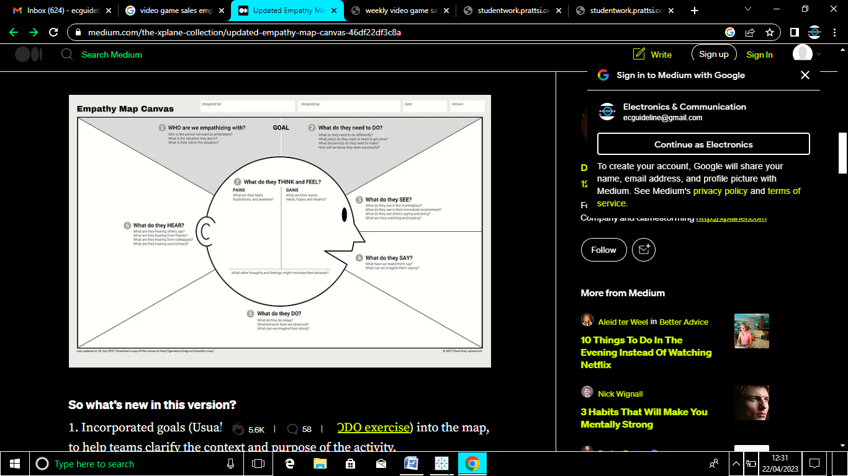

WORKING INTABLEAU

