

**IoT Based Smart Health Care Kit**

**INTERNSHIP REPORT**

**INT-300**

*Submitted by*

*MUKESH A E0420007*

***In partial fulfilment for the award of the degree of***

**BACHELOR OF TECHNOLOGY in**

**COMPUTER SCIENCE AND ENGINEERING**

**(Computer Science and Medical Engineering)**

**Sri Ramachandra Faculty of Engineering and Technology**

**Sri Ramachandra Institute of Higher Education and Research, Porur, Chennai - 600116**

**April,2022**

**IoT Based Smart Health Care Kit**

**INT 300 – INTERNSHIP 3 PROJECT REPORT**

*Submitted by*

**MUKESH A -E0420007**

#### *In partial fulfilment for the award of the degree of*

**BACHELOR OF TECHNOLOGY in**

**COMPUTER SCIENCE AND ENGINEERING**

**(Computer Science and Medical Engineering)**

**Sri Ramachandra Faculty of Engineering and Technology**

**Sri Ramachandra Institute of Higher Education and Research, Porur, Chennai**

**–**

**.600116**

**April,2022**



**CERTIFICATE**

Certified that this project report “**IoT Based Smart Health Care Kit”** is the bonafide record of work done by **“MUKESH A-E0420007”** who carried out the internship work under my supervision.

**Signature of the Supervisor Signature of Vice-Principal**

**Name of Supervisor Vice-Principal**

Prof. Manoj Kumaran Prof. M. Prema

Department of Computer Science Sri Ramachandra Faculty of Engineering and

and Engineering Technology

Sri Ramachandra Faculty of Engineering and Porur, Chennai-600116

Technology

Porur, Chennai-600116

**Evaluation Date:**



**ACKNOWLEDGEMENT**

I express my sincere gratitude to our Chancellor, Vice-Chancellor and our sincere gratitude to our Provost **Dr.V. Raju** and our Vice-Principal **Prof.**

**M. Prema** for their support and for providing the required facilities for carrying out this study.

I wish to thank my faculty supervisor(s), **Prof.Manoj Kumaran,** Department of Computer Science and Engineering, Sri Ramachandra Faculty of

Engineering and Technology and **Prof. Rajive Gandhi**, Department of Computer Science and Engineering, Sri Ramachandra Faculty of Engineering and Technology for extending help and encouragement throughout the project. Without his/her continuous guidance and persistent help, this project would not have been a success for me.

I am grateful to all the members of Sri Ramachandra Faculty of Engineering and Technology, my beloved parents and friends for extending the support, who helped us to overcome obstacles in the study.

**TABLE OF CONTENTS**

**CHAPTER TITLE PAGE NO**

**NO.**

**ABSTRACT**

**LIST OF FIGURES**

**1 INTRODUCTION**

1.1 ABOUT 1

1.2 OBJECTIVE 2 **2 LITERATURE SURVEY 3**

**3 REQUIREMENTS, ANALYSIS AND SYSTEM**

**SPECIFICATIONS.**

#### 3.1 SOFTWARE REQUIREMENTS SPECIFICATION 4

##### DOCUMENT 3.1.1 DATA REQUIREMENT 3.1.2 SYSTEM REQUIREMENT

1. **METHODOLOGY 5**
2. **IMPLEMENTATION** 
   1. RESOURCES USED **6** 
      1. IDE – ARDUINO
      2. THING SPEAK
      3. IOT SENSOR
      4. PULSE SENSOR
      5. LM-35.
      6. ECG SENSOR
3. **RESULTS AND DISCUSSIONS** 
   1. SAMPLE OUTPUT 10

#### 6.2 CONCLUSION 11

1. **FUTURE WORK 12**
2. **APPENDICIES**

Appendix-1: Code – Technical detail 13

Appendix-2: Circuit Diagram 16

1. **REFERENCES 17**

**ABSTRACT**

The internet of things, or IoT, is a system of interrelated computing devices, mechanical and digital machines, objects, animals or people that are provided with unique identifiers UID’S and the ability to transfer data over a network without requiring human-to-human or human-to-computer interaction. Some serious infections and disabilities such as heart blocks need close and constant observing system after analysis, so as to anticipate mortality or further harm as auxiliary to the referenced sicknesses or scatters. Observing such types of patients, as a rule, happen at clinics or human services trots. A Smart Health Care Kit, An IoT device which is proposed for elderly peoples who can check their Heart Rate Before Going to the Doctor. The patient will carry hardware having sensors with android application. The heartbeat sensor will allow checking heart beat readings and transmit them over the internet. The user may set the high and low level of heartbeat limits. Once these limits are set the system can start monitoring the patient’s heartbeat and as soon as the heart beat readings goes above or below the limit set by the user the system will send an alert about high or low heartbeat as well about chances of heart attack.

**LIST OF FIGURES**

**FIGURES PAGE**

**NO NO.**

1 Workflow diagram 5 2 Pulse sensor 7 3 LM-35 sensor 8

1. ECG Sensor 9
2. Pulse sensor output 10
3. LM-35 sensor output 10
4. ECG Sensor Output 11
5. Circuit diagram 12

**CHAPTER-1**

**1. INTRODUCTION**

## 1.1 ABOUT

Nowadays, broadcasting technology led to expansion of electronic gizmos, cell phones, and tablets which can be communicated substantially or remotely has turned into the key instrument of day-by-day life. The up-and-coming age of the associated world is the Internet of Things (IoT) which interfaces gadgets, sensors, machines, vehicles, and other "things". With the assistance of IoT, we interface anything, access from anyplace and whenever effectively get to any administration and data about any item. The point of IoT is to broaden the advantages of the Internet with remote control capacity, information sharing, steady availability, etc.

Utilizing an installed sensor which is dependable on and

gathering data, everyone would be attached to nearby and worldwide systems. Long halting time for ambulatory or hospitalization patient checking/treatment, are other surely understood issues for both the medicinal services establishments and the patients. This venture gives medicinal services experts to boost the quality and expansiveness of human services benefits by controlling expenses.

This part gives a concise depiction of the requirement for remote

patient checking framework and its significance. This part likewise gives a concise portrayal of the extent of the task and structure philosophy. Persistent Monitoring System is where a specialist can ceaselessly screen more than one patient at any given

## 1.2 OBJECTIVE

The Objective of this experiment is to build a system or device that will measure the rate of the heartbeat of the human body and detect heart attack. The device must be able to monitor all the heart rate in continuous interval length of time, it is important for the device in a continuous interval length of time. It is important for the device to able to display the information regarding the heart rate to the patient on LCD screen as well. IOT enable healthcare professionals to be more watchful and connect with the patients proactively. Data collected from IoT devices can help physicians identify the best treatment process for patients and reach the expected outcomes. Effect of IOT in healthcare is bringing the IOT into medicine helps in stronger, healthier and easier patient care. From the implantation of medical devices to smart sensors, the IOT will speed up healthcare delivery, enabling doctors to spend less time on transportation, diagnose illnesses and communicate with patient. Provides Real-Time Date. A critical component of diagnosing and addressing medical issues is acquiring accurate information in a timely manner, Streamlines Tasks, Saves Time and Resources, Assists Research and May Reduce Physician stress.

**CHAPTER-2**

# 2.LITERATURE SURVEY

The IoT revolution can give more data about human, articles, existence. At the same time linking the contemporary Internet innovation and IoT gives a lot of room and creative management dependent on sensors. IPv6 and Cloud registering has improvement of joining of Internet and IoT. This is giving conceivable results of information gathering, information handling, administration og port, and other subsequent administrations. Every article which lines with IoT needs a one-of-a-kind location or familiar evidence with IPv6. The current technologies to detect heart attack is by using Temperature sensor to calculate the body temperature of the human and measure heat variance with respect to blood pressure with these parameters the heart attack can be detected. Monitor body temperature using LM35 temperature sensor. The LM35 temperature sensor is connected to the Arduino uno board. After that creating a website in SQL database format. Arduino uno board is connected to that website. Then sensor output is sent to the website. Using this website anybody can monitor body temperature in login process. an IoTbased healthcare monitoring system that collects all the medically relevant data of patients, including patients heart rate, blood pressure and ECG and sends alerts to the patient’s doctor regarding patients’ full medical information, providing a fast and reliable health care service.

**CHAPTER-3**

# 3.REQUIREMENTS, ANALSYSIS AND SYSTEM SPECIFICATIONS

## 3.1 SOFTWARE REQUIREMENTS SPECIFICATION DOCUMENT

##### 3.1.1 Data Requirements

Data requirement involved in any project is the

primary process. For this project, the main data required is the iot sensors.

### 3.1.2 System Requirements

IoT sensors requires an Arduino IDE and Thing Speak

cloud storage for storing data.

**CHAPTER-4**

# 4.METHODOLOGY

Transmission types measure pulse waves by emitting red or infrared light from the body surface and detecting the change in blood flow during heart beats as a change in the amount of light transmitted through the body.

This method is limited to areas where light can easily penetrate, such as the fingertip or earlobe. ROHM is currently developing a reflection-type pulse sensor (Optical Sensor for Heart Rate Monitor). The reflection-type pulse sensor (Optical Sensor for Heart Rate Monitor)

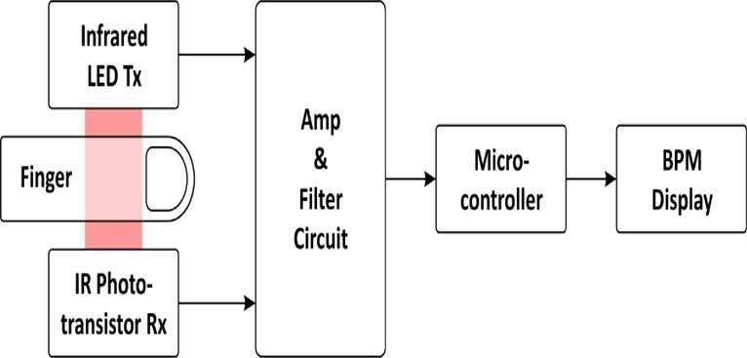

**Figure 1: Workflow Diagram**

**CHAPTER-5**

# 5.IMPLEMENTATION

## 5.1 RESOURCES USED

**5.1.1 IDE – ARDUINO**

The Arduino IDE is an open-source software, which is used to write and upload code to the Arduino boards. The IDE application is suitable for different operating systems such as Windows, Mac OS X, and Linu**x**. It supports the programming languages C and C++. Here, IDE stands for **Integrated Development Environment**. The program or code written in the Arduino IDE is often called as sketching. We need to connect the Genuino and Arduino board with the IDE to upload the sketch written in the Arduino IDE software. The sketch is saved with the extension ‘. Uno.'

.

##### 5.1.2 Thing Speak

Thing Speak is a Ruby-based open-source program that allows users to speak with internet-connected gadgets. By giving an API to both devices and social network websites, it makes data access, retrieval, and logging easier. Thing Speak was first introduced by iot Bridge in 2010 as an IoT application support service. Thing Speak now includes support for MathWorks' MATLAB numerical computing program, allowing Thing Speak users to analyze and display submitted data using MATLAB.

###### 5.1.3 IoT Sensors

We mainly used two sensors. Pulse sensor and LM-35 sensor to calculate Heart beat and temperature. These sensors are connected to Arduino. Once the data gets to be collected from the sensors, it will automatically be stored in Thing speak. Basically,

###### 5.1.4 PULSE SENSOR

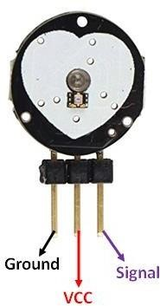

#### Figure 2: Pulse Sensor Diagram

A pulse sensor or heart rate sensor is a plug and play type sensor. The normal operating voltage is +5V or +3.3V and current consumption of 4mA. It consists of two sides; one side consist of LED and other side consist of circuitry.

##### 5.1.5 LM-35

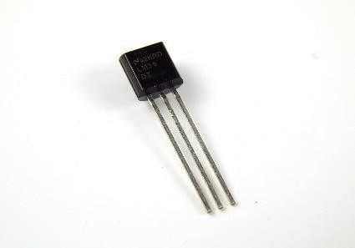

#### Figure 3: LM-35 Diagram

The LM35 series are precision integrated-circuit temperature devices with an output voltage linearly proportional to the Centigrade temperature. The low- output impedance, linear output, and precise inherent calibration of the LM35 device makes interfacing to readout or control circuitry**.**

* Minimum and Maximum Input Voltage is 35V and -2V respectively.

Typically, 5V.

* Can measure temperature ranging from -55°C to 150°C
* Output voltage is directly proportional (Linear) to temperature (i.e.) there will be a rise of 10mV (0.01V) for every 1°C rise in temperature.
* ±0.5°C Accuracy
* Drain current is less than 60uA
* Low-cost temperature sensor
* Small and hence suitable for remote applications
* Available in TO-92, TO-220, TO-CAN and SOIC package

##### 5.1.6 ECG SENSOR

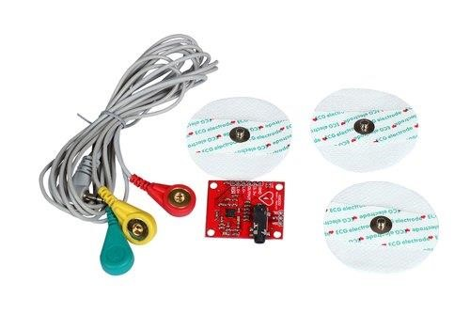

#### Figure 4: ECG Diagram

An electrocardiogram records the electrical signals in the heart. It's a common and painless test used to quickly detect heart problems and monitor the heart's health.

An electrocardiogram — also called ECG or EKG — is often done in a health care provider's office, a clinic or a hospital room. ECG machines are standard equipment in operating rooms and ambulances. Some personal devices, such as smartwatches, offer ECG monitoring. Ask your health care provider if this is an option for you.

#### 6.1 RESULTS

##### 6.1.1 Pulse Sensor with Arduino uno

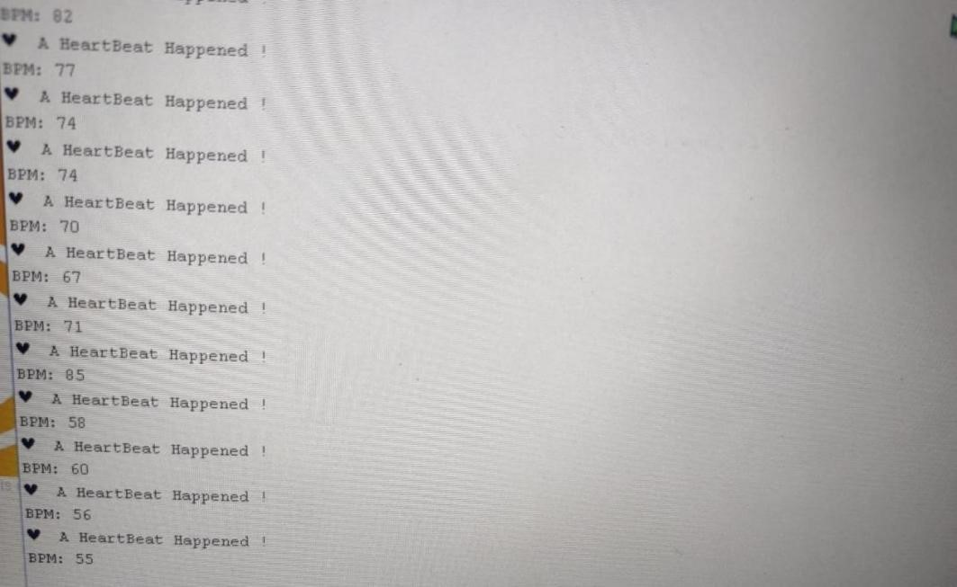

**Figure 5: Pulse Sensor with Arduino Diagram**

##### 6.1.2 LM-35 with Arduino uno

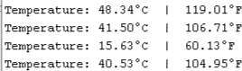

**Figure 6: LM-35 with Arduino Diagram**

.

6.1.3 ECG with Arduino uno

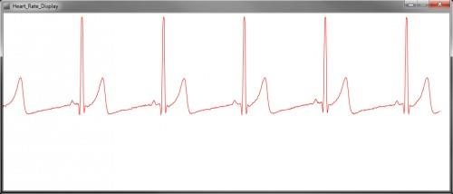

**Figure 7: ECG Sensor with Arduino Diagram**

## 6.2 Conclusion

Upload the code to Arduino UNO and Power on the system. The Arduino asks us to place our finger in the sensor and press the switch. Place any finger (except the Thumb) in the sensor clip and push the switch (button). Based on the data from the sensor, Arduino calculates the heart rate and displays the heartbeat in bpm.

In this system a real time heart rate monitoring and heart

attack detection system is realized by using IoT. The proposed design is advantageous to patients of different age groups by providing real time heart health monitoring. It also provides security and privacy to the data of the patient.

# FUTURE WORK

Monitoring device that could be used to detect the heart beat anomalies of physically challenged individuals without hands. Also, a graphical LCD can be used to display a Graph of the change of the heart rate over time. It could be integrated with mobile technology for e-health cloud transmission to health care providers.

**8.APPENDICES**

**APPENDIX-1: CODE COMPILER**

#### Pulse sensor code

int PulseSensorPurplePin = 0; PIN 0 int LED13 = 13; int Signal; int Threshold = 550; // The SetUp Function: void setup () pinMode (LED13, OUTPUT);

Serial.begin(9600);} // The Main Loop Function void loop () {

Signal = analogRead (PulseSensorPurplePin);

Serial.println(Signal);

if (Signal > Threshold)

{digitalWrite (LED13, HIGH);

} else { digitalWrite (LED13, LOW) delay (20);}

**LM-35 code**

void setup ()

{Serial.begin(9600

);} void loop () {

int reading = analogRead(sensorPin);

float voltage = reading * (5.0 / 1024.0); float temperatureC = voltage * 100;

Serial.print("Temperature: ");

Serial.print(temperatureC);

Serial.print("\xC2\xB0"); float temperatureF = (temperatureC * 9.0 / 5.0) + 32.0; Serial.print(temperatureF); Serial.print("\xC2\xB0"); delay (1000); // wait a second between readings

#### ECG CODE

void setup () {

// put your setup code here, to run once:

Serial.begin(9600); pinMode (10, INPUT); // Setup for leads off detection LO + pinMode (11, INPUT); // Setup for leads off detection LO -

} void loop () {

// put your main code here, to run repeatedly: if ((digital Read (10) == 1) || (digital Read (11) == 1)) {

Serial.println('!');

} else {

// send the value of analog input 0:

Serial.println(analogRead(A0));

}//Wait for a bit to keep serial data from saturating delay (1);}

## APPENDIX-2: CIRCUIT DIAGRAM

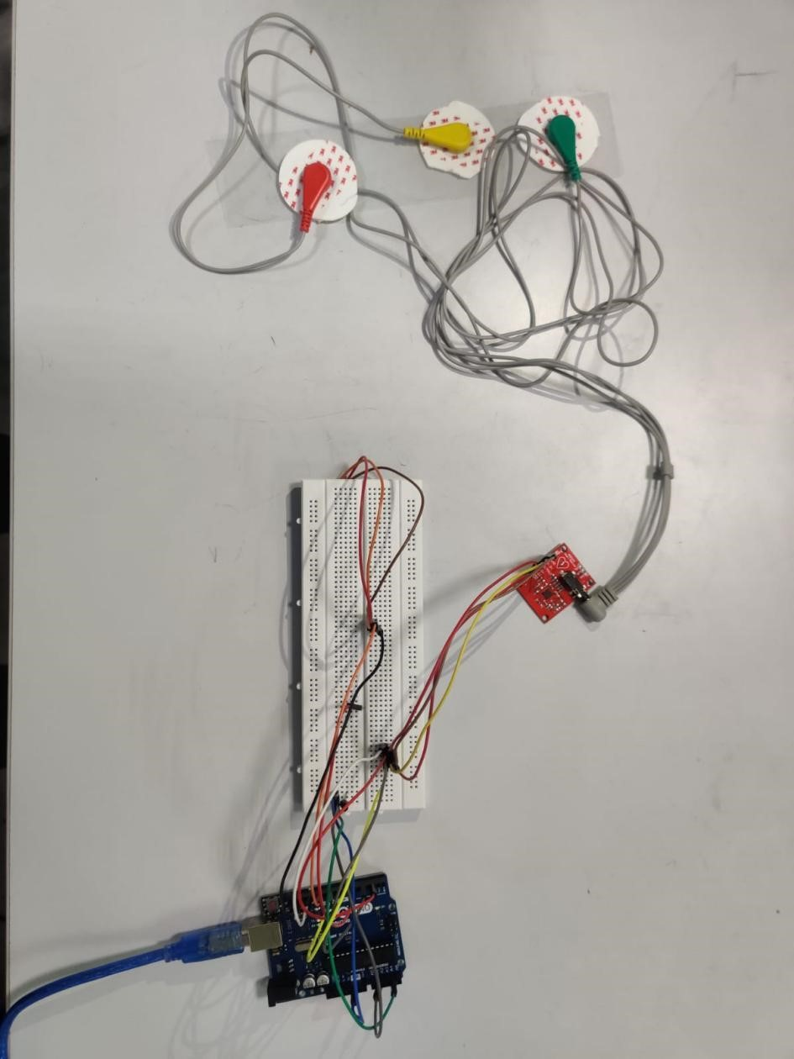

**Figure 8. Circuit Diagram**

# REFERENCES

**Web References:**

* **ECG Graph Monitoring with AD8232 ECG Sensor & Arduino** 

[https://how2electronics.com/ecg-monitoring-with-ad8232-ecg-sensor- arduino/#Arduino_Source_CodeProgram](https://how2electronics.com/ecg-monitoring-with-ad8232-ecg-sensor-arduino/#Arduino_Source_CodeProgram)

* **Heart Rate Monitoring System using Pulse Sensor** 

<https://www.ijeat.org/wp-content/uploads/papers/v8i6/F7919088619.pdf>

#### ✓ IoT based System for Heart Rate Monitoring

https://[www.ijert.org/research/iot-based-system-for-heart-rate-monitoring-](http://www.ijert.org/research/iot-based-system-for-heart-rate-monitoring-) IJERTV9IS070673.pdfInterfacing with Max30100 sensor 

✓ **Pulse Rate BPM Monitor arduino Pulse Sensor** 

<https://how2electronics.com/pulse-rate-bpm-monitor-arduino-pulse-sensor>

#### ✓ Code for Heart Rate Monitoring 

<https://forum.arduino.cc/t/simple-code-for-heart-rate-monitor/303503>

* [https://www.electronicshub.org/heartbeat-sensor-using-arduino-heart-rate- monitor/ ](https://www.electronicshub.org/heartbeat-sensor-using-arduino-heart-rate-monitor/)
* [https://www.researchgate.net/publication/329268152_Heart_Attack_Dete ction_and_Heart_Rate_Monitoring_Using_IoT ](https://www.researchgate.net/publication/329268152_Heart_Attack_Detection_and_Heart_Rate_Monitoring_Using_IoT)