**How to import the project: Open Any IDE(Eclipse)**

Clone or download the repository into local

Import🡪General🡪Existing Project into workspace🡪next🡪Browse from local path

**Project Details hierarchy:**

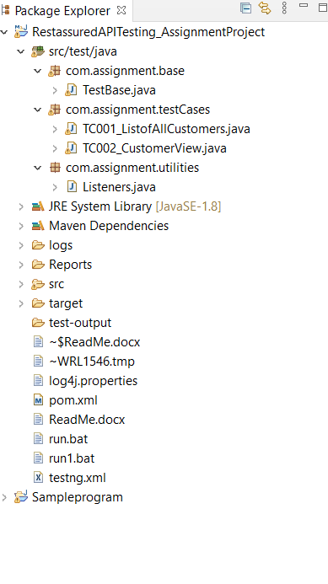

**RestassuredAPITesting_AssignmentProject:**

***com.assignment.testCases:*** package contains all the test case classes

***com.assignment.utilities:*** package contains all the extent report methods

***com.assignment.base:***  contains base class methods

pom.xml file has all the dependencies and plugins

**Blog.Api/Customers – Lists all customers:** is procured with ‘TC001_ListofAllCustomers.java’

**Blog.Api/1111/CustomerView:** is procured with ‘TC002_CustomerView.java’

**How to Run:**

‘Pom.xml’ 🡪

Right click🡪

Run As🡪

Maven Test.

**Before Run**: Input injection is required in **TC002_CustomerView.java** with respect to different customer ID

**int**[] arr= {1111,2222,3333,4444,5555,6666};

**char**[] chrarr= {'A','B','C','D','E','F'};

(ex: if to run with ID:5555 then arr[4] should be passed ) as shown below

String id = Integer.*toString*(arr[4]);

String email = "tester"+chrarr[4]+"@abc.com";

String first_name = "tester"+chrarr[4]+"First";

String last_name = "tester"+chrarr[4]+"Last";

**Post Run:**

Reports will be generated in Report folder

