NAAN MUTHALVAN

ARTIFICIAL INTELLIGENCE PROJECT TITLE

MEASURE ENERGY CONSUMPTION

REG.NO:712321104008

NAME : MUKESH S

DEPT : COMPUTER SCIENCE AND ENGINEERING YEAR & SEM : III & 05

COLLEGE : PARK COLLEGE OF TECHNOLOGY

PHASE 1

PROBLEM DEFINITION AND DESIGN THINKING

PROBLEM DEFINITION

The problem at hand is to create an automated system that measures energy consumption,analysis the data,and provides visualizations for informed decision making.This solution aims to enhance efficiency,accuracy,and ease of understanding in managing energy consumption across various sectors.

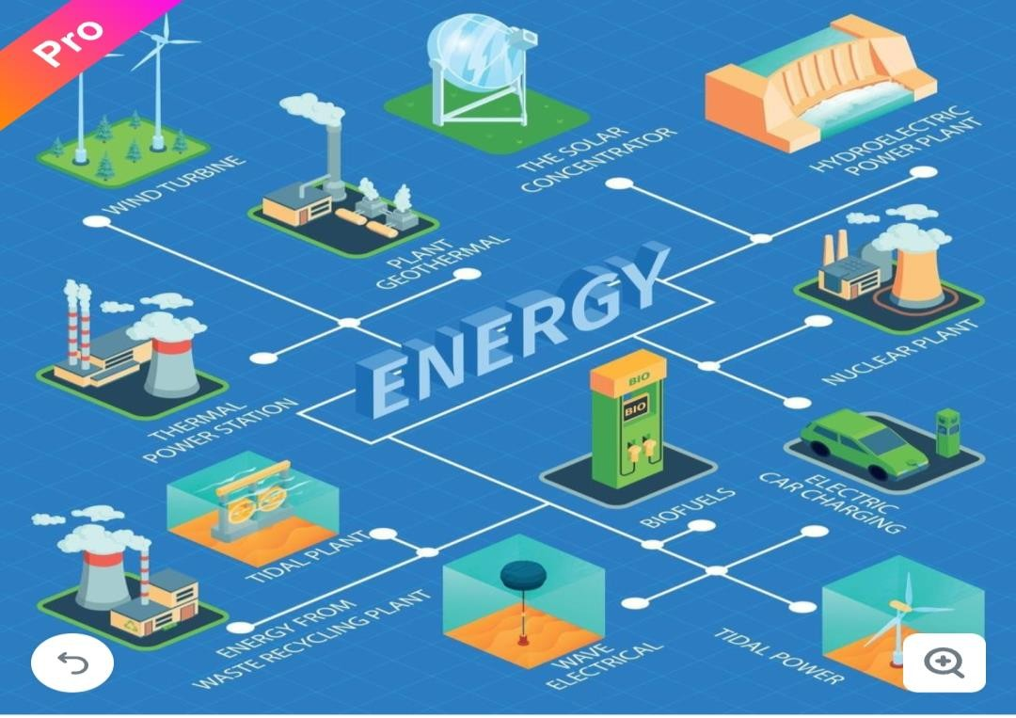

# DESIGN THINKING



Visualization



Feature Extraction



Data Source



Automation



Design Thinking



Data Preprocessing



Model Development

Data Source

Identify an available dataset containing energy consumption measurements.



# Data Preprocessing

Clean,transform and prepare the dataset for analysis.



Clean



Analysis

Transform

# Feature Extraction

Extract relevant features and metrics from the energy consumption data.





# Model Development

Utilize statistical analysis to uncover trends,patterns and anomalies in the data.

sis

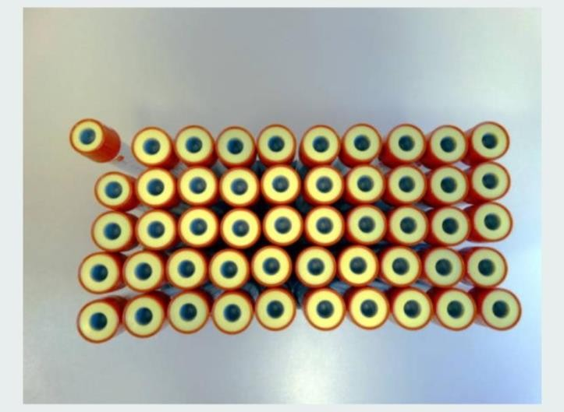

Patterns

# Visualization

Develop visualization (graphs,charts) to present the energy consumption trends and insights.

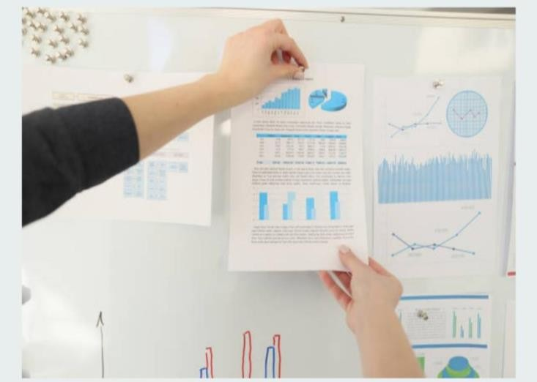

Visual Insights

# Automation

Build a script that automates data collection,analysis and visualization processes.





ss