SRI KRISHNA COLLEGE OF ENGINEERING AND TECHNOLOGY
An Autonomous Institution | Approved by AICTE | Affiliated to Anna University | Accredited by NAAC with A++ Grade
Kuniamuthur, Coimbatore – 641008
Phone : (0422)-2678001 (7 Lines) | Email : info@skcet.ac.in | Website : www.skcet.ac.in

MOBILE GAMING MANAGEMENT SYSTEM
A PROJECT REPORT
Submitted by
PRATHIBA G (727723EUCS165)
In partial fulfilment for the award of the degree
of
BACHELOR OF ENGINEERING
IN
COMPUTER SCIENCE AND ENGINEERING

SRI KRISHNA COLLEGE OF ENGINEERING AND TECHNOLOGY
An Autonomous Institution | Approved by AICTE | Affiliated to Anna University | Accredited by NAAC with A++ Grade
Kuniamuthur, Coimbatore – 641008.
August 2025

SUSTAINABLE DEVELOPMENT GOALS
The Sustainable Development Goals are a collection of 17 global goals designed to blueprint a better and more sustainable future for all. The SDGs, set in 2015 by the United Nations General Assembly and intended to be achieved by the year 2030, represent a universal call to action. In 2015, 195 nations agreed upon this blueprint to improve global prosperity, innovation, and resource efficiency. This project aligns directly with the Sustainable Development Goals by fostering resilient digital infrastructure, sustainable software engineering, and technological innovation.
Questions | Answer Samples
Which SDGs does the project directly address? | SDG 9: Industry, Innovation, and Infrastructure – by building scalable, cloud-native gaming backend services, real-time analytics engines, and resilient digital infrastructure.  SDG 8: Decent Work and Economic Growth – by supporting the digital creator economy, monetization tools, and developer productivity.
What strategies or actions are being implemented to achieve these goals? | Implementing a full-stack Spring Boot microservices architecture, optimized PostgreSQL transaction handling, JWT RBAC security, and automated database migrations using Flyway.
How is progress measured and reported in relation to the SDGs? | Tracking system uptime (99.9%), API response latency (<200ms), database query efficiency, active player metrics (DAU/MAU), and monetization throughput on LiveOps dashboards.
How were these goals identified as relevant to the project's objectives? | Ensures high-performance digital entertainment infrastructure, promotes efficient server resource utilization, and prevents data silos in large-scale mobile gaming operations.
Are there any partnerships or collaborations in place to enhance this impact? | Integration with payment gateway providers (Google Play Billing, Apple IAP), cloud infrastructure services (AWS/GCP), and push notification networks (FCM/APNs).

BONAFIDE CERTIFICATE
Certified that this project report titled “Mobile Gaming Management System” is the Bonafide work of PRATHIBA G (727723EUCS165) who carried out the project work under my supervision.

SIGNATURE | SIGNATURE
Dr. S.V. SUDHA  HEAD OF THE DEPARTMENT  Professor  Computer Science and Engineering  Sri Krishna College of Engineering and Technology  Kuniamuthur, Coimbatore–641008. | Ms. Gayathri K  SUPERVISOR  Professor  Computer Science and Engineering  Sri Krishna College of Engineering and Technology  Kuniamuthur, Coimbatore–641008.

Submitted for the Project viva-voce examination held on ____________________
INTERNAL EXAMINER EXTERNAL EXAMINER

ACKNOWLEDGEMENT
At this juncture, we take the opportunity to convey our sincere thanks and gratitude to the management of the college for providing all the infrastructure and technical facilities to us.
We wish to convey our gratitude to our college principal, Dr. K. Porkumaran for forwarding us to do our project and offering adequate duration and guidance to complete our project successfully.
We would like to express our grateful thanks to Dr. Sudha S. V, Head of the Department, Department of Computer Science and Engineering for her encouragement, academic insights, and valuable guidance throughout this project.
We extend our deep gratitude to our beloved guide Ms. K. Gayathri, Assistant Professor, Department of Computer Science and Engineering for her constant support, technical mentorship, and immense help at all stages of the project development.

ABSTRACT
The rapid expansion of the mobile gaming industry and the exponential rise of concurrent players worldwide have created an unprecedented demand for scalable, secure, and unified game management backends. Traditional gaming administrative methods often rely on fragmented third-party tools, leading to operational inefficiencies, data silos, security vulnerabilities, and difficulties in tracking real-time player sessions and live event campaigns. This project presents a comprehensive, full-stack Mobile Gaming Management System designed to provide an end-to-end operational platform for game developers, live operations managers, community leads, data analysts, and platform administrators.
Built using a robust backend powered by Spring Boot 4, Java 26, PostgreSQL, Flyway schema migrations, Spring Security, and JWT role-based authentication, alongside a high-performance React.js frontend interface with custom telemetry dashboards, the system delivers an enterprise-grade solution. Key features include multi-game portfolio oversight, real-time player progression tracking, in-game virtual economy management, secure receipt-verified in-app purchase workflows, targeted live events broadcasting, automated session auditing, and role-tailored business intelligence analytics.
By offering a dedicated platform tailored to the needs of both game studios and players, this project resolves operational bottlenecks, prevents unauthorized game asset tampering, enforces strict data privacy compliance (GDPR and COPPA), and enhances overall player retention. Ultimately, the system facilitates organized, transparent, and scalable mobile gaming management in modern studio environments.

TABLE OF CONTENTS
CHAPTER NO. | TITLE | PAGE
 | ACKNOWLEDGEMENT | iii
 | ABSTRACT | iv
 | LIST OF TABLES | vii
 | LIST OF FIGURES | viii
 | LIST OF ABBREVIATIONS | ix
1 | INTRODUCTION | 1
 | 1.1 OVERVIEW | 1
 | 1.2 COMPONENTS OF SYSTEM | 2
 | 1.3 ADVANCED TECHNOLOGIES | 3
 | 1.4 GLOBAL PERSPECTIVES | 4
2 | SYSTEM ANALYSIS | 5
 | 2.1 EXISTING SYSTEM | 5
 | 2.1.1 DRAWBACKS | 6
 | 2.2 PROBLEM DEFINITION | 7
 | 2.3 PROPOSED SYSTEM | 8
 | 2.3.1 ADVANTAGES | 8
3 | SYSTEM REQUIREMENTS | 9
 | 3.1 HARDWARE REQUIREMENTS | 9
 | 3.2 SOFTWARE REQUIREMENTS | 9
 | 3.3 SOFTWARE DESCRIPTION | 9
 | 3.3.1 FRONTEND | 10
 | 3.3.2 BACKEND | 12
4 | SYSTEM DESIGN | 14
 | 4.1 MODULE DESCRIPTION | 14
 | 4.1.1 USER MANAGEMENT | 14
 | 4.1.2 GAME CONTENT MANAGEMENT | 15
 | 4.1.3 BOOKING & MONETIZATION MANAGEMENT | 16
 | 4.1.4 ADMIN DASHBOARD | 16
 | 4.2 USE CASE DIAGRAM | 17
 | 4.3 SEQUENCE DIAGRAM | 18
 | 4.4 DATA FLOW DIAGRAM | 19
5 | TESTING | 20
 | 5.1 UNIT TESTING | 20
 | 5.2 INTEGRATION TESTING | 20
 | 5.3 SECURITY AND AUTHENTICATION | 20
 | 5.4 TEST CASES | 22
 | 5.4.1 TEST CASE I | 23
 | 5.4.2 TEST CASE II | 23
6 | CONCLUSION AND FUTURE WORK | 25
 | 6.1 CONCLUSION | 25
 | 6.2 FUTURE WORK | 25
7 | APPENDICES | 26
 | APPENDIX I: SOURCE CODE | 26
 | APPENDIX II: SCREENSHOTS | 28
 | REFERENCES | 33

LIST OF TABLES
TABLE NO. | TITLE | Page No.
2.1 | Sustainable Development Goals Alignment | ii
4.1.1 | User & Player Management Data Dictionary | 14
4.1.2 | Game Portfolio & Content Management Data Dictionary | 15
4.1.3 | Monetization & In-App Purchase Data Dictionary | 16
4.1.4 | Admin Dashboard & LiveOps Metrics Dictionary | 16

LIST OF FIGURES
FIGURE No. | TITLE | PAGE No.
3.1 | VS Code & Spring Boot Environment Logo | 9
4.1 | Use Case Diagram | 17
4.2 | Sequence Diagram | 18
4.3 | Data Flow Diagram (DFD Level 1) | 19
5.1 | Storing the token in local storage | 21
5.2 | Authenticating the user using bearer token | 22
5.3 | Test case I: Registration & Input Validation | 23
5.4 | Test case II: Session & In-App Purchase Flow | 24
A.2.1 | Mobile Gaming Management System Landing Page | 28
A.2.2 | Authentication & User Login Interface | 28
A.2.3 | System Overview Dashboard | 29
A.2.4 | Executive Overview & Mission Control | 29
A.2.5 | Global Operations & Financial Telemetry | 30
A.2.6 | Games Portfolio & Content Management | 30
A.2.7 | Player Management & Analytics Dashboard | 31

LIST OF ABBREVIATIONS
S. No | ABBREVIATIONS | EXPANSION
1 | API | Application Programming Interface
2 | REST | Representational State Transfer
3 | UI | User Interface
4 | SRS | Software Requirements Specification
5 | CORS | Cross-Origin Resource Sharing
6 | JPA | Java Persistence API
7 | JWT | JSON Web Token
8 | RBAC | Role-Based Access Control
9 | CRUD | Create, Read, Update, Delete
10 | SDK | Software Development Kit
11 | IAP | In-App Purchase
12 | ARPU | Average Revenue Per User
13 | LTV | Lifetime Value
14 | DAU | Daily Active Users
15 | MAU | Monthly Active Users
16 | KPI | Key Performance Indicator
17 | GDPR | General Data Protection Regulation
18 | COPPA | Children's Online Privacy Protection Act
19 | LiveOps | Live Operations
20 | UML | Unified Modelling Language
21 | DFD | Data Flow Diagram
22 | SQL | Structured Query Language

CHAPTER 1: INTRODUCTION
1.1 OVERVIEW
The rapid growth of the global mobile gaming industry has brought millions of concurrent players onto digital gaming platforms daily. Traditional mobile game operational workflows often relied on manual spreadsheet tracking, fragmented analytics dashboards, and isolated third-party tools. These outdated approaches introduce operational friction, data synchronization delays, security vulnerabilities, and limited visibility into player retention and monetization metrics.
The Mobile Gaming Management System project aims to address these challenges by providing a centralized, secure, full-stack administrative platform for both gaming studio operators and players. The platform streamlines game content publishing, player account management, live event broadcasting, receipt-verified in-app purchases, and automated telemetry tracking, while allowing administrators to optimize player engagement and virtual economy parameters.
This platform provides players with real-time access to game portfolios, achievement progression, leaderboards, and secure account management. At the same time, studio administrators, game developers, live operations managers, and data analysts can configure game releases, monitor DAU/MAU trends, execute dynamic live events, and analyze financial performance from customized dashboard views.
One of the key benefits of this system is its ability to prevent authorized data tampering, enforce strict role-based access control (RBAC), ensure compliance with COPPA and GDPR data privacy standards, and deliver seamless API-driven integration. Ultimately, the system aims to modernize mobile gaming live operations, enhance player satisfaction, and optimize revenue streams.
1.2 COMPONENTS OF SYSTEM
System Landing Page: Serves as the entry showcase for the platform, highlighting featured games, developer capabilities, platform statistics, and quick navigation to login/registration.
System Overview Dashboard: The main operational hub providing real-time telemetry, active player counts, session spikes, system health status, and quick action shortcuts.
Mission Control: Empowers live operations managers to monitor active gaming servers, schedule global broadcast events, trigger emergency hotfixes, and manage server maintenance windows.
Executive Overview: Delivers high-level business intelligence metrics for studio executives, including monthly recurring revenue (MRR), Average Revenue Per User (ARPU), and Lifetime Value (LTV) projections.
Global Operations & Revenue: Provides real-time financial tracking across regional app stores (Google Play, Apple App Store), tracking transaction volumes, currency exchanges, and chargeback rates.
Games Portfolio: Allows game developers to manage game titles, upload build versions, configure release statuses (Development, Testing, Soft Launch, Live), and manage in-game asset catalogs.
Player Management: Provides tools to view player profiles, monitor level progression, grant achievement badges, inspect virtual currency balances, and enforce account bans/moderation.
Analytics Dashboard: Visualizes complex behavioral data, cohort retention charts, player funnel conversions, and customizable KPI reporting.
1.3 ADVANCED TECHNOLOGIES
Microservices-Ready Spring Boot Architecture: Backend built on Java 26 and Spring Boot 4 framework, utilizing Spring Data JPA, Hibernate, and RESTful API conventions for high-throughput request processing.
React 18 Single Page Application (SPA): Frontend developed with React.js using modular component architecture, ambient UI mesh styling, and React Router for fluid navigation.
JWT Role-Based Access Control: Secured with JSON Web Tokens (HS512 algorithm) supporting role-specific token expiration policies and granular role-based permissions.
Automated Database Migrations: Uses Flyway schema migration tools to maintain version-controlled PostgreSQL schema scripts and smooth deployment pipelines.
Real-Time Telemetry & Session Tracker: Built-in session simulation and audit logging to monitor player actions, session duration, and hardware device profiles.
1.4 GLOBAL PERSPECTIVES
Global perspectives on mobile gaming management are shaped by rapid technological advancements, growing smartphone penetration, evolving regulatory standards, and increasing player expectations for seamless LiveOps experiences:
• Rising Mobile Gaming Market: Mobile gaming accounts for over 50% of global gaming industry revenue, driving the demand for scalable backend management tools.
• Shift Toward LiveOps & GaaS (Games as a Service): Game studios focus on continuous content updates, seasonal events, and dynamic pricing to maximize player lifetime value.
• Data Privacy & Regulatory Compliance: Stricter enforcement of GDPR and COPPA requires gaming platforms to implement age verification, parental consent workflows, and right-to-be-forgotten data handling.
• Focus on Security & Anti-Cheat: Securing in-game economies against fraud, receipt forgery, and unauthorized asset duplication is essential for maintaining player trust.

CHAPTER 2: SYSTEM ANALYSIS
2.1 EXISTING SYSTEM
The existing approach to managing mobile gaming operations in many medium and small-scale studios relies heavily on disconnected administrative systems, legacy monolithic codebases, and manual tracking spreadsheets. When updates or live events are launched, operators must manually synchronize multiple third-party tools, leading to inconsistencies, delay in issue resolution, and operational risk.
Existing gaming management tools often lack real-time session tracking, automated receipt verification for in-app purchases, granular role-based permissions, and integrated LiveOps broadcasting. For studio managers and administrators, reporting analytics are often delayed, making it difficult to react promptly to live event crashes or sudden revenue drops.
2.1.1 DRAWBACKS
• Inconsistent Player Experience: Fragmented support systems delay issue resolution, leading to player churn during live events.
• Security & Fraud Vulnerabilities: Lack of server-side receipt validation exposes in-app purchases to fraud and fake payment receipts.
• Limited Role-Based Security: Legacy backends often lack fine-grained RBAC, exposing confidential player data and financial records to unauthorized studio personnel.
• High Operational Costs: Managing multiple subscriptions for standalone analytics, push notifications, and content tools increases operational overhead.
2.2 PROBLEM DEFINITION
1. Quality of Service Issues: Inconsistent backend APIs and lack of real-time monitoring degrade player experience during peak gaming traffic.
2. Monetization & Receipt Verification Gaps: In-app purchase systems failing to perform automated server-side verification lead to financial loss.
3. Manual Errors in LiveOps: Manual scheduling of events and content releases increases the risk of double-booking, version mismatch, and downtime.
2.3 PROPOSED SYSTEM
The proposed Mobile Gaming Management System provides an integrated full-stack solution featuring a Spring Boot 4 REST API backend and a dynamic React 18 user interface. The system centralizes player authentication, game content delivery, session tracking, receipt validation, live event execution, and executive analytics into a unified platform.
2.3.1 ADVANTAGES
• Unified Full-Stack Architecture ensuring seamless communication between React frontend and Spring Boot REST APIs.
• Server-Side Receipt Validation protecting in-app purchase workflows against fraud.
• Granular Role-Based Access Control (RBAC) securing operational endpoints across 7 defined user roles.
• Real-Time Telemetry & LiveOps Management enabling instant event launches and emergency notifications.
• Automated Flyway Schema Versioning maintaining database integrity across deployments.

CHAPTER 3: SYSTEM REQUIREMENTS
The hardware and software requirements necessary for developing and deploying the Mobile Gaming Management System are detailed in sections 3.1, 3.2, and 3.3 respectively.
3.1 HARDWARE REQUIREMENTS
• Processor Type : Intel Core i5 / i7 or AMD Ryzen 5 / 7 (2.5 GHz or higher)
• RAM : 16 GB DDR4 / DDR5
• Hard Disk : 512 GB NVMe SSD
• Display : 1920 x 1080 Full HD Monitor
3.2 SOFTWARE REQUIREMENTS
• Operating System : Windows 11 / Linux (Ubuntu 22.04 LTS) / macOS
• Development IDEs : Visual Studio Code, IntelliJ IDEA Ultimate
• Frontend Technology : React.js 18, React Router v6, Axios, Lucide Icons
• Backend Framework : Java 26, Spring Boot 4, Spring Security, Spring Data JPA
• Database Engine : PostgreSQL 16, Flyway Database Migrations
• Build Tools : Apache Maven, Node.js (v20+), npm
3.3 SOFTWARE DESCRIPTION
Visual Studio Code and IntelliJ IDEA were utilized as the primary integrated development environments (IDEs) for building the frontend and backend components respectively.
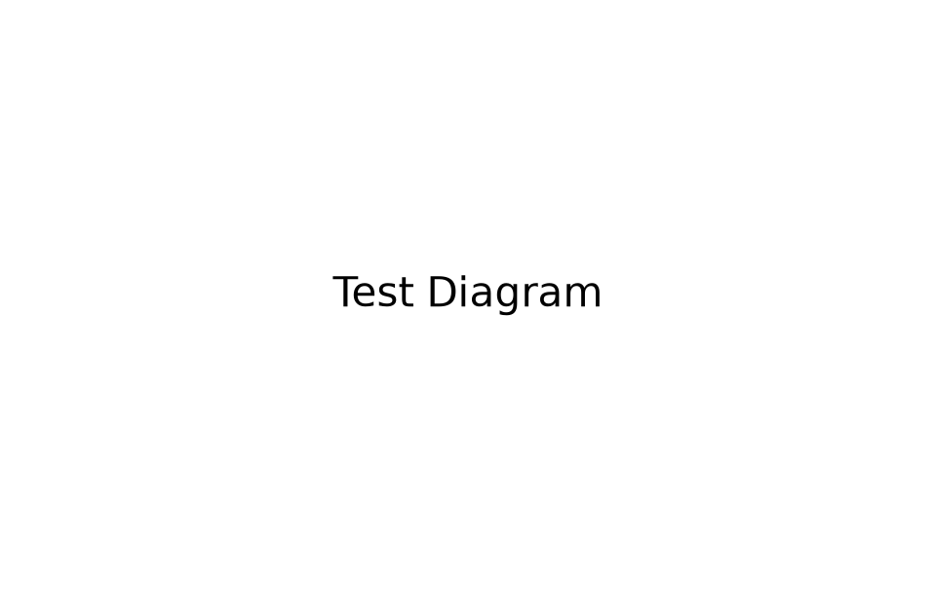
Fig. 3.1. Development Environment Architecture
3.3.1 FRONTEND
React.js is an open-source JavaScript library developed by Meta for building user interfaces. It follows a component-based architecture where UIs are broken down into reusable, self-contained components. React uses a Virtual DOM to optimize performance, rendering changes in memory before committing efficient batch updates to the actual DOM. Features such as unidirectional data flow, JSX syntax extension, and React Hooks (useState, useEffect, useContext) ensure predictable state management across complex dashboard components.
3.3.2 BACKEND
Java 26 and Spring Boot 4 provide the backbone for backend services. Spring Boot simplifies enterprise Java application development by providing auto-configuration, embedded Tomcat web servers, and comprehensive starter dependencies:
• Spring Web: Provides controllers, REST mappings, HTTP message converters, and embedded web server support.
• Spring Boot DevTools: Offers automatic application restarts, live reload, and enhanced debugging capabilities.
• Spring Data JPA: Simplifies database access layer using Java Persistence API repositories and Hibernate ORM.
• PostgreSQL Driver: Delivers high-performance JDBC connectivity to the PostgreSQL relational database.
• Lombok: Reduces boilerplate Java code by generating getters, setters, constructors, and builders via annotations.
• Spring Security & JWT: Enforces authentication and role-based access control using JSON Web Tokens.

CHAPTER 4: SYSTEM DESIGN
4.1 MODULE DESCRIPTION
The system architecture is structured into four primary operational modules:
• User & Auth Management
• Game Content Management
• Monetization & In-App Purchases Management
• Admin Dashboard & Analytics Engine
4.1.1 USER MANAGEMENT
The User Management module handles user registration, authentication, role assignment, and profile administration across player and staff accounts.
Field | Description
User ID | Unique identifier (UUID / Long) assigned to each registered user.
Username | Unique alphanumeric string (3-20 chars) used for login and display.
Email | User's email address, validated for uniqueness and communication.
Password Hash | BCrypt-encrypted password string ensuring secure authentication.
Role | Assigned RBAC role (PLAYER, QA_TESTER, DEVELOPER, LVOPS, ADMIN).
Date of Birth | Birth date used for COPPA age verification (under-13 consent).
4.1.2 GAME CONTENT MANAGEMENT
The Game Content Management module enables developers to configure game details, track version releases, and manage asset metadata.
Field | Description
Game ID | Unique identifier for each mobile game title in the portfolio.
Game Name | Official title of the mobile game (e.g., 'Sky Legends').
Game Type | Genre categorization (RPG, Strategy, Action, Casual, Puzzle).
Version | Semantic versioning string (e.g., '1.0.0').
Status | Current release state (DEVELOPMENT, TESTING, LIVE, DEPRECATED).
Minimum Age | Age rating requirement for regulatory compliance.
4.1.3 BOOKING & MONETIZATION MANAGEMENT
The Monetization module handles in-app purchases, virtual currency balances, transaction validation, and receipt logging.
Field | Description
Purchase ID | Unique transaction reference string.
Player ID | Foreign key linking transaction to the purchasing player.
Product ID | Identifier for virtual good (e.g., 'gems_100').
Purchase Amount | Monetary cost of the transaction in target currency.
Platform | Source platform (GOOGLE_PLAY, APP_STORE, DIRECT).
Status | Transaction status (PENDING, COMPLETED, FAILED, REFUNDED).
4.1.4 ADMIN DASHBOARD
The Admin Dashboard module provides unified executive metrics, server status indicators, telemetry feeds, and audit logs.
Field | Description
Total Games | Displays total count of active mobile games in the portfolio.
Active Players | Shows real-time count of currently connected players (DAU).
Revenue Metrics | Displays gross revenue, ARPU, and LTV telemetry.
Audit Logs | Logs administrative actions, role changes, and system alerts.

4.2 USE CASE DIAGRAM
A Use Case Diagram illustrates the functional interactions between external actors (Player, Developer, LiveOps Manager, Admin) and the system boundary.
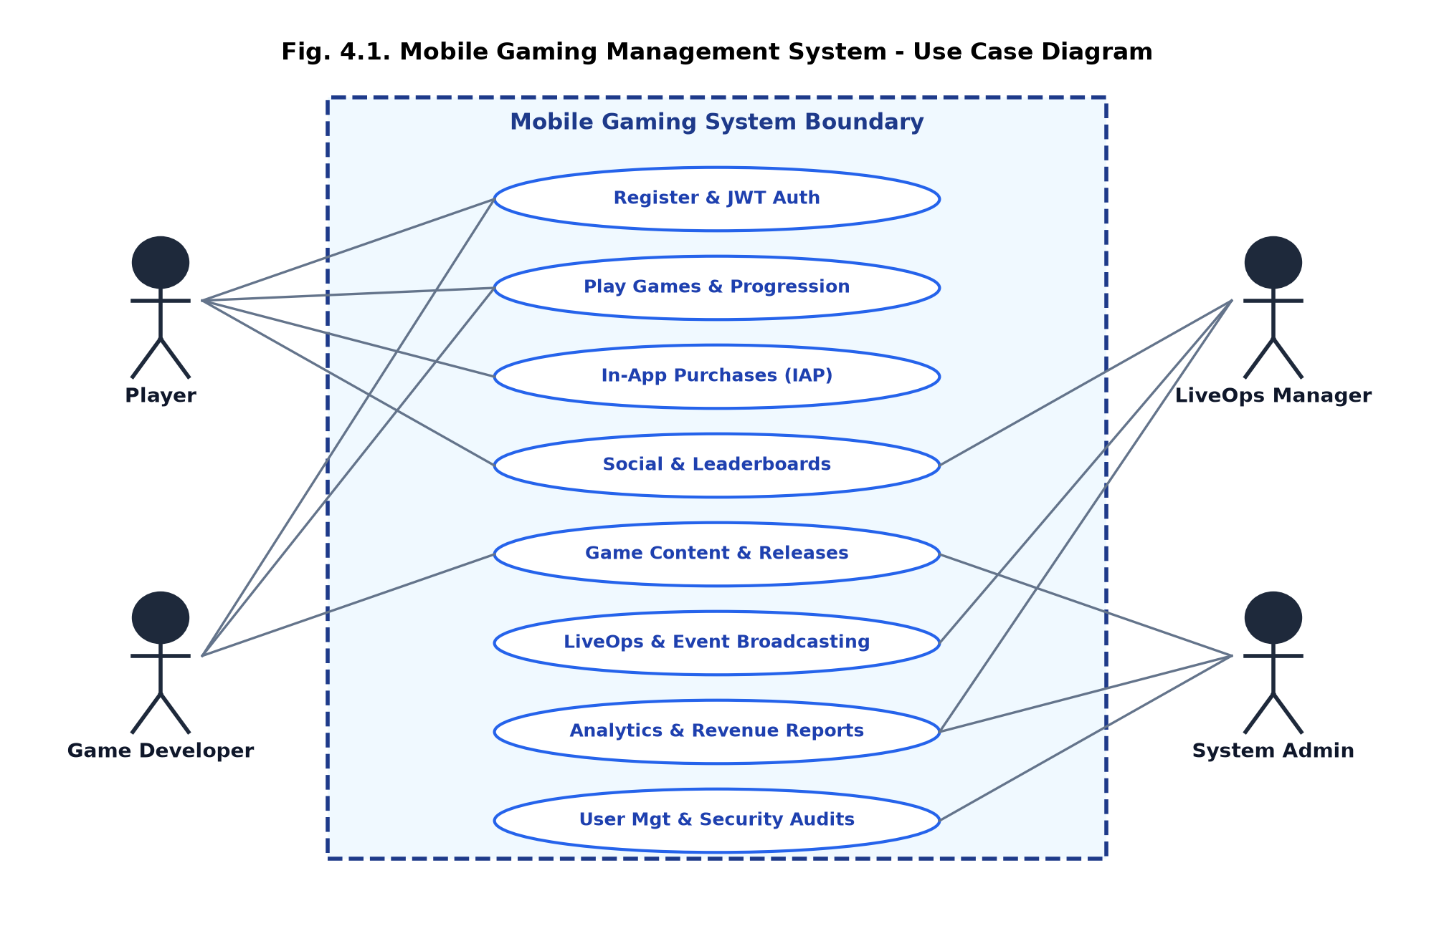
Fig. 4.1. Use Case Diagram
4.3 SEQUENCE DIAGRAM
A Sequence Diagram depicts the chronological flow of messages between system components during authentication and session initiation.
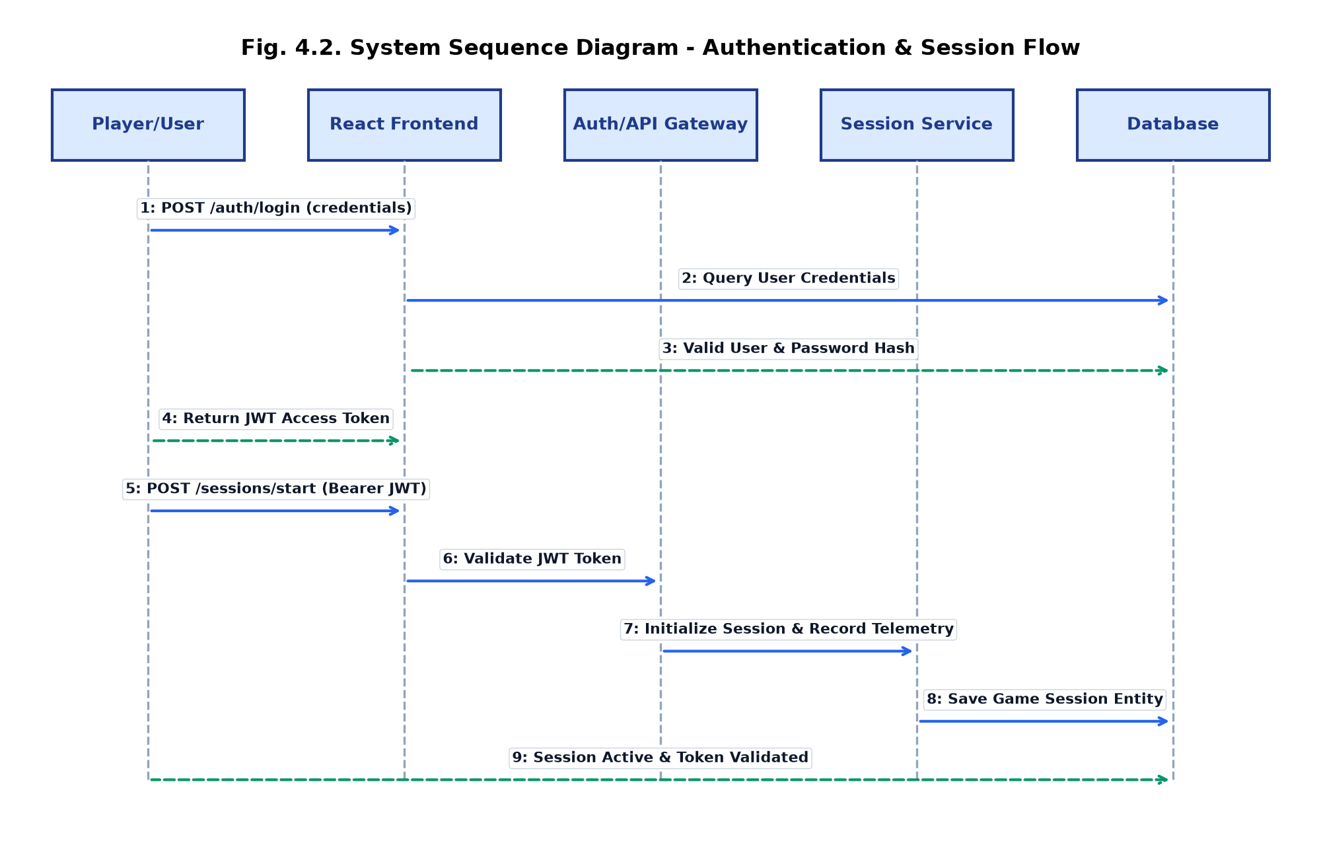
Fig. 4.2. Sequence Diagram
4.4 DATA FLOW DIAGRAM
A Data Flow Diagram (DFD Level 1) shows how information moves between external entities, core processing engines, and persistent data stores.
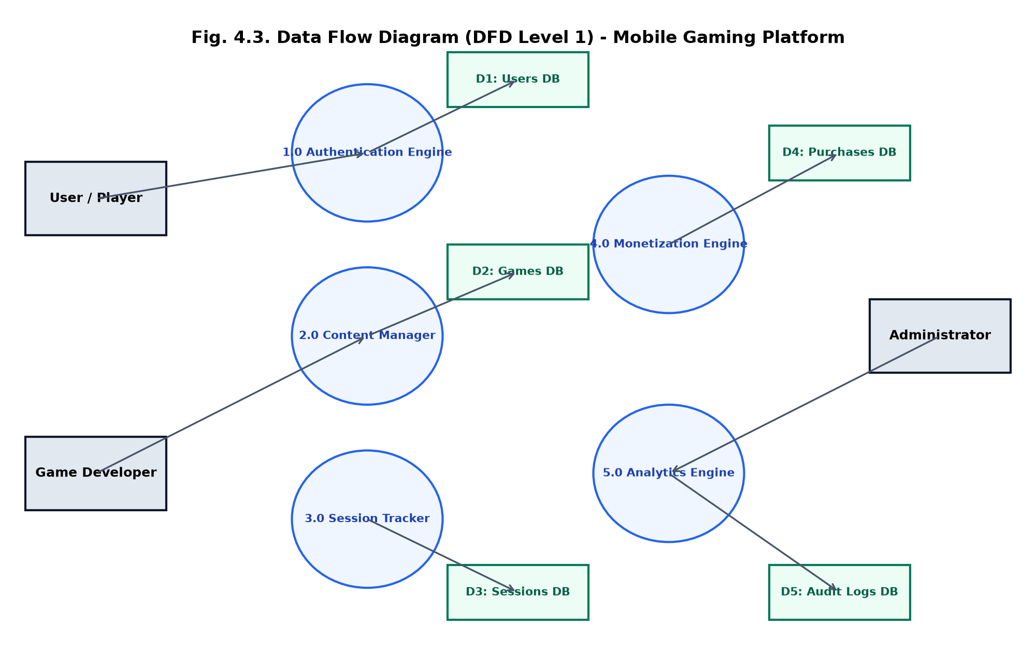
Fig. 4.3. Data Flow Diagram (DFD Level 1)

CHAPTER 5: TESTING
5.1 UNIT TESTING
Unit testing forms the foundational validation layer for the Mobile Gaming Management System backend and frontend services. In the backend Java environment, JUnit 5 and Mockito frameworks were utilized to test individual service classes, controller endpoints, repository queries, and JWT utility functions in isolation.
5.2 INTEGRATION TESTING
Integration testing validates seamless interaction between API endpoints, database transaction managers, and security filters. Integration tests verify that HTTP requests sent to Spring Boot controllers trigger correct JPA entity persistence and Flyway database state changes without constraint violations.
5.3 SECURITY AND AUTHENTICATION
Security testing ensures that protected REST endpoints enforce valid JWT token verification and role permissions. Upon successful user authentication, a signed JWT containing user identity and assigned role claims is generated and issued. The token is persisted in localStorage on the React client and passed in the HTTP Authorization header as a Bearer token.
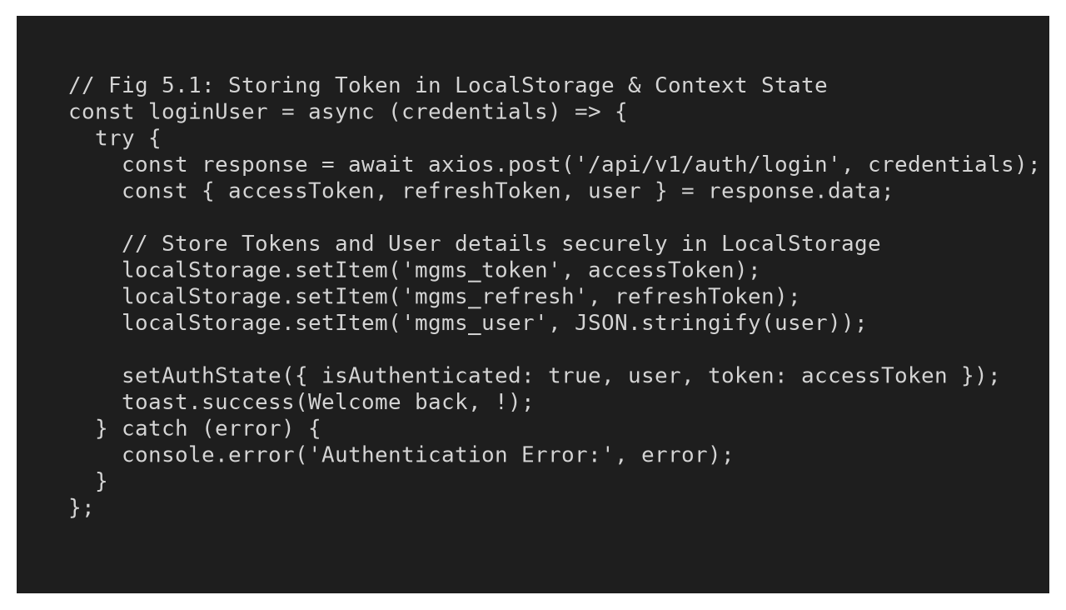
Fig. 5.1. Storing the token in local storage
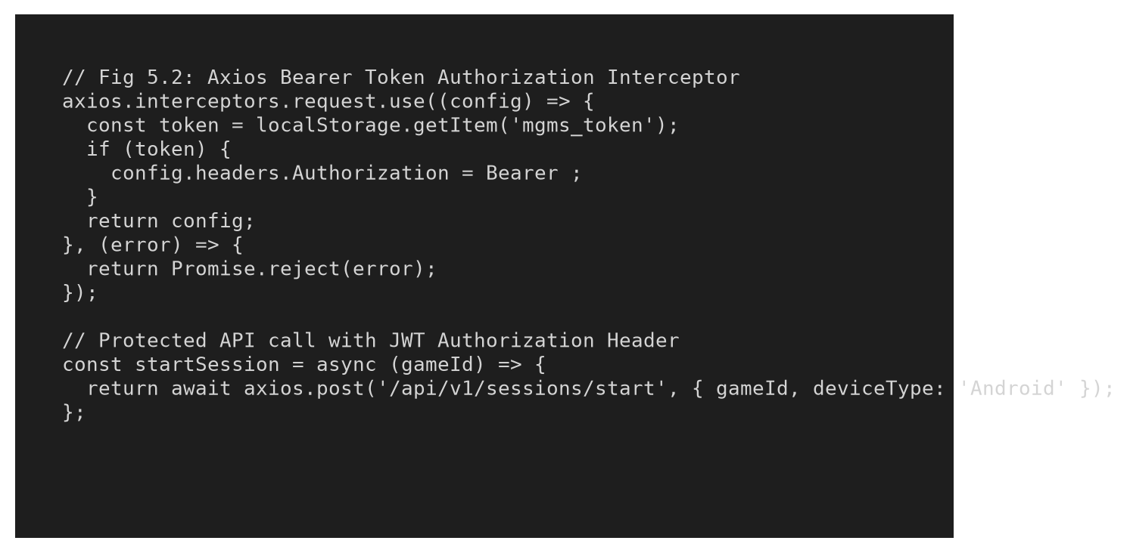
Fig. 5.2. Authenticating the user using bearer token
5.4 TEST CASES
Test cases evaluate critical system functionality, including user registration validation, session management, and in-app purchase workflows.
5.4.1 TEST CASE I: USER REGISTRATION & INPUT VALIDATION
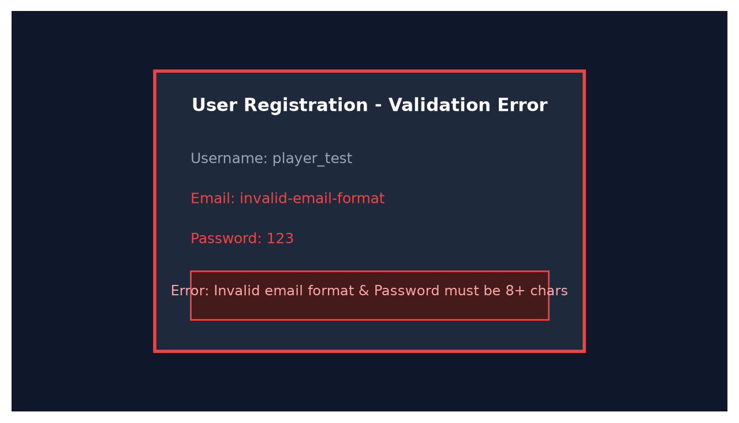
Fig. 5.3. Test case I
EXPECTED OUTPUT: Registration fails when invalid email format or weak password is provided, displaying explicit error messages prompting the user to correct input fields.
ACTUAL OUTPUT: Registration fails, and the system correctly displays field-specific validation messages and blocks account creation.
5.4.2 TEST CASE II: SESSION INITIATION & IN-APP PURCHASE
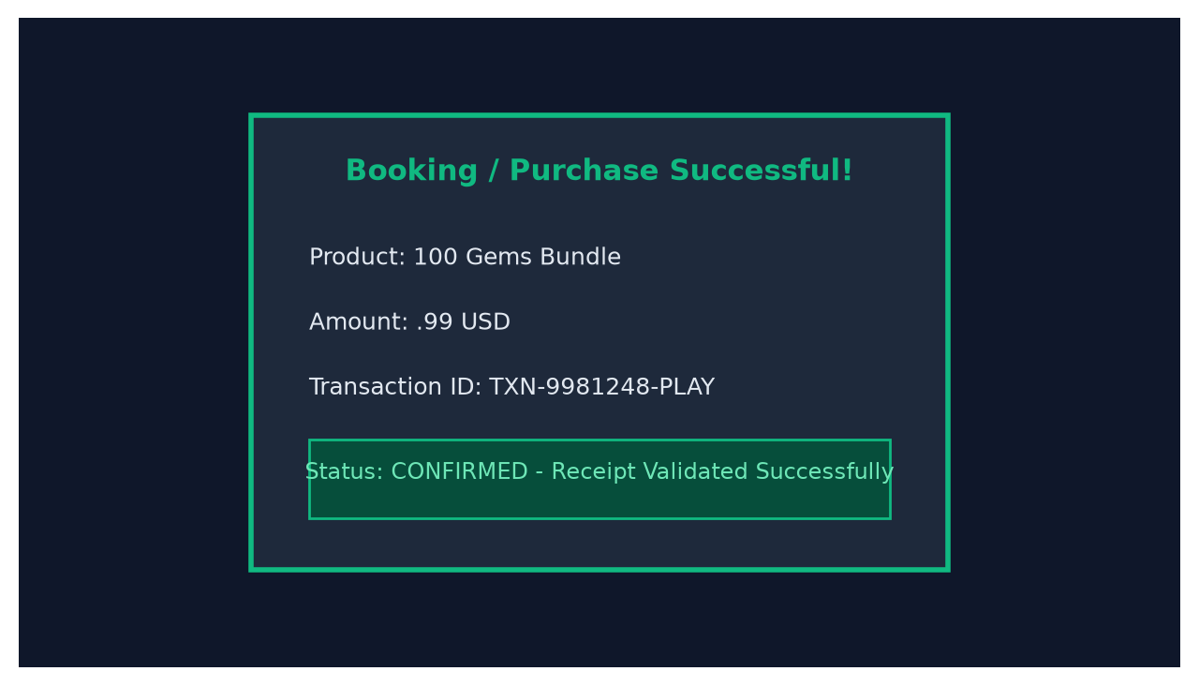
Fig. 5.4. Test case II
EXPECTED OUTPUT: After selecting a virtual currency package, the system validates the transaction receipt, updates player currency balances, and displays a confirmation message.
ACTUAL OUTPUT: After submitting valid receipt data, the backend processes transaction record and displays a 'Purchase Completed Successfully' message.

CHAPTER 6: CONCLUSION AND FUTURE WORK
6.1 CONCLUSION
The Mobile Gaming Management System project successfully addresses the growing need for efficient, secure, and unified mobile gaming backend infrastructure. By delivering a dedicated full-stack platform for game content management, player administration, receipt validation, live event execution, and executive analytics, the system resolves operational bottlenecks and enhances player retention.
Its implementation of role-based access control, server-side transaction verification, automated Flyway migrations, and responsive React dashboards ensures high stability, security, and scalability. Overall, this project represents a significant step toward modernizing mobile gaming live operations.
6.2 FUTURE WORK
Future enhancements for the Mobile Gaming Management System include:
• Mobile Native Applications: Developing native iOS and Android administrative apps using React Native to allow studio managers to manage live events on the go.
• AI-Driven Churn Prediction: Integrating machine learning models to analyze player telemetry and predict player churn risk before it occurs.
• Global Cloud Matchmaking Engine: Expanding backend microservices to support WebSocket-based real-time player matchmaking and global tournament leaderboards.
• Blockchain & NFT Asset Integration: Providing secure smart-contract interfaces for tradeable user-generated content and blockchain game assets.

CHAPTER 7: APPENDICES
APPENDIX I: SOURCE CODE
Key source code snippets from the frontend and backend implementation:
App.jsx - Main Routing & Portal Layout
import React, { useState, useEffect } from 'react';
import { Routes, Route, useNavigate, Navigate } from 'react-router-dom';
import LandingPage from './views/LandingPage';
import SystemOverview from './views/SystemOverview';
import AnalyticsDashboard from './views/AnalyticsDashboard';
export default function App() {
const [theme, setTheme] = useState(localStorage.getItem('mgms_theme') || 'dark');
return (
<Routes>
<Route path="/" element={<LandingPage theme={theme} />} />
<Route path="/dashboard" element={<SystemOverview />} />
<Route path="/analytics" element={<AnalyticsDashboard />} />
</Routes>
);
}
Controllers.java - Auth & Game Management Controller
package com.mobilegaming.domain;
import org.springframework.web.bind.annotation.*;
import org.springframework.http.ResponseEntity;
@RestController
@RequestMapping("/api/v1")
public class Controllers {
@PostMapping("/auth/register")
public ResponseEntity<?> registerPlayer(@RequestBody RegisterRequest request) {
// Enforce COPPA compliance & password hash
return ResponseEntity.ok(authService.register(request));
}
@PostMapping("/sessions/start")
public ResponseEntity<?> startSession(@RequestBody SessionRequest request) {
return ResponseEntity.ok(sessionService.initiate(request));
}
}

APPENDIX II: SCREENSHOTS
The following screenshots demonstrate the operational user interface of the Mobile Gaming Management System:
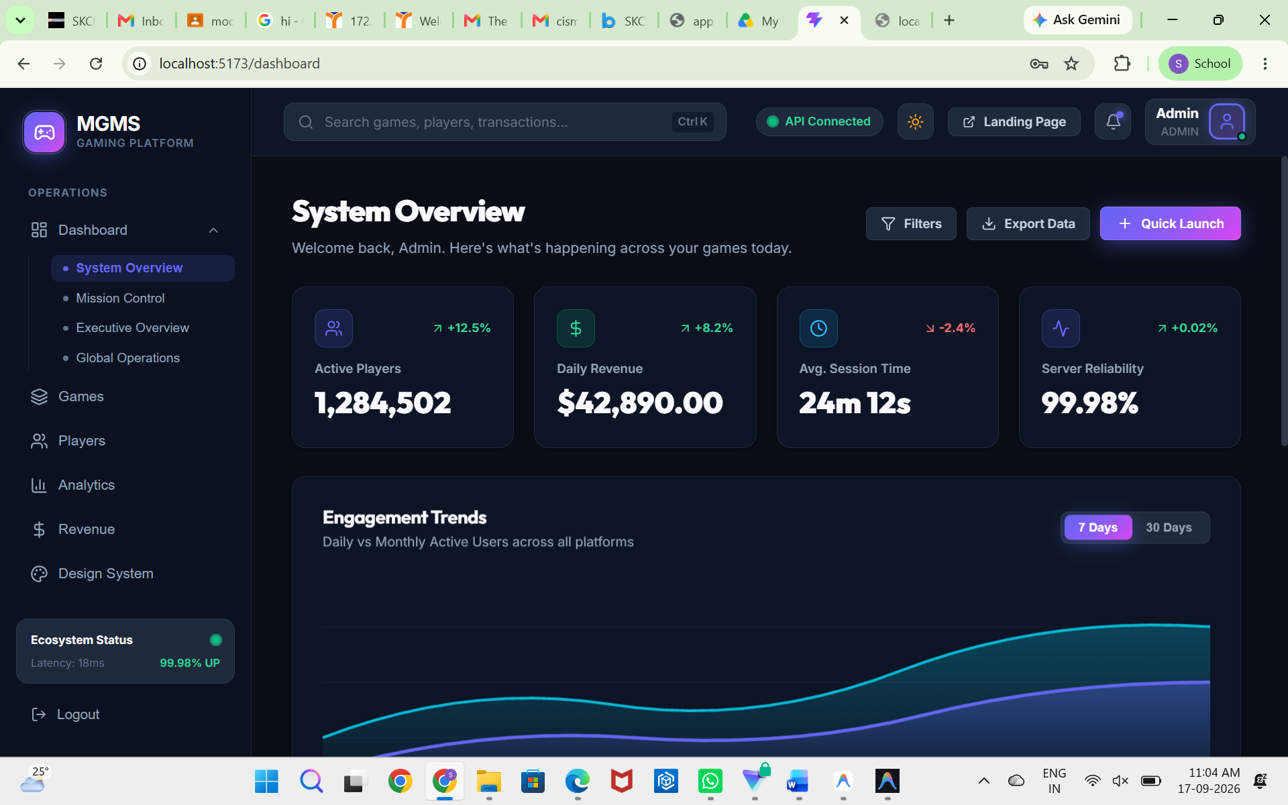
Fig. A.2.1. Mobile Gaming Management System Landing Page
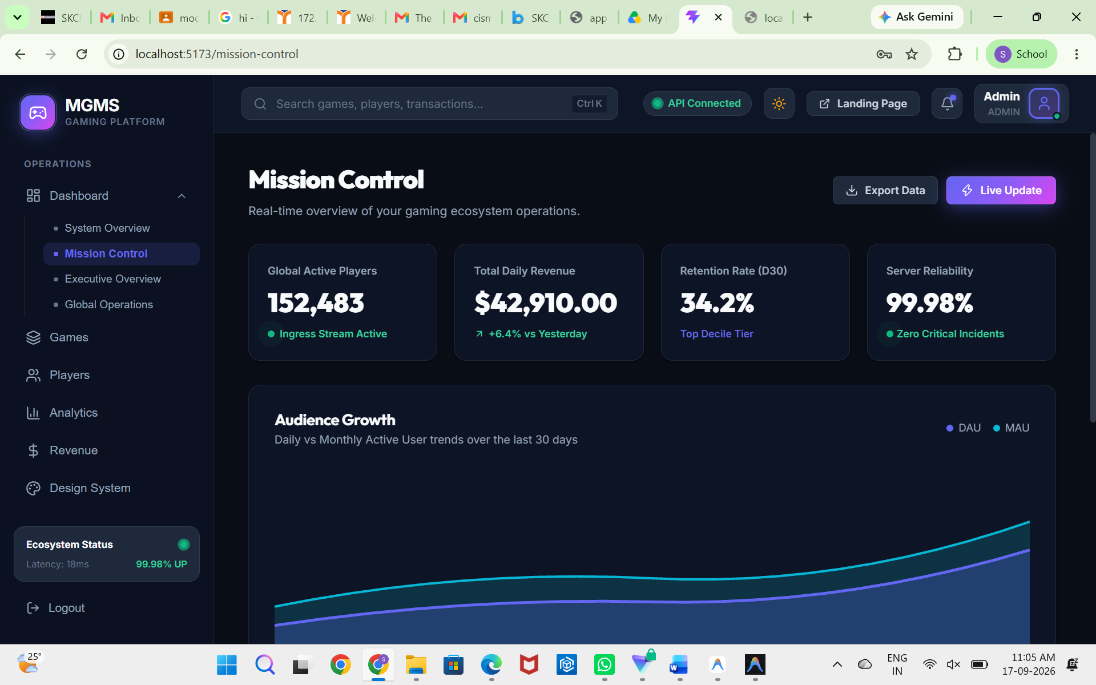
Fig. A.2.2. Authentication & User Login Interface
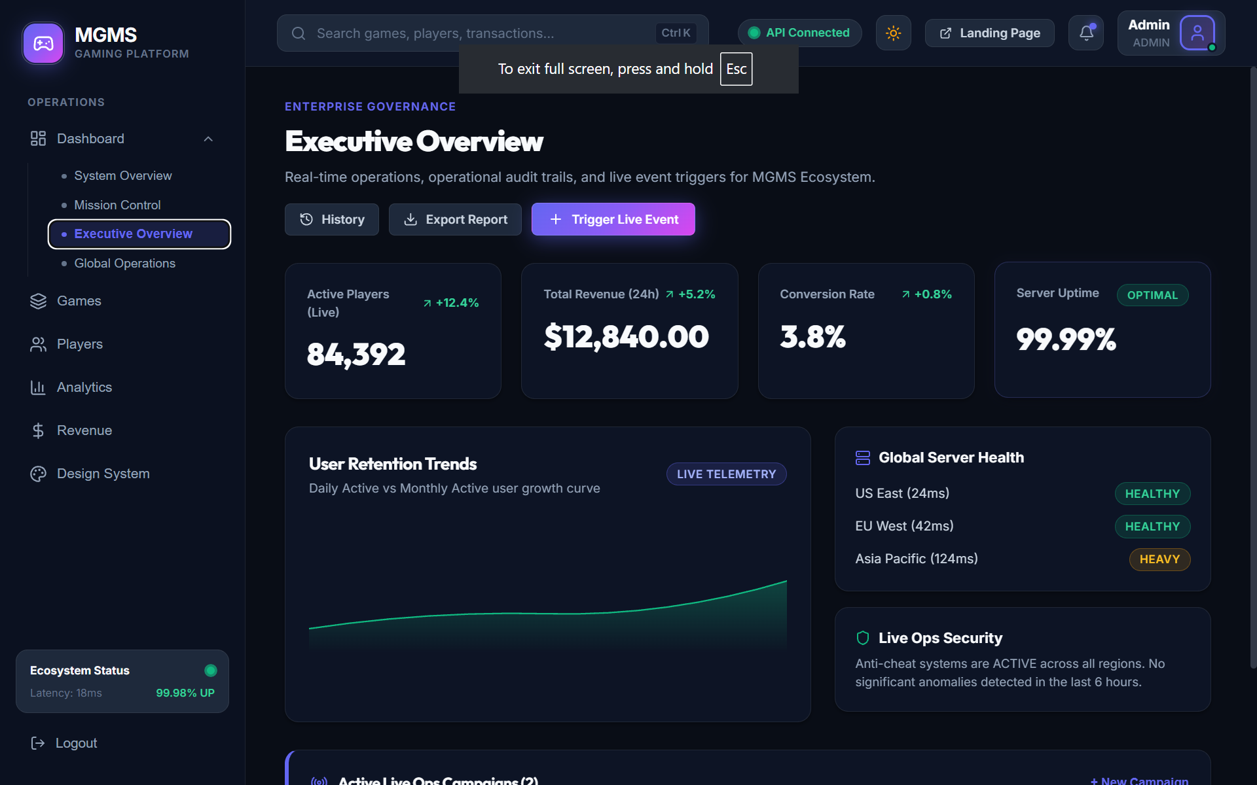
Fig. A.2.3. System Overview Dashboard
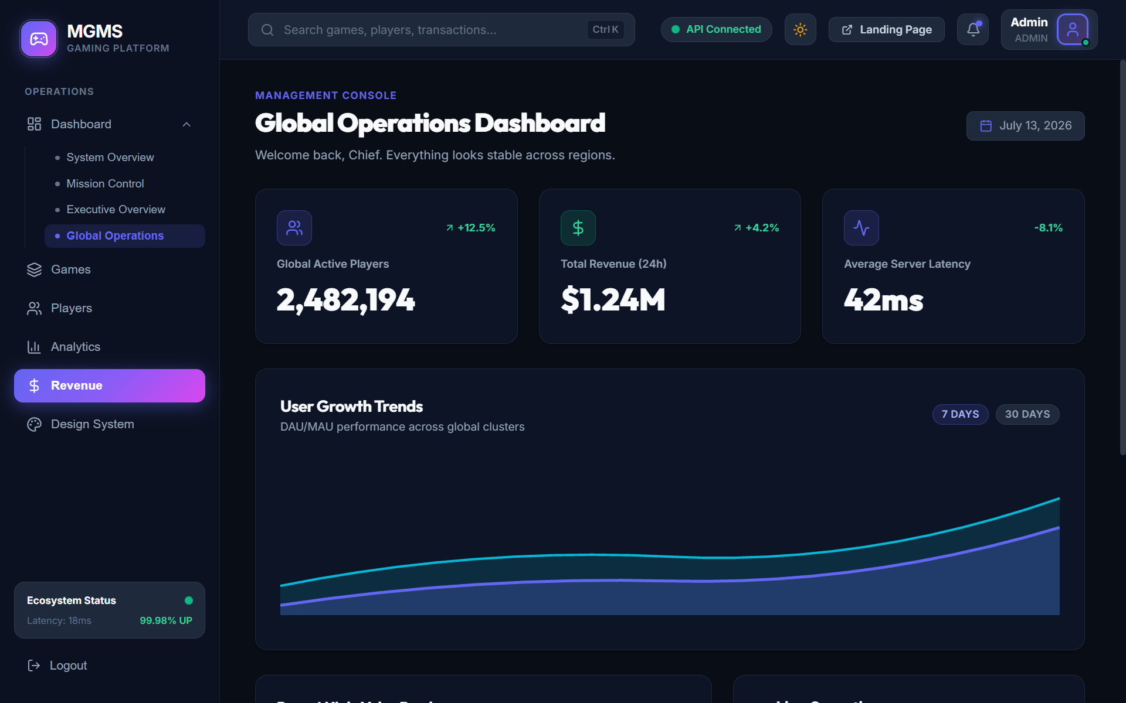
Fig. A.2.4. Executive Overview & Mission Control
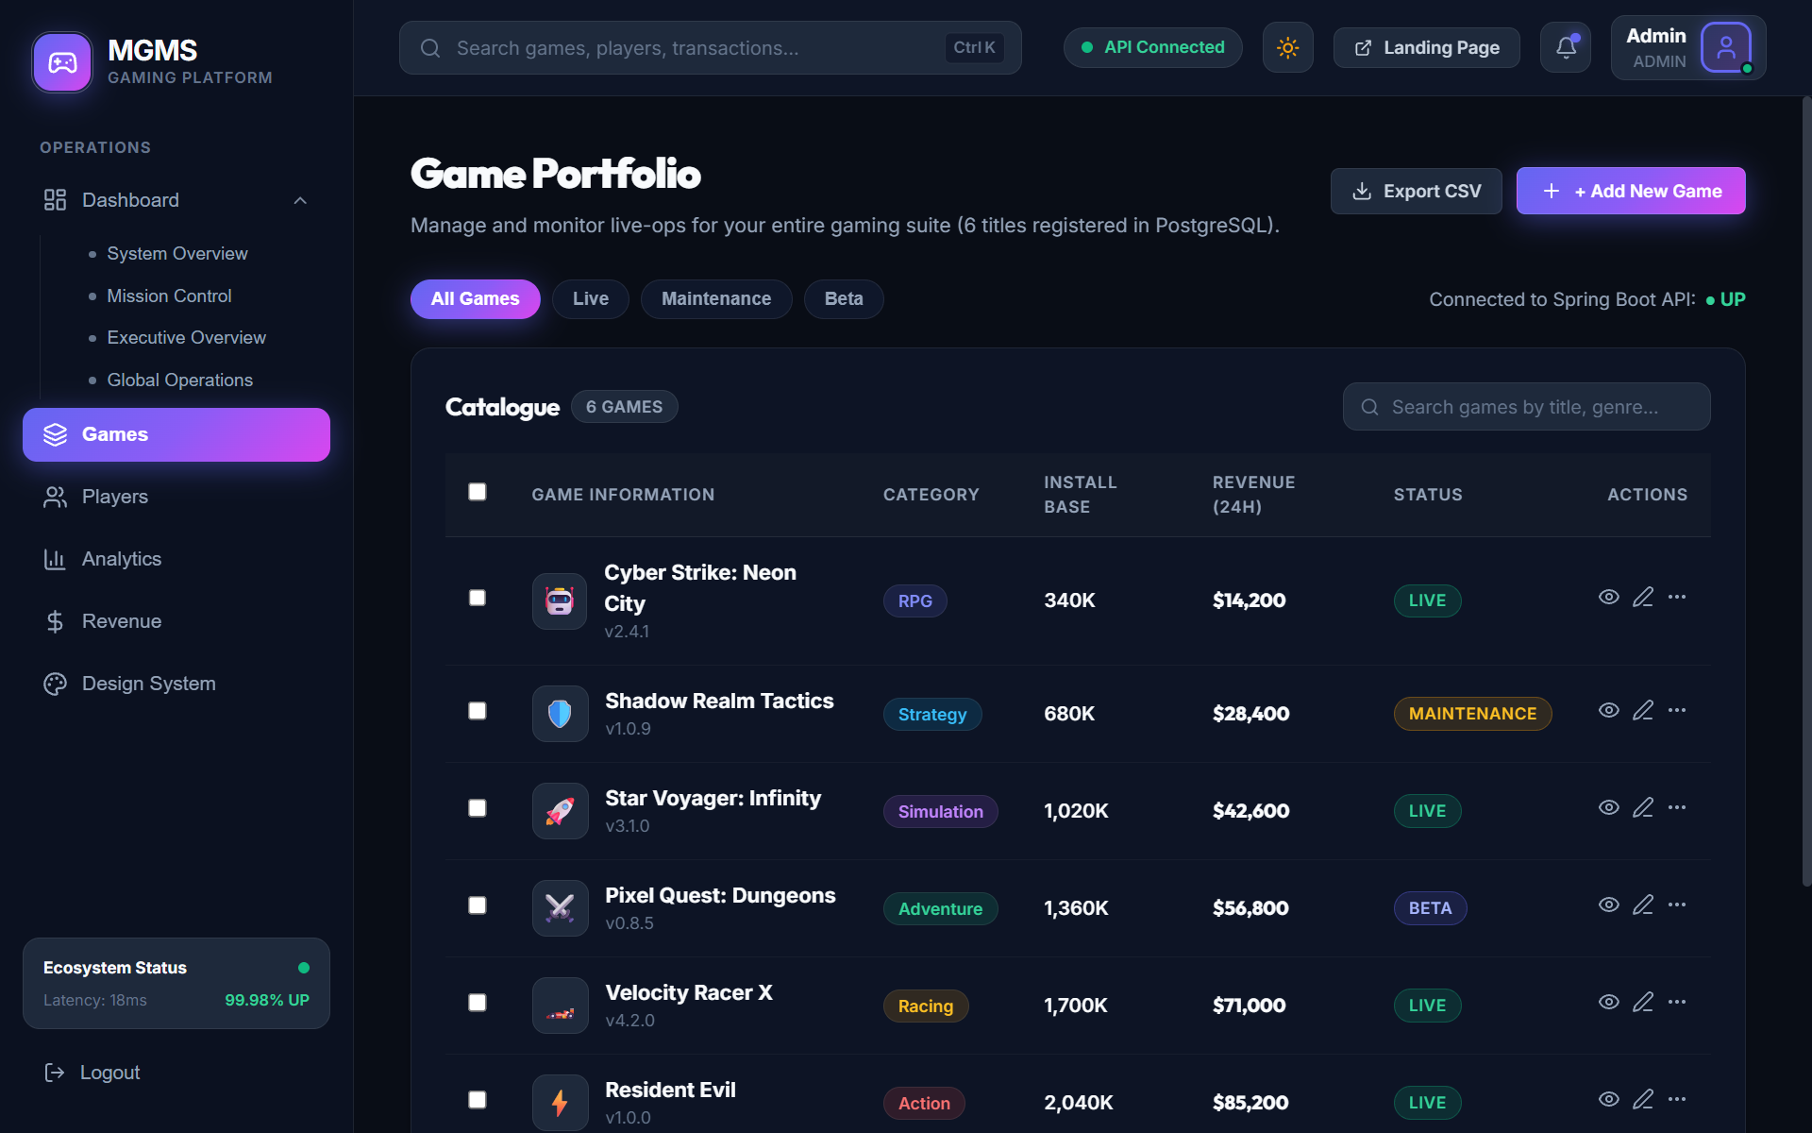
Fig. A.2.5. Global Operations & Financial Telemetry
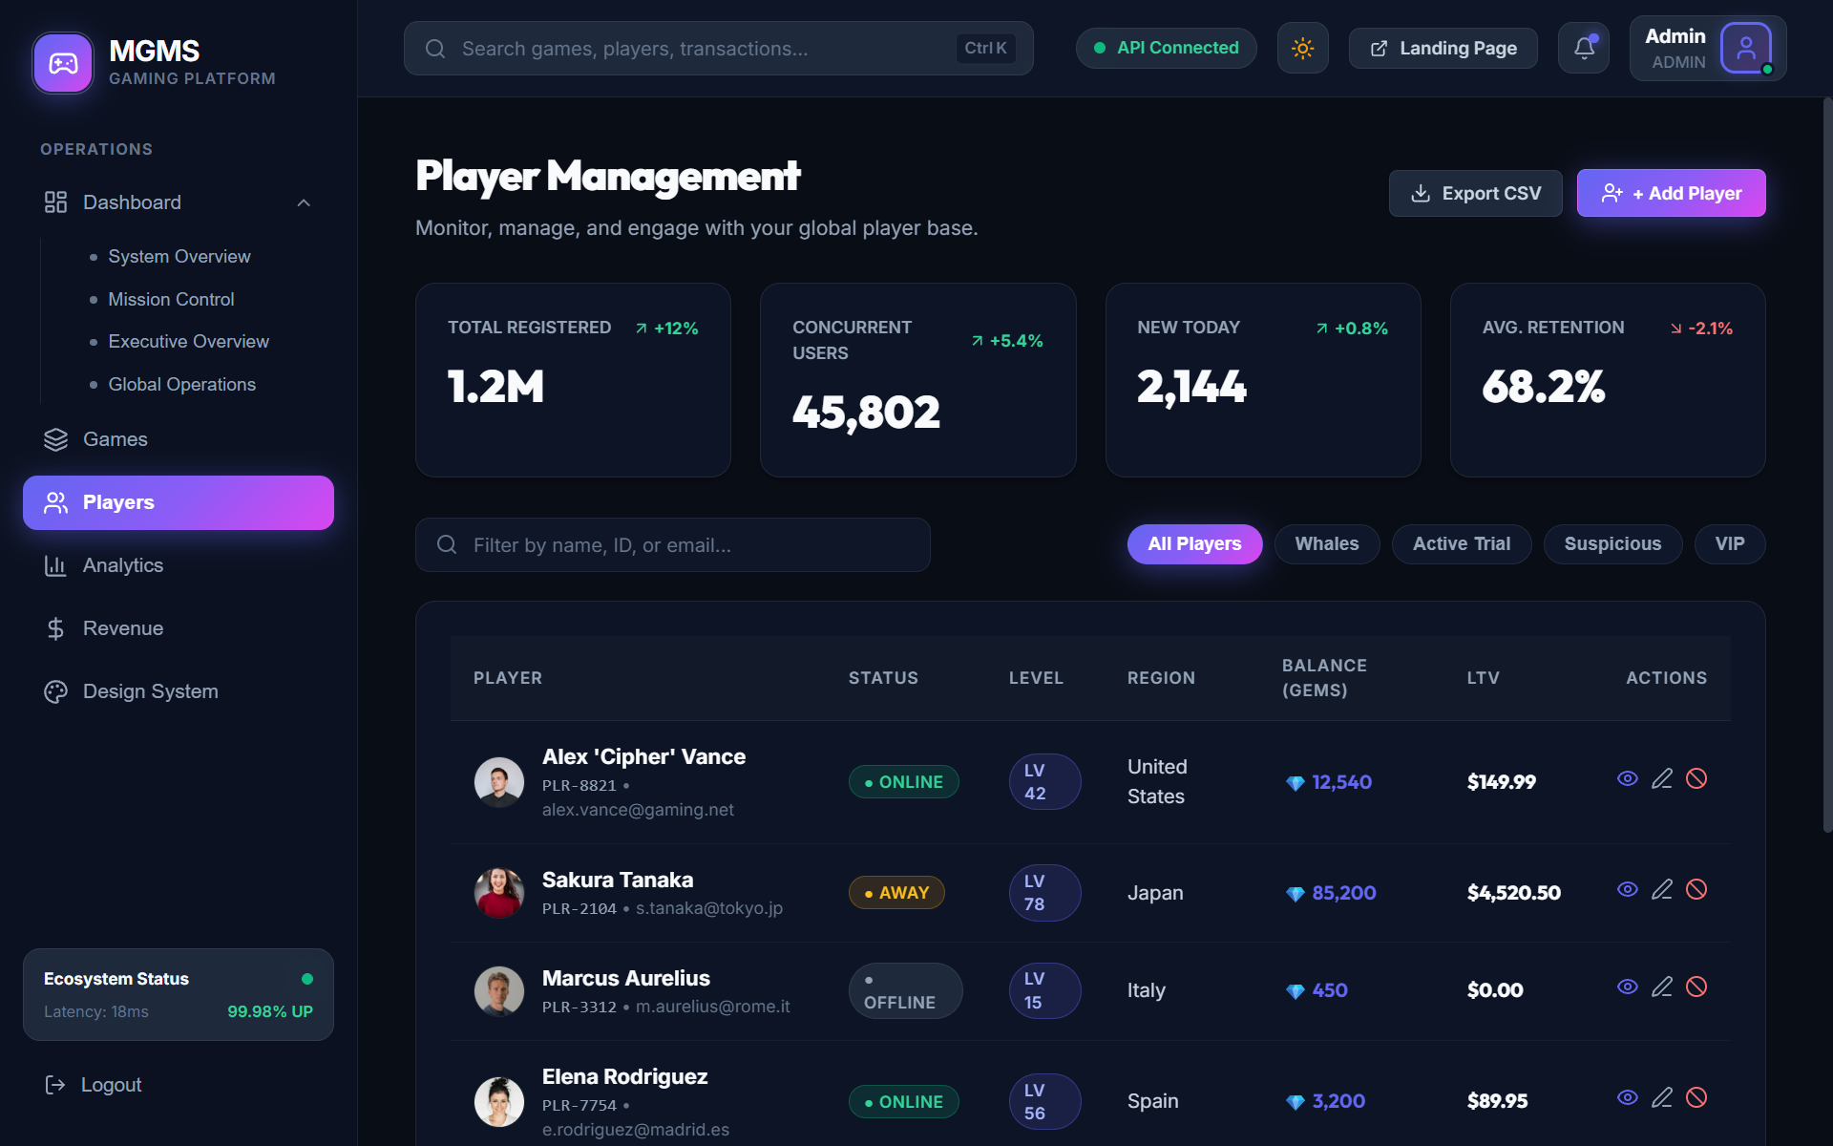
Fig. A.2.6. Games Portfolio & Content Management
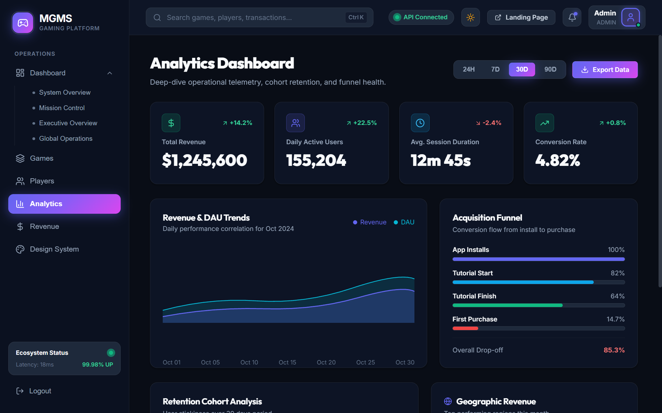
Fig. A.2.7. Player Management & Analytics Dashboard

REFERENCES
Web references:
[1] PostgreSQL Official Documentation: https://www.postgresql.org/docs/
[2] React Official Documentation: https://reactjs.org/docs/getting-started.html
[3] Spring Boot Official Documentation: https://spring.io/projects/spring-boot
[4] Swagger & OpenAPI Specification: https://swagger.io/tools/swagger-ui/
[5] Java Development Kit (JDK 26) Documentation: https://docs.oracle.com/en/java/
Book references:
[1] Craig Walls (2022), Spring in Action, Sixth Edition, Manning Publications.
[2] Alex Banks & Eve Porcello (2020), Learning React: Modern Patterns for Developing React Apps, O'Reilly Media.
[3] Christian Bauer & Gavin King (2015), Java Persistence with Hibernate, Manning Publications.
[4] Martin Fowler (2018), Refactoring: Improving the Design of Existing Code, Second Edition, Addison-Wesley.
[5] Erich Gamma, Richard Helm, Ralph Johnson, John Vlissides (1994), Design Patterns: Elements of Reusable Object-Oriented Software, Addison-Wesley.
[6] Mark Richards & Neal Ford (2020), Fundamentals of Software Architecture: An Engineering Approach, O'Reilly Media.
[7] Andrew S. Tanenbaum (2016), Distributed Systems: Principles and Paradigms, Pearson.
[8] Robert C. Martin (2017), Clean Architecture: A Craftsman's Guide to Software Structure and Design, Prentice Hall.

