SPRING-CORE AND MAVEN EXERCISES

WEEK 2
EXERCISE 1:
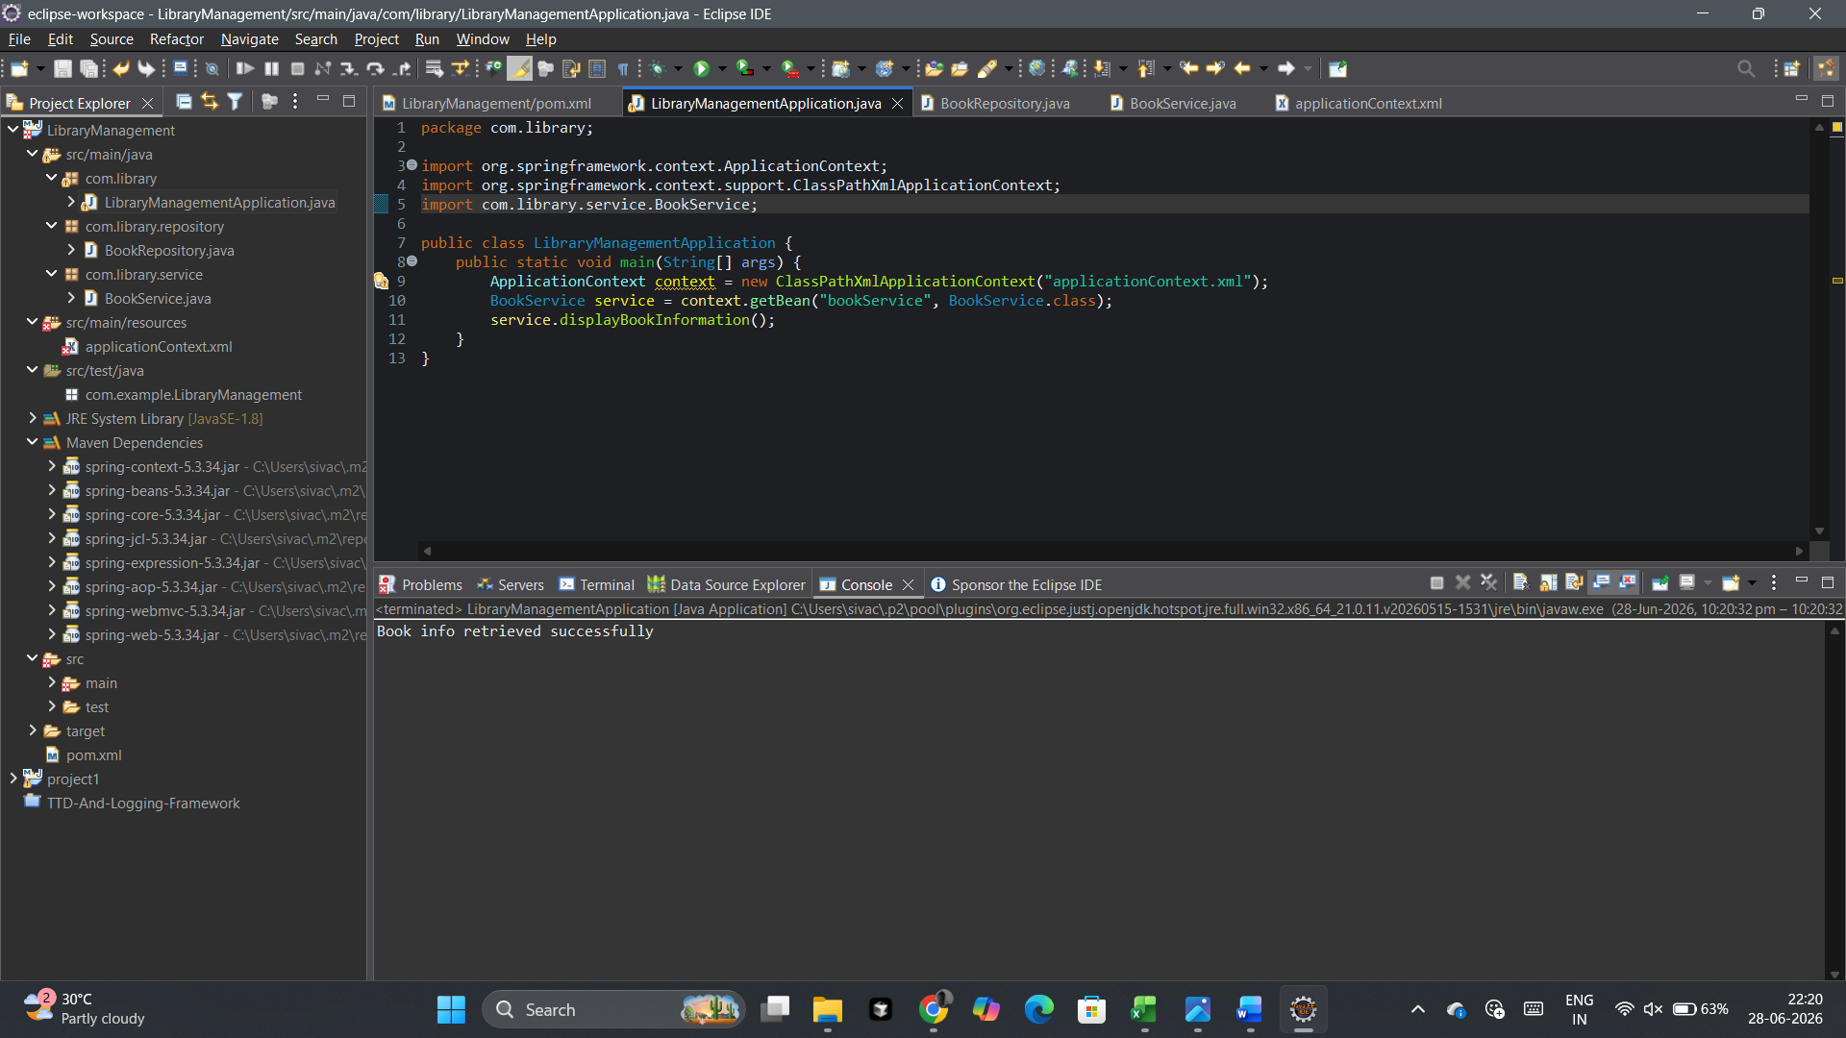

EXERCISE 2:


EXERCISE 4:
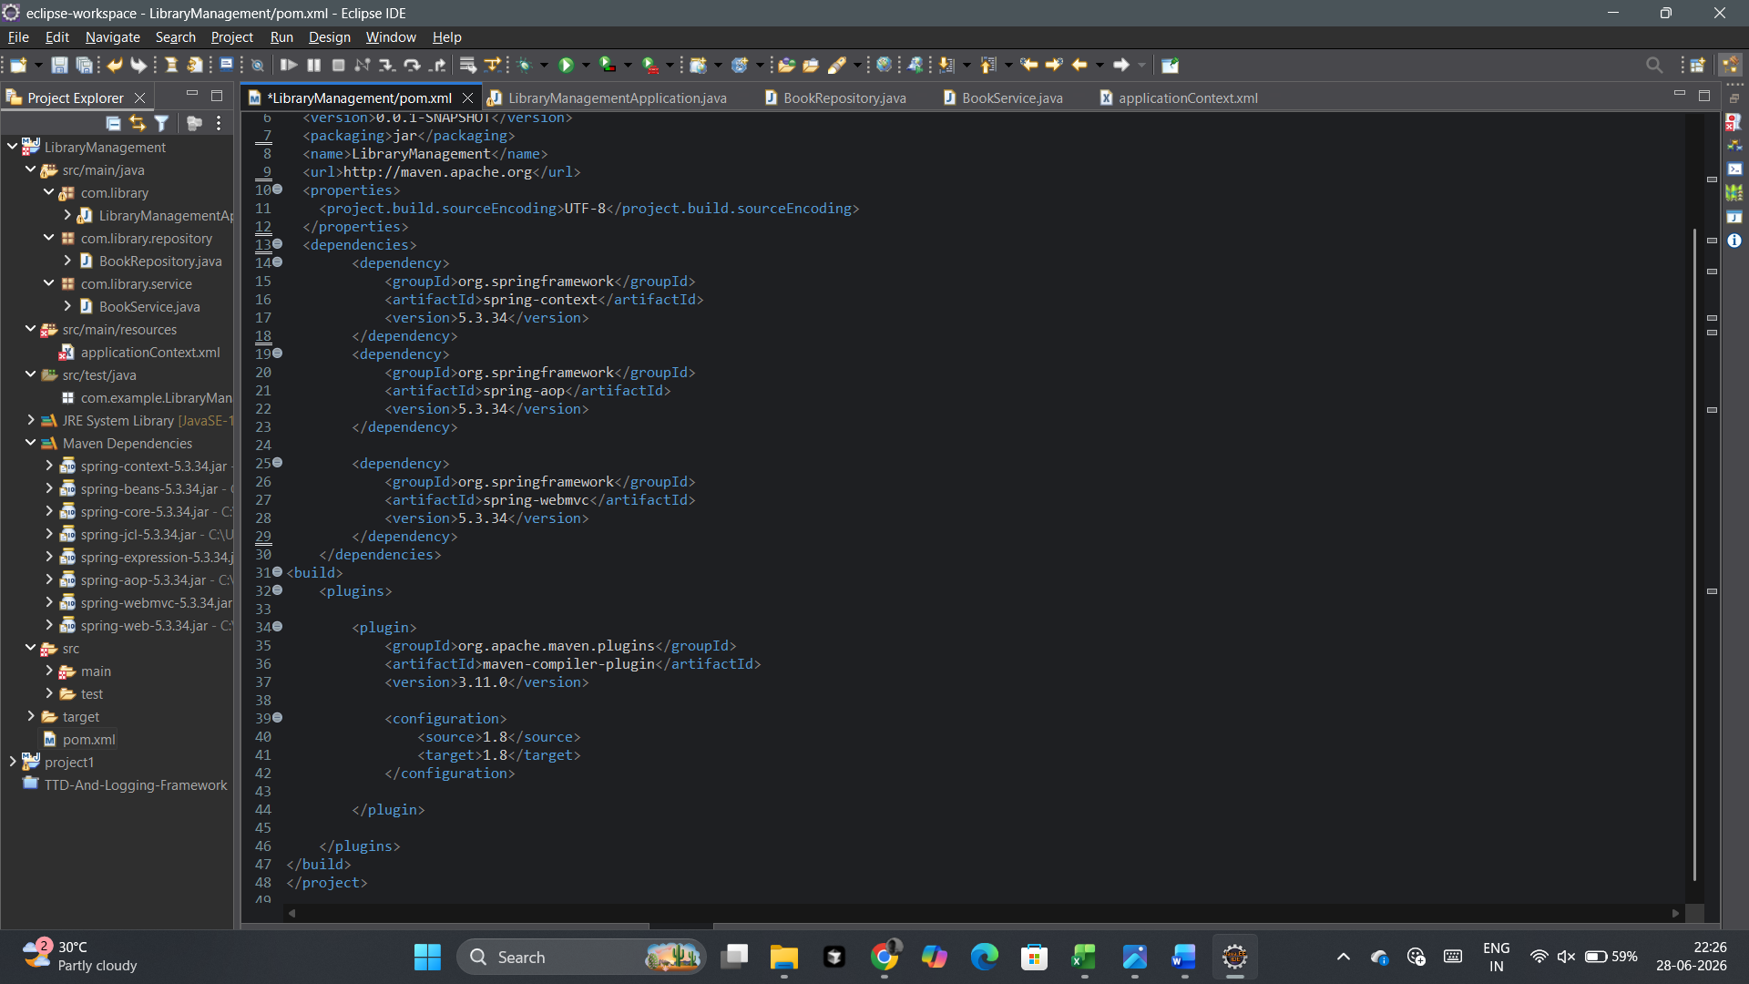

COMMON SCREENSHOTS:
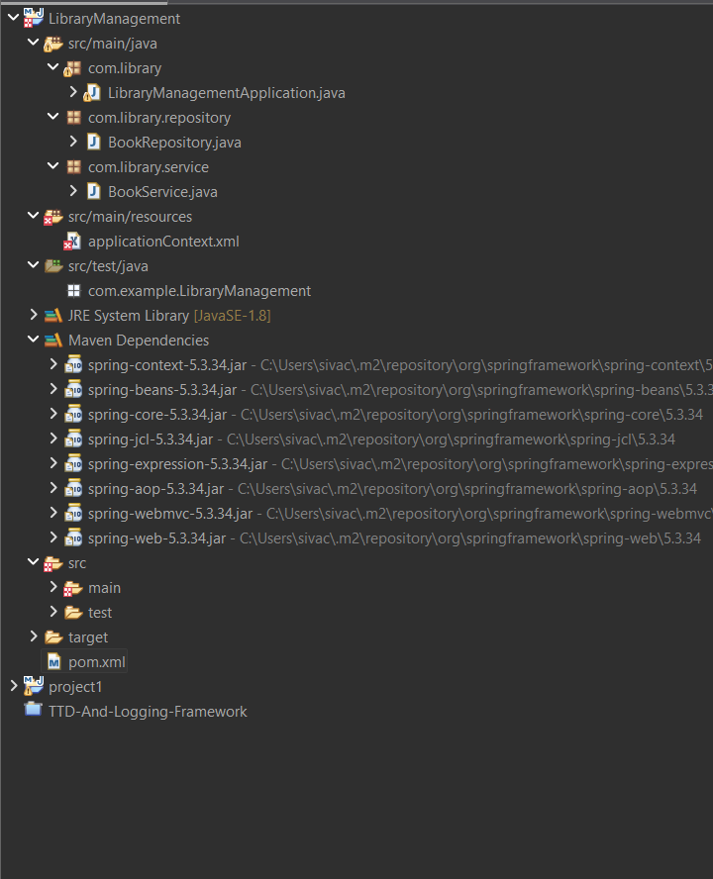

applicationContext.xml :
