User Activity Diagram - Misfits Streaming Platform
This activity diagram describes how a user moves through the streaming platform as a viewer, streamer, or community member.
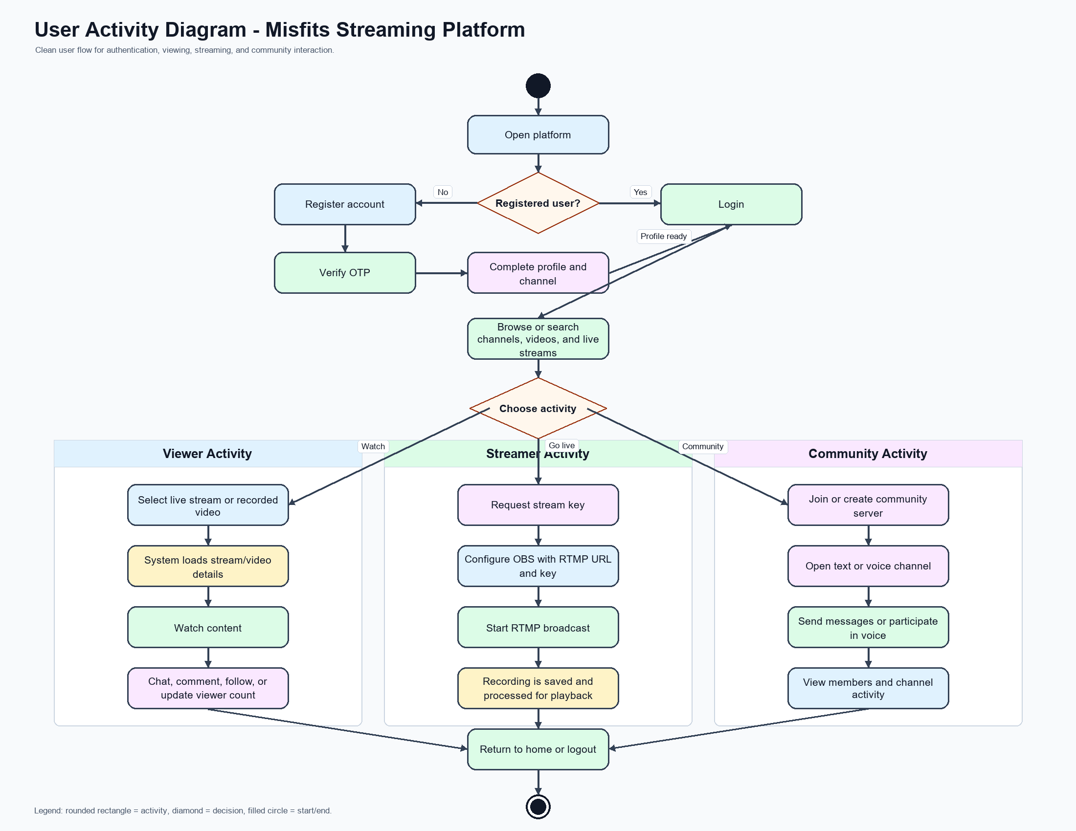
Activity Notes
Authentication path: the user registers, verifies OTP, completes the profile, or logs in directly.
Viewer path: the user browses content, opens a live or recorded video, then interacts through chat, comments, follow actions, and viewer count updates.
Streamer path: the user requests a stream key, configures OBS with the RTMP endpoint, starts the broadcast, and the system records and processes the stream.
Community path: the user joins or creates a community and participates in text or voice channels.

