Passport Visa Management System

“Application Integration Module

Functional Specification Document

Software Requirements Document
V 1.0


 | Prepared By | Reviewed by | Approved By
Name | Rajeshwar Chary
Role | Team member | Project Leader/ Team Leader/ Team Member | Project Manager/ Team Leader
Signature | VS
Date | 11/26/2014

Table of Contents
1 Introduction 3
1.1 About this document 3
1.1.1 Purpose & Scope of the document 3
1.1.2 Intended Audience 3
1.2 About the Software System 3
1.2.1 Scope of the system 3
1.2.2 Exclusions 4
1.2.3 System Perspective 4
1.2.4 System diagram 4
1.2.5 System Environment 5
1.2.6 User Characteristics 5
1.2.7 Impact of the System 5
1.2.8 Assumptions, Risks / Constraints 6
1.2.9 Design Constraints 6
2 System Requirements 7
2.1 Functional Requirements 7
2.1.1 Branch Admin Registration Module 8
2.1.2 Medicine Details Registration Module 10
2.1.3 Stock Details Registration Module 11
2.1.4 Request/Cancel for Medicine Module 13
2.1.5 Approve Requests Module 15
User Interface Requirements 16
2.2 Nonfunctional Requirements 16
2.2.1 UI Requirements: Inn 16
2.2.2 Performance Requirements: Pnn 17
2.2.3 Installation, Deployment & Operational Requirements: Onn 17
2.2.4 Maintainability & Portability Requirements: MPnn 17
2.2.5 Security Requirements Snn: 17
3 Requirements / Use Case Summary Table 18
4 Make /Buy analysis 18
4.1 Reusable components 18
5 Annexure 18
6 Change Log 19

Introduction

About this document

Purpose & Scope of the document
The purpose of the software requirements document is to systematically capture requirements for the project and the system “Passport Visa Management System” to be developed. Both functional and non-functional requirements of this system are captured in this document. It also serves as the input for the project scoping.
The scope of this document is limited to addressing the requirements from a user, quality, and non-functional perspective. It is recommended that design aspects are not added in this document

Intended Audience
Project Team

About the Software System
The following section will cover aspects related to
Passport Visa Management System (PVMS) application. PVMS is a system used for managing the supply activities of different medicines to various vendors. It checks the stock updates, sales details and also helps to order medicines.

The following are the modules in this proposed system
- User Registration (Registration type: passport /visa)
- Apply Passport
- Apply Visa
- Passport Renewal
- Visa Cancellation

Scope of the system
The scope of the system is explained through its modules as follows
- User Registration(Registration type: passport /visa):This use case will be used by the user to register the service based on different parameters. The system will calculate the User id, find the Citizen type and store the details in the database.
- Apply Passport: This use case will be used by the user to apply the passport based on different parameters. The system should generate the passport id and expiry date. Update the details into the database.
- Apply Visa :This use case will be used by the user to apply visa based on different parameters.
- Passport Re-Issue :This use case will be used by the user to request renewal of passport.
- Visa Cancellation: This use case will be used by the user to perform visa cancellation. Update all the details into the system.

Exclusions
- The system will operate only on the modules discussed above and will not include any additional functionality.
Use Case Diagram
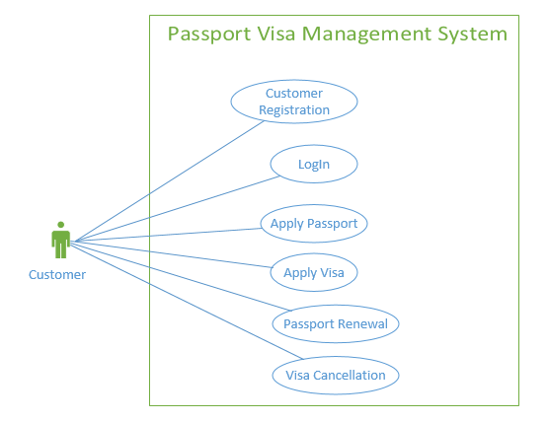

System Perspective
The PVMS is an independent software system developed to manage the activities like Registering New Medicines, Ordering New Medicines, etc. using the Java/Dotnet architecture.

System diagram

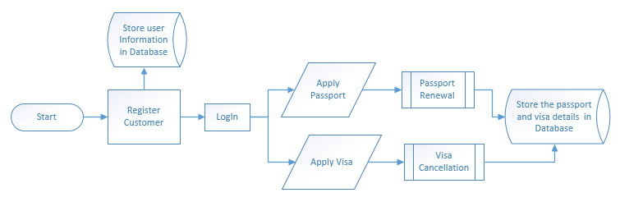

Architecture diagram

Physical Architecture:
A physical architecture is an arrangement of physical elements, (system elements and physical interfaces) that provides the designed solution for a product, service, or enterprise. It is intended to satisfy logical architecture elements and system requirements. Passport Visa Management Process follows a three layered architecture namely presentation layer, business logic layer and data access layer.
- Presentation Tier is the tier in which the users interact with an application. Presentation Tier contents Shared UI code, Code Behind and Designers used to represent information to user.
- Business Tier is mainly working as the bridge between Data Tier and Presentation Tier. All the Data passes through the Business Tier before passing to the presentation Tier. Business Tier is the sum of Business Logic Layer, Data Access Layer and Value Object and other components used to add business logic.
- Data Tier is basically the server which stores all the application’s data. Data tier contents Database Tables, XML Files and other means of storing Application Data.
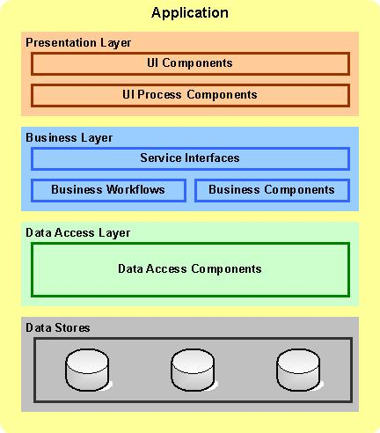

Logical Architecture:
The Logical Architecture defines the Processes (the activities and functions) that are required to provide the required User Services. Many different Processes must work together and share information to provide a User Service. The Processes can be implemented via software, hardware, or firmware. The Logical Architecture is independent of technologies and implementations.

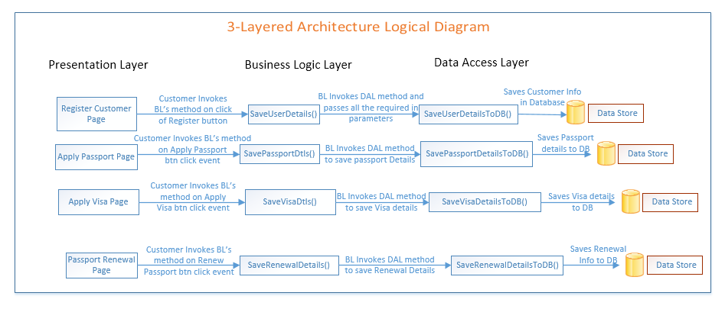

System Environment
The “PVMS” application will be operated from the client server with parallel processor support. When a user connects to the Web Server, the Web Server will interact with the Database after processing the business logic to transfer data to and from a database.
- Java/J2EE or .NET Framework application deployment.
- My SQL/SQL server database for data storage

User Characteristics
The application should be user friendly; in such a way that the user would not need any software and hardware knowledge. The user may be new to the client products having never used them before.
The types of users likely to use the system are as follows,
- Client
- Delivery Assurance Group, Process Engineering group
- Developers, testers, other associates in the project

Impact of the System
This is a new product which is developed for internal users. Expected impact of the product is to automate existing manual processes in order to make them more efficient and cost effective.

Assumptions, Risks / Constraints
Assumptions:
- The processing admin must possess prior knowledge on PVMS operations undertaken offline.
- The admin should have the details of the Medicines to be registered updated into the system.
Risks:
- If there is any failure in stock management processes, the system should be able to handle such a financial risk.

Design Constraints
- The Admin registration module and the Medicine registration modules should remain independent, without affecting Passport Visa Management System.
- Application should have single login feature. Login functionality should be the Welcome Page for the application.
- Only Main Administrator and registered Branch Administrator can access the application.
- None of the application features can be accessed without login.

System Requirements

Functional Requirements
Passport Visa Management Process  Req-2.1.1 | Home Page
Functional Requirements |  | When the User enter the following link http://localhost:8080/PassportManagementSystem in the browser, Home page appears which will have a short welcome message; a brief introduction to the purpose of the Passport Visa Management Process, the User can choose appropriate options.  Under home page, we need below interface.
Home page Interface Requirements |  | - Login/Signup  - About Us  - Contact Us

User Registration Module

User Registration Page
Passport Visa Management System  Req-2.1.1.1 | User Registration Page
Functional Requirements | This module will be used by the user to register the service based on different parameters. The system will calculate the User id, find the Citizen type and store the details in the database.
User Interface Requirements | - First name: Name of the user  - Sur name: Name of the father  - Date Of Birth: User DOB in DD/MM/YYYY format  - Address: Address of the User  - Contact no: Contact number of the Applicant  - Email Address: Email Address of the User  - Qualification: Educational qualification of the user  - Gender: Gender of the user  - Apply Type: Apply type (Passport r Visa)  - Hint Question: Hint question for recovery of password  - Hint Answer: Answer for the question  After successfully validation of the details, System should generate the User id, password and citizen type.  Update all the details in the database.
Trigger | User triggers the functionality once he/she submits the details into the system.
Pre-Conditions | The system should collect all the required details for User Registration.
Post Conditions | System should generate the user id and decide citizen type based on date of birth.
Success End Condition | On successfully saving the details the message should be displayed in this format:  Dear User,  Your User Id is <userId> and your password is <password>.  You are planning for <apply Type> and your citizen type is <citizen type>.
Failed End Condition | The system should throw an error message if any one or more of the validations fail. The error messages and error codes need to be identified during design. The validation and business rules are mentioned in the business rules section.
Steps & Actions | - System should get the all the required information from the user.  - Identify the citizen type based on the age. Age can be calculated with the help of Date of Birth.  - Identify the citizen type as follows  - Generate the User id from apply type as follows.  If (apply type is passport) then  User id is PASS-XXXX  If (apply type is visa) then  User id is VISA-XXXX.XXXX  Fetch the last generated user id to identify the new number. But the last generated user id has to be retrieved separately from the database for VISA and PASSPORT.  (Example: if the last value for Passport is PASS-1234 in USER_REGISTRATION table, then 1234 will be taken and 1 will be added. So the next record for Passport will be PASS-1235.)  - Generate the password as follows.  Password = (current date (dd) )+(current month (mmm) ) + (# or @ or $) +unique random 3 digit number  Example: 02apr@234, 03may$452  Note: Special character should be any of this (# or @ or $) that can be decided randomly.  Make sure the last random 3 digits number should not be duplicated.
  Age | Citizen type
  0-1 | infant
  1-10 | Children
  10-20 | Teen
  20-50 | Adult
  50-till date | Senior Citizen
Business Rules & Validation | - All the information’s are mandatory.  - User Name should be alphabets.  - Email id should have special character @ and dot (.)  - Contact should contain number.  - Gender needs to be selected.  - Date of birth cannot be after the current date.  - Email id should not exist in the system.

Authenticate User Page

Passport Visa Management System  Req-2.1.4.2 |  | Authenticate User Page
Functional Requirements |  | This module will be used by customers to login into the system.
User Interface Requirements |  | - Customer ID: The Customer name should be filled by the user  - Contact Number: Displays the Contact Number of the customer  - Password: The Customer Password should be filled by the user
Trigger | Customer triggers the functionality to login to the system.
Pre-Conditions / Assumptions | The customer details must already exist in the system.
Post Condition | The customer can login into the system.
Success End Condition | The customer can book the hotels or cancel/edit the reservation and can make the payment.
Failed End Condition | The system should throw an error message if the validation is wrong. The error message and error code needs to be identified during design. The validation and business rules are mentioned in the business rules section.
Steps & Actions | System should authenticate the user details.
Business Rules & Validations | - Customer Id and Old password must match with the database. If not, throw an error message.  - New password must not be the same as the old password.  - New password and confirm password must be the same.  - Password must be alphanumeric and must contain at least one symbol and it should not contain the customer name. Password should not allow any blank spaces.

Apply Passport Module

Apply Passport Page
Passport Visa Management System  Req-2.1.2.1 | Apply Passport Page
Functional Requirements | This module will be used by the user to apply the passport based on different parameters. The system should generate the passport id and expiry date. Update the details into the database.
User Interface Requirements | - User ID: Login Id entered by the user  - Country: Represents which country the user belongs to.  - State: Represents the State of the user.  - City: Represents the city user belongs.  - Pin: Security Pin Number  - Type of Service: Service type of the application  - Booklet type: Booklet type of the passport  - Issue Date: Date of issue passport  After successful validation of the details, the system generates the Temporary ID, the expiry Date of the passport and the amount to be paid.
Trigger | User triggers the functionality once he/she submits the details into the system
Pre-Conditions / Assumptions | - Up on valid login all the details to apply the passport should be given.
Post Conditions | - System should generate the temporary id and passport expiry date based on date of issue.  - The user passport data should be stored into the system.
Success End Condition | On successfully saving the details, message will be displayed as  Need the passport number while giving payment? Please note down your Id  “<Passport Id >”. Passport application cost is Rs. <Amount>
Failed End Condition | The system should throw an error message if one of the validations is wrong. The error message and error code needs to be identified during design. The validation and business rules are mentioned in the business rules section.
Steps & Actions | - System should collect all the necessary information.  - Get the username, password for the login. After successful login authentication collect the required details for apply passport.  - Generate the passport id.  Step - 1: Decide the passport Id format with the help of following details  Step - 2: Get the maximum passport number from the database table.  Step - 3: Next XXXX = XXXX + 1  - Generate the passport expiry date.  Expiry Date = issue Date + 10 Years.  - Get the passport application cost as follows  - Identify the state and city information as follows.( Needs to be maintained in DB)
  TYPE_OF_BOOKLET | ID Generation Format
  30 Pages | FPS-30XXXX
  60 Pages | FPS-60XXXX
  TYPE_OF_SERVICE | AMOUNT | PASSPORT_TYPE
  Normal | 2500 | NEW
  Tatkal | 5000 | NEW
  STATE_ID | STATE_NAME
  S_O001 | Orissa
  S_W002 | West Bengal
  S_B003 | Bihar
  S_K004 | Kerala
  S_A005 | Andhra Pradesh
  STATE_ID | CITY_NAME
  S_O001 | Bhubaneswar
  S_O001 | Cuttack
  S_O001 | Jajpur
  S_W002 | Kolkata
  S_W002 | Howrah
  S_B003 | Patna
  S_B003 | Gaya
  S_K004 | Kochi
  S_K004 | Kayamkulam
  S_A005 | Hyderabad
  S_A005 | Bellampalle
Business Rules & Validations | - User Id entered should be in valid id (PASS-XXXX) format. XXXX should be a 4 digit number. Otherwise system should display appropriate error message.  - Pin has to be numeric and must be of six digits otherwise system should display appropriate error message.  - Booklet type has to be chosen should be either (“30 Pages” or ”60 Pages”).  - Issue date entered should be of valid date format (dd/mm/yy) and must not be less than current date otherwise system should display appropriate error message.  - User Id can’t be left blank.  - Country can’t be left blank.  - State can’t be left blank.  - City can’t be left blank.  - Pin can’t be left blank.  - Booklet Type can’t be left blank.  - Issue date can’t be left blank.

Apply Visa Module

Apply Visa Page
Passport Visa Management System  Req-2.1.3.1 | Apply Visa Page
Functional Requirements | This module will be used by the user to apply visa based on different parameters.
User Interface Requirements | User ID - User id used while Login.  Country - To place which your applying for Visa.  Occupation- Occupation of the User.  Date of Application - Represent the date of applying for visa
Trigger | User triggers the functionality once he/she submits the details into the system
Pre-Conditions / Assumptions | The system needs to collect the required information for applying Visa.
Post Conditions | The system needs to generate the date of expiry and Visa number.
Success End Condition | On successfully saving the details the information should be displayed in the below format:  Dear User your Visa request has been accepted successfully with id <VISA_ID>, User Id <userId> Destination <destination> Employee Occupation <occupation> Date of Application <date Of Application>  Date of Issue <date Of Issue>  Date of Expiry <date Of Expiry>  Registration Cost <registration Cost>
Failed End Condition | The system should throw an error message if any one or more of the validations fail. The error messages and error codes need to be identified during design. The validation and business rules are mentioned in the business rules section.
Steps & Actions | - System should collect all the necessary information for applying visa.  - Get the Country where he/she needs the visa.  Decide visa Registration cost is based on place and applicant’s occupation  - Date of Issue for the visa is calculated as 10 days after date of application.  - Date of expiry for the visa (in years) is based on the applicant’s occupation.  - Check the date of expiry of the passport is after the date of expiry of the Visa. If not give expiry date of visa as expiry date of passport.  - Visa number is generated based on applicant’s occupation as follows  Note: The (XXXX) value is separate for each category.
  APPLICANT’SOCCUPATION | PLACE | COST
  Student | USA | 3000
  Private Employee | USA | 4500
  Government Employee | USA | 5000
  Self Employeed | USA | 6000
  Retired Eemployee | USA | 2000
  Student | CHINA | 1500
  Private Employee | CHINA | 2000
  Government Employee | CHINA | 3000
  Self Employeed | CHINA | 4000
  Retired Eemployee | CHINA | 2000
  Student | JAPAN | 3500
  Private Employee | JAPAN | 4000
  Government Employee | JAPAN | 4500
  Self Employeed | JAPAN | 9000
  Retired Employee | JAPAN | 1000
  APPLICANT’S_OCCUPATION | VISA PERMIT(IN YEARS) | VISA ID Generation Format
  Student | 2 | STU-XXXX
  Private Employee | 3 | PE-XXXX
  Government Employee | 4 | GE-XXXX
  Self Employed | 1 | SE-XXXX
  Retire Employee | 1.5 | RE-XXXX
Business Rules & Validations | - All fields are mandatory.  - Passport Number should exist in the system.  - Date of Application cannot be before the current date.  - Check the date of expiry of the passport is after the date of expiry of the Visa. If not give expiry date of visa as expiry date of passport.

Re-issue Passport Module

Passport Re Issue Page
Passport Visa Management System  Req-2.1.4.1 |  | Passport Re-Issue Page
Functional Requirements | This module will be used by the user to request renewal of passport.
User Interface Requirements | - Reason for re issue: Reason for applying the passport again  - User ID: Login Id entered by the user  - Country: Represents which country the user belongs to.  - State: Represents the State of the user.  - City: Represents the city user belongs.  - Type of Service: Service type of the application  - Booklet type: Booklet type of the passport  - Issue Date: Date of issue passport  After successful validation of the details, the system generates the Temporary ID, the expiry Date of the passport and the amount to be paid. Update the new details in the database for the existing user.
Trigger | User triggers the functionality once he/she submits the details into the system.
Pre-Conditions / Assumptions | - In the User Login screen all fields should be displayed properly.
Post Condition | - System should check reason for the re issue, collect all the required information.
Success End Condition | - On Successful saving the details the message display is  Passport re issue is successfully done.  Amount to be paid is Rs. <amount>  Passport issue date is <issue date> and expiry date is <expiry date>
Failed End Conditions | The system should throw an error message if any one or more of the validations fail. The error messages and error codes need to be identified during design. The validation and business rules are mentioned in the business rules section.
Steps & Actions |  |  | - System should collect all the necessary information.  - Get the username, password for the login. After successful login authentication collect the required details for apply passport.  - Update the passport information like new passport number, Type of booklet selected,  expiry date of the passport for that user.  - The old passport details also to be maintained in the database.  - Generate the passport id.  Step - 1: Decide the passport Id format with the help of following details  Step - 2: Get the maximum passport number from the database table.  Step - 3: Next XXXX = XXXX + 1  - Generate the passport expiry date.  expiry Date = issue Date + 10 Years.  - Get the passport application cost as follows  - Identify the state and city information as follows.( Needs to be maintained in DB)
  TYPE_OF_BOOKLET | ID Generation Format
  30 Pages | FPS-30XXXX
  60 Pages | FPS-60XXXX
  TYPE_OF_SERVICE | AMOUNT | PASSPORT_TYPE
  Normal | 1500 | RENEWAL
  Tatkal | 3000 | RENEWAL
  STATE_ID | STATE_NAME
  S_O001 | Orissa
  S_W002 | West Bengal
  S_B003 | Bihar
  S_K004 | Kerala
  S_A005 | Andhra Pradesh
  STATE_ID | CITY_NAME
  S_O001 | Bhubaneswar
  S_O001 | Cuttack
  S_O001 | Jajpur
  S_W002 | Kolkata
  S_W002 | Howrah
  S_B003 | Patna
  S_B003 | Gaya
  S_K004 | Kochi
  S_K004 | Kayamkulam
  S_A005 | Hyderabad
  S_A005 | Bellampalle
Business Rules & Validations |  |  | - User Id entered should be in valid id (PASS-XXXX) format. XXXX should be a 4 digit number. Otherwise system should display appropriate error message.  - Pin has to be numeric and must be of six digits otherwise system should display appropriate error message.  - Booklet type has to be chosen should be either (“30 Pages” or”60 Pages”).  - Issue date entered should be of valid date format (dd/mm/yy) and must not be less than current date otherwise system should display appropriate error message.  - User Id can’t be left blank.  - Country can’t be left blank.  - State can’t be left blank.  - City can’t be left blank.  - Pin can’t be left blank.  - Booklet Type can’t be left blank.  - Issue date can’t be left blank.

Visa Cancellation Module

2.1.5.1 Visa Cancellation Page
Passport Visa Management System  Req-2.1.5.1 | Visa Cancellation Page
Functional Requirements | This module will be used by the user to perform visa cancellation. Update all the details into the system.
User Interface Requirements | - User ID: User ID of the user who is currently logged in.  - Passport Number: Passport number of the user  - Visa Number: Visa number to cancel  - Date of Issue: Date of issue of visa  After getting the valid details, System needs to calculate the amount to be paid. Update the status as cancelled.
Trigger | None
Pre-Conditions / Assumptions | It is assumed that at the time of commencement of this module the user is logged in. So that the user ID is available module-wide.
Post Conditions | The system will calculate the cancellation charges and update the same in database.
Success End Condition | After the VISA Cancellation request is submitted into the system, a message should be displayed saying  “Your request has been submitted successfully.  Please pay $$$ to complete the cancellation process”  Where $$$ is the cancellation charge.
Failed End Condition | The system should throw an error message if one of the validations is wrong. The error message and error code needs to be identified during design. The validation and business rules are mentioned in the business rules section.
Steps & Actions | 1. System should collect all the required details from the user.  2. After login get the security question and answer from the user.  3.Once the user had been authenticated, the system will ask for the Passport Number, VISA Number and VISA Issue Date.  4.The system should calculate the cancellation charges as follows..  5.Get the difference between the date of expiry of VISA  and the date of VISA-cancellation request should be  calculated in months (say Diff_mon).  - Update the status of the visa as cancelled in the database.
  Student | Diff_mon < 6 months | 15% of the registration cost
  Student | Diff_mon >= 6 months | 25% of the registration cost
  Private Employee | Diff_mon < 6 months | 15% of the registration cost
  Private Employee | 6 <=Diff_mon < 12 months | 25% of the registration cost
  Private Employee | Diff_mon >= 12 months. | 20 % of the registration cost
  Govt. Employee | Diff_mon < 6 months | 12% of the registration cost
  Govt. Employee | 6 <= Diff_mon < 12 months | 20% of the registration cost
  Govt. Employee | Diff_mon >= 12 months. | 25 % of the registration cost
  Self Employed | Diff_mon < 6 months | 15% of the registration cost
  Self Employed | Diff_mon >= 6 months | 25% of the registration cost
  Retired Employee | Diff_mon< 6 months | 10% of the registration cost
  Retired Employee | Diff_mon>= 6 months | 20% of the registration cost
Business Rules & Validations | - The selected security question should be same as the Hint question.  - The security question and given answer should be a valid pair.  - The visa number field in the Visa Cancellation Screen should not be left blank.  - The passport number field in the Visa Cancelation Screen should not be left blank.  - Neither of the visa number nor the passport number should accept any value which is not numeric or alphabet  - The given passport number should correspond to the User ID.  - The visa for which the cancellation is requested should not have expired already.

Nonfunctional Requirements

UI Requirements:
- The front end should be user-friendly and pleasant
- Any error message or exception displayed to the user should be user-readable (and not technical)
- All entered values should be validated
- The UI screens are designed with any theme color along with the logo of the company.
- Exceptions should not be shown on console.
- No debug message should come on console.
- All the errors and exceptions should be logged to log file.
- Log file path should be configurable.
- Database connections should be configurable.
- It should not be hard coded.
- Requirements involving UI features should be taken care in console accordingly

Performance Requirements:
- All front-end pages should be served up in less than 5 seconds post click when up to 1000 users are on the application concurrently.
- Since it’s a financial operations application, transactions should be safe and fast.

Installation, Deployment & Operational Requirements:
- Application Java and J2EE deployment with My SQL database or SQL Server database for persistence
Or
Application .NET Framework deployment with SQL Server database for persistence
- This system must be up 24X7

Maintainability & Portability Requirements:
- If the allocated memory space for the existing application needs to be increased then it should be possible without any impact to performance

Security Requirements :
- No unauthorized users should be able to log on to the system
- User Id/Login Id should have combination of letter and numeric values, none of the special characters are allowed (#,@,$,%,&).
- Validate the user id/login id and password, accordingly to the user it will redirect to the appropriate page.

Requirements / Use Case Summary Table

Business Requirement ID | Software Requirements ID | Short Description | Requirement Provider (Originator) | Priority | Complexity | Requirement type | Remarks
BR001 | SR001 | User Registration | Client | High | Medium | UI screen & backend processing | -
BR002 | SR002 | Apply Passport | Client | Medium | Medium | UI screen & backend processing | -
BR003 | SR003 | Apply Visa | Client | High | Medium | UI screen & backend processing | -
BR004 | SR004 | Re-Issue Passport | Client | Medium | Medium | UI screen & backend processing | -
BR005 | SR005 | Visa Cancellation | Client | High | High | UI screen & backend processing | -

Make /Buy analysis

Reusable components
The PVMS can be used for Passport Visa process.

Annexure
NA

Change Log
Please note that this table needs to be maintained even if a Configuration Management tool is used.
Version Number | Changes made
V1.0 | First version developed by Rajeshwar Chary V on Dec 22 2014.
V1.1 | <If the change details are not explicitly documented in the table below, reference should be provided here>
V1.1 | Page no | Changed by | Effective date | Changes effected
V1.2 | <If the change details are not explicitly documented in the table below, reference should be provided here>
V1.2 | Page no | Changed by | Effective date | Changes effected

