📘 Project Overview
This project simulates real-world business scenarios faced by a food delivery company, focusing on analyzing customer behavior, restaurant performance, delivery efficiency, and overall business growth through SQL-based data analytics.
The goal of this case study is to demonstrate advanced SQL proficiency in:
- Structuring relational databases
- Cleaning and preparing datasets
- Solving complex business problems through analytical SQL queries
- Deriving insights for data-driven decision-making
Note: All data is synthetic and generated purely for educational and learning purposes.

🧩 Project Structure
- Database Setup: Designed a relational schema and created tables for customers, restaurants, orders, deliveries, and riders.
- Data Import: Populated tables using CSV data files representing different aspects of a food delivery system.
- Data Cleaning & Validation (EDA): Checked for missing and null values, ensured referential integrity, verified correct data types, updated incomplete fields.
- Exploratory Data Analysis (EDA): Conducted descriptive exploration to understand order volume, customer demographics, delivery success rate, and restaurant performance.
- Business Analysis: Addressed 20 real-world business questions using advanced SQL techniques like window functions, ranking, aggregation, and conditional logic.

🛠️ Tech Stack
Tool | Purpose
PostgreSQL | Database management and SQL analytics
pgAdmin 4 | Query execution and visualization
Excel | Initial data preparation and cleaning
GitHub | Version control and project documentation

🗃️ Database Schema
The project consists of five main tables:
Table Name | Description
customers | Stores customer details such as ID, name, and registration date
restaurants | Contains restaurant name, city, rating, and location data
Orders | Tracks order details including items, timestamps, and total amounts
Deliveries | Records delivery status, delivery time, and associated rider
Riders | Stores information about delivery personnel

🧭 Entity Relationship (ER) Diagram
The following ER diagram illustrates the relationships between key entities in the food delivery database, including customers, restaurants, orders, deliveries, and riders.
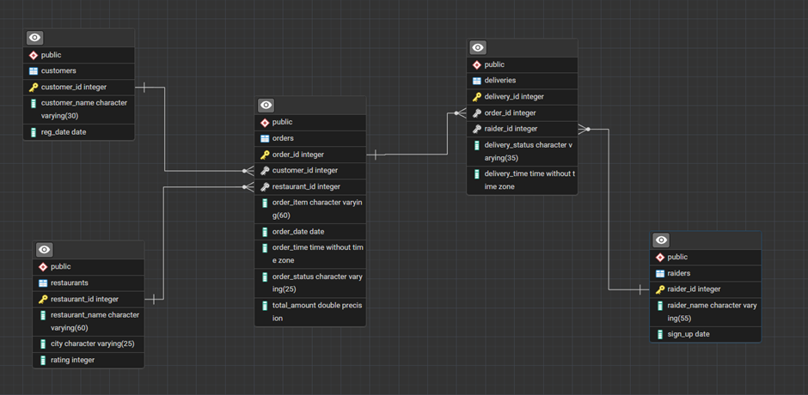

🔍 Exploratory Data Analysis (EDA)
- Data Verification: Imported datasets and validated record counts and data types.
- Handling Missing Values: Identified and corrected null entries and ensured referential integrity.
- Data Quality Checks: Checked delivery status validity, numeric field accuracy, and timestamp consistency.
- Initial Observations: Found top-performing cities, daily order trends, and delivery performance metrics.

📊 Business Questions and Analytical Objectives
This project addresses 20 real-world business questions across operations, customer behavior, and growth:

- Top 5 Most Ordered Dishes by a Customer

WRITE A QUERY TO FIND THE TOP 5 MOST FREQUENTLY ORDERED DISHES BY CUSTOMER CALLED "Arjun Mehta" IN LAST 1 YEAR.

SQL QUERY:
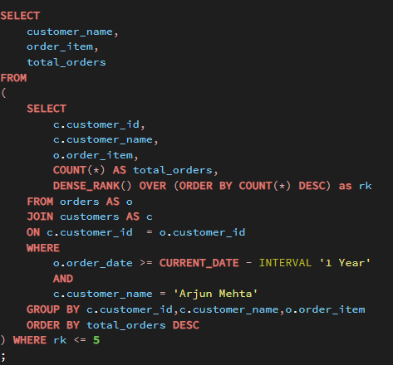

OUTPUT:
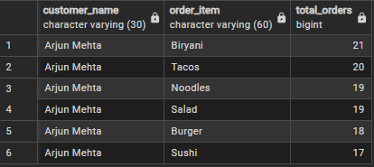
- Peak Time Slots
IDENTIFY THE TIME SLOTS DURING WHICH THE MOST ORDERS ARE PLACED. BASED ON 2 HOUR INTERVAL.
SQL QUERY:
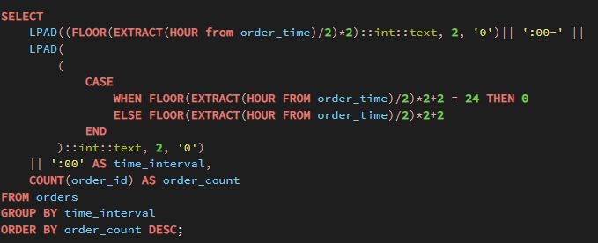
OUTPUT:
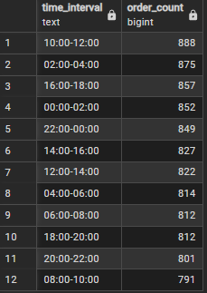

- High-Frequency Customer AOV
FIND THE AVERAGE ORDER VALUE PER CUSTOMER WHO HAS PLACED MORE THAN 330 ORDERS.RETURN CUSTOMER NAME AND AVERAGE ORDER VALUE
SQL QUERY:
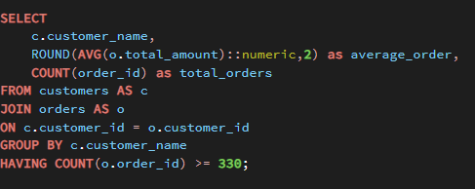
OUTPUT:
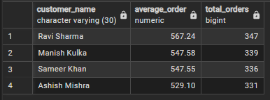

- High-Value Customers
LIST THE CUSTOMERS WHO HAVE SPENT MORE THAN 175K IN TOTAL ON FOOD ORDERS.RETURN CUSTOMER NAME AND CUSTOMER ID

SQL QUERY:
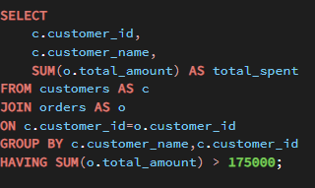

OUTPUT:
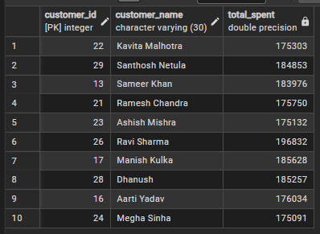

- Failed Deliveries
WRITE A SQL QUERY TO FIND ALL THE DELIVERIES THAT FAILED FOR EACH FAILED DELIVERY RETURN ORDER ID,CUSTOMER ID,RESTAURANT ID,RESTAURANT NAME RAIDER ID, DELIVERY ID, DELIVERY STATUS.

SQL QUERY:
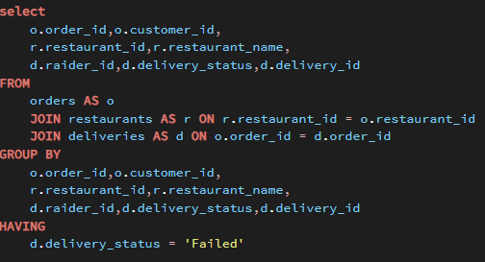

OUTPUT:
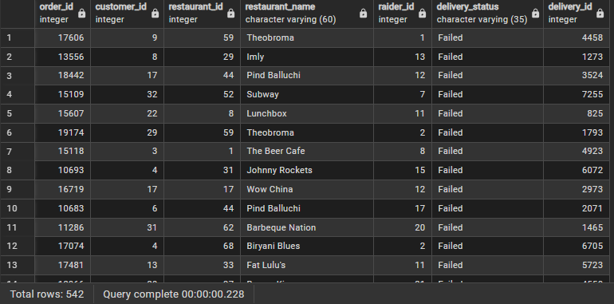

- Restaurant Revenue Ranking
RANK RESTAURANTS BY THEIR TOTAL REVENUE FROM THE LAST YEAR, INLCUDING THEIR NAME, TOTAL REVENUE, RANKING

SQL QUERY:
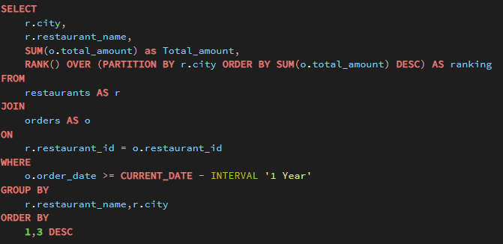
OUTPUT:
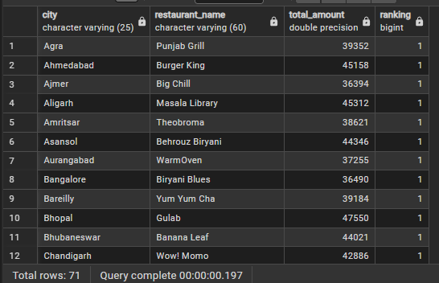

- Most Popular Dish by City
IDENTIFY THE MOST POPULAR DISH IN EACH CITY BASED ON NUMBER OF ORDERS

SQL QUERY:
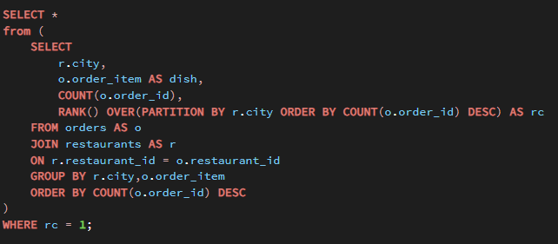
OUTPUT:
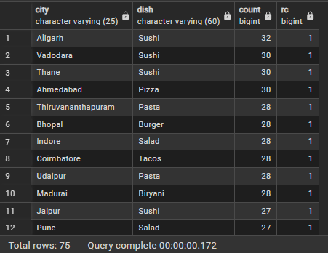

- Customer Churn
FIND THE CUSTOMERS WHO HAVEN'T placed an order in 2025 but did in 2024

SQL QUERY:
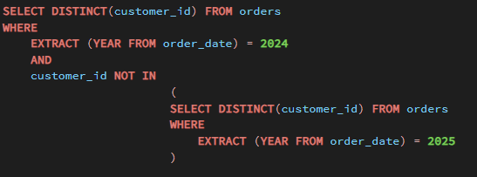

- Cancellation Rate Comparison
CALUCULATE AND COMPARE ORDER CANCELLATION RATE FOR EACH RESTAURANT BETWEEN THE CURRENT YEAR AND LAST YEAR
SQL QUERY:
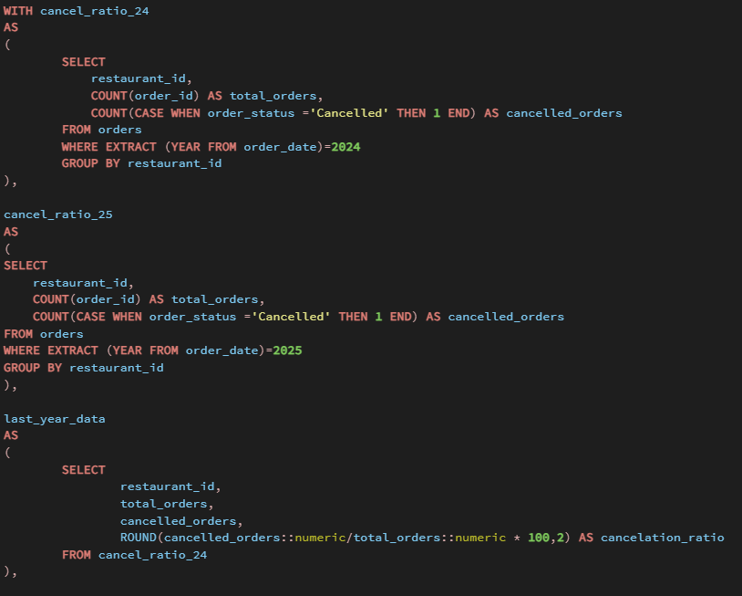
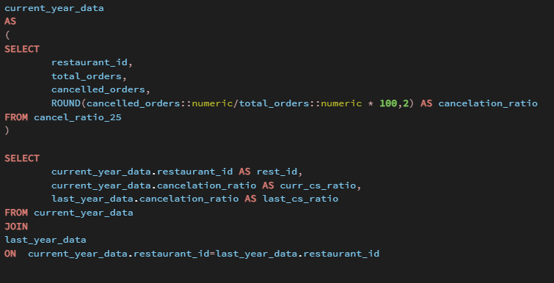
OUTPUT:
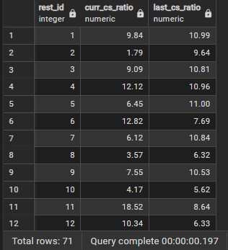

- Rider Delivery Time
CALUCULATE EACH RIDERS'S AVERAGE DELIVERY TIME

SQL QUERY:
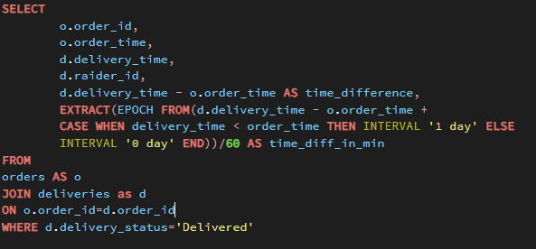
OUTPUT:
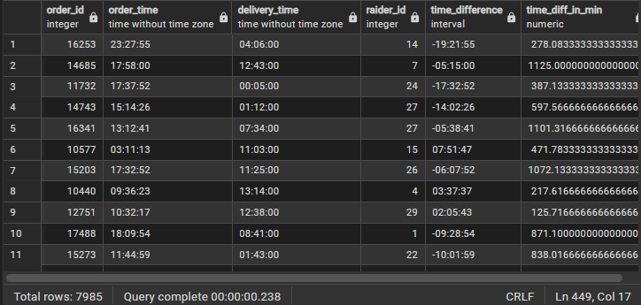

- Restaurant Growth Ratio
CALUCULATE EACH RESTAURANT GROWTH RATIO BASED ON THE TOTAL NUMBER OF DELIVERED ORDERS

SQL QUERY:
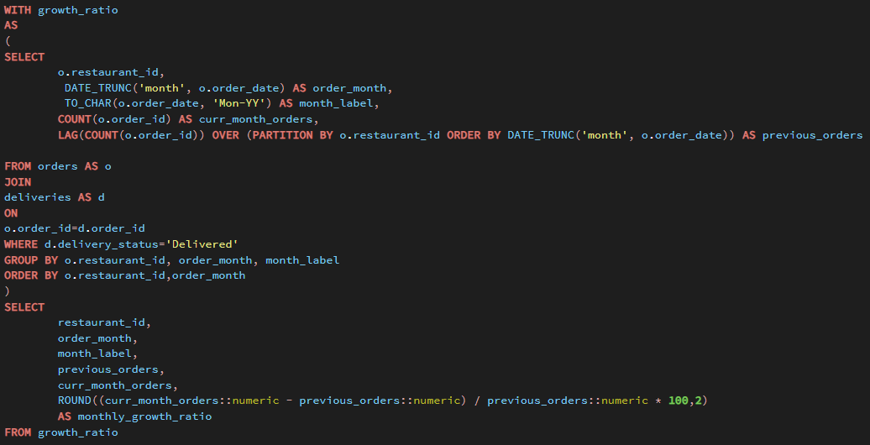
OUTPUT:
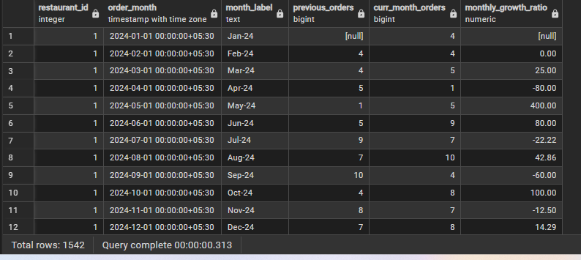
- Customer Segmentation
SEGMENT CUSTOMER INTO 'GOLD' OR 'SILVER' GROUPS BASED ON THEIR TOTAL SPENDIN. COMPARED TO THE AVERAGE ORDER VALUE,IF THE CUSTOMER AOV INCREASES AOV,LABEL THEM AS 'GOLD' OTHER WISE LABEL THEM AS 'SILVER' .WRITE AN SQL QUERY TO DETERMINE EACH SEGMENTS TOTAL NUMBER OF ORDERS AND TOTAL REVENUE

SQL QUERY:
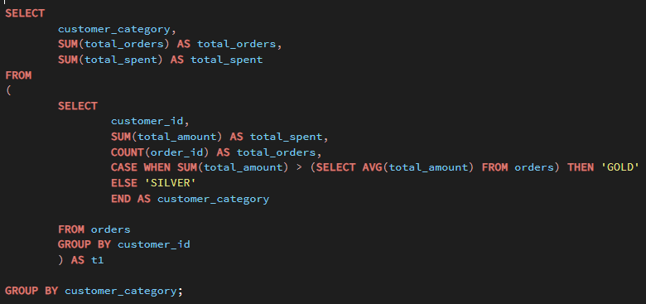
OUTPUT:
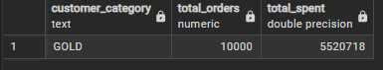

- Rider Monthly Earnings
CALUCULATE EACH RIDER MONTHLY EARNINGS, ASSUMMING THEY EARN 8% FROM THE ORDER AMOUNT

SQL QUERY:
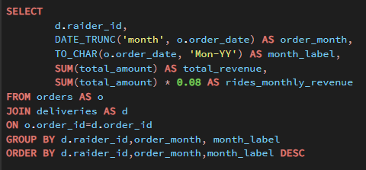
OUTPUT:
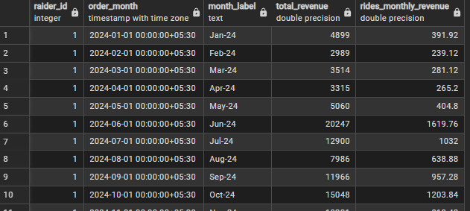

- Rider Ratings by Delivery Time
FIND NUMBER OF 5-STAR, 4-STAR, 3-STAR RATINGS EACH HAVE RIDERS RECEIVE THIS RATING BASED ON DELIVERY TIME
IF ORDERS DELIVERED BELOW 30-MINUTES OF ORDER RECIEVED TIME THE RIDER GET 5-STAR RATING
IF THEY DELIVER 30 AND 60 MINUTE THEY GOT 4-STAR RATING
IF THEY DELUVER AFTER 60 MINUTE THEY GET 3-STAR RATING

SQL QUERY:
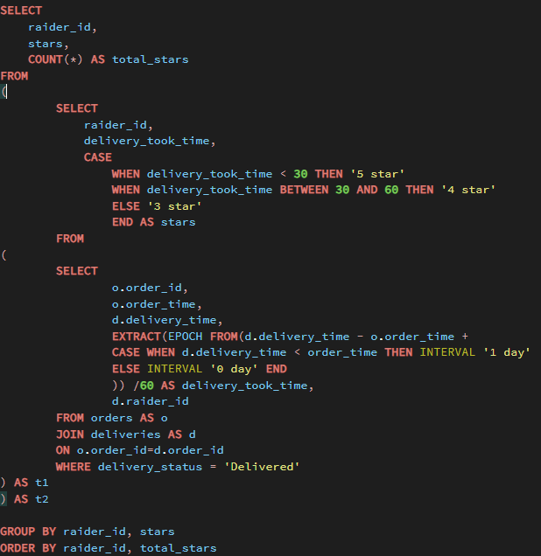
OUTPUT:
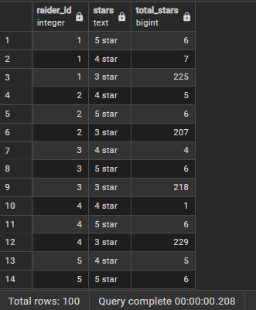
- Restaurant Peak Days
ANALYZE ORDER FREQUENCY PER DAY OF WEEK AND IDENTIFY THE PEAK DAY FOR EACH RESTAURANT

SQL QUERY:
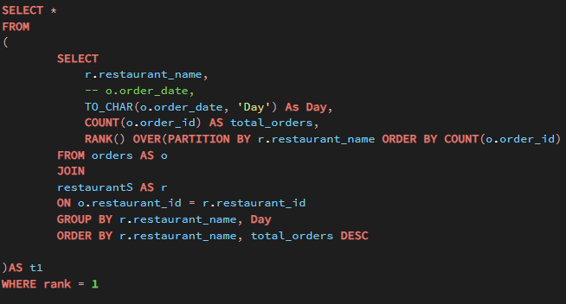

OUTPUT:
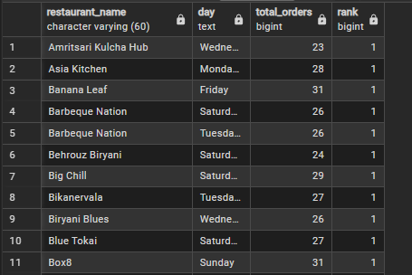

- Customer Lifetime Value (CLV)
CALUCULATE THE TOTAL REVENUE GENERATED BY EACH CUSTOMER OVER ALL THEIR ORDERS

SQL QUERY:
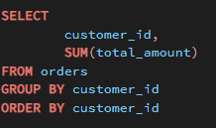
OUTPUT:
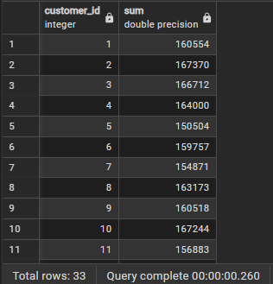

- Monthly Sales Trends
IDENTIFY SALES TRENDS BY COMPARING EACH MONTH'S TOTAL SALES TO PREVIOUS MONTH
SQL QUERY:
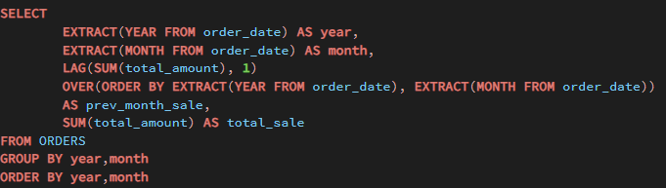

OUTPUT:
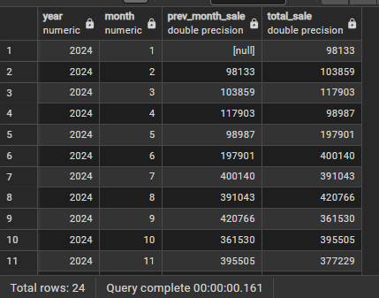

- Rider Efficiency
VALUATE RIDER EFFICIENCY BY DETERMINING AVERAGE DELIVERY TIMES IDENTIFYING THOSE WITH THE LOWEST AND HIGHEST AVERAGES
SQL QUERY:
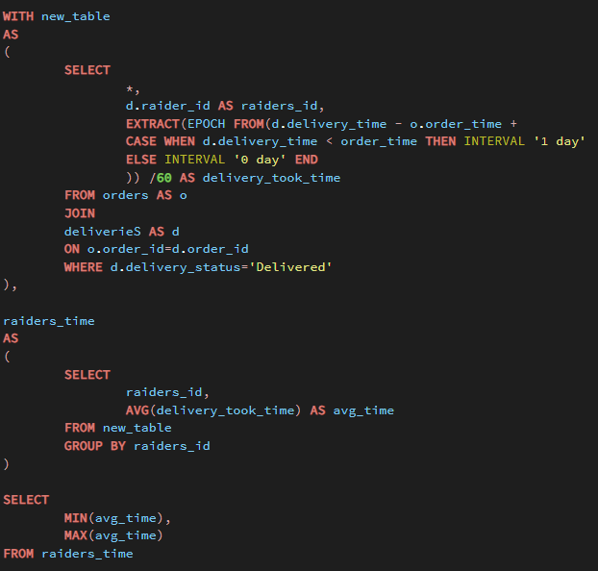
OUTPUT:
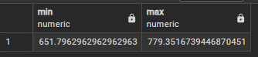

- Seasonal Order Trends
TRACK THE POPULARITY OF SPECIFIC ORDER ITEMS OVER TIME AND IDENTIFY SEASONAL DEMAND SPIKES.
SQL QUERY:
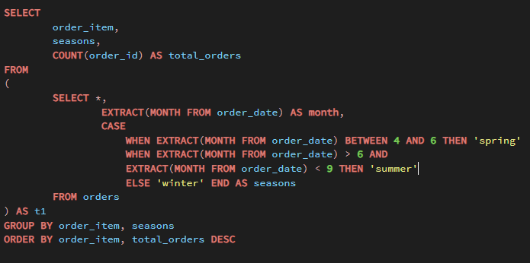

OUTPUT:
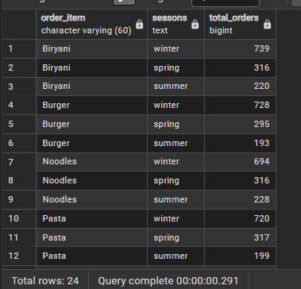

- City Revenue Ranking
RANK EACH CITY BASED ON THE TOTAL REVENUE FRO LAST YEAR 2023

SQL QUERY:
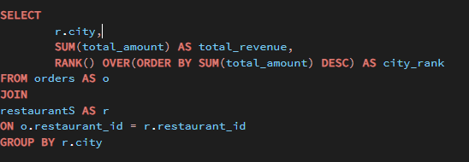OUTPUT:
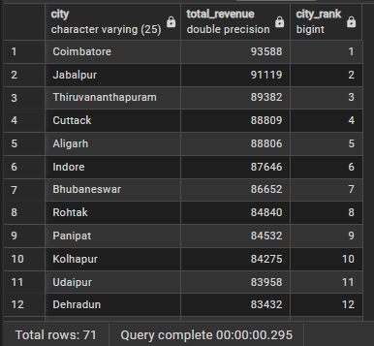

📈 Insights Gained
🔹 Customer Insights
- Identified top customers and their most-ordered items.
- Segmented customers into Gold and Silver tiers based on total spending.
- Computed Customer Lifetime Value (CLV) for retention campaigns.
🔹 Restaurant Insights
- Ranked restaurants by revenue and growth.
- Identified popular dishes and seasonal preferences.
- Measured month-over-month growth ratios to highlight emerging performers.
🔹 Delivery & Operations
- Analyzed peak order hours and busiest weekdays.
- Measured rider efficiency and delivery time performance.
- Estimated earnings and classified riders by delivery speed.
🔹 Business Trends
- Observed monthly revenue growth patterns.
- Tracked cancellation and churn rates over time.

🧠 Key Skills Demonstrated
- SQL query design and optimization
- Analytical problem-solving using CTEs and window functions
- EDA, data validation, and transformation for clean analysis
- Data storytelling and KPI extraction from SQL results
- Real-world business reasoning through data insights

Author
Mukesh Gopi Nandh
📧 Email: mukeshudatha7@gmail.com
🔗 LinkedIn: www.linkedin.com/in/mukesh-gopi-nandh
📂 GitHub: https://github.com/Mukeshgn

