Software Requirements Specification
TradeVerse AI
An AI-Assisted Web and Mobile Platform for Virtual NEPSE Stock Trading and Market Analysis
Prepared for: Web Programming and Mobile Application Development
Computer Science and Engineering Discipline
, Khulna University, Khulna
Document drafted with AI-assisted requirement writing; reviewed and edited by the project team.
Prepared by
Team members:
Mukesh Kumar Mandal
Student ID: 220242
Nuzhat Liana
Student ID: 220205
Prepared for
[Dr. Kazi Masudul Alam (Professor)]
Course Instructor
Computer Science and Engineering Discipline
Khulna University, Khulna

Table of Contents
Table of Contents 2
1. Introduction 3
1.1 Purpose 3
1.2 Objectives 3
1.3 Scope 3
1.4 References 4
2.1 Product Perspective 4
2.2 Product Functions (Summary) 4
2.3 User Classes and Characteristics (User roles) 4
2.4 Operating Environment 4
2.5 Design and Implementation Constraints 4
2.6 Assumptions and Dependencies 5
3.1 User Registration & Authentication 5
3.2 Stock Discovery, Search & Watchlist 5
3.3 Trading Engine (Order Placement & Execution) 6
3.4 Portfolio & Transaction History 6
3.6 Price Alerts & Notifications 7
3.8 Public Market Transparency 7
4.1 User Interfaces 7
4.2 Hardware Interfaces 7
4.3 Software Interfaces 7
4.4 Communication Interfaces 7
5. Non-Functional Requirements 8
6.1 Client Layer 9
6.2 Application / Service Layer 9
6.3 Data Layer 9
6.4 Market Data Layer 10
7.1 Appendix A: Glossary 10
7.2 Appendix B: Analysis Models 10
7.3 Appendix C: Issues List 11

1. Introduction

1.1 Purpose
This Software Requirements Specification (SRS) defines the functional and non-functional requirements for TradeVerse AI, a virtual stock-trading and AI-assisted market-analysis platform for Nepal Stock Exchange (NEPSE) listed companies. It is intended to guide design, implementation, and evaluation of the system across the course project.

1.2 Objectives
- Close the gap between learning about stock trading and practising it, by letting a user trade NEPSE-listed stocks with simulated funds instead of real money.
- Increase trust in the platform's numbers, by executing every order, balance change, and profit/loss calculation exclusively on the backend rather than trusting client-submitted values.
- Surface the most decision-relevant information first, using a stock detail view that combines price, historical chart, technical indicators, and AI trend signal in one place.
- Make the platform usable on both desktop and mobile, by shipping a responsive web app and a Flutter mobile app against the same backend APIs.
- Increase transparency around AI-generated output, by labelling every prediction and sentiment reading as experimental and educational, never as financial advice.
- Demonstrate a resilient service architecture, where the AI service is advisory rather than load-bearing, so the trading engine remains fully functional even if the AI service is unreachable.
- Extend educational value beyond order execution, by including portfolio analytics, watchlists, price alerts, and a public market summary.
- Design with NEPSE's actual market structure in mind (sector classification, listed company set, market hours), rather than assuming a generic, exchange-agnostic model.

1.3 Scope
TradeVerse AI allows a registered user to browse NEPSE-listed companies, view live or mocked market data, and place virtual buy/sell orders using a simulated cash balance. The platform additionally provides portfolio tracking, a watchlist with price alerts, AI-based trend prediction, financial-news sentiment analysis, and an admin dashboard for user and model monitoring.
Submitted orders are validated, priced, and executed entirely by a backend-authoritative trading engine before a user's holdings and balance are updated.
Real brokerage integration and real-money transactions remain out of scope for this academic project, as such integration requires formal NEPSE/broker licensing, KYC infrastructure, and regulatory review well beyond a course timeline. For development and demonstration purposes, the project uses a virtual wallet: every account receives a fixed simulated starting balance, and no real payment instrument, bank account, or government identity document is collected, stored, or used at any stage. This design choice is permanent for the current scope, not a temporary sandbox — TradeVerse AI is not intended to become a real trading platform. A production-grade, rate-limit-respecting live NEPSE data integration and a fully managed PostgreSQL deployment remain future work, documented with a stated upgrade path.

1.4 References
- Investopedia Stock Simulator (virtual trading reference)
- MarketWatch Virtual Stock Exchange
- HowTheMarketWorks educational trading simulator
- Zerodha Varsity paper-trading and market-education content
- Nepal Stock Exchange (NEPSE) official market data and listed company information

2. Overall Description

2.1 Product Perspective
TradeVerse AI is a new, standalone system with a client-server architecture: a responsive web app and a mobile app as clients, a NestJS/Node.js backend, and a relational database. It is scoped to NEPSE's specific market structure (listed companies, sectors) and adds an AI service for trend prediction and news-sentiment analysis rather than relying solely on raw price data.

2.2 Product Functions (Summary)
- Account creation with email verification and JWT-based session management
- Stock browsing, search, and an interactive historical price chart per company
- Virtual wallet with market/limit order placement and backend-authoritative execution
- Portfolio tracking: holdings, cash balance, realized/unrealized profit-loss, transaction history
- Watchlist management with configurable price alerts and real-time notifications
- AI trend prediction (XGBoost, LSTM) and financial-news sentiment analysis (FinBERT)
- Admin dashboard for user management, audit logs, and AI model monitoring
- Public market summary browsable without an account

2.3 User Classes and Characteristics (User roles)
- Registered User (Trader) — trades virtually, manages a watchlist, and reviews portfolio and AI insights; assumed to have basic web/smartphone literacy and general familiarity with stock market terms.
- Administrator — manages user accounts, reviews audit logs, and monitors AI model performance; assumed to have basic computer literacy and access to a desktop/laptop for the admin dashboard.
- Public visitor (unauthenticated) — can browse the public market summary and general company information without an account.

2.4 Operating Environment
- Server: NestJS + Node.js, deployable on standard Linux hosting via Docker
- Database: PostgreSQL (Prisma ORM), with Redis for caching and session/rate limiting
- Client: any modern desktop or mobile browser (responsive web); Android/iOS via a Flutter app
- AI service: Python + FastAPI, deployed as an internal microservice callable by the backend

2.5 Design and Implementation Constraints
- Real brokerage/payment integration is out of scope; the project uses a simulated wallet with a fixed starting balance and no real payment instrument at any stage.
- Every AI-backed feature must have a defined fallback so the trading engine works without a reachable AI service.
- Historical price charting depends on a MarketDataProvider abstraction, swappable between a live NEPSE source and a mock provider.
- All monetary and quantity fields use fixed-precision Decimal types, never floating point, to avoid rounding errors in trading calculations.

2.6 Assumptions and Dependencies
- A usable NEPSE market data source (official, licensed, or reasonably approximated) is available for development, or the MockMarketDataProvider is used in its place. This is a deliberate design trade-off — a mock provider carries no live-market guarantees, which is why every AI prediction is labelled experimental regardless of data source.
- An external AI service (FastAPI, hosting XGBoost/LSTM/FinBERT) is available for prediction and sentiment requests, with a documented "insufficient data" fallback (REQ-AI-05) ensuring the trading engine still completes end-to-end if the AI service is unreachable or unavailable during development or demonstration.
- NEPSE data licensing and rate limits are assumed sufficient for development and demo use; coverage and limits for the project's demo dataset will be verified during implementation.
3. System Features (Functional Requirements)

3.1 User Registration & Authentication
ID | Requirement | Priority
REQ-UM-01 | System shall allow a user to register with an email, password, and full name. | High
REQ-UM-02 | System shall verify a user's email address before granting full account access. | Medium
REQ-UM-03 | System shall authenticate all sessions using JWT tokens and store passwords using bcrypt hashing. | High
REQ-UM-04 | System shall route a logged-in user automatically to the trading dashboard or admin dashboard based on account role, with no manual toggle. | High
REQ-UM-05 | System shall allow a user to reset a forgotten password via a time-limited email link. | Medium

3.2 Stock Discovery, Search & Watchlist
ID | Requirement | Priority
REQ-MD-01 | System shall display the full list of NEPSE-listed companies with symbol, name, and sector. | High
REQ-MD-02 | System shall allow a user to search companies by ticker symbol or company name. | High
REQ-MD-03 | System shall display current price, OHLC, volume, and turnover for a selected stock. | High
REQ-MD-04 | System shall render an interactive historical price chart with selectable ranges (1D-5Y). | High
REQ-MD-05 | System shall let a user add or remove a stock from a personal watchlist. | Medium
REQ-MD-06 | System shall source market data through a MarketDataProvider abstraction, falling back to a mock provider if the live feed is unreachable. | High

3.3 Trading Engine (Order Placement & Execution)
ID | Requirement | Priority
REQ-TE-01 | System shall issue every new user a fixed virtual starting balance of NPR 1,000,000. | High
REQ-TE-02 | System shall allow a user to place MARKET and LIMIT buy or sell orders. | High
REQ-TE-03 | System shall validate order funds, quantity, and stock validity entirely on the backend before execution. | High
REQ-TE-04 | System shall execute an order at the authoritative price returned by the MarketDataProvider, never a client-submitted price. | High
REQ-TE-05 | System shall allow a user to cancel a pending LIMIT order before it fills. | Medium
REQ-TE-06 | System shall record every filled order as one or more Trade entries linked to the originating Order. | High

3.4 Portfolio & Transaction History
ID | Requirement | Priority
REQ-PF-01 | System shall maintain a Holding record per user per stock with quantity and average price. | High
REQ-PF-02 | System shall compute and display unrealized and realized profit/loss per holding and in aggregate. | High
REQ-PF-03 | System shall show a chronological, filterable transaction history of all past trades. | Medium
REQ-PF-04 | System shall display daily and overall portfolio return alongside an asset allocation breakdown. | Medium
3.5 AI Prediction & Sentiment Pipeline
ID | Requirement | Priority
REQ-AI-01 | System shall generate a short-term trend prediction for a stock using an XGBoost model. | High
REQ-AI-02 | System shall generate a short-term trend prediction using an LSTM model, for comparison against the XGBoost baseline. | Medium
REQ-AI-03 | System shall evaluate every trained model using MAE, RMSE, MAPE, and directional accuracy on a chronological hold-out set. | High
REQ-AI-04 | System shall classify financial news sentiment per stock as positive, negative, or neutral using FinBERT. | Medium
REQ-AI-05 | Every AI-backed feature shall have a defined "insufficient data" fallback so the trading engine remains usable if the AI service is unreachable. | High
REQ-AI-06 | System shall label all AI-generated output as experimental and educational, never as financial advice. | High

3.6 Price Alerts & Notifications
ID | Requirement | Priority
REQ-AL-01 | System shall let a user configure an above/below price alert for a watchlisted stock. | Medium
REQ-AL-02 | System shall deliver a triggered alert to the user as a real-time in-app notification. | Medium
REQ-AL-03 | System shall let a user view, mark as read, and clear past notifications. | Low
3.7 Admin Dashboard
ID | Requirement | Priority
REQ-AD-01 | System shall let an administrator view and search all registered user accounts. | High
REQ-AD-02 | System shall let an administrator view an append-only audit log of trading and account actions. | High
REQ-AD-03 | System shall let an administrator view stored evaluation metrics for each deployed AI model version. | Medium

3.8 Public Market Transparency
ID | Requirement | Priority
REQ-TP-01 | System shall provide a public NEPSE market summary (index, top gainers, top losers) viewable without an account. | Medium
REQ-TP-02 | System shall display general company information for any NEPSE-listed stock without requiring login. | Low

4. External Interface Requirements

4.1 User Interfaces
- Trader web app: dashboard, stock search, stock detail with chart and AI panel, trade ticket, portfolio, watchlist
- Trader mobile app (Flutter): mirrors the web app's core screens against the same backend APIs
- Admin web dashboard: user management, audit log viewer, AI model performance monitoring
- Public (unauthenticated) view: market summary and general company information

4.2 Hardware Interfaces
- No specialized hardware is required beyond a standard internet-connected desktop, laptop, or smartphone; TradeVerse AI does not use device cameras, GPS, or biometric hardware, since it collects no identity documents or location-based verification.

4.3 Software Interfaces
- NEPSE market data source (live feed or mock provider) via the MarketDataProvider abstraction
- AI/ML service (FastAPI) for predictions (XGBoost, LSTM) and sentiment (FinBERT)
- Redis for caching, session/rate limiting, and pub-sub delivery of live price ticks
- Email provider for verification and password-reset messages

4.4 Communication Interfaces
- HTTPS/REST between client and backend
- WebSocket for live price ticks, order-fill updates, and notifications
- HTTPS/REST from backend to the AI microservice and the market data source

5. Non-Functional Requirements
Category | Requirement
Performance | Stock search and order placement (excluding AI service latency) shall complete in under 2 seconds on a typical broadband or 4G connection.
Security | All API traffic shall use HTTPS/TLS; passwords hashed with bcrypt; JWT tokens shall expire and require refresh.
Data Privacy | No real financial account numbers, payment credentials, or government ID data are collected at any stage, since TradeVerse AI never processes real money; user data is limited to email, name, and trading activity.
Usability | The web interface shall be responsive and usable on both desktop and mobile browsers; core actions shall be reachable within 3 clicks from the dashboard.
Reliability | The trading engine shall remain operational for order placement even if the AI service is unreachable, via the documented "insufficient data" fallback.
Scalability | The database layer shall be designed with a documented upgrade path from a single PostgreSQL instance (prototype) to a managed, replicated PostgreSQL + Redis cluster (production), without changing the application-layer data-access interface.
Availability | Core trading flow (web) shall target 99% uptime during the project demonstration period.
Accessibility | Market data and stock listings shall remain viewable without requiring an account.
6. System Architecture Overview
The overall system layout first, then an order's step-by-step journey through the trading pipeline.
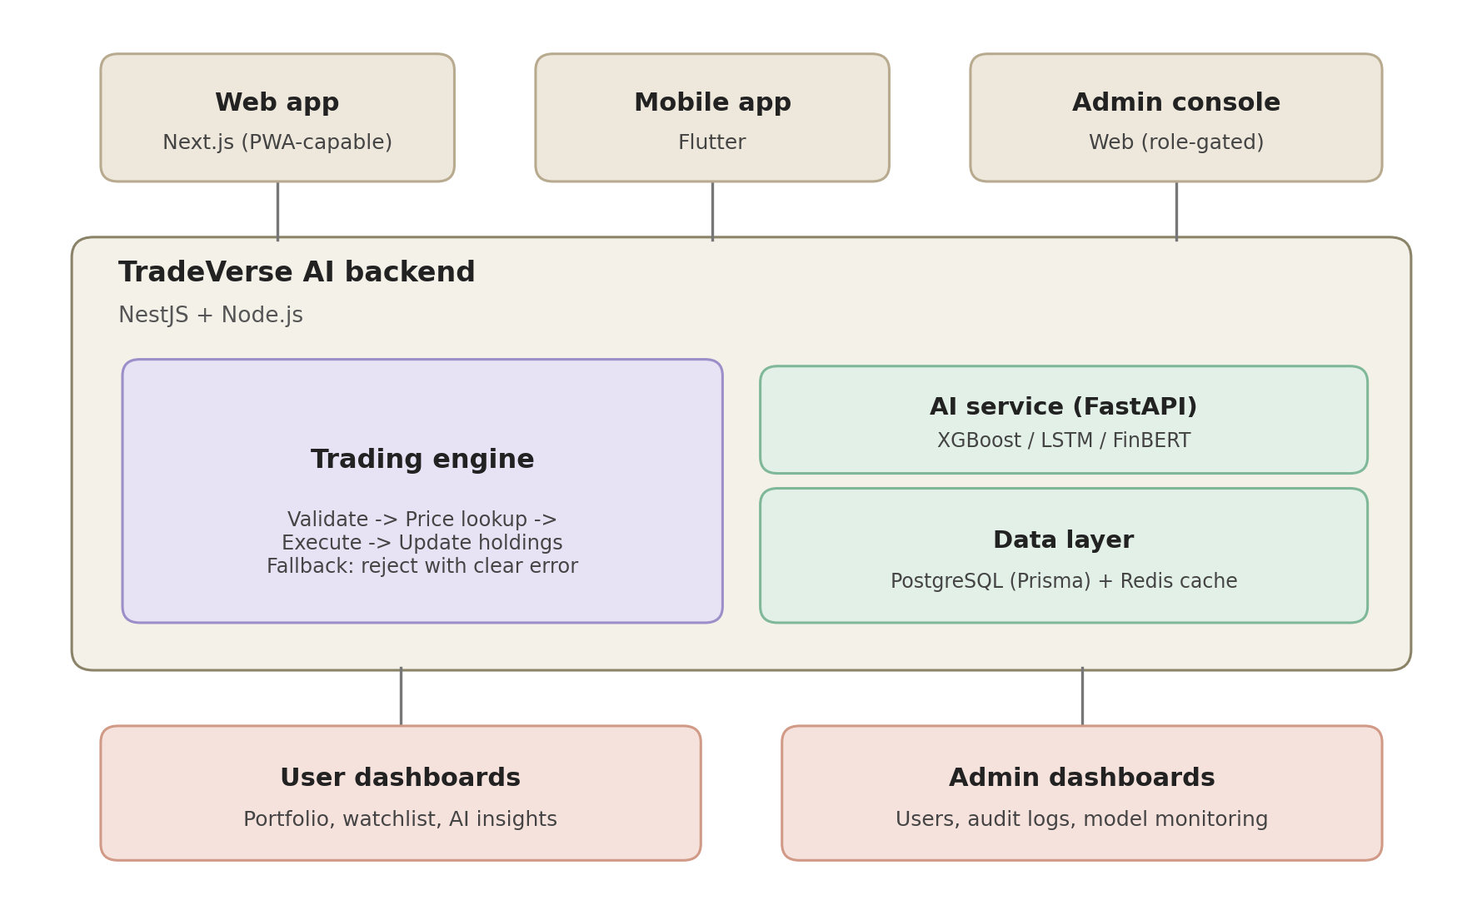
That's the layer view — users reach the system through the web app, mobile app, or admin console, the backend runs everything through the trading engine plus the AI service and data layer, and results surface either to user dashboards or admin dashboards. Now here's what happens to a single order as it moves through that pipeline:
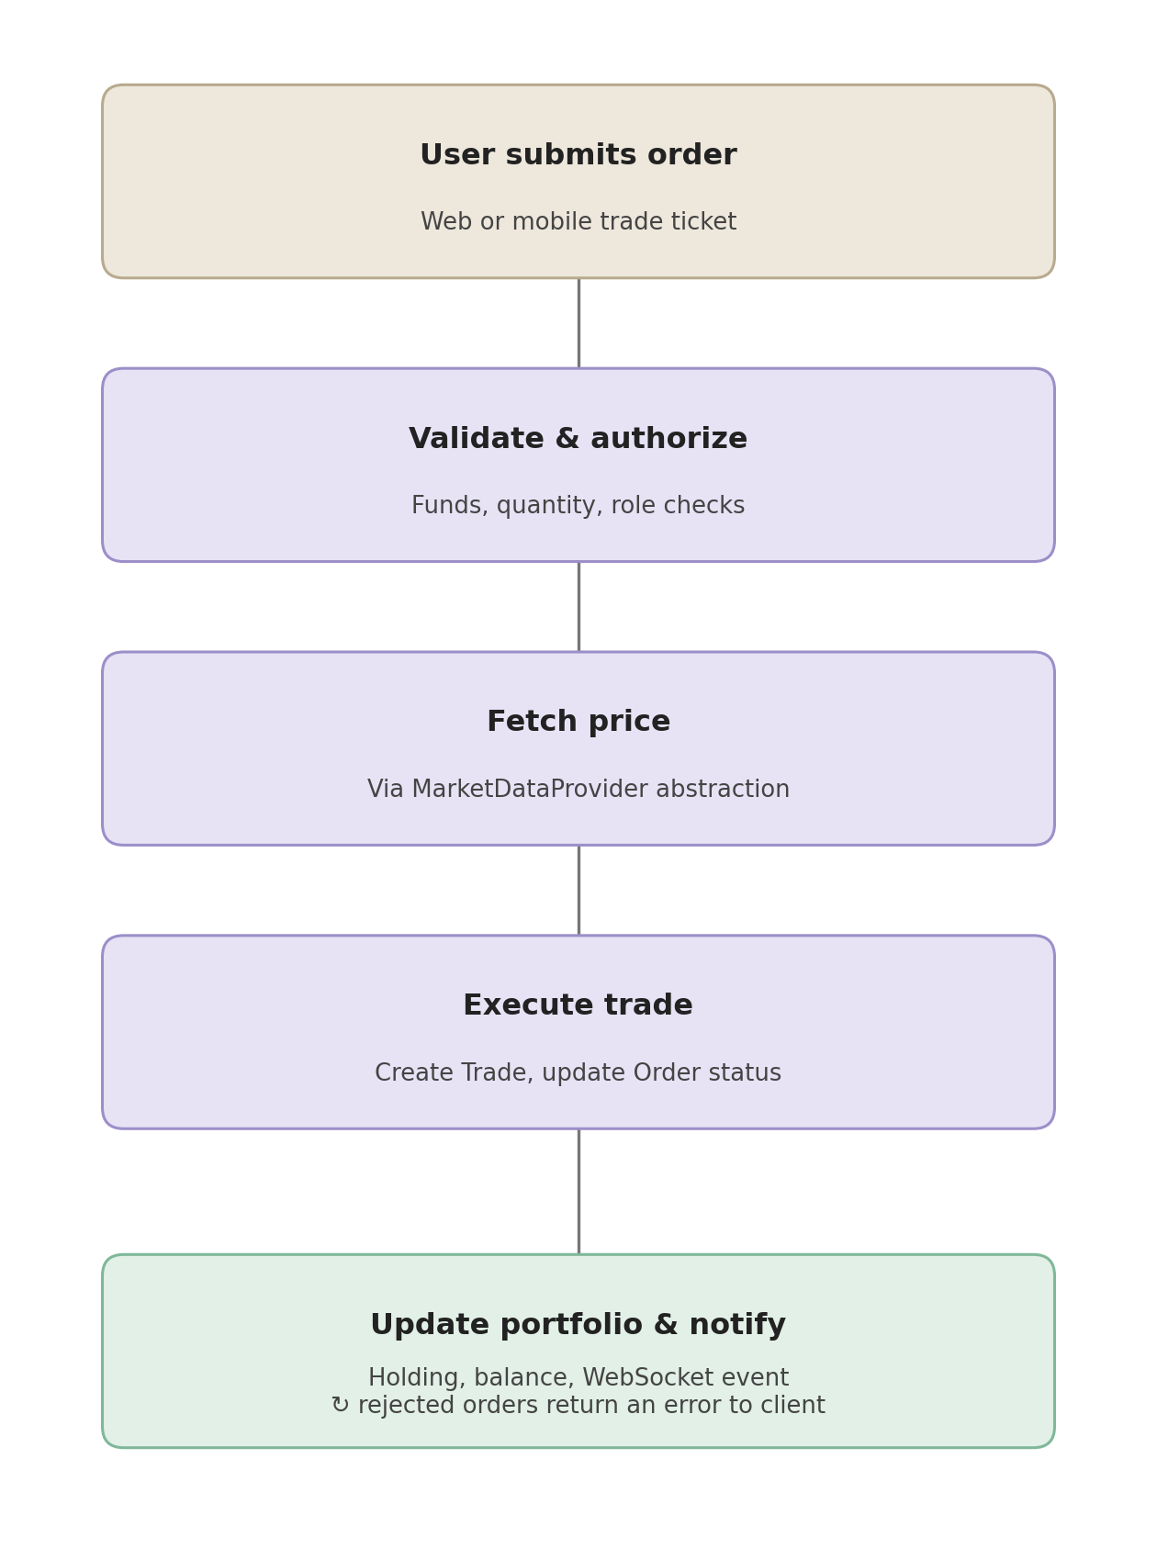
The system follows a modular, service-oriented architecture layered over a conventional client-server web application:

6.1 Client Layer
- Responsive web app (Next.js, PWA-capable) — primary, current build
- Mobile app (Flutter) — shares the same backend APIs as the web app
- Admin console (web, role-gated) — no separate app; access controlled by the ADMIN role

6.2 Application / Service Layer
- Auth → Trading → Portfolio → Watchlist → Notification modules (NestJS, deterministic, backend-authoritative)
- Each AI-backed feature has a rule-based or "insufficient data" fallback for availability without a reachable AI service
- The system depends on two external sources — the NEPSE market data feed and the AI service — both with documented fallback behavior if unreachable

6.3 Data Layer
- Relational database: local PostgreSQL via Docker (development) → managed PostgreSQL + Prisma (production upgrade path)
- Redis for caching, session/rate limiting, and pub-sub delivery of live price ticks
- Historical price and audit data are retained; no real-money records exist anywhere in the system by design

6.4 Market Data Layer
- Resolves every trade request to an authoritative current price before execution, never trusting a client-submitted price
- Implemented via the MarketDataProvider interface, with a live NepseProvider and a MockMarketDataProvider fallback
- Live NEPSE data source coverage and rate limits will be verified during implementation; the mock provider serves as fallback if the live feed proves unavailable or rate-limited during development

7. Appendix

7.1 Appendix A: Glossary
Term | Definition
SRS | Software Requirements Specification
NEPSE | Nepal Stock Exchange, the sole stock exchange of Nepal
MVP | Minimum Viable Product — the smallest complete, demonstrable version of the system
RBAC | Role-Based Access Control — restricting actions by assigned user role
OHLC | Open, High, Low, Close — the four core price points of a trading period
LSTM | Long Short-Term Memory — a recurrent neural network used for time-series prediction
XGBoost | A gradient-boosted decision tree library used for short-term trend prediction
FinBERT | A BERT-based language model fine-tuned for financial-text sentiment analysis
JWT | JSON Web Token — used for session authentication
PWA | Progressive Web App
P/L | Profit and Loss — realized or unrealized gain or loss on a position
MarketDataProvider | The system's abstraction layer for sourcing live or mock NEPSE market data
Prediction Score | A model's confidence-style output accompanying a trend prediction
Trend Signal | The AI service's bullish/bearish/neutral classification for a stock
Holding | A user's current quantity and average price for a given stock
Watchlist | A user's personal list of stocks tracked for quick reference and alerts
REQ-XX-## | Requirement identifier format used throughout this SRS (module prefix + sequence number), e.g. REQ-TE-01

7.2 Appendix B: Analysis Models
At the time of this document's current version, the following analysis models are planned or in progress:
- Entity-Relationship Diagram (ERD) — covering users, stocks, orders, trades, holdings, watchlists, alerts, and predictions. Scheduled for Week 2 alongside the API contract.
- System architecture diagram — the layered structural diagram and the order-execution flow diagram in Section 6 have been produced and are embedded in this revision.
- Data flow diagram (DFD) — tracing an order's path from submission through validation, pricing, and execution to portfolio update; planned for Week 2.
These will be added to or refined in this appendix as they are completed; this SRS version documents their status rather than omitting mention of them.

7.3 Appendix C: Issues List
# | Issue | Status
1 | Live NEPSE data source/vendor has not been finalized; MockMarketDataProvider is the current default. | Open — pending evaluation
2 | Whether the Flutter mobile app is a hard course requirement, or the responsive web app alone satisfies the "mobile application development" component, is unconfirmed. | Open — pending supervisor clarification
3 | FinBERT hosting approach (self-hosted vs. hosted inference API) has not been decided. | Open
4 | Historical NEPSE price dataset for model training has not yet been collected. | Open
5 | License for the project (open-source vs. restricted) has not been decided. | Open
6 | ER diagram field-level detail and the API contract are scheduled for Week 2, not yet finalized. | Open — scheduled Week 2
7 | Data flow diagram (Appendix B) not yet produced. | Open — scheduled Week 2

