Library Management System
Step1: (project Created)

Create a project and an app:
django -admin startproject restAPI
python manage.py startapp core

Core app created for admin page where we login through emailID.

Django directly provide admin panel where we can create super user and login to panel with username but here we need to do some code cause we want to login through email ID.

Step2: (setting.py)

Here we are using My SQL database so we need to change database setting.

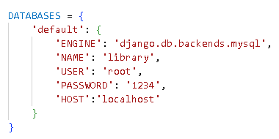

Here i enterd by database name ,password and host.

Step 3: (core.model.py)

The following codes in models.py file in the core folder
from enum import unique
from unittest.util import _MAX_LENGTH
from django.db import models
from django.contrib.auth.models import AbstractBaseUser, PermissionsMixin, BaseUserManager

class CustomUserManager(BaseUserManager):
def _create_user(self,email, password, first_name, lat_name, **extra_fields):
if not email:
raise ValueError("Email must be provided")
if not password:
raise ValueError("password is not provided")
user= self.model(
email=self.normalize_email(email),
first_name = first_name,
lat_name= lat_name,
**extra_fields
)
user.set_password(password)
user.save(using=self._db)
return user

def create_user(self, email, password, first_name, lat_name,**extra_fields):
extra_fields.setdefault('is_staff',True)
extra_fields.setdefault('is_active',True)
extra_fields.setdefault('is_suoeruser',False)
return self._create_user(email, password, first_name, lat_name,**extra_fields)

def create_superuser(self, email, password, first_name, lat_name,**extra_fields):
extra_fields.setdefault('is_staff',True)
extra_fields.setdefault('is_active',True)
extra_fields.setdefault('is_superuser',True)
return self._create_user(email, password, first_name, lat_name,**extra_fields)

class user(AbstractBaseUser,PermissionsMixin):
email = models.EmailField(db_index=True, unique=True, max_length=254)
first_name = models.CharField(max_length=240)
lat_name=models.CharField(max_length=255)
is_staff= models.BooleanField(default=True)
is_active = models.BooleanField(default=True)
is_superuser = models.BooleanField(default=False)

objects= CustomUserManager()

USERNAME_FIELD = 'email'
REQUIRED_FIELDS= ['first_name','lat_name']

class Meta:
verbose_name = 'user'
verbose_name_plural = 'users'

Code Explanation:
Models.py file does the database connectivity.

book() model stores the details of the student in the institution.

CharField(): It stores strings in the database.

Step 4: (core.admin.py)
from django.contrib import admin
from .models import user

admin.site.register(user)

Code Explanation:

The models that are created in the models.py file are registered in admin.py. By adding models in admin.py these tables can be seen in the database.
register(): It helps to register the model in the database.

python manage.py makemigartions
python manage.py migrate

Step 5: (setting.py)

Mentioned App name in installed app
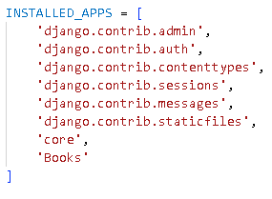
To access the database you need to create a superuser. To create a superuser, run the command given below on the terminal. It will prompt you to enter the emailID, first name, last name and password. After entering these fields superuser will be created.
python manage.py createsuperuser
Step 5: (Book.model.py)
Book app created for a storing a code of crud operation.
First i created book table in model.py
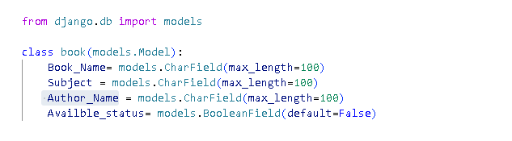
After this I run migrate coommad for creation of book table in database.
After creating this table I have registered table name in Book.admin.py that’s why table control goes on admin panel and there by default we can add, update and delete data. Once we visit admin panel by default it show all data mean retrieve all data from table.
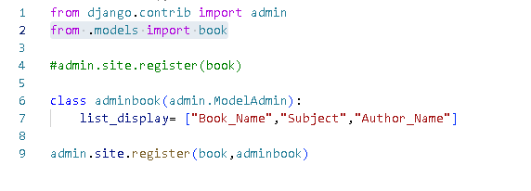
Step 6 : (urls.py)
We need to create student view so whenever user will visit website he need to see all book available in a library so simply we are retrieving all data from book table on home page so first we need to set URL for that.
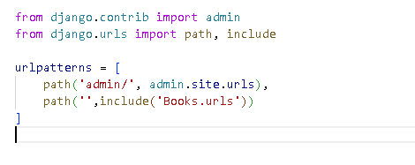
Now we need to set URL in app(Book.urls.py)
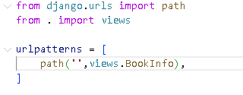
Code Explanation:
a. path(): It returns the element that is included in the url patterns
Step 7: (Book.view.py)
.Now when request coming from Book.urls.py it’s searching for BookInfo method in Views.py so let’s create
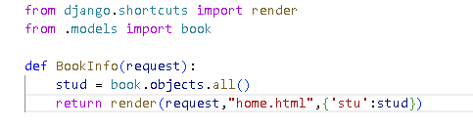
Render: HttpResponse object is returned and it also combines the template with the dictionary that is passed in render.
Step 8:( home.html)
Now we need to create HTML file under template folder so where view.py file can post all data and it’ll visible on home page.
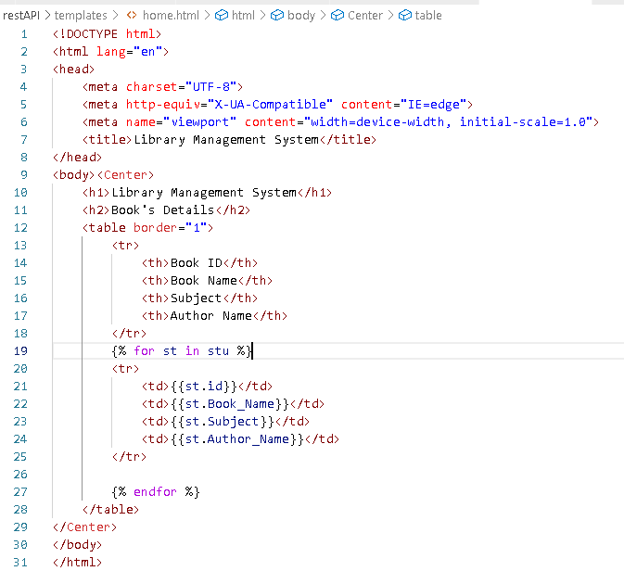
Let register template folder in setting.py
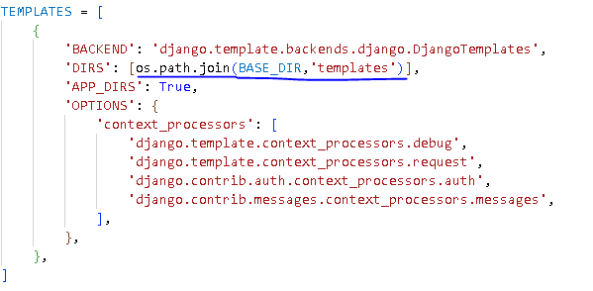
Step9 : (Run Project)
Use below command for running current project
Python manage.py runserver

