5. Empirical Findings: Triangulated Evidence on the Business Value of Voice AI at Better.com

5.1 Introduction to Empirical Findings
This chapter presents the empirical findings of the thesis by integrating three evidence streams: qualitative case-study evidence on the integration of Betsy into Better.com’s Tinman-based mortgage origination workflow, longitudinal financial evidence drawn from SEC filings and a descriptive benchmark comparison against Rocket Mortgage, and customer-perception evidence derived from a Natural Language Processing (NLP) analysis of Trustpilot reviews. The chapter is organized around the two research questions of the thesis. RQ1 asks how voice LLM agents have been integrated into Better.com’s mortgage origination process and what architectural, workflow, and human-AI collaboration prerequisites this integration implies. RQ2 asks what measurable business value can be associated with Better.com’s voice AI deployment across operational efficiency, productivity, customer experience, and financial performance, and what factors mediate the realization of this value.
RQ1 is answered primarily through the qualitative case-study evidence established in Chapter 4, supplemented by company disclosures and vendor materials (Better Home & Finance Holding Company, 2024a, 2026; ElevenLabs, 2026). RQ2 is answered through two largely independent quantitative streams: the longitudinal financial analysis of Better’s 2021–2025 SEC filings, contextualized against Rocket Mortgage as a directional industry benchmark; and the NLP analysis of 1,915 cleaned Trustpilot reviews segmented around Betsy’s October 17, 2024 launch (Better Home & Finance Holding Company, 2024a). Following the convergent parallel mixed-methods design described in Chapter 3, the three streams are interpreted together, with explicit attention to where they converge and where they diverge.
Two interpretive constraints frame the chapter. First, the thesis relies on observational, public, secondary data; consequently, the chapter does not claim causal identification of Betsy’s independent contribution. It evaluates whether the post-deployment evidence is consistent with AI-enabled operational leverage in the sense theorized by Brynjolfsson et al. (2023) and Aggarwal et al. (2025), and how customer-discourse evidence supports, complicates, or qualifies that interpretation. Second, the chapter foregrounds an analytically valuable divergence: financial and operational metrics improve materially across 2024–2025, while independent Trustpilot star ratings and VADER sentiment decline significantly over the same period and explicit AI mentions remain near-zero. Rather than treating this divergence as a contradiction, the chapter treats it as a triangulation insight: different measurement instruments capture different facets of customer experience, and the business value of voice AI in financial services appears to be multidimensional and mediated rather than uniformly directional.
The chapter proceeds in six analytical sections. Section 5.2 addresses RQ1 by analyzing how Tinman, Betsy, ElevenLabs, and human escalation fit together as an integration mechanism. Sections 5.3 and 5.4 address the operational/financial and customer-experience dimensions of RQ2. Section 5.5 synthesizes the three streams into a triangulated interpretation. Section 5.6 records the boundary conditions of the empirical findings, and Section 5.7 presents direct, evidence-bounded answers to RQ1 and RQ2 and transitions to the design-pattern argument developed in Chapter 6.
A note on terminology is appropriate before the empirical sections begin. Throughout this chapter, the phrase “the broader Betsy/Tinman AI operating model” is used as shorthand for the joint configuration of the Tinman platform, the Betsy voice agent, the ElevenLabs voice infrastructure, the human-in-the-loop escalation structure, and the organizational practices that surround them. Where the chapter refers specifically to Betsy as a discrete component, this is made explicit. This convention reflects the analytical position established in Chapter 3 that the unit of analysis is not Betsy in isolation but Betsy as one component of an integrated operating model, and it is consistent with the cautious causal language adopted throughout the thesis.

5.2 RQ1: Integration of Voice LLM Agents into Mortgage Origination
RQ1 asks how voice LLM agents have been integrated into Better.com’s mortgage origination process and under what prerequisites this integration becomes operationally meaningful. The case evidence developed in Chapter 4 supports four interlocking observations: Tinman is the architectural prerequisite that makes a conversational layer operationally useful; Betsy is best understood as a coordination layer rather than a stand-alone underwriter; ElevenLabs supplies the voice infrastructure but does not own Better’s mortgage logic; and the deployment is structured as task reallocation between AI and licensed human specialists, not as full labor substitution. Together, these observations indicate that voice LLM integration in financial services is best interpreted as a workflow-integration problem rather than a front-end chatbot problem.

5.2.1 Tinman as the Architectural Prerequisite
Better.com’s ability to deploy a voice AI loan assistant rests on the fact that its mortgage process is already encoded in Tinman, the company’s proprietary, integrated mortgage operating platform. Tinman functions as the system of record for borrower data, pricing, documentation, eligibility checks, workflow routing, and audit trails (Better Home & Finance Holding Company, 2026). This matters because, in the task-technology fit tradition of Goodhue and Thompson (1995), the fit between a conversational technology and the work it is asked to perform depends on whether the technology has access to the data and process state needed for the task. A voice LLM agent operating without access to a structured mortgage system would be limited to generic informational dialogue. Operating on top of Tinman, by contrast, the agent can plausibly reference an applicant’s loan stage, request a specific missing document, or surface a status update derived from the system of record. The case evidence therefore suggests that the operational meaningfulness of Betsy is not a property of the voice agent in isolation; it is a joint property of Betsy and the Tinman-mediated workflow into which it is embedded.
This interpretation is consistent with the broader literature on AI in customer-facing financial services. Hentzen et al. (2022) emphasize that AI systems in mortgage and banking contexts are most effective when embedded in compliant, auditable workflows; Mogaji and Nguyen (2021) note that consequential AI applications often operate as backend or infrastructure-level components rather than as branded customer-facing chatbots. Better.com’s public materials position Tinman as such an architectural foundation: the company describes itself as a technology-first mortgage lender whose digital infrastructure was designed to digitize the end-to-end home-finance process before voice AI was layered on top (Better.com, n.d.; Better Home & Finance Holding Company, 2026). The case therefore supports the argument that the preconditions for a meaningful voice LLM deployment include not only model quality but also a process-aware operating platform that exposes structured workflow state to the conversational layer.

5.2.2 Betsy as a Conversational Coordination Layer
Betsy is described in Better.com’s investor and press materials as a voice-based AI loan assistant rather than as an underwriting engine (Better Home & Finance Holding Company, 2024a; ElevenLabs, 2026). The publicly disclosed scope of Betsy’s tasks centers on borrower communication: handling inbound and outbound calls, answering routine questions about rates and processes, collecting and chasing missing documentation, providing application-status updates, and triaging borrower inquiries. In this sense, Betsy is best interpreted as a conversational coordination layer over the mortgage workflow. It automates the high-volume, repetitive communicative work that historically consumed loan-officer time, while leaving credit decisions, complex problem solving, and final closing steps to licensed human specialists.
This division of labor is consistent with Huang and Rust’s (2018) service-AI hierarchy, which distinguishes mechanical, analytical, intuitive, and empathetic dimensions of service work. Betsy operates primarily within the mechanical and analytical dimensions — retrieving structured information, executing predictable conversational scripts, and handling routine status communication — while higher-stakes interactions involving borrower-specific judgment, regulatory advice, or escalation are routed to humans. It is also broadly consistent with the field-experimental evidence from Wang et al. (2023) on voice-based AI in call-center settings, where voice AI agents complement rather than replace human workers, and from Zhang et al. (2023) on the operational performance effects of AI-based conversational agents in call centers. Crucially, however, the case-study evidence does not allow attribution of any specific operational outcome at Better.com to Betsy in isolation; it shows that Betsy is positioned as a coordination layer within a broader Betsy/Tinman operating model.

5.2.3 ElevenLabs as Voice Infrastructure
ElevenLabs functions as the underlying voice-agent infrastructure for Betsy. According to the joint Better.com–ElevenLabs materials, ElevenLabs provides the conversational AI agents (“ElevenAgents”), low-latency speech synthesis, and the agentic conversational runtime that lets Betsy speak naturally with borrowers (ElevenLabs, 2026; Better Home & Finance Holding Company & ElevenLabs, 2026). This vendor relationship is analytically important for two reasons. First, it clarifies that the voice layer is delivered through a third-party platform rather than constructed in-house, which aligns with broader industry patterns in which financial-services firms compose AI-supported workflows from specialized infrastructure components (Liu et al., 2024). Second, it bounds the analytical claims that can be made: ElevenLabs supplies the voice-agent capabilities, but it does not own the mortgage logic, the customer relationship, or the regulated decision-making. Better.com retains those through Tinman and through its licensed loan officers.
The vendor evidence must therefore be treated cautiously. ElevenLabs and Better.com both have incentives to present the deployment favorably in joint case-study materials, and figures cited in vendor communications are not independently audited. Following Mogaji and Nguyen’s (2021) caution about treating AI vendor claims as independent evidence of business value, this thesis uses the Better.com–ElevenLabs materials to characterize the integration mechanism rather than to substantiate magnitude claims about cost savings or revenue uplift. Where vendor materials and Better’s own SEC disclosures align (for example, on Betsy’s role as a voice-based loan assistant), the alignment is reported; where vendor materials extend beyond what Better’s SEC filings disclose, the claim is treated as moderate-strength descriptive evidence only.

5.2.4 Human-AI Collaboration and Regulated Task Boundaries
A consistent feature of the public materials is that Betsy’s operating model preserves human escalation. Better Home & Finance Holding Company (2024a) describes Betsy as an assistant that handles routine borrower communication and surfaces escalations to licensed loan officers, and the joint Better–ElevenLabs materials emphasize compliance-oriented controls around the conversational layer (ElevenLabs, 2026; Better Home & Finance Holding Company & ElevenLabs, 2026). The case evidence therefore supports an interpretation of the deployment as task reallocation rather than full labor substitution: high-volume informational and procedural communication is reallocated to a voice AI agent, while consequential, regulated, or borrower-specific judgments remain with human specialists. This pattern is consistent with Acemoglu and Restrepo’s (2019) framework, in which automation simultaneously displaces labor on some tasks and reinstates labor on adjacent tasks that the technology cannot perform as effectively.
From a regulatory perspective, mortgage origination in the United States is governed by federal and state-level disclosure, fair-lending, and consumer-protection rules administered through agencies such as the Consumer Financial Protection Bureau (Consumer Financial Protection Bureau, 2024, 2025). Many of these rules ultimately require licensed personnel to validate or sign off on consequential decisions and disclosures. A voice LLM agent integrated into a regulated origination workflow must therefore be embedded in an architecture that maintains auditable handoffs, documented decision trails, and visible human-in-the-loop checkpoints. The Better.com case is consistent with this configuration: Tinman maintains the workflow and audit trails, Betsy mediates routine communication, and licensed loan officers retain authority over consequential decisions.

5.2.5 Integration Prerequisites: Synthesis for RQ1
Synthesizing the case evidence, RQ1 can be answered as follows. Voice LLM agents become operationally meaningful in mortgage origination when they are integrated into a process-aware operating platform that exposes structured workflow state, when they are scoped to a communication-coordination role rather than a regulated decision-making role, when they sit on top of low-latency voice infrastructure capable of natural conversation, and when they are governed by an explicit human-AI collaboration model with auditable escalation paths. In the Better.com case, Tinman supplies the first prerequisite, Betsy operationalizes the second, ElevenLabs supplies the third, and the regulated task structure of mortgage origination supplies the fourth. These prerequisites are case-derived and therefore most directly applicable to firms whose business processes can be analogously encoded in a digital operating platform. They are nonetheless consistent with the broader literature on task-technology fit (Goodhue & Thompson, 1995), AI-augmented service work (Huang & Rust, 2018), and AI in customer-facing financial services (Hentzen et al., 2022; Mogaji & Nguyen, 2021).

5.3 RQ2: Operational and Financial Business Value
This section addresses the operational and financial dimensions of RQ2. The analytical strategy is descriptive and longitudinal. The 2024-to-2025 comparison is treated as the primary post-transition window, because Betsy launched on October 17, 2024 and 2025 is therefore the first full post-launch fiscal year (Better Home & Finance Holding Company, 2024a). The 2023-to-2025 comparison is reported as supporting evidence of recovery from the 2023 trough rather than as a Betsy-specific causal comparison. The pre-period 2021–2023 average is used as a robustness check, to show that 2025 revenue and revenue per employee, while materially higher than the 2024 trough, have not fully returned to pandemic-era levels. Throughout, Rocket Companies is used as a directional industry benchmark; differences in scale, business model, and the 2025 Mr. Cooper acquisition mean that Rocket cannot serve as a formal counterfactual.
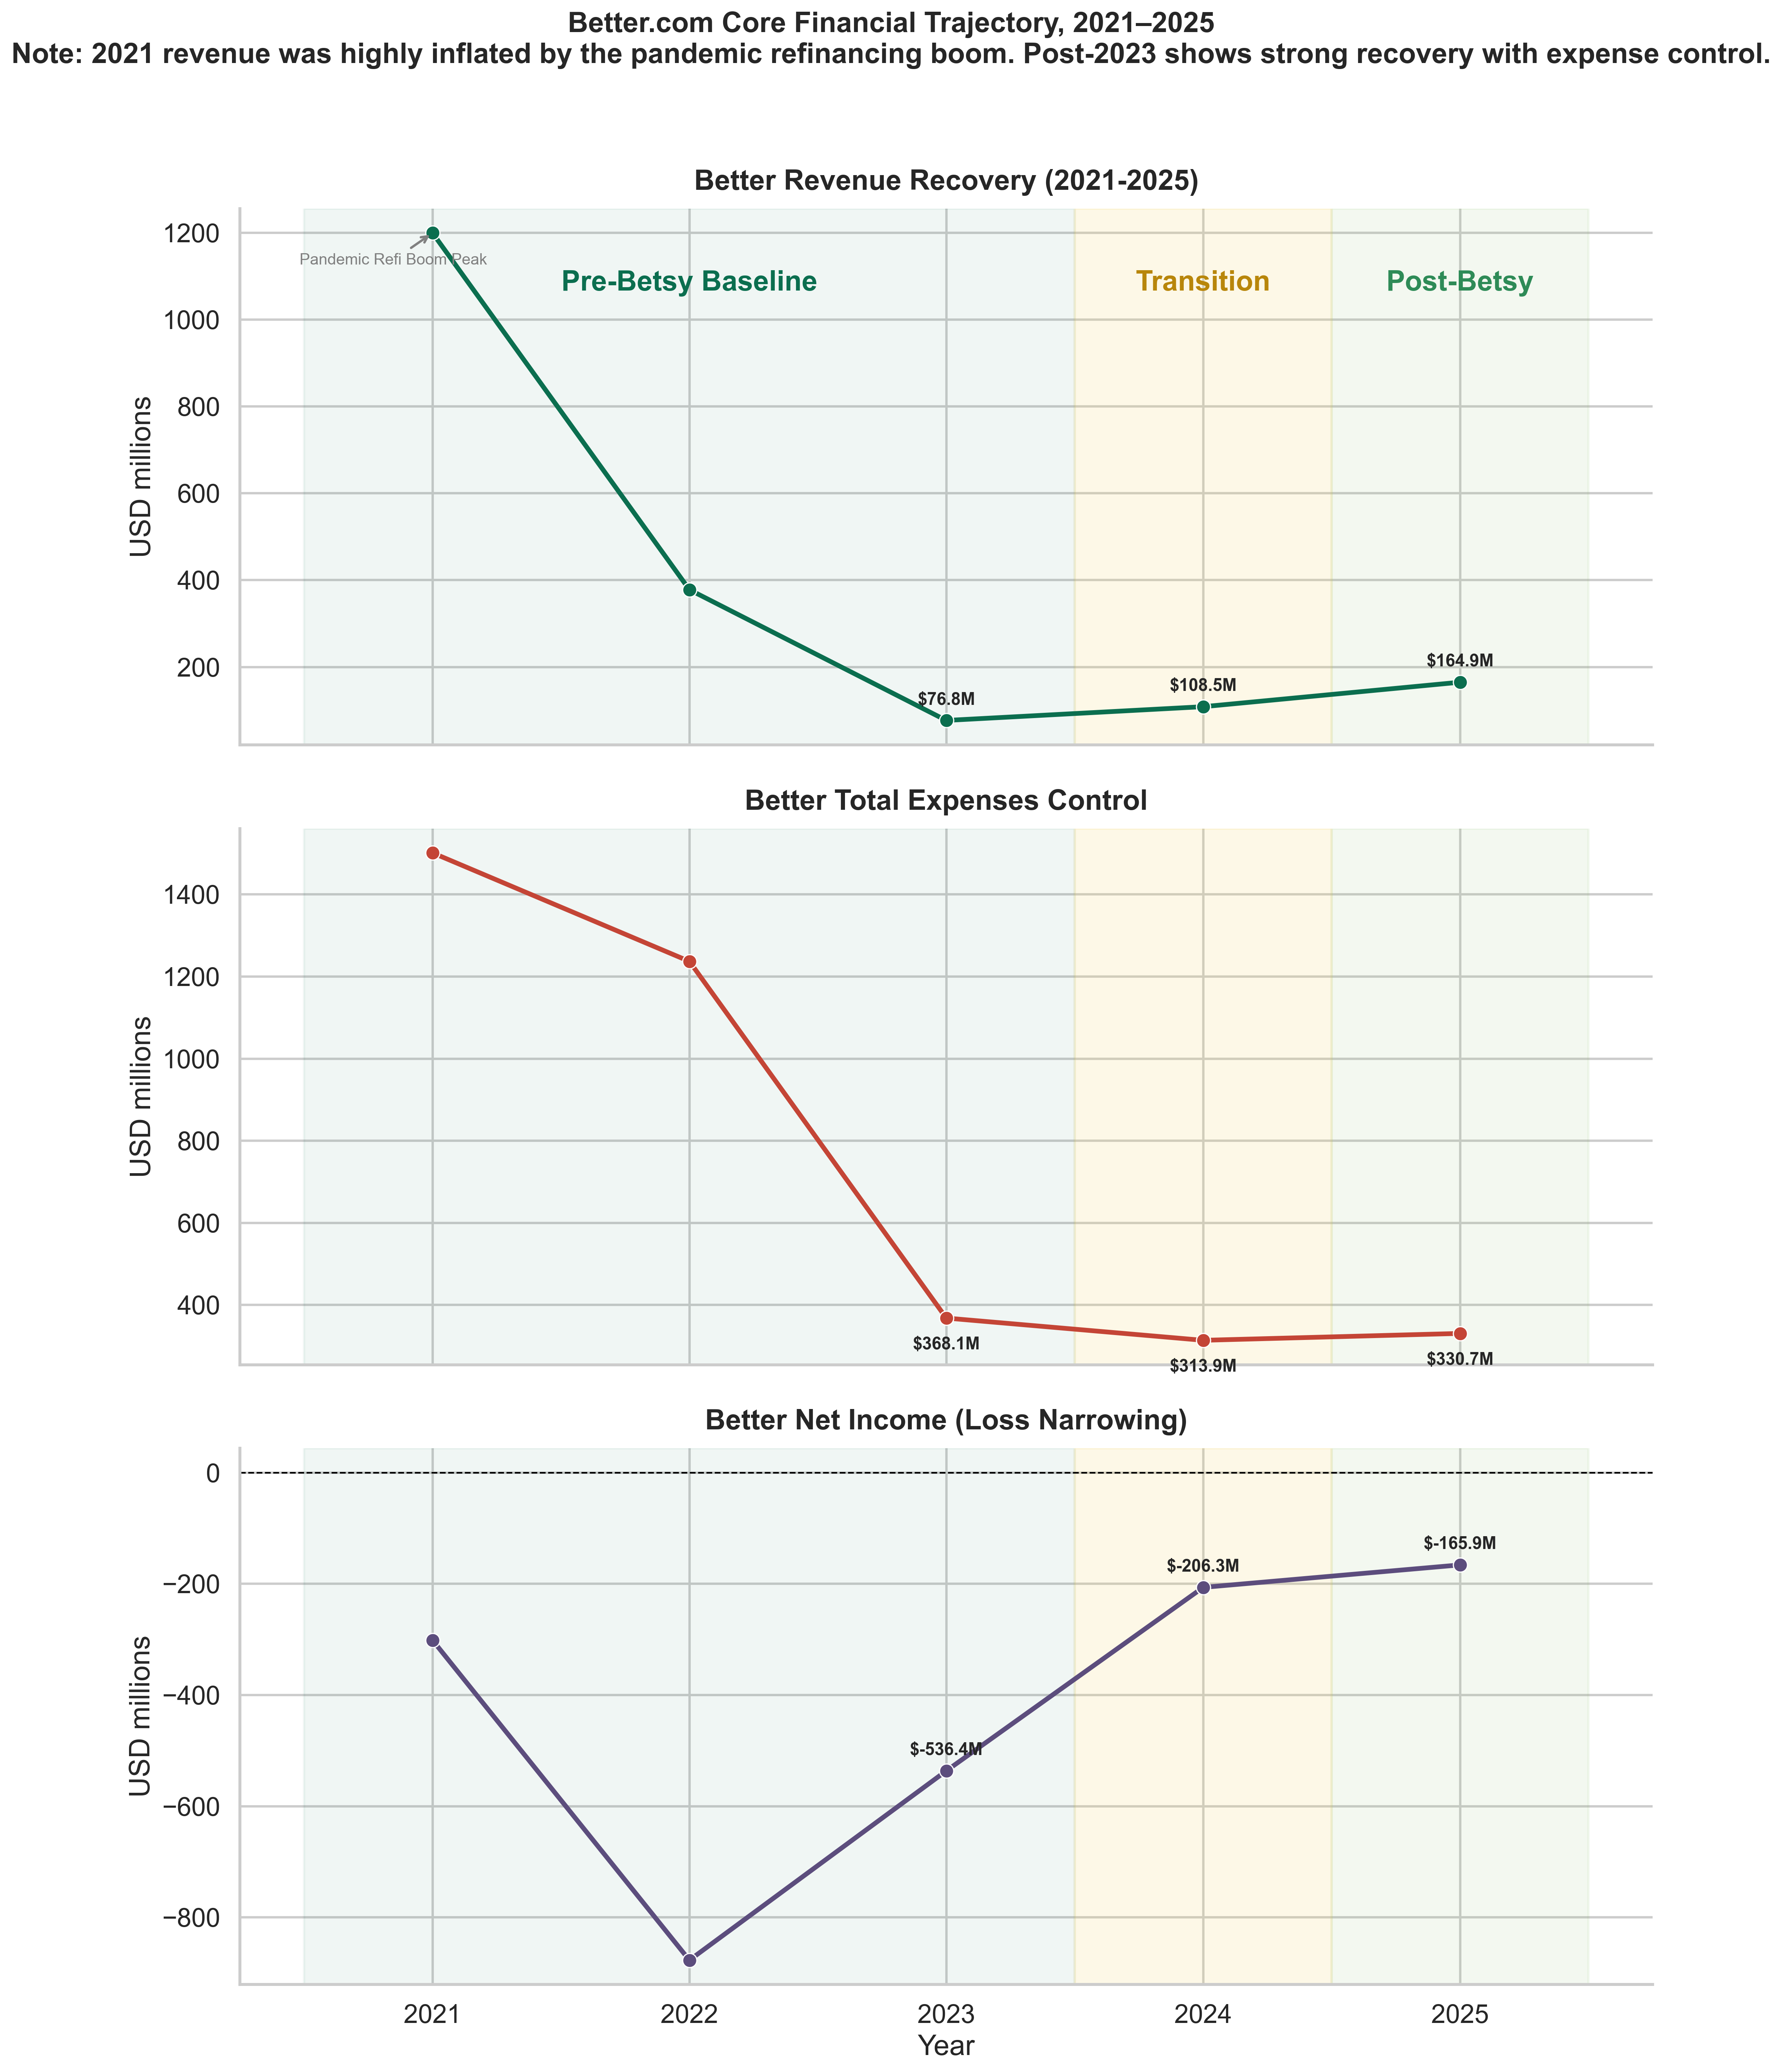
Figure 5.1. Better.com’s revenue, standardized total expense base, and net income/loss, 2021–2025. The shaded periods distinguish the pre-Betsy baseline (2021–2023), the 2024 transition year, and the 2025 post-Betsy fiscal year. Source: Author’s construction from Better Home & Finance Holding Company SEC filings (S-1; 10-K filings for fiscal years 2023, 2024, and 2025). Figure provides descriptive evidence of revenue recovery, expense containment, and narrowing losses; it does not isolate Betsy’s causal contribution.

5.3.1 Revenue Recovery and Post-Transition Growth
Better.com’s revenue trajectory across 2023–2025 displays a clear recovery pattern. Reported total net revenue rose from approximately $76.8 million in 2023 to approximately $108.5 million in 2024 and approximately $164.9 million in 2025 (Better Home & Finance Holding Company, 2024b, 2025a, 2026a). The headline post-transition comparison is therefore an increase of approximately 52.0 percent from 2024 to 2025. Across the longer 2023-to-2025 window, revenue grew by approximately 114.6 percent, but this larger figure incorporates the trough-year baseline of 2023, when the U.S. mortgage market was constrained by elevated interest rates and depressed origination volumes (Mortgage Bankers Association, 2024). Funded loan volume moved in the same direction, rising from approximately $3.0 billion in 2023 to approximately $3.6 billion in 2024 (Better Home & Finance Holding Company, 2024b, 2025a). Figure 5.1 visualizes this trajectory alongside the standardized total expense base and the net loss line.
Two additional contextual observations help calibrate this revenue recovery. First, the recovery is partial rather than complete. Even at the 2025 level of approximately $164.9 million, revenue remains materially below Better’s 2021 pandemic-era peak, when the U.S. mortgage refinancing boom drove unusually high origination volumes. The 2025 revenue figure is therefore best read as a meaningful recovery from the 2023 trough rather than as a return to pre-restructuring scale. Second, the recovery is occurring in a U.S. mortgage market that is itself only partially recovering. Mortgage Bankers Association (2024) data indicate that independent mortgage banker production margins improved from late-2023 lows but remained below long-run averages through 2024, with origination volumes still constrained by elevated rates. The descriptive benchmark comparison with Rocket Mortgage in Section 5.3.5 helps separate firm-specific from sector-wide effects, although it cannot do so with causal precision.
The revenue trajectory is consistent with the operational-leverage interpretation that Better’s broader Betsy/Tinman AI operating model is associated with growth that does not require proportional expansion of the cost base. It is not, however, evidence that voice AI alone produced the recovery. The same period encompasses concurrent product developments (notably the launch of the NEO channel in early 2025), ongoing restructuring, the maturation of Tinman, and a partial recovery in the broader U.S. mortgage market that affected most originators (Mortgage Bankers Association, 2024). The most defensible framing is therefore that the post-transition revenue recovery is consistent with AI-enabled operational leverage, while leaving the specific contribution of Betsy unresolved.

5.3.2 Expense Intensity and Operational Efficiency
The strongest descriptive evidence for operational efficiency at Better.com is the trajectory of the expense ratio, defined here as the standardized total expense base divided by total net revenue. On this construction, the expense ratio improved from 4.79 in 2023 to 2.89 in 2024 and 2.01 in 2025. Equivalently, between 2024 and 2025 revenue grew by approximately 52.0 percent while the standardized expense base grew by only approximately 5.3 percent (from approximately $368.1 million in 2023 to approximately $313.9 million in 2024 and $330.7 million in 2025). This pattern — a substantial step up in revenue with only marginal growth in expenses — is the textbook descriptive signature of operational leverage and is consistent with the AI-enabled operational-leverage hypothesis examined in this thesis.
The decomposition of the expense ratio is informative. The 2024-to-2025 improvement from 2.89 to 2.01 reflects an approximately 30.6 percent decline. The bulk of that decline is attributable to revenue growth (the denominator effect), with the remainder attributable to only modest expense growth (the numerator effect). In a pure cost-cutting story, one would expect the numerator to fall sharply; in a pure demand-recovery story, one would expect the numerator to rise in proportion to the denominator. The Better.com evidence fits neither pure pattern. Instead, expenses grew only marginally while revenue grew substantially, which is what an operational-leverage trajectory should look like when a process-aware operating platform absorbs additional volume without proportional cost. This is the descriptive pattern most consistent with the central hypothesis of the thesis, with the caution that the pattern reflects the broader Betsy/Tinman operating model rather than Betsy in isolation.
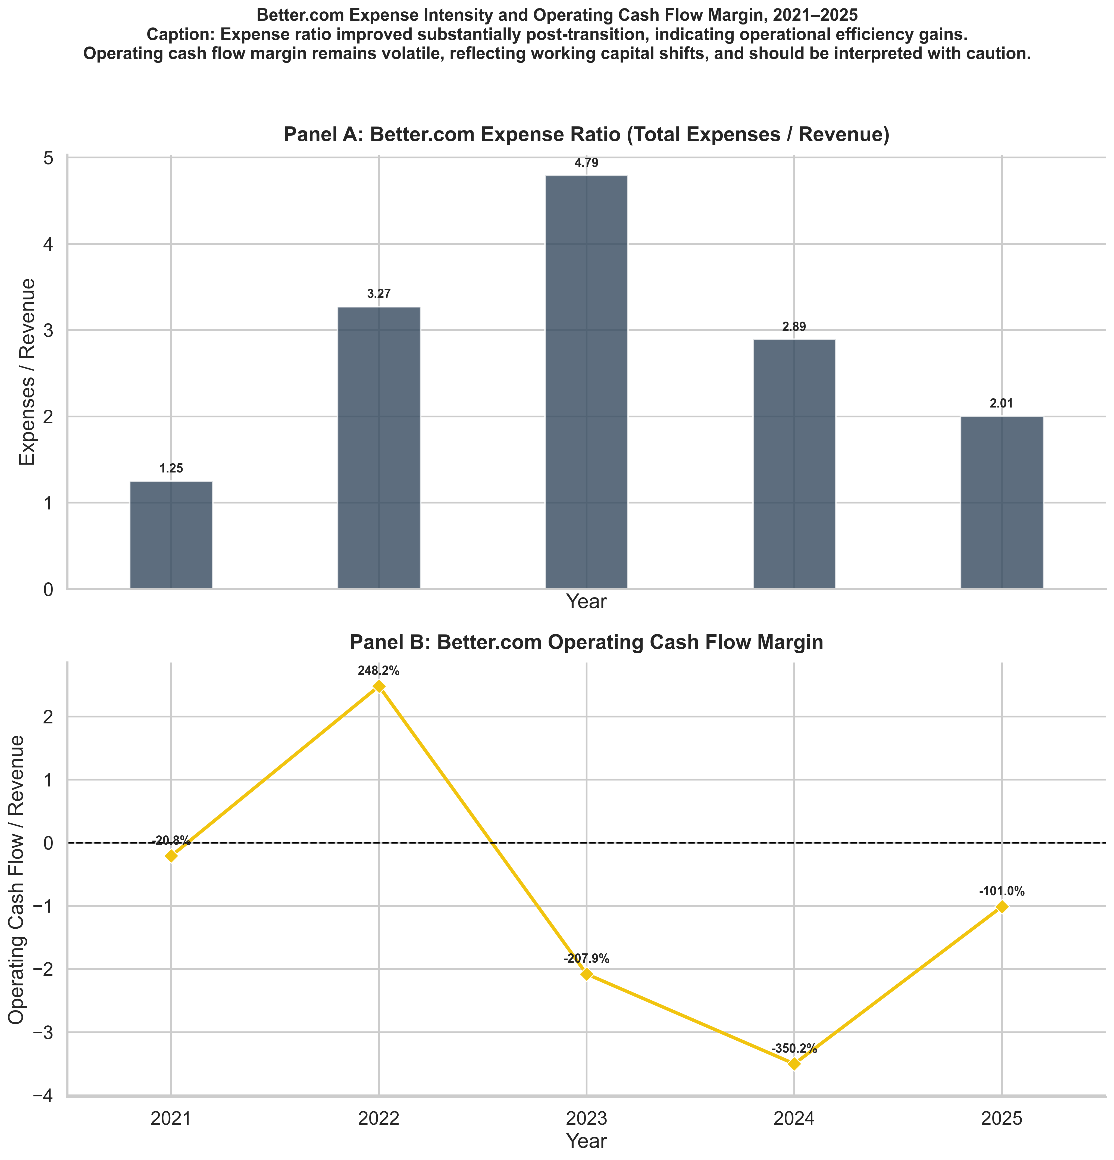
Figure 5.2. Better.com’s expense ratio (standardized total expense base / total net revenue) and operating cash flow, 2021–2025. The expense-ratio trajectory is the principal descriptive indicator of expense intensity; the operating cash flow panel is included to show that 2025 expense-ratio improvements are not yet matched by sustained positive operating cash flow. Source: Author’s construction from Better Home & Finance Holding Company SEC filings (S-1; 10-K filings for fiscal years 2023, 2024, and 2025).
Two interpretive caveats apply. First, the construction of the standardized total expense base is consistent within Better’s reported financial statements, but Better and Rocket use different accounting presentations (Rocket Companies, 2024, 2025). Cross-company expense-ratio comparisons should therefore be interpreted directionally, not as precise like-for-like measurements. Second, the operating cash flow panel in Figure 5.2 makes clear that improvements in the expense ratio are not yet matched by sustained positive operating cash flow; Better remained operating-cash-flow negative through 2025. The expense-ratio improvement is therefore best read as evidence of intensifying operational leverage rather than as evidence that the cost-base improvements have already translated into self-funding operations.

5.3.3 Net Loss Reduction and Profitability Trajectory
Better.com’s net loss narrowed from approximately $536.4 million in 2023 to approximately $206.3 million in 2024 and approximately $165.9 million in 2025 (Better Home & Finance Holding Company, 2024b, 2025a, 2026a). On a year-over-year basis, the 2024-to-2025 net-loss improvement is approximately 19.6 percent. The direction is favorable and the magnitude of the multi-year improvement is substantial. At the same time, the company has not achieved profitability. Reading the 2025 result as a financial turnaround would therefore overstate the evidence: losses narrowed materially, but the company remained unprofitable in 2025, and the profit margin remained negative.
The trajectory is consistent with the operational-leverage interpretation that revenue is growing faster than the cost base, while also suggesting that the cost base remains structurally large relative to revenue. The comparison with Rocket Companies (Section 5.3.5) helps contextualize this trajectory: across 2023–2025, both originators experienced cyclical pressures and partial recovery, but Better’s relative loss-narrowing is descriptively more pronounced. Because Better and Rocket differ substantially in scale, business mix, and 2025 acquisition context, this comparative observation is treated as directional rather than as a controlled estimate.
It is also useful to record what the loss-narrowing trajectory does not establish. It does not establish that Better’s underlying business model is profitable at current scale; the company’s 2025 net loss remains substantial in absolute terms, and the implied profit margin remains negative. It does not establish that further loss-narrowing will continue at the same rate; the 2024-to-2025 improvement of approximately 19.6 percent is smaller in proportional terms than the 2023-to-2024 improvement, and a substantial portion of the absolute improvement reflects revenue growth rather than cost reduction. Finally, it does not establish that the path to profitability is uniquely AI-driven; the joint Better–ElevenLabs materials and Better’s own SEC filings emphasize multiple concurrent levers, including capital structure changes, channel diversification, and cost discipline. The most defensible reading is therefore that the loss-narrowing trajectory is consistent with the operational-leverage interpretation, but does not yet support a stronger claim of financial turnaround.

5.3.4 Labor Productivity and Scalability
Revenue per employee (RPE), defined as total net revenue divided by year-end headcount, is used as the primary proxy for labor productivity and scalability. RPE moved from approximately $0.094 million in 2023 to approximately $0.087 million in 2024 and approximately $0.124 million in 2025. The 2024-to-2025 change is approximately +42.9 percent, indicating a substantial step up in revenue per worker during the first full post-Betsy fiscal year. Across the 2023-to-2025 window, the RPE improvement is approximately +32.3 percent. Headcount itself contracted sharply from the pandemic-era peak (approximately 10,400 in 2021) to a 2023 trough near 820, before rising modestly to approximately 1,250 in 2024 and 1,329 in 2025 (Better Home & Finance Holding Company, 2024b, 2025a, 2026a). The post-transition RPE improvement is therefore not driven primarily by further headcount contraction but by faster revenue growth on an essentially flat headcount base.
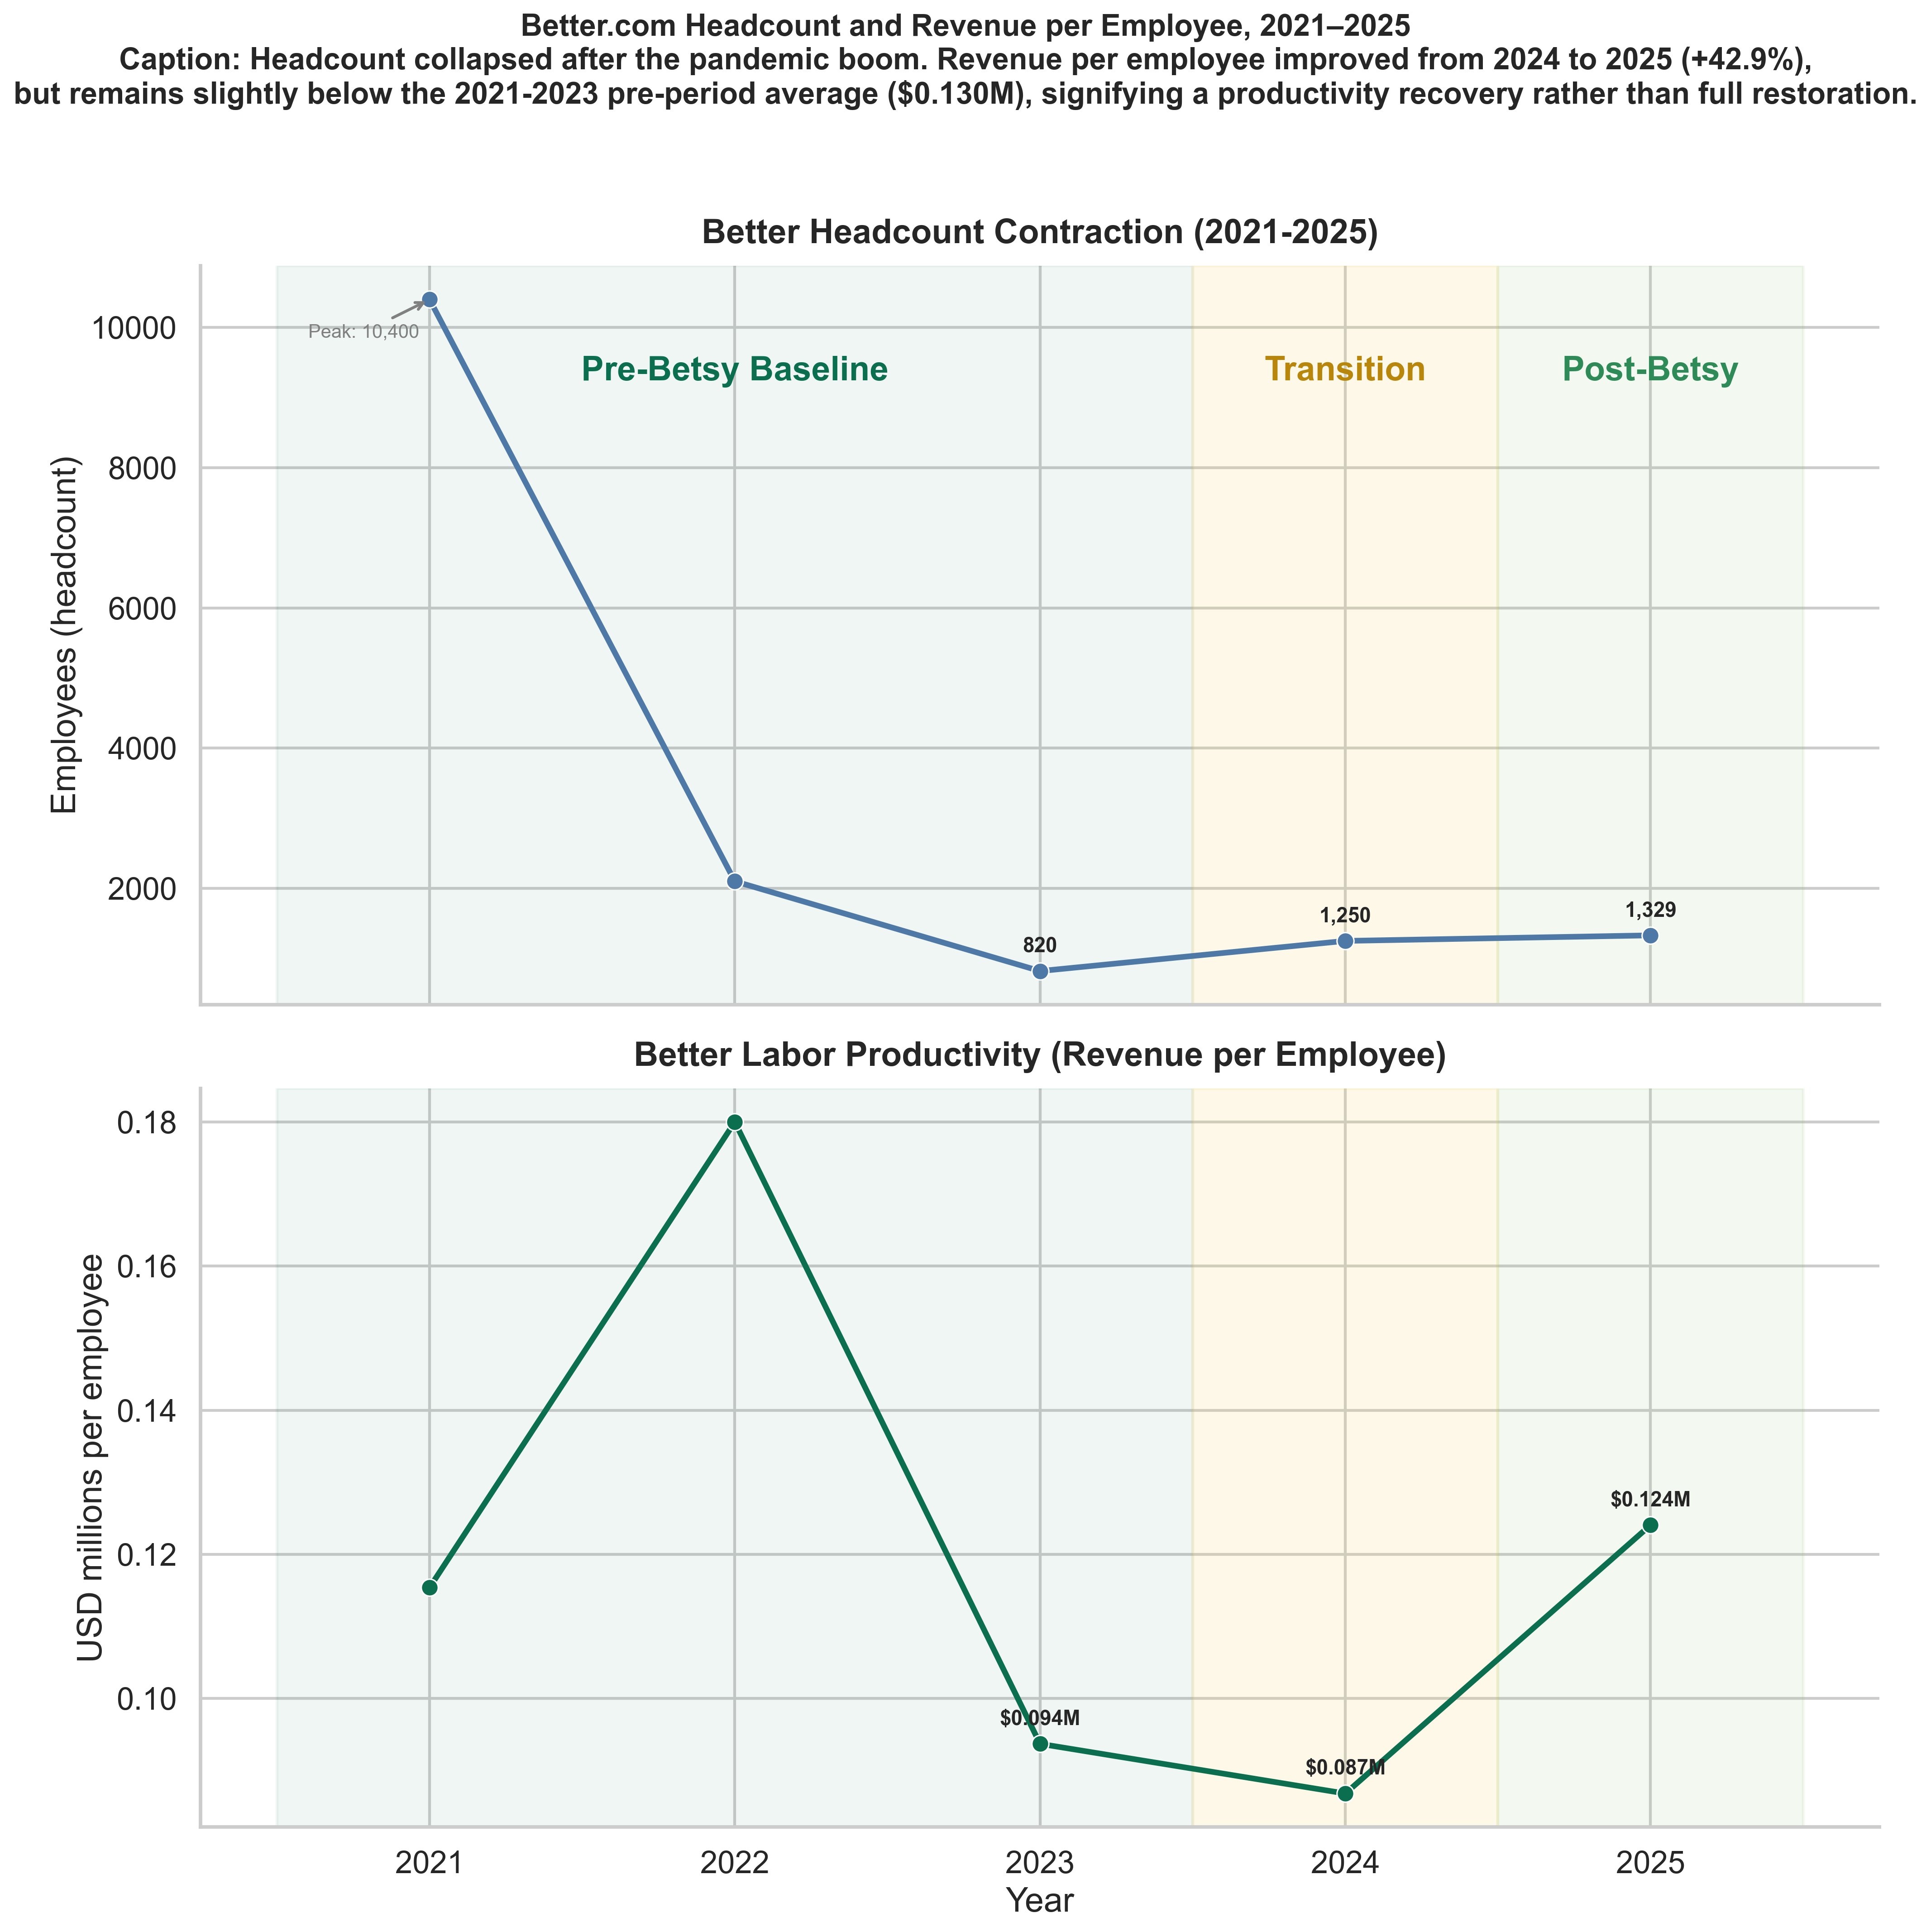
Figure 5.3. Better.com’s year-end headcount and revenue per employee (RPE), 2021–2025. The figure shows the post-2021 workforce contraction and the partial recovery of RPE in 2025. Source: Author’s construction from Better Home & Finance Holding Company SEC filings. The figure supports the productivity dimension of business value but also shows that 2025 RPE remains below the 2021–2023 pre-period average of approximately $0.130 million.
The productivity evidence is moderately strong but should be qualified. Although 2025 RPE is materially higher than 2024 RPE, it remains below the 2021–2023 pre-period average of approximately $0.130 million. The post-Betsy productivity recovery is therefore best characterized as a partial recovery toward, rather than past, pre-restructuring productivity levels. As an author-constructed supplementary indicator, the Operational Leverage Index (OLI) reaches 195.3 in 2025 with 2023 set to 100 (see Appendix A.1). The OLI is equally weighted across Revenue Growth, Revenue per Employee, and Inverse Expense Ratio indices, and is sensitive to the choice of baseline year and weighting scheme. It is therefore retained as a compact visualization of multiple normalized trends rather than as primary evidence.

5.3.5 Benchmark Context with Rocket Mortgage
Rocket Companies is included in this analysis as a directional industry benchmark, not as a control group. The two firms differ substantially in scale (Rocket’s 2024 revenue exceeded $5 billion, compared with Better’s approximately $108.5 million), in business mix, and in their 2025 strategic context: Rocket’s 2025 financial results reflect the Mr. Cooper acquisition, which materially distorts per-employee comparisons (Rocket Companies, 2024, 2025). With those caveats, the benchmark exercise indicates that across 2023–2025 both originators experienced cyclical pressure followed by partial recovery. Better’s relative improvement in expense ratio (4.79 → 2.01) is more pronounced than Rocket’s (1.106 → 1.032), and Better’s relative movement in profit margin and revenue per employee is also more favorable. These descriptive differences are consistent with the interpretation that Better’s post-transition trajectory is not explained solely by macroeconomic recovery in the U.S. mortgage market, since Rocket experienced the same macroeconomic environment yet displayed a smaller relative improvement.
The benchmark exercise also produces honest counter-evidence. Rocket remains far larger and more diversified than Better, and Rocket’s absolute profitability profile across 2018–2022 is structurally different from Better’s. In particular, Rocket reports positive net income in most years across the benchmark window, whereas Better reports net losses throughout 2021–2025. A descriptive reading of this pattern is that Better is operating from a much smaller and more constrained base, so even an operational-leverage trajectory does not yet bring it to profitability. A complementary reading is that Rocket’s structurally lower expense ratio reflects scale economies and a more mature operational base, neither of which can be matched by Better in the short term, and neither of which is the object of this thesis. The benchmark therefore contextualizes Better’s trajectory against broad market recovery effects without replacing the central case-level interpretation.
This descriptive benchmark comparison is not equivalent to a formal econometric counterfactual. The descriptive benchmark comparison with Rocket Mortgage contextualizes Better.com’s trajectory against broad market recovery effects rather than controlling for them. It is therefore reported in support of the descriptive operational-leverage interpretation, alongside the explicit acknowledgement that scale, business model, and acquisition-context differences preclude a treatment-effect interpretation.

5.3.6 Financial Interpretation Boundaries
Several boundary conditions limit the strength of the financial evidence presented in Sections 5.3.1–5.3.5. First, the analysis rests on annual financial data, but Betsy launched on October 17, 2024 (Better Home & Finance Holding Company, 2024a). Fiscal year 2024 therefore blends approximately ten months of pre-deployment performance with only two months of post-deployment performance, which is why the 2024-to-2025 window is used as the primary post-transition comparison and why the 2023-to-2025 window is reported only as supporting recovery-from-trough evidence. Second, multiple non-AI factors operated concurrently with Betsy’s deployment, including the ongoing maturation of Tinman, the launch of the NEO channel in early 2025, broader cost-restructuring initiatives, and partial recovery of the U.S. mortgage market (Better Home & Finance Holding Company, 2025a, 2026a; Mortgage Bankers Association, 2024). Third, the company-reported net-loss and revenue figures are audited, but the OLI is author-constructed and supplementary. Taken together, these boundary conditions imply that the financial findings should be interpreted as descriptively consistent with AI-enabled operational leverage, while leaving the analysis unable to isolate Betsy’s specific contribution from the broader Betsy/Tinman operating model.

5.4 RQ2: Customer Experience and NLP Evidence
This section addresses the customer-experience dimension of RQ2 by integrating two complementary signals: management-reported Net Promoter Scores (NPS) and the independent NLP analysis of Trustpilot reviews. The argument developed across the four subsections is not that the NLP evidence establishes a deterioration in customer experience post-Betsy, but that customer-experience evidence is mixed and methodologically valuable because it complicates the management-reported NPS narrative. The pre-Betsy and post-Betsy windows are defined relative to Betsy’s October 17, 2024 launch date (Better Home & Finance Holding Company, 2024a), with 1,746 reviews falling into the pre-period and 169 into the post-period.

5.4.1 Management-Reported NPS as Medium-Reliability Evidence
Better.com’s public materials report that NPS improved from approximately 39 to approximately 64 over the relevant post-deployment period (Better Home & Finance Holding Company, 2025b, 2026a). At face value, this is a substantial improvement in an industry-standard customer-experience indicator and would be consistent with an interpretation that Betsy supports a faster, more responsive customer experience. NPS is therefore included as an evidentiary input. However, the NPS figure is management-reported and unaudited, and the underlying sampling, weighting, and survey-instrument details are not fully disclosed. Following the evidence-hierarchy logic established in Chapter 3, NPS is treated as medium-reliability evidence: it is a meaningful internal customer-experience signal, but it should not dominate the customer-experience interpretation, particularly when an independent customer-discourse stream is available.
Two interpretive caveats are required. First, the NPS movement reported by Better.com is consistent with patterns reported in adjacent literature on AI-augmented customer service. Studies of AI-based conversational agents in call-center contexts (Wang et al., 2023; Zhang et al., 2023) document operational-performance gains alongside variable customer-satisfaction effects, and Brynjolfsson et al. (2023) report meaningful productivity gains for less-experienced workers in AI-augmented service settings. Whether the magnitude of Better’s reported NPS movement is plausible relative to those benchmarks cannot be evaluated from public disclosures alone. Second, NPS is a single summary metric based on a structured survey instrument and is sensitive to question wording, sampling timing, and respondent self-selection. The divergence with the Trustpilot evidence in Section 5.4.2 is therefore not a contradiction in the strong sense, but a divergence between two customer-experience instruments that measure partially overlapping but non-identical constructs.

5.4.2 Trustpilot Ratings and VADER Sentiment as Independent Customer Discourse
The independent customer-discourse stream is a corpus of 1,915 cleaned Trustpilot reviews of Better.com (1,746 pre-Betsy; 169 post-Betsy). Two complementary signals are computed on the full clean dataset: the average star rating and the lexicon-based VADER compound sentiment score (Hutto & Gilbert, 2014). On both signals, the post-Betsy period is associated with statistically significant declines. Mean star ratings fall from approximately 4.2806 to 3.8580, a decline of approximately 0.4226 points, with Welch’s t-test p = 0.0019 and Cohen’s d = 0.2899 (small-to-medium effect). VADER sentiment falls from approximately 0.6416 to 0.5151, a decline of approximately 0.1265, with p = 0.0057 and d = 0.2505.
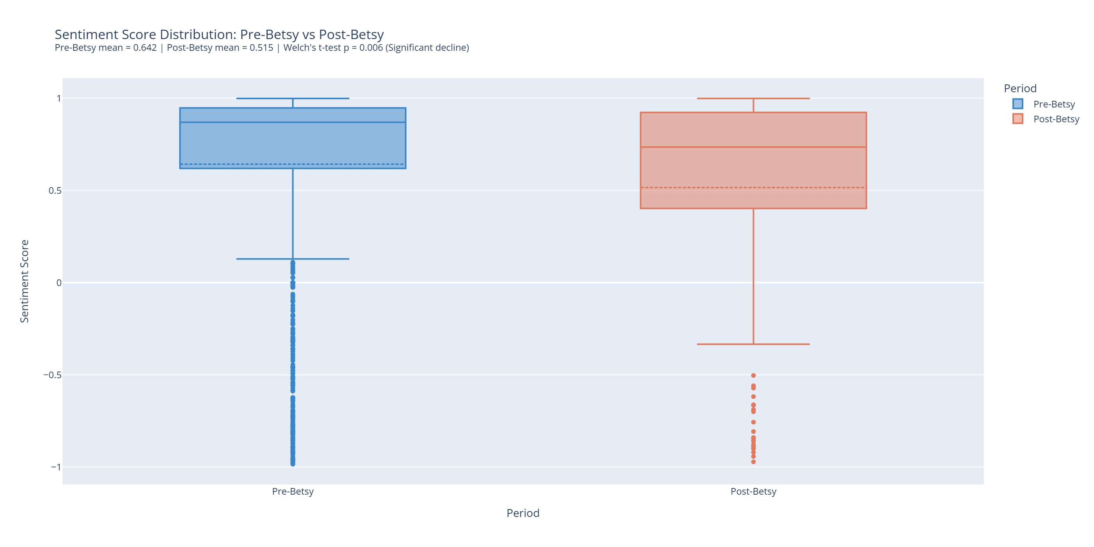
Figure 5.4. Distribution of Trustpilot VADER compound sentiment scores for Better.com pre-Betsy (n = 1,746) and post-Betsy (n = 169). The post-Betsy distribution is shifted modestly downward and exhibits a longer negative tail. Source: Author’s analysis of 1,915 cleaned Trustpilot reviews (Apify scrape; collected on Better.com’s public Trustpilot profile). Welch’s t-test p = 0.0057, Cohen’s d = 0.2505. The post-Betsy sample is substantially smaller than the pre-Betsy sample; the figure represents unsolicited Trustpilot review discourse rather than the full Better.com customer population.
Three interpretive moves are required to read this evidence responsibly. First, the post-Betsy sample is approximately ten times smaller than the pre-Betsy sample (169 vs. 1,746), meaning the post-period estimate is more sensitive to a small number of unusually negative reviews. Second, Trustpilot reviewers are self-selected and prone to extreme-response bias (Filieri, 2015; Luca, 2016), and the platform is therefore not representative of the full Better.com customer base. Third, the evidence is associative rather than causal: many factors changed concurrently with Betsy’s launch, including product mix, market conditions, and broader service operations, and the keyword analysis cannot determine whether individual reviewers interacted with Betsy. With those caveats, the most defensible interpretation is that independent customer discourse on Trustpilot does not mirror the management-reported NPS improvement and instead displays a small-to-medium statistically significant decline in both ratings and sentiment over the post-Betsy window.
Effect-size context is useful. Cohen’s d values of approximately 0.29 (ratings) and 0.25 (sentiment) correspond, in conventional terms, to small-to-medium effects. They are not negligible, but they are also not large. In substantive terms, the rating decline of approximately 0.42 points on a 5-point scale is consistent with a moderate downward shift in the distribution rather than a collapse of customer discourse, and the corresponding VADER sentiment decline of approximately 0.13 on a roughly −1-to-+1 compound scale fits the same characterization. The Trustpilot stream therefore complicates any reading of the customer-experience evidence as uniformly positive, but it does not support the strong claim that customer experience deteriorated dramatically post-Betsy.

5.4.3 Keyword Prevalence and the AI-Invisibility Finding
A targeted keyword-prevalence analysis was conducted across seven thematic groups on the full 1,915-review clean dataset. Reviews were binary-coded for the presence of group-specific keywords using strict word-boundary regular expressions, and Pearson’s chi-squared tests evaluated whether prevalence shifted between the pre- and post-Betsy periods. A Bonferroni correction was applied to mitigate Type I error risk from multiple comparisons. The Cost/Rates group declined from 28.92 percent to 16.57 percent (−8.98 pp before rounding to 12.35 percentage points; p = 0.0009), surviving strict Bonferroni correction. The Digital/Process group declined from 32.65 percent to 23.67 percent (−8.98 pp; p = 0.0211), significant under the unadjusted alpha but not after Bonferroni. Speed/Efficiency declined from 52.00 percent to 44.38 percent (p = 0.0698), suggestive but not statistically significant. Human Support, Communication, and Delay/Friction did not change significantly.
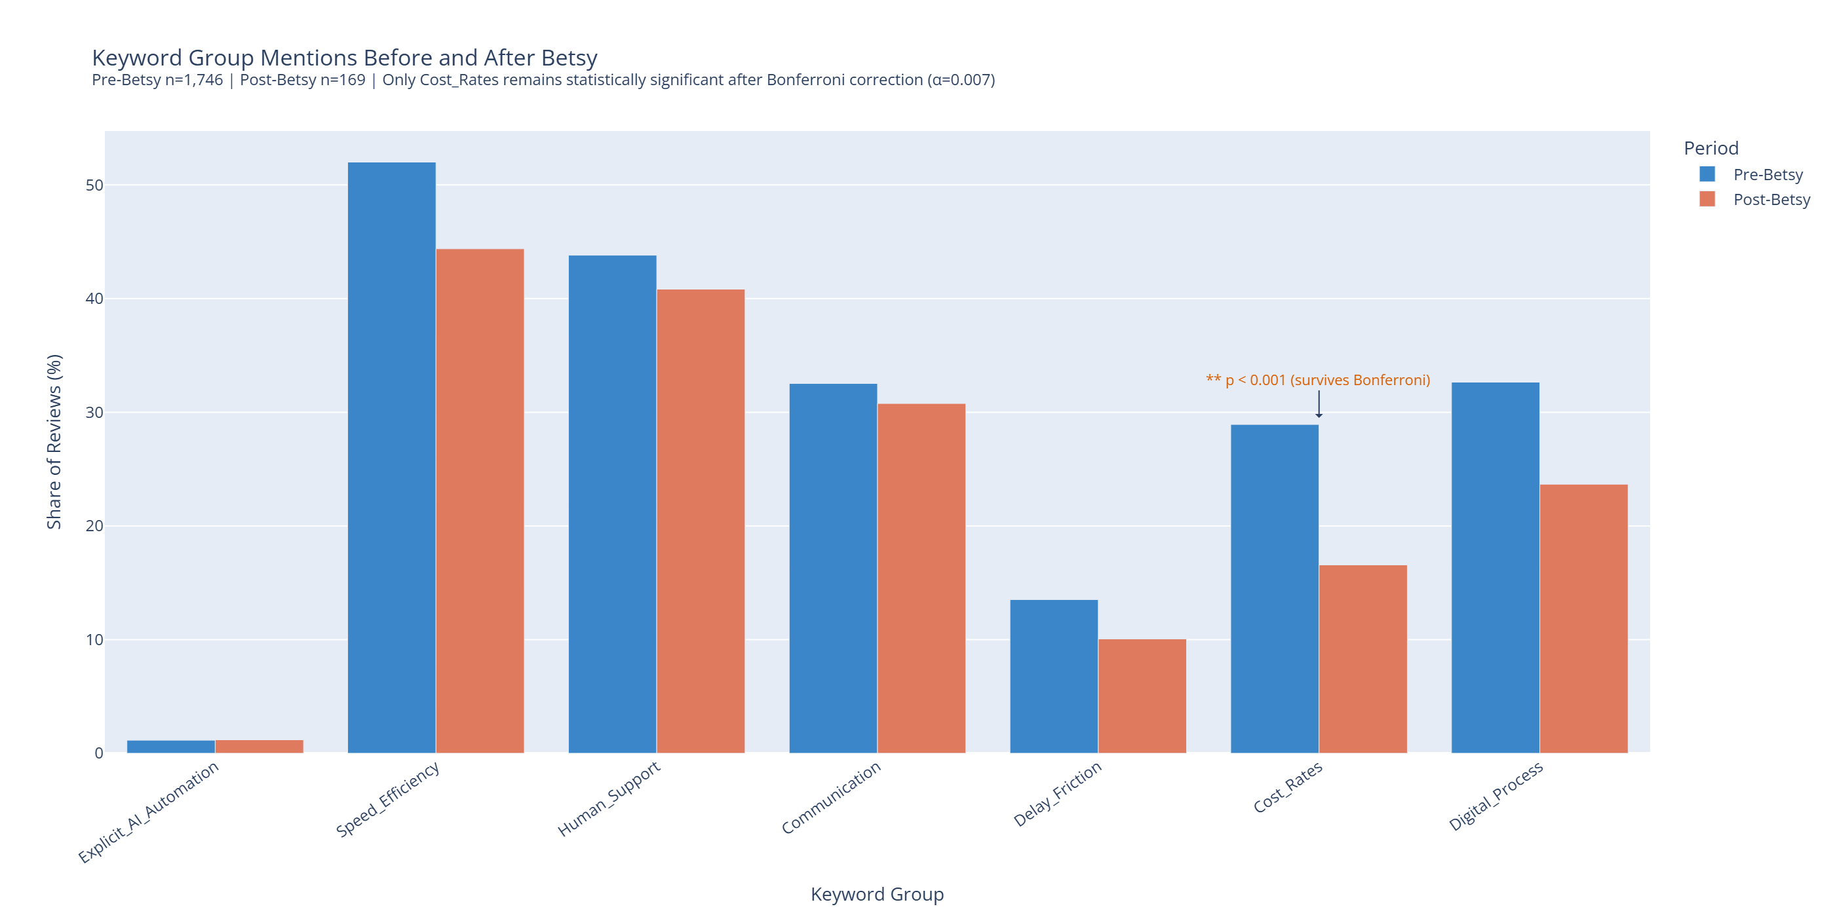
Figure 5.5. Prevalence of seven keyword groups in pre-Betsy (n = 1,746) and post-Betsy (n = 169) Trustpilot reviews. Only the Cost/Rates decline survives strict Bonferroni correction (p = 0.0009). Explicit AI/Automation mentions remain near 1 percent in both periods (Fisher exact p = 1.0000). Source: Author’s analysis of 1,915 cleaned Trustpilot reviews using strict word-boundary regular expressions and Pearson’s chi-squared tests with Bonferroni correction.
The most thesis-relevant keyword result is the Explicit AI/Automation group. The prevalence of explicit AI mentions is essentially unchanged across the two periods (1.15 percent pre-Betsy versus 1.18 percent post-Betsy; Fisher exact p = 1.0000). This near-zero difference is interpreted in this thesis as the AI-invisibility finding: the near-zero explicit AI mention rate suggests that Trustpilot reviewers do not usually frame their mortgage experience in AI-specific terms. This supports the interpretation of voice AI as invisible infrastructure (Mogaji & Nguyen, 2021), although the keyword analysis cannot determine whether individual reviewers interacted with Betsy. The finding is therefore a discourse observation about what customers write about, rather than a behavioral claim about who interacted with the AI agent.
The Cost/Rates result deserves a complementary interpretive note. A decline in the prevalence of cost- and rate-related keywords post-Betsy does not necessarily mean that Better’s pricing improved in customers’ experience. It indicates that the salience of cost- and rate-related language in the Trustpilot corpus declined. The most plausible compositional explanation is the broader interest-rate environment and a partial shift in product mix, rather than a direct effect of voice AI on price perception. The Digital/Process result is treated as suggestive only, given that it fails strict Bonferroni correction; this is consistent with the approach in Wang et al. (2023) and Zhang et al. (2023), which emphasize cautious interpretation of NLP signals when sample sizes differ markedly between groups.
The non-significant keyword groups are themselves analytically useful. The Human Support group (43.81 percent pre versus 40.83 percent post) shows that customer attention to human-mediated service did not collapse after Betsy’s deployment, which is consistent with the task-reallocation interpretation rather than a labor-substitution interpretation. The Communication group (32.53 percent pre versus 30.77 percent post) is essentially unchanged, suggesting that the salience of communication-quality language in customer reviews did not shift in the post-Betsy window. The Delay/Friction group (13.52 percent pre versus 10.06 percent post) declines modestly but not significantly. None of these groups individually justifies a strong interpretive claim, but together they suggest that the post-Betsy customer-discourse environment did not undergo a wholesale compositional shift toward or away from any single keyword theme. What did shift, modestly but reliably, was overall sentiment and rating, alongside a salient decline in cost/rates language and a persistent absence of explicit AI vocabulary.

5.4.4 Topic Modeling and Product-Mix Interpretation
BERTopic neural topic modeling (Grootendorst, 2022) was applied to a 1,804-document subset of the cleaned Trustpilot corpus, after filtering CEO- and 2021-controversy-related reviews that focused on the company’s leadership rather than its mortgage product. The pipeline produced 44 topics; 1,198 documents were successfully clustered and 606 were assigned to the HDBSCAN noise class. The clustered non-outlier subsample used for the topic-share comparison consists of 1,077 pre-Betsy and 121 post-Betsy reviews. Because the post-Betsy clustered non-outlier sample is small, topic-share differences are interpreted as descriptive signals rather than as statistically tested population-level changes.
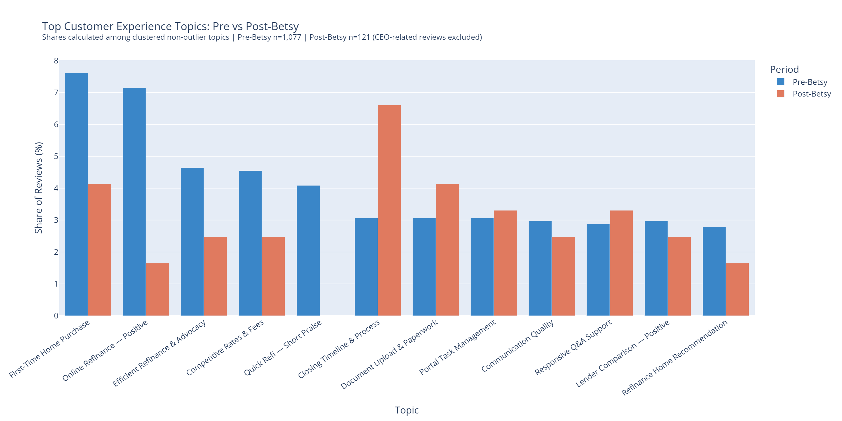
Figure 5.6. Selected topic-share changes between pre-Betsy (n = 1,077) and post-Betsy (n = 121) clustered non-outlier Trustpilot reviews. The figure is presented as a descriptive overview of the topical composition shift, not as a statistical test. Refinance topics decline by approximately 7.66 percentage points combined; HELOC Complaints, Smooth Transaction, Responsive Service, and Closing Timeline rise by between 3.55 and 4.22 percentage points. Source: Author’s analysis using BERTopic with all-MiniLM-L6-v2 embeddings, UMAP, and HDBSCAN.
Read descriptively, several patterns are visible. The combined share of refinance-oriented topics declines by approximately 7.66 percentage points, while the share of HELOC-related complaints rises by approximately 4.22 percentage points and the share of Home Purchase topics declines by approximately 3.48 percentage points. The Smooth Transaction (+4.03 pp), Responsive Service (+3.93 pp), and Closing Timeline (+3.55 pp) topics also rise modestly. The most plausible interpretation of the refinance decline is the macro-level interest-rate environment, which suppressed refinancing demand across the U.S. mortgage industry rather than reflecting a Betsy effect (Mortgage Bankers Association, 2024). The rise in HELOC complaints is most plausibly read as a product-mix signal, given Better’s strategic emphasis on the HELOC product over the relevant period. The simultaneous rise of Smooth Transaction and Responsive Service shares is directionally consistent with the operational-efficiency interpretation, but cannot be associated solely with Betsy given the small post-period sample, the absence of controls, and concurrent product- and process-mix changes.
Two methodological observations sharpen the topic-level reading. First, BERTopic clustering depends on hyperparameter choices in the UMAP and HDBSCAN stages and on the all-MiniLM-L6-v2 embedding model. As Grootendorst (2022) notes, topic identities are stable across reasonable hyperparameter perturbations but exact topic shares are sensitive to those choices; the percentage-point figures reported above should therefore be interpreted as approximate compositional signals rather than as fixed population parameters. Second, the clustered non-outlier denominator structure (Pre n = 1,077 versus Post n = 121) is even more imbalanced than the full clean dataset, which means topic-share estimates for the post-period are particularly sensitive to a small number of reviews. The figures reported in this section therefore serve as a descriptive map of the post-Betsy discourse rather than as inferential claims about population-level topic prevalence. Appendix figures (intertopic distance map, topic-word importance, and quarterly keyword trends) are provided for transparency but are not used to substantiate any claim in the main chapter.

5.4.5 Customer-Experience Boundaries: Synthesis for the NLP Stream
Synthesizing the customer-experience evidence, the NLP stream answers RQ2’s customer-experience dimension as follows. Independent Trustpilot discourse displays a small-to-medium, statistically significant decline in star ratings and VADER sentiment across the post-Betsy window, while management-reported NPS rises substantially. Customers rarely frame their experience in explicit AI terms, which is consistent with the interpretation of voice AI as invisible infrastructure but is silent on individual exposure to Betsy. Topic shifts are best interpreted as descriptive evidence of product-mix and macro-environment effects rather than as evidence of Betsy’s direct effect on customer experience. The customer-experience stream therefore complicates rather than confirms the financial-operational interpretation, and this complication is itself analytically valuable.

5.5 Triangulated Interpretation
Taken together, the three evidence streams support a multidimensional interpretation of voice AI business value at Better.com. The qualitative case evidence shows that Betsy is not a stand-alone chatbot but a voice interface embedded in Better’s Tinman-based mortgage operating platform, with ElevenLabs as voice infrastructure and licensed humans retaining authority over consequential decisions. The financial evidence shows that the post-transition period is associated with revenue recovery, expense-intensity improvement, narrowing losses, and partial labor-productivity recovery. The customer-experience evidence is mixed: management-reported NPS improves materially, while independent Trustpilot star ratings and sentiment decline significantly, and explicit AI mentions remain near-zero in both periods.
The strongest evidence is for the operational-efficiency and financial-trajectory dimensions of business value. The expense-ratio improvement from 2.89 to 2.01 between 2024 and 2025, achieved with approximately 52 percent revenue growth against approximately 5 percent expense growth, is the textbook descriptive signature of operational leverage and is consistent with the AI-enabled operational-leverage hypothesis examined in this thesis. The evidence for productivity and scalability is moderately strong: RPE improves substantially in 2025 but remains below the 2021–2023 pre-period average of approximately $0.130 million, indicating partial rather than full recovery. The evidence for customer-experience improvement is weak and divergent: NPS supports an improvement narrative, but the Trustpilot signals run in the opposite direction. The case evidence on RQ1 supplies the integration mechanism that makes the financial signature plausible: a Tinman-mediated workflow into which a voice LLM agent has been embedded with auditable human escalation.
The divergence between the financial-operational and customer-discourse streams is methodologically valuable rather than analytically embarrassing. It indicates that different measurement instruments capture different facets of customer experience and business value. Management-reported NPS captures customers’ internal evaluation in a structured survey context. Trustpilot ratings and VADER sentiment capture self-selected, unsolicited public discourse from a smaller, more vocal subset of customers. Topic and keyword analyses capture the linguistic salience of particular themes in that public discourse, which is sensitive to product-mix and macro-environment effects. The most defensible synthesis is therefore that voice AI in the Better.com case is associated with measurable improvements in operational efficiency and financial trajectory, while its effects on customer experience are uneven, mediated, and possibly under-detected by any single instrument. This is consistent with Aggarwal et al.’s (2025) argument that voice AI value creation occurs across both B2B and B2C surfaces in ways that are not captured by a single metric, and with the broader literature on AI in customer-facing financial services (Hentzen et al., 2022; Mogaji & Nguyen, 2021).
The triangulated interpretation also clarifies the limits of attribution. Even where the financial evidence is strong, it cannot isolate Betsy’s specific contribution from the broader Betsy/Tinman AI operating model. The case evidence indicates that Betsy operates as one component of an integrated technology stack and operating model, alongside Tinman, ElevenLabs, the NEO channel, restructuring, and broader market dynamics. The thesis therefore does not claim that Betsy alone caused Better.com’s post-transition financial trajectory. It claims that the post-transition trajectory is consistent with AI-enabled operational leverage when interpreted alongside the qualitative case evidence on Betsy’s deployment and Tinman’s architectural role, and that customer-experience effects appear to be more uneven than the financial signature would suggest.
From a theoretical perspective, the triangulated pattern is most naturally read through three complementary lenses. First, in the task-technology fit tradition (Goodhue & Thompson, 1995), the financial-operational improvement is consistent with a high fit between Betsy’s task scope (high-volume, structured, communication-intensive coordination work) and Tinman’s structured workflow environment, while the customer-experience divergence is consistent with a more uneven fit between AI-mediated voice interaction and the more relational, emotionally laden moments of the borrower journey (Blümel et al., 2024). Second, in the AI service hierarchy of Huang and Rust (2018), Betsy is positioned in the mechanical and analytical layers, where productivity gains are most likely to materialize, while the customer-experience layer engages intuitive and empathetic dimensions where AI substitution is more contested. Third, in the AI-enabled productivity tradition revisited by Brynjolfsson et al. (2023) and Aggarwal et al. (2025), AI-related productivity gains tend to emerge alongside ambiguous customer-perception effects when the AI system operates as backend infrastructure rather than as a branded front-of-house experience. The Better.com pattern is consistent with all three lenses simultaneously, which strengthens the descriptive interpretation without resolving the causal question.
The triangulated interpretation also has implications for the design-pattern argument that Chapter 6 develops. The Better.com case suggests that voice AI in financial services is most likely to generate measurable business value when it is integrated with a process-aware operating platform that exposes structured workflow state, when its task scope is bounded to communication coordination rather than regulated decision-making, when its voice infrastructure supports natural conversation at low latency, and when human escalation is preserved and auditable. These integration prerequisites are summarized as a design pattern in Chapter 6, with explicit acknowledgement that the pattern is derived from a single revelatory case and is therefore proposed for analytic generalization rather than for statistical generalization.

5.6 Limitations and Boundary Conditions of the Empirical Findings
Five boundary conditions should be kept in mind when reading the empirical findings. First, the study is a single-case design and therefore does not support statistical generalization to all U.S. mortgage originators or to financial services more broadly; Better’s digital-first architecture and Tinman platform are unusually favorable conditions for voice LLM integration. Second, the financial data are reported at annual granularity, which limits the temporal resolution of the post-Betsy window; the 2024 fiscal year blends approximately ten months of pre-deployment performance with two months of post-deployment performance. Third, the NLP corpus is drawn from a single review platform, is unsolicited, and is dominated by self-selected reviewers; the pre/post imbalance (1,746 vs. 169) further limits the precision of the post-period estimates. Fourth, Rocket Companies is included as a directional industry benchmark rather than a counterfactual; differences in scale, business model, and the 2025 Mr. Cooper acquisition preclude treatment-effect interpretation. Fifth, vendor materials from ElevenLabs are subject to an obvious incentive structure and are therefore used to characterize the integration mechanism rather than to substantiate magnitude claims about cost savings or revenue uplift.
These limitations do not invalidate the findings, but they bound the kind of claim the thesis can make. The strongest defensible claims are descriptive and triangulated: the post-deployment period is associated with revenue recovery, expense-intensity improvement, narrowing losses, and partial productivity recovery; customer discourse on Trustpilot is mixed and includes a statistically significant rating and sentiment decline; explicit AI mentions are rare; and the case-study evidence supplies the workflow-integration mechanism through which a voice LLM agent could plausibly contribute to operational leverage.
A further conceptual boundary deserves explicit statement. The thesis focuses on the deployment of a voice LLM agent in mortgage origination, a regulated, communication-intensive financial-services context. The empirical findings are most directly informative for analogous contexts — retail banking servicing, insurance servicing, and other high-volume, communication-intensive financial workflows where a process-aware operating platform is or could be in place. They are less directly informative for less-regulated or less-communication-intensive contexts, and they should not be read as a general claim about AI-enabled productivity in financial services as a whole. Chapter 6 develops the design-pattern implications of this scope condition.

5.7 Summary of Empirical Findings
Chapter 5 has integrated qualitative case-study evidence, longitudinal financial evidence, and customer-discourse evidence into a single empirical argument addressing the two research questions of the thesis.
RQ1 (integration). Voice LLM agents become operationally meaningful in mortgage origination when they are embedded in a process-aware operating platform that exposes structured workflow state, when they are scoped to a communication-coordination role rather than a regulated decision-making role, when they are supported by low-latency voice infrastructure, and when they are governed by an explicit human-AI collaboration model with auditable escalation. In the Better.com case, Tinman supplies the architectural prerequisite, Betsy operationalizes the conversational coordination layer, ElevenLabs supplies the voice infrastructure, and the regulated task structure of mortgage origination supplies the human-in-the-loop boundary.
RQ2 (business value). The empirical evidence is consistent with AI-enabled operational leverage in the financial-operational dimension and is mixed in the customer-experience dimension. Concretely, the post-transition period (2024–2025) is associated with approximately 52.0 percent revenue growth and only approximately 5.3 percent expense growth, an expense-ratio decline from 2.89 to 2.01, an approximately 19.6 percent narrowing of net loss, and an approximately 42.9 percent improvement in revenue per employee — although the company remained unprofitable in 2025 and RPE remained below the pre-period average. Customer-experience evidence is mixed: management-reported NPS rises from 39 to 64, while independent Trustpilot star ratings decline from 4.2806 to 3.8580 (p = 0.0019; d = 0.2899) and VADER sentiment declines from 0.6416 to 0.5151 (p = 0.0057; d = 0.2505). Explicit AI mentions remain near 1 percent in both periods. Topic shifts are descriptive and most plausibly reflect product-mix and macro-environment effects rather than direct Betsy effects.
Synthesized across the three streams, the central empirical finding of the thesis is that voice AI in financial services should be understood as creating multidimensional, mediated business value rather than uniformly directional improvement. The financial signature is consistent with AI-enabled operational leverage but cannot isolate Betsy’s specific contribution; the customer discourse is mixed in ways that complicate, but do not invalidate, the management-reported NPS narrative; and the case-study evidence supplies the workflow-integration mechanism through which the financial signature becomes plausible. Chapter 6 develops the managerial and theoretical implications of these findings, including the design pattern that the Better.com case suggests for voice LLM integration in regulated, communication-intensive financial-services workflows.

