Notebooks/data_preparation.ipynb created:
Train 60, Validate 20, Test 20

Problem:
Feature selection first: before/after encoding of categorical X
Or Feature Engineering first: before/after encoding of categorical X
I will go first with Feature Engineering then Feature Selection

After preparation analysis, it was saved into “after_preparation.pkl”: df_train, df_valid, df_test

Comparing imputation graphs with frequency counts with value_counts(normalize = True) to check if it makes sense to correct missing data or better to drop

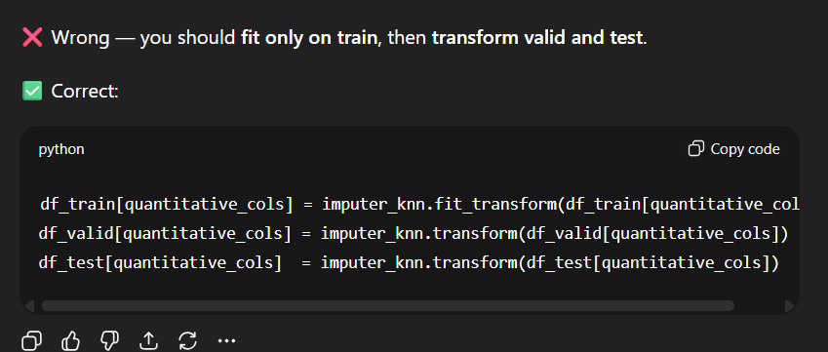

Only in train — fit the Y transformation (e.g., log or scaler) on train, then apply the same transform to valid and test.
Missing values are handled properly – KNN Imputer for Numerical Variables and fillna(‘Unknown’) for categorical features.
Now time for Y – scaling and check its distribution, should be normal for better model.
Np.log() was similar to boxcox and yeojohnson, but I chose it due to its simplicity – to scale Y.
own_type is near-zero variance (both high_freq_ratio=1 and low_unique_ratio=1), so it’s safe to remove it from your features.

Then apply get_dummies transformation BEFORE feature selection.

After applying get_dummies() still variables were in “object” form so I had to pd.to_numeric
- I mean to convert them to make it numerical data types

