NATIONAL DONG HWA UNIVERSITY

STOCK MARKET FORECASTER

USE OF TECHNICAL ANALYSIS INDICATORS AND NEURAL NETWORK BASED PREDICITVE MODEL AT TRADING SHARES OF NASDAQ MARKET

MUSA MUKHAMMED

410621332

ADVISOR: CHIH – HUNG LAI

**Abstract**

This research applies a market profile to establish particular technical indicators to classify the correlation between the variation in price and value within stock trends. The indicators and technical indices are Moving Average Convergence Divergence (MACD), Relative Strength Index (RSI), and neural network (NN) architecture parameters, that assist to extrapolate the market logic and knowledge rules that influence future NASDAQ market structures via an integral assessment of physical quantities. The secondary objective is the optimization of indicator’s parameters of technical analysis and subsequent comparison of profitability of business strategies based on these optimized parameters. To implement the theory of market profile on neural network architecture, this study proposes qualitative and quantitative methods to compute a market profile indicator. In addition, the indicator considers the variation and relevance between long-term and short-term trends, by incorporating long-term and short-term market variation in its calculations. These two strategies together assess the predictions of market profiles based on technical indicators and a predictive model. Analyzed was the period of around 16 months, commencing in 2018 and until present time, with measurement based upon the daily closing prices of the shares of some NASDAQ market companies.

**1. Introduction**

**1.1 Stock Market**

A stock market, equity market, or share market is the accumulation of buyers and sellers of stocks (also called shares), which represent ownership claims on businesses. These may include *securities (a proof of ownership or debt that that has been assigned a value and may be sold)* listed on a public stock exchange, as well as stock that is privately traded, such as the shares of private companies which are sold to investors through equity platforms. Investment in the stock market is most often done via electronic trading and stockbrokerages. Electronic trading is the process of setting up an account, including contact and financial, to service transfers between the broker and bank. A stockbroker also known as a registered representative, investment adviser or simply broker, is a professional who carries out buy and sell orders for stocks and other securities on behalf of their clients. Investments are usually made with an investment strategy in mind beforehand.

Stock markets have existed for centuries with the oldest stock exchange originating in Belgium in 1531. The brokers and moneylenders used to meet there to deal with businesses, however, they never used actual stocks but traded in promissory notes and bonds. Years later the Amsterdam Stock Exchange was established in 1602 by the Dutch East India Company and registered as the first official stock exchange. From the beginning, stock markets have served many purposes, with the most important being to offer companies a place to raise capital for investment and expansion and to provide opportunities for people to let their money work for them, and not only as a place of storage.

Stock markets exist to serve the wider economy. It helps individuals earn a profit on their income when they invest in the stock market and allows firms to take big risks with the hope of reaping large rewards. It also enables governments to increase spending through the tax revenue they earn from corporations that trade in the stock exchange. Governments then can use the revenue to promote further re-investment and increase employment capacity.

The stock market plays an important role in the economy of a country in terms of spending and investment. Without stock markets, many countries would not have reached the development level they currently have. Furthermore, companies would have to resort to borrowing money from the bank to afford business expansions, and this would ultimately become a burden on their budgets since they would be required to repay loans with interest rates. Fortunately, with stock markets, businesses have the ability to create an initial public offering and raise significant funding without having to worry about repayment. Moreover, publicly traded companies have no obligation to pay dividends when they incur loses and as a consequence the capital raised can help companies expand operations and create jobs for economy. From a greater economic perspective, consumer and government spending increases, and there are lower levels of unemployment.

Alongside these benefits, stocks have also helped many individuals become wealthy and has increased the overall standard of living for multiple societies. For the individual investor, stock markets afford an opportunity for them to invest their income in order to earn a share of a companies’ profits. This revenue can then increase spending in the local economy which then has a multiplier effect in the wider economy. Increased individual spending leads to increased investment and employment as a result.

This article is focused on analysis, selection of technical indicators, and optimization of those indicators’ parameters. It is also focused on using advanced technologies to help analyze determined data. The aim of this article is to attempt to forecast the future stock trends of NASDAQ companies and to compare the results achieved for investors with the results of other researchers. Optimization is carried out to make a given indicator read better in a new trend at a given volatility while under the assumption that volatility, unless there is a sudden shock, does not change too much. Usually volatility is at low levels in comparison to a period of distrust and fear in the markets. Therefore, by optimizing the influence of volatility should be reduced. At higher volatility readings the indicator generates reasonable signals, while at the initial setting an indicator might create a higher quantity of signals, from which more can be false and thus may harm an investor as mentioned in “OPTIMZIED INDICATORS OF TECHNICAL ANALYSIS ON THE NEW YORK STOCK EXCHANGE” article by [**Martin Širůček**](https://www.researchgate.net/profile/Martin_Sirucek2).

**1.2 Technical indicators**

Technical indicators are heuristic or pattern based signals produced by the price, volume, and/or open interest of a security or contract used by traders who follow technical analysis. By analyzing historical data, technical analysists use indicators to help forecast future price investments. Examples of common technical indicators include the Relative Strength Index (RSI), Moving Average Convergence Divergence (MACD) and Bollinger Bands (BB).

MACD:

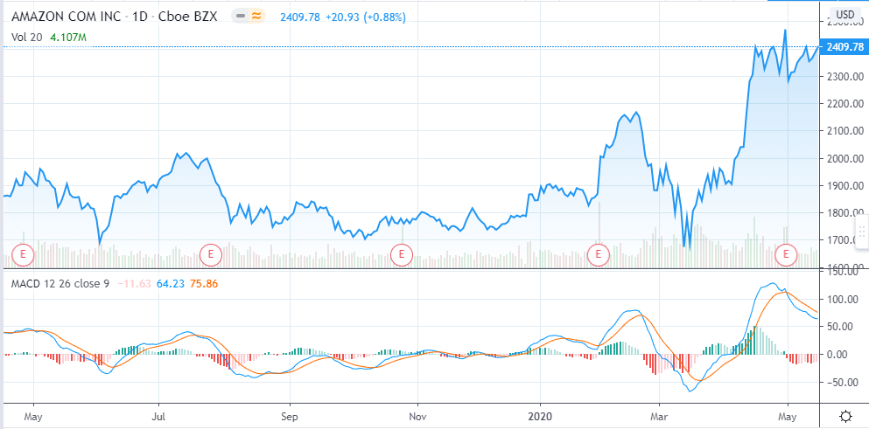

Moving Average Convergence Divergence is a trend following momentum indicator that shows the relationship between two moving averages of a security’s price. Momentum is the measurement of the speed and the velocity of price changes. In “Technical Analysis of the Financial Markets,” John J. Murphy explains:

“Market momentum is measured by continually taking price differences for a fixed time interval. To construct a 10-day momentum line, simply subtract the closing price 10 days ago from the last closing price. This positive or negative value is then plotted around a zero line. “

The MACD is calculated by subtracting the 26-period Exponential Moving Average (EMA) from the 12-period EMA. The result of that calculation is the MACD line. A nine-day EMA of the MACD called the “signal line,” is then plotted on top of the MACD line, which can function as a trigger for buy and sell signals. Traders may buy the security when the MACD crosses above its signal line and sell or short the security when the MACD crosses below the signal line. Moving Average Convergence Divergence (MACD) indicators can be interpreted in several ways, but the more common methods are crossovers, divergence and rapid rises/falls.

Price line, MACD line, and signal line are plotted on the above picture. MACD line and signal line are shown below the price line as blue and orange lines respectively.

RSI:

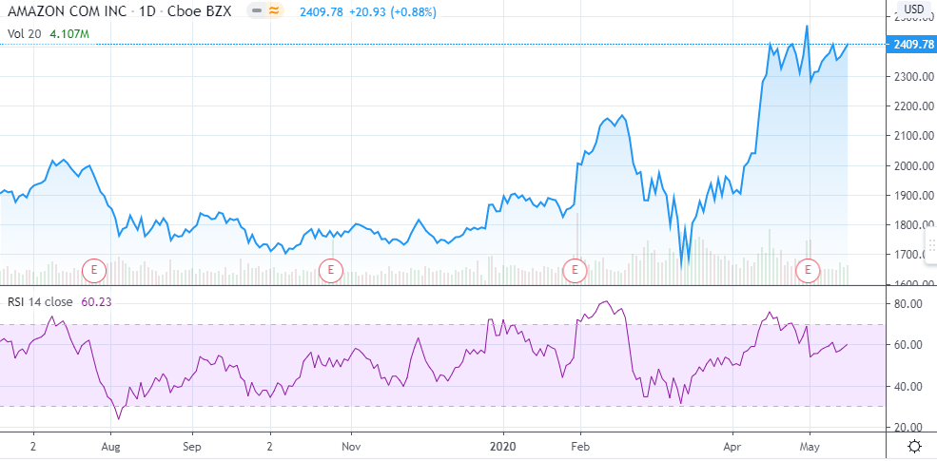

The Relative Strength Index (RSI) is a momentum indicator used in technical analysis that measures the magnitude of recent price changes to evaluate overbought or oversold conditions in the price of a stock or other asset. The RSI displayed is an oscillator (a line graph that moves between two extremes) that can have a reading from 0 to 100. The indicator was originally developed by J. Welles Wilder Jr. and introduced in his seminal 1978 book, “New Concepts in Technical Trading Systems.”

Traditional interpretation and usage of the RSI are that values of 70 or above indicate that a security is becoming overbought or overvalued and may be primed for a trend reversal or corrective pullback in price. An RSI reading of 30 or below indicates an oversold or undervalued condition.

On the graph above the RSI line is plotted below the price line and values 70 and 30 are displayed by dashed lines. What is notable on the graph is whenever the RSI line crosses line 70 or line 30 it returns to the pink area which is between 70 and 30. Therefore, when the RSI line crosses line 70 it usually causes an alert to traders that it is time to sell, because the price is likely to decrease. And when the RSI line crosses line 30 it forecasts that the prices is likely to grow, with traders suggested to buy stocks when the RSI line goes to or below line 30.

Bollinger Bands (BB):

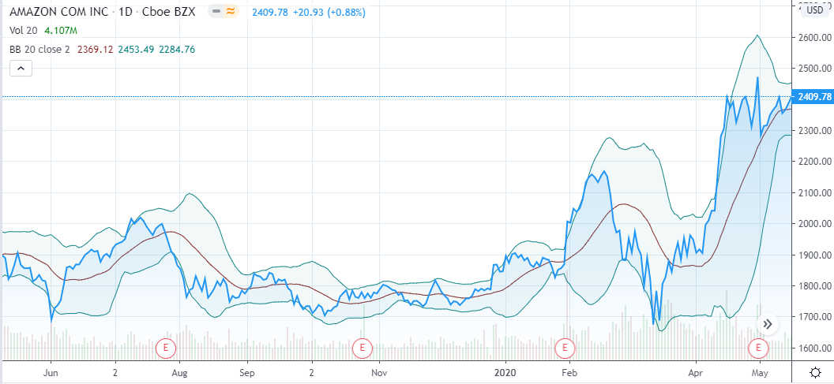

Bollinger Bands were created by John Bollinger in 1980s as a method for traders to identify extreme short term prices in a security. The indicator is created by plotting the average of predetermined number of prices / simple moving average (SMA) along with two trading bands above and below. The outer bands are created by simply adding and subtracting one standard deviation from the moving average.

The standard deviation is a statistic that measures the distribution of a dataset relative to its mean and is calculated as the square root of the variance. Variance in statistics is a measurement of the spread between numbers in a data set. That is, it measures how far each number in the set is from the mean and therefore from every other number in the set. The standard deviation is calculated as the square root of variance, by determining the variation between each data point relative to the mean. If the data points are further from the mean, there is a higher deviation within the data set; thus, the more spread out the data, the higher the standard deviation.

A simple moving average (SMA) calculates the average of a selected range of prices, usually closing prices, by the number of periods (days) in that range.

Under normal conditions traders will nearly always see the price of a security to trade within the bands. The bands will expand and shrink as the price action of a security becomes volatile. The main concept to understand when using Bollinger Bands is that the periods of low volatility generally tend to be followed by periods of high volatility and vice versa. Another way of using Bollinger Bonds is through observing when the price line crosses the outer bands. When the price line crosses the upper band the stock is thought to be overbought and the price may immediately return to the safe region (between the outer bands). Conversely, when the price line crosses the lower band then the stock is considered to be oversold and the price is likely to grow.

On the graph above the Bollinger Bands indicator is displayed with price, SMA, and outer bands, with a blue line, red line, and light blue line representing them respectively.

**2. Methodology**

**2.1 Related Works**

 Considering the numerous amount of technical indicators, a trader could wonder which one is the most accurate, or which one is the most efficient, and if they are truly able to forecast the future price trends of a stock. The truth is there is no best technical indicator, an example being the sorting algorithm. There are no best sorting algorithms, there are certain situations where a particular algorithm can perform better than others, however, it is not guaranteed that the algorithm will always work better than all other algorithms. Similarly, to analyze stock market trends there are many different kinds of indicators, and it is best not to use an immoderate number of indicators at the same time. A trader might think to use many indicators to get as precise a forecast as possible, but that strategy is not appropriate. Because all indicators have different values and estimators, using many technical indicators might confuse a trader when they are given many different types of numbers, and excess data shown on the graph/screen. It is better to keep the data clear and simple by implementing only one or a few indicators plotted on the graph.

[Maria Janošková (Antošová)](https://www.researchgate.net/profile/Maria_antosova2) in her paperwork selected the RSI indicator in order to analyze the successfulness of a trader utilizing it whilst trading the shares of the largest international steel companies. The RSI indicator itself was calculated based upon the daily closing prices of individual companies, with calculations being determined from a chosen duration of 14 days. The relative strength index was focused on 3 major deficiencies of those technical analysis indicators that fall into oscillator group:

1) Values of oscillators are often erroneously influenced by development of the past data that present an integral part of their calculations. In this way determined values of indicators can be often unclear. In other words, the more volatile the market becomes the less precise the indicators can get.

2) The problem with oscillators is the proper selection of the upper and lower limits, overrunning of which is a signal for either purchase or sell.

3) To be calculated, oscillators necessitate use of prolonged and “dense” time series.

Calculation:

RSI = 100 – 100 / (1 + RS)

RS = Average gain / Average loss.

Average gain and average loss in the calculation is the average percentage gain or loss during a look-back period. The formula uses positive value for the average loss. The standard is to use 14 periods to calculate the initial RSI value.

[Maria Janošková (Antošová)](https://www.researchgate.net/profile/Maria_antosova2) also interprets RSI as an analysis of divergences, which consists of comparing the course of development of the rate and the course of RSI. Therefore, If the indicator develops contrary to the rate of the share it could indicate to a coming change in the trend. There are 2 types of divergences that appear in markets rarely, but they have very high accuracy, those are bullish and bearish divergences. Bullish divergence occurs when the price trend of a stock is moving down and the momentum of the stock (RSI) is moving up, which means that the price trend has gone too far down, so it is very likely for the price trend to start moving up. Bearish divergence occurs when the price trend of a stock is moving up and the momentum (RSI) of a stock is going down, this means that the price trend has gone too far up, so it is very likely that the price trend will start declining soon.

[Maria Janošková (Antošová)](https://www.researchgate.net/profile/Maria_antosova2) mainly uses RSI to reveal the moments when the under-laying asset is overvalued or undervalued. For extreme limits the limits 70 and 30 are recommended, though limits of 80 and 20 or 75 and 25 are also possible. Maria Janošková’s made use of the limits 80 and 20 when conducting her analysis.

Maria recorded in a period of one year 94 occasions in which, based on the RSI indicator, the market was overbought and 238 times it was oversold.

The key point to take away from Maria’s research is that the moment the stock market is overbought; the RSI indicator shows the price of the supporting asset going down. For traders owning shares this should signal the need to sell the stock. Analyzed were all 94 moments when the RSI indicator attained the value above 80. For traders with shares this was supposed to signal a decline in the price of shares. Beside the moment when the RSI indicates that the market has been overbought, analyzed is the opposite case when the market is oversold. The case occurs when the RSI indicators attain a value lower than 20 points. For the traders with shares this was supposed to signal a turn in the market and the possibility to make profit through purchase of shares. In 10 days after the RSI declined further than 20, price fluctuation would then begin to turn upwards, which showcases the volatility of prices, but it should be noted that in most cases the gain was greater than the loss.

Of the overall 332 analyzed events, the opportunity to attain profit over the next 10 could be seen in 216 cases. From this perspective, the RSI indicator is well applicable for trade among the steel companies.

RSI is a very unique indicator that can be combined with other indicators to improve data analysis. [Martin Širůček](https://www.researchgate.net/profile/Martin_Sirucek2) used RSI along with other indicators in order to forecast the direction of future stock prices in the NYSE. The main aim of Martin’s research is the evaluation of technical analysis for selected index instruments which are traded in the NYSE. The second aim was the optimization of indicator’s parameters of technical analysis, and the subsequent comparison of the profitability of business strategies based upon these optimized parameters. The empirical analysis included the back testing of optimized indicators and comparisons with the default settings of these indicators. The optimization and back testing were performed on cyclical stocks, represented by stock index S&P 500 Financial from 2014/11/1 to 2015/10/31.

For the comparison of optimized parameters technical indicators with recommended parameters; average convergence divergence (MACD), Bollinger Bands (BB), relative strength index (RSI) and simple moving average (SMA) were selected.

Recommended parameters for technical indicators:

MACD:

Long-term period set to 26 periods. Short-term period set to 12 periods. Signal line is moving average of 9 periods. All these settings are recommended by the creator of MACD, Gerald Appel.

BB:

Simple moving average (SMA) set to 20 periods. Bandwidth is given as two standard deviations. One standard deviation is added to the SMA and the other standard deviation is subtracted from the SMA. This setting is recommended by the author of the indicator John Bollinger.

RSI:

To calculate RSI values 14 periods are used. The bottom boundary is set to 30 and the top boundary is set to 70. This setting is also recommended by the author of the indicator J. W. Wilder. The important thing to be noted when setting RSI parameters is that the shorter the periods, the more volatile the RSI values, and conversely the longer the periods set the smoother the RSI graph will be.

SMA:

For a simple moving average (SMA) a 20 periods length is selected. This setting corresponds with the duration period which is recommended in literature (e.g. Kirpatrick, Dahlquist, Drasnar) and at the same time it corresponds with the setting of a BB indicator.

The time period for the optimization of technical analysis indicators is from 1st November 2013 to 31st October 2014 and for the subsequent back testing a period from 1st November 2014 to 31st October 2015. The input data used were of a daily period in closing prices of indices.

SMA selected limits are from 1 to 200 days.

For BB the bottom boundary of the moving average is selected as 1 and the top boundary as 200. At the same time the boundaries for standard deviation are 1 to 8.

For RSI, a range in which testing occurs is set so that the length of RSI is optimized for the values from 1 to 100, the bottom boundary 10 to 40 (the most used are 8, 9 and 25, Wilder (1978) recommended 14 days) and the top boundary 60 to 90.

In the case of MACD, for a faster SMA the range 1 to 50 is selected and for a slower SMA 10 to 100 and for the trigger 1 to 50 as well (similar settings were used e.g. by Williams (2006)).

The strategy based on the optimized settings generated very low success for traders and high average loss per trade.

The strategy based on recommended settings had a slightly better outcome, yet it still resulted in losses. Although the strategy exceeded the 50% boundary of successful trade, its deeper loss exceeded the profit, resulting in a negative average profit per trade.

SMA’s recommended strategy clearly performed better than the optimized strategy. The recommended SMA strategy had less losses and greater profit gains than the optimized strategy.

In the case of BB, the recommended strategy performed poorly, as its total quantity of trades stood at 2 and its quantity of losing trades at 2. Along with that it had a negative percentage of total profit and 0% of profitable trades.

On the contrary, the optimized BB had percentage of profitable trade of 100% and quantity of losing trades stood at an impressive 0.

Back tests of RSI showed that the recommended settings outperformed the optimized settings, with total profit being of positive percentage, while optimized settings were negative. Also, recommended settings had profitable trades of 100% while optimized settings had 0%.

Although the recommended settings for MACD showed >50% profitable trades and its total profit was negative (-0.55%), optimized settings for MACD had >80% profitable trades and its total profit was positive. Additionally, the results of the percentage of average profit in profitable trades was also similar between optimized MACD and recommended MACD settings.

The author of BB recommends the use of the BB indicator in combination with other indicators. However, after optimization the indicator achieved better results on its own, while not generating false signals. It is clearly evident that this indicator appears to be conservative, which makes it successful and profitable at the same time. For this indicator optimization and exclusive use are recommended.

Turek (2008) states that thanks to the property of RSI indicators, RSI values can stay irrational for a very long time, allowing this indicator to generate very small quantities of trade signals. Therefore, as is proven by [Martin Širůček](https://www.researchgate.net/profile/Martin_Sirucek2)’s work, it is appropriate to use this indicator with an additional one in order to confirm the strength of a trend or to warn about its change.

On the other hand, MACD was also relatively successful. With the data we can say that a strategy based on optimized MACD parameters will bear similar results. The results also show that the MACD indicator is an acceptable indicator of trend movements.

The resulting values of optimization came out differently for every instrument; it is even possible to say that there were extreme differences. It implies that every indicator behaves differently during use with a given instrument. Therefore, the conclusion is that optimization needs to be carried out continuously, alternatively in combination with another indicator. Investors must build their own strategy and it is contingent on them to choose how often they carry out optimization. They must act carefully because optimization is a strong tool only if used correctly, as an incorrect execution may lead to a staggering loss.

Although MACD did not show the best performance in Martin’s research, Chiu-Chin Chen, Yi-Chun Kuo, Chien-Hua Huang, An-Pin Chen selected MACD with KD indicators and Neural Network structure to forecast TAIFEX market stock prices.

In the control group model, the MACD and KD of the technical indicators are used as the NN input variables. The input variables of the experimental group are used to consider the technical indicators and market profile indicators.

KD (also known as Stochastic) is an indicator that measures the relationship between an issue’s stock closing price and its price range over a predetermined period of time. Stochastic was developed in the late 1950s by George Lane. The premise of KD is that when a stock trends upwards, its closing price tends to trade at the high end of the day’s range or price action. Price action refers to the range of prices at which a stock trades throughout the daily session. For example, if a stock opened at $20, traded as low as $19.25, reached as high as $20.25, but then closes at $20.10 for the day, the price action/range would be between $19.25 (the low of the day) and 20.25$ (the high of the day). Conversely, if the price has a downward movement, the closing price tends to trade at or near the low range of the day’s trading session. Stochastic is mainly used to determine when the stock is overbought or oversold.

Chiu-Chin Chen, Yi-Chun Kuo, Chien-Hua Huang in their work set both MACD and KD to the traditionally recommended parameters, which are 12/26/9 and 9 days respectively. Their study was based on market profile theory with technical indicators established to judge the relationship between prices and changes in trends, and in addition also used technical indicators to observe the same relationship, however, this time with in NN architecture. The NN output variable is the future fluctuation of the stock price, but considers that if the forecast period is in the wrong direction then must be given punishment. Therefore, they used a specific type of NN called BPNN (back-propagation neural network), which feeds back its own output in order to train the model to become more accurate.

Experimental samples during the study period from August 2009 to 2010 were selected for observation. Chiu-Chin Chen, Yi-Chun Kuo, Chien-Hua’s study is based on the market profile theory Dalton et al., 2007 proposes qualitative and quantitative index calculation method. Qualitative market research is any research conducted using observation or unstructured questioning, while quantitative research answers the what, where, when, and who of decision making, with qualitative research also answering the why and how. The goal of qualitative research is to gain insights into the deeper motives behind consumer purchases. The goal of quantitative research, on the other hand, is to quantify and generalize the results so that the marketer can come to a final conclusion about the best course of action. Qualitative research should not be used instead of quantitative research as they are complementary of each other. Qualitative research in and of itself is not conclusive, however, it is used to explain quantitative research results, conduct market research when traditional surveys are not available, and conduct market research when more structured research is not possible. The range of the values and price trends in the relationship between variables are examined for advantages and disadvantages. To investigate the stock price at the same time “long-term protection of the short-term, short-term support for long-term” benefits, as the market profile indicators calculated on a long-term basis (75 min market changes). The prediction effect is better than simply using the long-term market profile model. Therefore, the experimental group was calculated according to different market profile and divided into four groups:

1. The market profile indicators to calculate the long-term (75 min) qualitatively market profile.
2. The market profile indicators to calculate the long-term (75min) quantitatively market profile.
3. The market profile indicators to calculate the long-term (75min) and short-term (15min) qualitatively market profile.
4. The market profile indicators to calculate the long-term (75min) and short-term (15min) quantitative market profile.

All four experiments’ ways to calculate the long-term 75-min market profile indicators, coupled with technical indicators as input variables. Respectively, to the prediction of 5, 15, 30 min after the stock change range amplitude following experimental results:

1. 5min accuracy = 67.63%, 15min accuracy = 73.3%, 30min accuracy = 76.43%.
2. 5min accuracy = 64.16%, 15min accuracy = 71.11%, 30min accuracy = 83.38%.
3. 5min accuracy = 74.67%, 15min accuracy = 75.34%, 30min accuracy = 79.78%.
4. 5min accuracy = 66.78%, 15min accuracy = 71.67%, 30min accuracy = 81.84%.

The experimental and the control groups are summarized in the test result number 5:

1. 5min accuracy = 66.4%, 15min accuracy = 68.19%, 30min accuracy = 72.82%.

Their study investigated the three directions, as follows:

(1) To investigate whether there are differences between the quantitative and qualitative market profile calculation methods.

(2) To explore the added short-term market profile variables and their performance is better than only with the long-term market profile.

(3) To prove the market profile can help predict the future stock price trends.

Experimental results show qualitative market profile indicators outperform the quantitative approach in terms of the short-term forecast period. In contrast, the quantitative market profile indicator has a better trend-predicting ability and thus it is more effective in long-term forecast periods. The results also manifest that both approaches considering the combination of long-term and short-term change in market, enhance forecasting performance, and are most effective in short-term time intervals. In conclusion, the integration of market profile and technical analysis surpasses technical analysis as a parameter to NN architecture by effectively improving forecasting performance and profitability.

**2.2 The analyzer**

Based on Maria Janošková (Antošová)’s research, if only RSI indicators are utilized to forecast a market’s future price trends, a >50% accuracy rate will often be recorded. However, she also mentions that when the market becomes volatile, an RSI indicator running on recommended settings could possibly generate a high quantity of false signals. Therefore, in order to reduce the confusion caused by the market’s volatility, it is recommended that RSI parameters be optimized. However, in Martin Širůček’s research the RSI using the recommended strategy showed better results than the RSI with optimized parameters, which Martin suggests is implemented with other technical indicators. Martin’s work primarily made comparisons between technical indicators using optimized parameters, and technical indicators using recommended settings, with the selected indicators being SMA, MACD, BB and RSI. The best performances demonstrated were BB with optimized parameters and RSI with recommended parameters. Additionally, Martin stated that BB performs better on its own, while RSI produces more accurate results if it is combined with other indicators. Therefore, from these conclusions the RSI indicator was selected for this research.

Chiu-Chin Chen, Yi-Chun Kuo, Chien-Hua’s paperwork demonstrated how well technical indicators, such as MACD/KD, can perform with advanced technologies, such as Neural Network architecture. The idea of putting technical indicators’ values into a neural network input was both interesting and impressive in its results, and from it, a similar strategy was developed for this research. The analyzer is based around a neural network architecture, with a MACD indicator implemented using recommended settings (12/26/9), and whose values are fed into the input of the neural network structure. From all this, the NN then outputs the future price trend forecast. Additionally, the analyzer has a RSI built around the recommended settings 30/70/10, which are similar to the commonly used settings of 30/70/14. Although these settings for the RSI calculate for a period of 14days, Maria notes in her research that the longer the period of the RSI the smoother the graph, while conversely shorter periods result in one more volatile one. For this research, volatile market profiles are needed in order to test the NN model’s accuracy and its compatibility with other indicators. For the same reason, a 9-day period was selected for the MACD calculation, while the recommended period is 14 days.

Calculation:

RSI = 100 – 100 / ( 1 + RS )

RS = Relative Strength = AvgU / AvgD

AvgU = average of all up moves in the last N price bars.

AvgD = average of all down moves in the last N price bars.

First, calculate the bar-to-bar changes for each bar:

Change = Close_price – Close_price (a day before).

if Change is positive then up_move = Change

else up_move = 0

if Change is negative then down_move = absolute value |Change|

else down_move = 0

There are 3 different commonly used methods for the exact calculation of AvgU and AvgD, all of them were tested on the analyzer:

1. SMA – this calculation is straightforward, sum up past prices of N period AvgU values and divide the result by N. Then do the same for AvgD. The problem with this method is that each SMA value is given the same importance and it reacts to market profile changes slowly and does give signals when it needs to. For using SMA would help trade in the markets with low volatility.
2. EMA – AngU and AngD are calculated by the formula of exponential moving average:

AvgU = a * up_move + (1-a) * AvgU (a day before) where a is the smoothing factor.

AvgD = a * down_move + (1-a) * AvgD (a day before)

a = 2 / (N + 1)

This indicator reacts quick if current price/data changes. For RSI indicator EMA might be too volatile, because during the process of testing the analyzer, RSI gave a high amount of signals, most of which were falsely generated by small movements of the price trends.

1. Wilder’s Smoothing Method – the author of RSI calculated the indicator with the same logic as an exponential moving average, only the smoothing factor is different. In this research Wilder’s Smoothing Method to be the most useful and accurate.

a = 1 / N

MACD – Moving average convergence divergence for this analyzer is set to the recommended strategy as its performance was not bad in [Martin Širůček](https://www.researchgate.net/profile/Martin_Sirucek2)’s research, it is calculated by subtracting EMA long from EMA short.

MACD = 12-period EMA – 26-period EMA.

12-period EMA = a * Close price (today) + (1-a) * 12-period EMA (yesterday)

26-period EMA = a * Close price (today) + (1-a) * 26-period EMA (yesterday)

a = 2 / N (number of periods)

Adil MOGHARa ,Mhamed HAMICHE did research named “Stock Market Prediction Using LSTM Recurrent Neural Network”. Their predictive model built as recurrent neural network (RNN) based on LSTM (long short time memory) structure. The testing results of their model conformed that the model is able to trace the evaluation of opening prices for both assets.

In general, Artificial Neural Network (ANN) consists of three parts:

1. Input layer
2. Hidden layer
3. Output layer

RNN – Models can have feedback loops, which means neurons of ANN are able to feed their output back to their input, therefore, using loops in this type of network structure do not cause problems. Recurrent neural networks have proved one of the most powerful models for processing sequential data. With these memory cells, networks are able to effectively associate memories and input remote in time, hence suit to grasp the structure of data dynamically over time with high prediction capacity. Since stock market trends are volatile most of the time and dependent on time limits, RNN models are well suited for forecasting future stock market trends.

LSTM – Is one of the many types of RNN which are able to learn long-term dependencies. Remembering information for long periods of time is practically their default behavior, not something they struggle to learn. All recurrent neural networks have the form of a chain of repeating models of neural networks. In standard RNNs, this repeating module will have a very simple structure, such as a single neural network layer. LSTMs also have this chain like structure, but the repeating module is different. Instead of having a single neural network layer, there are four of them that interact in a very special way.

The predictive models’ structure in this research were inspired by Adil MOGHARa ,Mhamed HAMICHE’s work. The analyzer in this research consists of two predictive models. One accepts inputs of MACD values and outputs future values of the MACD. The second, accepts inputs of prices and forecasts future prices of a stock

The models start analyzing data when the RSI signals that a stock’s price trend has crossed either of its boundaries. The calculated MACD values, predicted future prices, and future MACD values help make a decision of whether a stock will be bought, sold or left as it is, this process of defining an action to a stock is stipulated as WD (Weighted Decision).

Buy = 1, Sell = -1, no action = 0.

If sum is greater than 1 then buy.

Else if sum is less than -1 then sell.

Otherwise no action.

**3. Test Results and Analysis**

|  |  |  |  |  |  |
| --- | --- | --- | --- | --- | --- |
|  | | | | | |
|  | **RSI** | **Pred Price** | **MACD** | **Pred MACD** | **WD** |
| **Profitable trade** | 75% | 60.71% | 60.71% | 75% | 75% |
| **Lost trade** | 0% | 7.14% | 0% | 0% | 0% |
| **Profitless - Lossless trade** | 25% | 32.14% | 39.29% | 25% | 25% |

|  |  |  |  |  |  |
| --- | --- | --- | --- | --- | --- |
|  | | | | | |
|  | **RSI** | **Pred Price** | **MACD** | **Pred MACD** | **WD** |
| **Profitable trade** | 76.19% | 85.71% | 66.67% | 80.95% | 85.71% |
| **Lost trade** | 0% | 0% | 28.57% | 0% | 0% |
| **Profitless - Lossless trade** | 23.81% | 14.29% | 4.76% | 19.05% | 14.29% |

|  |  |  |  |  |  |
| --- | --- | --- | --- | --- | --- |
| **SUMMARY** | | | | | |
|  | **RSI** | **Pred Price** | **MACD** | **Pred MACD** | **WD** |
| **Profitable trade** | 75.6% | 73.21% | 63.69% | 77.96% | 80.36% |
| **Lost trade** | 0% | 3.57% | 14.29% | 0% | 0% |
| **Profitless - Lossless trade** | 24.4% | 23.26% | 22.03% | 22.03 | 19.64% |

It was noted that the RSI indicator had a low accuracy when the price trend of a stock was moving up/down slowly and continuously, and the indicator either gave an excessive amount of signals, or false signals. On the other hand, RSI performed very well when dealing with fast changing trends, and if a trader at those moments used the signals generated to take quick actions, his/her profit would be highly probable.

Most traders use RSI as a setter of boundaries, just as it is used when comparing an RSI indicator using optimized parameters, with one using recommended parameters, as in [Martin Širůček](https://www.researchgate.net/profile/Martin_Sirucek2)’s research. However, there is another function of RSI that is frequently being overlooked, which is divergence determination. Divergence determination itself is classified into several types, with two being bullish divergence and bearish divergence. [Maria Janošková (Antošová)](https://www.researchgate.net/profile/Maria_antosova2) talked about divergences in her research, but she did not seem to use it, as it was not mentioned in her analysis. This is probably because those events occur very rarely, as can be seen from 2018 to present time where from those 2 divergences they were only noticed once. Bearish divergence appeared in Amazon stock history from 2018, where the price trend was going up but the momentum was declining, and consequently, the price trend started declining from 2018 September 27 to 2018 October 11, with a price drop from $2027.04 to $1723.17. In the case of Netflix, bearish divergence appeared in its 2018 stock history with a momentum line growing twice as fast as the price trend. This event was a signal for traders to buy the stock because the price was preparing to grow. Those traders who noticed the divergence and bought the stock, were able to attain a profit of 38% of the stock price.

The predictive models in some cases showed very accurate predictions, and in other times they predicted absolutely opposite scenarios. Most of the time the models were able to figure out when the market was becoming extremely volatile, and when the market was having little fluctuations in stock price. As it is displayed on the tables above, the predictive models performed better with the Netflix stock data than with Amazon’s. The reason for that is that Amazon’s stock from 2018 had continuous increases for months, and that phenomena confused not only the RSI indicator but also the two neural network predictive models and the MACD indicator. The MACD indicator itself showed the lowest accuracy in this research. However, with all the difficulties of forecasting Amazon stock, MACD had 0 losses and with regard to Netflix’s stock, MACD had 28.57% of lost trade. Meanwhile Weighted Decision (WD) had 0% of its trade lost, which means when other indicators do not know how to react to market changes, MACD prefers to make decisions that do not have any impact on loss and gain, so it could reduce risks for traders while other indicators could make mistakes. Furthermore, when other indicators know how to react to market changes, it is better to collect all the decisions from all the indicators that a trader is using and make a “weighted decision” to gain maximum profit from the stock price trend change resulting in reduced risk of losing profit.

**4. Conclusion**

This article is focused on analysis, selection of technical indicators, and optimization of those indicators’ parameters. It is also focused on using advanced technologies to help analyze determined data. The aim of this article is to attempt to forecast the future stock trends of NASDAQ companies and to compare the results achieved for investors with the results of other researchers.

After studying and comparing paperwork of several researches, it was decided to select RSI and MACD technical indicators along with two neural network based predictive models in order to forecast future markets’ stock price trends. The parameters of the selected technical indicators were slightly changed to meet the needed standards that were used in this research. The input of one of the predictive models is historical price data and its output is future price trend prediction. The input of the other model is calculated MACD values and its output is predicted future MACD values.

The test results shown on the tables above have presented some promises for the future of successful investments. The test results confirmed that the analyzer is capable of tracing the evaluation of closing prices for both assets, Amazon and Netflix. For future work the strategy will be focused more on the divergences of RSI indicators and optimizing MACD indicator’s parameters, along with designing a more sophisticated neural network structure in order to forecast NASDAQ companies’ stock price trends.

**5. References**

1. <https://ir.nctu.edu.tw/bitstream/11536/24386/1/000335629500010.pdf?fbclid=IwAR2DPQMlnVVG_2ZabAxc0WUtlbHHstACf-LMyLPRFy9lhUM3YdXwXtiQozw>
2. <https://www.researchgate.net/publication/270271526_Use_of_technical_analysis_indicators_at_trading_shares_of_steel_companies?fbclid=IwAR2VaRLL4a_T8kwaSzJJLelgYVMLsDO5MZ-C0cv1K5FT57fV9Ql8F7Vsc1k>
3. <https://www.researchgate.net/publication/311862672_Optimized_Indicators_of_Technical_Analysis_on_the_New_York_Stock_Exchange?fbclid=IwAR1KQ-qVX7FlUr6SBztoM4jJofF6fj2mzT_fSbG2Uhptzym4gM-5uxBASOo>
4. <https://www.sciencedirect.com/science/article/pii/S1877050920304865>
5. <https://www.fidelity.com/bin-public/060_www_fidelity_com/documents/EdWorkshopAug2017.pdf>
6. <http://neuralnetworksanddeeplearning.com/>
7. <https://www.investopedia.com/>