a.

select name,telegram_contact from student where city='Казань' or city ='Москва' order by name desc

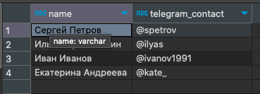

b.

select 'университет: ' || name || '; количество студентов: '::varchar || size as "полная информация" from college order by "полная информация" asc

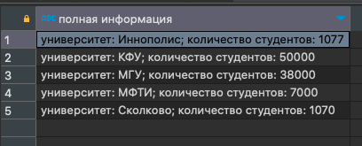

c.

select c.name, count(s.id) as cnt from college c left join student s on (c.id=s.college_id)

where c.id in (10,30,50)

group by c.name

order by cnt, c.name asc

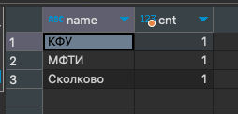

d.

select c.name, count(s.id) as cnt from college c left join student s on (c.id=s.college_id)

where c.id not in (10,30,50)

group by c.name

order by cnt, c.name asc

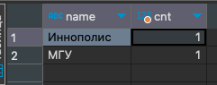

e.

select name, amount_of_students from course where amount_of_students between 27 and 310

order by name desc, amount_of_students desc

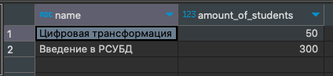

f.

select name from student

union all

select name from course

order by name desc

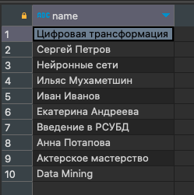

g.

select name,'университет' as object_type from college

union all

select name,'курс' as object_type from course

order by object_type desc, name asc

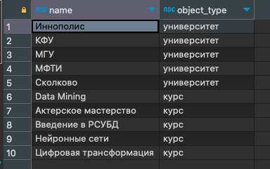

h.

select name, amount_of_students

from course

order by case when amount_of_students = 300 then 1 else 0 end desc, amount_of_students asc

limit 3

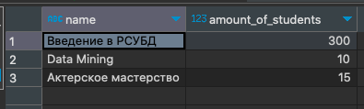

i.

insert into course (id,name,is_online,amount_of_students,college_id)

select 60,'Machine Learning','f',17, college_id from course where name = 'Data Mining'

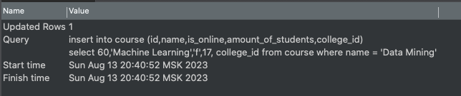

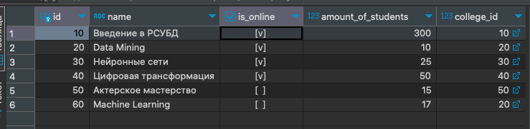

j.

(select id from course

except select id from student_on_course

)

union

(select id from student_on_course

except select id from course )

order by id



k.

select s.name as student_name, c.name as course_name, col.name as student_college, soc.student_rating as student_rating

from student s

left join student_on_course soc on s.id=soc.student_id

left join course c on soc.course_id = c.id

left join college col on s.college_id = col.id

where

soc.student_rating > 50

and col.size > 5000

order by student_name asc, course_name asc

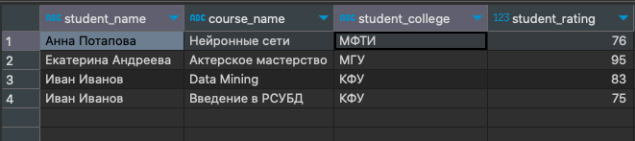

l.

select s1.name as student_1, s2.name as student_2, s1.city

from student s1

inner join student s2 on s1.city = s2.city and s1.id > s2.id

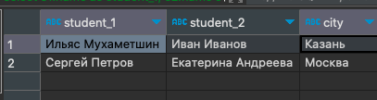

m.

select "оценка",count(*) as "количество студентов" from (

select

case when soc.student_rating < 30 then 'неудовлетворительно'

when soc.student_rating >= 30 and soc.student_rating < 60 then 'удовлетворительно'

when soc.student_rating >= 60 and soc.student_rating < 85 then 'хорошо'

else 'отлично' end as "оценка", s.name

from student s

left join student_on_course soc on s.id=soc.student_id

) as t

group by "оценка"

order by "оценка" asc

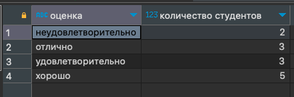

n.

select "курс","оценка",count(*) as "количество студентов" from (

select

case when soc.student_rating < 30 then 'неудовлетворительно'

when soc.student_rating >= 30 and soc.student_rating < 60 then 'удовлетворительно'

when soc.student_rating >= 60 and soc.student_rating < 85 then 'хорошо'

else 'отлично' end as "оценка", c.name as "курс", s.name

from student s

left join student_on_course soc on s.id=soc.student_id

left join course c on soc.course_id = c.id

) as t

group by "курс","оценка"

order by "курс" asc,"оценка" asc

