Perform this procedure once for tables and once for views
- Log on to server 10.97.11.12 from SQL server Management Studio

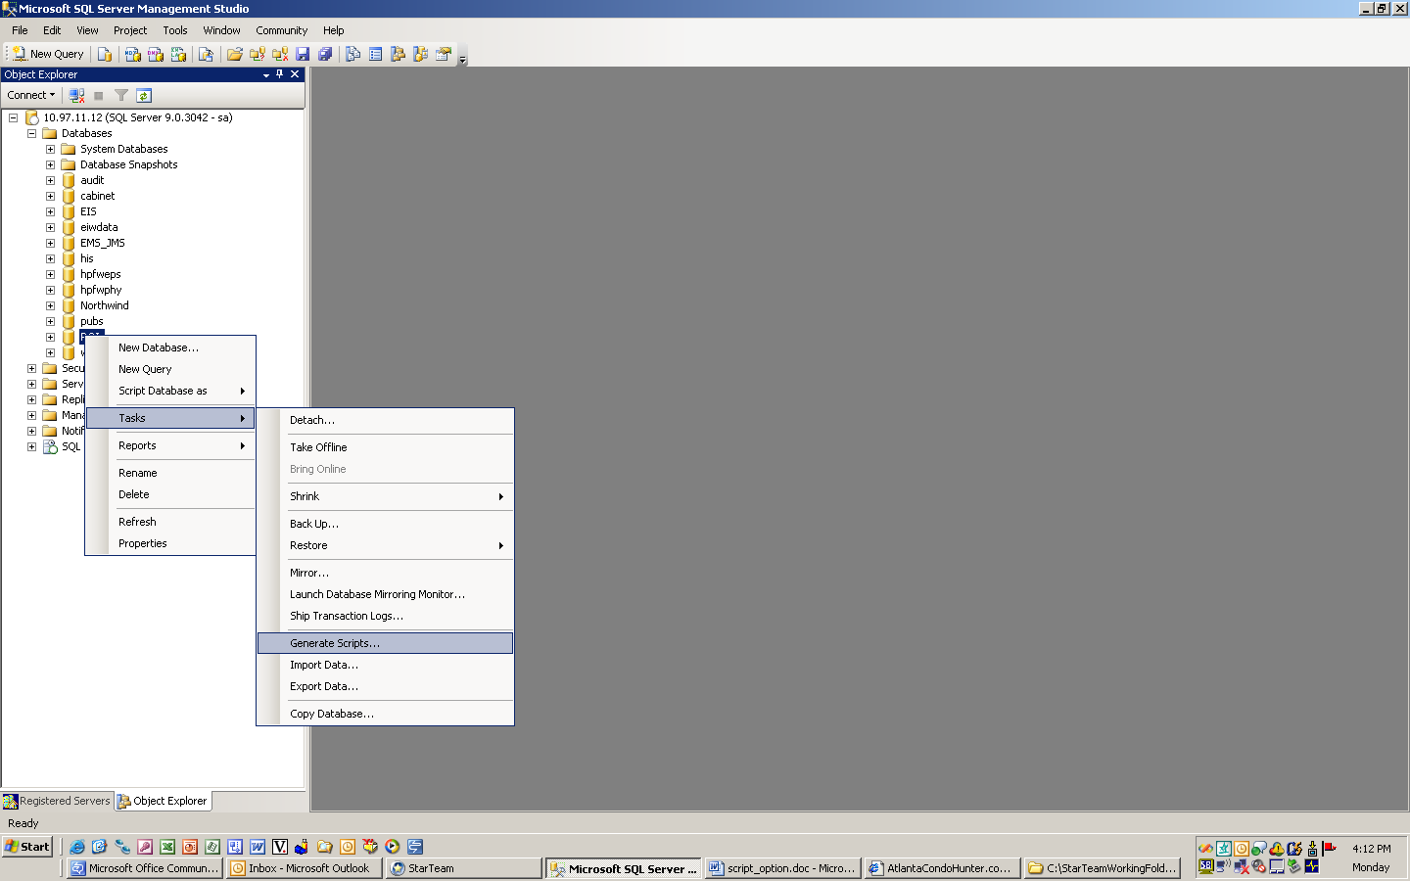
- Locate ROI database. Right click on ROI database. Select ‘Tasks’ and Select ‘Generate Scripts’
- Click on ‘Next’ to continue
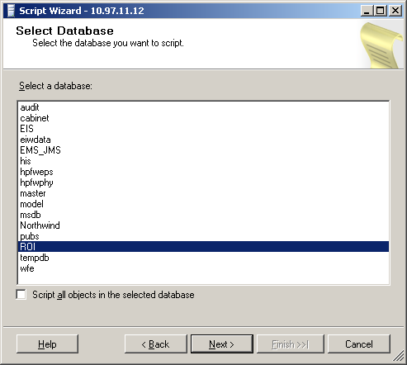
- Select ‘Next’ to continue

- Choose script options screen appears, use following screen’s value to configure options and click on ‘Next’ to continue

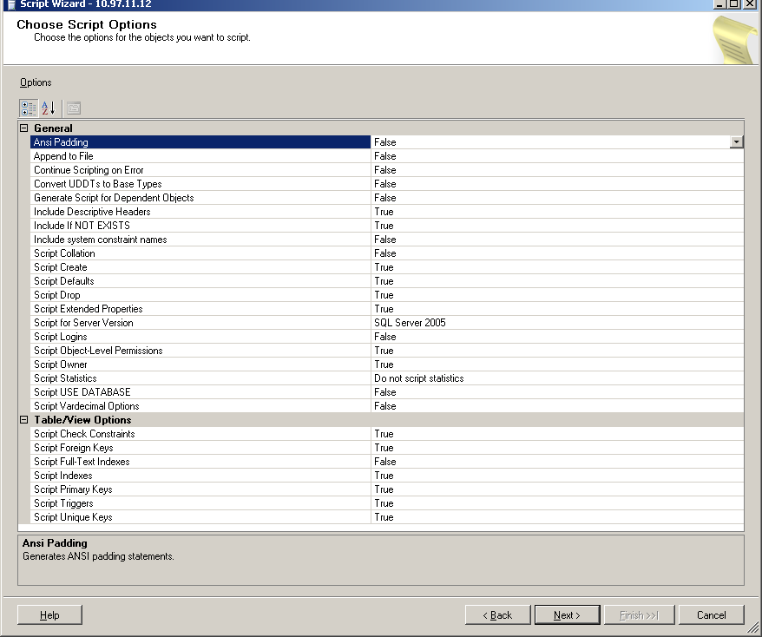

- Select ‘Tables’ and click on ‘Next’ to continue.

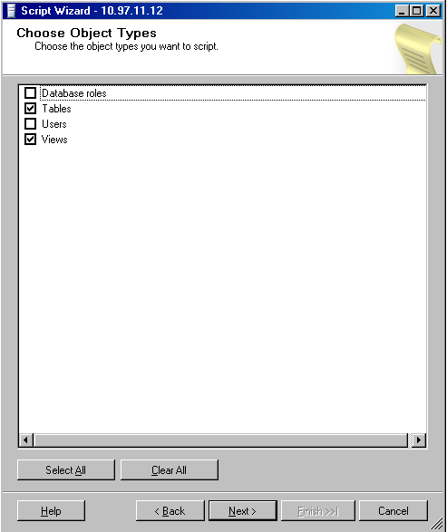

- Click on ‘Select All’ and ‘Next’ to continue

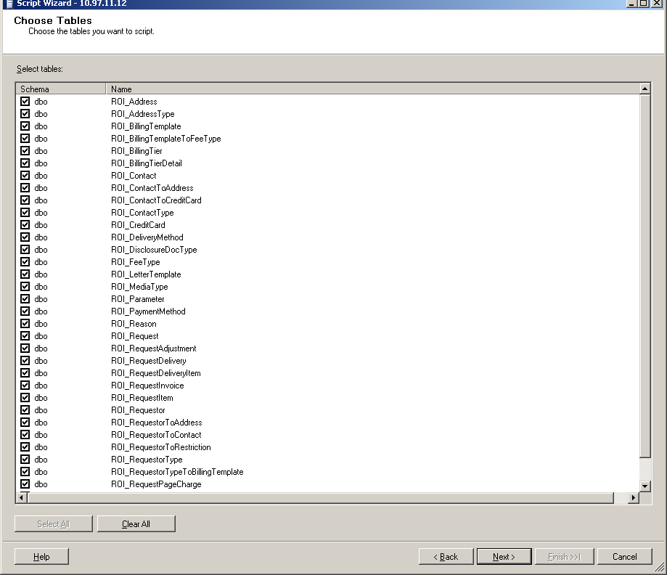

10) Select ‘script to file’. The file name for tables is Create_roi_tables.tb3. The file name for views is Create_roi_views.sch. Select ‘Single file’ and ‘ANSI text’

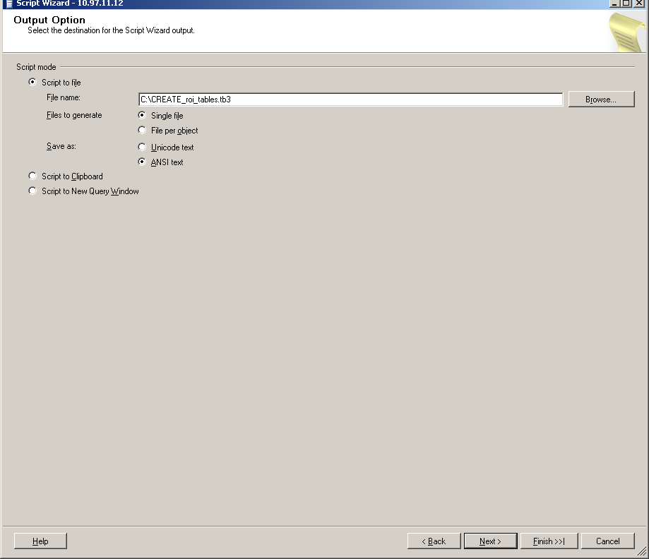

- Click on ‘Finish’

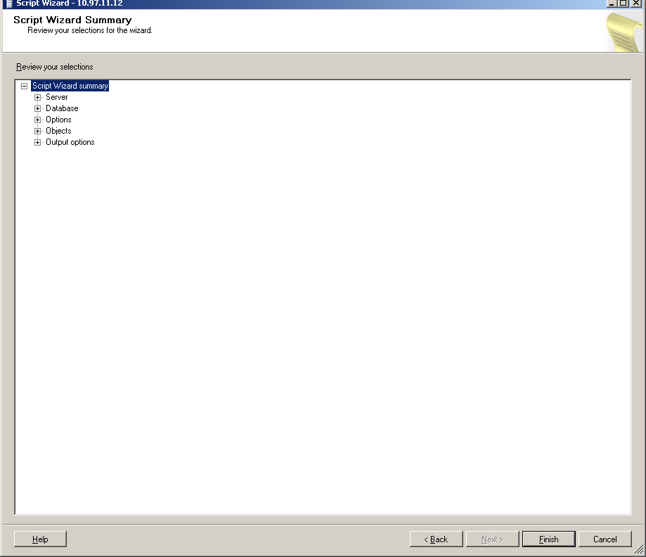

- Repeat from step 1 selecting views in step 6
- Check in scripts CREATE_roi_tables.tb3 and Create_roi_views.sch to Star Team under ‘StarTeamWorkingFolders\eig\roi\src\database\upgrade\Cabinet Copy the upgrade folder and subfolders to the test server
- Run the upgrade command
- Verify the creation of all tables and views

