Folder Structure
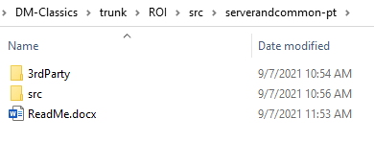
- Step 1 – Add dependent jar to local maven repository
  - Go to 3rdParty folder -> Run Add-Jars-to-Nexus.bat
- Step 2 – Run Maven for parent project
  - Go to src folder.
  - Open command prompt at that level
  - Execute the following command – mvn clean install -DskipTests
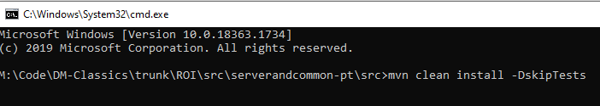
- Import project in Eclipse or IntelliJ

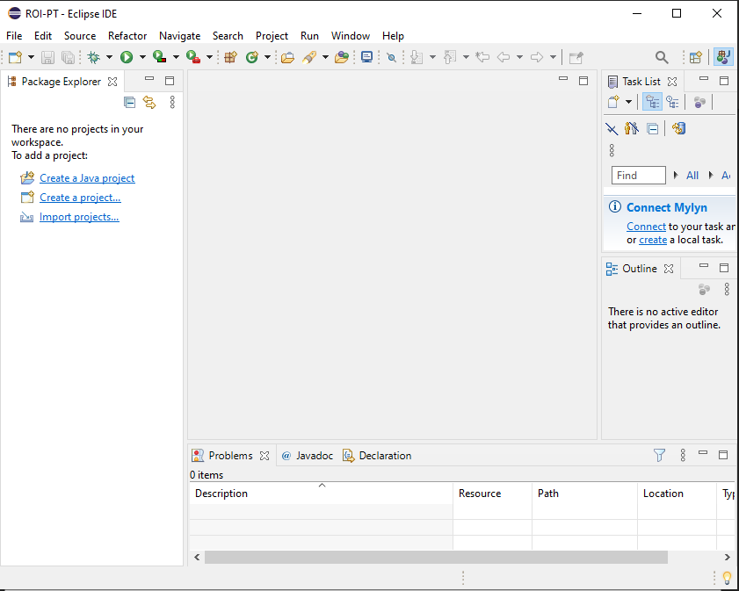

Click on Import Project
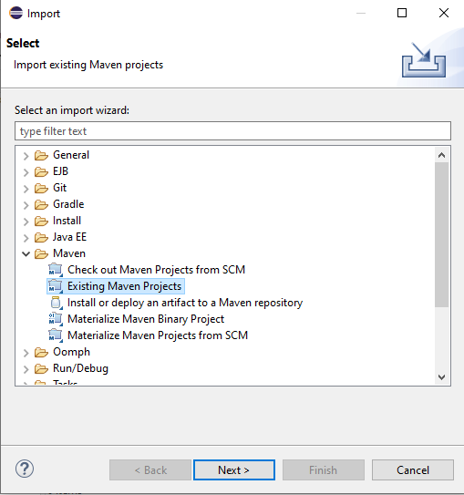
Select Maven Projects
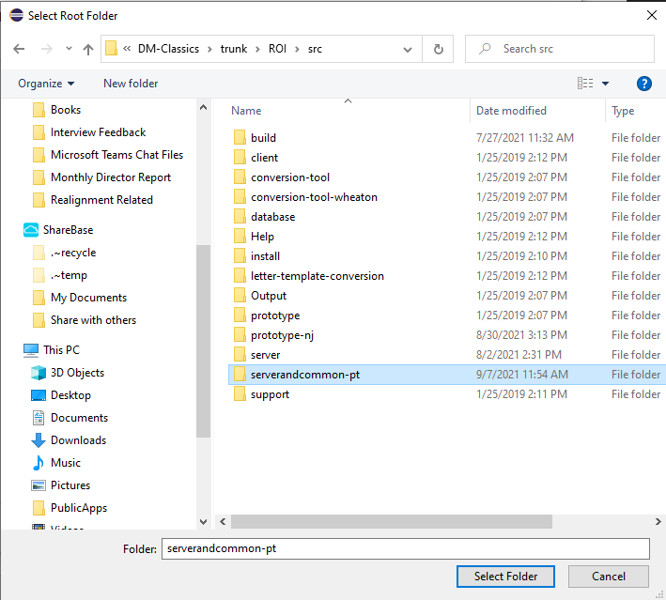
Select code base directory
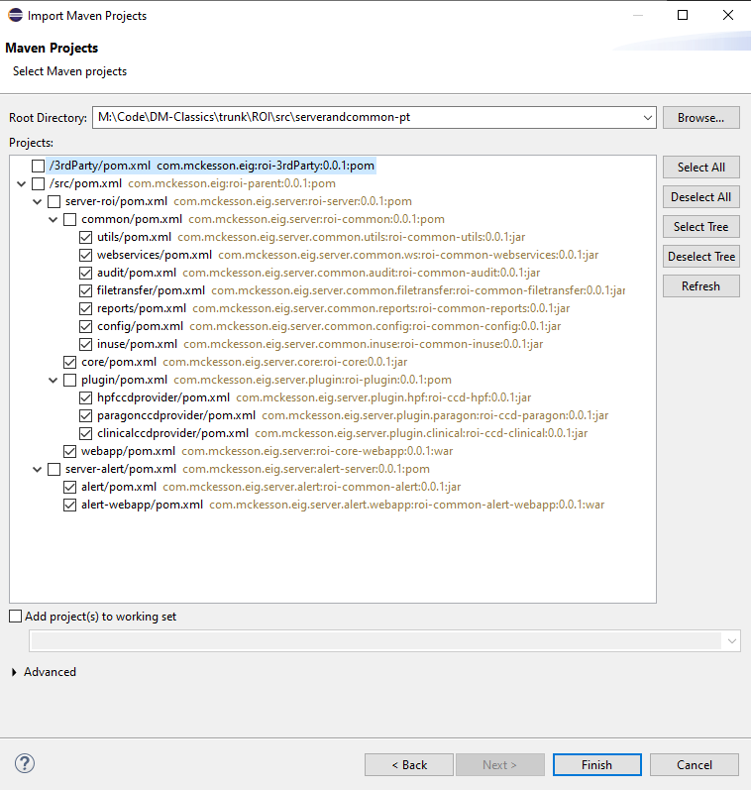
Select all the child projects (Its ok to include parent project as well).

