UI / UX & Wireframe Brief
AI scam, phishing and malicious-link protection app — Android first, Flutter
Checkpoint 1 · companion to the model package (scamguard_model.zip) · 10 October 2026
What this document is
The expectations a Flutter developer (or designer) needs to build the app: the three-tab structure, what each page contains, what every widget looks like and how it behaves, the real-time floating widget / notch / quick-settings layer, the five extra features I recommend, and 20 candidate app names.
The wireframes are low-fidelity layout sketches (grey boxes, one accent colour) — they fix structure and content, not final visual style. “<App>” stands for the name you pick in section 9.

Contents 1 Principles · 2 Navigation & feature map · 3 Wireframes (Shield, Check, Result sheet, Learn & Report, Settings) · 4 Real-time layer (floating widget, notch, quick-settings tile) · 5 Component library · 6 Detection explanations · 7 Design tokens, accessibility, languages · 8 Feature shortlist and five new features · 9 Twenty app names · 10 Decisions needed

1 Design principles
- Small phone first. Design at 360 × 640 dp; everything reachable with one thumb; primary actions in the bottom 40 % of the screen; touch targets ≥ 48 dp.
- Verdict in one glance, reasons one tap away. Every result shows a risk number, a colour + word (Low risk / Suspicious / Dangerous) and a “Why was this flagged?” list. Never colour alone — always an icon and a word.
- Protect first, explain second. Danger interrupts (floating card); everything else stays quiet in the feed. No alert fatigue: safe results never pop up.
- Works offline. The on-device model + allow/deny lists answer instantly; the backend adds depth when online. The UI always says which mode produced the answer (“Live” vs “Offline-safe”).
- Warnings, not accusations. Copy says “looks like / matches patterns of”, never “is a criminal site”. Verdicts are probabilistic; the Disclaimer is one tap from every result.
- Plain language, many languages. English default; Swahili, French, Spanish, Portuguese, Arabic (RTL), Hindi and Chinese planned. Explanations are written for non-technical users.

2 Navigation and feature map
The bottom navigation bar has exactly three items. Every feature you listed lives inside one of them; settings open from the gear icon on the Shield tab (and from a link at the bottom of Learn & Report) as a full-screen page, not a fourth tab.
Tab | Job to be done | Contains
1 Shield | See that I am protected and what was just blocked | Protection status ring, mode selector, counters, live detection feed, quick link box, protection settings (filter modes, blockers, custom filters, per-site permissions, floating-widget settings).
2 Check | Check something myself, right now | Link / QR, Message / SMS, Business check, File check, App audit, Cable & hardware, Page behaviour (API sniffing), WhatsApp & Meta. Recent checks; auto-check toggle.
3 Learn & Report | Report, learn, recover and get help | Report a scam (categories, sub-categories, evidence, authorities), ScamIQ test (red / green flags), Recovery tips, Scam University and scholarships, Check-it-for-me, Authorities directory, community alerts, FAQ, Partners, Privacy, Terms, Disclaimer, Copyright, Language.

Feature coverage — nothing from your brief is left out
Requirement from the brief | Where it lives | How it works in the app
Scrape / check any link clicked on the phone | Shield (feed) + Check ▸ Link / QR | “Pre-click Link Guard”: app registered as link handler and share target; scans links in notifications and the clipboard; domain-level check via local VPN DNS when enabled. See section 4.3 for what Android allows.
Sniff malicious ads / click-through | Shield blockers + Check ▸ Page behaviour | Counters for blocked ads, pop-ups, forced redirects, notification spam; per-page report lists the ad behaviours found.
WhatsApp / Meta takeover links | Check ▸ WhatsApp & Meta + Shield alerts | Detects the lures (code-sharing requests, device-link QR, fake “GB/Plus” apps, deep-link abuse). Cannot see an actual takeover — it warns before it happens.
Fake businesses, money-laundering risk | Check ▸ Business check | Domain age, registration/contact consistency, payment-method red flags (personal numbers, crypto-only, pay-to-receive), community reports.
Malicious sign-in “handshake” tap-ins | Check ▸ Link / QR (OAuth detail) + alert | Flags sign-in links asking for broad access, redirecting to an unrelated site, or “enter this code” device-login lures.
App usage and apps that redirect to unofficial sites | Check ▸ App audit | Permission combos, install source, usage-access based “opens browser / unknown links N times” timeline.
Direct link check-up and automated real-time check-up | Check (manual) and Shield (automatic) | Same engine; Shield shows the automatic results, Check lets you paste / scan / share.
Malicious cables, data-collection hardware | Check ▸ Cable & hardware | On USB attach: lists what the accessory identifies as (keyboard, storage, network…) and warns when it does not match what it should be. Best-effort (see 4.3).
Funny documents / uncensored file extensions | Check ▸ File check + download watcher | Executable/macro/archive/double-extension/RTL-trick/unknown-type detection before you open a download.
Weird API requests used for hacking | Check ▸ Page behaviour | Page-source sniffing: Telegram/Discord/form-collector exfiltration, clipboard reads, camera/mic prompts, obfuscated scripts, hidden frames.
Explanations of key points | Result sheet on every detection | “Why was this flagged?” accordion + “What to do”, localised.
ScamAdvisor-style features | Learn & Report | See section 8.1 for the shortlist and where each one goes.
uBlock-style features | Shield ▸ Protection settings | Filtering modes, ad / pop-up / tracker blocking, custom filters, per-site permissions.
Hovering widget, notch, control-centre widget | System layer | Floating bubble, side-notch tab, status-bar connectivity icon and Quick Settings tile (section 4).

3 Wireframes — the three tabs
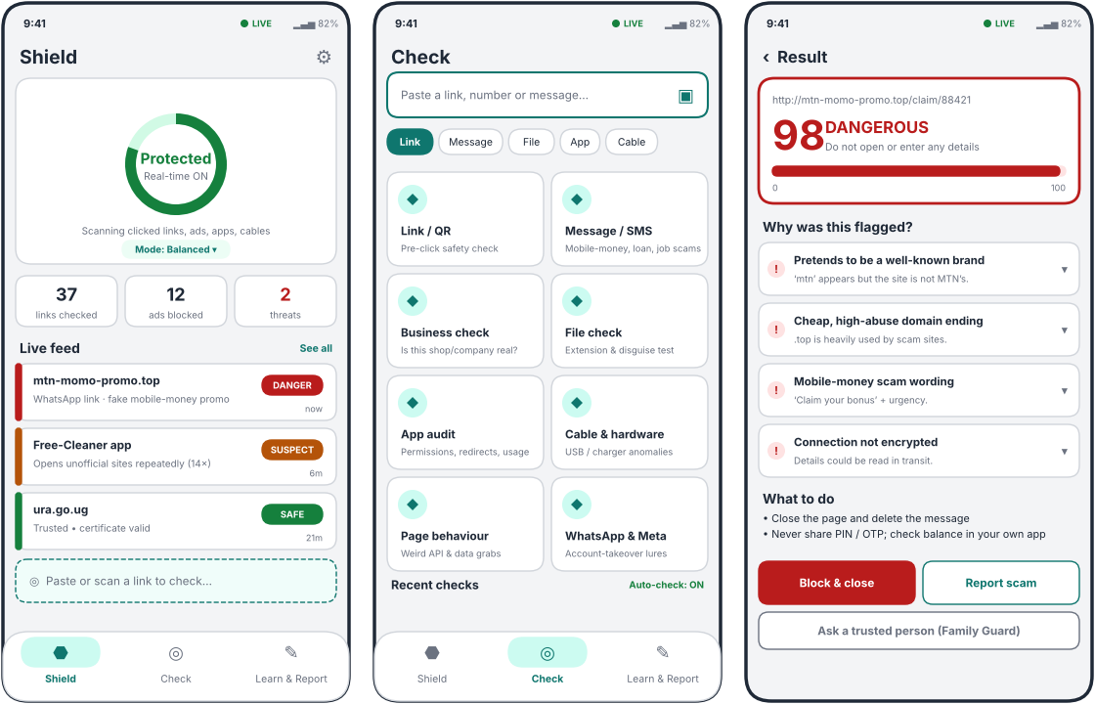
Figure 1 — Shield (home), Check hub, Result / explanation sheet

3.1 Shield tab
Purpose: reassurance and awareness. This is the screen people open to confirm the app is working. It must feel calm when nothing is wrong.
Element (top → bottom) | Content and behaviour
Top bar | Title “Shield”, live-status dot, gear icon → Protection settings.
Status ring card | Large ring + word: Protected (green) / Partial (amber, with the missing permission named) / Paused (grey, countdown to auto-resume) / Threat (red, 1 unseen detection). Sub-text: “Real-time ON”. Tap the ring to pause 15 min / 1 h / until tomorrow.
Mode chip | Current filtering mode: Relaxed / Balanced / Strict / Custom. Tap opens a bottom sheet with the four modes and one-line explanations.
Counter tiles (3) | Links checked · Ads blocked · Threats. Tap a tile to filter the feed. Counters reset daily; weekly totals in a long-press sheet.
Live feed | Newest first. Each row: colour bar, domain/app name, one-line reason, verdict pill, relative time. Tap → Result sheet. Swipe left = mark safe (asks to confirm), swipe right = report. Empty state: “All quiet — nothing risky has reached you.”
Quick link box | Dashed field pinned above the nav bar: paste, scan QR, or accept text shared from other apps. Auto-fills when a link is on the clipboard (with a visible “Check clipboard link?” chip, never silent).

3.2 Check tab
Purpose: do-it-yourself checks. One search-style input at the top accepts a link, phone number / till / paybill or pasted message; chips (Link, Message, File, App, Cable) switch the input type. Below it, eight tiles open dedicated tools.
Tool tile | Input | Output (always the Result sheet pattern)
Link / QR | Paste, camera QR scan, share-in | Risk 0–100, verdict, reasons, redirect chain preview, “open in safe preview” option.
Message / SMS | Pasted or shared text | Matched scam patterns (mobile money, loan, job, investment, prize, pressure, credential requests) plus any links inside.
Business check | Name, website, phone / till / paybill | Domain age & TLS, registration/contact consistency, payment red flags, community reports; verdict “Looks established / Unverified / Looks fake”.
File check | Pick a file or name | Extension class, double-extension and right-to-left tricks, macro documents, archive warnings. Never opens the file.
App audit | List of installed apps | Per app: dangerous permissions and combos, install source, redirect/usage timeline. Sort by risk.
Cable & hardware | Plug in an accessory | Live card: what the accessory says it is vs. what it should be; action “Disconnect now”.
Page behaviour | URL | Page-source findings (data exfiltration endpoints, clipboard/camera requests, hidden frames, obfuscation). Backend-only; shows “Needs internet”.
WhatsApp & Meta | Link or message | Takeover lures, fake mod apps, deep-link abuse, investment-group bait; shortcut to “Secure my WhatsApp” checklist (two-step verification, linked devices).

3.3 Result sheet (shared by every detection)
A full-screen page (or a bottom sheet when launched from the floating widget). Structure is identical for links, messages, files, apps and hardware so users learn it once.
- Header card: subject (URL / file / app), big risk number, verdict word + colour, a 0–100 meter, and one sentence of advice.
- “Why was this flagged?”: accordion of key points. Collapsed row = title + severity dot; expanded = why it matters + evidence snippet (e.g. the matched phrase). Only points that fired are shown.
- “What to do”: 2–4 imperative bullets (e.g. “Check your balance in your own M-Pesa app; never send money back on request”).
- Actions: Block & close (primary, danger colour) · Report scam · Ask a trusted person (Family Guard) · Mark as safe (needs confirm; feeds back as a false-positive report).
- Footer: “Checked on-device” or “Checked on-device + online”, model version, tiny link to Disclaimer.

3.4 Learn & Report tab
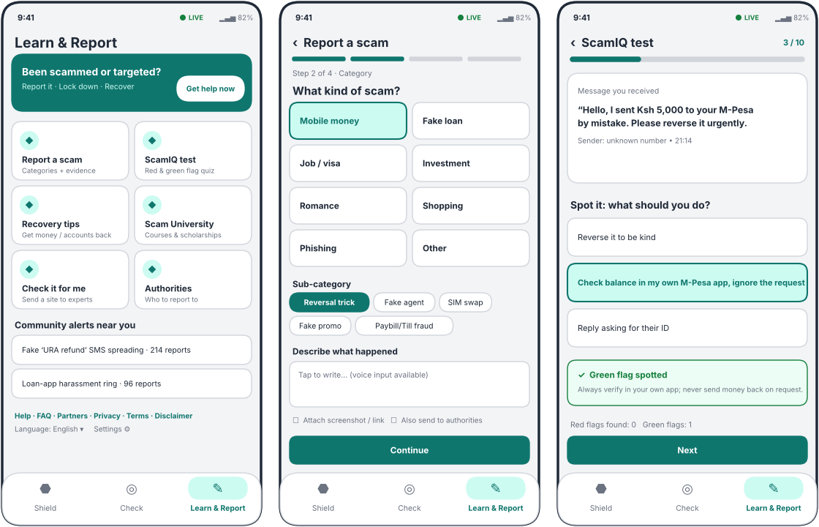
Figure 2 — Learn & Report hub, Report flow (step 2 of 4), ScamIQ question
Section | Content
“Been scammed or targeted?” banner | Always on top. Opens the Recovery Kit (section 8.2, feature 3): lock-down checklist, evidence pack, who to call. Designed for panic: big type, one action per screen.
Report a scam | 4-step flow: (1) What happened — free text or voice; (2) Category and sub-category; (3) Evidence — screenshot, link, number, amount, date; (4) Review and choose: save locally, share to community, send to authorities. Categories: Mobile money, Fake loan, Job / visa, Investment, Romance, Shopping, Phishing, Impersonation, Other — each with sub-categories (e.g. Mobile money ▸ Reversal trick, Fake agent, SIM swap, Fake promo, Paybill / Till fraud).
ScamIQ test | 10-question scenario quiz in the user’s language. Each question shows a real-looking message or page; the user picks the safest action; feedback names the red flag or green flag spotted. End screen: ScamIQ score, flags found, three tips, share card. Replayable with new scenarios.
Recovery tips | Scenario guides: sent money to a scammer, shared a PIN/OTP, WhatsApp taken over, installed a malicious app, data leaked. Each is a checklist with time-critical steps first.
Scam University | Short lessons (2–4 min), certificates, scholarship listings and partner courses. Offline-readable.
Check it for me | Send a suspicious site/number to the review team; status tracker (Received → Reviewed → Verdict).
Authorities | Directory by country: police cyber-crime units, financial regulators, telecom regulator, mobile-money provider fraud lines. Each entry: what they handle, how to contact, “last verified” date. (Content must be curated and verified per country before launch.)
Community alerts near you | Region-aware scam alerts with report counts; tap → details and “I got this too”.
Footer links | Help / FAQ · Partners · Privacy policy · Terms of use · Disclaimer · Copyright · Language · Settings.

3.5 Protection settings (opened from the gear on Shield)
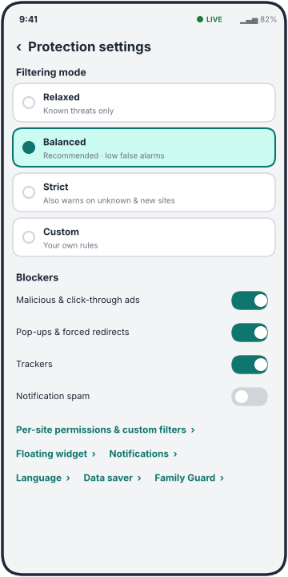
Figure 3 — Protection settings: filtering modes, blockers, shortcuts
Setting | Behaviour
Filtering mode | Relaxed (known threats only) · Balanced (recommended) · Strict (also warns on new / unknown sites; more false alarms) · Custom (user rules). Changing mode shows what changes in one sentence.
Blockers | Toggles: malicious & click-through ads, pop-ups and forced redirects, trackers, notification-permission spam. Each shows a 7-day count.
Per-site permissions & custom filters | List of sites with allow / warn / block; add a rule by domain, keyword or pattern; import / export list; “Trusted sites” never alert.
Floating widget | Enable, size, opacity, auto-dock edge, when to auto-collapse, vibration, do-not-disturb schedule.
Notifications, Language, Data saver, Family Guard | Standard pages; Data saver disables backend deep checks on mobile data.

4 Real-time layer: floating widget, notch and quick-settings tile
This is the signature interaction of the app: protection that is visible only when it matters.
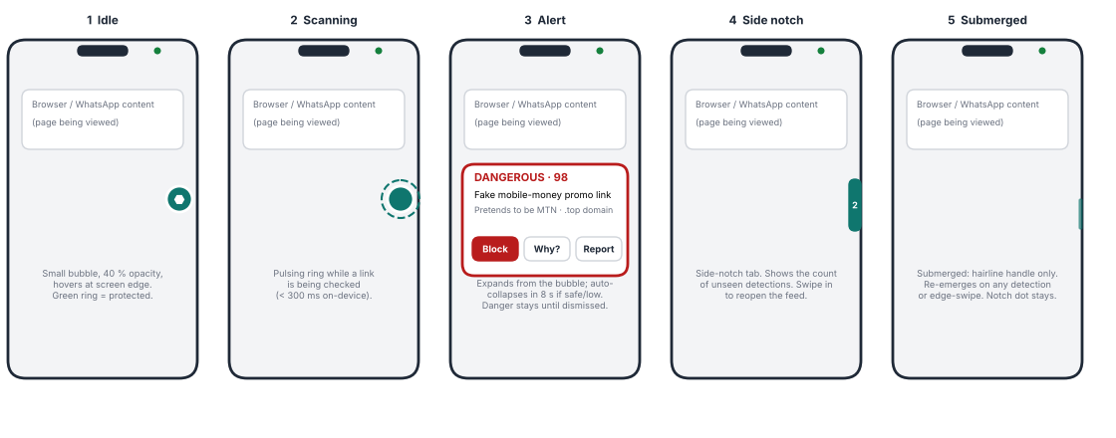
Figure 4 — Floating widget states (connectivity dot in the notch area shown on every state)
State | Appearance | Trigger → next state
1 Idle | 40 dp bubble at 40 % opacity hugging a screen edge; teal hexagon icon; green ring = protected. | Link / app / file / USB event → Scanning. Long-press → quick menu (pause, open app).
2 Scanning | Bubble at full opacity with a pulsing dashed ring. Typical duration < 300 ms on-device, up to ~3 s when a backend check is needed. | Result safe → fades back to Idle with a green tick (400 ms). Result suspicious / dangerous → Alert.
3 Alert | Card expands from the bubble: verdict word, risk number, one-line reason, three buttons — Block, Why?, Report. Suspicious cards auto-collapse after 8 s; Dangerous stays until dismissed and vibrates once. | Why? → Result sheet. Block → closes the page / app action. Dismiss → Side notch.
4 Side notch | Slim vertical tab on the screen edge with a number badge (unseen detections). | Swipe in or tap → feed bottom sheet. Idle for 10 s → Submerged.
5 Submerged | Hairline handle only (3 dp, 50 % opacity); optional “hide completely” keeps just the notch dot. | Any detection or edge-swipe → re-emerges to Alert / Side notch.

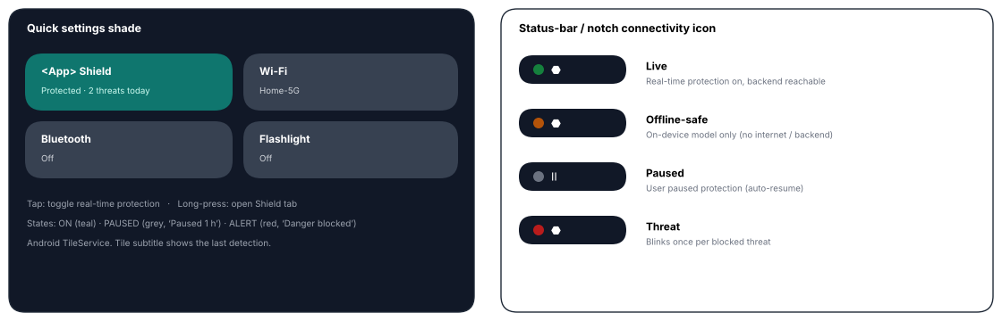
Figure 5 — Quick Settings tile and the status-bar / notch connectivity icon

4.1 Quick Settings tile (control-centre shade)
- Tap = toggle real-time protection; long-press = open the Shield tab. Subtitle shows the last detection (“Protected · 2 threats today”).
- Three states: ON (accent), PAUSED (grey, with countdown), ALERT (red, “Danger blocked”) — alert state clears when the user opens the app.

4.2 Status-bar / notch connectivity icon
- Small pill with a coloured dot + glyph: Live (green: protection on, backend reachable), Offline-safe (amber: on-device only), Paused (grey), Threat (red, blinks once per blocked threat).
- Delivered as a persistent foreground-service notification with a small monochrome status icon; on notch devices the dot sits beside the camera cut-out via the status-bar icon area. Android does not let apps draw inside the cut-out itself, so the floating bubble / side-notch tab provide the “notch” effect.

4.3 What Android allows — be honest with users
Platform realities that shape the design
• Floating bubble: needs the “Display over other apps” permission (SYSTEM_ALERT_WINDOW) and a foreground service. Straightforward and Play-Store-allowed when clearly disclosed.
• Seeing clicked links: an app cannot read other apps’ taps. Realistic routes: be the default link handler / share target, read link text from notifications (Notification Listener), read the clipboard with a visible prompt, and use a local VPN to see domains (not full HTTPS paths). Accessibility Service can see more but is tightly restricted by Google Play — treat it as an optional, clearly justified mode, not the default.
• SMS: reading SMS needs Play-restricted permissions; prefer the SMS User Consent API, notification listening, and “share to app”.
• Cables / USB: the phone only sees what a device announces when it enumerates (class: keyboard, storage, network…). We can flag mismatches (e.g. a “charge-only” accessory announcing a keyboard). We cannot inspect hardware inside a cable.
• iOS: no overlays, no system-wide link interception — a reduced share-sheet-based version only. This brief targets Android first, as agreed.

5 Component (widget) library
Names below are suggested Flutter widget names so design and code stay aligned.
Component | Looks like | States / behaviour
ShieldStatusRing | 120 dp ring, 11 dp stroke, status word centred, caption beneath. | Protected (green), Partial (amber), Paused (grey), Threat (red). Animates 600 ms on change. Tap = pause sheet.
ModeChip / ModeSheet | Pill “Mode: Balanced ▾”; bottom sheet with 4 radio cards. | Selected card tinted teal with 1.5 dp border; each card has a one-line consequence.
CounterTile | Rounded card, large number, small caption. | Tap filters the feed; threats tile number is red when > 0.
FeedRow | 58 dp card, 6 dp colour bar at left, title, one-line reason, pill, time. | Verdict colours; swipe actions; unseen items have a dot; long-press = multi-select.
VerdictPill | 20 dp pill with white bold 7–8 sp text (DANGER / SUSPECT / SAFE). | Colour + icon + word; localised words.
RiskMeter | 10 dp rounded bar with 0 and 100 labels, plus large numeric score. | Colour steps at 30 and 60; animates fill 500 ms.
ReasonTile (accordion) | 54 dp row: severity dot, title, one-line gist, chevron. | Expands to why / tip / evidence; only fired reasons appear.
QuickCheckBar | 46 dp field with dashed or teal border, QR icon. | Paste, scan, share-in; shows a “Check clipboard link?” chip when applicable.
ToolTile | 160 × 96 dp card, icon disc, title, subtitle. | Disabled variant shows lock + “Needs internet / Needs permission”.
PermissionBanner | Amber inline banner with one button. | Appears on Shield when overlay / notification / usage access is missing; explains the benefit before opening system settings.
FloatingBubble / NotchTab | See section 4. | Drag, snap to edge, auto-dock, haptics on alert.
AlertCard | 166 dp wide overlay card, red border for danger. | Buttons Block / Why? / Report; keyboard-free; respects reduced-motion.
QsTile | Android Quick Settings tile. | ON / PAUSED / ALERT as in 4.1.
FilterModeSelector | Four stacked radio cards. | Custom opens rule editor.
ToggleRow | Label left, 44 × 22 dp switch right, optional 7-day count. | Haptic tick on change.
ReportStepper | 4-segment progress bar, large category cards (2 per row). | Sub-category chips appear after a category; draft autosaved.
ScamIQCard | Message / page snapshot card, three answer cards, feedback panel. | Correct = green panel naming the green flag; wrong = amber panel naming the red flag; progress bar.
FlagChip | Pill with ⚑ (red) or ✓ (green) + short label. | Used in ScamIQ and in tips.
EmptyState | Illustration + one sentence + one button. | Every list has one; tone is reassuring.
LanguagePicker | Searchable list with native names. | Applies instantly; RTL mirrors layout.

6 Detection explanations (“key points”) — what the user sees
The model package returns, for every detection, an id with a localised title, “why it matters” and “what to do”. The UI only needs to render them. Categories and typical key points:
Category | Key points shown (examples) | Default action
Link | Raw IP address · hidden “@” trick · brand impersonation · free hosting · shortened link · high-abuse domain ending · look-alike characters · many sub-names · scam keywords · risky download · no encryption · link inside link | Warn; Block & close if Dangerous
Local scam patterns | Mobile-money “sent by mistake / reversal” · fake or advance-fee loan · job offer that charges fees · guaranteed or doubled returns · prize / giveaway · pay-to-receive · authority impersonation | Warn with recovery link
Social-engineering lure | Pressure to act now · request for PIN / password / OTP · fake “your phone is infected” alert | Warn
WhatsApp / Meta | Account-takeover lure (code or device-link QR) · fake / modified WhatsApp download · suspicious deep link · money-promise group | Block; open “Secure my WhatsApp” checklist
Page behaviour (API sniffing) | Data sent to Telegram bot / Discord webhook / form collector · clipboard read or hijack · camera / mic / location prompts · obfuscated script · hidden frame · forced redirect · pop-up loop · opens app / call / SMS | Warn; offer Close tab
File | Executable or installer · macro document · archive · disguised double extension · right-to-left trick · unknown type | Block open; offer Delete
Sign-in / handshake | Very broad access requested · token handed to page · returns to a different site · “enter this code” device-login lure | Cancel sign-in
App | Screen-control, SMS-reading, overlay, device-admin, install-other-apps permissions · dangerous combinations · installed outside a store · redirect timeline | Review / uninstall guidance
Hardware | Charging accessory behaving like a keyboard · keyboard + storage in one device · unexpected network / serial interface | Disconnect now
Reputation | Listed in a phishing database · well-known trusted site (shown as a reassurance line) · very new domain · invalid certificate · many redirects | Block / reassure

Rule for copy: at most one sentence for “why”, one sentence for “what to do”, no jargon in the title (“Link uses a raw IP address”, not “IPv4 literal host”).

7 Design tokens, accessibility and languages
Token | Value / rule
Brand accent | Teal #0F766E (light tint #CCFBF1). Neutral greys #1F2937 / #6B7280 / #D1D5DB / #F3F4F6.
Verdict colours | Low risk / safe #15803D · Suspicious #B45309 · Dangerous #B91C1C — each paired with an icon and a word; all pass 4.5:1 contrast on white.
Typography | System sans (Roboto on Android; Noto for Arabic / Hindi / Chinese fall-backs). Title 20 sp bold, section 15 sp bold, body 14 sp, caption 12 sp. Respect system font scale up to 200 %.
Spacing & shape | 4 dp grid; screen gutter 16 dp; card radius 12–16 dp; bottom nav 72 dp high with 80 × 30 dp active pill.
Motion | 150–250 ms standard, 500 ms for the meter / ring; honour “remove animations” (reduced motion).
Dark mode | Provided from day one: surfaces #111827 / #1F2937, same accent and verdict hues lightened for contrast.
Accessibility | TalkBack labels on every control (“Dangerous, 98 out of 100, mtn-momo-promo.top”); minimum 48 dp targets; no colour-only meaning; the floating card is announced as an assertive live region.
Languages | English (default), Swahili, French, Spanish, Portuguese, Arabic (RTL), Hindi, Chinese (Simplified); more later via ARB files. The model package already returns explanations in these eight languages (titles translated for link / text / WhatsApp findings, English fall-back elsewhere — machine-drafted, needs native review).
Low data / low end | Data-saver mode disables backend checks on mobile data; app must run smoothly on 2 GB RAM phones; on-device model is ~340 KB and runs in well under 100 ms.
Privacy | URLs are checked on-device by default; only “deep check” sends a URL to the backend, with a clear one-time consent. Reports are opt-in. No contacts, SMS bodies or browsing history leave the device without an explicit action.

8 Feature shortlist and recommendations

8.1 Favourites shortlisted from ScamAdvisor and uBlock
Source | Feature | Keep? | Where it goes / how it is adapted
ScamAdvisor | Report scam + categories / sub-categories + description + report to authorities | ★ Favourite | Learn & Report ▸ Report a scam (4-step flow, authority hand-off).
ScamAdvisor | ScamIQ test with red / green flags and language selection | ★ Favourite | Learn & Report ▸ ScamIQ; scenarios localised and region-specific.
ScamAdvisor | Scam advice, how to recover money, scam sensitisation | ★ Favourite | Recovery tips + Recovery Kit; sensitisation as short lessons.
ScamAdvisor | Check sites for me | Keep | Learn & Report ▸ Check it for me (human-reviewed queue).
ScamAdvisor | Scam University, scholarships | Keep | Learn & Report ▸ Scam University.
ScamAdvisor | Browser extensions | Replace | Phones rarely run extensions; replaced by system-level link handling + floating widget.
ScamAdvisor | API filtering | Adapt | Becomes Check ▸ Page behaviour (suspicious API / endpoint sniffing).
ScamAdvisor | FAQ, partnerships, privacy, terms, disclaimers, copyright | Keep | Footer of Learn & Report; Disclaimer link on every result.
uBlock | Ad block and pop-up block | ★ Favourite | Shield blockers with live counters.
uBlock | Tracker blocking | Keep | Shield blockers.
uBlock | Filtering modes | ★ Favourite | Relaxed / Balanced / Strict / Custom.
uBlock | Custom filters and permissions | ★ Favourite | Protection settings ▸ Per-site permissions & custom filters.

8.2 Five additional features I consider critical
# | Feature | Why it is critical | Where it lives
1 | Pre-click Link Guard | Most harm happens at the click. Verdict before the page loads (link handler, share target, notification and clipboard scanning) beats any after-the-fact warning. | Shield feed; floating widget
2 | Pay-Safe Check (mobile-money guard) | Fraud in the target region is dominated by mobile money. Before sending, the user types or pastes the number / till / paybill: community reports, name-mismatch prompt, “pay-to-receive” interstitial for loans, jobs and prizes. (Does not touch the mobile-money app or credentials.) | Check ▸ Business check; Message / SMS
3 | Panic & Recovery Kit | Victims need speed. One-tap checklist ordered by urgency (call provider, freeze SIM / wallet, change passwords, WhatsApp two-step, report), evidence pack (auto-collected screenshots, links, timestamps) and pre-filled report. | Learn & Report banner; Result sheet
4 | Community Threat Feed (offline-first) | Region-aware crowd reports become signed list updates every few hours, so new local scams are caught before global feeds list them — the gap identified in your proposal. Needs reputation weighting and abuse protection. | Learn & Report ▸ alerts; background updates
5 | Family Guard | Elders and first-time smartphone users are the main targets. “Ask a trusted person” sends a suspicious item to a chosen contact for a second look; elder mode = bigger type, simpler verdicts, auto-block of dangerous results. | Result sheet; Settings

9 Twenty short, unique app-name candidates
Most are Swahili words, understood across East Africa; a few are neutral coinages. I have not checked trademark, Play Store or domain availability — do that before choosing.
# | Name | Meaning / feel | Possible tagline
1 | Kinga | Swahili: protection | Protection that follows you
2 | Ngao | Swahili: shield | Your shield against scams
3 | Linda | Swahili: protect / guard | Linda what is yours
4 | Boma | Swahili: fenced enclosure | A safe boundary for your phone
5 | Jicho | Swahili: eye | The eye that spots scams
6 | Macho | Swahili: eyes | Eyes open, always
7 | Mlinzi | Swahili: guardian | A guardian in your pocket
8 | Askari | Swahili: guard / watchman | On watch, 24/7
9 | Onya | Swahili: warn | Warned before you click
10 | Kataa | Swahili: refuse / reject | Reject the scam
11 | Zuia | Swahili: stop / block | Stop it before it starts
12 | Tazama | Swahili: look / watch | Look before you tap
13 | Hakika | Swahili: certainty | Be certain before you trust
14 | Kweli | Swahili: truth / real | Is it real? Know for sure
15 | Nuru | Swahili / Arabic: light | Shine light on scams
16 | Tunza | Swahili: take care of | We take care of you
17 | Scamly | Coinage: scam + -ly | Scams, spotted
18 | Vigil | English: staying watchful | Always watchful
19 | Warden | English: protector / keeper | Your phone’s warden
20 | Scudo | Italian: shield | A small shield with a big job

My top three: Kinga (shortest, clear meaning, easy to say in many languages), Ngao (strong shield imagery, great as an icon) and Boma (distinct, memorable, suggests a protected space). Whichever you pick, the in-app wording “<App> Shield” works for the tile and the floating widget.

10 Decisions needed before checkpoint 2 (Flutter app)
- App name from the list above (or your own).
- Distribution: Google Play, or direct APK for pilots? Play restricts Accessibility and SMS permissions, which changes how much automatic link capture is possible.
- Launch countries for the Authorities directory, community alerts and ScamIQ scenarios (Uganda first? Kenya, Tanzania, Rwanda?).
- Backend hosting for deep checks and model updates (needs a small server; the FastAPI service is ready).
- Accounts: anonymous by default with optional sign-in for reports and Scam University progress, or sign-in required?
- Visual direction: the teal wireframe palette is a placeholder — send a brand colour or logo if you have one.

Checkpoint 2 will deliver the Flutter project: the three-tab shell, Shield / Check / Learn & Report screens wired to the exported ONNX model and rules, localisation scaffolding, and the Android native layer (floating bubble, foreground service, Quick Settings tile) as far as the permissions above allow.

