
CSA15 Cloud Computing and Big Data Analytics
CO1 AT2 - Digital Concept Map and Service Model Matrix
Individual Student Submission Template

Student and Faculty Details
Student Name | Mukilan.R | Register Number | 192421043
Class / Section | Cloud computing | Slot | B
Course Code | CSA1512 | Course Title | Cloud Computing and Big Data Analytics
Capstone Title | SkillHire Cloud - Resume-to-Job Matcher Using NLP Skill Gap Intelligence
Submission Date
Faculty Name | Dr.Rajesh Babu | Employee ID
Department

Assessment Brief
Course Outcome | CO1 - Explain the evolution, architecture, characteristics, service models, and emerging paradigms of cloud computing.
Assessment Type | Individual concept mapping, service-model responsibility analysis, and capstone-cloud interpretation.
Assessment Focus | Each map must show key nodes, link labels, relationship meaning, and a logical hierarchy. The response must connect cloud fundamentals to the student's own perception of the capstone title.
Submission Mode | Editable DOCX + exported diagram evidence + GitHub repository link submitted in Google Classroom.
Permitted Tools | draw.io / diagrams.net, Lucidchart, Miro, Canva, PowerPoint, Google Drawings, or equivalent diagramming tool.
Individual Rule | Every student must submit their own concept map, matrix, capstone-cloud mapping, and reflection. The capstone title may be shared by a team, but the assessment answer must not be common.
Total Marks | 100 marks

Code of Conduct and Student Assurance
Academic Integrity Statement
This assessment must be completed individually. Students may discuss the capstone domain with their team, but the concept map, service model matrix, explanations, GitHub evidence, and reflection submitted here must be individually prepared.
Student Assurance | I confirm that this submission represents my own understanding of CO1 concepts and my individual interpretation of the selected capstone title.
Tool Use | I have used digital tools only for diagram preparation, organization, and presentation. I have not copied another student's diagram, matrix, or explanation.
Evidence | I have uploaded the required files to my GitHub repository and submitted the repository link / evidence link through Google Classroom.
Student Signature
Date

Procedure for Preparing the Digital Concept Map
Use the following procedure to prepare the diagram and upload evidence. Students who already know another diagramming tool may use it, but the exported evidence and source file must still be submitted.
- Open https://app.diagrams.net/ or the desktop version of draw.io / diagrams.net.
- Choose Device, Google Drive, or OneDrive as the save location according to availability.
- Create a blank diagram and name the file as CSA15_CO1_AT2_RegisterNumber_Concept_Map.drawio.
- Place the capstone title at the center or as a clearly visible anchor node.
- Add major cloud nodes: cloud definition, cloud evolution, cloud architecture, service models, deployment models, virtualization, web services, SOAP, REST, APIs, elasticity, scalability, resource pooling, measured service, and emerging paradigms.
- Connect nodes with labeled arrows such as uses, depends on, enables, scales through, communicates through, belongs to, supports, provides, consumes, or controls.
- Use colors meaningfully: one color for service models, one for cloud characteristics, one for API/web-service concepts, and one for capstone-specific elements.
- Export the final diagram as PNG or PDF. Keep the editable .drawio source file also.
- Paste the exported diagram image or screenshot in this DOCX under Task 1.
- Upload the DOCX, exported PNG/PDF, and .drawio file to GitHub, then submit the GitHub link in Google Classroom.

GitHub Submission Procedure
Step | Required Action | Expected Evidence
1 | Create or use your individual GitHub account. | GitHub profile link.
2 | Create a repository named CSA15-CO-Assessments-RegisterNumber or use the repository instructed by faculty. | Repository URL.
3 | Create a folder named CO1_AT2 inside the repository. | Folder visible in repository.
4 | Upload this completed DOCX, exported diagram PNG/PDF, and editable .drawio source file. | At least three evidence files uploaded.
5 | Add a short README.md explaining the capstone title and files submitted. | README visible in the AT2 folder.
6 | Submit the GitHub folder link in Google Classroom. | GCR submission with repository/folder link.

Assessment Questions and Student Response Sections
Important
The capstone project may be developed by a team, but every response below must be written from the individual student's own perspective. Do not submit a common team answer.

Task 1 - Digital Cloud Concept Map
Create one integrated digital concept map for CO1. The map must show key nodes, link labels, relationship meaning, and a logical hierarchy. It must also connect the concepts to your selected capstone title from your individual perspective.
Mandatory Concept Group | Minimum Concepts / Nodes to Include
Cloud Fundamentals | Definition, characteristics, benefits, limitations, on-demand access, measured service.
Cloud Evolution and Drivers | Hardware evolution, internet software evolution, distributed systems, cost economics, mobility, remote access, big data growth.
Architecture and Deployment | Front-end, back-end, network layer, data center, management software, public/private/hybrid/community cloud.
Service Models and Responsibility | IaaS, PaaS, SaaS, XaaS, provider responsibility, user responsibility, shared responsibility.
Virtualization and Web/API Layer | Virtual machine, hypervisor, abstraction, resource pooling, multi-tenancy, web services, SOAP, REST, API request/response.
Capstone Connection | Your capstone users, app/module, cloud backend, database/storage, dashboard/analytics, scalability and elasticity idea.
Paste exported concept map image / screenshot here. Resize neatly within this white space.
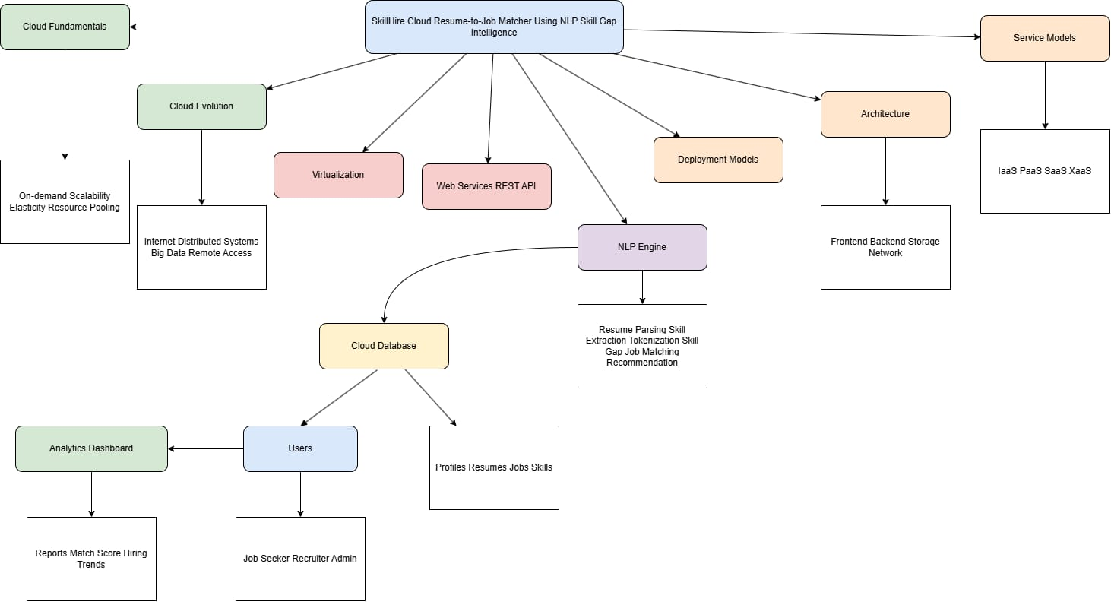

Brief explanation of your concept map: explain the most important nodes, link labels, hierarchy, and capstone connection.

1. Cloud Fundamentals
This is the foundation of the project. It provides cloud features such as on-demand services, scalability, elasticity, and resource pooling, allowing the application to handle many users efficiently.
2. Cloud Evolution
Cloud computing has evolved from distributed systems to support internet-based services, big data processing, and remote access, making the application accessible from anywhere.
3. Virtualization
Virtualization creates virtual servers and resources, helping the application run efficiently while reducing hardware costs and improving resource utilization.
4. Web Services (REST API)
REST APIs enable communication between the frontend, backend, NLP engine, and cloud database, allowing seamless data exchange.
5. Deployment Models
The application can be deployed using Public Cloud, Private Cloud, Hybrid Cloud, or Community Cloud, depending on organizational requirements.
6. NLP Engine
This is the core module of the system. It performs:
- Resume Parsing
- Skill Extraction
- Tokenization
- Skill Gap Analysis
- Job Matching
- Personalized Recommendations
7. Cloud Database
Stores all application data, including:
- User Profiles
- Resumes
- Job Listings
- Skills
This ensures secure and scalable data management.
8. Users
The system supports three user roles:
- Job Seeker – Uploads resumes and receives job recommendations.
- Recruiter – Posts jobs and finds suitable candidates.
- Admin – Manages users, jobs, and the overall system.
9. Analytics Dashboard
Provides insights such as:
- Match Scores
- Hiring Trends
- Reports
These help recruiters analyze recruitment performance and make better decisions.
10. Architecture
The application follows a cloud architecture consisting of:
- Frontend (User Interface)
- Backend (Business Logic)
- Storage (Database)
- Network (Communication)
11. Service Models
The project uses cloud service models:
- IaaS – Virtual servers and networking.
- PaaS – Platform for application development and deployment.
- SaaS – End users access the application through a web browser.
- XaaS – Additional cloud services such as AI APIs, monitoring, and analytics.
Overall Working
The user uploads a resume through the web application. The REST API sends the resume to the NLP Engine, which extracts skills, compares them with job requirements, identifies skill gaps, and recommends suitable jobs. All information is stored in the Cloud Database, while recruiters and administrators use the Analytics Dashboard to monitor hiring performance and generate reports. The entire system runs on cloud infrastructure, ensuring scalability, security, and high availability.

Task 2 - Service Model Matrix
Complete the matrices by making technical decisions for your capstone project. Select only the rows that are relevant to your capstone design. If a row is not used, write a short technical reason instead of leaving it blank.
Your answer should show how responsibility shifts between cloud provider and student development team, and how the chosen services support the capstone workflow, API design, storage, security, scalability, and evidence submission.

Task 2A - Service Model Responsibility Matrix
Service Model | Capstone Role / Module | Provider Responsibility | Student Responsibility | Evidence to Submit
IaaS | Virtual Server & Network | Provide VMs, storage, networking and security | Configure server, deploy application and manage OS | VM Screenshot, Deployment Evidence
PaaS | Backend & NLP Engine | Runtime environment, database services, scaling | Develop REST APIs, NLP logic and integrate database | Source Code, API Screenshot
SaaS | Web Application | Host application and ensure availability | Design UI, manage users and application features | Website Screenshots
XaaS / Specialized Service | AI/NLP Services | Provide AI APIs and cloud analytics | Integrate AI APIs for resume parsing and recommendations | API Integration Evidence

Task 2B - Capstone Cloud Service Decision Matrix
Cloud Layer / Function | Selected Tool or Service | Data / Resource Handled | API or Integration Path | Security / Scaling Note
Client access and UI | HTML, CSS, JavaScript | User Requests | Browser -> REST API | HTTPS, Responsive UI
API / backend logic | Spring Boot REST API | Resume & Job Data | REST API | JWT Authentication
Authentication and identity | JWT + Spring Security | User Login | Login API | Role-Based Access
Database / structured records | MySQL | Users, Jobs, Skills, Resumes | JPA / Hibernate | Backup & Encryption
File / object storage | Cloud Storage | Resume PDF Files | Upload API | Secure Storage
Monitoring / logs / usage metrics | Cloud Monitoring | Logs & Performance | Monitoring Dashboard | Auto Scaling
Analytics / reporting output | Dashboard | Match Scores & Reports | Analytics API | Read-only Reports
Technical justification: Explain why the selected cloud service pattern fits your capstone project's users, data, API flow, scalability, and security needs.
The project uses cloud services because they provide scalability, high availability, secure storage, and easy deployment. REST APIs connect the frontend, backend, NLP engine, and database efficiently. Cloud storage allows secure resume management, while analytics dashboards help recruiters analyze hiring trends. This architecture supports thousands of users without performance issues.

Task 3 - Capstone Cloud Flow Mapping
Study the sample architecture-flow template below. Redraw it in draw.io / diagrams.net using your own capstone architecture. Replace every generic label with your actual user role, screen, API endpoint, backend logic, cloud storage, analytics output, security control, and scalability or elasticity decision.
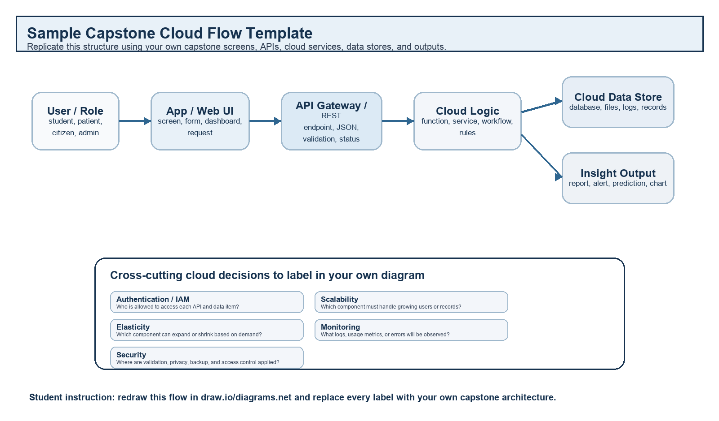
Student Drawing Requirement
Do not copy the sample as it is. Use it as a layout model, then create your own capstone-specific flow diagram with meaningful labels, arrows, data movement, API names, and cloud service choices.
Flow Component | Student Entry
User role and action | Job Seeker uploads resume
Frontend / app screen | Resume Upload Dashboard
API endpoint and method | POST /api/resume/upload
Backend processing rule | Resume parsing, skill extraction, job matching, recommendation generation
Cloud database / storage operation | Store user profile, resume, extracted skills and match score
Response, alert, report, or dashboard output | Recommended jobs, skill gap report and match percentage
Security, scalability, and elasticity labels added in diagram | HTTPS, JWT Authentication, Auto Scaling, Load Balancer
Paste your redrawn capstone cloud-flow diagram here.

Brief explanation: explain one complete request-response path from user action to cloud response.

A job seeker logs into the SkillHire application and uploads a resume. The frontend sends the resume through the REST API to the backend. The NLP engine extracts skills, compares them with available job requirements, identifies missing skills, and calculates a job match score. The processed data is stored in the cloud database. Finally, the application displays recommended jobs, skill gap analysis, and analytics on the user's dashboard. Cloud infrastructure ensures secure access, automatic scaling, and reliable performance.

Task 4 - Individual Reflection
Answer the following from your own perspective. Avoid team-common wording.
1. What is the strongest cloud concept represented in your capstone project?

The strongest cloud concept is scalability, because the system can support many users uploading resumes and receiving recommendations simultaneously without reducing performance.

2. Where will elasticity or scalability become important in your capstone product?
Elasticity becomes important during peak recruitment periods when many job seekers and recruiters use the system at the same time. Cloud resources automatically increase to maintain fast response times.

3. Which API or web-service idea is most relevant to your project and why?
REST API is the most relevant because it enables communication between the frontend, backend, NLP engine, and cloud database. It provides secure, fast, and standardized data exchange.

4. What did you personally understand better after preparing this concept map and matrix?
I understood how cloud computing concepts such as service models, virtualization, REST APIs, databases, scalability, and cloud architecture work together to build a real-world application. This activity improved my understanding of cloud-based software design and deployment.

Evaluation Rubric - 100 Marks
Criteria | Marks | Expected Standard
Concept identification | 20 | Major CO1 concepts are accurately identified: cloud fundamentals, characteristics, evolution, service models, deployment models, virtualization, web services, SOAP/REST, APIs, elasticity, and scalability.
Relationship mapping | 20 | Links between concepts are accurate, meaningful, and labeled. The map should explain how concepts depend on, enable, consume, provide, scale, or control one another.
Hierarchy and organization | 15 | Concepts are arranged in a logical hierarchy with clear grouping, readable flow, and no disconnected keyword clusters.
Technical relevance | 15 | The map strongly reflects cloud course content and avoids decorative or generic non-technical content.
Service model matrix | 15 | IaaS, PaaS, SaaS, and XaaS are compared with provider responsibility, user responsibility, examples, capstone usage, and risks or limitations.
Capstone alignment and individual reflection | 10 | The student's own capstone interpretation is visible in the concept map, flow mapping, justification, and reflection. Team-common answers are avoided.
Visual clarity and digital evidence | 5 | Diagram is neat, readable, exported properly, and supported with GitHub evidence including source and exported files.

Faculty Evaluation Record
Evaluator Name |  | Marks Awarded
Observation |  | Signature

