**BLOCK DIAGRAM:**

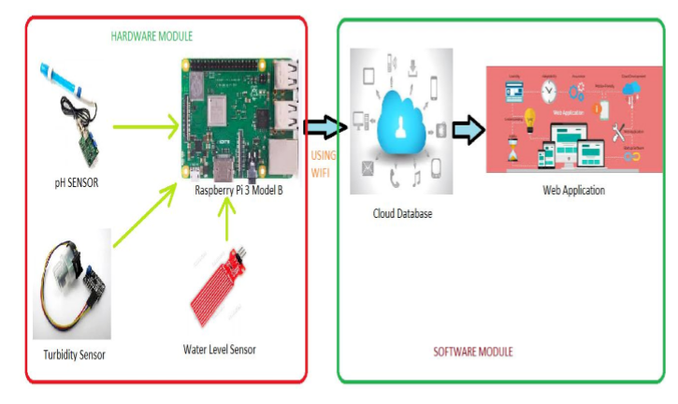

**HARDWARE REQUIREMENTS:**

i. Raspberry Pi 3 Model B

ii. pH sensor

iii. Turbidity Sensor (TS-300B)

iv. Water Level Sensor

**SOFTWARE REQUIREMENTS:**

i. Raspbian OS

ii. 000webhost Web Hosting Service(Online)

iii. Notepad++

**NOTE:**

* Enable SPI interface in Raspberry Pi by the procedure given in link: https://www.raspberrypi-spy.co.uk/2014/08/enabling-the-spi-interface-on-the-raspberry-pi/

**INTERFACING pH SENSOR WITH RASPBERRY PI**

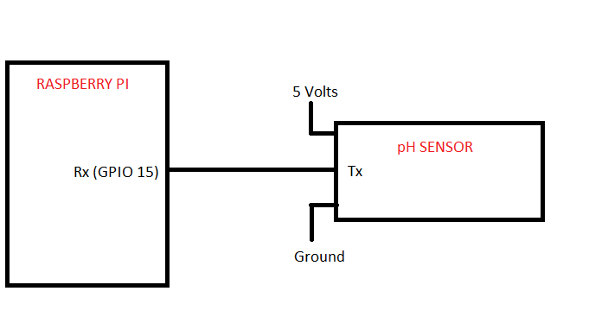

**INTERFACING TURBIDITY SENSOR (TS-300B) AND WATER LEVEL SENSOR WITH RASPBERRY PI:**

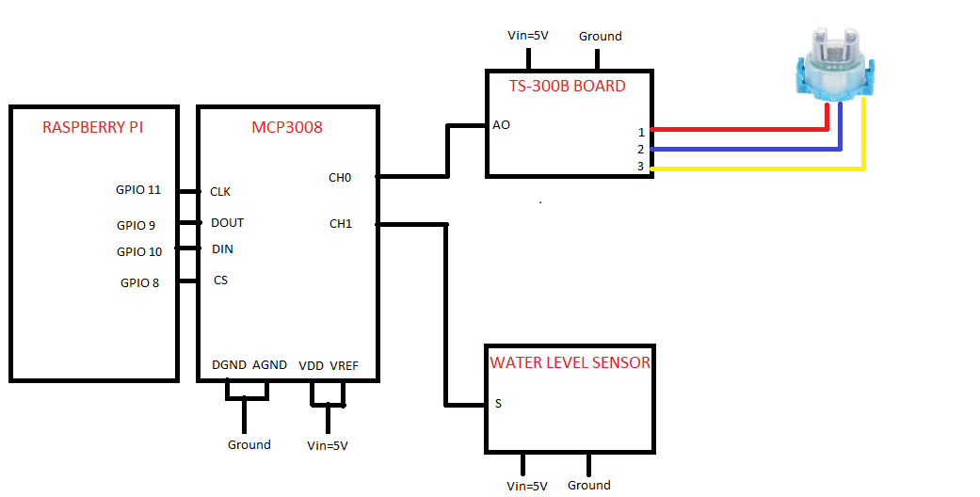

In the Hardware side, if we establish the above circuit connections and run the code with raspberry pi connected to Internet , It works well.

**SOFTWARE SIDE:**

In order to collect data from pi and store it in database I used the free web hosting service **– 000webhost.com.**

**So create an account in 000webhost to start the project if you didn’t have.**

Here are some basic video links and materials to know about 000webhost

1. <https://www.youtube.com/watch?v=3Qkn9ju1Sj0>
2. <https://www.youtube.com/watch?v=-y4x8DyQHDE>
3. <https://www.000webhost.com/forum/t/how-to-connect-to-database-using-php/42093>:
4. <https://www.youtube.com/watch?v=IgbsrCv0a_E>

STEPS TO CREATE WEBHOST:

* Open the database manager and create a new database.
* In the database create a new table namer watermonitor with fields id, pH, turbidity, waterlevel, luminous, temperature. The field id must be selected as primary key and must be autoincremented.
* Now open the file manager and upload all the php files, images and folder Table_Responsive_v1.
* In DBCONFIG change the database user name, Your database password and Your database name.
* Now open the waterresourcetable.php file the website works which displays the water quality parameters measured by Pi.
* Here the inswat.php file acts as the api to update the 000webhost database table with water quality parameters from Pi