**BLOCK DIAGRAM:**

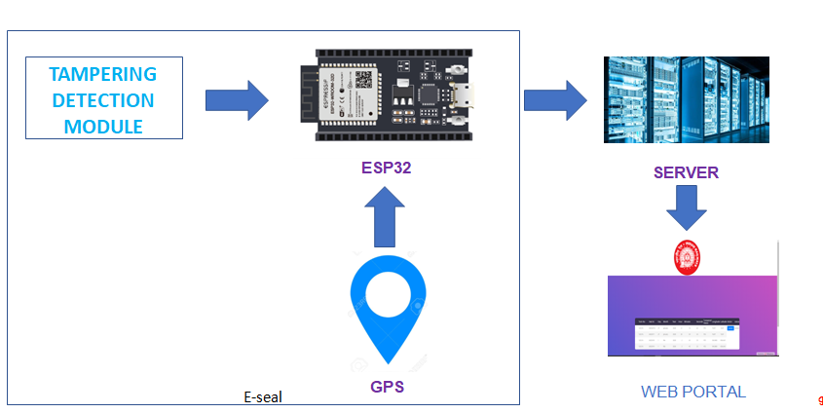

**E-SEAL DESIGN:**

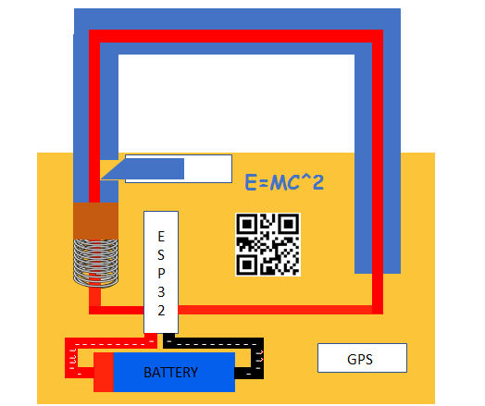

**Hardware Required:**

ESP32, GPS, Solenoid Lock, Connecting Wires

**Programming Languages Required:**

HTML, CSS, JavaScript, PHP

**Hardware Side:**

* The microprocessor used here is ESP32.
* So we need to install the Arduino ide to work with the processor.
* The steps to connect the arduino ide with the esp32 board is explained in below link:

<https://randomnerdtutorials.com/installing-the-esp32-board-in-arduino-ide-windows-instructions/>

* The steps to connect the GPS module with the esp32 board is explained in below link:

<https://www.youtube.com/watch?v=hh-_s-NNab4>

* In this project oled display is not required as shown in above link.
* The steps to connect the solenoid with the esp32 board is explained below :
* Connect the power supply to the 5 volt and ground pins of the solenoid.
* Connect the data pin of solenoid to the 13th pin of esp32.
* Now connect the 3.3 volt pin of esp32 to the 23rd pin of esp32. This acts as tampering mechanism when integrated along with solenoid lock. When someone tries to break the solenoid lock to break the seal, the signal to the 23rd pin will get disrupted thus trigerring tampered signal.
* Copy the code in maincode text file to the new file in arduino ide and compile and load the code to esp32.
* The hardware side portion is completed.

**Software Side:**

In order to collect data from pi and store it in database I used the free web hosting service **– 000webhost.com.**

**So create an account in 000webhost to start the project if you didn’t have.**

Here are some basic video links and materials to know about 000webhost

1. <https://www.youtube.com/watch?v=3Qkn9ju1Sj0>
2. <https://www.youtube.com/watch?v=-y4x8DyQHDE>
3. <https://www.000webhost.com/forum/t/how-to-connect-to-database-using-php/42093>:
4. <https://www.youtube.com/watch?v=IgbsrCv0a_E>

STEPS TO CREATE WEBHOST:

* Open the database manager and create a new database.
* In the database create a new table namer tampstatus with fields id, day, month, year, hour, min, sec, tamperedstatus, longitude and latitude. The field id must be selected as primary key and must be autoincremented.
* In the database create another new table named lockstatus with fields id, status. The field id must be selected as primary key and must be autoincremented.Insert a single record with id as 1 and status as locked.
* Now open the file manager and upload all the php files, images and folder Table_Responsive_v1.
* In DBCONFIG change the database user name, Your database password and Your database name.
* Now open the list.php file the website works which displays the status of E-SEAL.
* Here the INSERT.php file acts as the api to update the 000webhost database table with E-SEAL parameters from ESP32.
* Here the updatelock.php file acts as the api to update the 000webhost database table with E-SEAL lock and unlock state from authorities from webpage.
* Here readall.php and readall1.php is used to display the records of tampstatus and lockstatus tables respectively.