**BLOCK DIAGRAM**

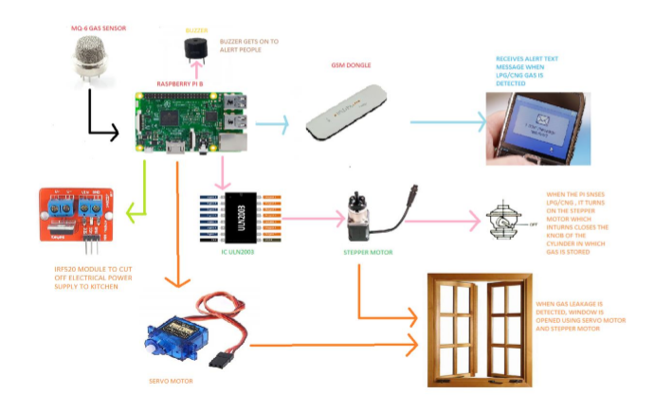

**HARDWARE REQUIREMENTS**

i. Raspberry Pi 3 Model B.

ii. Gas Sensor - MQ6.

iii. Stepper Motor.

iv. Servo Motor.

v. ULN2003.

vi. GSM Dongle.

vii. Buzzer.

viii. Relay IRF520.

**SOFTWARE REQUIRED**

i. MATLAB 2018a.

ii. Raspberry Pi Hardware Support Package.

**Steps to download Raspberry Pi Hardware Support Package for Matlab can be found in the below link:**

<https://in.mathworks.com/help/supportpkg/raspberrypiio/index.html>

CIRCUIT DIAGRAM:

**INTERFACING MQ-6 SENSOR WITH RASPBERRY PI**

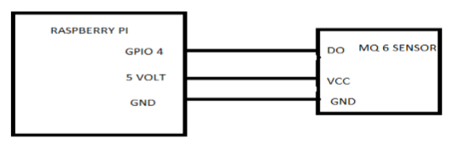

**INTERFACING BUZZER WITH RASPBERRY PI**

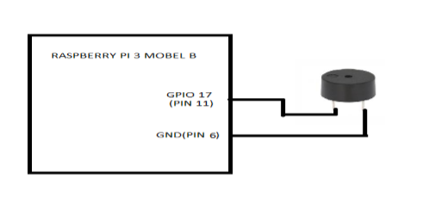

**INTERFACING RELAY WITH RASPBERRY PI**

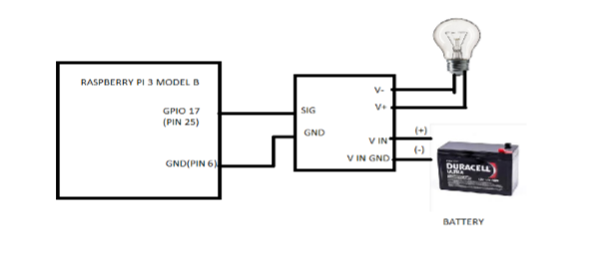

**INTERFACING STEPPER MOTOR WITH RASPBERRY PI TO CLOSE KNOB**

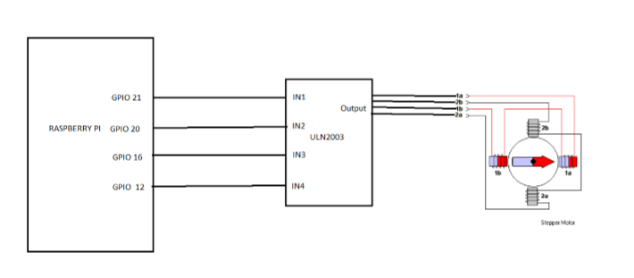

**INTERFACING STEPPER MOTOR AND SERVO MOTOR WITH RASPBERRY PI TO OPEN AND CLOSE WINDOW**

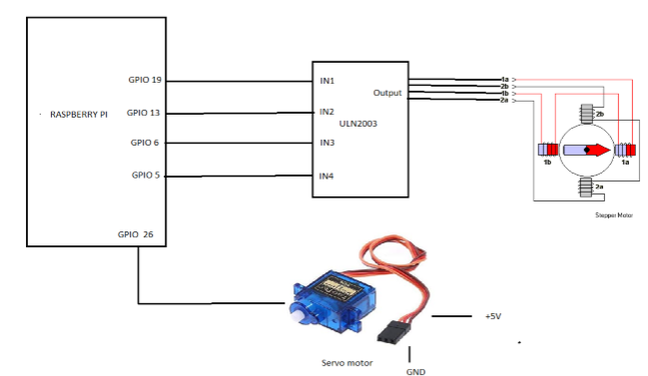

**STEPS TO RUN THE PROJECT:**

* After installing Raspberry Pi Support Package to Matlab and connecting the sensors and devices to Pi, Download the matlab files to a single folder.
* Run the maincode.m in matlab and the project works!