CIVIC ISSUE REPORTING SYSTEM
INNOVATIVE PROJECT  April/May 2026 | INNOVATIVE / MULTI-DISCIPLINARY PROJECT REPORT SUBMITTED IN PARTIAL FULFILLMENT OF THE REQUIREMENTS FOR THE AWARD OF  THE DEGREE OF BACHELOR OF ENGINEERING IN COMPUTER SCIENCE AND ENGINEERING  OF THE ANNA UNIVERSITY
 | 
PROJECT
WORK | Submitted by
 | KARTHIK RAJA G – 722823104067
 | MUGILAN R – 722823104096
 | MUKISH KUMAR T – 722823104097
 | RAGUL RAJ N – 722823104120
BATCH 2023 – 2027
Under the Guidance of
Dr. A. SARFARAZ AHMED M.E., Ph. D.,
Assistant Professor Computer Science and Engineering

 | Sri Eshwar College of Engineering  (An Autonomous Institution)  Kinathukadavu (Tk), Coimbatore - 641 202, Tamil Nadu Approved by AICTE, New Delhi and Affiliated to Anna University, Chennai |  | 
CIVIC ISSUE REPORTING SYSTEM

INNOVATIVE PROJECT  April/May 2026 |  | INNOVATIVE / MULTI-DISCIPLINARY PROJECT REPORT SUBMITTED IN PARTIAL FULFILLMENT OF THE REQUIREMENTS FOR THE AWARD OF  THE DEGREE OF BACHELOR OF ENGINEERING IN COMPUTER SCIENCE AND ENGINEERING  OF THE ANNA UNIVERSITY
 |  |  | 
PROJECT
WORK |  |  | Submitted by
KARTHIK RAJA G – 722823104067
MUGILAN R – 722823104096
MUKISH KUMAR T – 722823104097
RAGUL RAJ N – 722823104120
BATCH 2023 – 2027
Under the Guidance of
Dr. A SARFARAZ AHMED M.E., Ph.D.,
Assistant Professor Computer Science and Engineering



BONAFIDE CERTIFICATE

Certified that this Report titled “CIVIC ISSUE REPORTING SYSTEM” is the bonafide work of
KARTHIK RAJA G | 722823104067
MUGILAN R | 722823104096
MUKISH KUMAR T | 722823104097
RAGUL RAJ N | 722823104120
who carried out the project work under my supervision.

SIGNATURE | SIGNATURE
Dr. R. Subha, M.E, Ph.D.,  HEAD OF THE DEPARTMENT  Computer Science and Engineering, Sri Eshwar College of Engineering, Coimbatore – 641 202. | Dr. A SARFARAZ AHMED M.E., Ph.D.,  SUPERVISOR  Assistant Professor,  Computer Science and Engineering, Sri Eshwar College of Engineering, Coimbatore – 641 202.

Submitted for the Autonomous Semester End Innovative / Multi-Disciplinary Project Viva-Voce held on ………………….
INTERNAL EXAMINER | EXTERNAL EXAMINER



QUALITY POLICY
To establish a system of Quality Enhancement, which would on a continuous basis evaluate and enhance the quality of teaching – learning, research and extension activities of the institution, leading to improvements in all processes, enabling the institution to attain excellence.

INSTITUTE VISION
To be recognized as a premier institution, grooming students into globally acknowledged engineering professionals.

INSTITUTE MISSION
- Providing outcome and value-based engineering education
- Nurturing research and entrepreneurial culture
- Enabling students to be industry ready and fulfill their career aspirations
- Grooming students through behavioral and leadership training programs
- Making students socially responsible
DEPARTMENT OF COMPUTER SCIENCE AND ENGINEERING DEPARTMENT VISION
To groomstudents into globally competent software professionals and meet the ever changing requirements of the industry.
DEPARTMENT MISSION
  - Creating a quality academic environment with relevant IT infrastructure and empowering faculty and students with emerging technologies.
  - Motivating staff and students to actively involve in lifelong learning and fostering research.
  - Inculcating leadership and entrepreneurship skills in students.
  - Generating opportunities for students to evolveas competent softwareprofessionals with societal consciousness.

PROGRAM EDUCATIONAL OBJECTIVES
PEO1: To preparegraduates for a career in software engineering
PEO2: To preparestudents for higher studies, research, entrepreneurial and leadership roles by imparting the quality of lifelong learning
PEO3: To enable students to apply innovative solutions for real-life problems in computer science domain.

PROGRAM OUTCOMES
PO1: Engineering Knowledge: Apply knowledge of mathematics, natural science, computing, engineering fundamentals and an engineering specialization as specified in WK1 to WK4 respectively to develop to the solution of complex engineering problems.
PO2: Problem Analysis: Identify, formulate, review research literature and analyze complex engineering problems reaching substantiated conclusions with consideration for sustainable development. (WK1 to WK4) PO3: Design/Development of Solutions: Design creative solutions for complex engineering problems and design/develop systems/components/processes to meet identified needs with consideration for the public health and safety, whole-life cost, net zero carbon, culture, society and environment as required. (WK5) PO4: Conduct Investigations of Complex Problems: Conduct investigations of complex engineering problems using research-based knowledge including design of experiments, modelling, analysis & interpretation of data to provide valid conclusions. (WK8).
PO5: Engineering Tool Usage: Create, select and apply appropriate techniques, resources and modern engineering & IT tools, including prediction and modelling recognizing their limitations to solve complex engineering problems. (WK2 and WK6)
PO6: The Engineer and The World:Analyze and evaluate societal and environmental aspects while solving complex engineering problems for its impact on sustainability with reference to economy, health, safety, legal framework, culture and environment. (WK1, WK5, and WK7).
PO7: Ethics: Apply ethical principles and commit to professional ethics, human values, diversity and inclusion; adhere to national & international laws. (WK9)
PO8: Individual and Collaborative Team work: Function effectively as an individual, and as a member or leader in diverse/multi-disciplinary teams.
PO9: Communication: Communicate effectively and inclusively within the engineering community and society at large, such as being able to comprehend and write effective reports and design documentation, make effective presentations considering cultural, language, and learning differences
PO10: Project Management and Finance: Apply knowledge and understanding of engineering management principles and economic decision-making and apply these to one’s own work, as a member and leader in a team, and to manage projects and in multidisciplinary environments.
PO11: Life-Long Learning: Recognize the need for, and have the preparation and ability for i) independent and life-long learning ii) adaptability to new and emerging technologies and iii) critical thinking in the broadest context of technological change. (WK8)
PROGRAM SPECIFIC OUTCOMES
PSO1. Demonstrate knowledge in open source technologies
PSO2. Develop innovative solutions by adapting emerging technologies for industry oriented applications.
PSO3. Implement SDLC principles for project/product development.

ACKNOWLEDGEMENT

ACKNOWLEDGEMENT

We thank God for his grace and blessing that have been showered upon us to bring success for this project. The success we have accomplished in our project would not have been possible without the timely help and guidance rendered to us by many people. We take this opportunity to thank them all.

We wish to express our deep gratitude Mr. R. Mohanram, Chairman, Sri Eshwar College of Engineering, Kondampatti for being kindly permitted us to carry on the project. He has an abiding interest in our wellbeing.

We are grateful to Dr. Sudha Mohanram M.E., Ph.D Principal, Sri Eshwar College of Engineering, Kondampatti for having made all provision available to us.

We are thankful to Mr. R. Rajaram, Director, Sri Eshwar College of Engineering, Kondampatti for all his support to complete the project effectively.

We would like to express our heartfelt gratitude and humble thanks to Head of the Department Dr. R. Subha M.E., Ph.D., for having facilitated us to complete the project successfully.
With the deep sense of gratitude, we extend our earnest and sincere thanks to our project guide Mr. A. Sarfaraz Ahmed M.E., Ph.D., Assistant Professor, Department of Computer Science and Engineering, for his kind suggestion and co-operation for doing the project. Finally, we would like to extend our thanks to our teaching and non-teaching staffs those who helped us in bringing out project successfully.

TABLE OF CONTENT

TABLE OF CONTENT

CHAPTER NO. | TITLE | PAGE NO.
 | ABSTRACT | I
 | LIST OF FIGURES | II
 | LIST OF TABLES | IV
 | LIST OF ABBREVIATIONS | VI
1 | INTRODUCTION | 1
 | 1.1 OBJECTIVE | 1
 | 1.2 LITERATURE SURVEY | 2
2 | SYSTEM ANALYSIS AND DESIGN | 6
 | 2.1 EXISTING SCENARIO | 7
 | 2.2 PROBLEM STATEMENT | 8
3 | PROPOSED SOLUTION | 9
 | 3.1 OVERVIEW | 10
 | 3.2 BLOCK DIAGRAM | 11
4 | SYSTEM SPECIFICATION | 12
 | 4.1 SOFTWARE REQUIREMENTS | 13
5 | PROJECT DESCRIPTION | 14
 | 5.1 METHODOLOGY | 15
 | 5.2 IMPLEMENTATION | 16

6 | RESULT AND IMPLEMENTATION | 17
7 | CONCLUSION | 20
8 | REFERENCES | 22

ABSTRACT
Urban communities often face significant challenges in reporting and resolving civic issues such as potholes, water leakage, waste mismanagement, and public safety concerns due to the inefficiencies of traditional reporting systems, which are typically manual, time-consuming, and lack transparency. These conventional methods fail to provide real-time updates or effective communication between citizens and authorities, resulting in delayed resolutions, reduced accountability, and growing dissatisfaction among the public. Additionally, the absence of mechanisms for community participation makes it difficult to prioritize critical issues, further weakening governance effectiveness. To address these limitations, the proposed system, CivicPulse, is developed as a modern full-stack civic issue reporting and management platform that enhances interaction between citizens and authorities. It enables users to report issues with detailed descriptions, images, and location data, while also supporting features such as upvoting and commenting to encourage community engagement and prioritization. The system follows a structured workflow where issues progress from submission to resolution, with real-time notifications keeping users informed at every stage. This transparent, dynamic, and user-centric approach improves accountability, accelerates issue resolution, and transforms traditional civic management into an efficient digital governance solution.

LIST OF FIGURES

LIST OF FIGURES

FIGURE NO. | TITLE | PAGE NO.
3.1 | BLOCK DIAGRAM | 11
6.1 | STUDENT DASHBOARD | 18
6.2 | SKILL MATCHING PAGE | 18
6.3 | COMPANY DASHBOARD | 19
6.4 | COMPANY ENGAGEMENT TRACKING PAGE | 19

LIST OF TABLES

LIST OF TABLES

TABLE NO. | TITLE | PAGE NO.
1.1 | LITERATURE SURVEY | 03

LIST OF ABBREVIATIONS

LIST OF ABBREVIATIONS

ACRONYM | ABBREVIATION
API | Application Programming Interface
ATS | Applicant Tracking System
HTTP | Hyper Text Transfer Protocol
JWT | JSON Web Token
RBAC | Role-Based Access Control

CHAPTER 1 INTRODUCTION

CHAPTER 1 INTRODUCTION

  - OBJECTIVE
The process of reporting and resolving civic issues has become increasingly important in rapidly growing urban environments, where problems such as potholes, water leakage, waste mismanagement, and infrastructure failures directly impact daily life. However, traditional complaint systems are often fragmented, inefficient, and lack transparency. Citizens typically rely on manual methods or disconnected platforms to report issues, making the process time-consuming and unreliable. At the same time, local authorities face difficulties in managing large volumes of complaints, tracking their status, and prioritizing critical issues. The absence of a centralized system for issue tracking and communication often leads to delays, poor accountability, and reduced public trust.
CivicPulse is designed to address these challenges by providing a unified civic issue reporting and management platform that connects citizens and authorities through a single system. The platform enables users to report issues with detailed descriptions, images, and location data, while also allowing them to track the progress of their complaints in real time. Authorities can efficiently manage reports, update issue statuses, and prioritize tasks through a structured administrative dashboard. By incorporating features such as role-based access, community engagement through upvoting and commenting, and real-time notifications, the system improves communication, enhances transparency, and ensures faster and more effective resolution of civic problems.

  - LITERATURE SURVEY
Several studies have focused on improving civic issue reporting and urban governance systems using digital platforms and web-based technologies. Traditional complaint systems mainly provide basic functionalities for submitting issues, often through manual processes or simple online forms. However, these systems lack transparency, real-time tracking, and effective communication between citizens and authorities. Researchers have identified that such limitations lead to delayed responses, unresolved complaints, and reduced public trust in governance systems. Additionally, the absence of a centralized and structured platform makes it difficult for authorities to efficiently manage and prioritize large volumes of reported issues.
Recent research has explored the use of modern web technologies to enhance the efficiency and usability of civic management systems. Features such as centralized dashboards, real-time status updates, and location-based issue reporting have been introduced to improve system performance. Furthermore, community-driven approaches like upvoting and commenting have gained importance, as they allow citizens to participate in prioritizing issues based on urgency and impact. These techniques help authorities focus on critical problems while also increasing citizen engagement and involvement in the decision-making process.
In addition, the adoption of full-stack development frameworks has enabled the creation of scalable and interactive civic platforms. Technologies such as React.js for frontend development and backend frameworks like Spring Boot32.02, along with databases such as MySQL, provide efficient data handling. By integrating these technologies with role-based access control and structured workflows, modern systems can automate issue tracking, improve communication, and ensure accountability.

S.No. | Title | Author(s) | Organization & Year | Brief Description
1 | Job Recommendation System Based on Machine Learning | Y. Zhang, Q. Wang, H. Li | IEEE  Conference, 2021 | Proposes a machine learning based system that recommends jobs by analyzing candidate profiles and job  requirements to improve matching  accuracy.
2 | Job Recommendation System Using Machine Learning | S.  Gadegaonkar,  D. Lakhwani,  S. Marwaha, A. Salunke | IEEE ICAIS, 2023 | Presents a job recommendation platform that uses machine learning techniques to match job seekers with suitable opportunities based on their skills and  experience.
3 | Resume Parser and Job Recommendation System Using Machine Learning | A. Sharma, R. Gupta, K. Verma | IEEE  Conference, 2024 | Introduces a system that automatically extracts information from resumes and recommends relevant jobs using machine learning  algorithms.
4 | Enhancing Resume Recommendation System Through Skill-Based Similarity Using Deep Learning Models | L. Chen, Y. Liu, M. Zhao | IEEE  Conference, 2024 | Uses deep learning models to improve resume recommendation systems by analyzing skill  similarity and candidate qualifications.

5 | A Hybrid Approach for Job Recommendation Systems | P. Singla, V. Verma | IEEE ICCCNT, 2024 | Proposes a hybrid recommendation model that combines multiple algorithms to  improve job recommendation accuracy and efficiency.
6 | Skill Recommendation System and Resume Analysis Using Artificial Intelligence | R. R. Mirajkar,  S. Patil, P. Kulkarni | IEEE Pune Section Conference, 2024 | Describes an AI-based system that analyzes resumes and recommends relevant skills and  job opportunities to candidates.
7 | CaPaR: A Career Path Recommendation Framework | B. Patel, R. Mehta, S. Shah | IEEE Big Data Service Computing Conference, 2017 | Introduces a  framework that recommends career paths by analyzing user profiles, interests, and industry  requirements.
8 | Smart Job Recruitment Automation: Bridging Industry and University | V. Yadav, A. Sharma, R. Singh | IEEE  Advanced Informatics Conference, 2019 | Discusses an automated recruitment system that connects universities and  industries to simplify the hiring process for  students.
9 | Movie Recommendation System Using Cosine Similarity | A. Kumar, S. Patel, R. Shah | IEEE  Conference, 2023 | Demonstrates the use of the Cosine Similarity algorithm to recommend items based on similarity between user preferences.

10 | Enhancing Resume Recommendation Using Deep Learning and Skill Similarity | J. Lee, H. Kim,  S. Park | IEEE  Conference, 2024 | Explores deep learning techniques combined with skill similarity methods to improve resume recommendation  accuracy.

Table 1.1: Literature Survey

CHAPTER 2 SYSTEM ANALYSIS AND DESIGN

CHAPTER 2
SYSTEM ANALYSIS AND DESIGN

  - EXISTING SCENARIO
In the current civic issue reporting environment, citizens typically rely on traditional methods such as visiting government offices, making phone calls, or using basic online complaint portals to report problems like potholes, water leakage, or waste management issues. This fragmented approach makes it difficult for users to track the status of their complaints and often results in delays or no response at all. Many existing systems lack user-friendly interfaces and do not provide features for uploading images or precise location details, which reduces the clarity and effectiveness of reported issues.
From the authorities’ perspective, managing civic complaints is equally challenging. Officials often deal with a large volume of issues that are recorded through manual or semi-digital systems such as emails, registers, or basic databases. This makes it difficult to organize, prioritize, and monitor complaints efficiently. The absence of automated workflows further complicates the process and increases the workload on administrative staff.
Additionally, the lack of a centralized platform for communication and issue tracking creates transparency issues in the overall system. Citizens are often unaware of the progress of their complaints, while authorities may struggle to maintain clear and organized records. These limitations highlight the need for an integrated and modern solution that can streamline civic issue reporting, improve communication, and ensure accountability between citizens and authorities.

PROBLEM STATEMENT
The current civic issue reporting process is often unstructured, manual, and inefficient, making it difficult for citizens to report problems and track their resolution. Citizens typically rely on traditional methods such as visiting offices, making phone calls, or using basic online portals, which do not provide a unified system for managing complaints. This lack of a centralized platform leads to poor communication, delayed responses, and uncertainty regarding the status of reported issues. Additionally, citizens have limited ability to highlight the urgency or importance of issues, which affects proper prioritization.
From the authorities’ perspective, handling a large number of civic complaints is a time-consuming process that is often managed through manual or semi-digital systems. This makes it challenging to organize, monitor, and resolve issues efficiently. The absence of an automated system for tracking issue progress and prioritizing tasks further reduces operational efficiency and increases the chances of delays or overlooked complaints.

Therefore, there is a need for a centralized and efficient platform that can streamline civic issue reporting, improve communication between citizens and authorities, and provide a structured workflow for managing complaints. Such a system should enhance transparency, enable real-time tracking, and ensure faster and more effective resolution of civic issues.

CHAPTER 3 PROPOSED SOLUTION

CHAPTER 3 PROPOSED SOLUTION

  - OVERVIEW
To address the challenges in the existing civic issue reporting system, the proposed solution CivicPulse provides a centralized web-based platform that connects citizens and local authorities in a structured and efficient manner. The platform enables users to report civic issues by submitting detailed descriptions, images, and location information through a single system. At the same time, authorities can view, manage, and update reported issues through a dedicated administrative dashboard. This centralized approach simplifies the reporting process and eliminates the need for multiple disconnected channels, ensuring better organization and faster response.
The system incorporates role-based authentication to ensure secure access and controlled functionality for different users. Citizens and administrators are provided with separate interfaces tailored to their needs. Citizens can track the status of their reported issues in real time, while administrators can efficiently monitor complaints, update their progress, and manage issue lifecycles in an organized manner. This structured workflow enhances communication, improves transparency, and ensures accountability throughout the issue resolution process.
In addition, the platform integrates community engagement features such as upvoting and commenting, allowing users to participate in prioritizing issues based on urgency and impact. By enabling collective feedback, the system helps authorities identify critical problems more effectively and allocate resources accordingly. This interactive and user-centric approach reduces manual effort, improves decision-making, and enhances the overall efficiency of civic issue management.

BLOCK DIAGRAM

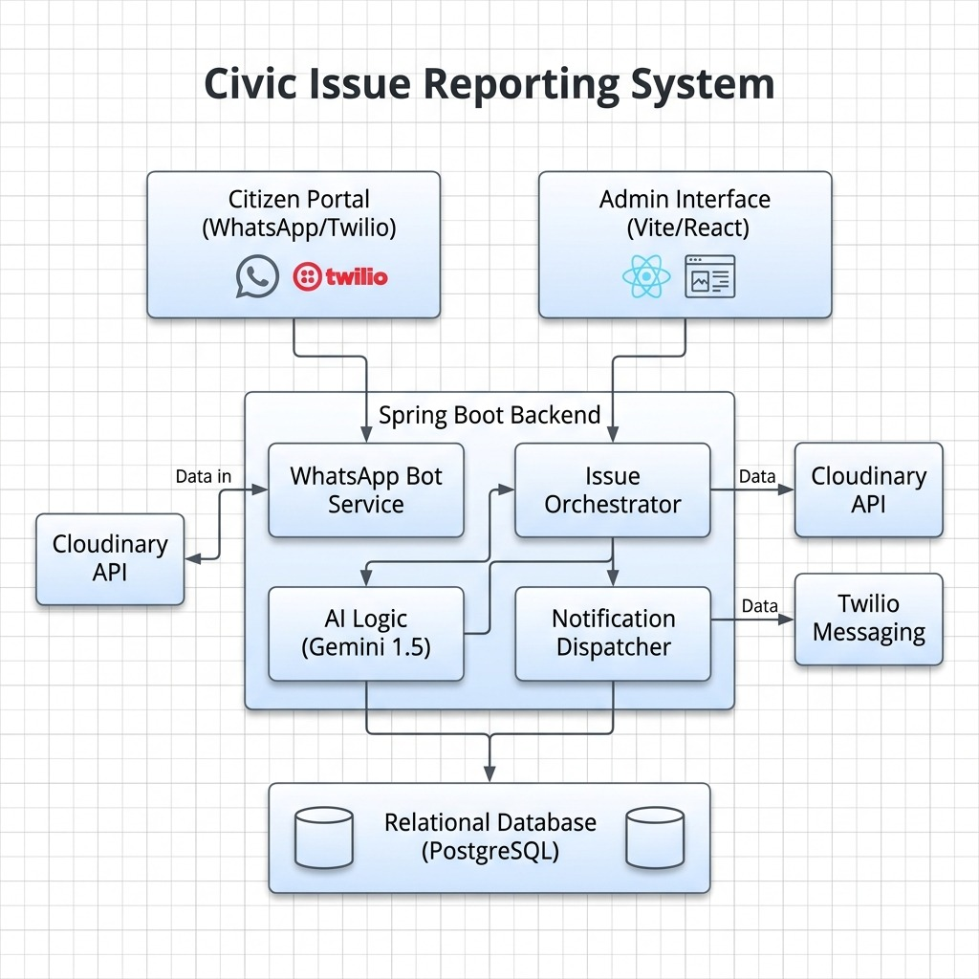
Figure 3.1 – Block Diagram

Fig. 3.1 depicts the workflow of the AI-based internship recommendation system. The process begins with user registration followed by student profile creation and detailed profile submission, where skill vectors are generated from the student’s information. Internship requirements posted by recruiters are also converted into job skill vectors. The system then performs AI-based skill matching using cosine similarity to compare student skills with internship requirements. Based on the similarity score, the system provides internship recommendations, ranks candidates for recruiters, and supports application submission, tracking, and recruiter dashboard management.

CHAPTER 4 SYSTEM SPECIFICATION

CHAPTER 4 SYSTEM SPECIFICATION

  - SOFTWARE REQUIREMENTS
    - Operating System : Windows 10 and above
    - IDE / Code Editor : Visual Code Studio
    - Frontend Framework : React.js
    - Backend Framework : Spring Boot (Java)
    - Database : SQL
    - Authentication : JWT(JSON Web Token)

CHAPTER 5 PROJECT DESCRIPTION

CHAPTER 5 PROJECT DESCRIPTION

  - METHODOLOGY
The CivicPulse system is designed using a modular architecture where the application is divided into different modules to efficiently handle various functionalities. The frontend is developed using React.js to provide an interactive and user-friendly interface, including features such as the user dashboard, admin dashboard, issue reporting forms, and issue tracking pages. These components allow users to register, log in, report civic issues with descriptions, images, and location details, and track the status of their complaints in real time. The frontend communicates with the backend through RESTful APIs to retrieve and update data dynamically. The backend is developed using Spring Boot to manage server-side operations and business logic, while SQL is used as the database to store user details, issue reports, comments, notifications, and upvote data. The system also incorporates structured workflows for issue lifecycle management, ensuring smooth transition of issues from reporting to resolution. Additional modules such as CORS enable secure communication between the frontend and backend, while features like file uploads, authentication using JWT and BCrypt, notifications, and proper error handling improve the overall functionality and reliability of the system. The modular architecture enhances scalability, maintainability, and efficient management of the CivicPulse platform. We have modules like
    - Spring Boot
    - JPA (Hibernate)
    - BCrypt
    - Cors
    - React-router-dom

IMPLEMENTATION
The implementation of the CivicPulse system focuses on developing a centralized web-based platform that enables efficient reporting and management of civic issues. The frontend is developed using React.js to provide an interactive and responsive user interface. Citizens can register, log in, report issues with descriptions, images, and location details, and track the status of their complaints, while administrators can view, manage, and update issues through a dedicated dashboard. The frontend communicates with the backend through RESTful APIs to ensure smooth data exchange and real-time updates.
The backend is implemented using Spring Boot to manage server-side operations and business logic. MYSQL is used as the database to store user information, issue reports, comments, notifications, and upvote details, with Mongoose handling database interactions. Secure authentication and authorization mechanisms using JWT and BCrypt are implemented to ensure that only authorized users can access specific features of the system. Additional functionalities such as image uploads, real-time notifications, and proper error handling are integrated to enhance the reliability and usability of the platform.
The system also incorporates structured issue lifecycle management, where each reported issue moves through different stages such as PENDING, IN_PROGRESS, and RESOLVED. Community engagement features like upvoting and commenting allow users to highlight the importance of issues and provide additional context. Based on user interactions and administrative actions, the system ensures efficient prioritization and resolution of civic problems, thereby improving transparency, communication, and overall effectiveness of civic issue management.

CHAPTER 6 RESULT AND IMPLEMENTATION

CHAPTER 6
RESULT AND IMPLEMENTATION

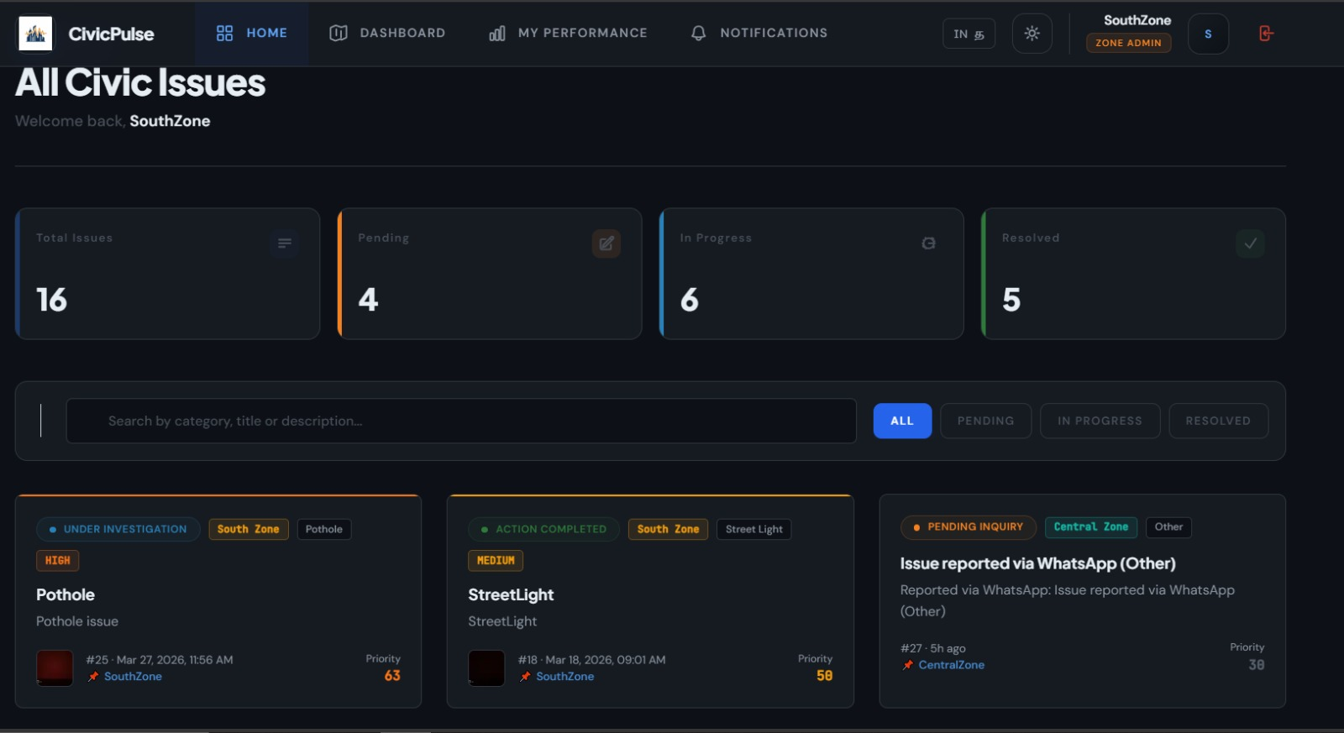
Figure 6.1 Student Dashboard

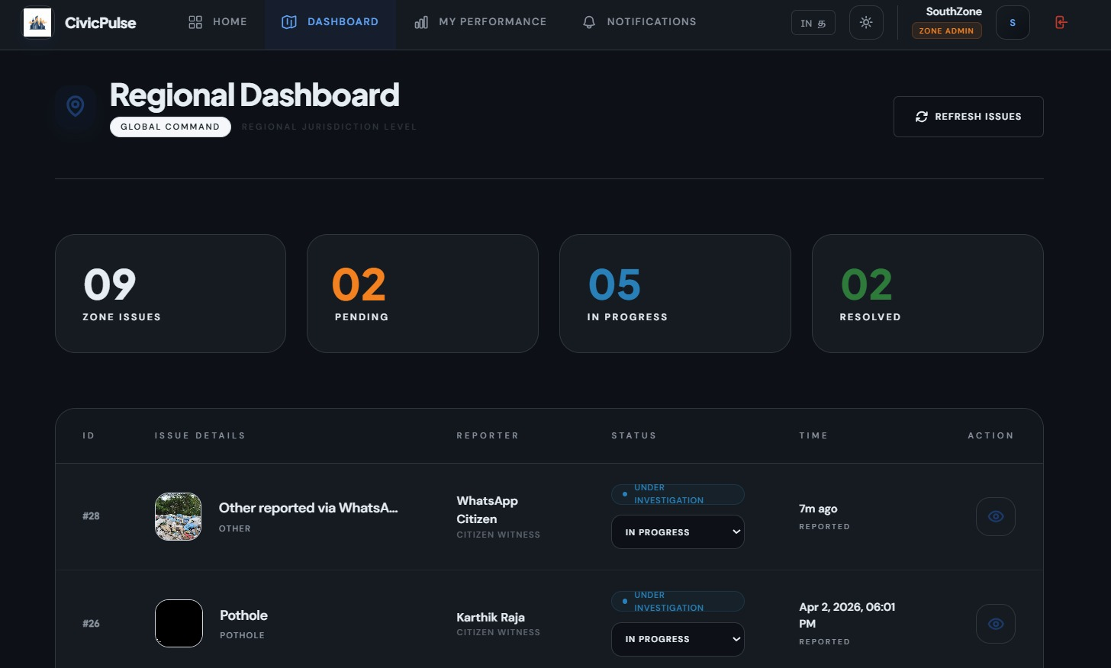
Figure 6.2 – Skill Matching Page

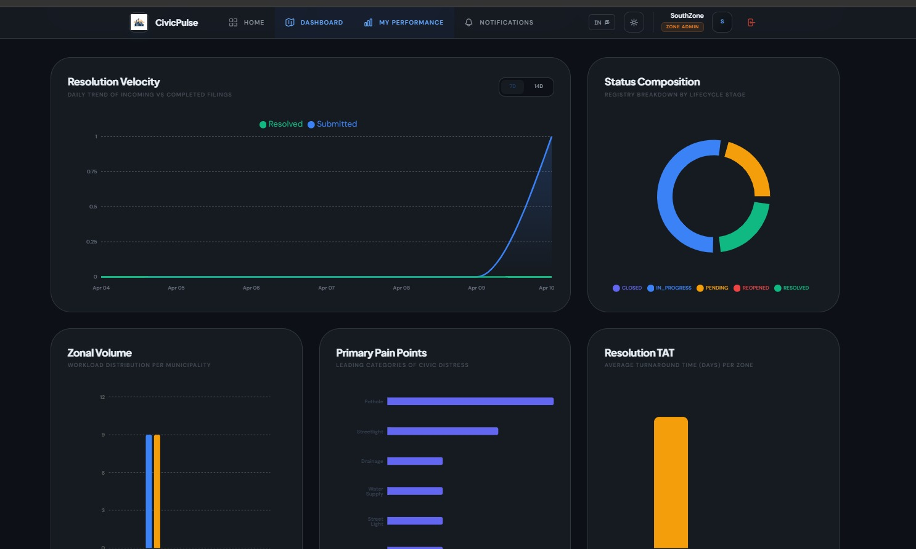

Figure 6.3 – Company Dashboard

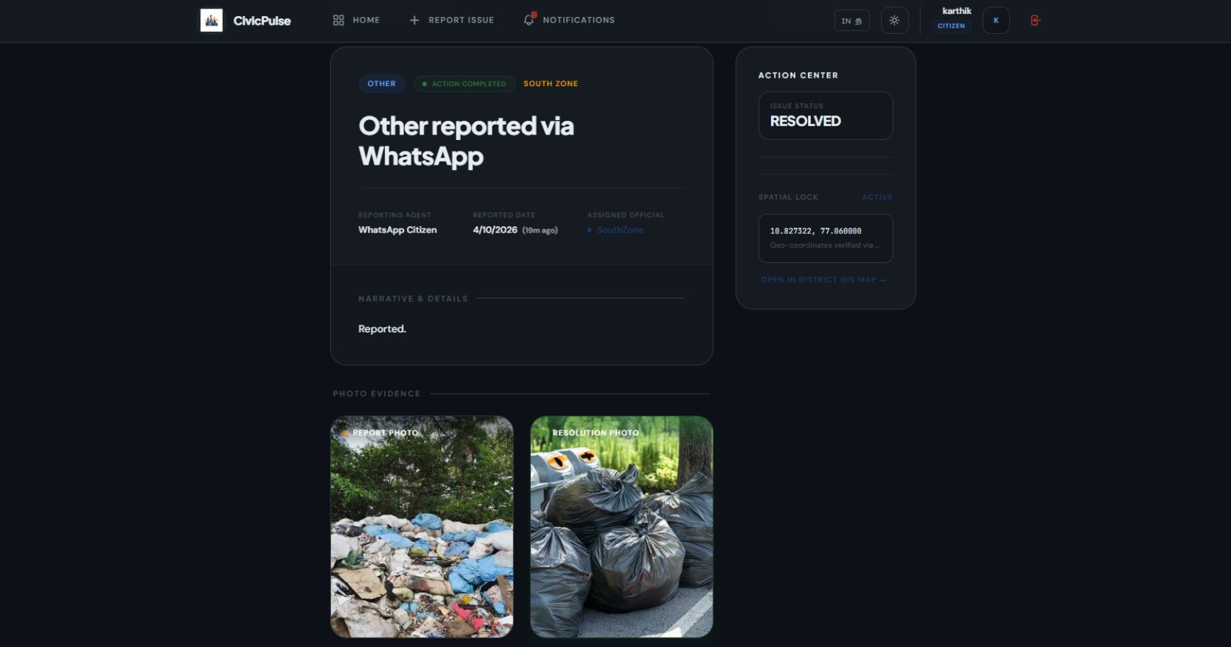
Figure 6.4 Company Engagement Tracking

CHAPTER 7 CONCLUSION

CHAPTER 7 CONCLUSION
The CivicPulse platform provides an efficient and centralized solution for managing civic issue reporting and resolution between citizens and authorities. By integrating features such as issue reporting with images and location details, real-time status tracking, and interactive dashboards, the system simplifies the process of identifying, reporting, and resolving public issues. The web-based nature of the platform ensures easy accessibility and improves communication, enabling citizens to stay informed while allowing authorities to respond more effectively.
The system utilizes modern web technologies such as Spring Boot, JPA/Hibernate and MySQL to manage data and handle server-side operations efficiently. Secure authentication and role-based access control ensure that users and administrators can safely access functionalities based on their roles. The modular architecture of the system enhances scalability, maintainability, and overall performance, making it suitable for handling large volumes of civic data and user interactions.
In addition, the inclusion of community engagement features such as upvoting and commenting allows users to actively participate in prioritizing issues based on urgency and impact. This approach helps authorities focus on critical problems and allocate resources more effectively. Overall, CivicPulse improves transparency, reduces manual effort, and provides a smart, reliable, and user-friendly platform for efficient civic issue management and enhanced digital governance.

CHAPTER 8 REFERENCES

REFERENCES

[1] M. A. Hoque, S. R. Sabuj, and M. S. Alam, “Smart City Civic Issue Reporting System Using Mobile Application and GIS Integration,” in Proc. IEEE 11th Annual Computing and Communication Workshop and Conference (CCWC), Las Vegas, NV, USA, 2021, pp. 0423–0429.
[2] S. S. Bhat and V. S. Rajendra, “Deep Learning Based Automatic Pothole and Garbage Detection System for Smart Cities,” in Proc. IEEE International Conference on Evolutionary Computing and Mobile Sustainable Networks (ICECMSN), 2023, pp. 112–119.
[3] J. Zhang, Y. Wang, and L. Sun, “A Multimodal Large Language Model Framework for Intelligent Urban Infrastructure Monitoring,” IEEE Transactions on Smart Cities, vol. 5, no. 2, pp. 156-168, Apr. 2024.
[4] R. K. Singh and A. Gupta, “WhatsApp Bot and Conversational AI: Bridging the Gap Between Citizens and Municipal Corporation,” in Proc. IEEE International Conference on Advances in Computing, Communication and Control (ICAC3), 2023.
[5] P. Kumar, S. Verma, and L. H. Chergui, “A Cyber-Physical-Social System for Real-time Grievance Redressal in Urban Governance,” IEEE Access, vol. 11, pp. 24567–24581, 2023.
[6] M. Rossi and G. Vercelli, “AI-Driven Decision Support System for Zonal Assignment and SLA Tracking in Smart Cities,” in Proc. IEEE International Smart Cities Conference (ISC2), 2022.
[7] N. Pathare and S. Deshmukh, “Automated Priority Scoring for Civic Issue Resolution using Machine Learning,” International Journal of Computer Applications (IJCA), vol. 184, no. 48, pp. 12-19, Jan. 2023.
[8] H. Li, Q. Wang, and T. Brown, “Citizen Engagement 2.0: Crowdsourcing Urban Maintenance with Image-based AI Verification,” Journal of Urban Technology (IEEE CrossRef), vol. 30, no. 3, pp. 45–62, 2024.
[9] “Data Integrity and Image Verification in Participatory Sensing for City Infrastructure,” in Proc. IEEE European Conference on Smart Objects, Systems and Technologies (SmartSys), 2020.
[10] B. Sharma and R. Patel, “Smart Governance: Integrating IoT and AI for Transparent Municipal Operations,” IEEE Internet of Things Journal, vol. 9, no. 14, pp. 12045-12060, July 2022.

Annexure


PROJECT TITLE | HIRE.IO – AI BASED INTERNSHIP RECOMMENDATION ENGINE
PROGRAM | B.E. COMPUTER SCIENCE AND ENGINEERING
PROJECT BATCH NUMBER | 27
BATCH MEMBERS | 722823104067 | KARTHIK RAJA G
 | 722823104096 | MUGILAN R
 | 722823104097 | MUKISH KUMAR T
 | 722823104120 | RAGUL RAJ N
NAME OF THE SUPERVISOR | Dr. A SARFARAZ AHMED
NAME OF THE SDG GOALS MAPPED | Quality Education  Decent Work and Economic Growth Industry, Innovation, and Infrastructure
MENTION THE SDG GOALS NUMBER | 4,8,9
NAME OF THE TRL LEVEL | First of a kind Commercial System
MENTION THE TRL LEVEL | 8

POs & PSOs Mapping (Put a tick mark in the mapped PO’s & PSO’s):

Program Outcomes |  |  |  |  |  |  |  |  |  |  | Program  Specific Outcomes
PO1 | PO2 | PO3 | PO4 | PO5 | PO6 | PO7 | PO8 | PO9 | PO10 | PO11 | PSO1 | PSO2

Signature of the Supervisor
Mr. A. Sarfaraz Ahmed M.E., Ph. D.,
Annexure

VENUE AND EXPENDITURE STATEMENT FOR THE PROJECT WORK

Laboratory details where the  project is carried out | Project Lab, CSE
Software / Hardware details

Details of the Component and Expenditure

S. No | Name of the Component | Qty | Price / Unit in (Rs.) | Amount (Rs.)

(*Include any other charges which includes fabrication cost and others)

Signature of the student Signature of the Supervisor
(Names of the Student) Mr. A. Sarfaraz Ahmed M.E., Ph. D.,

