Ulkasemi
Analog Design Department

Week 1 Report
Analog Design Basics

Performed by:
Abdul Mukit
abdulmukit832@gmail.com

- Application:

Most of the processors/arithmetic units now-a-days are made using digital circuits. But analog system is also needed and used in many application. One example can be in the communication system. Radio signal filter is used to receive radio signal, and then it is passed through low noise amplifier for amplification. Both of these circuits are analog circuits. Then Analog to analog to digital conversion is performed, which is a mixed circuit containing both analog and digital components.
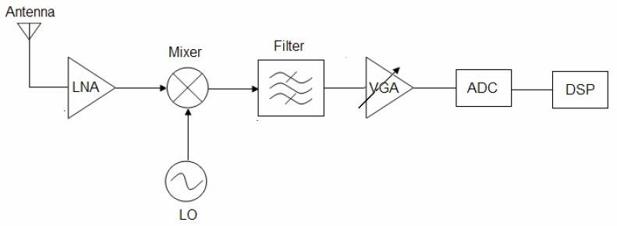

- Why analog design today are not fully automated like digital design?
Analog circuit parameters vary from PDK to PDK, so full automation is not posssible. It still requires the human touch.

- Mosfet operation Region:
There are mainly 3 operation regions for an NMOS
- Accumulation: V_{GB} is negative
- Depletion: 0<V_{GB}<Vth, no channel is formed and mosfet is said to be in cut-off
- Inversion: V_{GB} > Vth, channel is formed and current flow is possible by applying drain to source voltage.

- Characteristic I-V Curve

In the Inversion mode, we can see from the I_{D} vs V_{DS} graph that there are two region of operation, linear region and saturation region.
As V_{GS}>V_{TH}, if we apply a positive V_{DS} , then a current flow is found. As Vds is increased for certain Vgs, Current continues to Rise.
After a certain point, no matter how much Vds we increase, I_{D} remains the same, the curve gets flattened. This is called the saturation region, which our desired region for analog operation as the resistance is infinite. The current equation in the saturation region is:
I_{D} = 0.5* u_{n} * C_{OX} * (W/L) * (V_{GS –} V_{th})², we see that the current is invariant of Vds.
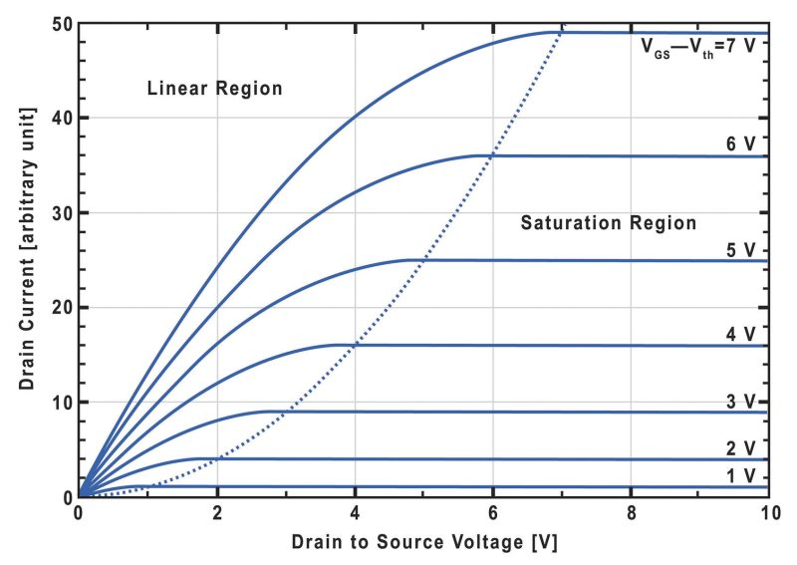

Also, as the gate to source voltage increases, I_{D} also increases and the curve shifts upwards.
Now, at linear region, Vds tends to zero, we get:
V_{DS} / I_{D} = [u_{n} * C_{OX} * (W/L) * (V_{GS –} V_{th})]⁻¹
So at linear region the mosfet works as voltage controlled resistor.

- Mosfet as Current Source
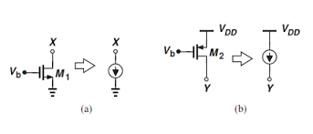

We know that, ideal current sources have infinite impedance, at saturation ideal mosfets show infinite impedance, so they can be used as current source. According to our desired connection, we can use either NMOS or PMOS as the current source.

- Transconductance of Mosfet
Mosfets are called transconductance amplifier, because they take voltage as input (Vgs) and gives current as output (I_{D}). We can find out the transconductance of mosfets by taking derivation of I_{D} vs Vgs curve.
In the I_{D} vs Vgs curve, we see that if Vgs<Vth, there is not output current from the mosfet. But after Vgs>Vth, output current is found and it gradually increase with respect to Vgs increase.

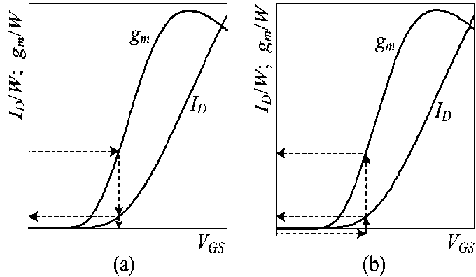

From the graph, we see that at first g_{m} increases, then it falls off. g_{m} has two expression:
g_{m} (Linear) = u_{n} * C_{OX} * (W/L) * [V_{DS} + {-1/Vgs (Vth*V_{DS –} (V_{DS}/2)²)}]
g_{m} (saturation) = 0.5* u_{n} * C_{OX} * (W/L) * (V_{GS –} 2V_{th} + V_{th}²/ V_{GS})
g_{m} (Linear) portion gives the maximum value of tranconductance.

- Non Ideal Effects
- Threshold Voltage Vs Temperature
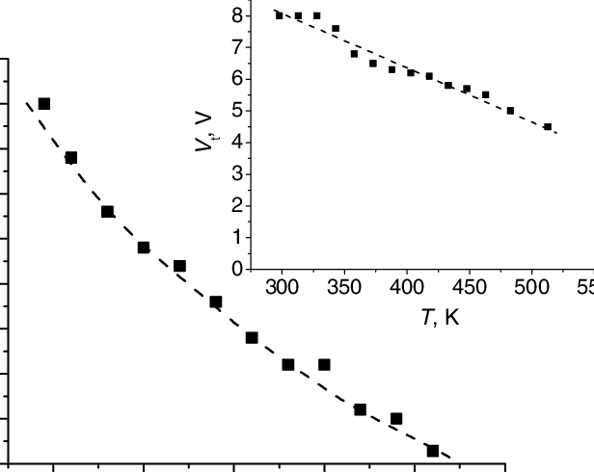

As the temperature increases, threshold voltage drops off. This happens because excess carrier concentration increase with respect to temperature increase, so the substrate needs less voltage to create a channel.

- Mobility vs Temperature

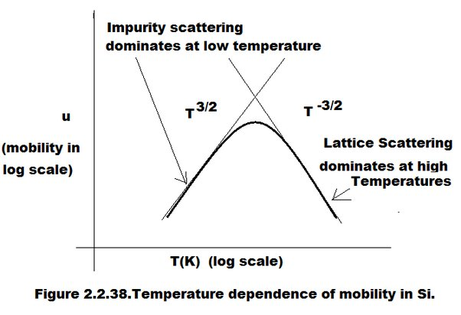

Mobility in silicon substrate is influenced by two major properties, impurity scattering and lattice scattering.
Impurity scattering happens due to p/n doping. As temperature increase, they produce more carriers so in turn, mobility is increased.
On the other hand, lattice scattering happens due to vibration of atoms. As the temperature rises, the vibration of atoms increases too, reducing the mean free path of electrons. So, mobility is decrease.
At room temperature or higher temperatures, Lattice scattering dominates the impurity scattering effect. So as a whole mobility and current flow decrease with increasing temperature.

- Channel Length Modulation

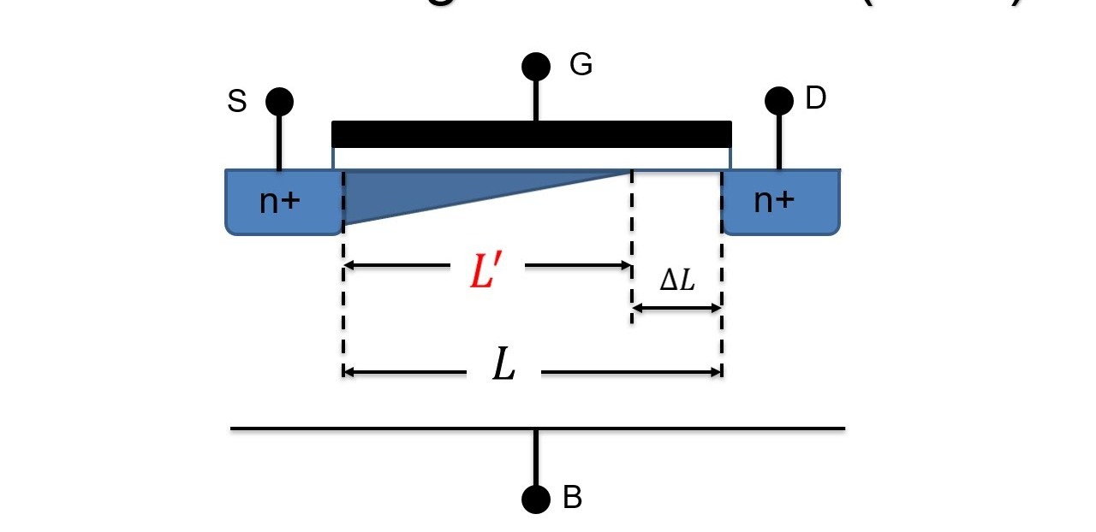
When the saturation point is reached, the current is supposed to be invariant with the change of drain to source voltage. But in real cases, it is seen that after saturation point, current still increases with increasing Vds. It is caused by channel length modulation. If Vds is increase after the saturation point, the channel gets pinched off and the effective channel length decreases. So the (W/L) parameters increases, and it in turn increases the output current.

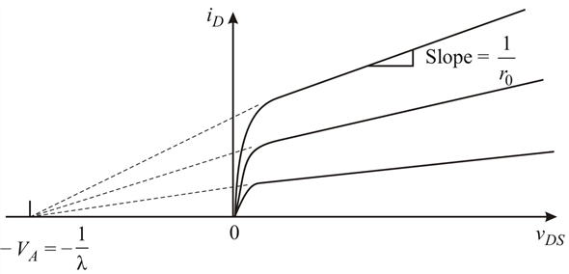

So, in case of channel length modulation, we don’t get infinite resistance at the saturation region, instead we get a finite resistance with a large value (ro). Here, λ is the channel length modulation co-efficient.
- Body Effect:
If the body of the mosfet is not connected at the same potential as the source, body effect occurs. Due to body effect, the change of threshold voltage occurs.
V_{th} = V_{tho} + Ɣ[√(2φ_{F} +V_{SB}) -√ 2φ_{F}]

- 2nd Order Effects: Subthreshold Current
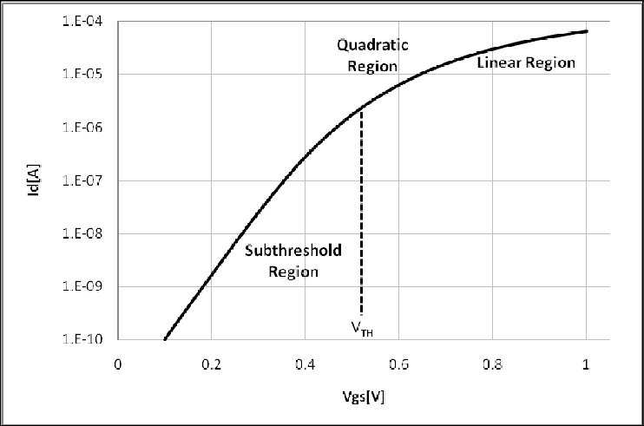

We learned that, when Vgs<Vth, we should get no current. But in practical conditions, we get current at nano ampere/micro ampere range even in the weak depletion region, this is called the subthreshold current. This current flow happens because of minority carriers.

- Subthreshold Region as a PTAT Generator

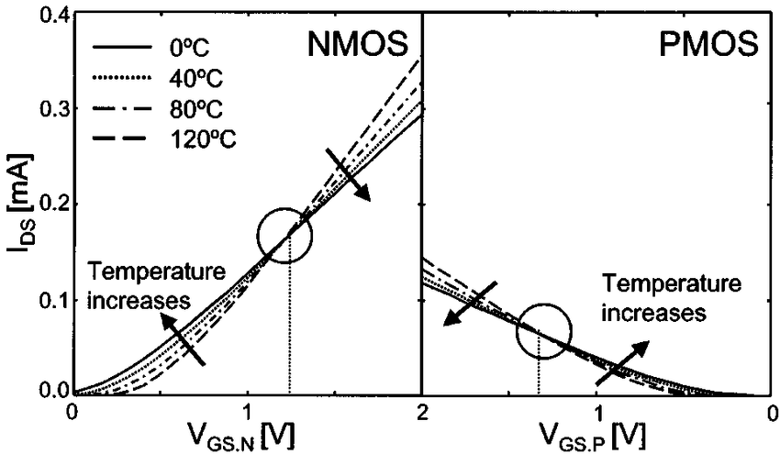
We learned that, in the room temperature or above, mosfet works as a CTAT. But from the graph, we see that as temperature increases, subthreshold currents also increase. So, in this region the mosfet is working as a PTAT (proportional to absolute temperature) generator. The point where all the curves intersect is called the zero temperature coefficient.

- Small Signal Model

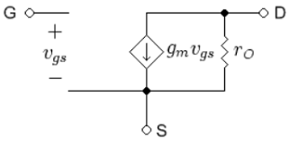
Using appropriate DC bias, we can set the mosfet to operate in the saturation region. Then the AC signal is superimposed on the DC signal. If the AC signal amplitude is around 0.1* DC signal amplitude, we can treat it as small signal. Then we can use a separate model to only calulate the AC signal components separately, which decreases the complexity of our circuit.

As the gate of the mosfet has insulating material beneath, the gate node is kept open. Output current I_{D} is given by transconductance*input AC voltage. r_{o} is included to consider the channel length modulation. To include body effect, we add another current component having a value of g_{mb}V_{bs}.

- Common Source Amplifier
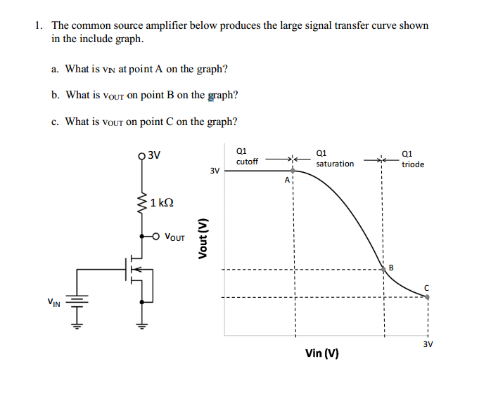

We operate the mosfet in the saturation region for analog circuits. Appropriate bias is selected for the DC operating point to remain in the middle of the saturation region. The DC operating point is selected in such a way that no clipping happens to the output signal. We ensure that the mosfet is in saturation region by maintaining V_{DS} > V_{GS} – V_{TH} .

