GAM6001-18 Major Project

Individual Report

Assessment 02

McDonald, Bradley

1608793

Contents

Abstract (Do Last) 2

1.Background 2

1.1 What was your team aiming to do? 2

1.2 What was the composition of the team? 2

1.3 What role did you play in the team? 2

•1.4 What state was your prototype in at the point when this module started? 2

2.Introduction 3

3.Technical Art 3

3.1 A Designer Creating Technical Art 3

3.1.1 Brief discussion of relevant literature 3

3.1.2 How this work was approached (design etc) 4

3.1.3 Problems, solutions and evaluation of this work in comparison to research undertaken 4

3.2 The second task undertaken(change) 4

3.2.1 Brief discussion of relevant literature 4

3.2.2 How this work was approached (design etc) 4

3.2.3 Problems, solutions and evaluation of this work in comparison to research undertaken 4

4. Reflection 4

5. Conclusion 5

6. Bibliography 6

Figure Table

Figure 1- Unreal Engine Profiler- ‘Koala Rama After Optimisation’. Date- 14th March 2019 4

Figure 2- Unreal Engine Profiler- ‘Koala Rama Before Optimisation’. Date- 12th March 2019 4

Figure 3- Moving Platform Tool 5

Figure 4- Fence Tool 6

# Abstract (Do Last)

This report covers the intricate details of the development of the project Koala Rama from one of the designers. The topics covered are to be backed up with relevant literature and

# 1.Background

The Team, for this module, created a 3D platforming game. The game was based on a bi-pedal Koala, who has to rescue his friends throughout a variety of worlds by utilising a variety of mechanics. The title of this game was Koala Rama.

## 1.1 Aims of the project.

The team wanted to create an aspiring 3D platformer with added unique gameplay mechanics whilst also including generic 3D platformer mechanics (such as Walking, Running, Jumping and double Jumping) as to still seem familiar to people who have played 3D platformers before. The team decided to add the unique elements as to set it aside from other previously released games in the same genre. Games of the same genre consist of Mario and Spyro, though these are developed by different companies they fall within the same genre, a 3D platformer. A 3D platformer as described by…

## 1.2 The Team Composition

The team was made up of five third year undergraduate games students from various disciplines, an artist, a programmer and three designers. Each person applied skills that adhered to their role. Whilst branching into artist or programmer depending on workload. The artist created 3D models, unwrap, textured and imported into engine for the designers to place within the game. The Programmer focused primarily on Enemy AI and fixed bugs when attempting to build the game. The Designers would create tools and polish to the game in the form of particle effects or sound whilst creating and designing multiple levels for the player to navigate in Unreal Engine 4 (UE4), (Epic Games,1998).

## 1.3 The authors role in the team

The Author carried out his role in the team as a designer in a small independent game development (indie) team would. As quoted by Mike Bithell: 'The highs and lows of creative freedom are very addictive'; Having developed Thomas Was Alone and Volume, the indie games designer is both a one-man studio and a devoted collaborator. But what does his work actually involve? 2015, , Guardian Newspapers’. Which implies to use and learn a wide range of skills within the project, this is different than being a designer on a large AAA team, where the role would have been more specific. The role of being a generic designer meant going into different aspects of game development, such as; Gameplay Programming, Animating, UI Design, Technical Art and VFX. This allows for constant learning and developing new skills as the project progressed.

## •1.4 The state of production from first milestone

The prototype was at as stage where the core mechanics were working, such as; walking, jumping, rolling and throwing the boomerang. With these mechanics there were a small number of visual glitches to do with animations, of which needed polishing. The game itself was playable with one main level. However, with the overall design of the level done and with the better tools developed for level design, it became easier and more apparent to make more levels. Of which the team reorganised with the intent to create more playable areas.

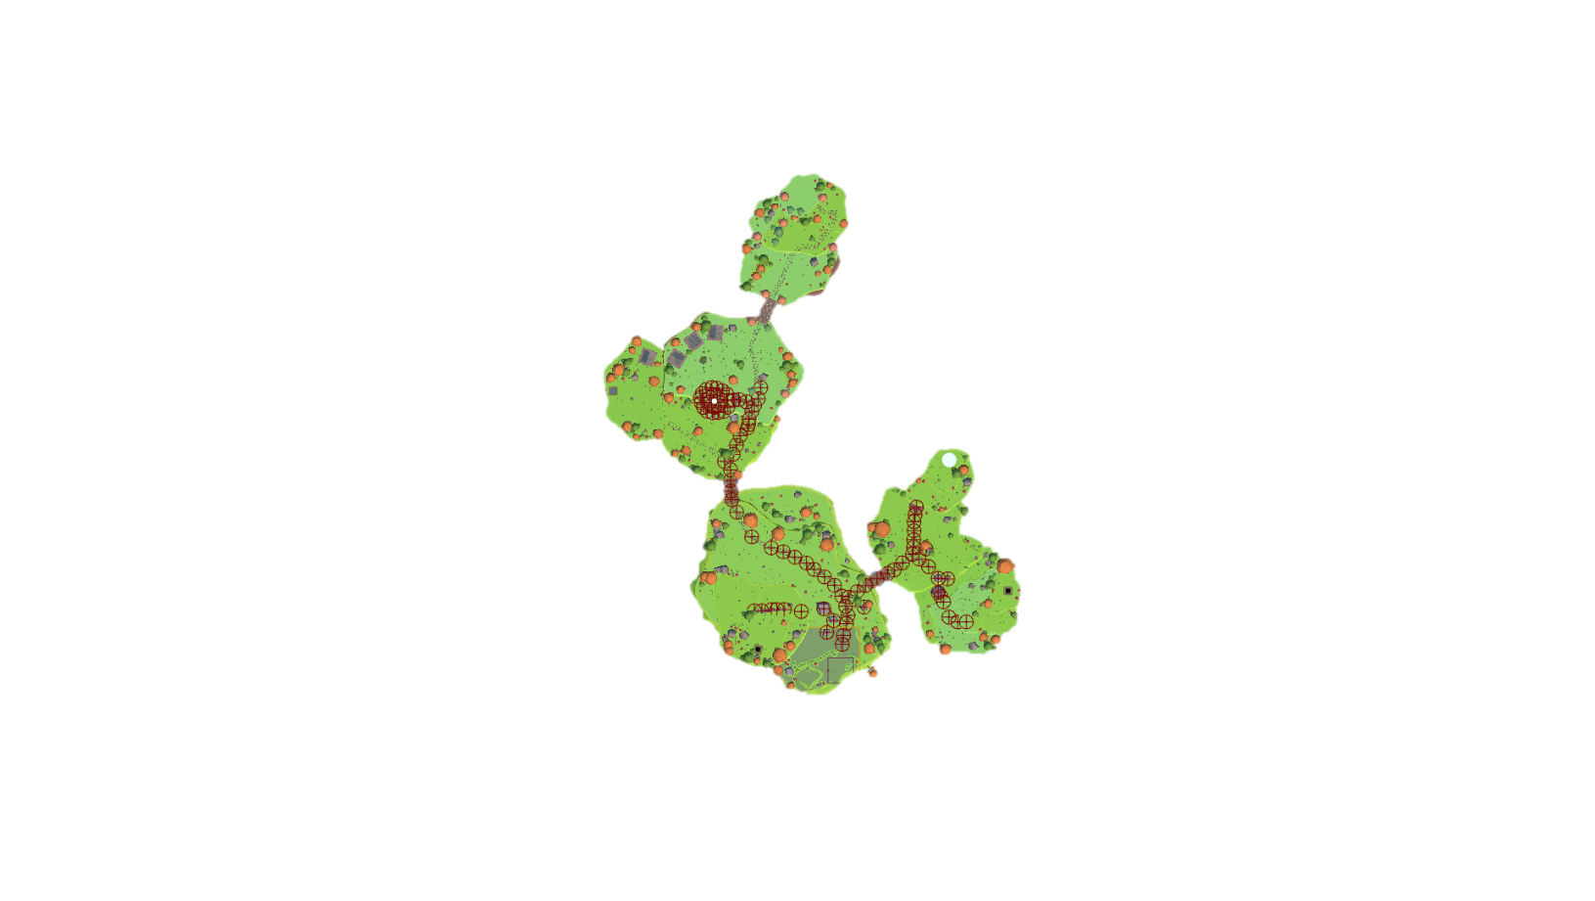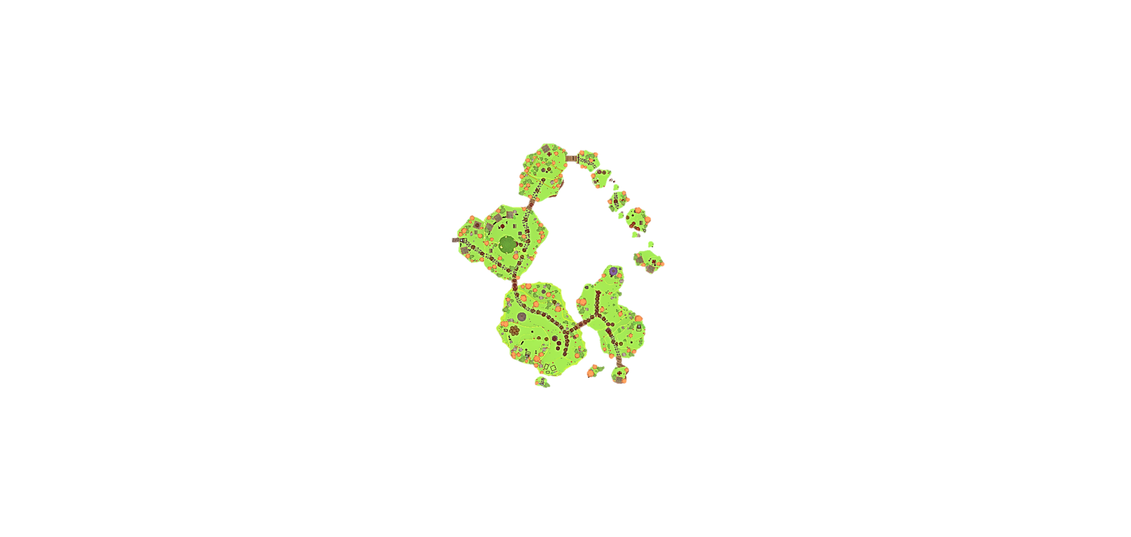

## 2.Introduction

As one of the Designers of the team, many roles had to be undertaken to provide a quality product. The document will go into detail of these roles, what they were, how they were done and what effect these implementations had on development. These effects can range from implementing feedback from testing results, to setbacks in development which led to rework of the original design. This document will also go into detail of relevant literature and research of which informed the approach in this project, and if these findings actually were reflected in the project or not. The document will go into detail of the work the author has done on the project, the testing of the project and the potential political implications of the project. This will be followed by a reflection and conclusion of the authors work through the project, Koala Rama.

The author will relate back to previous submitted work at relevant parts to show how the project developed based upon certain aspects of the submitted work and project. This will primarily be focused upon when discussing testing and implementation of design into the developed project, including the potential political aspects of the project.

# 3.Technical Art

This section will cover the role of a technical artist and how the author took up this role through development to provide a greater service to the team and project.

The job of a technical artist as defined by (Full Sail University, 2018)

“Something of a hybrid between an artist and a programmer is the video game technical artist. This person works under the direction of the art director and technical art director, and is responsible for the systems and tools associated with creating and porting art assets”.

Though that is a definition of a technical artist, it is not the clearest. As an article by (Sokanu, 2019) states that

“The role of technical artist is a relatively new one, but it is becoming increasingly important as consoles and PC hardware become more complicated. A technical artist works closely with the lead artist and the creative director, as well as the lead programmers. Their responsibilities include setting up and maintaining the workflow of art production, deciding which art packages and tools a studio should use, investigating new techniques, and then going ahead and implementing them”.

Both quotes interlink with saying that the technical artist works alongside programmers and artists however verge when discussing tools, (Full Sail University, 2018) makes it seem that the technical artist simply decides on the tools that are being implemented whereas (Sokanu, 2019) goes into that the technical artist actually creates the tools needed for production. A technical artist at Ubisoft Bucharest (Ubisoft, 2016) goes onto say that “In the beginning we’re focused on creating the pipeline, workflow and the tools the artists can work with”. This keeps with how the author approached the role, creating various tools for the designers and artists whilst maintaining a stable version of the game through optimisation.

To take up the role of a technical artist is to utilise both art and programming to create a multitude of tools so that Designers can speedily design, create and test level layouts and adjust them easily based on feedback. Be that feedback internal or external. As the author’s role of being a designer, with experience in both art and programming. The job was possible. With existing knowledge of game design, allowed the author to tailor the tools so that a fellow designer would be able to fully utilise the tool with little or no tutorial. As they knew themselves of what a tool needed and how it needed to function in the editor.

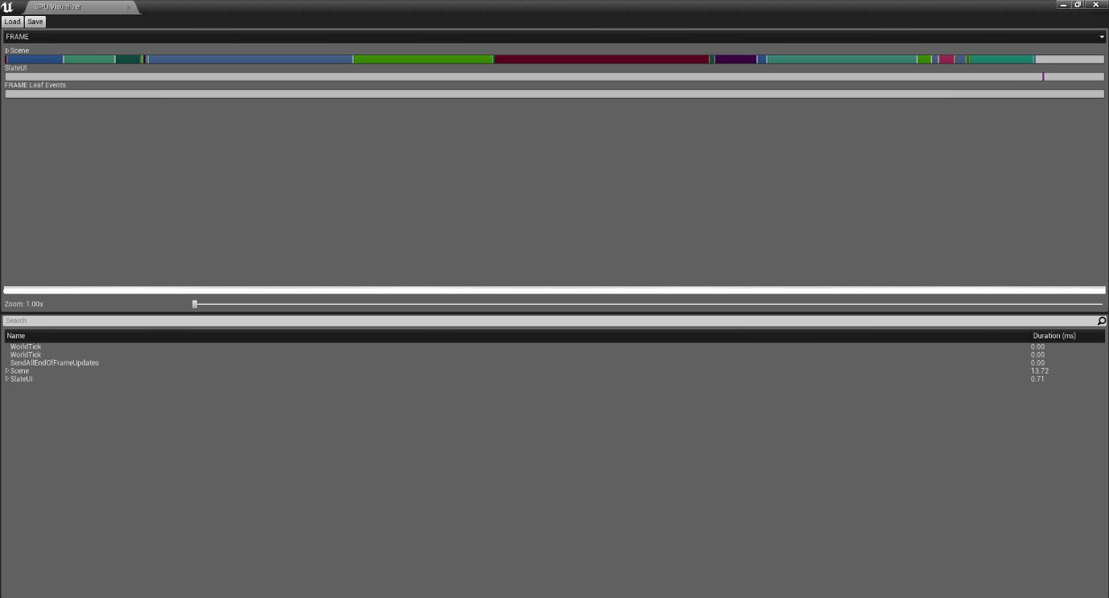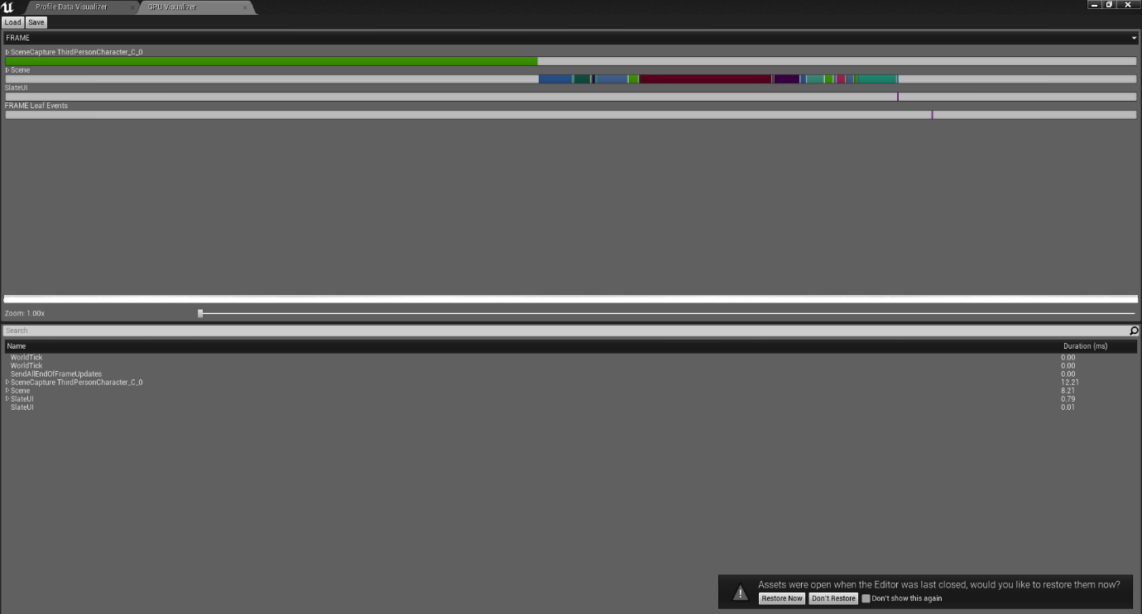Another task that comes with the role of a technical artist it to optimise the game, by viewing the in-engine profiler, to see if any imported assets, created by the artist, effect the game. Either by performance (Frames per second) or if they create visual glitches (missing polys or wrong facing normals). This can lead to unanticipated stops in production of which then need to be solved before any new alteration or iterations are added to the game.

Figure 1- Unreal Engine Profiler- ‘Koala Rama After Optimisation’. Date- 14th March 2019

Figure 2- Unreal Engine Profiler- ‘Koala Rama Before Optimisation’. Date- 12th March 2019

Figure 2- Unreal Engine Profiler- ‘Koala Rama After Optimisation’. Date- 14th March 2019

Figure 1- Unreal Engine Profiler- ‘Koala Rama Before Optimisation’. Date- 12th March 2019

As you can see if in Figure 1 there is a large green bar which take up a majority of the space, this is a visualisation of the memory being used by a particular asset. In this instance it was the Third Person Character Blueprint that was taking the majority of the memory. So, to optimise the game the author researched a variety of methods to optimise the game. Originally in the design of the game the player was to gradually gain their abilities such as double jump and roll, with this in mind the author researched ‘Composition over inheritance’ a resource is (Johansson, 2015) whom details to ‘define objects of what they can do rather than what they are’. So that later I could define the playable character as an object that could ‘fight’ or ‘roll’ rather than constantly checking if they could due do those things by what it is. This method was ideal however later in production the team decided it was better to ensure the player has all the abilities from the start of the game. This meant that this was of optimisation was no longer needed. So other methods were researched and implemented.

## 3.1 A Designer Creating Technical Art tools

The tools that were created were to primary aid designer in prototyping levels and to quickly alter them for further development.

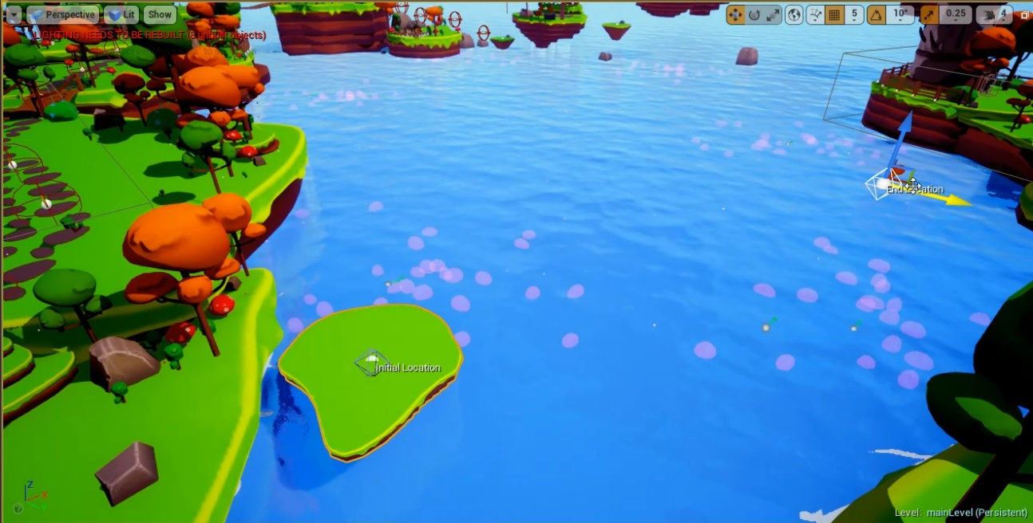

Figure - Moving Platform Tool

## 

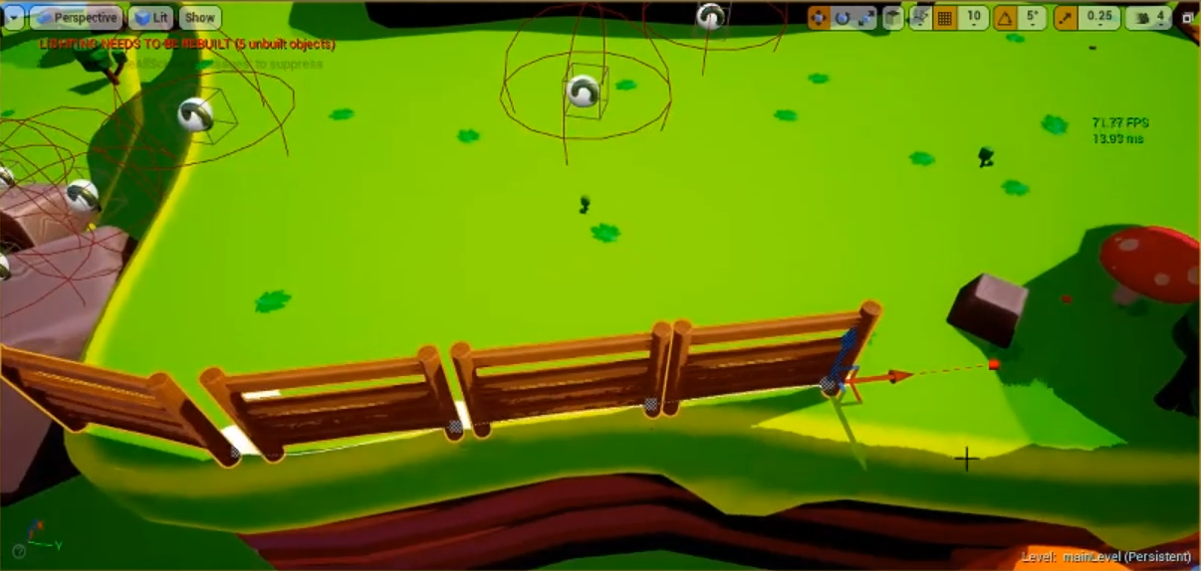

Figure - Fence Tool

## 3.1.1 Brief discussion of relevant literature

* James Miller Uni lecture
* Real-time cinematography for games-by Hawkins, Brian

## 3.1.2 How this work was approached (design etc)

## 3.1.3 Problems, solutions and evaluation of this work in comparison to research undertaken

## 3.2 The second task undertaken(change)

## 3.2.1 Brief discussion of relevant literature

## 3.2.2 How this work was approached (design etc)

## 3.2.3 Problems, solutions and evaluation of this work in comparison to research undertaken

## Reflection

## Conclusion

# Bibliography

Hawkins, BM 2005, Real-Time Cinematography for Games, Charles River Media, Hingham. Available from: ProQuest Ebook Central. [1 April 2019].

HacknPlan

Unique New Academic Degree in Visual & Game Programming for Southern California; Curriculum to Train 'Technical Artists' for Animation and Video Game Industries 2006, , PR Newswire Association LLC, New York

# Bibliography

Full Sail University. (2018). *Technical artist*. Retrieved from GetInMedia.com: http://getinmedia.com/careers/technical-artist

Johansson, M. P. (2015, 9 20). *Composition Over Inheritence*. Retrieved from Medium.com: https://medium.com/humans-create-software/composition-over-inheritance-cb6f88070205

Sokanu. (2019, 04 15). *What does a technical artist do?* Retrieved from CareerExplorer: https://www.careerexplorer.com/careers/technical-artist/

Freeman, W. (2015, Oct 13). Mike bithell: 'the highs and lows of creative freedom are very addictive'. The Observer Retrieved from <https://search-proquest-com.ezproxy.bolton.ac.uk/docview/1721796971?accountid=9653>

EPIC GAMES. (1998) *Unreal Engine.* [Software] Unreal Engine 4.20.3 Cary, NC: EPIC GAMES.